Productivity Edition

October 2022

© Commonwealth of Australia 2022

ISSN: 2653-6196

This publication is available for your use under a [Creative Commons Attribution 3.0 Australia](http://creativecommons.org/licenses/by/3.0/au/deed.en) licence, with the exception of the Commonwealth Coat of Arms, the Treasury logo, photographs, images, signatures and where otherwise stated. The full licence terms are available from <http://creativecommons.org/licenses/by/3.0/au/legalcode>.

Creative Commons attribution licence 3.0 icon. 

Use of Treasury material under a [Creative Commons Attribution 3.0 Australia](http://creativecommons.org/licenses/by/3.0/au/deed.en) licence requires you to attribute the work (but not in any way that suggests that the Treasury endorses you or your use of the work).

**Treasury material used as supplied.**

Provided­­ you have not modified or transformed Treasury material in any way including, for example, by changing the Treasury text; calculating percentage changes; graphing or charting data; or deriving new statistics from published Treasury statistics – then Treasury prefers the following attribution:

*Source: The Australian Government the Treasury*.

**Derivative** **material**

If you have modified or transformed Treasury material, or derived new material from those of the Treasury in any way, then Treasury prefers the following attribution:

*Based on The Australian Government the Treasury data*.

**Use of the Coat of Arms**

The terms under which the Coat of Arms can be used are set out on the Department of the Prime Minister and Cabinet website   
(see [http://www.pmc.gov.au/government/commonwealth‑coat‑arms](http://www.pmc.gov.au/government/commonwealth-coat-arms)).

**Other uses**

Enquiries regarding this licence and any other use of this document are welcome at:

Manager  
Media Unit  
The Treasury  
Langton Crescent   
Parkes ACT 2600  
Email: [media@treasury.gov.au](mailto:media@treasury.gov.au)

# Contents

Foreword 3

Overview: Understanding productivity in Australia and the global slowdown 4

Competition in Australia and its impact on productivity growth 14

How dispersed are new technologies in the Australian job market? 21

Why the real wages of graduates with bachelor’s degrees have fallen 28

Children and the gender earnings gap 36

Data disclaimers 45

Edited by Iris Day and Kate Fernandes

Foreword

Steven Kennedy

As Australia emerges from the COVID‑19 pandemic, attention is returning to long‑run policy objectives including fiscal sustainability and the maintenance of strong and equitable growth in living standards. Addressing the productivity slowdown is important in achieving these goals.

Productivity growth is the key driver of living standards over the long run. Over the past 30 years, labour productivity growth has accounted for around 80 per cent of growth in real income per capita in Australia. Even small variations in productivity growth can have large, long‑run impacts on living standards. The 2021 Intergenerational Report showed that if Australia’s productivity growth remains around 1.2 per cent instead of rising to 1.5 per cent, gross national income per person is estimated to be $13,000 lower in real terms by 2060. Accordingly, productivity was chosen as the theme for this first edition of the reinstated Treasury Round Up.

The first article – ‘Understanding productivity in Australia and the global slowdown’ – is an overview of why productivity growth is important for rising living standards. Australia and other advanced countries have experienced a slowdown in growth for a decade or more. This suggests some shared headwinds, be it trends in competition, technology adoption or human capital. The articles that follow further examine these areas that influence productivity.

‘Competition in Australia and its impact on productivity growth’describes how competition drives productivity growth via more innovative and dynamic markets. At the same time, a range of indicators point to an increase in market power and a decline in dynamism since the early 2000s. The authors consider a range of explanations and show that reduced competition was likely partly responsible and, in turn, contributed to the productivity slowdown.

Productivity growth relies on the diffusion and adoption of new technologies, which is the subject of the third article: ‘How dispersed are new technologies in the Australian job market?’ The authors use novel job advertisement data to show how emerging technologies are being adopted, but at a rate slower than the United States.

Discussions about labour productivity often involve proposals to reform the higher education system. This is the subject of the next article: ‘Why the real wages of graduates with bachelor’s degrees have fallen’.The authors investigate causes of lower real wages for graduates, disentangling the role of increased graduate supply and variable demand, with changes in the composition of recent graduates.

‘Children and the gender earnings gap’ is the final article. It considers the increase in the gender earnings gap brought about by parenthood, and shows that it reflects lower participation rates, working hours and somewhat lower hourly wages of mothers. Barriers to people making the most of their talents are an important headwind to productivity, and as such the authors provide a timely reminder of how labour market inequality is tied to future prosperity.

I congratulate all the authors for their contributions, in particular the editorial team of Iris Day and Kate Fernandes, and commend to you this newly reinstated volume of the Treasury Round Up.

Overview: Understanding productivity in Australia and the global slowdown

|  |
| --- |
| Prepared by Zac Duretto, Omer Majeed and Jonathan Hambur[1]* |
|  |

|  |
| --- |
| *Productivity growth is a key driver of living standards, but it has slowed since the mid*‑*2000s in Australia. The slowdown in productivity growth is consistent with the experience in most other advanced economies, suggesting that global factors are contributing. As in other countries, declining economic dynamism and competition has weighed on firms’ incentives to adopt technologies, and for resources to flow to more productive firms. Research and development have lagged other countries somewhat, though broader innovation metrics have improved moderately. Domestic policy can have significant impacts by facilitating innovation, diffusion of technologies, and better resource reallocation to move Australia closer to the global frontier.* |

# Productivity growth has slowed

Productivity growth has slowed in Australia since the mid‑2000s (Figure 1, PC 2017). Nationally, productivity growth averaged 1.6 per cent over the past 30 years, but only 1.2 per cent over the past 20 years. A similar slowdown is visible in the market sector.[2]

Labour productivity growth can be decomposed into 2 components: capital deepening and multifactor productivity (MFP) growth.[3] The weakening in productivity growth mostly reflects a decline in MFP growth, which slowed to 0.2 per cent in the market sector over the last 2 complete productivity cycles (2004-2018), compared to 1.7 per cent over the previous 2 productivity cycles (1989-2004) (Figure 2). Capital deepening has also slowed in the most recent years.[4]

Figure 1: Whole economy labour productivity growth

Column chart of labour productivity growth across ABS productivity growth cycles where growth declines in recent years.

Notes: Productivity cycles determined by the ABS. Final cycle (2018‑21*) is incomplete.

Source: ABS Australian System of National Accounts, 2020‑21.

Figure 2: Market sector labour productivity growth decomposition

Column chart of market sector labour productivity growth which is decomposed into multifactor productivity growth and capital deepening. The chart shows multifactor productivity growth has slowed more than capital deepening in recent years.

Notes: Productivity cycles determined by the ABS. Final cycle (2018‑21*) is incomplete. Market sector labour productivity measured by GVA per hour in 12 selected industries.

Source: ABS Estimates of Industry Multifactor Productivity, 2020‑21.

The shift towards the services sector does not account for the slowdown in productivity growth (Campbell and Withers 2017), with declines in productivity growth observed across most industries (Figure 3).

The overall productivity slowdown is broadly consistent with the experiences of other advanced economies. For instance, labour productivity growth in the United States was 1.1 per cent on average over the past 10 years, compared to 1.6 per cent over the past 20 years (Feenstra et al. 2015). The broad‑based decline in productivity across advanced economies suggests that global factors at least partly explain the decline in productivity growth in Australia.

Figure 3: Average annual labour productivity growth, by industry

Bar chart shows average labour productivity growth over two periods by industry. Productivity growth was lower between 2005-2020 compared to 1990-2005 for most industries.

Notes: Growth rates determined by compound average growth.

Source: ABS Estimates of Industry Multifactor Productivity, 2020‑21.

# What explains the global slowdown?

Many factors have likely contributed to slower global productivity growth, and we explore some of the key discussions below.

## Are current innovations transformative?

Techno‑pessimists argue that past innovations were far more significant than current innovations. For example, electrification completely re‑shaped the way we lived, while we have also potentially reaped most of the gains from the information technology expansion era of the 1990s and early 2000s (Gordon 2012).

Techno‑optimists argue that current innovations − such as artificial intelligence (AI) − can be just as transformative, but that many of the benefits will take time to accrue. This is because these ‘general‑purpose technologies’ require complementary investments and skills to fully realise the benefits (Brynjolfsson and McAfee 2011).

While the debate between the 2 camps is ongoing, continued strong productivity growth among ‘frontier’ firms suggests current technologies are transformative, but may be slower to diffuse to other firms (Andrews, Criscuolo, and Gal 2019).

## Have we become worse at measuring productivity over time?

A related explanation is that we may have become worse at measuring inputs and outputs over time. Accounting for improvements in the quality of goods and services is challenging. This may have become even harder with the advent of new and digital technologies, as well as free services and platforms (for example, Google and Facebook). Similarly, measuring investments in intangibles such as ideas, processes, and brands can be difficult.[5] Some economists argue that these challenges mean productivity growth is underestimated.

However, research has found that while measurement errors exist, they are unlikely to explain a large share of the decline in labour productivity (Boppart and Li 2021, Burnell and Elnasri 2020).

## Is the slowdown in trade a factor?

Increased trade and use of global value chains (GVCs) contributed to productivity growth over the 1990s and early 2000s by enabling cheaper production, specialisation, increasing competition and diffusing technologies and knowledge. However, many of these gains may have already been reaped. Growth in trade also slowed after the global financial crisis reflecting a shift away from import‑intensive goods, slowdown in growth in Asian economies and heightened economic uncertainty (Jääskelä and Mathews 2015). Recent studies suggest that diminishing gains from trade could account for a moderate portion of the global productivity slowdown − Goldin et al. (2021) suggest it could account for around 15 per cent of the slowdown.

## Is the economy less dynamic and competitive?

Resources, ideas, and technologies flow easily between firms in a dynamic economy. New firms enter and either thrive and grow, or exit. This allows resources to flow to their most productive use, and creates competitive pressures that cause firms to innovate, invest and improve.

However, measures of dynamism have been declining in the United States and other advanced economies (Calvino, Criscuolo and Verlhac 2020). Fewer firms are opening and closing. Job reallocation has slowed. Young firms now make up a smaller share of economic activity. Meanwhile, measures of competitive pressures have declined. Firms appear to be slower to adopt new technologies and converge to the productivity frontier (Akcigit and Ates 2019). Declining dynamism appears to be an important contributor to slower productivity growth.

## Is human capital playing a role?

Human capital is an important driver of productivity since skilled workers can perform tasks and produce output more efficiently. Improvements in human capital have been estimated to boost productivity (Égert and Turner 2022) and differences in human capital can drive differences in productivity at the firm level (Criscuolo et al. 2021). A slowdown in the growth of human capital may have impacted the productivity slowdown in some countries such as the US (Vollrath 2019). To date, there is limited evidence of this in Australia, particularly given that quality‑adjusted measures of labour productivity in Australia have followed similar trends to unadjusted labour productivity.

# What evidence is there for Australia?

Much of the recent evidence for Australia has focused on declining dynamism, competitive pressures, and innovation.

## The economy is less dynamic

As in other countries, business dynamism has declined in Australia. Entry and exit rates have fallen (Figure 4), and the share of economic activity done by young firms, which often drive innovation, has fallen. People have become less likely to switch jobs, with the lack of new firms appearing to be an important factor (Deutscher 2019; Andrews and Hansell 2021).

Figure 4: Entry and exit rates

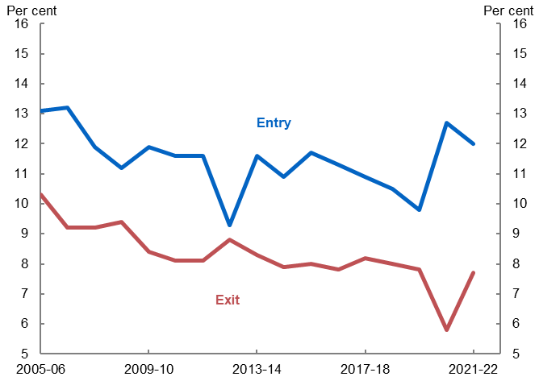

Notes: Entry and exit rates are for employing firms. Entry and exit rates during the pandemic period may have been affected by temporary government support and changes in insolvency laws.

Source: Treasury analysis of ABS Counts of Australian Businesses, including Entries and Exits.

## Competitive pressures have declined

Measures of competitive pressures have also declined in Australia since the mid‑2000s. On average industries have become more concentrated, while mark‑ups have also increased. At the same time, the largest firms in each industry have become more entrenched. Declines in competitive pressures appear smaller than those documented overseas. However, they still appear to have weighed on productivity, lowering business incentives to innovate and reallocate resources to more productive uses (see Day, Duretto, Hambur and Hartigan, this edition).

## Resources are slower to be allocated to productive firms

Historically, Australia was good at allocating resources to the most productive use, comparing favourably with the United States on measures of allocative efficiency, particularly in manufacturing.

However, labour now flows to more productive firms more slowly. Estimates suggest this accounts for around one-quarter of the slowdown in productivity growth. The slowing in reallocation was worse in industries where competitive pressures declined (Andrews and Hansell 2021, Hambur 2021).

## Adoption of new technology is slower and Australian firms are falling further behind the global frontier

Australian businesses are falling further behind the global frontier (Figure 5), and the rate at which they catch up has slowed. This suggests they are slower to adopt new cutting‑edge technologies and processes (Bahar and Lane, this edition). This finding is consistent with evidence overseas. Diffusion of many new technologies is also far from complete (Treasury 2019).

Figure 5: Labour productivity dispersion – business sector

Line graph comparing Australian frontier and laggard firms to global frontier firms where Australian firms lag behind. 

Notes: Frontier is top 5 per cent of firms in an industry. Business sector is defined here as the manufacturing sector plus the services sector. Indexed to 2002=1, so that the vertical axis shows cumulative productivity growth.

Source: Andrews et al. (2022).

The slowdown was larger in sectors with declining entry and exit rates, and where measures of competitive pressures had declined. This suggests that declining dynamism and competitive pressures have lowered the impetus for firms to adopt new technologies and improve their productivity (Andrews et al. 2022).

## Innovative activity continues to grow slowly, while research and development (R&D) lags global peers

Business R&D (BERD) is an important input into innovation and, therefore, productivity. As a share of GDP, Australia’s BERD declined from 1.3 per cent in 2009−10 to 0.9 per cent in 2019−20 (DISER 2021). In contrast, BERD as a percentage of GDP has increased slightly for OECD economies, going from 1.5 per cent in 2010 to 1.9 per cent in 2020.[6]

While this result is important, the extent of Australia’s underperformance may be slightly overstated. Much of the decline reflects a decrease in mining exploration following the end of the resources boom. After excluding the mining sector, the decline in BERD as a percentage of GDP is much smaller, and some industries such as professional, scientific and technical services have seen increases (from 3.0 per cent in 2009−10 to 4.5 per cent in 2019−20).[7]

Other measures of innovation have also been more favourable. The share of human resources devoted to R&D increased slightly between 2005−06 to 2019−20, from 0.41 per cent of the labour force to 0.57 per cent.[8] Broader measures of innovation have also improved moderately over this time; for example, the share of firms actively innovating has steadily risen from 42.4 per cent in 2005−06 to 50.7 per cent in 2019−20 (DISER 2021).

# Fiscal impacts of slowing productivity growth

If Australia was closer to the global frontier of productivity growth, this would lead to permanent increases in income levels and higher living standards. Australia is limited in the extent to which it can grow more rapidly than comparable countries, however, it is likely we are not near that limit.

There are fiscal implications if the slowing of productivity over the past 2 decades persists. Modelling from the Intergenerational Report 2021 suggests that if productivity growth averaged 1.2 per cent over the medium term rather than 1.5 per cent, real GDP growth would be lower and real gross national income per person would be around $13,000 smaller by 2060. Additionally, the underlying cash balance as a percentage of GDP would be around 2.2 percentage points lower.

# Policy can support productivity growth

Policy can play a crucial role in addressing the productivity slowdown. Slower global productivity growth will weigh on Australia’s productivity growth, especially as a small open economy that tends to adopt innovations from the frontier. However, domestic policy can still have significant impacts on productivity growth. Policies that could support Australia to move closer to the global productivity frontier include: incentivising and facilitating the innovation and diffusion of technologies; supporting firm growth and innovations of higher novelty (new‑to‑world, new‑to‑country); and removing barriers to resource reallocation and formation of trade linkages (particularly global value chains) (Athukorala at el. 2017).

This is evident overseas. OECD research has shown that declines in dynamism were larger when there were higher regulatory barriers, less efficient bankruptcy rules, and lower levels of education and skills (Calvino, Criscuolo and Verlhac 2020). Good policy can partly offset the global factors weighing down dynamism. Previous reform eras of the 1980s and 1990s were followed by periods of strong productivity growth, bringing Australia closer to United States levels (Figure 6).

Figure 6: Ratio of Australian to US labour productivity

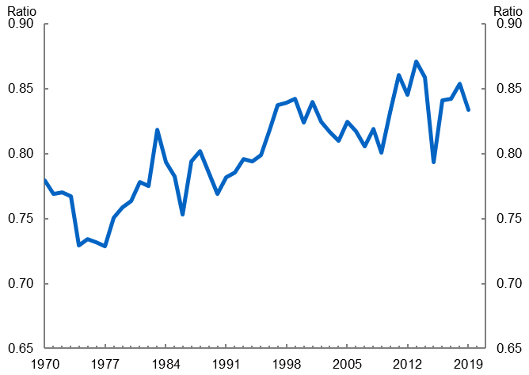

Notes: GDP per hour worked in Australia divided by GDP per hour worked in the US (output‑side GDP at chained PPPs in 2017 USD).   
Source: Feenstra et al. 2015 (Penn World Table)

While some of the larger reforms of the 1980s and 1990s have been realised, there are still many important reforms that can be undertaken. The Productivity Commission has commenced its second 5‑yearly review to identify this next round of productivity‑enhancing reforms.

While there is evidence Australia avoided a shakeout of highly productive firms during the COVID‑19 lockdowns, it is too early to ascertain the productivity impacts of COVID‑19 (Andrews, Bahar and Hambur 2021). There is evidence that, globally, COVID‑19 has sped up the process of digital adoption and policy can potentially help facilitate this. However, disruptions to schooling may have negative implications for human capital, while global shifts towards domestic production undo some of the productivity gains provided by global value chains.

# References

Akcigit U and Ates S (2019) ‘Ten Facts on Declining Business Dynamism and Lessons from Endogenous Growth Theory’, *NBER working paper* 25755.

Andrews D, Criscuolo C and Gal PN (2019) ‘The Best Versus the Rest: Divergence across Firms during the Global Productivity Slowdown’, *CEP Discussion Paper* 1645.

Andrews D, Bahar E and Hambur J (2021) ‘The COVID‑19 shock and productivity‑enhancing reallocation in Australia: Real‑time evidence from Single Touch Payroll’, *OECD Economics Department Working Papers*.

Andrews D, Hambur J, Hansell D and Wheeler A (2022) ‘Reaching for the Stars: Australian Firms and the Global Productivity Frontier’, *Treasury Working Paper*.

Andrews D and Hansell D (2021) ‘Productivity‑Enhancing Labour Reallocation in Australia’, *Economic Record*, 97(317): 157‑169.

Athukorala PC, Talgaswatta T and Majeed O (2017) ‘Global production sharing: Exploring Australia’s competitive edge’, *The World Economy*, 40(10): 2172‑2192.

Australian Bureau of Statistics (2020−21 financial year a) ‘Tables 1 to 19: Estimates of industry multifactor productivity’ [time series spreadsheet], [*Estimates of Industry Multifactor Productivity*](https://www.abs.gov.au/statistics/industry/industry-overview/estimates-industry-multifactor-productivity/latest-release#data-download), accessed 17 December 2021.

Australian Bureau of Statistics (2020−21 financial year b) ‘Australian industry by division’ [time series spreadsheet], [*Australian Industry*](https://www.abs.gov.au/statistics/industry/industry-overview/australian-industry/latest-release#data-download), accessed 14 January 2022.

Australian Bureau of Statistics (2019−20 financial year) ‘Business expenditure on R&D, by ANZSIC06 industry subdivision, by employment size’ [data cube], [*Research and Experimental Development, Businesses, Australia*](https://www.abs.gov.au/statistics/industry/technology-and-innovation/research-and-experimental-development-businesses-australia/latest-release#key-statistics)*,* accessed 14 January 2022.

Australian Bureau of Statistics (July 2017 – June 2021) ‘Data cube 1: Tables 1‑20 of counts of Australian businesses, including entries and exits’ [data set], [*Counts of Australian Businesses, including Entries and Exits*](https://www.abs.gov.au/statistics/economy/business-indicators/counts-australian-businesses-including-entries-and-exits/latest-release#data-download)*,* accessed 21 July 2022.

Boppart T and Li H (2021) ‘Productivity Slowdown: Reducing the Measure of Our Ignorance’, *Federal Reserve Bank of San Fransisco working paper*.

Burnell DS and Elnasri A (2020) ‘Does Measurement of Digital Activities Explain Productivity Slowdown? The Case for Australia’, *Economie et Statistique / Economics and Statistics*, 517-518-519: 123–137.

Brynjolfsson E and McAfee A (2011) ‘Race Against The Machine: How the Digital Revolution is Accelerating Innovation, Driving Productivity, and Irreversibly Transforming Employment and the Economy’, *Digital Frontier Press*.

Calvino F, Criscuolo C and Verlhac R (2020) ‘Declining business dynamism: structural and policy determinants’, *OECD Science, Technology and Innovation Policy Papers*, 94.

Campbell S and Withers H (2017) ‘Australian productivity trends and the effect of structural change’, *Department of the Treasury*, <https://treasury.gov.au/publication/p2017-t213722c>.

Criscuolo C, Gal P, Leidecker T and Nicoletti G (2021) ‘The human side of productivity: Uncovering the role of skills and diversity for firm productivity’, *OECD Productivity Working Papers*, 29, OECD Publishing, Paris.

DISER (Department of Industry, Science, Energy and Resources) (2021) ‘Australian Innovation System Monitor’, Australian Government, viewed 25 October 2021 <[www.industry.gov.au/aismonitor](http://tweb/sites/meg/rcg/ru/www.industry.gov.au/aismonitor)>.

Department of the Treasury (2021) ‘2021 Intergenerational Report’, Australian Government, viewed 22 October 2021, <[https://treasury.gov.au/publication/2021‑intergenerational‑report](https://treasury.gov.au/publication/2021-intergenerational-report)>.

Department of the Treasury (20 June 2019) [*Keeping pace with technological change: the role of capabilities and dynamism*](https://treasury.gov.au/speech/s2019-390085) [media release], Department of the Treasury, accessed 10 July 2022.

Deutscher N (2019 ‘Job‑to‑Job transitions and the wages of Australian workers’, *Treasury Working Paper*.

Égert B and Turner D (2022) ‘A new macroeconomic measure of human capital exploiting PISA and PIAAC: Linking education policies to productivity’, *OECD Economics Department Working Papers*, 1709, OECD Publishing, Paris.

Feenstra RC, Inklaar R and Timmer MP (2015) ‘The Next Generation of the Penn World Table’ *American Economic Review*, 105(10): 3150‑3182, available for download at <[www.ggdc.net/pwt](http://www.ggdc.net/pwt)>.

Goldin I, Koutroumpis P, Lafond F and Winkler J (2021) ‘Why is productivity slowing down?’, *Oxford Martin Working Paper Series on Economic and Technological Change*.

Gordon RJ (2012) ‘Is US Economic Growth Over? Faltering Innovation Confronts Six Headwinds’, *NBER Working Paper* 18315.

Hambur J (2021) ‘Product Market Power and its Implications for the Australian Economy’, *Treasury working paper*.

Jääskelä J and Mathews T (2015) ‘Explaining the slowdown in global trade’, *Reserve Bank of Australia Bulletin, September*, 39‑46.

PC (Productivity Commission) (2017) ‘Shifting the Dial: 5‑year productivity review’, Australian Government, viewed 3 November 2021, <[https://www.pc.gov.au/inquiries/completed/productivity‑review/report](https://www.pc.gov.au/inquiries/completed/productivity-review/report)>.

PC (Productivity Commission) (2021) ‘Things you can’t drop on your feet: An overview of Australia’s services sector productivity’, Australian Government, PC Productivity Insights, viewed 29 November 2021, <[https://www.pc.gov.au/research/ongoing/productivity‑insights/services](https://www.pc.gov.au/research/ongoing/productivity-insights/services)>.

Vollrath D (2019) *Fully Grown: Why a Stagnant Economy Is a Sign of Success*, University of Chicago Press, Chicago and London.

Competition in Australia and its impact on productivity growth

|  |
| --- |
| Prepared by Iris Day, Zac Duretto, Patrick Hartigan and Jonathan Hambur[9]* |
|  |

|  |
| --- |
| *Competitive pressure can lead to more efficient markets and drive firms to innovate. These benefits can lead to productivity growth. A range of competition indicators − including industry concentration, incumbency, and firm mark‑ups − suggest a deterioration in competition in the Australian economy since the early 2000s. Further analysis in Treasury working papers suggests that increasing market power and changing technology are both playing a role. This increase in market power in turn has been shown to contribute to the slowdown in productivity in Australia via lower incentives for firms to innovate, for resources to flow to their most productive use, and for the least productive firms to exit the market.* |

# Competition can affect dynamism and productivity

Declining competition has been suggested as a potential explanation for declining dynamism, and in turn productivity (see Article 1; IMF 2019). The mechanisms can be split into 2 channels: a between‑firm reallocation channel, and a within‑firm improvement channel.

Focusing on the within‑firm channel, extensive research considers how competition shapes firms’ decisions about their management and operations.[10] Competitive pressure can also drive firms to innovate. Some empirical evidence suggests that greater competition promotes more innovation. The UK Competition and Markets Authority (CMA) (2015), for example, assessed evidence of the impact of competition on R&D activity and patents. It found that competition can boost innovation, particularly when complemented by effective intellectual property rights. Other research has found that there may be a positive or negative relationship between competition and innovation, depending on the market structure (for example, Aghion et al. 2005).

When considering the between‑firm channel, competition can incentivise the flow of resources towards more productive firms and away from less productive ones. This is a process known as dynamic reallocation (for example, Decker et al. 2017 and Decker et al. 2020). Less productive firms are then more likely to exit the market than more productive firms (selection). The between‑firm effect on productivity of unsuccessful firms being forced from the market has also been established in the literature (for example, Syverson 2004).

Given the clear link to productivity, it is important to examine how the state of competition in Australia has changed and whether declining competition could help to explain slower productivity growth. The sections below present evidence that competition has lessened across industries, and market power has grown from the 2000s to the present. This has weighed on productivity growth.

# Measures of market power have increased in Australia

There is no single best measure of competition or market power (OECD 2021). As a result, we look at a range of measures to gauge the state of competition and its evolution since the early 2000s, including industry concentration, incumbency and mark‑ups.

**Industry concentration** metrics seek to explain the extent to which a small number of firms dominate an industry. One simple way of measuring this is the proportion of sales accounted for by the largest firms. In 2018−19, the largest 4 firms in each industry (4‑digit ANSZIC industry) made up around 43 per cent of total industry sales on average. This is around 2 percentage points higher than 2001−02 (Figure 1).A similar increasing trend is found using the Herfindahl‑Hirschman Index (HHI), which is calculated as the sum of squared market shares of each firm. Increases in concentration since the early 2000s have also been experienced overseas (Bajgar et al. 2019).

Figure 1: Average market share of top four firms in each industryThis figure shows the average market share of the top four firms in each industry from 2001-02 to 2019-20. Average market share of the top four firms in each industry had an upward trend over this period, increasing from approximately 41 per cent in 2001-02 to 43 per cent in 2018-19. 

Note: Unweighted average of industries, excluding finance and non‑market sectors.

Source: Treasury calculations based on ABS BLADE.

**Incumbency** metrics of competition explore how long firms can maintain a high market share relative to their competitors. A highly concentrated industry may still be competitive if leading firms are frequently displaced from their position by new firms.

One measure of incumbency is the proportion of top 4 firms in an industry that remain among the top for a substantial period (Figure 2). Around 75 per cent of firms in the top 4 of their industry in 2016−17, were still there in 2018−19. This has increased from around 71 per cent in 2001−02.

Figure 2: Share of top four firms that were still in the top four after 2 and 4 years

This figure shows a time series of the share of top four firms that were still in the top four after 2 and 4 years. Both measures show an upward trend since 2001-02. Around 75 per cent of firms who were in the top 4 firms in their industry in 2016-17 were still there two years later, up from around 71 per cent in 2001-02. Similar, around 65 per cent of firms in the top 4 in 2014-15 were still there four years later, up from 56 per cent in 2001-02. 

Source: Treasury calculations based on ABS BLADE.

Another proxy for market power that is increasingly popular in the literature is a firm’s mark-ups, or the ratio of a firm’s price to its marginal cost of production. This is a more direct measure of market power compared to concentration or incumbency since it provides insight into a firm’s ability to influence the price it receives for the goods and services it sells.[11]

Mark-ups were estimated in a Treasury working paper for employing firms in the non‑financial market sector, capturing on average about 60 per cent of the sales in each constituent industry division (see Hambur 2021). Average firm mark-ups increased by around 6 per cent between 2003−04 and 2016−17 (Figure 3).This was a little smaller than alternative estimates for Australia (De Loecker and Eeckhout 2018). While there is moderate variation in the evolution of mark‑ups across industries, they appear to have increased for firms in most parts of the economy.

Figure 3: Average firm‑level mark‑ups

This figure shows average firm-level mark-ups from 2003-04 to 2016-17, indexed to 2003-04. Average firm-level mark-ups had an upward trend over this period, increasing by approximately 6 percent from 2003-04 to 2017-18.

Notes: Index = 100 in 2003‑04; unweighted.

Source: Hambur (2021)

Taken together, measures of market power have trended upwards in Australia since the mid‑2000s. Other economies have also experienced similar increases in market power (Bajgar et al. 2019; De Loecker et al. 2020; De Loecker and Eeckhout 2018; IMF 2019; CMA 2020) as well as decreases in dynamism (Decker et al. 2017).

# Increases in market power metrics likely reflect decreases in competition

We examine several potential explanations for the rise in these metrics, including the superstar hypothesis, changing technology, and declining competitive pressure in the economy.

The increase in mark‑ups may reflect a rise in ‘superstar firms’ where the most productive firms benefit at the expense of others (Autor et al. 2020). However, this does not appear to be the key driver of increased market power in Australia. While the increase in mark‑ups is larger for the upper part of the mark‑up distribution, the increase is broad based (Figure 4).The increase in firm mark‑ups is driven by within‑firm increases rather than reallocation in activity towards high mark‑up firms (Hambur 2021). These findings provide evidence against the superstar firms hypothesis for Australia.

Figure 4: Distribution of firm‑level mark‑ups

This figure shows average firm-level mark-ups from 2003-04 to 2016-17, indexed to 2003-04, for different percentiles of the mark-up distribution. The five lines on the chart represent the change in mark-ups over time for the 10th, 25th, 50th (median), 75th and 90th percentiles of the mark-up distribution. While mark-ups in the 90th and 75th percentiles of the mark-up distribution increased by more between 2003-04 to 2016-17, all percentiles show an upward trend over this period. 

Note: Index 2003‑04=100; Unweighted distribution

Source: Hambur (2021)

Changing technology could explain higher firm concentration and mark‑ups. Software and other digital technologies often have increasing returns to scale, which inherently offer greater benefits to larger firms. This is particularly true for digital firms which often have little to no marginal costs and operate in markets with strong network effects. Increasing measures of mark‑ups and concentration and greater incumbency advantages may as a result be caused by the greater adoption of digital technologies.

The increase in mark‑ups was more than twice as large for firms in the most digitally intensive sectors, suggesting some role for changing technologies (Figure 5). However, mark‑ups have also increased for the other group of firms, suggesting other dynamics, like an increase in market power, are also important.

Figure 5: Mark‑ups by digital intensity of industry

This figure shows average firm-level mark-ups in the most digitally intensive sectors compared to all other sectors from 2003-04 to 2016-17. Both series are indexed to 2003-04. Mark-ups have increased by more than twice as much for firms in the most digitally intensive sectors over this period, although markups have still increased in the other sectors. 

Notes: Index 2003‑04=100. Industries assigned a digital intensity based on the taxonomy outlined in Table 3 of Calvino et al. (2018). Requires mapping of ISIC classifications used in that paper, to the ANZSIC classifications used in BLADE. Firm‑weighted averages then taken for each quartile of industries. Most digitally intensive sectors are top quartile. All other sectors are an unweighted average of the series for the other three quartiles.

Source: Hambur (2021)

Finally, these increases in measures of market power could reflect declines in competitive pressure. Hambur (2021) provides evidence for this, showing selection and dynamic reallocation are weaker in industries with increasing mark‑ups.

For dynamic reallocation, there is evidence that more productive firms increase employee numbers more slowly in industries with increasing mark‑ups. We would expect to see this result if weakening competitive pressure reduced the ability of productive firms to attract resources at the expense of their unproductive peers. Likewise, the results show that as mark‑ups increase, unproductive firms become less likely to exit the market.

The decline in competitive pressure appears to have weighed on aggregate productivity growth, through both the within‑ and between‑firm channels. On the within‑firm channel, Andrews et al. (2022) find that lower competitive pressure has led to Australian firms becoming slower to adopt the inventions and practices of frontier firms. On the between‑firm channel, Hambur (2021) estimates that reduced dynamic allocation lowered annual labour productivity growth by 0.1 percentage points, accounting for about one-fifth of the observed slowdown since 2012.

# Conclusion

A range of metrics point towards declining competitive pressures in Australia. Research by Treasury economists suggest that this is playing a non‑trivial role in the productivity growth slowdown. However, further work is needed to better understand why market power has increased in Australia. Potential explanations for lower competitive pressures include regulatory burdens on entry, or financing frictions that prevent new and innovative firms from entering, growing, and challenging incumbents. A better understanding of the drivers will also help government design policy interventions for specific sectors.

# References

Aghion P, Bloom N, Blundell R, Griffith R, and Howitt P (2005) ‘Competition and Innovation: an Inverted‑U Relationship’, *The Quarterly Journal of Economics*, 120(2): 701–728.

Andrews D, Hambur J, Hansell D and Wheeler A (2022) ‘Reaching for the Stars: Australian Firms and the Global Productivity Frontier’, *Treasury Working Paper*.

Autor D, Dorn D, Katz L, Patterson C and Van Reenen J (2020) ‘The Fall of the Labor Share and the Rise of Superstar firms’, *The Quarterly Journal of Economics*, 135(2): 645‑709.

Backus M (2020) ‘Why is productivity correlated with competition?’, *Econometrica*,88(6): 2415‑2444.

Bajgar M, Berlingieri G, Calligaris S, Criscuolo C, and Timmis J (2019) ‘Industry concentration in Europe and North America’, *OECD Productivity Working Papers*, OECD Publishing, Paris.

Bloom N, Propper C, Seiler S and Van Reenen J (2015) ‘The Impact of Competition on Management Quality: Evidence from Public Hospitals’, *The Review of Economic Studies*, 82(2): 457‑489.

CMA (2015) ‘Productivity and competition: a summary of the evidence’, *Competition & Markets Authority, UK.*

CMA (2020) ‘The State of UK Competition’, *Competition & Markets Authority*, UK.

Calvino F, Criscuolo C, Marcolin L and Squicciarini M (2018) ‘A taxonomy of digital intensive sectors’, *OECD Science, Technology and Industry Working Papers*, 2018/14, OECD Publishing, Paris.

Decker R, Haltiwanger J, Jarmin R and Miranda J (2017) ‘Declining Dynamism, Allocative Efficiency, and the Productivity Slowdown’, *American Economic Review*, 107(5): 322‑326.

Decker R, Haltiwanger J, Jarmin R, and Miranda J (2020) ‘Changing Business Dynamism and Productivity: Shocks versus Responsiveness’, *American Economic Review*, 110(12): 3952‑90

De Loecker J and Eeckhout J (2018) ‘Global Market Power’, *NBER Working Paper* 24768.

De Loecker J, Eeckhout J and Unger G (2020) ‘The Rise of Market Power and the Macroeconomic Implications’, *The Quarterly Journal of Economics*, 135(2), pp 561‑644.

Hambur J (2021) ‘Product Market Power and its Implications for the Australian Economy’, *Treasury Working Paper*.

IMF (2019), ‘The Rise of Corporate Market Power and Its Macroeconomic Effects’, *World Economic Outlook*, Chapter 2.

Leigh A (2022) A More Dynamic Economy, 25 August, F.H. Gruen Lecture, Australian National University.

OECD (2021) ‘Methodologies to Measure Market Competition’, *OECD Competition Issues Paper*.

Syverson C (2004) ‘Market Structure and Productivity: A Concrete Example’, *Journal of Political Economy* 112(6): 1181–1222.

How dispersed are new technologies in the Australian job market?

|  |
| --- |
| Prepared by Elif Bahar and Oscar Lane[12]* |
|  |

|  |
| --- |
| *The diffusion of new technologies is an important driver of productivity growth, particularly in Australia − a small open economy that tends to adopt innovations from the global frontier. Using Lightcast job ad data, we show that Australia’s adoption of emerging technologies has increased over the past decade. Job ads referencing cloud computing, machine learning and artificial intelligence − innovations most likely to become general‑purpose, productivity‑enhancing technologies − have increased strongly and become more evenly spread across industries. However, the prevalence of these technologies appears to be lower in Australia than in the United States.* |

# Diffusion of new technologies is a key driver of productivity growth

Innovation and the use of new technologies are important determinants of firm performance and aggregate productivity. Typically, new technologies are developed by frontier firms and then diffused through the economy as they are adopted by other firms.

Previous Treasury analysis has demonstrated a slowdown in the rate at which Australian firms reached the global productivity frontier between 2002 and 2016, suggesting slower adoption of cutting‑edge technologies and processes (Andrews et al. 2022). This article builds on this evidence by examining the extent to which Australian job advertisement data referenced cutting‑edge technologies between 2012 and 2020.

We focus particularly on technologies that may become ‘general-purpose’. General‑purpose technologies are widely used across industries and spark widespread innovation and productivity growth across the whole economy. Electricity and the internet are examples of previous general‑purpose technologies. While complementary investments are necessary, general‑purpose technologies will ultimately produce significant productivity gains (Brynjolfsson et al. 2021).

# Emerging technologies

We use a list of 29 emerging global technologies identified by Bloom et al. (2021). These authors selected technologies based on how frequently they are mentioned in patents, job postings and earnings conference calls in the US. They argue that each of the 29 technologies has significantly disrupted businesses and jobs in the US in the past 2 decades. They also had significant global implications. All these technologies had emerged (at least in the US) by the 2000s or early 2010s.

We pay particular attention to cloud computing, machine learning and artificial intelligence. It has been argued that these technologies have the most potential to become the next general‑purpose technologies (Goldfarb et al. 2022).

# Text analysis of job ads

Lightcast[13]1 scrapes online company job boards and makes that data available for analytical purposes. The data used here are individual online job ads collected by Lightcast for 2012 to 2020.[14]2 This provides us with a sample of about 8.5 million Australian job ads over this period. The data contains the full text of the job ads, as well as some pre‑defined characteristics of each job such as the industry, occupation and location.

We take two approaches to examining the job ad data. First, we use text analysis techniques to search for keywords related to each technology within the job description, similar to Bloom et al. (2021). For example, searches for the ‘autonomous cars’ technology also includes searches for ‘self‑driving car’, ‘robot car’, and ‘driverless truck’. Second, we use the skills identified by Lightcast to compare the adoption of technologies in Australia and the US.

Figure 1: References to emerging technologies in Australian job ads



Notes*:* Size of font refers to frequency of jobs ad references.

Source*:* Treasury analysis of Lightcast data for Australia (2012‑2020).

# Emerging technologies are becoming more prevalent in Australia

Figure 1 maps how frequently each of the 29 emerging technologies is mentioned in Australian job ads, with the size of each word indicating how often they are referenced by employers. Overall, the top 3 referenced emerging technologies by employers in Australia were social networking, cloud computing, and smart devices. Other top demanded skills are related to GPS, online streaming, and machine learning/artificial intelligence. Table 1 in the Appendix enumerates all 29 technologies.

Our text analysis suggests that references to the top 29 emerging global technologies in job ads have become more prevalent over time, indicating demand for these technologies has become more prominent in the Australian labour market. The share of job ads referencing any of the 29 emerging technologies increased from 4 per cent in 2012 to 7 per cent in 2020 (Figure 2).

Figure 2: Share of job ads that reference emerging technology, Australia

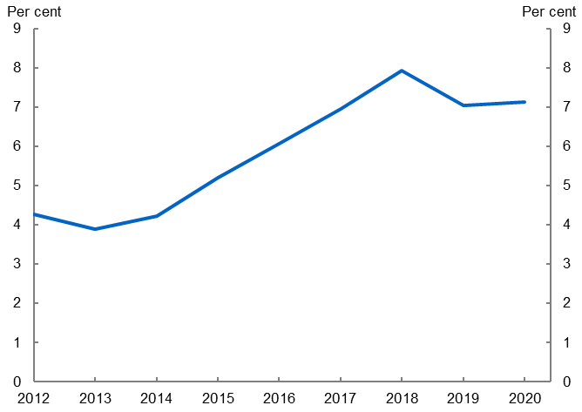

Notes*:* One job ad may correspond to multiple vacancies. Emerging technology job ads refer to any instance where a technology is mentioned in the job description. A list of the 29 emerging technologies is in Table 1 in the Appendix.

Source*:* Treasury analysis of Lightcast data for Australia (2012‑2020).

The share of total job ads that reference cloud computing, machine learning or artificial intelligence − technologies most likely to become general-purpose − have increased over the past decade in Australia and the US (Figure 3). Adoption of these technologies particularly strengthened from around 2017. Despite strong growth in the past decade, the share of job ads referencing these technologies remains lower in Australia than in the US.

In 2020, the share of job ads referencing machine learning and artificial intelligence was broadly flat in Australia. There was a slight increase in the share of job ads referencing cloud computing, consistent with Australian Bureau of Statistics analysis reporting greater use of these services (Australian Bureau of Statistics 2021). However, more data are required to understand how the pandemic impacted technological adoption.

Figure 3: Share of job ads requiring technological skills

|  |  |  |
| --- | --- | --- |
| This figure charts the share of jobs ads requiring cloud computing skills for both Australia and the United States. Both countries have an upward trend across the 2012-2020 period, though Australia is below the United States. | This figure charts the share of jobs ads requiring machine learning skills for both Australia and the United States. Both countries have an upward trend across the 2012-2020 period, though Australia is below the United States. There is a steeper increase in the share for Australia in the latter 3-4 years. | This figure charts the share of jobs ads requiring artificial intelligence skills for both Australia and the United States. Both countries have an upward trend across the 2012-2020 period, though Australia is below the United States. There is a steeper increase in the share for Australia in the latter 3-4 years. |

Notes: 12‑month rolling average of monthly share of job ads that require each technology skill. These charts use Lightcast’s predefined skill categories, rather than the text analysis approached used in Figure 2. Cloud Computing also includes Cloud Storage and Cloud Solutions.

Source: Treasury analysis of Lightcast data for Australia and the United States (2012‑2020).

# Diffusion across industries for general‑purpose technologies has increased

Initially, disruptive general-purpose technologies tend to be produced and used by a single industry. They diffuse to other industries over time, helping them modernise and improve their production processes. Stronger diffusion of general-purpose technologies across multiple industries will help support improved productivity growth over time.

We measure cross‑industry diffusion by calculating the Coefficient of Variation (CoV). This metric captures the take‑up of these technologies across industries, with a lower CoV indicating a more evenly distributed take‑up across industries. The CoV is measured as the ratio of the standard deviation and mean of the share of job ads referring to the technology, calculated across all industries.

Cloud computing and machine learning/artificial intelligence have become more evenly dispersed across industries over the sample, suggesting firms across a range of industries have increased their adoption of these technologies in recent years (Figure 4).

Figure 4: Diffusion of technologies across industries

|  |  |
| --- | --- |
| This figure shows two charts side-by-side with the coefficient of variation for 'cloud computing' and 'machine learning/artificial intelligence', respectively, in Australia. The charts show that these technologies have become more diffuse across industries, especially since about 2017 as the lines are decreasing over time.  Charts use Lightcast data. | This figure shows two charts side-by-side with the coefficient of variation for 'cloud computing' and 'machine learning/artificial intelligence', respectively, in Australia. The charts show that these technologies have become more diffuse across industries, especially since about 2017 as the lines are decreasing over time.  Charts use Lightcast data. |

Notes: Series charts average yearly Coefficient of Variation (CoV) across 1‑digit divisions. The CoV takes the share of job ads that mention each technology and calculates the ratio of the standard deviation to the mean across all divisions. In a hypothetical economy with 10 industries where every industry had the same share of job ads with a technology, the CoV would be 0. If the technology was only used by 1 out of the 10 industries (regardless the exact share in that industry), the CoV would be 3.16.

Source: Treasury analysis of Lightcast data for Australia (2012‑2020).

# Conclusion

Adoption of new technologies has increased over the past decade. However, Australia remains behind the US, which is one factor likely contributing to the growing gap between Australian and global frontier firms (Andrews et al. 2022).

The lower adoption of emerging technologies in Australia relative to the US could reflect the fact that some technologies are still quite new to the Australian market,[15]3 or that we are yet to develop the technological or human capability required to use them. Different industry make‑up, management capabilities, and investment in research and development between the 2 countries may also contribute to the different diffusion rates.

Investment in new technologies also comes with a delay as firms often need to make complementary investments in other areas like high‑speed internet or intangibles like organisational change. Brynjolfsson et al. (2021) argue that productivity slowdowns often accompany the rise of general‑purpose technologies as firms are delayed in making the required complementary investments. These implementation lags have been noted as the biggest reason why advanced technologies like artificial intelligence have been slow to instigate mass productivity growth (Brynjolfsson et al. 2017).

Policy can support greater technological adoption through the provision of appropriate infrastructure (for example, high‑speed internet) and skills training. Incentivising and facilitating investment in new technologies, particularly those most likely to become general-purpose, has the potential to increase the speed of technological diffusion and ultimately boost Australia’s productivity.

# References

Australian Bureau of Statistics (2021) [*Characteristics of Australian Business*](https://www.abs.gov.au/statistics/industry/technology-and-innovation/characteristics-australian-business/2019-20)– 2019-20 financial year [data set], ABS Website, accessed 23 September 2022.

Andrews A, Hambur J, Hansell D and Wheeler A (2022) ‘[Reaching for the stars: Australian firms and the global productivity frontier](https://treasury.gov.au/publication/p2022-243535)’, *Treasury Working Paper 2022#01*.

Bloom N, Hassan TA, Kalyani A, Lerner J and Tahoun A (2021) ‘[The Diffusion of Disruptive Technologies](https://www.nber.org/papers/w28999)’, *National Bureau of Economic Research Working Paper No. 28999*.

Brynjolfsson E, Daniel R and Syverson C (2017) ‘[Artificial Intelligence and the Modern Productivity Paradox: A Clash of Expectations and Statistics](https://www.nber.org/papers/w24001)’, *National Bureau of Economic Research Working Paper No. 24001*.

Brynjolfsson E, Daniel R and Syverson C (2021) ‘[The Productivity J‑Curve: How Intangibles Complement General Purpose Technologies](https://doi.org/10.1257/mac.20180386)’, *American Economic Journal: Macroeconomics*, 13(1):333–372.

Goldfarb A, Taska B and Teodoridis F (2022) ‘[Could Machine Learning be a General‑Purpose Technology? A Comparison of Emerging Technologies Using Data from Online Job Postings](https://www.nber.org/papers/w29767)’, *National Bureau of Economic Research Working Paper No. 29767*.

Hope A, Yemm N, Nguyen G, Raza MA, Sparke E, Buhagier C and Neumann R (2022) [*Digital skills in the Australian and International economies*, National Skills Commission](https://www.nationalskillscommission.gov.au/reports/digital-skills-australian-and-international-economies), Australian Government.

# Appendix

Table 1: Total job postings (2012‑2020) by technology

|  |  |
| --- | --- |
| Technology | Count |
| Social networking | 150,830 |
| Cloud computing | 122,426 |
| Smart devices | 92,986 |
| GPS | 44,729 |
| Machine learning/artificial intelligence | 19,994 |
| Online streaming | 19,211 |
| Wi‑Fi | 14,155 |
| Search engine | 11,818 |
| Oled display | 9,897 |
| Solar power | 6,852 |
| Electronic gaming | 3,714 |
| Virtual reality | 2,248 |
| Touch screen | 2,063 |
| Hybrid vehicle/electric car | 1,868 |
| 3d printing | 1,800 |
| Autonomous cars | 1,492 |
| Computer vision | 1,380 |
| RFID tags | 887 |
| Mobile payment | 875 |
| Lithium battery | 607 |
| Fracking | 241 |
| Software defined radio | 109 |
| Drug conjugates | 38 |
| Stent graft | 25 |
| Millimeter wave | 20 |
| Wireless charging | 16 |
| Fingerprint sensor | 6 |
| Bispecific monoclonal antibody | 0 |
| Lane departure warning | 0 |

Notes: Count of jobs postings will not necessarily equal the count of new hires. Each technology is identified by a list of related keywords. For example, Machine Learning/Artificial Intelligence jobs can refer to any of the following keyword pairs: neural network; deep learning; language processing; machine learning; machine intelligence; natural language; artificial intelligence; ai technology; supervised learning; learning algorithms; unsupervised learning; reinforcement learning; ai machine. For a full list of keywords for each technology, see Appendix in Bloom et al. (2021).

Source: Treasury analysis of Lightcast data for Australia (2012‑2020).

Why the real wages of graduates with bachelor’s degrees have fallen

|  |
| --- |
| Prepared by Patrick Hartigan and Jonathan Hambur[16]* |
|  |

|  |
| --- |
| *The real average wages of graduates with bachelor’s degrees have fallen over the 2010s. This period also coincided with the ‘demand‑driven’ reforms to higher education funding. We test whether the decline in real average wages was due to changes in the composition of graduates after the reforms. Using causal forests, we adjust for changes to the cohort of bachelor’s graduates after the reforms and find evidence that changes in the demand for, and supply of, graduates accounted for much of the decline. For demand, adjusted graduate wages moved in line with local labour demand. For supply, outcomes were worse in labour markets with the largest increases in the number of graduates post‑reforms. Changes in the characteristics of people graduating does not appear to explain the fall in real average wages.* |

# Education and training reforms are often proposed to increase productivity growth

Australian policy makers often propose reforms to education or training to increase labour productivity and, in turn, wage growth. However, research into the impact of previous Australian education and training reforms on labour markets is sparse and has been limited by a lack of appropriate data.

In this article, we focus on the shift to demand‑driven higher education funding, one of the most significant federal government education reforms in the 2010s. We investigate the relationship between this reform and falling average real wages for bachelor’s degree graduates over the same period.[17]

We test whether changes in characteristics of the graduate cohort explain the fall in graduates’ real average wages following the reforms. This has implications for the appropriate policy response to the decline in wages for this cohort, and the design of future higher education funding.

# Higher education reforms coincided with a fall in real wages for graduates with bachelor’s degrees

Wage growth for younger workers was weak over the 2010s, with real wages for people aged 18 to 34 declining between 2008 and 2018 (Productivity Commission 2020). The decline in real wages was particularly large for those with a bachelor’s degree. In real terms, people who graduated in 2009 earned more on average in each of the first 5 years post‑graduation than those who graduated in 2013 (Figure 1).

|  |  |
| --- | --- |
| Figure 1: Real average wages for bachelor’s degree graduates  This line chart with two lines shows real average wages for bachelor's graduates who graduated in 2009 and 2013, across the first five years post-graduation. Real wages are lower for 2013 graduates than 2009 graduates in every year. Chart contains data from the Higher Education Information Management System (HEIMS) and ATO Personal Income Tax (PIT). | Figure 2: Share of bachelor’s graduates with an ATAR equal to or less than 60  This line chart with two lines shows the proportion of bachelor's graduates with an ATAR less than 60, in ten high enrolment, high median ATAR universities, and in all other universities, between 2006 and 2019. The proportion is higher for the latter group and increases sharply from 2010 onwards for both groups. Chart contains data from HEIMS. |

Notes: Figure 1 is in 2021 AUD. In Figure 2 ten largest universities are 10 universities nationwide with high median ATAR for bachelor’s graduates and large enrolment.

Source: Treasury analysis using the ABS DataLab, including HEIMS data from the Department of Education and personal income tax filings from the Australian Tax Office.

One potential cause of poorer outcomes for graduates is the introduction of a demand‑driven model for higher education funding which was phased in from 2010. The reforms led to a substantial increase in bachelor’s degree enrolments − from around 195,000 in 2009 to 260,000 in 2015 − and improved access for people from under‑represented groups.[18]

The composition of graduates differed before and after the reforms. For example, many of the additional graduates who attended university after the reforms had on average lower ATAR scores (Productivity Commission 2019; Figure 2). This may reflect a lower earning potential in the types of roles that require bachelor’s degrees. We separate out this effect from other potential explanations by comparing wages for students with similar characteristics before and after the reforms.

# Data on Australian bachelor’s degree graduates

We use anonymised data on graduates’ characteristics, incomes and locations from the Higher Education Information Management System (HEIMS) accessed via the ABS. This dataset provides detailed information about graduates’ educational characteristics, including tertiary entrance score, field of study, tertiary education institution, and personal characteristics. We also have information on graduates’ salaries and estimates of their location and commuting zone from the ATO and Bureau of Infrastructure and Transport Research Economics (BITRE). The full list of variables in our models is in Table 1.

We compare wage outcomes for a sample of domestic students who graduated in 2009 and 2013 in our main results, and 2009 and 2014 as a robustness test. Our dataset includes graduates who were not employed (had no wage income on their personal income tax filing or did not file income tax in a year) and who re‑enrolled. Given its importance for earnings, we exclude graduates for whom we have no location data. Our sample includes approximately 75,000 bachelor’s degree graduates from each of the 2009, 2013 and 2014 cohorts, a substantial majority of the graduates in each cohort.

**Table 1: Variables included in model of ‘macro effects’**

|  |  |  |
| --- | --- | --- |
| Variable | Selected in final model? | Source |
| Institution | 9 institutions | HEIMS |
| Attended one of 10 largest institutions | Yes | HEIMS |
| Field of education | 12 fields | HEIMS |
| Gender | Yes | HEIMS |
| LOTE | Yes | HEIMS |
| Born overseas | Yes | HEIMS |
| Self‑identified disability status | Yes | HEIMS |
| ATAR score | Yes | HEIMS |
| State/Territory | Yes | ATO |
| Commuting zone | 6 commuting zones | ATO and BITRE |
| Lives outside a capital city | Yes | ATO |
| Lives in one of 10 fastest growing labour markets | Yes | ATO |
| Lives in one of 50 fastest growing labour markets | Yes | ATO |
| Whether graduate re‑enrolled | Yes | HEIMS |

Notes: Variables selected by model of macro effects. Institution, field of education and location (commuting zone) are converted into dummy variables. The model has selected only some institutions and commuting zones. Models estimated as per Wager and Athey (2021).

Source: Treasury analysis using the ABS DataLab.

# We use machine learning to control for compositional changes and isolate the demand and supply impacts on wages

We compare outcomes for 2013 graduates (post‑reform) who have very similar educational and personal characteristics to 2009 graduates (pre‑reform) for the first 5 years following graduation. This provides us with an estimate of how wages would have changed if the characteristics of the graduate cohort had remained the same. We can then separate observed wage changes due to changing graduate characteristics (cohort characteristics effects) from those that reflect change in the supply of or demand for graduates (macro effects).[19]

The macro effects can also be thought of as the extent to which the same person at the same point in their career would be paid differently pre‑ and post‑reform. Someone who studied quantitative finance, for example, would have likely earned more in their first job if they graduated before the GFC than if they graduated immediately after it.

Our main results use a machine learning technique known as causal forests. Calculating the degree of similarity between students is difficult with so many variables on students’ educational and personal backgrounds. Causal forests are a data‑driven way of identifying similar students from before and after the reforms. The approach helps identify which of the more than 700 variables available (including interactions) that could drive wage outcomes are most important for identifying students that are similar pre‑ and post‑reform (Table 1). In this way, the causal forests technique has the advantage of not needing to pre‑judge which of the variables to include.[20]

# Macro effects account for most of the decline in real wages

Average real wages for the 2013 cohort were on average 3.5 per cent below real wages for 2009 graduates over the first 5 years post‑graduation. In the first year, post‑graduation, around one‑fifth of this was due to the changing characteristics of graduates (cohort characteristics effects), as shown by relative sizes of the dark and light blue bars in year 1 (Figure 3). The remaining four-fifths reflect macro effects: changes in supply of and demand for graduate labour. In the following years, the cohort effects are small and statistically insignificant, while macro effects continue to weigh on graduate wages.

These results are robust to changes in model choice, for example using a propensity score matching model with variables selected via an elastic net. The results also hold if we use 2014 graduates instead of 2013 graduates as the post‑reform cohort.

Figure 3: Decline in graduates’ real wages due to macro and cohort characteristic effects, 2013 versus 2009 graduates[21]

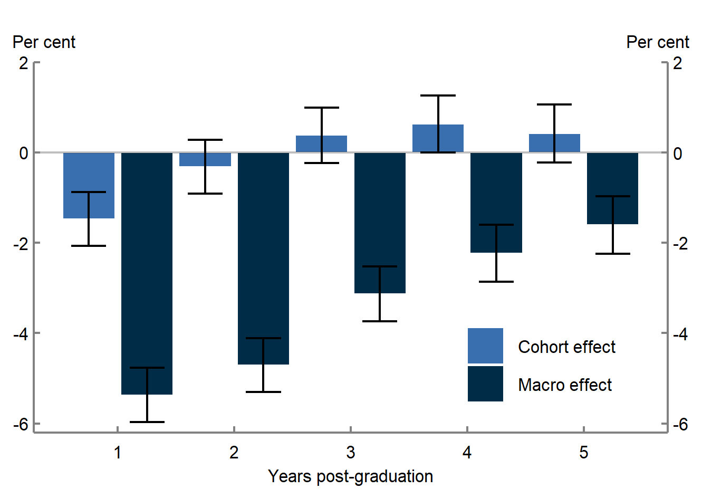

Notes: Dark blue bars and black error bars show mean estimate of macro effects on real wages and 95% confidence interval, respectively, for all graduates, 2013 versus 2009. Light blue bars and black error bars show estimated cohort effects, calculated as (unconditional) total effect minus estimated macro effect, and 95% confidence intervals, 2013 versus 2009.

Source: Treasury analysis using the Labour Market Tracker, including HEIMS data from DESE and personal income tax filings from the ATO.

# Greater supply of graduates is correlated with lower adjusted graduate wages in local labour markets

We now turn to exploring whether demand or supply factors are driving the macro effects identified above.

If the increase in supply of graduates was a key factor, we would expect to see greater real wage declines in locations and fields with the greatest increase in graduates. As such, we identify the 50 fastest growing local labour markets − the commuting zones and academic fields with the highest growth in graduates by 2018 − and estimate whether the compositionally adjusted wage declines (macro effects) were more pronounced.[22] Local labour markets that grew the fastest had larger adjusted graduate real wage declines in the first 2 years (green error bars, Figure 4), although this had dissipated by the third year.[23]

The short‑lived nature of the decline suggests that the increased supply of graduates may have lowered wages by making it more difficult for graduates to match with roles that suit their interests and skills. Over time this effect dissipates as graduates move to better-suited jobs.

Figure 4: Macro effects on real graduate wages, 50 fastest growing local labour markets compared with everywhere else, 2013 versus 2009 cohorts

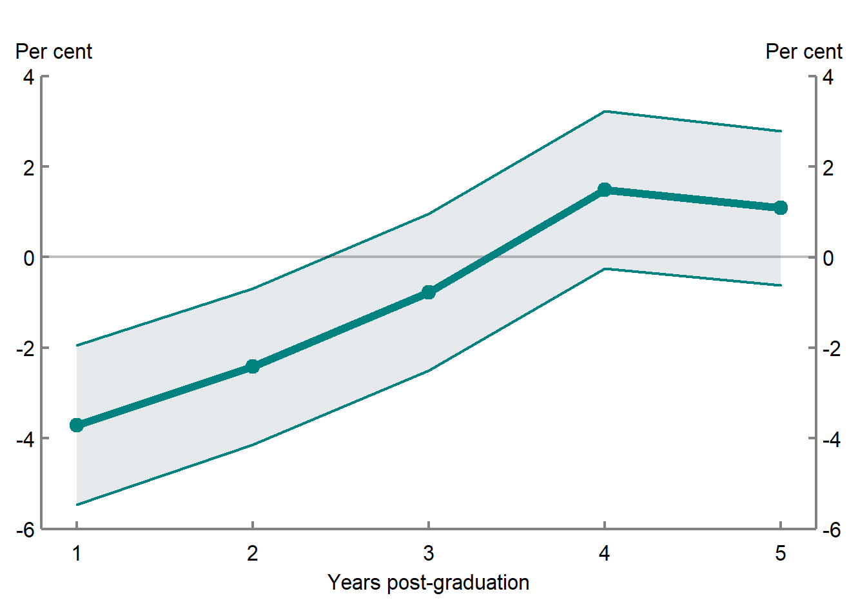

Notes: Green dots and error bars show coefficient estimate and 95% confidence interval from regression of estimated macro effects for the fifty fastest growing labour markets, 2013 versus 2009 graduates.

Source: Treasury analysis using the Labour Market Tracker, including HEIMS data from DESE and personal income tax filings from the ATO.

# Adjusted graduate wages appear to have moved in line with broader labour demand

There is also evidence that demand played a role in graduates’ real wage outcomes. For example, compositionally adjusted real wages declined in regions where labour markets were weakening, like Western Australia, as the mining‑construction boom ended (Figures 5 and 6). In Victoria, where labour markets were strengthening, the macro effect real wage penalty for men disappeared. This evidence suggests that after controlling for cohort characteristic effects, the decline in graduate wages was associated with the broader weakness in labour demand.

|  |  |
| --- | --- |
| Figure 5: Macro effects on male real graduate wages in Victoria and Western Australia, 2013 versus 2009 cohorts  Line chart with error bars showing our estimates of the macro effect on wages, 2013 cohort versus 2009 cohort, for male graduates in WA versus VIC, over the first five years post-graduation. The chart shows that the decline in real wages due to macro effects was initially worse for graduates in VIC compared with WA. Over the following five years the macro effect wage penalty for VIC graduates reduced to 0, whereas the penalty for WA graduates increased to -10%. This evidence is considered in conjunction with the trends in Figure 6. Chart contains data from HEIMS, ATO PIT, ATO customer locations, and BITRE commuting zones. | Figure 6: Employment to population ratio – Victoria and Western Australia  Line chart with two lines showing the employment to population ratio for people aged 18-24, 2014 - 2019. The chart shows that the ratio, which take as a proxy for labour demand, declined over the period in WA and rose in VIC. This evidence is considered in conjunction with the trends in Figure 5. Chart contains data from HEIMS, ATO PIT, ATO customer locations, and BITRE commuting zones. |

Notes: Green dots and shaded areas in Figure 5 show average real wage macro effects and 95% CI for men in WA and VIC, 2013 versus 2009 graduates.

Source: Treasury analysis using the Labour Market Tracker, including HEIMS data from DESE and personal income tax filings from the ATO.

# Conclusion

We find that the decline in real average wages for bachelor’s degree graduates over the 2010s is largely explained by macro factors, rather than changing characteristics of students. With respect to the demand for bachelor’s degree graduates’ labour, our results are consistent with earlier Treasury working papers which show the sensitivity of graduates’ labour market outcomes to broader labour market conditions (Andrews et al. 2020). Both pieces add to evidence of the importance of macro stabilisation policies given the potential for long‑run labour market scarring for young workers entering a weak labour market.

On the supply side, our findings are consistent with the hypothesis that increases in the number of university graduates increased competition for skilled jobs and, in turn, were partly responsible for young people’s falling wages (Productivity Commission 2020). This highlights the importance of ensuring any future skills and higher education policy interventions that go beyond supporting informed student choices are well targeted towards sectors with growing demand for skills; for example by using the National Skills Commission’s Skills Tracker. In neither case, however, did changes in the *characteristics* of people graduating drive the fall in real wages.

# References

Chernozhukov V, Demirer M, Duflo E, and Fernandez‑Val I (2018) ‘[Generic machine learning inference on heterogenous treatment effects in randomized experiments](https://arxiv.org/abs/1712.04802).’ Technical report, *National Bureau of Economic Research*.

Andrews, D, Deutscher N, Hambur J, Hansell D (2020) ‘[The career effects of labour market conditions at entry](https://treasury.gov.au/sites/default/files/2020-06/p2020-85098-202006.pdf)’, *Treasury Working Paper*.

Productivity Commission (2020) [*Why did young people’s incomes decline?,*](https://www.pc.gov.au/research/completed/youth-income-decline/youth-income-decline.pdf) Commission Research Paper, Canberra.

Productivity Commission (2019) [*The Demand Driven University System: A Mixed Report Card*](https://www.pc.gov.au/research/completed/university-report-card/university-report-card.pdf), Commission Research Paper, Canberra.

Wagner S, Athey S (2018) ‘[Estimation and Inference of Heterogeneous Treatment Effects using Random Forests](https://www.tandfonline.com/doi/abs/10.1080/01621459.2017.1319839?journalCode=uasa20)’, *Journal of the American Statistical Association*, 113:523, 1228‑1242, DOI: 10.1080/01621459.2017.1319839

Wagner S, Athey S (2021) ‘[Estimating Treatment Effects with Causal Forests: An Application](https://www.gsb.stanford.edu/faculty-research/working-papers/estimating-treatment-effects-causal-forests-application)’, *Stanford University Business School Working Paper*, California.

Children and the gender earnings gap

|  |
| --- |
| Prepared by Elif Bahar, Natasha Bradshaw, Nathan Deutscher and Maxine Montaigne[24]* |
|  |

|  |
| --- |
| *The arrival of children creates a large and persistent increase in the gender earnings gap. Women’s earnings are reduced by an average of 55 per cent in the first 5 years of parenthood. The gap in earnings − termed the ‘motherhood penalty’ − remains significant a decade into parenthood. We find the motherhood penalty is* *due to a combination of lower participation rates and reduced working hours and, to a lesser extent, a reduced hourly wage.* *We show the decline in women’s earnings is similar regardless of their household breadwinner status, implying that relative earnings prior to children have little influence over the intrahousehold allocation of paid work following children. Along with broader gender norms, workplace settings may also explain the penalty, with greater access to flexible working conditions increasing the likelihood a woman remains employed after having children. Addressing Australia’s persistent motherhood penalty and boosting women’s labour force participation after having children could help support improved productivity growth.* |

# The gender earnings gap and productivity

Despite a considerable reduction in gender inequality over recent decades, there remains a significant gender earnings gap in Australia, as in other advanced economies. A gender earnings gap presents a challenge for aggregate output and productivity − it typically represents significant untapped potential in the labour market.

Greater female labour force participation could boost aggregate output and productivity through several channels. Women represent an under-utilised labour cohort. This is especially important in a tight labour market where labour supply is a constraint. In the long run, removing barriers to women’s participation also allows better matching between jobs and those best able to perform them. The improved allocation of talent that occurs when women are no longer restricted to certain kinds of work can substantially lift productivity growth (Hsieh et al. 2019). There are also potential productivity gains from diversifying the workforce within firms and sectors (Criscuolo et al. 2021; Ostry et al. 2018).

This article explores the role of children in labour market participation and earnings for women. We estimate the motherhood penalty by examining the differential impact of children on men’s and women’s earnings in Australia in the years following the arrival of their first child.

# The motherhood penalty

We follow Kleven et al. (2019b) and run an ‘event study’ which examines how earnings evolve for men and women in the lead‑up to and in the years immediately after the arrival of their first child. We use the Household, Income and Labour Dynamics in Australia (HILDA) survey to analyse the impact of children up to 5 years after the arrival of the first child and extend our analysis up to 10 years using administrative tax data from the Australian Taxation Office (ATO) (Carter et al. 2021). A full discussion of the data and empirical framework can be found in a forthcoming Working Paper (Bahar et al. forthcoming).

Men’s and women’s earnings follow similar paths until parenthood, at which point their earnings begin to diverge. The arrival of children reduces women’s earnings by an average of 55 per cent across the first 5 years of parenthood (Figure 1 Panel A). Men’s earnings are unaffected by entry into parenthood. Moreover, the motherhood penalty remains persistent for at least a decade into parenthood, though there is a slight recovery in the later years (Figure 1 Panel B).

Our results will include effects not only from the first child, but any additional children born during the observation window. We find that the motherhood penalty for women who have only one child is smaller than the penalty estimated for multiple children but remains persistent. Importantly, for women with one child, there is no significant recovery in earnings at year 5 when children generally start school.

Figure 1: Impact of children on earnings, by sex

|  |  |
| --- | --- |
| Panel A: Short run motherhood penalty (HILDA)  This line chart shows changes in earnings by gender from 3 years before parenthood to 5 years after.  Female earnings drop around 60 percent in the first year of parenthood and remain around that level for the time period shown on chart. Male earnings remain broadly steady through the whole period. The graph uses HILDA survey data. | Panel B: Long run motherhood penalty (ALife tax data)  This line chart shows changes in earnings by gender from 3 years before parenthood to 10 years after. Female earnings fall by around 45 per cent after parenthood begins and trends up to about 30 per cent towards the end of the 10 year sample.  Male earnings trend slightly upwards through the entire timeseries. This chart uses ALife tax data. |

Notes: Motherhood penalty estimated after running an event study of the form specified in Kleven et al. (2019b). Estimated magnitudes across panels will differ due to different data sources. Shaded area shows 95% confidence intervals, based on robust standard errors.

Source*:* Treasury analysis of HILDA Release 19.0 (Panel A) and ALife 2019 (Panel B).

# Drivers of the penalty

The motherhood penalty can come from 3 margins − employment, hours of work, and the hourly wage rate. All 3 margins contribute, with particularly large effects for employment and hours of work (Figure 2). There is a sharp drop in the probability of employment of about 45 per cent in the year the first child arrives, with only modest recovery after 5 years. For women who remain employed, hours worked falls by about 35 per cent across the first 5 years and does not significantly recover over this period. There is also some evidence that for women who remain employed, their hourly wages are about 5 per cent lower than if they had not had children, though the estimates are imprecise and only just significantly different from zero.

Figure 2: Drivers of the motherhood penalty

|  |  |  |
| --- | --- | --- |
| This line chart shows changes in employment by gender from 3 years before parenthood to 5 years after.  Employment for females drops by around 45 per cent in the year that parenthood begins and trends up to around 25 per cent below pre-parenthood levels at year 5. Male employment remains broadly steady throughout the time period. | This line chart shows changes in hours worked by gender from 3 years before parenthood to 5 years after.  Hours worked for females drops by around 30-40 per cent in the year that parenthood begins and remains around that level until year 5. Male hours worked remains broadly steady throughout the time period. | This line chart shows changes in hourly wages by gender from 3 years before parenthood to 5 years after.  Hourly wages for females and males increase by around 5 per cent in the first year after parenthood. After the first year female hourly wages fall to around 5 per cent below pre-parenthood levels while males remain steady around pre-parenthood levels.  The error bars shown are wide. |

Notes: Effects on participation are estimated unconditional on employment status, while the effect on hours and wages are conditional on participation. Shaded area shows 95% confidence intervals, based on robust standard errors.  
Source: Treasury analysis of HILDA Release 19.0.

# Potential explanations of the penalty

## Household allocations of work and care

One potential explanation for the motherhood penalty is that couples make choices about allocations of household work and care based on relative earnings. We find the same penalty regardless of a woman’s breadwinner status before children (Figure 3). This is the case even for women who significantly out‑earn their partner. Furthermore, highly educated women experience a larger penalty, despite the higher opportunity cost of reducing their participation − suggesting again that choices around work and care are not always responding purely to financial considerations.

Figure 3: Motherhood penalty, by breadwinner status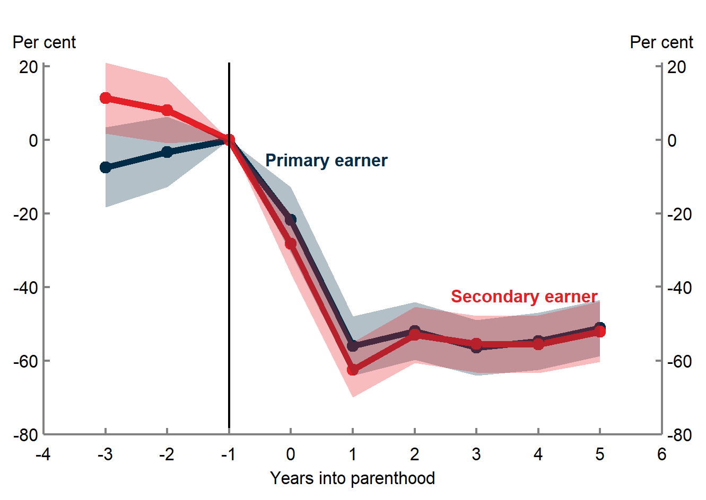

Notes: Chart shows effects for women only. Breadwinner status defined in year before children. Similar results are observed if breadwinner status is based on the 3 years before children, and hence less subject to idiosyncratic shocks. Shaded area shows 95% confidence intervals, based on robust standard errors.

Source: Treasury analysis of HILDA Release 19.0.

## Preferences

While not necessarily financially optimal, couples may be making choices consistent with their preferences. As an exploratory analysis of the preferences of parents, we study questions in HILDA around parents’ satisfaction with their employment opportunities and work‑family life.

Following children, mothers experience a decrease in satisfaction with their employment opportunities, in line with their worsening employment outcomes (Figure 4). Women’s satisfaction with their employment opportunities begins to fall the year prior to children and becomes significant one year after, indicating women may anticipate reduced work opportunities prior to parenthood. However, their satisfaction troughs later than their employment outcomes, implying that the longer‑term impacts of children may be unanticipated and that there are significant challenges in re‑engaging in the labour market. This is consistent with recent research suggesting that women, particularly highly educated women, underestimate the challenges they will face in combining work and family (Kuziemko et al. 2018). In contrast, men’s satisfaction with their employment opportunities does not change significantly over time.

Figure 4: Impact of children on parent’s satisfaction with their employment opportunities

|  |  |
| --- | --- |
| This line chart shows fathers' reported satisfaction with their employment opportunities from 3 years before parenthood to 5 years after. Satisfaction drops slightly 1 year into parenthood, but then trends slightly upwards for the remainder of the time series. The error bars are wide. | This line chart shows mothers' reported satisfaction with their employment opportunities from 3 years before parenthood to 5 years after. Satisfaction trends downwards after parenthood - reaching around 10 per cent below pre-parenthood levels 3 years after parenthood - before trending up slightly 5 years after parenthood to about 6 per cent. |

Notes: Includes parents who are observed 3 years before and 5 years after the birth of their first child. Shaded area shows 95% confidence intervals, based on robust standard errors. The base year is t=‑2, to allow for anticipatory effects. Question asks respondents their satisfaction with their employment opportunities on a 0‑10 scale.

Source: Treasury analysis of HILDA Release 19.0.

We also construct 2 indexes to measure the work‑family balance of parents. We find that fathers with young children are more likely than mothers to report that their work affects their family life. Mothers are more likely than fathers to report the opposing imbalance, regardless of the age of their youngest child, that their family life impacts their work (Figure 5). While parental preferences around work and care are difficult to measure, these results together provide suggestive evidence that preferences are not the only factor driving the motherhood penalty. Parents appear unsatisfied in ways that suggest a more equal allocation of paid and unpaid work could be beneficial, lifting the employment opportunities for women and improving work‑life balance for both genders.

Figure 5: Work‑family balance indexes, by sex and child age

This image includes two bar charts. The left chart shows an index indicating how work effects family life for those with a child under 5 and those with a child under 18. Both series are split by gender. The chart indicates that fathers are more likely to report that work effects family life than mothers if the child is under 5. The index is similar for both parents if the child is under 18.

The right chart shows an index indicating how family life affects work for parents with a child under 5 and parents with a child under 18. Both series are split by gender. Mothers are more likely to report that family life affects work regardless of child age. 

Notes: Sample only includes parents who are currently employed. Indexes constructed using a combination of questions in HILDA that asks respondents about their work‑family balance. Differences are statistically significant in cases mentioned in text.

Source: Treasury analysis of HILDA Release 19.0.

## Workplace flexibility

A potentially important mechanism for the motherhood penalty is how workplace settings around flexible working differ across occupations. Flexible work may make it easier for some parents to adjust their labour supply responses after having children, while coming with its own costs. To assess the availability of flexible work, we use a question in HILDA that asks respondents whether flexible start or finish times are available as an entitlement in their workplace.

Women who had greater access to flexible conditions before having children are more likely to remain employed after having children. Conversely, for women who remain employed, the hourly wage penalty is larger for women in more flexible occupations, potentially reflecting foregone promotion opportunities (Figure 6). These results suggest a role for workplace settings, particularly around the availability of flexibility, in potentially mitigating the motherhood penalty in employment and hours worked, but potentially at the cost of hourly wages. Similar findings in Kleven et al. (2019b) point to parenthood disproportionately leading women to be more likely to be in a flexible workplace but less likely to be in management. Workplace flexibility is only half the story then. Goldin (2014) argues that disproportionate rewards for long and particular hours in some sectors result in larger gender pay gaps that could be ameliorated with more considered job design. This would benefit women, but also men, seeking greater flexibility at work.

Figure 6: Outcomes for women, by workplace flexibility

|  |  |  |
| --- | --- | --- |
| This line chart shows changes in employment for women by workplace flexibility from 3 years before parenthood to 5 years after. Earnings for all women drop after parenthood, but the effect is smaller for those with more flexible conditions. | This line chart shows changes in hours worked for women by workplace flexibility from 3 years before parenthood to 5 years after. Hours worked for all women drop after parenthood, and the effect is very similar for both groups. | This line chart shows changes in hourly wages for women by workplace flexibility from 3 years before parenthood to 5 years after. Hourly earnings for those with more flexible conditions drop by around 10 per cent after parenthood, while hourly earnings those with less flexible conditions increases after parenthood but then returns to pre-parenthood levels 5 years later. The error bars on these series are wide. |

Notes: Chart shows effects for women only. Effects on participation are estimated unconditional on employment status, while the effect on hours and wages are conditional on participation. More flexibility defined as average occupational flexibility above median in year before children.

Source: Treasury analysis of HILDA Release 19.0.

## Gender norms

Our estimated long-run motherhood penalty (43 per cent) is similar to the United Kingdom (44 per cent), larger in magnitude than estimates for Denmark (21 per cent), Sweden (26 per cent) and the US (31 per cent), but smaller than estimates for Germany (61 per cent) and Austria (51 per cent) (Kleven et al. 2019a). These cross‑country differences may be driven by differences in gender norms, as well as institutional and policy settings across countries.

Using a cross‑country survey, we show that countries with more conservative gender norms have worse long-run penalties (Figure 7). Australia displays both conservative norms about men’s and women’s roles, and a high motherhood penalty relative to other countries surveyed. This suggests underlying gender norms likely reinforce the penalty. Recent research shows the motherhood penalty can also vary greatly within countries (the US), in ways that suggest a strong role for social norms (Kleven 2022).

Figure 7: Gender norms and motherhood penalties across countries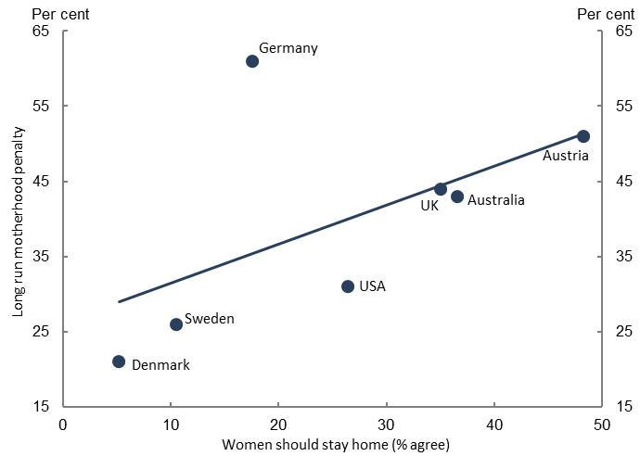

Notes: Chart plots share of respondents who state that women should stay at home when either their child is under school age or their youngest child is in school against each country’s long-run (i.e. average of years 5 to 10) child penalty, fitting a linear line through these observations.

Source: Kleven et al. (2019a), Treasury analysis of International Social Survey Programme 2012 and long run child penalty for Australia from Chart 1b.

In contrast to the importance of gender norms, the link between policies and the motherhood penalty is less clear‑cut. For example, Kleven et al. (2020) find ‘enormous’ expansions in parental leave and child care in Austria had little impact on the penalty and again emphasise the importance of norms. As they note, however, the interaction between policy and norms is complex, and may result in large policy changes having little impact but also small policy changes triggering a tipping point. Such tipping points have been seen before, with Pan (2015) highlighting tipping points in the desegregation (by gender) of occupations over time. Changing social and workplace attitudes, together with a supportive policy environment, also has the potential to make substantial inroads into Australia’s sizeable motherhood penalty.

# Conclusion

Our results highlight the significant impact of children on the long-run labour market outcomes of women. Women’s earnings more than halve after the arrival of children and remain lower for at least a decade. Participation and hours worked are the primary drivers of the penalty. While flexible workplaces ameliorate some of these effects, they are associated with more sizeable gender hourly wage gaps.

Australia’s motherhood penalty has important implications for both gender equality and aggregate productivity. On average, Australian women are now more educated than Australian men − with 37 per cent of women attaining a bachelor’s degree or above in 2020, compared to only 29 per cent of men (Australian Bureau of Statistics 2020). Improving the utilisation of women’s skills would increase the returns on investments made in women’s human capital. Neither men nor women seem satisfied with their balance between family and work following parenthood, in ways suggesting gains from a more equal allocation of responsibilities. Barriers to this likely exist within social norms, and workplace norms and policies, as well as government policy settings. Tackling these barriers will nonetheless be a necessary precursor to further gains in female labour force participation, the allocation of talent across paid and unpaid work, and improved diversity in the workplace.

## References

Australian Bureau of Statistics (2020) [*Gender Indicators, Australia*](https://www.abs.gov.au/statistics/people/people-and-communities/gender-indicators-australia/2020)– 2020 [data set], ABS Website, accessed 23 September 2022.

Carter A, Abhayaratna T and Johnson S (2021) ‘[The ATO Longitudinal Information Files (Alife): Individuals – A New Dataset for Public Policy Research](https://taxpolicy.crawford.anu.edu.au/publication/ttpi-working-papers/19025/ato-longitudinal-information-files-alife-individuals-new)’, *Tax and Transfer Policy Institute Working Paper No.* *13*.

Criscuolo C, Gal P, Leidecker T and Nicoletti G (2021) ‘[The Human Side of Productivity: Uncovering the role of skills and diversity for firm productivity](https://www.oecd.org/innovation/the-human-side-of-productivity-5f391ba9-en.htm)’, *Organisation for Economic Cooperation and Development Productivity Working Papers No. 2021‑29*.

Goldin C (2014) ‘[A grand gender convergence: Its last chapter](https://doi.org/10.1257/aer.104.4.1091)’, *American Economic Review*, 104(4):1091–1119.

Hsieh CT, Hurst E, Jones CI and Klenow PJ (2019) ‘[The allocation of talent and US economic growth](https://doi.org/10.3982/ECTA11427)’, *Econometrica*, 87(5):1439–1474.

Kleven H, Landais C, Posch J, Steinhauer A and Zweimüller J (2019a) ‘[Child Penalties across Countries: Evidence and Explanations](https://doi.org/10.1257/pandp.20191078A)’, *AEA Papers and Proceedings*, 109:122–126.

Kleven H, Landais C and Søgaard JE (2019b) ‘[Children and gender inequality: Evidence from Denmark](https://doi.org/10.1257/app.20180010)’, *American Economic Journal: Applied Economics*, 11(4):181–209.

Kleven H, Landais C, Posch J, Steinhauer A and Zweimüller J (2020) ‘[Do family policies reduce gender inequality? Evidence from 60 years of policy experimentation](https://www.nber.org/papers/w28082)’, *National Bureau of Economic Research Working Paper No. 28082*.

Kleven H (2022) ‘[The Geography of Child Penalties and Gender Norms: Evidence from the United States](https://www.nber.org/papers/w30176)’, *National Bureau of Economic Research Working Paper No. 30176*.

Kuziemko I, Pan J, Shen J and Washington E (2018) ‘[The mommy effect: Do women anticipate the employment effects of motherhood?](https://www.nber.org/papers/w24740)’, *National Bureau of Economic Research Working Paper No. 24740*.

Ostry JD, Alvarez J, Espinoza R and Papageorgiou C (2018) ‘[Economic Gains from Gender Inclusion: New Mechanisms, New Evidence](https://www.imf.org/en/Publications/Staff-Discussion-Notes/Issues/2018/10/09/Economic-Gains-From-Gender-Inclusion-New-Mechanisms-New-Evidence-45543)’, *International Monetary Fund Staff Discussion Note No. 2018/006*.

Pan J (2015) ‘[Gender segregation in occupations: The role of tipping and social interactions](https://doi.org/10.1086/678518)’, *Journal of Labor Economics*, 33(2):365–408.

Data Disclaimers

## ALife

The final article ‘Children and the gender earnings gap’ uses data from the Australian Taxation Office (ATO) Longitudinal Information Files (ALife), specifically the 2019 release of the individuals’ file. The findings and views reported are those of the authors and should not be attributed to the ATO or the Australian Government.

## BLADE/MADIP

The results presented here are based in part, on ABR data supplied by the Registrar to the ABS under A New Tax System (Australian Business Number) Act 1999 and tax data supplied by the ATO to the ABS under the Taxation Administration Act 1953. These require that such data is only used for the purpose of carrying out functions of the ABS. No individual information collected under the Census and Statistics Act 1905 is provided back to the Registrar or the ATO for administrative or regulatory purposes. Any discussion of data limitations or weaknesses is in the context of using the data for statistical purposes and is not related to the ability of the data to support the ABR’s core operational requirements. Legislative requirements to ensure privacy and secrecy of this data have been followed. Only people authorised under the Australian Bureau of Statistics Act 1975 have been allowed to view data about any particular firm in conducting these analyses. In accordance with the Census and Statistics Act 1905, results have been confidentialised to ensure that they are not likely to enable identification of a particular person or organisation.

## HILDA

This article uses unit record data from the Household, Income and Labour Dynamics in Australia (HILDA) Survey. The HILDA Project was initiated and is funded by the Australian Government Department of Social Services (DSS) and is managed by the Melbourne Institute of Applied Economic and Social Research (Melbourne Institute). The findings and views reported in this paper, however, are those of the authors and should not be attributed to either DSS or the Melbourne Institute.

## Lightcast

The data is provided ‘as is’, without warranty for a particular purpose or project. Lightcast is not liable for their misuse, or for the results of any planning errors based thereon. Licensee is fully responsible for the decisions that are made based on the Subscription Services and the outcomes of those decisions, including any economic loss.

The reports and forecasts in the Services are created using proprietary analytical processes applied to data from public, proprietary, and government data sources. Lightcast uses estimates when there are suppressed or missing data points, and such estimates are subject to error. Data, reports, and forecasts included in the Services may differ significantly from actual circumstances or outcomes. In addition, Lightcast cannot make any representation of the completeness of data aggregated from any source.

The Services use global professional profiles built with data posted online by individuals about themselves. Such data comes from sources such as professional networking sites, talent hubs, blogs, publications, journals, and social networks. Any information obtained from such sources cannot be guaranteed or verified to be accurate or up to date.

Lightcast updates and upgrades products and services periodically. Except as expressly stated otherwise herein, Lightcast is not obligated to continue to support legacy versions of any product or service or make legacy versions of products or services available to Licensee.

1. * The authors completed this work while in Macroeconomic Analysis and Policy Division, Macroeconomic Group. The authors would like to thank Thomas Goh for his input and quality assurance. The views expressed are those of the authors and do not necessarily reflect those of The Australian Treasury or the Australian Government.
2. The market sector excludes industries such as Public Administration and Safety, Health, and Education.
3. Capital deepening occurs when there is more capital for each worker and MFP growth occurs when labour and capital are used more efficiently.
4. MFP growth is likely to have been understated, and capital deepening overstated, in the investment phase of the mining boom in the late 2000s before production ramped up. The reverse is true as output ramped up over the early 2010s.
5. The challenges of measuring productivity in the service sector are outlined in Productivity Commission (2021).
6. OECD data on BERD as a percentage of GDP <[https://stats.oecd.org/Index.aspx?DataSetCode=MSTI_PUB#](https://stats.oecd.org/Index.aspx?DataSetCode=MSTI_PUB)>.
7. Treasury calculations using ABS Research and Experimental Development, Businesses 2019-20, and Australian Industry 2020-21.
8. Human resources devoted to R&D is measured using person years effort (PYE) and labour force is measured using the number of persons. One PYE is equal to a full-time employee devoted to R&D for a whole year. Treasury calculations using ABS Research and Experimental Development, Businesses, and Labour Force data.
9. * Iris Day, Zac Duretto and Patrick Hartigan completed this work while in Macroeconomic Analysis and Policy Division, Macroeconomic Group. Jonathan Hambur completed some of this work while on secondment from the Reserve Bank of Australia to Treasury. The authors would like to thank Treasury’s Market Conduct Division for their helpful feedback. The views expressed are those of the authors and do not necessarily reflect those of The Australian Treasury or the Australian Government. This article uses data from BLADE (see Data Disclaimers below). Analysis in this article featured in the 2022 FH Gruen Lecture delivered by the Hon. Dr Andrew Leigh, Assistant Minister for Competition, Charities and Treasury (Leigh 2022).
10. For example, Backus (2020) examines the US ready‑mix concrete market, where the uniformity of the product simplifies the analysis. It finds that within‑firm improvements in productivity are largely responsible for the correlation between competition and productivity. Bloom et al. (2015) finds evidence of a positive relationship in the public sector, showing that management quality improves with competition in the UK National Health Service.
11. This metric also has the advantage of better capturing international competition given that overseas competition would influence a firm’s ability to increase their mark-up.
12. * The authors completed this work in Macroeconomic Analysis and Policy Division, Macroeconomic Group. The authors would like to thank Iris Day, Jonathan Hambur and Patrick Hartigan for their helpful feedback and assistance in the construction of this article. The views expressed are those of the authors and do not necessarily reflect those of The Australian Treasury or the Australian Government. This article uses data from Lightcast (see Data Disclaimers below).
13. 1 Lightcast was previously known as Emsi Burning Glass.
14. 2 Data will necessarily only include job ads posted online and will not perfectly represent the number of new hires in the economy.
15. 3 A recent report by the National Skills Commission indicates that digital skills are growing in Australia, and that this demand is creating new occupations. However, the report also notes Australia remains behind Singapore, the US and Canada (Hope et al. 2022).
16. * Patrick Hartigan completed this work in Macroeconomic Analysis and Policy Division, Macroeconomic Group. Jonathan Hambur completed some of this work while on secondment from the Reserve Bank of Australia to Treasury. The authors would like to thank the Gradient Institute and Dr Daniel Steinberg in particular, and participants in presentations to the ABS, Data Insights at DESE, and from the Productivity Commission. The authors would also like to thank participants at the 2022 Australian Conference of Economists for helpful feedback and suggestions. The views expressed are those of the authors and do not necessarily reflect those of The Australian Treasury or the Australian Government. This article uses data from BLADE/MADIP (see Data Disclaimers below).
17. From here on, ‘graduates’ refers to bachelor’s degree graduates, unless specified otherwise.
18. The reforms were implemented in response to the Bradley Review and aimed to improve equity of access to higher education and to ensure there would be enough bachelor’s degree graduates to meet the modern economy’s needs (Productivity Commission 2019).
19. One of our key assumptions is that macroeconomic conditions do not affect the cohort of graduates, beyond whether to re‑enrol in university post‑graduation, which we account for in our model.
20. We estimate the causal forest models as per Athey and Wager (2021). For a more technical discussion about causal forests, see Athey, Tibshinrani and Wager (2019).
21. Graduates have become more likely to re‑enrol in post‑graduate study since the reforms. This compositional change is likely to have had a negative effect immediately following graduation, as more graduates re-enrol rather than enter work, and become positive as these graduates enter the workforce after their further studies.
22. The analysis is robust to using markets that grew faster than average, and the 10 fastest growing labour markets. We exclude very small markets with fewer than 500 graduates in 2011.
23. If between 2009 and 2013 the distribution of graduates across subjects changed because of expectations of higher/lower future wage growth, our macro effect estimates would be understated and would not include these *anticipated* macro effects.
24. * The authors completed this work in Macroeconomic Analysis and Policy Division, Macroeconomic Group. The authors would like to thank Mark Cully, Rebecca Cassells, colleagues in Social Policy Division, and seminar participants at the Treasury, the Australian Conference of Economists 2022, and the e61 Institute for helpful feedback and suggestions. We also thank Pauline Grosjean and Kristen Sobeck for invaluable comments on the related working paper. The views expressed are those of the authors and do not necessarily reflect those of The Australian Treasury or the Australian Government. This article uses data from HILDA and Alife (see Data Disclaimers below).