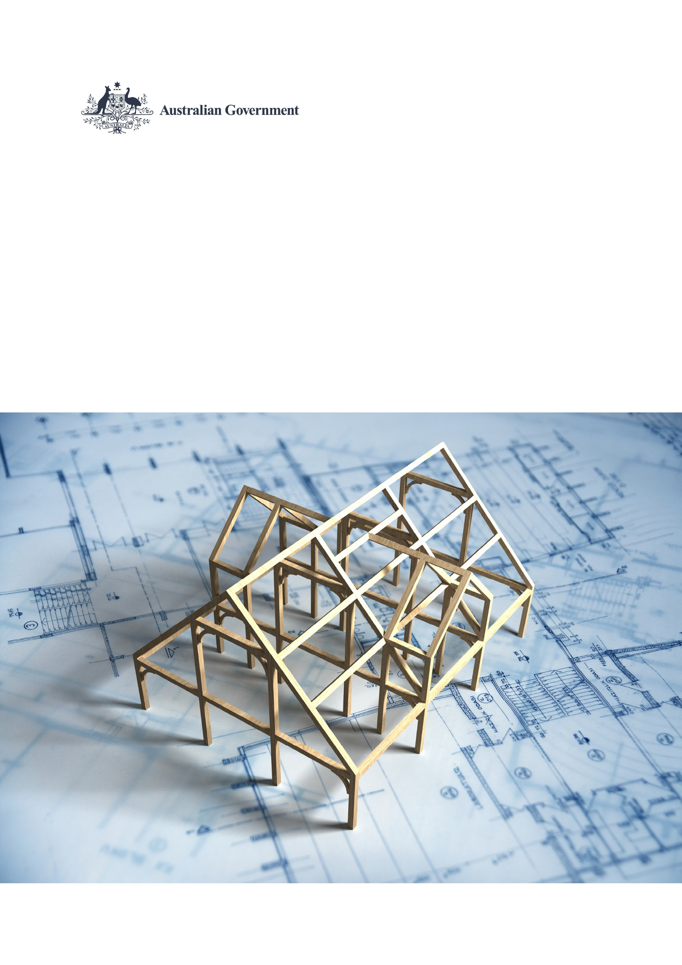

National Planning Reform Blueprint  
Commonwealth March 2024 progress report

|  |
| --- |
| Measure 4 Planning Ministers will identify well-located ‘development ready’ land before 1 March 2024, having appropriate regard to the protection of land with key attributes e.g., environmental or economic. Measure 10 All levels of government will ensure the efficient use of government land, including the identification of surplus land suitable for housing and the delivery of best practice projects to support housing supply, diversity and affordability. |

## Efficient use of Commonwealth-held land

Due to the ongoing divestment of surplus Commonwealth properties, most of the land with a high potential for housing has already been made available to the property market. Under the Commonwealth Property Management Framework, surplus Commonwealth property must be sold on the open market unless otherwise agreed by the Minister for Finance. Commonwealth properties are only held where they demonstrably contribute to government service delivery outcomes and ownership represent value for money.

More information on the Commonwealth’s Property Disposal Policy can be found at <https://www.finance.gov.au/government/property-and-construction/commonwealth-property-disposal-policy>.

## Best practice development of Commonwealth-held land

While the Commonwealth does not generally redevelop land for housing, it does make well-located surplus land available to other levels of government for redevelopment.

For example, the Minister for Defence announced on 10 November 2023 that the Defence barracks located at Keswick, an inner south-western suburb of Adelaide, and Smithfield in north-east Adelaide, would be divested to the State of South Australia for urban renewal, including increasing housing supply. At least 15 per cent of dwellings in any future development of Keswick will be reserved for affordable housing, while the Smithfield development will target a minimum of 40 per cent.

More information can be found at   
<https://www.minister.defence.gov.au/media-releases/2023-11-10/land-agreement-build-australias-nuclear-powered-submarines>

# Appendix – Update as of July 2024

In the 2024–25 budget, the Government announced it will undertake fast-tracked feasibility studies on the release of Commonwealth land to support social and affordable housing. These studies will consider potential barriers to making identified surplus Commonwealth properties available for social housing such as contamination, environmental and heritage value, zoning and town planning considerations and explore potential release options that accelerate divestment.