Document checklist
7 September 2022
You will need some information to start your application under the Youpla Group Funeral Benefits Program.
If you need help you can call us on 1800 296 989. We can help you to find a policy number. We can also help you to find documents.

Details of the person who has passed away
☐ | The name of the person who has passed away and if known, their date of birth and their date of passing.
☐ | The Youpla Group or Aboriginal Community Benefit Fund policy number.  Don’t worry if you don’t have the number, we can help you find it.

A copy of one of the below documents:
☐ | Death Certificate
☐ | Coroners Form 20A  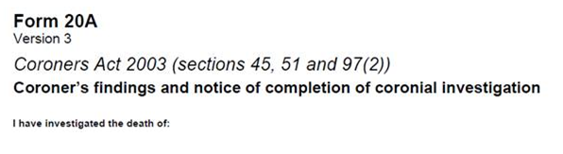
☐ | State government Cause of Death Certificate
☐ | Life Extinct Form from a health care provider (Local Aboriginal Medical Service, Hospital, Doctor)  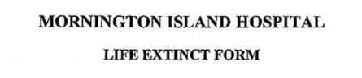
Please do not send us your original forms. We only need copies. You can also take a photo of each document and send it to us.
If you do not have one of these documents there are other ways that we can help you get this information. We can contact:
- your funeral director
- the health care provider (Local Aboriginal Medical Service, Hospital or Doctor) that was looking after the person where they passed away.

Details about you
☐ | Your full name
☐ | Your date of birth
☐ | Your relationship to the person that has passed away
☐ | Your address
☐ | Your phone number if you have one
☐ | Your email address if you have one

Copies of two forms of identification on this list:
☐ | Birth certificate
☐ | Driver’s licence
☐ | Medicare card
☐ | Centrelink Health Care Card
☐ | Commonwealth Seniors Health Card
☐ | Centrelink Deduction Statement
☐ | Centrelink Pensioner Concession Card
☐ | Passport
☐ | Change of Name Certificate
☐ | Marriage Certificate
You can lodge your application even if you only have one of these documents (such as a Medicare card). Please attach a copy of this document to your application.
Please contact us if you do not have any of these documents. We may be able to help you verify this information another way. Call us on 1800 296 989 or email youpla@treasury.gov.au.

Information on where to pay you the money
☐ | Your bank account details
☐ | Your funeral director’s contact details – you can choose to make a payment directly to your funeral director. To do this, tell us the amount (up to the policy limit) you want paid and the funeral director’s contact details.

Having someone else make your application for you
Please fill in the Alternate Contact Form if you would like someone to act on your behalf.
You can download at www.treasury.gov.au/youpla or get a copy of by calling us on 1800 296 989
or sending an email to youpla@treasury.gov.au.
If you have someone acting on your behalf and you don’t want them to anymore, you can stop this at any time.

