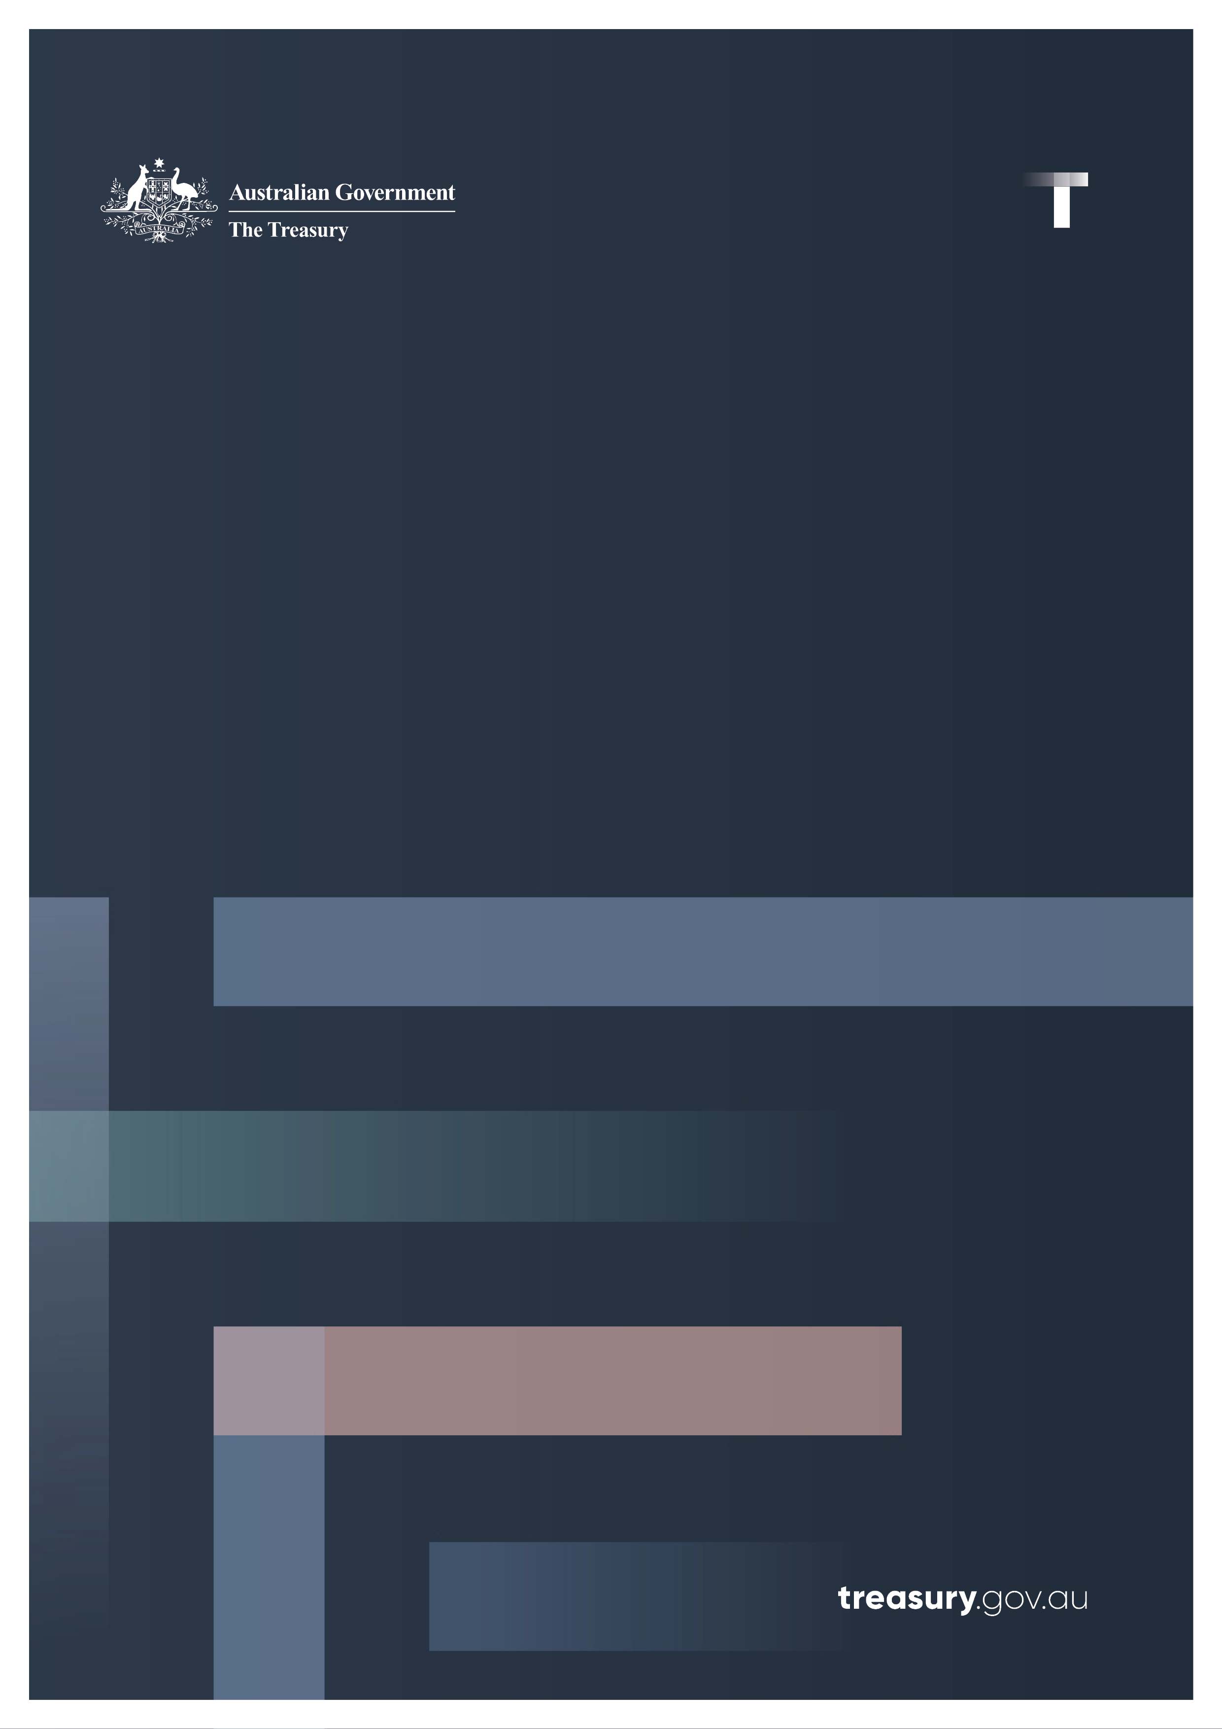

Cyber Wardens Program
  - Privacy Impact Assessment – Agency Response

© Commonwealth of Australia 2026
This publication is available for your use under a Creative Commons Attribution 4.0 International licence, with the exception of the Commonwealth Coat of Arms, the Treasury logo, photographs, images, third party materials, materials protected by a trademark, signatures and where otherwise stated. The full licence terms are available from creativecommons.org/licenses/by/4.0/legalcode.

Use of Treasury material under a Creative Commons Attribution 4.0 International licence requires you to attribute the work (but not in any way that suggests that the Treasury endorses you or your use of the work).
Treasury material used ‘as supplied’
Provided you have not modified or transformed Treasury material in any way including, for example, by changing the Treasury text; calculating percentage changes; graphing or charting data; or deriving new statistics from published Treasury statistics – then Treasury prefers the following attribution:
Source: The Commonwealth of Australia.
Derivative material
If you have modified or transformed Treasury material, or derived new material from those of the Treasury in any way, then Treasury prefers the following attribution:
Based on Commonwealth of Australia data.
Use of the Coat of Arms
The terms under which the Coat of Arms can be used are set out on the Department of the Prime Minister and Cabinet website (see www.pmc.gov.au/government/commonwealth-coat-arms).
Other uses
Enquiries regarding this licence and any other use of this document are welcome at:
Manager
Media Unit
The Treasury
Langton Crescent
Parkes ACT 2600
Email: media@treasury.gov.au
In the spirit of reconciliation, the Treasury acknowledges the Traditional Custodians of country throughout Australia and their connections to land, sea and community. We pay our respect to their Elders past and present and extend that respect to all Aboriginal and Torres Strait Islander peoples.

Contents
Contents iii
Context…………………………………………………………………………………………………………………………………………………1
Recommendation 1 …………………………………………………2
Recommendation 2 2

Context
The $23.4 million Cyber Wardens program (the Program) was announced as part of the 2023–24 Budget and runs from 6 November 2023 to 31 July 2026.
Cyber Wardens forms part of the Government’s investment of more than $80 million since 2023 to help small businesses uplift their cyber security and digital capabilities.
Cyber Wardens is a free, online, e-learning platform that aims to build the capabilities of small business owners and their staff to protect against cyber security threats by training in-house ‘Cyber Wardens’. The grant also funds research on small business cyber security challenges, and promotion of the program.
Cyber Wardens is available through the Cyber Wardens website (https://cyberwardens.com.au/).
Cyber Wardens is delivered by the Council of Small Business Organisations Australia (COSBOA), the Grantee. The Program is managed by Treasury and the Business Grants Hub (BGH) in the Department of Industry, Science and Resources (DISR).
COSBOA is required to collect information from clients and disclose it to the Australian Government for program monitoring, assurance and evaluation purposes. Client information is also disclosed to COSBOA contractors (89 Degrees East) and to consultants undertaking program monitoring services (Quantum Market Research).
Treasury engaged HWL Ebsworth to conduct a Privacy Impact Assessment (PIA) of the information collection, disclosure and use requirements of the Program. The final PIA made 2 recommendations. This document provides Treasury’s response to each of these recommendations.

Recommendation 1 – third-party assurance measures
Issue: Treasury currently relies primarily on Grant Agreement and standard Commonwealth Government template contract clauses to ensure compliance with the Privacy Act, but takes limited additional steps to confirm that COSBOA, 89 Degrees East and Quantum are meeting their privacy obligations in practice.
Recommendation: Treasury should introduce additional proportionate assurance measures to provide assurance that third parties engaged in the Project are complying with their privacy obligations. These measures may include seeking periodic confirmation of privacy practices, requiring reporting on subcontractor arrangements, and reserving the right to request further information where risks warrant.
Agency response: Support
Treasury will continue to ensure that COSBOA and their contractors, as well as any consultants employed by Treasury, are aware of their responsibilities under the Privacy Act 1988 and the Australian Privacy Principles. Treasury may seek further information from the Grantee or consultants, if necessary, through periodic discussions with the Grantee. This, combined with the existing use of the standard Commonwealth Grant Agreement, is a proportionate approach.

Recommendation 2 – assurance of subcontractor-provided protections
Issue: The Commonwealth standard Grant Agreement requires COSBOA to make subcontractors “aware of” privacy obligations but does not expressly require subcontractors who handle Project personal information to comply with them. This creates ambiguity given the central role of 89 Degrees East in collecting and handling information.
Recommendation: Treasury should seek assurance from COSBOA that subcontractor arrangements, including with 89 Degrees East, provide protections equivalent to those required under the Privacy Act and the Grant Agreement.
Agency response: Support
Treasury has sought and received additional assurance from COSBOA that their subcontractor arrangements provide protections equivalent to those required under the Privacy Act 1988 and outlined in the Cyber Wardens Grant Agreement between COSBOA and BGH (DISR).

