

Treasury
Corporate Plan
  - 2026–27

© Commonwealth of Australia 2026
This publication is available for your use under a Creative Commons Attribution 4.0 International licence, with the exception of the Commonwealth Coat of Arms, the Treasury logo, photographs, images, third party materials, materials protected by a trademark, signatures and where otherwise stated. The full licence terms are available from creativecommons.org/licenses/by/4.0/legalcode.
Use of Treasury material under a Creative Commons Attribution 4.0 International licence requires you to attribute the work (but not in any way that suggests that the Treasury endorses you or your use of the work).
Treasury material used ‘as supplied’
Provided you have not modified or transformed Treasury material in any way including, for example, by changing the Treasury text; calculating percentage changes; graphing or charting data; or deriving new statistics from published Treasury statistics – then Treasury prefers the following attribution:
Source: The Commonwealth of Australia.
Derivative material
If you have modified or transformed Treasury material, or derived new material from those of the Treasury in any way, then Treasury prefers the following attribution:
Based on Commonwealth of Australia data.
Use of the Coat of Arms
The terms under which the Coat of Arms can be used are set out on the Department of the Prime Minister and Cabinet website (see www.pmc.gov.au/government/commonwealth-coat-arms).
Other uses
Enquiries regarding this licence and any other use of this document are welcome at:
Manager
Media Unit
The Treasury
Langton Crescent
Parkes ACT 2600
Email: media@treasury.gov.au

Acknowledgement of Country and Traditional Owners
The Treasury acknowledges the traditional owners of country throughout Australia, and their continuing connection to land, water and community. We pay our respects to them and their cultures and to Elders past and present.

Contents
Secretary’s introduction 1
Treasury Corporate Plan 2026–27 to 2029–30 2
Operating context 4
Environment 4
Capability 7
Risk oversight and management 10
Risk appetite and tolerance 10
Enterprise risk 10
Governance 13
Our approach to performance 14
Key activity 1: Treasury’s policy advice and analysis is impactful, informed and influential 15
Key activity 2: Treasury’s implementation of policies and regulation supports Australia’s economy and national interest 19
Key activity 3: Treasury’s external engagements enable implementation of the government’s economic and fiscal agenda 26
Appendix: Corporate plan requirements 29

Secretary’s introduction
In 2026, Treasury celebrates its 125th year as the Australian Government’s lead economic adviser.
We help the government respond to complex challenges and uncertainties. We assist in the preparation for and management of economic shocks, maintenance of fiscal sustainability, and fostering of a fairer and more prosperous economy.
During the past year, Australia’s economy has continued to show resilience despite heightened global uncertainty. Growth has rebounded solidly and unemployment remains low. Inflation has increased recently, similar to many advanced economies and partly due to temporary factors. Headline and underlying inflation remain well below their 2022 peaks.
There is a significant agenda in front of us. Domestic economic conditions, changing technologies and escalating global instability will continue to affect critical supply chains, economies and costs of living. There is renewed emphasis on productivity, competition and better regulation which is central to Australia’s medium-term economic performance and improvement in living standards.
What stands out is the scale and breadth of our work. In the coming year, Treasury will provide advice on the government’s social and economic policy priorities. This includes assessing their impact on the fiscal position, productivity, inflation and resilience. We will work to deliver effective taxation and retirement income systems as well as the government’s housing supply and affordability agenda. We will continue to engage with our stakeholders and the wider community to understand these priorities in the context of their impact on Australians and the Australian economy.
The way Treasury works has been a consistent strength. We need to remain flexible, strategic and responsive to new and emerging issues and government priorities. Our effectiveness and influence depend on our people. Developing our workforce and improving our management practices to attract and retain the skills we need remain a priority. We are continuing to enhance our data and digital capabilities, including the responsible adoption of artificial intelligence (AI).
We have a strong commitment to transparency and accountability in the Australian public sector. We share well-informed and insightful advice with Commonwealth, state and territory governments, international counterparts and external stakeholders, building effective, collaborative relationships.
I am pleased to present our Corporate Plan as required under paragraph 35(1)(b) of the Public Governance, Performance and Accountability Act 2013 (PGPA Act). This is our primary planning document and has been prepared in accordance with the requirements of the PGPA Act.
I look forward to leading Treasury in 2026–27 and reporting on our progress in the annual performance statements included in Treasury’s Annual Report.

Jenny Wilkinson PSM
Secretary
August 2026

Treasury Corporate Plan 2026–27 to 2029–30

Our purpose
We provide advice to the government and implement policies and programs to achieve strong and sustainable economic and fiscal outcomes for Australians.

Our operating context
- Navigating short-term complexities and uncertainties
- Addressing medium-term structural challenges
- Promoting strong and sustainable outcomes

Our areas of focus
- A strong and sustainable economic and fiscal environment
- Effective government policies, programs and regulation
- Organisational capability, pro-integrity culture, sound governance and assurance

Enablers

People
Successful delivery of our purpose relies on our capable and professional workforce. We are committed to investing in our people and supporting their wellbeing.

Information management
Access to high-quality data, modelling and analysis as well as timely access to information is important for delivering high-quality advice to government. We also rely on responsive information and communication technology solutions as enablers of our work.

Risk oversight and management
Risk management is an enabler of good decision making and robust advice to government. It supports accountability, transparency, and engagement and helps identify opportunities as they arise.

How
- Ensuring our work aligns with our purpose
- Creating and sustaining productive relationships
- Developing high performing teams
- Rewarding an inclusive and pro-integrity culture
- Sound governance and assurance

Our key activities and intended results

Key activity 1: Treasury’s policy advice and analysis is impactful, informed and influential
- Treasury’s policy advice on fiscal, macroeconomic, tax, markets, housing, small business and regulatory issues reflects a whole of economy view and supports improved productivity outcomes for the Australian economy.
- Treasury forecasts inform policy advice to government and are in an acceptable range of variance with actuals.
- Budgets, fiscal and economic updates are timely and comply with the Charter of Budget Honesty.

Key activity 2: Treasury’s implementation of policies and regulation supports Australia’s economy and national interest
- Treasury’s policy advice on markets and regulatory issues assists the Australian economy to be competitive and key markets to be dynamic.
- Treasury’s policy advice on prudential and financial market infrastructure issues contributes to the stability of Australia’s financial system and provides confidence to consumers and investors, supporting economic growth.
- Treasury’s policy advice, research, support, and coordination across government and jurisdictions addresses structural barriers to housing supply, access, and affordability, including social and affordable housing programs delivered by Housing Australia.
- Treasury’s regulatory functions:
- – Treasury administers Australia’s foreign investment framework consistent with Australia’s national and economic interests.
- – Treasury administers the Payment Times Reporting Scheme to improve payment practices and foster a prompt payment culture to support economic growth and outcomes for small business suppliers.

Key activity 3: Treasury’s external engagements enable implementation of the government’s economic and fiscal agenda
- Relationships with Treasury ministers, Treasury portfolio agencies and regulators, and key stakeholders enable implementation of the government’s agenda.
- Partnering with international financial institutions promotes international monetary cooperation, fosters financial system stability and economic growth, and facilitates the government’s objectives in international forums.
- Payments to the states and territories (the states) are administered in accordance with the Intergovernmental Agreement on Federal Financial Relations and other relevant agreements between the Commonwealth and the states.

Operating context

Environment
Australia’s economy, and Treasury’s operating environment, continues to be shaped by evolving structural and geopolitical forces that are creating significant uncertainty.

Navigating short-term complexities and uncertainties
The conflict in the Middle East has disrupted global supply chains and had a substantial impact on commodity prices. This is expected to weigh on the global economic outlook, resulting in higher inflation and lower growth. The economic and geopolitical impacts of the conflict in the Middle East are likely to linger beyond the resolution of the conflict.
Australia is not immune from the impacts of the conflict, which are expected to weigh on growth in household consumption and real incomes in the near term. However, Australia is well placed to navigate the challenges. Our economy is growing faster than other major advanced economies, unemployment remains low, and public finances are among the strongest in the developed world.
There are risks to the outlook. There are significant risks in relation to the duration of the conflict and the extent of the disruption in the Middle East. Ongoing global uncertainty also creates the risk of volatility in financial markets, with any significant repricing of financial assets likely to have real economy impacts. There is also the risk that domestic inflation could remain persistently higher and that the conflict could weigh more heavily on economic growth, including creating downside risks for housing supply in the near term.
Continued subdued productivity growth and rising global protectionism could lead to lower growth in output and real wages although strong investment in AI and other emerging technologies provides an offsetting new source of growth.

Addressing medium-term structural challenges
Complex structural changes continue to shape Australia’s economic, social and fiscal performance. The geopolitical environment means that economic and national security issues have become more interconnected. International engagement and connectivity are increasingly important.
Geopolitical tensions are increasing volatility in global commodity and financial markets and complicating the climate and digital transformations, affecting trade and investment flows and increasing the likelihood of economic shocks. Australia’s economic and fiscal performance will depend on harnessing the opportunities that arise from these transitions, managing the challenges and lifting productivity.
Housing remains one of Australia’s biggest domestic challenges, particularly as the population grows. Unaffordable or insufficient housing reduces economic participation, affects social inclusion and increases fiscal costs. Increasing the supply of affordable, well-located dwellings will support Australia’s economy.
Effective competition policy settings are necessary to support the government’s drive for productivity gains and economic resilience. A more competitive market environment drives innovation, enhances productivity, and encourages fairer pricing, wider choice and better-quality goods and services for consumers.
Working effectively with state and territory governments is crucial to delivering the government’s economic reforms. This includes significant measures across housing, productivity, competition and better regulation. Delivering this agenda requires strong alignment between Treasury, our portfolio agencies and regulators.

Promoting strong and sustainable outcomes
Throughout 2026–27, Treasury will monitor evolving global and domestic economic developments and advise on achieving strong and sustainable economic, social and fiscal outcomes. We will provide advice to the government on how to strengthen the budget to prepare for future economic shocks and manage long-term fiscal pressures. We will also provide advice on the operation of the tax system and how it can be improved.
Treasury will prepare the 2027–28 Budget, other economic and budget updates, the annual Population Statement, the 2026 Intergenerational Report and the 2026 Measuring What Matters Statement.
Treasury will support implementation of major tax and spending reforms targeting equity, efficiency and intergenerational fairness. Reforms to the tax system aim to help more Australians realise home ownership, encourage productive investment and boost business activity.
We will continue to provide whole-of-economy advice on national and economic security issues to support the government and our portfolio agencies. We will advise on industrial priorities relating to net zero and economic resilience and security.
Treasury will continue to support the government’s productivity and better regulation agendas. This includes advancing National Competition Policy reforms, working with states and territories, to create a single national market and support worker mobility. We will also continue to review competition policy settings, including in respect of AI, and implement non competes reforms.
Treasury will continue to work with the Council of Financial Regulators and other stakeholders to strengthen Australia’s financial system. Priorities include strengthening investor protections, supporting community access to cash, working with regulators and industry to address geopolitical risks and responding to the rapid digital transformation of payments and capital markets.
Treasury will support the government to implement reforms announced in the 2026–27 Budget to further streamline and strengthen the foreign investment framework. We will continue using a risk-based approach to streamline the approvals of low-risk investments, increase scrutiny of high-risk investments, and bolster compliance monitoring and enforcement activities. This will ensure Australia attracts the significant foreign investment needed to promote and protect the national interest.
Treasury will continue to implement the government’s housing initiatives, including the National Housing Accord and delivery of the $47 billion Homes for Australia national plan released in May 2026. We will work closely with Housing Australia, states and territories and industry partners to ensure delivery of key government commitments. Priorities include continuing delivery of the Housing Australia Future Fund, implementation of the Local Infrastructure Fund and modernisation of the National Construction Code. We will advise on approaches to improve housing supply and affordability.
Treasury will provide policy advice and administer programs to support a sustainable and productive small business sector, recognising its contribution to the economy and local communities. Priorities include implementing the National Small Business Strategy and improving payment times through the Payment Times Reporting Scheme.
Through the First Nations Economic Partnership, Treasury will continue to collaborate with First Nations people and communities to support economic empowerment and self-determination. Priorities include strengthening mainstream systems to better serve First Nations interests, fostering job creation, supporting thriving businesses, and unlocking the potential of land and Native Title to build enduring economic prosperity for First Nations peoples, communities and organisations. Through the Housing Policy Partnership, Treasury is collaborating with First Nations representatives and representatives from federal, state and territory governments to address and improve the housing outcomes of Aboriginal and Torres Strait Islander people, aligned with Closing the Gap Outcome 9.

Capability

Our people
Treasury is committed to investing in our people to ensure we continue to deliver on our priorities and purpose to government.
Our Strategic Workforce Plan (the Plan) is central to this commitment. It sets a clear, forward-looking approach to building the workforce capabilities and management practices we need to attract, develop and retain skills now and into the future.
In 2026–27, Treasury will continue to deliver actions under the Plan, with a focus on:
- supporting employees and leaders to effectively navigate and lead through change
- strengthening system controls and reducing manual processing to support data-driven workforce investment
- implementing the Respect@Treasury Framework with behaviour expectations across all cohorts
- developing and implementing best practices at every stage of Treasury’s recruitment lifecycle.
These actions are supported by our enduring commitment to foster safe, respectful and accessible workplaces, where difference is valued. This strengthens our capability to respond to complex policy challenges and deliver high-quality advice to government. Treasury will also continue to embed and support the staff and functions that transferred as part of the machinery of government changes last year.
Treasury remains committed to prioritising building internal capability and bringing ICT and digital solutions core work in-house in line with the APS Strategic Commissioning Framework. Treasury’s outsourcing of core work is limited, and measures are in place to continue embedding the Framework within the department.

Our pro-integrity culture
Treasury is committed to the highest standards of integrity, professionalism and ethical behaviour, including through:
- building and maintaining a pro-integrity culture
- ensuring integrity is embedded in everything we do as an organisation, and our employees are supported to do the right thing at the right time.
Treasury’s Integrity Strategy 2024–2028 reflects our commitment and approach to building and sustaining trust with government, stakeholders and the Australian people.
Treasury’s Integrity Framework is a core foundation of the strategy (Figure 1). The Framework brings together standards, legislation, policies and structures to foster integrity and reduce the risk of corruption. In 2026–27, Treasury will continue to embed the Strategy and pro-integrity culture into everything we do. We will focus on values, behaviours and institutional practices. We will continue to strengthen conflict of interest identification, management and reporting.

Figure 1 – Treasury’s Integrity Framework

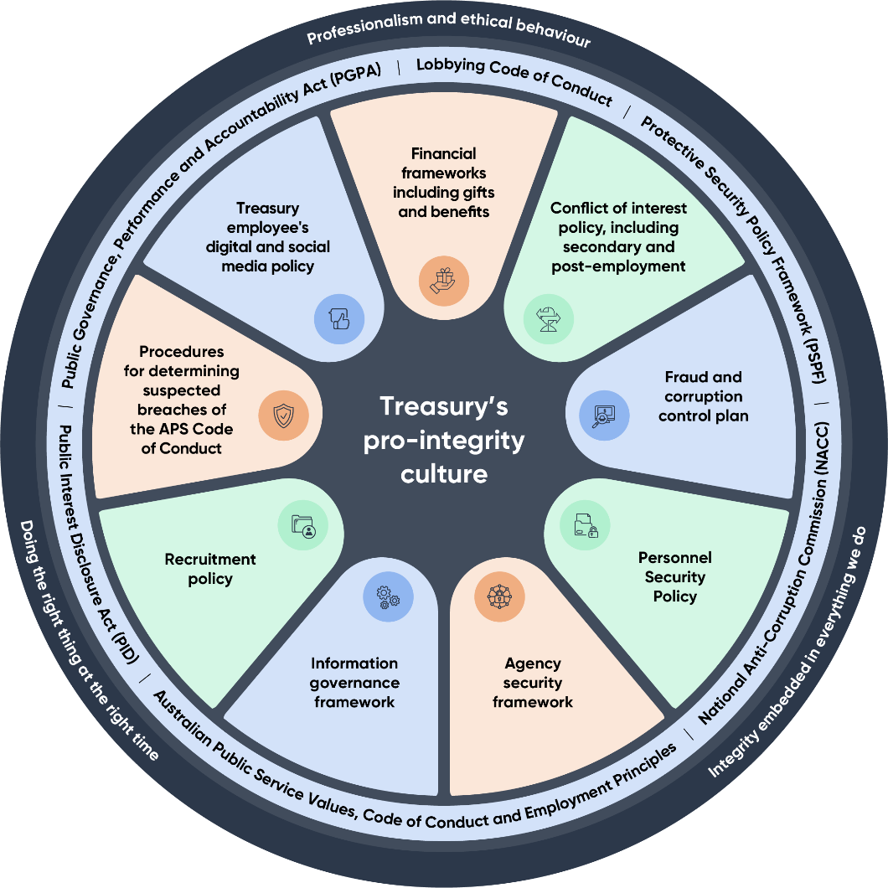

Our cooperation and collaboration
Effective stakeholder engagement is core to Treasury’s work. It helps us deliver timely, informed and influential advice. Stakeholder perspectives improve our advice to government and the engagement process deepens our relationships with the Australian community.
Treasury’s stakeholder group is broad and diverse. It includes peak bodies, regulators, consumers, academics, business, unions, community groups and other government entities at the international, Commonwealth and state and territory levels. It also includes bilateral and multilateral international cooperation. We engage through a variety of forums to understand our environment and actively seek views through formal and informal consultation processes.
Treasury is committed to fostering a culture of effective stakeholder engagement. The Corporate Plan sets out how we will measure the effectiveness of our stakeholder engagement and consultation. For 2026–27, we have updated the questions in our annual stakeholder surveys to reflect the 6 principles in the Charter of Partnerships and Engagement. The principles are: be open, be responsive, be transparent, be accountable, be informed and be collaborative.
We work closely with the other agencies in the Treasury portfolio, across the Australian Government and with international institutions to deliver our shared objectives and Treasury’s purpose. Treasury uses data from our portfolio entities and other organisations to achieve policy outcomes and demonstrate our performance.
Through the First Nations Economic Partnership and Housing Policy Partnership, Treasury will work in genuine partnership with other government agencies and First Nations Partners to co-design First Nations policy advice to lift economic empowerment and enhance housing outcomes.
The Australian Centre for Evaluation (ACE) in Treasury provides support across government to enhance the quality and depth of evidence available to help drive better outcomes for individuals, communities and society. The ACE Strategy outlines how Treasury works with entities across government and beyond to oversee a service-wide evaluation capability uplift.
Treasury also supports the Evaluation Professional stream, in collaboration with the Australian Public Service Commission. This brings together people who assess the effectiveness and efficiency of government policies, programs and initiatives and champion evaluation in all its forms across the APS.

Our technology and digital capability
Treasury’s Digital and Cyber Security Strategy 2026–29 sets a clear strategic direction for the next three years. It defines priorities across four core digital pillars, including AI, cyber security, data and information management. Together, these capabilities support secure and reliable operations, protect information and improve productivity in an increasingly complex and evolving environment.
By investing in digital capability and responsible adoption of AI, Treasury will use emerging technologies to drive operational efficiency and enhance service delivery. AI will be embedded as a core capability to improve how we work and support innovation across the department.
Cyber threats are becoming increasingly sophisticated and persistent, requiring a coordinated and deliberate response to build trust and actively defend our people, systems and information.
During 2026–27, Treasury will launch its second Enterprise Data Strategy (the Strategy). This Strategy will set out a vision and direction for investment in data culture, capability, governance and use across Treasury and will complement the Digital and Cyber Security Strategy.

Risk oversight and management
Risk management at Treasury enables good decision making and robust, high-quality, timely analysis and advice to government and effective delivery of our policy and program priorities.
Our risk management policy and framework support Treasury’s accountable authority, the Secretary, to meet her obligations under section 16 of the PGPA Act in line with the Commonwealth Risk Management Policy.
In 2026–27, we will continue to embed risk-based decision-making and practices in our day-to-day operations and governance, in line with our Risk Management Policy and Framework. We will strengthen our approach by integrating risk with governance and strategic planning to build capability and further mature our risk practices. Our arrangements are reviewed regularly to ensure they remain current and effective, with the next review of the Risk Management Policy and Framework scheduled for 2027.
A suite of tools supports implementation of the risk policy and framework, ensuring consistent risk identification, communication, monitoring and decision making. Risk and opportunities are managed at the group and program level, overseen by our governance committees. At the operational level, the focus is on identifying, assessing and managing risks through effective controls, with escalation through appropriate governance channels.

Risk appetite and tolerance
Treasury strives to achieve the right balance between engaging with risk to effectively deliver our policy and program outcomes, while upholding accountability requirements and protecting the reputation of the department and our status as trusted advisers.
To deliver on our purpose, we have a moderate appetite to engage with risk. Treasury must consider our appetite for pursuing risk in the context of the potential consequences of each risk we take, that is, our risk tolerance. Our tolerance for risk varies depending on the activity. Acceptance of risk within the agreed tolerance range is based on good professional judgement. This requires all Treasury staff to understand potential threats and opportunities and focus on ensuring there are sensible measures in place to mitigate and manage undesirable outcomes.

Enterprise risk
Treasury has identified risks that may impact our ability to deliver our purpose and priorities, and the opportunities we must pursue and realise.

Treasury enterprise risks 2026–27

Influential, impactful and trusted policy advice, analysis and reform
Risks
1. We do not build and maintain key relationships and effectively collaborate to enable delivery of impactful, informed and influential advice and analysis and implementation of government policy.
2. Our modelling and analytical capability does not enable the provision of timely and reliable advice in an environment of rapid change.
3. Our work does not realise opportunities to drive policy and regulatory reform to support the government to improve Australia’s economic, social, environmental and fiscal outcomes.

Risk management strategies
Effective stakeholder engagement is core to establishing and maintaining trust and is embedded into our processes through dedicated engagement functions. Robust arrangements are in place to protect the integrity of policy consultation activities.
We invest in our modelling and analytical capability and innovate to improve the quality, reliability and responsiveness of our analysis over time. We measure the accuracy, timeliness, and robustness of our microdata and analysis to assess our performance and inform areas of improvement.
We continuously build our understanding of the areas where our work can have the greatest impact. Our risk appetite and tolerance settings encourage engagement with opportunities to maximise the benefit they represent.

Delivery of the economic agenda
Risks
4. We do not efficiently, effectively and ethically deliver the government’s program and policy priorities, missing opportunities to improve economic, housing, environmental and fiscal outcomes for Australians.
5. Our regulation administration is not effective, flexible, transparent, and fair, and creates unnecessary burdens on, or uncertainty for, industry and consumers.
6. We do not effectively and ethically steward the financial resources and responsibilities allocated to us and do not adopt strong budget management processes, leading to poor value for money and loss of trust in Treasury.

Risk management strategies
Treasury’s activities are documented and reviewed through governance and assurance mechanisms to ensure they align with the expectations of government and interested parties including the wider public.
We build our internal capability to support the planning, consultation and analysis needed to enable effective partnerships and solutions.
We maintain strong financial management policies, processes, systems and governance arrangements. Key policies and frameworks that support our financial management include accountable authority instructions, budget processes and reporting.
We adopt a risk-based approach to approving payments to states and territories and regulation, with a focus on continuous improvement, centralised coordination and building trust.

People, capability and culture
Risks
7. We do not sustain and embed a culture that promotes health, safety, wellbeing, inclusion, diversity and integrity, and we do not attract, retain, continually develop and fully utilise the potential of our staff, including future leaders.
8. We do not adequately invest in our ICT platforms and capability, impacting our ability to protect Treasury's digital assets and evolve and transform our digital solutions and capability, resulting in reduced operational resilience, unmet business needs and elevated cyber security risks.

Risk management strategies
Through our people initiatives and priorities, we embed appropriate behaviours, leadership expectations and responsibilities. Through our contemporary workplace strategies, policies and procedures; we provide a safe environment where inclusion, diversity, wellbeing, and continual learning is encouraged and supported at all levels.
Our Digital and Cyber Security Strategy outlines our direction in digital and cyber security.
We leverage emerging technologies to transform how we work and deliver value, while also embedding security into every layer of the digital environment.
We continuously maintain, improve and evolve the department’s digital solutions, services, capabilities, and underpinning technology estate to support operational resilience and meet changing business needs.

Governance
An impactful and efficient governance structure enables Treasury to achieve our purpose and meet our performance objectives.
Our enterprise governance committees provide transparency, direction and oversight of risks and complex strategic and operational matters that affect Treasury.
In 2026, Treasury refreshed the governance committee structure to support effective oversight by management. In 2026–27, we will continue to strengthen our governance arrangements, including to address the opportunities and challenges arising from AI, climate change and the security environment.

Figure 2 – Treasury’s governance committee structure

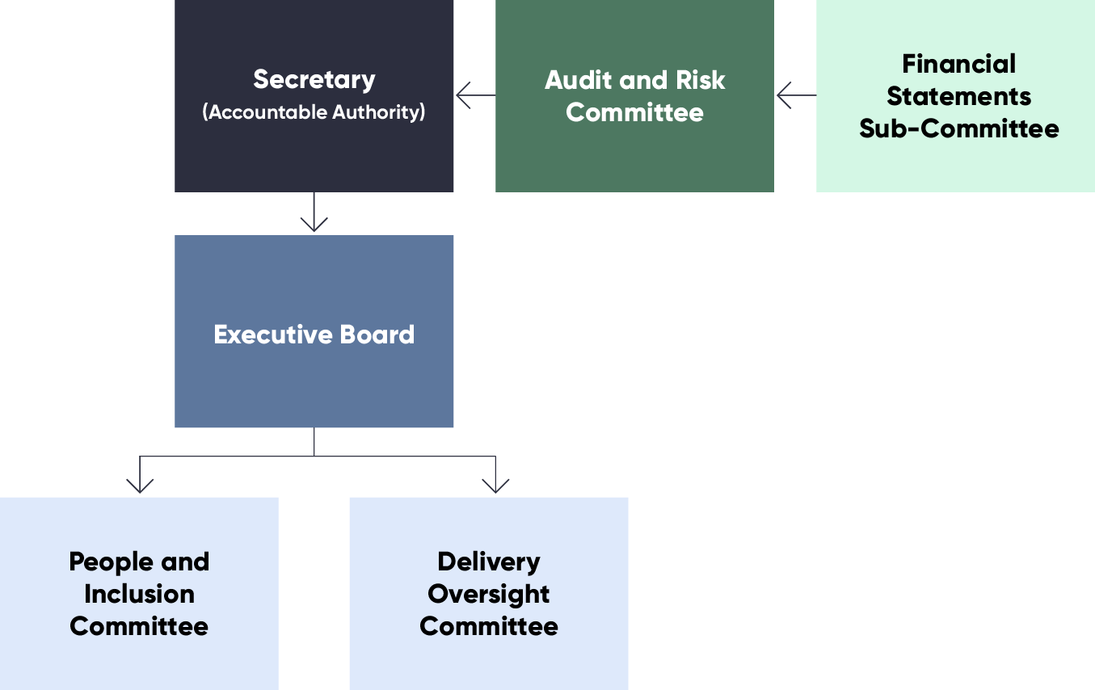

Information about the role of our governance committees is available in Treasury’s annual report.

Our approach to performance
The Corporate Plan 2026–27 is Treasury’s primary planning document.
Treasury continues to improve our performance framework to better reflect what we do and to explain how we achieve our purpose. Treasury reviews the performance framework annually to assess completeness.
We refine our performance assessment methodologies through each reporting cycle to improve reporting outcomes. We rely on existing data sources, including publicly available and third-party. Further insights come from an independent stakeholder survey and structured interviews with Treasury ministers or their representatives. This approach informs our decision making and improves the reliability and our ability to verify performance reporting over time.
Treasury has introduced a new performance measure for 2026–27 and removed the measure for the delivery of the legislative program from the performance framework. The new measure provides accountability on the government’s priority to improve housing supply. It has been tested through internal reporting and audit to meet the requirements of the Public Governance, Performance and Accountability Rule 2014.
Treasury is revising the performance measure for commercial foreign investment proposals in response to the government’s announced changes to Australia’s foreign investment framework. The new performance measure will be reported in the annual performance statements 2026–27.
Treasury’s foreign investment framework and Payment Times Reporting Scheme are included in the Corporate Plan in accordance with the official guidance issued by the Department of Finance on Regulator Performance. The Ministerial Statement of Expectations and the Regulator Statement of Intent for the Payment Times Reporting Scheme are available on the regulator’s website: paymenttimes.gov.au.

Key activity 1: Treasury’s policy advice and analysis is impactful, informed and influential

Intended result 1.1
Treasury’s policy advice on fiscal, macroeconomic, tax, markets, housing, small business and regulatory issues reflects a whole of economy view and supports improved productivity outcomes for the Australian economy.

Performance measure 1
Proportion of Treasury ministers, key government entities and stakeholders that rate Treasury advice highly.
(Program 1.1 – Economic Management)
Year | Target: Ministerial feedback questionnaire | Target: Stakeholder survey
2026–27 | 87% | 80%
2027–28 | 100% | 80%
2028–29 | 100% | 80%
2029–30 | 100% | 80%

Target rationale
Treasury established an 80% target for the ministerial feedback questionnaire and stakeholder survey based on 2021–22 survey results. Treasury increased the targets for the ministerial feedback questionnaire for 2025–26 and forward years to align with the methodology for assessing performance and the prior year performance results. Treasury has maintained the targets for the stakeholder survey in 2026–27 and the forward years based on the 2025–26 performance results.

Methodology
Independent stakeholder survey with key government entities and stakeholders conducted by a third-party provider, and structured interviews with Treasury ministers or their representatives. The assessment of the ministerial feedback questionnaire will be weighted so that the Treasurer’s responses account for 50% of the overall percentage measure. Stakeholder selection is governed by transparent stakeholder selection rules.

Measure type
Effectiveness measure.

Data sources
Stakeholder lists and responses to the stakeholder survey and the ministerial feedback questionnaire from Treasury ministers or their representatives.

Changes from previous year
The target for the key stakeholder survey is maintained at 80% in 2026–27 and the forward years. Treasury annually reviews its stakeholders and areas of policy advice to incorporate new functions.

Intended result 1.2
Treasury forecasts inform policy advice to government and are in an acceptable range of variance with actuals.

Performance measure 2
Variance between actual real Gross Domestic Product (GDP) and forecast real GDP.
(Program 1.1 – Economic Management)
Year | Target
2026–27 | Real GDP falls within 70% confidence interval of forecast real GDP
2027–28 | Real GDP falls within 70% confidence interval of forecast real GDP
2028–29 | Real GDP falls within 70% confidence interval of forecast real GDP
2028–29 | Real GDP falls within 70% confidence interval of forecast real GDP

Target rationale
Consistency of economic and fiscal forecasts and projections are important for government decision making. The confidence interval is a widely used metric that provides a guide to the degree of uncertainty around forecasts, assuming that forecast errors are consistent with the distribution of past forecast errors. The choice of a 70% confidence interval is consistent with the narrower of the two confidence intervals published in budget papers (the other confidence interval being 90%) which is also consistent with the narrower of the two confidence intervals published by the Reserve Bank of Australia for their forecasts.

Methodology
Assessment of the variance between forecasts and outcomes in each year for real GDP growth. Real GDP forecasts incorporate assumptions that include exchange rates, interest rates, commodity prices, and population growth. The confidence interval is a widely used metric that provides a guide to the degree of uncertainty around forecasts. The 70% confidence interval means there is a 70% chance that the outcome falls in this range. This assumes future forecast errors are consistent with the distribution of past forecast errors from 1998–99 onwards.

Measure type
Effectiveness measure.

Data sources
Australian Bureau of Statistics Australian National Accounts: National Income, Expenditure and Product, and budget papers.

Changes from previous year
Treasury developed this performance measure for the Corporate Plan 2022–23. There are no changes for the 2026–27 reporting period.

Performance measure 3
Variance between actual Total Tax Receipts (excluding Company Tax) and forecast.
(Program 1.1 – Economic Management)
Year | Target
2026–27 | Total Tax Receipts (excluding company tax) for 2026–27 falls within 70% confidence interval of forecast at the 2026–27 Budget
2027–28 | Total Tax Receipts (excluding company tax) for 2027–28 falls within 70% confidence interval of forecast at the 2027–28 Budget
2028–29 | Total Tax Receipts (excluding company tax) for 2028–29 falls within 70% confidence interval of forecast at the 2028–29 Budget
2029–30 | Total Tax Receipts (excluding company tax) for 2029–30 falls within 70% confidence interval of forecast at the 2029–30 Budget

Target rationale
Consistency of economic and fiscal forecasts and projections are important for government decision making. The confidence interval is a widely used metric that provides a guide to the degree of uncertainty around forecasts, assuming that forecast errors are consistent with the distribution of past forecast errors. The choice of a 70% confidence interval is consistent with the narrower of the two confidence intervals published in budget papers (the other confidence interval being 90%) which is also consistent with the narrower of the two confidence intervals published by the Reserve Bank of Australia for their forecasts.

Methodology
Assessment of the variance between forecasts and outcomes in each year for actual total tax receipts (excluding company tax). Tax receipts forecasts are generally prepared using a ‘base plus growth’ methodology. The last outcome for each head of revenue is the base to which growth rates are applied, using appropriate economic parameters. Estimates for the current year also incorporate recent trends in tax collections. The confidence interval is a widely used metric that provides a guide to the degree of uncertainty around forecasts and a basis for assessing forecasting performance. The 70% confidence interval means there is a 70% chance that the outcome falls in this range. This assumes future forecast errors are consistent with the distribution of past forecast errors from
1998–99 onwards.

Measure type
Effectiveness measure.

Data sources
Australian Bureau of Statistics Australian National Accounts: National Income, Expenditure and Product, budget papers, and Final Budget Outcome.

Changes from previous year
Treasury developed this performance measure for the Corporate Plan 2022–23. There are no changes for the 2026–27 reporting period.

Intended result 1.3
Budgets, fiscal and economic updates are timely and comply with the Charter of Budget Honesty.

Performance measure 4
Delivered in line with the requirements of the Charter of Budget Honesty Act 1998 (Charter).
(Program 1.1 – Economic Management)
Year | Target
2026–27 | 100%
2027–28 | 100%
2028–29 | 100%
2029–30 | 100%

Target rationale
The Charter includes specific timelines and requirements that must be met. Treasury has delivered in accordance with the Charter over previous reporting periods. The 100% target is an indication of the importance of these deliverables.

Methodology
Assessment against the requirements and timeframes for the public release of the deliverables set out in the Charter for the 2026–27 reporting period. The deliverables for performance reporting in this period are the 2025–26 Final Budget Outcome, 2026–27 Mid-year Economic and Fiscal Outlook, and 2027–28 Budget. Additional reporting may also be required if the conditions of Part 6 and Part 9 of the Charter are met, if the Treasurer releases an Intergenerational Report, or if a statement of Commonwealth stock and securities is required. The Pre-election Economic and Fiscal Outlook is not included in the 2026–27 requirements.

Measure type
Output measure in relation to compliance. Timeliness measure as a proxy for efficiency.

Data sources
The released documents for the Final Budget Outcome, Mid-year Economic and Fiscal Outlook and Budget, and if provided, the Intergenerational Report and additional statement of Commonwealth stock and securities.

Changes from previous year
The performance measure allows for additional assessment against the requirements and timeframes of the Charter. There are no changes for the 2026–27 reporting period.

Key activity 2: Treasury’s implementation of policies and regulation supports Australia’s economy and national interest

Intended result 2.1
Treasury’s policy advice on markets and regulatory issues assists the Australian economy to be competitive and key markets to be dynamic.

Performance measure 5
Australia maintains or improves its 2022 score on markets related inputs to the World Competitiveness Ranking produced by the Institute for Management Development.
(Program 1.3 – Support for Markets and Business)
Year | Target
2026–27 | Competitiveness score ≥105
2027–28 | Competitiveness score ≥105
2028–29 | Competitiveness score ≥105
2029–30 | Competitiveness score ≥105

Target rationale
Treasury developed the competitiveness score of 105 for the 2022–23 and forward year reporting periods based on the 2022 data for 15 criteria of the World Competitiveness Rankings. The 15 criteria relate to areas of Treasury’s policy responsibility. The target reflects the performance goal of maintaining or improving Australia’s competitiveness in areas related to market performance that are within the policy responsibilities of Treasury and remains valid.

Methodology
The Institute for Management Development (IMD) produces a World Competitiveness Ranking based on a range of criteria. Fifteen of these criteria relate to the Treasury in the areas of policy responsibility for financial system, investment, retirement incomes, provision of actuarial services, and corporations, competition, and consumer data and law. Other performance measures do not assess these policy areas. IMD calculates the average value for each economy for publication in the IMD World Competitiveness Yearbook each year. Treasury will use the results against the 15 criteria to construct a competitiveness score relevant to this performance measure as an indicator of Treasury’s policy effectiveness.

Measure type
Effectiveness measure.

Data sources
Institute for Management Development World Competitiveness Rankings.

Changes from previous year
Treasury established this performance measure in the Corporate Plan 2022–23 with the target set during the first year. There are no changes for the 2026–27 reporting period.

Intended result 2.2
Treasury’s policy advice on prudential and financial market infrastructure issues contributes to the stability of Australia’s financial system and provides confidence to consumers and investors, supporting economic growth.

Performance measure 6
No disorderly failures of institutions prudentially regulated in Australia.
(Program 1.1 – Economic Management)
Year | Target
2026–27 | No disorderly failures of prudentially regulated institutions
2027–28 | No disorderly failures of prudentially regulated institutions
2028–29 | No disorderly failures of prudentially regulated institutions
2029–30 | No disorderly failures of prudentially regulated institutions

Target rationale
No disorderly failures of prudentially regulated institutions support financial system stability and economic growth. Treasury’s policy advice on the regulatory framework targets very low, but not zero, incidences of failure of the regulated entities. The orderly transfer or exit of prudentially regulated entities is part of a competitive financial system.

Methodology
A disorderly failure of a prudentially regulated institution occurs when there is material disruption to the critical economic functions and services that the institution provides, and that this results in significant impacts on the financial system and the wider economy. Treasury relies on regular bilateral engagement with the Australian Prudential Regulation Authority (APRA) to obtain information on prudentially regulated institutions that have failed or are at significant risk of failure.

Measure type
Effectiveness measure.

Data sources
APRA data for the Money Protection Ratio and register of prudentially regulated entities at the beginning and end of the relevant reporting period.

Changes from previous year
Treasury developed this performance measure for the Corporate Plan 2022–23. There are no changes for the 2026–27 reporting period.

Intended result 2.3
Treasury’s policy advice, research, support, and coordination across government and jurisdictions addresses structural barriers to housing supply, access, and affordability, including social and affordable housing programs delivered by Housing Australia.

Performance measure 7
Proportion of social and affordable dwellings that have become ready for tenants, compared to the contracted delivery schedule.
(Program 1.5 – Support for Housing Supply and Affordability)
Year | Target
2026–27 | 90%
2027–28 | 90%
2028–29 | 90%
2029–30 | 90%

Target rationale
The performance targets are calibrated to government policy targets for the delivery of social and affordable housing. The Housing Australia Future Fund supports the delivery of 30,000 social and affordable dwellings over five years to 30 June 2029, with the National Housing Accord Facility to support a further 10,000 dwellings over the same period. Annual targets are calibrated to be consistent with Treasury advice to government regarding progress towards the forecasted delivery of 40,000 dwellings over the five years to 2028–29, and the capacity of Housing Australia to administer housing programs.

Methodology
Calculation of the number of dwellings that have become ready for tenants under the Housing Australia Future Fund and National Housing Accord Facility in the reporting period, compared to the expected dwelling completion dates set out in funding recipients’ contracts.

Measure type
Effectiveness measure.

Data sources
Data will be provided by Housing Australia to Treasury via a formal report to the Minister for Housing and Homelessness. This data is for dwellings that have become ready for tenants under the Housing Australia Future Fund and National Housing Accord Facility, evidence of contracts signed, and independent audit reports.

Changes from previous year
Treasury developed this performance measure for the Corporate Plan 2025–26.
This measure has changed from monitoring contracted dwellings to now compare the expected and actual tenantable status of dwellings. Program delivery by Housing Australia, and program oversight by Treasury, have matured, allowing Treasury to compare the expected (as per contracts) and actual dwellings that have become ready for tenants. This is a more meaningful measure and aligns with expectations of the government’s investment in social and affordable housing.

Performance measure 8
Growth rate in residential dwellings exceeds the adult population growth rate.
(Program 1.5 – Support for Housing Supply and Affordability)
Year | Target
2026–27 | The residential dwelling growth rate exceeds the adult population growth rate by 0.5 percentage points.
2027–28 | The residential dwelling growth rate exceeds the adult population growth rate by 0.5 percentage points.
2028–29 | The residential dwelling growth rate exceeds the adult population growth rate by 0.5 percentage points.
2029–30 | The residential dwelling growth rate exceeds the adult population growth rate by 0.5 percentage points.

Target rationale
Treasury has set a target for the increase of housing supply to exceed an indicator for demand. The 0.5 percentage point target threshold reflects the average margin between 1981 and 2001. Achieving and consistently meeting a performance threshold from this period of comparatively higher supply relative to demand is a suitable benchmark. It is a measure of an ambitious outcome that encompasses a broad housing policy agenda, including reforms and initiatives to streamline approvals, improve housing sector productivity, and fund enabling infrastructure.
The Australian Government’s Homes for Australia national plan states that building more homes is central to addressing the housing challenge, and that increasing housing supply will improve affordability. The 2026–27 Budget also shows that housing was more affordable between 1981 and 2001 compared to the subsequent period, with a housing price-to-earnings ratio of 3.1 in 1981, 4.1 in 2001 and 8.1 in 2025.
The target threshold will be reviewed following a consistent 10-year period of achievement of the target.

Methodology
Calculation of the difference between residential dwelling growth rate and the adult population growth rate based on the most recent available data. Number of dwellings and adult population are the product of data collection and estimation by the Australian Bureau of Statistics, and the most recent available data has a time lag of around 6 months. The number of dwellings measures residential housing supply, and the adult population is an indicator for housing demand. Comparing the change in both values provides an indicator of changes in housing supply relative to demand.

Measure type
Effectiveness measure.

Data sources
Australian Bureau of Statistics Total Value of Dwellings and National, State and Territory Population.

Changes from previous year
This performance measure is new in 2026–27.

Intended result 2.4
Treasury’s regulatory functions:
- Treasury administers Australia’s foreign investment framework consistent with Australia’s national and economic interests
- Treasury administers the Payment Times Reporting Scheme to improve payment practices and foster a prompt payment culture to support economic growth and outcomes for small business suppliers.

Performance measure 9
Proportion of stakeholders that report a high level of satisfaction regarding:
- the clarity, transparency, and consistent application of Treasury’s regulatory frameworks (Regulator Performance (RMG 128) Principle 1)
- risk based, data driven decision making (RMG 128 Principle 2)
- Treasury’s responsive communication and collaboration (RMG 128 Principle 3)
(Program 1.1 – Economic Management and 1.3 – Support for Markets and Business)
Year | Target
2026–27 | 65%
2027–28 | 65%
2028–29 | 65%
2029–30 | 65%

Target rationale
Survey results from prior years have informed the 2026–27 target. Given that consecutive targets were not achieved, the target of 65% has been retained for 2026–27 and the forward years. Engagement with stakeholders, particularly regulated entities, is maturing.

Methodology
Independent surveys conducted by a third-party provider with foreign investment framework and Payment Times Reporting Scheme stakeholders. Stakeholder selection is governed by transparent stakeholder selection rules. Survey questions align with the Regulator Performance Principles. Treasury will report separately on its regulatory functions for the foreign investment framework and Payment Times Reporting Scheme.

Measure type
Effectiveness measure.

Data sources
Stakeholder lists and responses to the stakeholder surveys.

Changes from previous year
Treasury developed this performance measure for the Corporate Plan 2022–23. There are no changes for the 2026–27 reporting period.

Performance measure 10
Proportion of regulated entities that complied with their obligation to report under the Payment Times Reporting Act 2020.
(Program 1.3– Support for Markets and Business)
Year | Target
2026–27 | 85%
2027–28 | 85%
2028–29 | 85%
2029–30 | 85%

Target rationale
The Australian Government overhauled the Payment Times Reporting Scheme in response to the Statutory Review of the Payment Times Reporting Act 2020 (the Act) in 2024–25. Treasury re-established the Payment Times Reporting Regulator’s performance target for the 2025–26 reporting period. Treasury has identified a baseline target of 85% of regulated entities complying with their reporting obligations using 2025–26 reporting data.

Methodology
This performance measure assesses the proportion of regulated entities that comply with their obligation to report under section 12 of the Act, expressed as a percentage of all entities required to report under the Payment Times Reporting Scheme during the reporting period.

Measure type
Effectiveness measure.

Data sources
Data from the Payment Times Reporting Regulator’s IT system, the Australian Taxation Office, the Australian Securities and Investments Commission, and commercial data sources.

Changes from previous year
This performance measure commenced in 2025–26. Treasury developed the methodology and data sources for performance reporting in 2025–26 to reflect the legislative and regulatory reforms. The 2026–27 target remains unchanged. Treasury has realigned targets for the forward years to better reflect results from the 2025–26 reporting period.

Performance measure 11
Proportion of low-risk foreign investment proposals decided within 30 days.
(Program 1.1 – Economic Management)

Changes from previous year
Treasury is developing a new performance measure for the assessment of low-risk commercial foreign investment proposals within a 30-day statutory decision period. Treasury will report on the new performance measure in the annual performance statements 2026–27 and will publish the new measure and targets in the Corporate Plan 2027–28.

Rationale for change
The government announced on 19 May 2026 foreign investment reforms, including setting a new performance target of deciding all low-risk applications within 30 days, from 1 January 2027. Treasury will establish the measure using new methodology and data sources during 2026–27.

Key activity 3: Treasury’s external engagements enable implementation of the government’s economic and fiscal agenda

Intended result 3.1
Relationships with Treasury ministers, Treasury portfolio agencies and regulators and key stakeholders enable implementation of the government’s agenda.

Performance measure 12
Proportion of Treasury ministers, Treasury portfolio agencies and regulators and key stakeholders that highly rate working with the Treasury.
(Program 1.1 – Economic Management)
Year | Target: Ministerial feedback questionnaire | Target: Stakeholder survey
2026–27 | 87% | 80%
2027–28 | 100% | 80%
2028–29 | 100% | 80%
2029–30 | 100% | 80%

Target rationale
Treasury established 70% as a baseline for the stakeholder survey and ministerial feedback questionnaire in 2021–22. Treasury has increased the targets for the ministerial feedback questionnaire for 2025–26 and forward years to align with the methodology for assessing performance and the prior year performance results. Treasury has maintained the targets for the stakeholder survey in 2026–27 and the forward years based on the 2025–26 performance.

Methodology
Independent stakeholder survey conducted by a third-party provider and structured interviews with Treasury ministers or their representatives. The assessment of the ministerial feedback questionnaire is weighted so that the Treasurer’s responses account for 50% of the overall percentage measure. Stakeholder selection is governed by transparent stakeholder selection rules.

Measure type
Effectiveness measure.

Data sources
Stakeholder lists and responses to the stakeholder survey and the ministerial feedback questionnaire from Treasury ministers or their representatives.

Changes from previous year
Treasury has revised the questionnaire to align with the principles of the Charter of Partnerships and Engagement that is part of the APS Reform.
The target for the key stakeholder survey is maintained at 80% in 2026–27 and the forward years. Treasury annually reviews its stakeholders and areas of policy advice to incorporate new functions.

Intended result 3.2
Partnering with international financial institutions promotes international monetary cooperation, fosters financial system stability and economic growth, and facilitates the government’s objectives in international forums.

Performance measure 13
Proportion of payments to international financial institutions are transferred within legislated requirements and agreements.
(Program 1.2 – International Financial Relations)
Year | Target
2026–27 | 100%
2027–28 | 100%
2028–29 | 100%
2029–30 | 100%

Target rationale
Treasury has reported over previous periods that transfers to international financial institutions are within legislated requirements. The target is consistent with these performance results.

Methodology
Assessment of payments against the requirements of relevant legislation and agreements. The performance results are calculated as a percentage of total payments that meet requirements and timeframes against total payments (all payments including those that do not meet requirements and timeframes) for the period.

Measure type
Output measure.

Data sources
International Monetary Agreements Act 1947, International Finance Corporation Act 1955, Asian Development Bank Act 1966, Asian Infrastructure Investment Bank Act 2015, European Bank for Reconstruction and Development Act 1990, Official Development Assistance Multilateral Replenishment Obligations (Special Appropriation) Act 2020, and payment records from the Reserve Bank of Australia, World Bank Group, Asian Development Bank, Asian Infrastructure Investment Bank, European Bank for Reconstruction and Development and International Monetary Fund (where relevant).

Changes from previous year
Treasury developed this performance measure for the Corporate Plan 2022–23. There are no changes for the 2026–27 reporting period.

Intended result 3.3
Payments to the states and territories (the states) are administered in accordance with the Intergovernmental Agreement on Federal Financial Relations and other relevant agreements between the Commonwealth and the states.

Performance measure 14
Proportion of payments to the states are delivered within requirements of the Intergovernmental Agreement on Federal Financial Relations and other relevant agreements between the Commonwealth and the states.
(Program 1.4 – Commonwealth State Financial Relations)
Year | Target
2026–27 | 100%
2027–28 | 100%
2028–29 | 100%
2029–30 | 100%

Target rationale
Treasury has reported against this performance measure over previous periods. The target is set in accordance with Treasury’s obligations.

Methodology
Assessment of payments against the requirements of the Intergovernmental Agreement on Federal Financial Relations and other relevant agreements between the Commonwealth and the states. The assessment is calculated as a percentage of the number of payments that meet requirements against the total number of payments (all payments including those that do not meet requirements) for the period.

Measure type
Output measure.

Data sources
The Intergovernmental Agreement on Federal Financial Relations and other relevant agreements, records of payment requests in the Federal Payments Management System, approvals, and payment advice.

Changes from previous year
Treasury developed this performance measure for the Corporate Plan 2024–25. There are no changes to the assessment of delivery within requirements in 2026–27.
Treasury will include a supplementary assessment of the value of payments delivered within requirements to reflect its risk-based approach to managing federal financial relations.

Appendix: Corporate plan requirements
The table below shows the topics that must be included in a corporate plan under section 16E(2) of the Public Governance, Performance and Accountability Rule 2014, and page references in this plan.
Requirement | Page reference
Introduction: Statement of preparation | 1
Introduction: The reporting period for which the plan is prepared | 1
Introduction: The reporting periods covered by the plan | 2
Purpose | 2
Key activities | 3
Operating context: Environment | 4–6
Operating context: Capability | 7–9
Operating context: Subsidiaries (if applicable) | Not applicable
Risk oversight and management, including key risks and management | 10–13
Performance | 14–28

