Competition and firms' innovation outcomes
  - Omer Majeed, Nabeeh Zakariyya, Monica Wang & Sarah Davies | Competition Evaluation and Analysis Unit, CEAU | March 2026
Key points
- Innovation is fundamental to productivity growth. This note shows a strong association between increased competitive pressure and a higher likelihood of innovation.
- Competition is strongly associated with higher innovation at low to moderate levels, with predicted innovation probabilities around 10-15 percentage points higher when firms move from monopoly to roughly five or more competitors.
- This matters because a large share of Australian firms face limited competition—around two in five operate with fewer than five competitors, and one in seven report no effective competition.
- The results suggest substantial scope for competition‑enhancing policies to support innovation, as innovation remains positively associated with competition until competitive pressure becomes very intense.
- As innovation is associated with higher productivity, stronger competition is likely to contribute to broader productivity gains over time.
- Our robustness tests, using a more granular alternative dataset, yield evidence consistent with an inverted-U relationship. The results indicate lower innovation probabilities at very high levels of competition, consistent with international evidence. Importantly, this note shows that this effect emerges only when competition reaches relatively high levels of competitive pressure.
- Since competition can often be local, national‑level measures can obscure important geographic variation; this note therefore uses newly constructed, detailed local measures that capture an important dimension of the competitive pressure that firms face.

Introduction
Productivity growth relies on firms continually improving what they produce and how they operate. Innovation is central to this process (Palangkaraya et al., 2015; Majeed and Breunig, 2022; van Leeuwen, 2002). Without sustained innovation, living standards stagnate and fiscal sustainability becomes more challenging. Recognising this, as productivity has declined across the developed world in recent years, OECD economies have strengthened their emphasis on innovation policy (OECD, 2025). Against this backdrop, around 46 per cent of Australian firms were innovation-active in 2023, according to the latest ABS Business Characteristics Survey (BCS).
Competition plays a pivotal role in shaping innovation incentives. Firms exposed to rivals must adapt, improve, and differentiate to survive. In contrast, firms facing limited competitive pressure may have weaker incentives to innovate. However, this relationship likely exhibits an inverted-U shape, as too much competition may also lower incentives to innovate for profit shares (Aghion, 2005). Aghion et al. (2005) propose, and empirically test, an inverted-U relationship: as competition intensifies from low levels, industry-wide innovation initially increases but declines once competition becomes overly fierce. While competition can drive firms to innovate, excessive competition may limit their capacity to invest in R&D, particularly in industries where profits are tightly constrained.
The findings here show that Australian firms operating in more competitive environments are more likely to innovate. The relationship holds across product, process, organisational and marketing innovation, highlighting the importance of competitive markets for sustaining productivity growth. This is particularly noteworthy given ABS data indicating that many firms operate with relatively few competitors.
Examining this relationship is especially complex because both competition and innovation are hard to measure. To date, this relationship has largely been explored using patent data (Aghion et al. 2005); however, patents represent only a small fraction of total innovation activity. In this analysis, we instead use OECD Oslo Manual-based innovation measures from the Business Characteristics Survey (BCS), which capture innovation more broadly by asking firms whether they have undertaken new or significantly improved goods or services, processes, marketing methods, or organisational practices.
Moreover, as competition is often local, widely used national- or industry-level measures—such as the Herfindahl–Hirschman Index (HHI), mark-ups, and the Lerner Index (LI)—can obscure the geographic dimension of competition. Moreover, national- and industry-level classifications may not match the market-level competition that each individual firm faces. This note contributes by using firms' own perceived level of competition (from the BCS) and relying on highly granular local measures of competition, capturing aspects of the competitive environment that may be overlooked by national- or industry-level measures.
To capture the association between competition and innovation, this note draws on two novel datasets. First, we exploit firms’ self-reported perceptions of competitive pressure drawn from a representative survey. Second, we use linked employer–employee data to construct a local measure of competition based on the number of competitors a firm faces within its industry and work zone (hereafter referred to as the LEED-based competition measure). Together, these measures capture the local competitive environment faced by firms. Based on these measures, we explore the relationship between innovation and competition. These datasets are further discussed in the appendix.

Results – All innovation types
Our results show that increasing competition is associated with increased probability to innovate, with predicted probabilities around 15 percentage points higher when firms face roughly five or more competitors compared with monopoly. The results point to a non-linear association between competition and innovation (Figure 1), consistent with Aghion et al. (2005). The results indicate a strong association between innovation and competition at lower levels of competitive pressure, before flattening a bit as competition becomes more intense.
The BCS measure is especially useful because firms self-report the degree of competition they face, meaning it may provide additional insights on firm-level competitive conditions. The drawback of the BCS competition variable is reported in broad categories—no competitors, 1–2, 3–4, and five or more competitors—which limits the ability to assess the downward-sloping portion of the inverted-U relationship observed in the baseline analysis. As such, the robustness variable using LEED overcomes this shortcoming.

Figure 1. Predicted probability of innovation by perceived competition (probit model)
Any Innovation
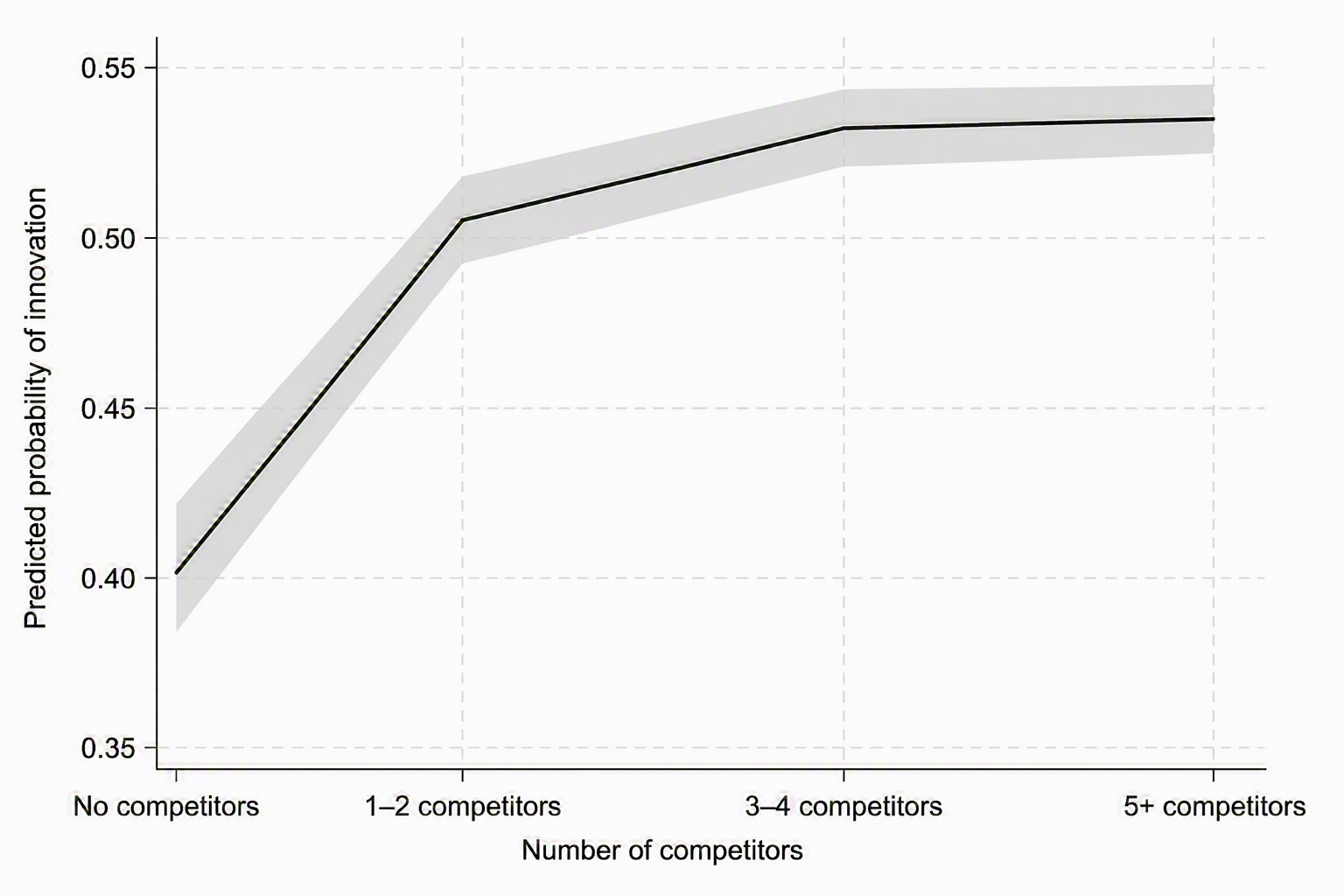
The results remain robust when disaggregating innovation into different types — namely goods and services, marketing, process, and organisational innovation (Figure 5 in the appendix). Across all innovation types, we continue to observe a positive association between competition and the predicted probability of innovation, alongside evidence of nonlinearity in the relationship. The broader “any innovation” measure encompasses all innovation channels, so it includes firms innovating in different ways, resulting in a higher overall probability than any single category. Although the magnitudes differ across innovation types, the underlying trend with respect to competition is broadly consistent.

Robustness and LEED competition measure
This note is the first to document an inverted-U relationship between competition and innovation in Australia, both across all industries and by region types (Figure 2). This pattern is consistent with Aghion et al. (2005), who argue that both too little and too much competition can dampen innovation.
The additional measure complements the previous results by showing a strong association between innovation probabilities and competition, as competition increases initially. However, with the peak occurring only at relatively high levels of competition. At very high competitor counts, predicted innovation probabilities tend to be lower on average. These results therefore present evidence of an inverted-U-shaped relationship.
An important policy implication of this analysis is that it identifies the range over which competition is most strongly associated with increased innovation activity, while also indicating that any decline in innovation emerges only at relatively high levels of competition. This suggests that increasing competition is likely to support innovation across a broad range for a large section of Australian forms.

Figure 2. Predicted probability of innovation by number of competitors (probit model)
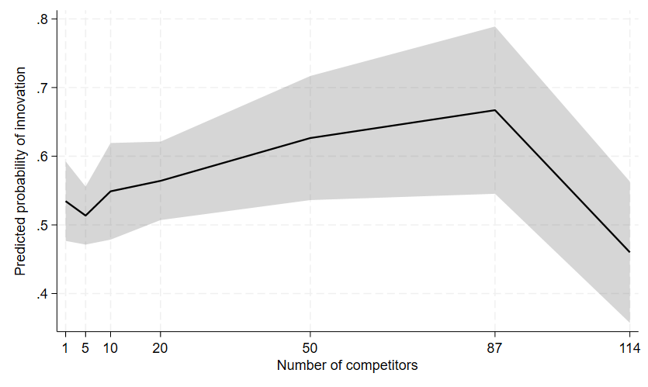
Note: Predicted probabilities are based on probit estimations of innovation outcomes on the BCS competition categories, averaged across all years. Shaded areas show 95% confidence intervals. Source: Treasury calculations from BLADE microdata.
Figure 3 shows that the association between competition and innovation is broadly similar in both metro and non-metro areas. Innovation probabilities are positively associated with the number of competitors at lower levels of competition, before flattening or declining at higher levels of competitive intensity. The inverted-U pattern is evident in both regions, although it occurs over a lower range of competitor counts in non-metro areas, reflecting the fact that local markets outside metropolitan areas typically support fewer firms. The construction of this variable is discussed in the appendix.
The metro results closely mirror the overall pattern, which is unsurprising given that the majority of firms in the sample are located in metropolitan areas. As a result, the aggregate estimates are largely reflective of the competitive dynamics observed in metro markets.
Table 1. Summary statistics of number of competitors
 | Mean | SD | p25 | p50 | p75
All firms | 65 | 95 | 9 | 26 | 80
Metro | 74 | 100 | 11 | 32 | 107
Non-metro | 29 | 57 | 3 | 10 | 29

Figure 3. Predicted probability of innovation by number of competitors – by metro status
Metro Area | Non-Metro Area
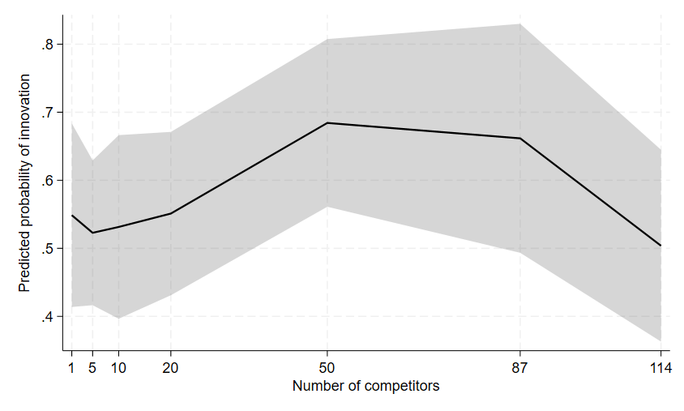 | 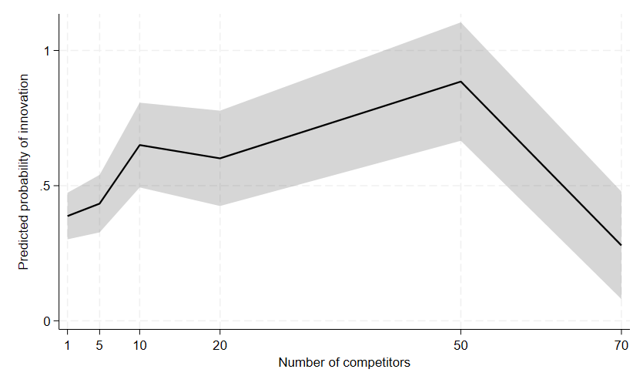
Note: X-axis values are based on observed competitor counts in the data. As some competitor levels are sparsely populated or unobserved, particularly at higher counts, the plotted values reflect representative observed points rather than regular intervals.
Here, the metro and non-metro disaggregation is based on the Modified Monash Model (MMM), an Australian geographic classification that categorises locations according to population size and geographic remoteness, spanning metropolitan areas, regional centres, rural towns, and remote and very remote communities. Unlike standard remoteness measures, the MMM also incorporates local town size, allowing for a more nuanced distinction between regional, rural, and remote areas. To focus on sizeable metropolitan markets, metro areas are defined as work zones with at least five LGAs.
An advantage of the LEED-based measure is that it provides substantially more variation in competitive intensity than the BCS measure, which groups firms into broad categories and caps the highest category at five or more competitors. However, because it is based on observed local competitor counts rather than firms’ perceived competitive pressure, it may not fully capture all dimensions of competition, such as interstate or export-oriented competitors. It is also noisier in industries with exceptionally large numbers of firms in major cities, such as accounting and personal services, where competitor counts can reach into the hundreds even thousands in some cases. Nonetheless, the two measures provide useful complementary evidence using alternate sources of data. Despite being constructed from different datasets and methodologies, the two measures are strongly correlated (correlation coefficient of 0.7), lending credibility to both measures and suggesting that they capture the same underlying competition dimension. Importantly, they both capture competition at the local market level, a dimension often overlooked by more commonly used measures of competition.

Analysis by size
Disaggregating by size, the evidence suggests that for large firms (firm with 200 or more employees based on FTE), increasing competition is associated with increasing probability to innovate even at higher levels of competition, whereas the inverted U shape is more likely associated with SMEs (firms with less than 200 employees). This provides suggestive evidence that the invested-U shape is likely driven by SMES. Moreover, larger firms are typically more likely to innovate at all levels of competition, consistent with previous evidence (Majeed and Breunig 2023).
Figure 4. Predicted probability of innovation by number of competitors – by small and large businesses
SME: BCS | Large firms: BCS
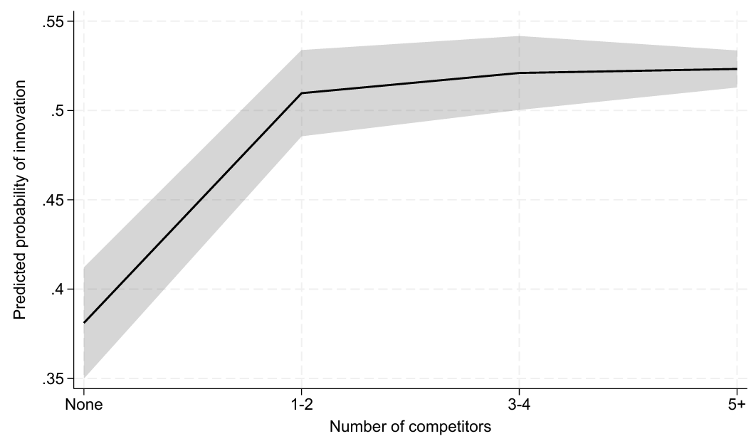 | 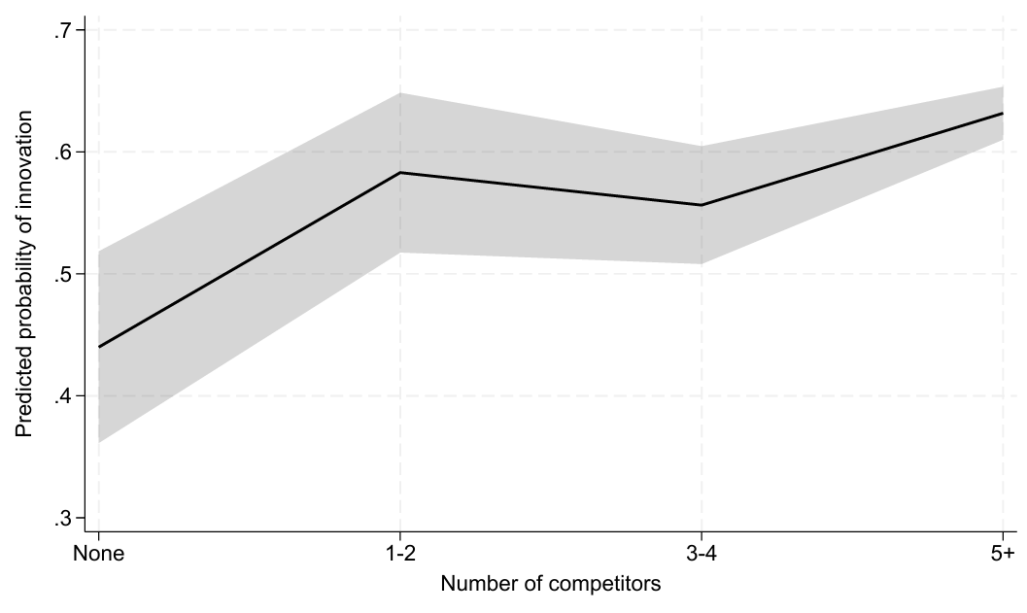
SME: LEED-BASED | Large firms: LEED-BASED
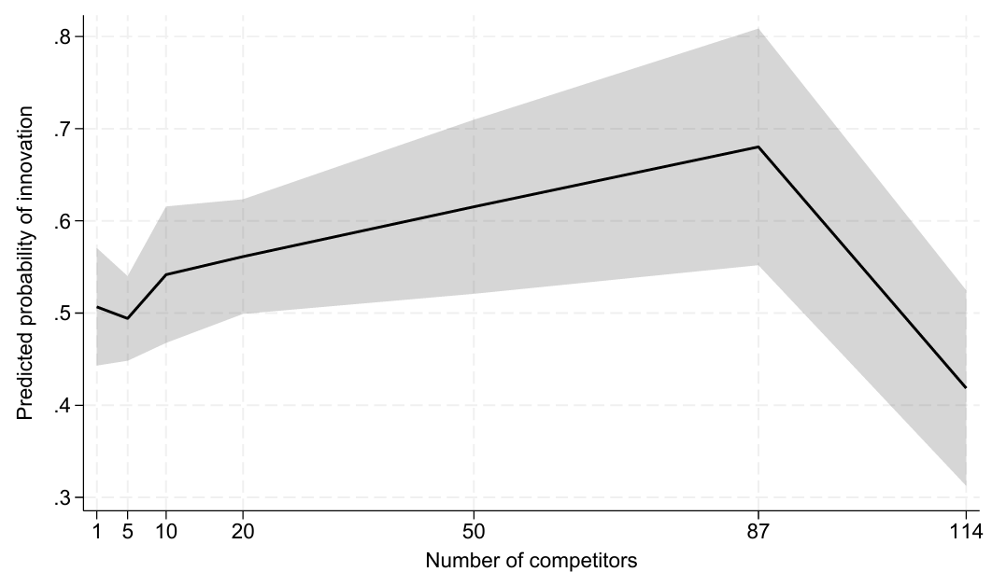 | 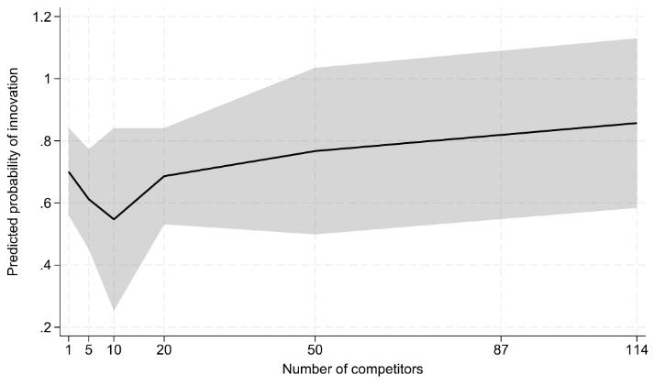
Note: X-axis values are based on observed competitor counts in the data. As some competitor levels are sparsely populated or unobserved, particularly at higher counts, the plotted values reflect representative observed points rather than regular intervals.

Methodology
To estimate the association between competition and innovation, the note estimates probit models in which the dependent variable is a binary indicator for whether a firm undertakes a specific type of innovation. The key explanatory variable is the number of competitors (using the Business Characteristics Survey (BCS)), with firms that have no competitors as the reference group. In an alternate setting, we use the LEED-based variable for competition.
Specifically, the note estimates:
$$\operatorname{Pr}\left(\left.Y_{it}=1\right|x_{it}\right)=Φ\left(α+\sum_{k=1}^{N}{β_{k}1\left[{Comp}_{it}=k\right]}+z_{it}^{'}γ+δ_{j}+τ_{t}+ε_{it}\right)$$
where $Y_{it}$​ is a binary indicator equal to one if firm $i$reports undertaking the specified innovation in year $t$, and zero otherwise. ${Comp}_{it}$​ denotes number of competitors (either from the BCS self reported competition measure or from LEED, measuring competitors in a work zone by division, z is a vector of controls that includes the two-year lag of the innovation variable, log of turnover, log of labour productivity, capital expenditure and log of employment, as well as indicators for foreign ownership. Industry ($δ_{j}$) and year ($τ_{t}$​) fixed effects are included in all specifications. Robustness additionally includes a variable for exporter status and dummy variables for four-digit industry classifications exhibiting unusually high competitor counts . To mitigate simultaneity concerns, firm-level controls enter the model as two-year lags.
Because probit coefficients are harder to interpret in probability terms, this note reports average marginal effects in Table 1. Specifically, we compute predicted probabilities of innovation for each competition category.
The definition of innovation used in the BCS follows the Oslo manual (OECD 2018) and is captured by the introduction of new or significantly improved goods or services; operational processes; organisational/managerial processes; or marketing methods. One drawback of survey responses is the possibility of measurement error, either through over- or under-reporting of innovation. However, cognitive testing of the Oslo manual indicates that the Oslo framework has largely succeeded at capturing how firms perceive innovations (Galindo-Rueda and Van Cruysen 2016, Majeed and Breunig, 2023).

Conclusion
Competition is strongly associated with higher levels of innovation — a key driver of productivity and long-run living standards. As such, the findings from this note position competition policy as an important contributor to the productivity agenda. Remote and regional markets cannot easily support many physical competitors (as a forthcoming note will discuss) and measures to improve competition in regional areas could be among the policy responses considered. Targeted digital, ICT and infrastructure policies can possibly enhance contestability and broaden competitive pressure across regions.

References
Aghion, P., Bloom, N., Blundell, R., Griffith, R., & Howitt, P. (2005). Competition and innovation: An inverted-U relationship. Quarterly Journal of Economics, 120(2), 701–728.
Garfinkel, J. A., & Hammoudeh, M. (2025). Competition and innovation revisited: A project-level view. Review of Financial Studies, 38(9), 2652–2717. doi:10.1093/rfs/hhae078
Griffith, R., & Van Reenen, J. (2021). Product market competition, creative destruction and innovation (IFS Working Paper No. W21/43). London, United Kingdom: Institute for Fiscal Studies.
Gustavsson Tingvall, P., & Poldahl, A. (2006). Is there really an inverted U-shaped relation between competition and R&D? Economics of Innovation and New Technology, 15(2), 101–118.
Australian Bureau of Statistics. (2023). Characteristics of Australian business, 2021–22 (Cat. No. 8167.0). Canberra, Australia: ABS.
Galindo-Rueda, F., & Van Cruysen, A. (2016). Testing innovation survey concepts, definitions and questions: Findings from cognitive interviews with business managers (OECD Science, Technology and Innovation Papers No. 20). Paris, France: OECD Publishing.
Majeed, O., & Breunig, R. (2023). Determinants of innovation novelty: Evidence from Australian administrative data. Economics of Innovation and New Technology, 32(8), 1249-1273. doi:10.1080/10438599.2022.2132239
Organisation for Economic Co-operation and Development. (2018). Oslo manual 2018: Guidelines for collecting, reporting and using data on innovation (4th ed.). Paris, France: OECD Publishing. doi:10.1787/9789264304604-en
Organisation for Economic Co-operation and Development. (2023). Competition and innovation: A theoretical perspective. Paris, France: OECD Publishing.
Organisation for Economic Co-operation and Development. (2025). OECD science, technology and innovation outlook 2025: Innovation policy transformed. Paris, France: OECD Publishing.
Palangkaraya, A., Webster, E., & Jensen, P. H. (2015). Misclassification between patent citations and patent family citations. Economics Letters, 128, 53–55.
Raihan, S., Uddin, M., & Khan, S. (2025). What drives firms to innovate? Empirical evidence from firm-level cross country data. The Indian Journal of Labour Economics, 1–22.
van Leeuwen, G. (2002). Linking innovation to productivity growth using two waves of the Community Innovation Survey (OECD Science, Technology and Industry Working Papers, 2002/08). Paris, France: OECD Publishing. doi: 10.1787/620221544571

Appendix

Measurement and Data

LEED based competition measure - geographic measurement of competitors
We measure local competition as the median number of competitors within each work zone and 1-digit ANZSIC industry. For each firm, competitors are defined as the number of firms in the same 4-digit ANZSIC industry–work zone cell minus one. The resulting measure is normalised by the number of local government areas in the work zone to account for differences in market size. The rest of the section details the creation of the broader dataset for competition. We aggregate to the 1-digit ANZSIC level to smooth variation arising from a small number of 4-digit industries with exceptionally high competitor counts, particularly in large metropolitan areas.
We define a business location where three or more employees associated with a firm are located within the same working zone. We adopt a threshold of three employees because it closely aligns with the median firm size in Australia, reflecting the fact that most firms are micro-businesses. As a validation exercise, we cross-checked this assumption using Census data on the proximity between employees’ residential locations and their reported workplaces. Below we give further details on how data was constructed and some of the challenges of using traditional measures of location.
Measuring local competition requires knowing where firms actually operate, not just where they are registered. Standard business datasets typically record firm activity at the national level and often attribute activity to a firm’s registered or headquarters address, even when substantial operations occur elsewhere. This “headquarters effect” can distort regional competition measures by overstating activity in head‑office locations and understating competitive pressure in operating markets. As a result, it is difficult to construct meaningful regional measures of competition, despite firms often competing locally and consumers facing choices within geographically bounded markets. To overcome this limitation, we use information on where employees are located as a proxy for where firms’ economic activity takes place. While this method is not perfect, it gives additional insights and may shed light on local dimensions of competition that are less visible in broader measures. Moreover, the finding employing it are consistent with the seminal work of Aghion et al. (2005).
We implement this approach by linking business‑level data from the Business Longitudinal Analysis Data Environment (BLADE), primarily Business Locations data, with person‑level administrative data from the Person‑Level Integrated Data Asset (PLIDA), which contains de‑identified tax records for individuals. Using employer–employee links, we observe where employees associated with each firm are located, and cross-reference this with the ABS Business Locations data in BLADE to identify operating locations. As the business locations dataset doesn’t have full coverage, we supplement it with additional imputed locations, identified by clusters of employees – if there are three employees in a working zone we impute a business location there, even in the absence of a location in the BLADE locations dataset. The threshold of three employees was chosen because it achieves a balance between false-positives and false negatives, when compared against census data.
We then aggregate this information to identify the firm’s local operational footprint by industry and working zone, which is constructed using commuting‑based geographic boundaries from the Bureau of Infrastructure and Transport Research Economics (BITRE). This allows us to construct a simple and intuitive measure of local competition based on the number of competing firms operating in the same industry and geographic area, for the period 2010-11 to 2021-22. In addition, we complement this objective measure with firms’ own self‑reported perceptions of competitive pressure from a representative survey conducted by the Australian Bureau of Statistics (discussed below).

BCS Data
This note also relies on firms’ self-reported competitive environment, measured as the number of competitors in their main market and grouped into four categories: none, 1–2, 3–4, and five or more competitors. The data are drawn from the Australian Bureau of Statistics’ Business Characteristics Survey (BCS), an unbalanced panel of Australian firms linked to administrative data from the Australian Taxation Office. The innovation and competition questions in the BCS follow the OECD Oslo Manual (OECD 2018).
An advantage of self‑reported competition measures is that they capture the competitive pressure firms perceive when innovating to protect profits and market share. Consequently, perceived competition may be more closely linked to innovation outcomes than objective measures.

Literature Review
The empirical relationship between innovation and competition has been studied extensively. A significant contribution is Aghion et al. (2005) which establishes an inverted-U relationship between competition and innovation variables using UK panel data, showing that innovation rises with competition at low levels but falls when competition becomes intense. More recent empirical work has found evidence consistent with this pattern across a range of country and industry contexts, although the literature remains mixed and sensitive to measurement, industry characteristics and technological distance from the frontier (Griffith & Van Reenen 2021; Poldahl & Tingvall 2006; Garfinkel and Hammoudeh 2022).
Much of the seminal evidence on the inverted-U relationship has relied on patents or R&D-based measures of innovation, or macro-level indicators of competition such as the Lerner Index or the Herfindahl-Hirschman Index. A key limitation of patents and R&D-based measures is that they capture a narrow section of innovation activity that is biased toward large firms and manufacturing sectors, missing informal or non-technological forms of innovation. Aggregate competition measures are similarly limited, failing to capture local variation in competitive conditions and remaining sensitive to market definition (OECD 2023). Survey-based measures offer a useful complement, capturing a wider range of innovation types spanning product, process, organisational and marketing innovations, as well as firms' perceived competitive pressures, although they can introduce limitations including self-reporting bias and variation in how firms interpret innovation. Where survey-based data is used, studies tend to find positive associations between competition and innovation, and are often unable to identify an inverted-U relationship, particularly when competition measures are coarse or top-coded. For example, Raihan et al. (2025) draws on World Bank Enterprise Survey data across 142 countries, finding that perceived domestic competition is associated with a higher likelihood of firm-level innovation.
This note makes several key contributions to the literature. By combining a broader set of innovation measures from survey data with detailed local competition data, this analysis is among the first to show that the inverted-U relationship holds in Australia and based on locations. It also introduces novel local measures of competition based on linked employer-employee data, a methodological contribution that has not been previously explored, addressing the recognised limitation of aggregate indices and enabling a more accurate characterisation of the competitive environments in which firms innovate. In doing so, it provides new evidence for Australia, where empirical work on the competition-innovation relationship has received limited attention.

Table 2: Estimated probability of innovation at different levels of competition
 | (1) | (2) | (3) | (4) | (5)
 | Any innovation | New operational processes | New goods or services | New managerial processes | New marketing methods
No competitors | 0.387*** | 0.188*** | 0.169*** | 0.226*** | 0.111***
 | (0.011) | (0.009) | (0.009) | (0.01) | (0.008)
1-2 competitors | 0.507*** | 0.265*** | 0.248*** | 0.297*** | 0.224***
 | (0.009) | (0.008) | (0.008) | (0.009) | (0.008)
3-4 competitors | 0.539*** | 0.298*** | 0.265*** | 0.334*** | 0.252***
 | (0.008) | (0.007) | (0.006) | (0.007) | (0.007)
5+ competitors | 0.540*** | 0.288*** | 0.267*** | 0.324*** | 0.270***
 | (0.004) | (0.004) | (0.003) | (0.004) | (0.004)
Firm level control variables | Yes | Yes | Yes | Yes | Yes
Industry fixed effects | Yes | Yes | Yes | Yes | Yes
Year fixed effects | Yes | Yes | Yes | Yes | Yes
Observations | 22,894 | 22,885 | 24,051 | 22,824 | 22,682
Pseudo-$R^{2}$ | 0.123 | 0.118 | 0.145 | 0.121 | 0.118
Note: Robust standard errors in parentheses. *** p<0.01, ** p<0.05, * p<0.1. The coefficients are marginal effects. The complete set of results, along with alternative model specifications are included in the supplementary materials. Source: Treasury analysis of BLADE data.

Figure 5. Predicted probability of innovation by perceived competition (probit model).
New Goods and Services | New Processes Innovation
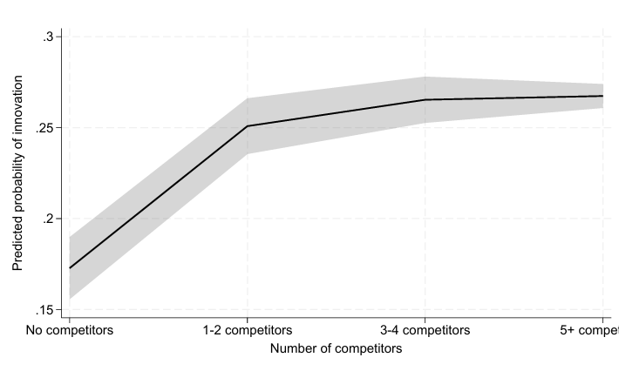 | 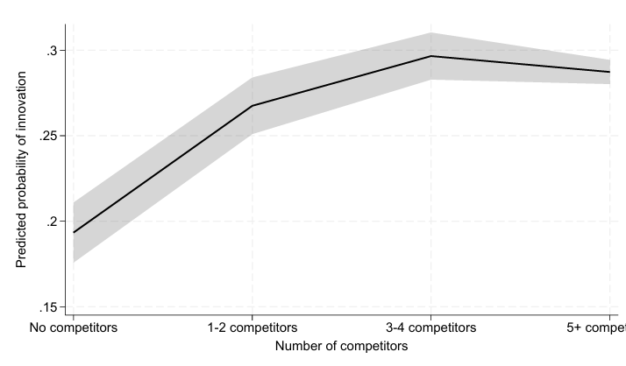
New Marketing | New Organisation
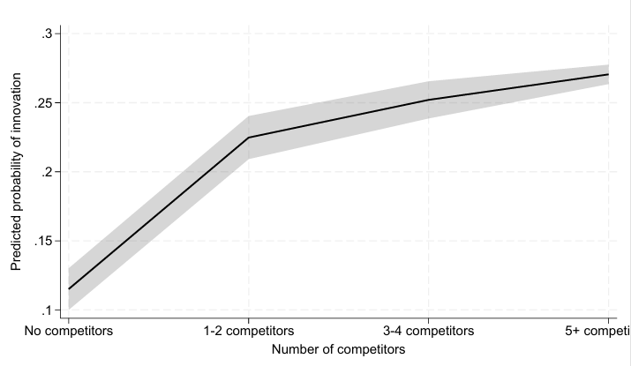 | 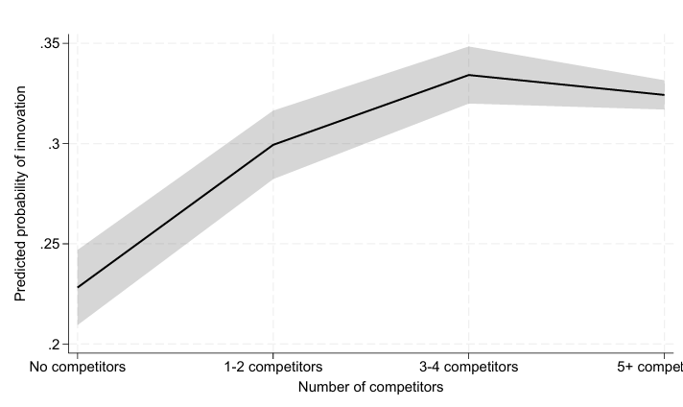
Note: Predicted probabilities are based on probit estimations of innovation outcomes on the BCS competition categories. Shaded areas show 95% confidence intervals. Source: Treasury calculations from BLADE microdata.

Acknowledgments
We are grateful to Professor Petr Sedlacek, Professor Robert Breunig, and Professor Flavio Menezes for their valuable comments and input on this paper.

Data disclaimer
The following data disclaimer should be noted: the results of these studies are based,
in part, on Australian Business Registry (ABR) data supplied by the Registrar to the ABS under A New
Tax System (Australian Business Number) Act 1999 and tax data supplied by the Australian Taxation
Office (ATO) to the ABS under the Taxation Administration Act 1953. These require that such data are
only used for the purpose of carrying out functions of the ABS. No individual information collected
under the Census and Statistics Act 1905 is provided back to the Registrar or ATO for administrative or
regulatory purposes. Any discussion of data limitations or weaknesses is in the context of using the
data for statistical purposes and is not related to the ability of the data to support the ABR’s or the
ATO’s core operational requirements. Legislative requirements to ensure privacy and secrecy of these
data have been followed. Only people authorised under the Australian Bureau of Statistics Act 1975
have been allowed to view data about any particular firm in conducting these analyses. In accordance
with the Census and Statistics Act 1905, results have been confidentialised to ensure that they are not
likely to enable identification of a particular person or organisation.

We are grateful to Prof. Flavio Menzies, Prof. Petr Sedlacek and Prof. Robert Breunig and for their comments on the note.
Cognitive testing of the Oslo manual indicates that the Oslo framework has largely succeeded at capturing how firms perceive innovations (Galindo-Rueda and Van Cruysen 2016). Webster, Palangkaraya, and Spurling (2021), Majeed and Breunig (2022) and Gault (2013) both discuss how the Oslo framework has been validated for measurement of innovation.
Innovation is captured using survey questions on whether firms introduced “new or significantly improved goods or services,” “processes,” “organisational/managerial processes,” or “marketing methods”.
Majeed and Breunig 2022, discusses the BCS innovation variables and Oslo Manual in more detail.
In large cities, industries such as construction and architecture often have very large numbers of competitors, sometimes exceeding 1,000
Many firms operate across multiple locations, making registered addresses an imperfect proxy for the markets in which competitive interactions occur.
As discussed earlier, cognitive testing of the Oslo Manual indicates that its framework has largely succeeded at capturing how firms perceive key variables (Galindo-Rueda and Van Cruysen 2016).

