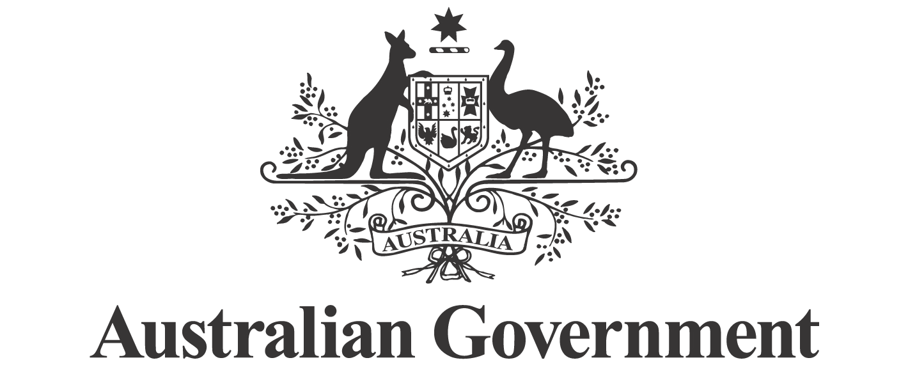
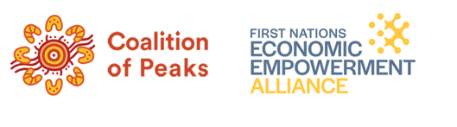
First Nations Economic Partnership

2025–26 Annual Workplan

About the First Nations Economic Partnership (Economic Partnership)
- The Economic Partnership has been established to advance the economic empowerment and lasting economic security of First Nations peoples, communities and organisations.
- The Economic Partnership establishes a mechanism for the Partners to share in decisions about reforms to First Nations economic policy, built around the ‘strong partnership elements’ of Priority Reform One of the Closing the Gap Agreement.
- The Partners’ commitment to work together is set out in the Economic Partnership Agreement (published online).
About this Annual Workplan (Workplan)
- The Partners have agreed to develop and publish a Workplan (Partnership Agreement, clauses 36–38).
- This is the inaugural Workplan, covering the period from signing of the Economic Partnership Agreement on 29 September 2025 through to 30 June 2026.
- This Workplan will be reviewed and updated at each meeting of the Economic Partnership.
Objectives – 2025–26
- The Partnership’s objectives for the period of this Workplan are to:
  - Develop policy options and initiatives for Government consideration, aligned with immediate priorities set out in the Workplan — including providing recommendations on practical policy options.
  - Establish inclusive engagement mechanisms with First Nations communities, Aboriginal and Torres Strait Islander community-controlled organisations, businesses and enterprises, Chambers of Commerce, experts, and stakeholders nationwide, consistent with the Partnership Agreement provisions on Additional Participation (clauses 23–26).
  - coordinate effectively with other partnerships and bodies to complement engagement efforts and support cross-government and cross-policy collaboration.
Deliverables – 2025–26
- The Partners agreed to focus on progressing immediate priorities for First Nations economic empowerment, as immediate actions (Partnership Agreement clauses 31–34). This Workplan sets out initial steps and initial deliverables for these areas of work. Many of these areas of work will continue in future years, building on these initial deliverables.
- One of the agreed priorities is to explore supporting capacity building within First Nations organisations through improved data governance practices in line with Indigenous data sovereignty (Partnership Agreement, clause 34(b)). Given the crosscutting nature of this priority, the Partners will consider this across all deliverables.

Revision History
Version | Date | Author | Approved by | Comments
1.0 | 8 December 2025 | Treasury | Economic Partnership | Agreed
1.1 | 18 February 2026 | Treasury/NIAA | Economic Partnership | Updated
1.2 | 20 May 2026 | NIAA | Economic Partnership | Updated

Key deliverables for 2025–26
Agreement clause | Agreed priority / area | 2025–26 deliverable(s) | Milestone dates (to be adjusted as necessary if meeting dates change) | Responsible and relevant contributors
32 | Partnership governance and implementation | 1. Annual Workplan  This document – the Workplan – is the first deliverable of the Economic Partnership. | Completed: 21 October 2025: Workplan discussed  Completed: 7 November 2025: Revised Workplan to be shared with Partners for decision  Each subsequent Partnership meeting: Workplan reviewed and updated as needed. | Operational Committee to draft for Partners’ consideration  Partners to endorse Workplan out of session in November
33 | Economic Framework | 2. First Nations Economic Framework  The Economic Partnership will, as a first priority, design an inclusive and transparent approach to developing the Economic Framework.  This approach will include the development of a discussion paper and involve deep engagement with First Nations people and organisations and mainstream financial institutions and businesses. The approach will be made public and include a timeline for completion of the Economic Framework. | Completed: 21 October 2025: Agreed to establish a Working Group to develop the Framework  Completed: 11 November 2025: Partner workshop on approach to Framework  May 2026: Steering Group commences  July 2026: Discussion Paper delivered to Economic Partnership  October 2026: Draft Framework  December 2026: Final Framework | Steering Committee co-chairs responsible for development of deliverables  Partners to endorse deliverables
34(a) | Explore establishing a First Nations investment and finance council to consider opportunities to improve investment mechanisms, access to capital, including the improved role of Specialist Investment Vehicles (SIVs)  (See clause 34(a)) | 3. Advice on strengthening (SIV) mandates  This is intended as a short-term deliverable drawing on existing advice and recommendations.  Longer-term work will be progressed through the Access to Capital and Institutional Reform Working Group (see below). | June 2026: Interim report finalised.  December 2026. Final Report finalised. | Government to draft for Partners’ consideration – building on existing programs, reviews and approaches  Access to Capital and Institutional Arrangements Working Group to consider  Partners to endorse
34(a) | Explore establishing a First Nations investment and finance council  (See clause 34(a)) | 4. Explore establishing a First Nations investment and finance council  This is a high priority for the Partnership, to be progressed through the Access to Capital and Institutional Arrangements Working Group.  Work may include considering SIVs, the roles of IBA and ILS C, and private capital, building on existing programs and approaches. | Completed 22 January 2025: Working Group Terms of Reference agreed  March 2026: Working Group commences  30 June 2026: Working Group Interim Report  31 December 2026: Working Group Final Report  Detailed milestones to be agreed in the Working Group Work Schedule | Working Group co-chairs responsible for development of deliverables  Partners to endorse deliverables
34 (c) | Explore developing an improved funding package for Prescribed Bodies Corporate (PBCs) and other Traditional Owner Representative Institutions | 6. Advice on Prescribed Body Corporate (PBC) Funding  PBC Steering Group to consult Economic Partnership to inform development of advice on implementation of PBC funding announced on 2 August 2025, including advice on pathways to long-term reform of PBC funding. | Completed 8 December 2025: Partners discussed and provided advice on implementation of PBC funding | PBC Steering Group  All Partners to provide advice on proposed approach.
34(d) | Explore establishing Economic Inclusion Zones led by local First Nations organisations to develop and implement employment, education and training initiatives; identify and remove systemic policy and program barriers; deploy flexible and pooled funding; and strengthen economic participation in sectors such as the care economy, infrastructure and maintenance, cultural enterprises, and land and water management | 7. Explore development of Economic Inclusion Zones  Develop an approach to exploring this priority.  Work will build on existing programs and approaches | Completed: 22 January 2026: Working Group Terms of Reference agreed  Completed: March 2026: Working Group commences  31 December 2026: Working Group Report (exploring development of Economic Inclusion Zones)  Detailed milestones to be agreed in the Working Group Work Schedule | Employment and Career Pathways Working Group to consider.  Working Group co-chairs responsible for development of deliverables  Partners to endorse deliverables  Leads: Coalition of Peaks, NIAA
34 (e) | Through new or existing measures, design funded programs to grow secure employment and career pathways for First Nations people in the Aboriginal and Torres Strait Islander community-controlled sector, supporting transitions from unemployment, achieving wage parity, creating new job streams, investing in professional development, and prioritising community-led service delivery in emerging local economies, including the care economy | 8. Explore approaches to grow secure employment and career pathways in community controlled sector and support capacity building  This is a high priority for the Partnership, to be progressed through a new employment and career pathways Working Group.  Work may include existing programs like Remote Jobs and Economic Development program and mobile TAFEs, as well as opportunities in specific sectors. | Completed: 22 January 2026: Working Group Terms of Reference agreed  Completed: March 2026: Working Group commences  30 June 2026: Working Group Report (exploring approaches to grow secure employment and career pathways)  Detailed milestones to be agreed in the Working Group Work Schedule | Employment and Career Pathways Working Group to consider.  Working Group co-chairs responsible for development of deliverables  Partners to endorse deliverables  Leads: Coalition of Peaks, NIAA
34(f) | Strengthening the outcomes and accountability of the Commonwealth’s Indigenous Procurement Policy (IPP), including implementation of the agreed recommendations from the June 2025 Australian National Audit Office report Targets for Minimum Indigenous Employment or Supply Use in Major Australian Government Procurements—Follow-up | 9. Indigenous Procurement Policy (IPP)  Explore strengthening the outcomes and accountability of the IPP | Completed: 18 February 2026: Advice on IPP, including implementation of the agreed recommendations from the June 2025 Australian National Audit Office report  23 September 2026: NIAA to bring a further paper on the IPP for discussion and agreement. | Government to draft for Partners’ consideration – building on existing programs and approaches  Partners to endorse  Government contributors: NIAA, Finance

Performance measures
Performance against these measures will be reported on a quarterly basis, at the Partnership meeting following the end of each quarter.
Measure | Target
Annual Workplan published | Publication
Approach to developing the Economic Framework published | Publication
Funding allocations published | 100% of allocations
Meeting outcomes published 15 business days after each meeting | 100% of meetings
Annual written update delivered to the Accountable Ministers by 31 July 2026 | Delivery
Annual written update published within 5 business days of being accepted by the Accountable Ministers | Publication
Monitoring and evaluation framework delivered and published by 30 June 2026 | Publication

This column summarises the agreed priorities for immediate action and other areas of work outlined in the Partnership Agreement. For full details refer to the listed clauses.

