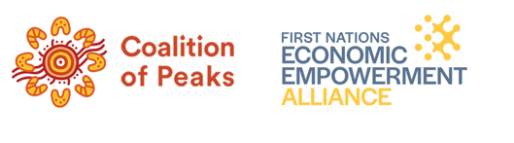
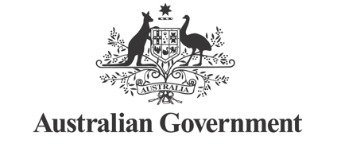
First Nations Economic Partnership

Access to Capital and Institutional Arrangements Working Group – Work Schedule
This Work Schedule sets out specific Working Group activities, milestones and outputs. It focuses on immediate priorities and early opportunities. It complements the Terms of Reference, which have a broad scope to reflect the opportunities relating to access to capital and institutional arrangements. At each phase, a specific key priority area will be considered, with conclusions and recommendations captured in meeting records.
Phase | Timeline | Key Activities | Milestones and Outputs | Responsibility
Working Group arrangements and governance | Feb–Mar 2026 | - Confirm scope and priorities with reference to Terms of Reference  - Confirm Secretariat function for Working Group  - Finalise Work Schedule and engagement plan  - Identify Members and Experts for Working Group  - Partners to approve Working Group Schedule, members and timeframes (out of session)  - Confirm funding arrangements with NIAA | - Early March: Work Schedule and Members/Experts agreed by Partnership  - Funding approved by NIAA  Phase output: A clear plan for the Working Group to start work, engage broadly and deliver tangible recommendations | - Co-Chairs
Phase 1: Start-up, scoping and alignment, as well as SIV advice | Mar–Apr 2026 | - The Working Group Co-Chairs will identify key priority areas, commencing with:  - SIVs  - the role of IBA and ILSC  - opportunities for PBCs  - other relevant issues identified by the Co-Chairs.  - Develop options for SIVs, e.g. investment mandate changes | - Mid-March 2026: SIV Meeting  - Late March 2026: Finalise early SIV Advice Note  Phase outputs:  1) Timeline for progressing key priorities, including engagement schedule  2) Practical options and recommendations on SIVs | - Co-Chairs  - Treasury and Department of Finance
Phase 2: Evidence review, mapping and initial engagement, and advice on other priority areas | May–Jun 2026 | - Assess current state and identify opportunities, including:  - review of existing evidence (Murru waaruu, First Nations Economic Empowerment Working Group, inquiries etc.)  - map types of capital, institutional roles, legislative impediments, stakeholders, and existing policy opportunities and levers  - examine international practices and case notes  - identify models to provide advice and capacity building around finance and access to capital  - Explore and develop options for the next key priority area(s) | - May 2026: Foundational Issues Paper; briefing to Economic Partnership  Phase outputs:  1) Initial Phase 2 assessment findings  2) Next set of options and recommendations on key priority area(s) (based on Phase 1) | - Co-Chairs  - Alliance, with Government input
Phase 3: Options to accelerate access to capital and markets, including a Finance and Investment Council and Institutional reforms | Jun–Aug 2026  6-month Interim Report due | - Drawing on Phase 2 and consultation with key stakeholders (e.g. targeted engagements, sector roundtables etc.), finalise the Interim Report that includes reform options to:  - accelerate the growth and long-term sustainability of First Nations businesses  - improve access to domestic and international markets, affordable capital, tailored investment support  - maximise institutional settings, including exploring the roles of a potential investment and finance council, institutional investors (e.g. banks, super funds etc.) and institutional reforms. | - July 2026: Finalise Interim Report  - Draft content for Economic Framework  Phase outputs:  1) Specific options and recommendations  2) Interim Report | - Co-Chairs  - Alliance to lead drafting of Interim Report, with Government input  Inputs into Interim Report (from Government/ Alliance/ others) to be agreed by the Co-Chairs and contributors.
Phase 4: Co-design of preferred package and Framework integration | Sep – Oct 2026 | - Refine options into preferred reform package (options could include an investment and finance council, capital mechanisms, institutional changes)  - Circulate Options and Package Paper, validation roundtables  - Develop MYEFO proposal for consideration by Government | - Oct 2026: Draft MYEFO proposal completed  Phase outputs:  1) Specific options  2) Draft MYEFO proposal | - Co-Chairs
Phase 5: Post-Framework finalisation and early implementation support | Nov 2026 – Jan 2027  12-month Final Report due | - Finalise report and ensure alignment with First Nations Economic Framework  - Develop recommendations for implementation of agreed policy options  - Co-chairs develop business case for Working Group extension | - Dec 2026: Final Report of advice and recommendations from Working Group  - Dec 2026: seek agreement to extend Working Group  Phase outputs:  1) Final Report  2) Specific recommendations on implementation | - Co-Chairs  - Alliance to lead drafting of Final Report, with Government input  Inputs into Final Report to be agreed by the  Co-Chairs and contributors.
Phase 6: Next steps: Consolidation, monitoring and extended handover | Jan–March 2027 | - Develop agreed implementation plan / roadmap and handover briefings  - Capture feedback and refine guidance based on lessons learned during 2026  - Co-Chairs to consider recommendations on how key learnings and reflections from Working Group could inform Partnership Work going forwards. | - Jan-Feb 2027: Consideration of next steps  - March 2027: Preliminary evaluation and assessment  Phase output: Summary of lessons learned | - Co-Chairs

