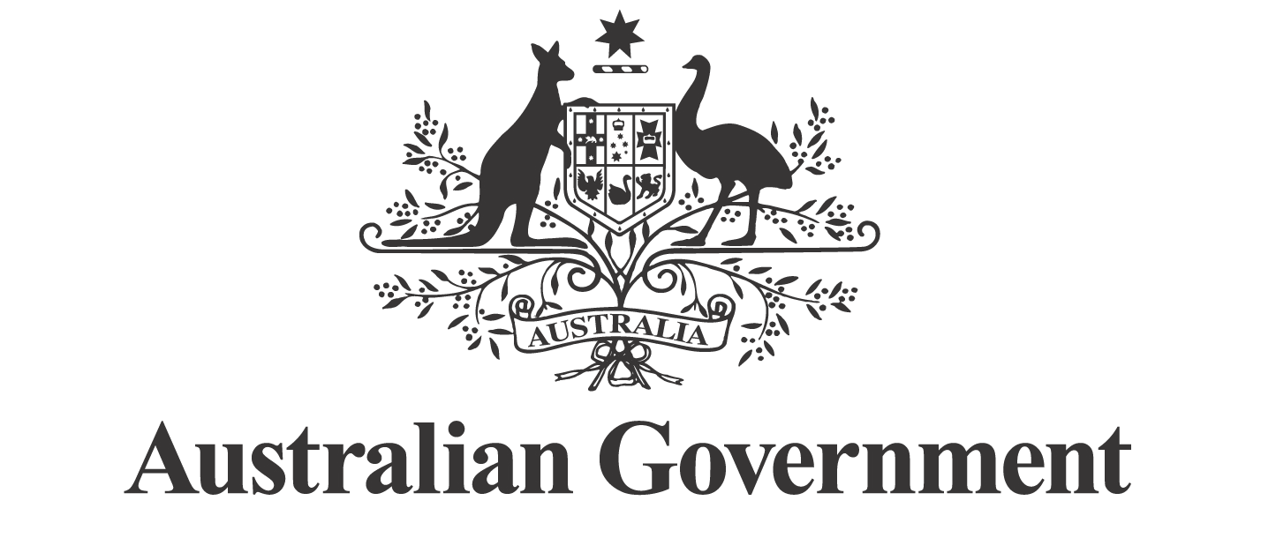

First Nations Economic Partnership

ACCESS TO CAPITAL AND INSTITUTIONAL ARRANGEMENTS WORKING GROUP
TERMS OF REFERENCE

PURPOSE

The purpose of the Working Group is to make policy recommendations to the First Nations Economic Partnership (Economic Partnership) on ways to improve Indigenous access to capital and optimise institutional arrangements to support economic empowerment, self-determination and wealth creation. The Working Group will make tangible and practical recommendations to accelerate the growth and long-term sustainability of First Nations businesses and boost economic opportunities for First Nations communities.

CONTEXT

The Economic Partnership has identified access to capital and optimising institutional arrangements as critical to advancing the ambitions of First Nations people, communities and businesses.

Access to capital: there are barriers to accessing affordable finance and capital due to historical economic exclusion, low intergenerational wealth and other restrictions on financing that affect First Nations people, communities and businesses.

Institutional arrangements: public financing and institutional arrangements remain fragmented and must be optimised to support First Nations ambitions for economic empowerment.

Agreement-making and benefit-sharing: access to capital and institutional reform intersect with evolving economic opportunities related to major projects and the clean energy transition. Legacy agreements are uneven and often lack free, prior and informed consent (FPIC), fair equity and revenue sharing arrangements, and generally do not sufficiently protect First Nations cultural or intellectual property rights and interests.

At the 21 October 2025 meeting of the Economic Partnership, the Partners agreed to establish a Working Group to identify opportunities to accelerate progress in these areas.

SCOPE

The Working Group will focus on the following areas:

Capital access and market engagement: considering public and private providers, financial products and mechanisms.

Public institutional effectiveness: exploring the roles of statutory bodies and public financing mechanisms to optimise capital access, improved financial administration and capability building.

Agreement-making and benefit-sharing: modernising arrangements by considering model clauses and standards including those impacting native title holders, addressing FPIC, equity and revenue sharing arrangements, dispute resolution arrangements, optimised trust arrangements, Indigenous cultural and intellectual property and data protections, and compensation - where relevant.

Intergovernmental coherence: identifying avenues for collaboration between the Commonwealth and states and territories, and relevant instruments.

Immediate Actions

The following immediate actions identified in the First Nations Economic Partnership Agreement (Partnership Agreement) will be considered by the Working Group:

Strengthening the role of Specialist Investment Vehicles (SIVs) in supporting improved First Nations access to capital, including consideration of investment mandates. In developing advice, the Working Group will consider work underway across Government on SIVs.

Exploring the establishment of a First Nations investment and finance council—chaired and majority-led by First Nations experts—to consider opportunities to improve investment mechanisms and access to capital.

See clause 34 (a) for full description.

The Working Group will also consider optimising existing institutional arrangements, including how Indigenous Business Australia and the Indigenous Land and Sea Corporation can best support improved access to capital and better deliver for First Nations communities.

As outlined in the Partnership Agreement (Clause 32), these priorities will be advanced immediately. The priority will be on developing practical, tangible and specific policy recommendations.

The Working Group may provide advice on related policy matters being considered or advanced across Commonwealth agencies.

The Working Group may identify additional issues, including those that may intersect with the development of the First Nations Economic Framework.

MEMBERSHIP

The Working Group will be co-chaired by a nominated representative of the First Nations Economic Empowerment Alliance and a nominated representative of the Commonwealth Government.

The Co-Chairs will jointly agree the membership of the Working Group. The Working Group membership may include:

representatives of Partners

Members

Experts.

The Co-Chairs will follow the mechanism agreed by the Partners when identifying and onboarding Members and Experts. An outline of the mechanism will be annexed to these Terms of Reference.

Each Founding Partner of the Economic Partnership may nominate a representative to participate.

CONFLICTS OF INTEREST

All members of the Working Group are expected to identify and manage any actual, perceived, or potential conflicts of interest in accordance with clauses 66 to 69 of the Partnership Agreement.
OPERATIONS AND DECISION MAKING

The Working Group will operate in accordance with the purpose of the Economic Partnership as outlined in the Partnership Agreement.

The Working Group will be accountable to the Economic Partnership and operate under its strategic direction.

In contributing to the Working Group, members of the Working Group have the same roles and responsibilities as Partners as set out in clauses 27 to 29 of the Partnership Agreement.

Decisions of the Working Group will be made in accordance with clause 44 of the Partnership Agreement. That is, by consensus and consistent with Priority Reform One of the National Agreement on Closing the Gap.

TIMELINE AND DELIVERABLES

The Co-Chairs will deliver advice on immediate priorities to the Economic Partnership, taking into account timelines for Government consideration of policy proposals throughout 2026 (e.g. Budget cycles).

The Co-Chairs will deliver to the Economic Partnership an interim report after 6 months and a final report of advice and recommendations after 12 months. This may be extended by agreement of the Partners.

The interim and final reports will outline research, consultation and engagement undertaken by the Working Group, including an outline of policy recommendations and advice relating to implementation.

RESEARCH, CONSULTATION AND ENGAGEMENT

The Co-Chairs will be responsible for facilitating research, consultation, and engagement connected to the Working Group – ensuring alignment with the Partnership Agreement.

The Working Group will draw on relevant data, evidence, inquiries, research, sector reports, and international insights and models to inform its work.

SUB-COMMITTEES

In targeted circumstances, the Co-Chairs may establish sub-committees to consider specific matters related to the Working Group. Sub-committees may include Experts and Members.

TERM

These Terms commence from 1 January 2026. The Working Group will be in operation for a period of 12 months from this date, and may be extended by agreement of the Partners.

REPORTING

The Co-Chairs will be jointly responsible for updating the Economic Partnership about Working Group progress at Partnership meetings or out-of-session as required.

RESOURCING

The Working Group will be funded in accordance with clauses 74 to 78 of the Partnership Agreement.

SCHEDULE OF WORK

A schedule for planned work under the Working Group will be developed by the Co-Chairs and annexed to these Terms of Reference.

AMENDMENT

These Terms of Reference may be amended by agreement in writing of all Partners.

