


National Planning Reform Blueprint
Northern Territory Progress Report

September 2025

© Northern Territory Government 2025
This publication is available for your use under a Deed - Attribution 4.0 International - Creative Commons licence, with the exception of the Northern Territory Government, photographs, images, signatures and where otherwise stated. The full licence terms are available from https://creativecommons.org/licenses/by/4.0/legalcode.en.
Use of Northern Territory Government material under a Deed - Attribution 4.0 International - Creative Commons licence requires you to attribute the work (but not in any way that suggests that Northern Territory Government endorses you or your use of the work).
Northern Territory Government material used ‘as supplied’.
Provided you have not modified or transformed Northern Territory material in any way including, for example, by changing the Northern Territory text; calculating percentage changes; graphing or charting data; or deriving new statistics from published Northern Territory statistics — then Northern Territory prefers the following attribution:
Source: Northern Territory Government Department of Lands, Planning and Environment
Derivative material
If you have modified or transformed Northern Territory material, or derived new material from those of the Northern Territory Government in any way, then Northern Territory Government prefers the following attribution:
Based on Northern Territory Government Department of Lands, Planning and Environment
Other uses
Enquiries regarding this licence and any other use of this document are welcome at:
Department of Lands, Planning and Environment
GPO Box 1680
DARWIN NT 0801

Contents
Measure 2 6
How the Northern Territory’s strategic plan(s) will deliver on housing supply targets 6
Measure 3 8
Summary of planning reforms 8
Summary of zoning reforms 9
Summary of land release reforms 10
Summary of density and other reforms 11
Measure 4 12
Key findings from a development ready land stocktake 12
Measure 5 14
Zoning, planning and other amendments to support dense, well-located housing 14
Reforms to non-planning barriers preventing a diversity of housing 16
Measure 6 17
Identifying barriers in development approvals 17
Key barriers to the timely issuing of development approvals 17
Barriers to delivering housing where development approvals have been granted 17
Reforms to development approvals 18
Reforms to social and affordable housing approval pathways 18
Reforms addressing barriers to the timely issuing of development approvals 19
Planning reforms to address existing development approvals which have not been acted upon 20
The Northern Territory’s position on planning and inclusionary zoning reforms to support permanent affordable, social and other specialist housing in developments 20
Other reforms to development approval pathways 20
Initiatives to share planning data and improve visibility of factors affecting housing delivery 21
Measure 10 22
Well located government land suitable for housing 22
Best practice examples of developing government land 1
Case Study – Katherine East Urban Village Precinct 1

Measure 2
Planning Ministers will report to National Cabinet on state, regional and local strategic plans that reflect their jurisdiction’s share of housing supply targets agreed by National Cabinet and links with infrastructure pipelines.

How the Northern Territory’s strategic plan(s) will deliver on housing supply targets
The NT has always had a plan for land release in place to ensure there is land supply available for entry and affordable housing products. Land use planning in the NT is done at a regional scale and is administered through a centralised (state level) planning system. Regional Land Use Plans establish an overarching regional framework to manage growth in the 4 major centres – Darwin, Katherine, Tennant Creek and Alice Springs. Each plan includes a Land Use Structure that identifies development opportunities throughout the relevant region, including locations to accommodate urban, peri-urban and rural lifestyle developments and their associated potential dwelling yields. These plans were developed by the NT Planning Commission through a 3-stage consultation process with the public and relevant government and industry stakeholders (including local government and regional bodies).
Area Plans, which give effect to regional targets, contain detail of the expected growth and potential capacity of new dwellings in each area. The number of additional dwelling/population numbers specified in Area Plans are based on detailed infrastructure. Regional and local plans in the NT have sufficient existing capacity to accommodate the agreed housing targets.
The NT undertakes land supply modelling to forecast a steady pipeline of residential land supply across the Territory’s major urban centres (Greater Darwin, Katherine, Alice Springs and
Tennant Creek) over the next 20 years. The forecasts are based on potential dwelling yields identified in strategic land use plans, using baseline population from the NT Department of Treasury and Finance, along with a high-growth scenario derived from the ABS five-year average over the past
20 years.
The supply pipeline provides a plan for sequencing of land development and guiding the
NT Government’s decisions regarding timing of investment into district-level enabling infrastructure required to support ongoing land supply.
District-level infrastructure includes key structuring roads within districts, and power, water and sewer headworks which are identified and costed in a Land Development Program (the infrastructure program for enabling infrastructure to facilitate land release/development), partially recovered through the uplift in the value and sale of Crown land.
The district-level enabling infrastructure delivered by the NT Government enables land development (i.e. subdivision) and housing supply that can be undertaken by the private sector. In a number of regional and remote towns, the NT Government also undertakes the land development role.
In terms of its contribution towards national housing supply targets to meet the National Housing Accord, the NT has committed to provide 11,430 homes, including 1,492 social and affordable homes, over the five-year period from 2024.

Measure 3
Planning Ministers will undertake planning, zoning, land release and other reforms, such as increasing density, to meet their jurisdiction’s share of housing supply targets agreed by National Cabinet.

Summary of planning reforms
Reduced density and parking to encourage housing supply, choice and affordably
In progress / First reported in September 2025
In August 2025, a proposed amendment to the NT Planning Scheme was exhibited to facilitate and encourage single bedroom dwellings in the NT, while also making the construction of some types of housing more affordable through reduced car parking requirements. It includes:
- amending dwelling density provisions in Zone LMR (Low-Medium Density Residential) to allow a density of 1 per 150m² to better support one-bedroom homes, reflecting smaller household sizes;
- amending car parking provisions for one bedroom group dwellings and multiple dwellings to require one-bedroom dwellings to provide one car parking space instead of two; and
- introducing car parking reductions for group dwelling and multiple dwelling development where it is considered ‘well-located’ and where the development or dwelling is for social housing.
The Department is currently reviewing feedback received from exhibition before seeking to finalise the amendment.

Increased maximum floor area for second dwellings
Enacted 1 December 2023| First reported in March 2024/ Reporting Complete
On 1 December 2023, an amendment to the NT Planning Scheme took effect that increased the maximum floor area of independent living units (second dwellings) allowed on single dwelling lots (without any planning approval being necessary) from 50m² to 75m².
This change provides for the increased utilisation of infill land for social and affordable housing purposes.

New design responses for mixed use developments
Enacted 17 February 2023 | First reported in March 2024 / Reporting Complete
On 17 February 2023, an amendment to the NT Planning Scheme took effect, which amongst other changes, included incorporating design responses for mixed use development contained in strategic land use plans as development requirements within the scheme. For example, replacing set density requirements for apartments and mixed-use buildings with a significantly more flexible plot ratio.
Introduction of a residential plot ratio for medium-high density development will provide greater flexibility in design and assist with achieving greater density.

Extended exemption from approvals for remote subdivisions
Enacted 3 March 2023 | First reported in March 2024 / Reporting Complete
On 3 March 2023, a time limited exemption under the Planning Act 1999 was extended to June 2028, conditionally removing the need for subdivision approval for land development in remote communities as part of the remote housing program, as long as these are supported by the community and Traditional Owners (through land tenure agreements).
This exemption provides for the fast-tracked release of land for social and affordable housing purposes.

Katherine Densification Policy – denser townhouses
Enacted 7 October 2022 | First reported in March 2024 / Reporting Complete
On 7 October 2022, an amendment to the NT Planning Scheme took effect, known as the Katherine Densification Policy. This facilitates townhouse development at a density of 1 dwelling per 400m² (rather than 1 dwelling per 800m² as is normally the case) for standard Low Density Residential
(Zone LR) lots in Katherine East.
This change provides for the increased utilisation of infill land for social and affordable housing purposes.

Summary of zoning reforms

Area Plans - Areas for Change
Update: In progress / First reported September 2024
Area Plans, contained within the NT Planning Scheme, implemented in the NT’s Compact Urban Growth Policy, identify compact urban growth localities around activity centres, public transport corridors and other localities that satisfy the objective of this Policy. These localities are identified as an ‘area for change’ in an Area Plan.
Planning scheme amendments can be requested by a landowner to rezone a parcel of land in an ‘area for change’. These are progressed by the NT Government in a timely manner to facilitate increased densities, where infrastructure and amenities are available.
Investigations continue in relation to additional reforms to improve housing related outcomes.

Summary of land release reforms

Bringing land to market report
Update: In progress | First reported in March 2024 / Updated September 2025
The NT has recently reformed the planning system to give effect to the ‘Bringing Land to Market Report’ which included 23 recommendations to achieve a titled land supply that satisfies the market demand (including for affordable housing) in a timely and efficient manner.
The Bringing Land to Market Report was commissioned by the NT Government in 2021 to identify improvements to bring titled land to the market to keep pace with Territorian’s needs. Further information and a copy of the report can be found here: https://environment.nt.gov.au/careers-programs-publications/land-development-process-report-and-recommendations.
Of the 23 recommendations, 15 have been implemented with the remaining recommendations recategorised into three Land Development Initiatives, which include:
- Land Development Initiative 1: Integrated Strategic Planning policy and guidelines that outline how the NT plans and delivers sufficient land supply to support population growth and economic development.

In July 2025, the NT has substantially implemented its Integrated Strategic Planning Framework and policy. These measures will be ongoing to ensure that the planning of land supply across the NT are aligned with and responsive to population growth and economic development.

- Land Development Initiative 2: Process improvement initiatives that require policy change, including policy subdivision development standards that cover the design, construction and handover of public infrastructure.

- Land Development Initiative 3: Economic Demand Forecasting that assesses demand for residential, commercial and industrial land associated with high economic growth scenarios within key industries to inform land supply planning.

Summary of density and other reforms
Investigations are continuing in relation to further initiatives and reform mechanisms to increase densities.

Measure 4
Planning Ministers will identify well-located ‘development ready’ land having appropriate regard to the protection of land with key attributes e.g. environmental or economic.

Key findings from a development ready land stocktake
Urban land supply
Update: In progress| First reported in March 2024 / Updated September 2025
The NT’s land supply pipeline identifies development-ready land as ‘Land Under Development’. This refers to land held by developers where reticulated infrastructure services are to be provided through the subdivision development process to deliver titled lots to market in Greater Darwin,
Alice Springs, Katherine and Tennant Creek.
The below table identifies:
- estimated number of lots and dwellings within Land Under Development for new development areas;
- infill opportunities identified in Area Plans that have current development approvals in place; and vacant undeveloped lots within existing developed urban centres with infrastructure capacity; and
- an estimated supply timeframe based on each urban centre’s 10-year average dwelling take-up rate.
Table 1 – Estimated dwellings in infill and Land Under Development
Region | Estimated Dwellings, including Attached |  | Estimated Years of Supply
Region | Land Under Development | Infill opportunities and vacant land | Estimated Years of Supply
Greater Darwin | 4,515 | 1,719 | 10 years
Katherine | 65 | 132 | 9 years
Tennant Creek | 34 | 117 | 25 years
Alice Springs | 239 | 99 | 8 years
Total | 4,853 | 2,067
Social and affordable housing
Update: In progress| First reported in March 2024 / Updated September 2025
Across the NT’s 4 major centres (Greater Darwin, Alice Springs, Katherine and Tennant Creek) the
NT Government has identified land holdings that will be utilised to deliver up to 100 new social housing dwellings under the Social Housing Accelerator Program.
The NT Government is currently planning for delivery of 102 social dwellings to be delivered under Housing Australia Future Fund (HAFF) Round 2 drawing on CEO (Housing) owned land.
Further opportunities to develop CEO (Housing) owned land, including refreshing aging stock through the Commonwealth’s national housing and homelessness reform agenda to increase supply is currently being investigated.
Allocation for land for social, community and affordable housing from Crown land greenfield developments are committed through confidential development agreements with the Territory.
When undertaking redevelopment of existing social and affordable housing sites, the NT Government aims to deliver a minimum one-for-one return of dwellings wherever possible, based on the principle of no-net-reduction in social and affordable housing stock. Where possible, brownfield developments also aim to increase and/or optimise dwelling yield within the parameters allowed under the
NT Planning Scheme.

Remote housing
Update: In progress | First reported in March 2024 / Updated September 2025
Work is currently underway to determine future land release requirements to support up to an additional 2,700 new remote public housing dwellings across 73 plus remote communities and selected town camps to be built over the next 10 years.
Since 1 July 2024 to 30 September 2025, 293 subdivision and infill lots have been completed. A further 199 subdivisions are in construction, 210 new subdivision lots are in detailed design, and
331 subdivision lots are in concept design.
Since 1 July 2024 to 30 September 2025, 264 new or replacement homes have been constructed. A further 198 homes have been awarded and are at various stages of the construction process.

Measure 5
Planning Ministers will streamline approval pathways and prioritise planning control amendments to support diverse housing across a range of areas, including promoting medium and high-density housing in well-located areas close to existing public transport infrastructure connections, amenities and employment.

Zoning, planning and other amendments to support dense, well-located housing
Strategic Directions Planning Policy
Update: In progress / First reported in September 2024 / Updated September 2025 / Complete
The NT Planning Commission identified the need for an overarching Strategic Planning Policy (SPP) to provide direction on how the objectives of the Planning Act 1999 are to be achieved; to ensure the planning framework responds to Territorians’ needs and aspirations; and to promote a prosperous, sustainable, liveable and resilient future.
The SPP was completed in September 2025 and includes Land Supply and Housing Diversity as a key theme.
Policy statements within the SPP aim to ensure sustainable, inclusive housing growth by identifying suitable land and promoting diverse, well-located housing options that meet community needs. They emphasise collaboration across all levels of government, support for regional and rural development, and the provision of social, affordable, and specialised housing. The approach encourages higher-density and mixed-use developments near transport and services, promotes climate-resilient, hazard-safe housing that supports long-term community wellbeing and recognises the need to be responsive to the needs and mobility of Aboriginal people across the NT.

Holtze development – new strategic land use plan
Update: In progress | First reported in March 2024 / Updated September 2025

A new strategic land use plan for the Holtze residential development area was approved in July 2024 for inclusion in the NT Planning Scheme. This is a planning policy that was completed by the NT Planning Commission in late 2023, and has been through a three stage public consultation process.

This land use plan has been developed based on the Compact Urban Growth Policy, which is included within the NT Planning Scheme and promotes high and medium density housing in a well located area, close to existing public transport, infrastructure connections, amenities and employment.
Greater Holtze will be the location of a large proportion of the new housing stock to be provided in the NT over the next 15 years. On 8 May 2024, the first land release for Greater Holtze was announced with the NT entering into a Development Agreement with a local company to deliver an entry level, urban residential subdivision of around 540 lots, in 18 stages over seven years. Lots within stages 1 and 2 of the development are now available for sale off-the-plan, with lot pricing starting from $189,000. Civil construction works commenced in May 2025 and first land titles are expected in late 2025.
The Holtze Land Release includes provisions for Social Housing to be developed and returned to the Territory at nil cost.
Social housing requirements for greenfield land
Update: Ongoing | First reported in March 2024 / Updated March 2025
The NT Government incorporates provisions akin to inclusionary zoning for affordable and social housing within many greenfield land releases in urban areas of the NT, through development agreements between the NT Government and private developers.
The NT Government is able to influence the proportion of new development that must be allocated for social and affordable housing.
In March 2025, the Australian Government announced funding of $25 million to boost housing in the NT through the Australian Government’s Housing Support Program Priority Works Stream. This funding includes $11 million to upgrade existing infrastructure networks (power, water and sewer) in Palmerston, which will support further development at Farrar West.
Government is negotiating with the Larrakia Development Corporation for delivery of a residential subdivision at Farrar West as part of the settlement of the Kenbi Land Claim, and to further support the release of residential land for future population growth. This development could provide up to 300 residential homes well located close to the Palmerston CBD, with provision for 5% of lots to be returned to the NT for Social Housing and 10% of lots to be allocated for Affordable Housing.

Reforms to non-planning barriers preventing a diversity of housing
The lack of scale (i.e. population) in the NT strongly impacts the commercial viability of higher construction cost, large scale single buildings or integrated developments generally.

Measure 6
Planning Ministers will create accelerated development pathways and streamline approval processes for eligible development types, particularly in well-located areas, including to support the rapid delivery of social and affordable housing.

Identifying barriers in development approvals

Key barriers to the timely issuing of development approvals
The simplicity of the NT planning system, including that the NT Planning Scheme applies across the Territory and in all local government areas, significantly reduces many potential barriers to the timely issuing of development approvals.
Key barriers that have a significant impact on the delivery of new social and affordable housing supply include negative (not-in-my-back-yard) community sentiment, seasonal weather patterns (delivery delays), constrained construction industry capacity and skilled labour shortages, and high construction costs relative to land and property values.

Barriers to delivering housing where development approvals have been granted

Key barriers that have a significant impact on the delivery of new housing include seasonal weather patterns (delivery delays), constrained construction industry capacity and skilled labour shortages, and high construction costs relative to land and property values.
Initiatives to Streamline Planning Processes Post Approval
Enacted 29 April 2025| First reported in September 2025
After planning approval has been granted there are sometimes changes made to an application or other planning processes that must be followed to enable development to occur. The following improvements have been made to shorten timeframes associated with such post application matters.
- Historically, when a planning application is completed, subsequent changes are limited to a
5% threshold. If proposed changes exceed this 5% threshold, even if they improve compliance with the planning scheme, a new planning application must be submitted, which often involves further public exhibition.

Recent modifications to the Planning Act 1999 now allow changes as long as they do not increase non-compliance with any measurable aspect of the development by more than 5% or impact on amenity. This change is expected to reduce delays associated with last-minute modifications and help streamline the development process.

- The Minister has declared certain classes of planning scheme amendments that do not require public exhibition under the Planning Act 1999. This is another tool that will reduce timeframes associated with proposals to amend the NT Planning Scheme by removing duplicative exhibition requirements. These include:
  - amendments which will facilitate the ‘normalisation’ of land – i.e. through the rezoning of land that is zoned FD (Future Development) or Specific Use Zone if it is consistent with an approved development application for subdivision; and
  - amendments to add a building setback plan to schedule 9 of the Planning Scheme, if the plan was previously exhibited under the Planning Act 1999 as part of an approved development application for subdivision.
Place Naming
First reported in September 2025

The current process of naming streets and parks in subdivisions is time consuming and requires months to undertake. If not commenced early in the subdivision process this can cause extensive delays as street names are required in order to connect services, and prior to settlement.

A pre-approved list of place names has been created by the NT Government for the Holtze land release to streamline residential development. This included research, stakeholder engagement, consideration by the Place Naming Committee and approval by the Minister.

Reforms to development approvals

Reforms to social and affordable housing approval pathways
The Department of Housing, Local Government and Community Development (DHLGCD) is continuing to work with Community Housing Providers to unlock pathways to the delivery of social and affordable housing. The former Chief Minister signed the Housing Accord 2022 with a target of 1,492 new social and affordable housing dwellings.
The first two HAFF rounds have resulted in a funding commitment for 168 new social and affordable homes. HAFF Round 3 is expected to be released late 2025, and DHLGCD have been working with community housing providers to identify potential projects for funding. The high cost of construction and low land values in the Northern Territory impacts the viability of projects, particularly in Katherine, Tennant Creek and Alice Springs.

Reforms addressing barriers to the timely issuing of development approvals
Initiatives to Fast Track and Streamline Processes
Enacted 29 April 2025| First reported in September 2025
A review of all processes involved in progressing development applications and planning scheme amendments has been undertaken. The following improvements have been made to shorten timeframes associated with such applications.
- A review of the Minister’s functions under the Planning Act 1999 was conducted to identify opportunities for delegation aimed at streamlining processes. As a result, delegations were established to allow the Department’s Executive staff to make initial decisions regarding planning scheme amendments.
This initiative reduces the number of people required to receive and review applications before they proceed to exhibition, saving time and improving efficiency.
- A legislative change was made to the Planning Act 1999 to half the submission period for service authorities and local governments to make a submission on an application that does not require public exhibition. This will speed up the approval process by shortening review times, enabling faster decisions while still allowing authorities to provide input.

- The Minister has declared certain classes of planning scheme amendments that do not require public exhibition under the Planning Act 1999. This is another tool that will reduce timeframes associated with proposals to amend the NT Planning Scheme by removing duplicative exhibition requirements and providing an accelerated assessment pathway for eligible low-risk amendments. These include:
- amendments to rezone land from Low Density Residential to Low-Medium Density Residential when the land is identified as an Area for Change in an Area Plan; and
- amendments to rezone land in a Major Remote Town, subject to conditions such as consultation with landowners and consistency with a strategic plan that has already undergone community consultation.

Planning approval process improvements - reduced red tape
Enacted 31 July 2020 | First reported in March 2024
On 31 July 2020, an amendment to the NT Planning Scheme took effect (associated with Government’s Planning Reform Initiative) which amongst other things, reduced regulatory burden and red tape associated with the planning approval process specifically for housing by:
- introducing streamlined tracks of assessment for all ‘housing’ development applications
(as well as a number of other types of developments). These applications now have the option of being assessed against only the basic ‘tick box’ planning requirements (such as height, setback, car parking etc.) and not whether or not they are appropriate in the location;
- removing the need for a planning application for fully compliant duplex developments; and
- creating a much more flexible outcomes based system which emphasises the importance of strategic ‘placed based’ planning. This includes identifying higher density infill development opportunities to streamline rezoning approvals.
The amendments provide expedited pathways for the delivery of housing, as well as for the achievement of increased housing densities in appropriate locations (above those normally allowed for within the existing zone).

Planning reforms to address existing development approvals which have not been acted upon
The NT currently tracks all approved development applications for multi-storey unit complexes and reports on a monthly basis on Land Under Development including tracking of all lots with approved subdivision/development permits (for detached dwellings and townhouses) throughout the NT. Compliant single detached houses, granny flats, and duplexes do not require planning consent in the NT.

The Northern Territory’s position on planning and inclusionary zoning reforms to support permanent affordable, social and other specialist housing in developments
The NT supports planning measures to help deliver more affordable, social and other specialist housing in developments. Whilst the benefits of inclusionary zoning are recognised such as increased social inclusion and reduce the concentrations of disadvantage, care must be taken to ensure that it does not run counter to the broader goal of increasing the supply of new dwellings worsening overall affordability. Research needs to be undertaken to ensure such a reform does not add time, cost, complexity and uncertainty to the development approval process.
This is a policy area that would benefit from national leadership in establishing and facilitating regulatory coherence.

Other reforms to development approval pathways
Relevant measures are already identified in Measure 3, noting that the NT Planning Scheme 2020 applies Territory-wide, and the NT Government has sole responsibility for the administration of planning in the NT. Therefore, there is no disconnect between local government and Territory level strategic and statutory planning policy.

Initiatives to share planning data and improve visibility of factors affecting housing delivery
The NT is supportive of sharing any relevant data.

Interactive Online Tool
First reported in September 2025
As part of the NT’s land supply planning, work is underway to deliver an interactive online tool that will provide clear, up-to-date information on the land supply pipeline and the availability of land ready for development across the Territory’s four major centres (Greater Darwin, Katherine, Tennant Creek and Alice Springs). The initiative aims to improve transparency, support investment decisions, and enhance visibility of land development opportunities for stakeholders and the broader community. Consultants have been appointed to deliver the tool by the end of the 2025/26 financial year.
The NT Government also shares information on the Remote Housing Program on the Our Future website managed by DHLGCD:
https://ourfuture.nt.gov.au/accountability-and-reporting/program-progress

Measure 10
All levels of government will ensure the efficient use of government land, including the identification of surplus land suitable for housing and the delivery of best practice projects to support housing supply, diversity and affordability.

Well located government land suitable for housing
Update: First reported in March 2024 / Updated March 2025
The NT is unique in that the majority of its new greenfield developments are on vacant Crown land, particularly in the regional urban centres.
Table 3 outlines the anticipated dwellings expected from Crown land greenfield developments, categorised within the 4 stages of development and in accordance with land supply modelling parameters as follows:
- Land Under Development (LUD): land that is in the hands of the developers, with reticulated infrastructure service connections to be provided through the subdivision development process to produce titled land to market. This land is identified in measure 4 whereas the Land Under Development below is solely Government owned land.
- Land with Enabling Infrastructure (LEI): is land that has design and construction of enabling infrastructure underway.
- Land Under Investigations (LUI): Land that requires consideration of environmental, geotechnical works and land tenure.
- Land Under Planning (LUP): is land that is undergoing or has underdone strategic integrated land use and infrastructure planning including subregional land use planning and area planning.
Projected years of supply is also included based on population projections from the NT Department of Treasury and Finance (and ABS data).
Table 3 identifies ample supply of government-owned land to support the next 20 years of growth and beyond.
Table 3: Supply of Government owned land in the Northern Territory
 | Land Under Development | Land with Enabling Infrastructure or Under Investigations / Land use Planning | Total estimated lot and dwelling supply across region | Years of supply*
Greater Darwin
Detached (lots) | 2,453 | 4,700 | 7,153
Attached (dwellings) | 383 | 440 | 823
Total Dwellings | 2,836 | 5,140 | 7,976 | 13 years
Katherine
Detached (lots) | 53 | 583 | 636
Attached (dwellings) | 19 | 165 | 184
Total Dwellings | 72 | 748 | 820 | 36 years
Tennant Creek
Detached (lots) | 6 | 250 | 256
Attached (dwellings) | 28 | 25 | 53
Total Dwellings | 34 | 275 | 309 | 52 years
Alice Springs
Detached (lots) | 65 | 637 | 702
Attached (dwellings) | 30 | 63 | 93
Total Dwellings | 95 | 700 | 795 | 20 years
* Based on average take up with population projections
Note: the numbers are estimates and are subject to change.
The NT Government has also identified land suitable for immediate development to support the delivery of up to 100 new dwellings under the Social Housing Accelerator (SHAP). New supply to be constructed as part of the SHAP, including expected distribution across different locations is outlined in the NT SHA Implementation Plan: https://treasury.gov.au/sites/default/files/2023-11/shap-nt.pdf
Another initiative is the NT Government’s Community Land Grant Scheme, which makes suitable Crown land available to eligible entities at a nil or reduced rent for the development of Community Infrastructure. This program has allowed developments by not for profit organisations on Zone CP (Community Purpose) land for housing types that provide 24/7 care. An example of land rented at nil cost under the Scheme includes for the development of 10 accommodation units by a community provider to support mental health rehabilitation.
Below is a best practice example of the development of Crown land in Katherine to achieve broader whole of government priorities. The concept plan identifies the delivery approach and vision for the
precinct which includes affordable and social housing, commercial land and community land for supporting services. Enabling district-level infrastructure such as key structuring streets and power, water and sewer headworks is delivered by the NT Government to facilitate future land releases through transparent market processes and to enable private sector land development.

Best practice examples of developing government land

Case Study – Katherine East Urban Village Precinct
This development is a best practice example of the development of Crown land in Katherine to achieve broader whole of government priorities. The concept plan identifies the delivery approach and vision for the precinct which includes affordable and social housing, commercial land and community land for supporting services. Enabling district-level infrastructure such as key structuring streets and power, water and sewer headworks is delivered by the NT Government to facilitate future land releases and to enable private sector land development.
The Vision - Local shopping and urban opportunities
A new neighbourhood centre is planned to support the existing and emerging Katherine East community as part of a Katherine East Urban Village Precinct.
The Precinct
Will incorporate a range of uses that are framed and focussed around a central park and linear open space link. The intent is to foster a range of urban living opportunities, including mixed use apartment living.
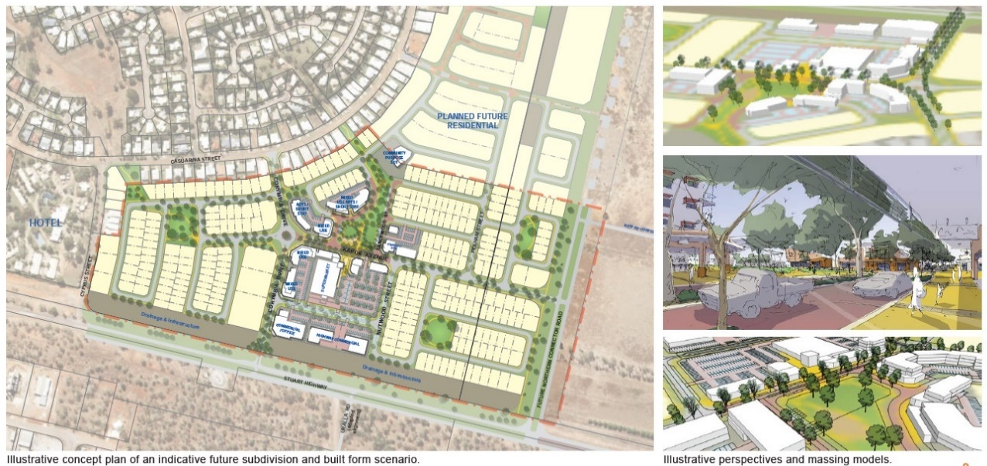
Delivery approach and construction progress – enabling infrastructure, key roads and superlots
Key structuring streets and enabling headworks infrastructure are being constructed. These works have been partially funded via a commonwealth agreement.
A range of lots and englobo lots will be made available to the market for development in sequence with the residential development front coming down from the north.
Key structuring streets and enabling headworks infrastructure are being masterplanned to enable a range of lots and englobo lots to be made available for future development and in sequence with the residential development front coming down from the north.
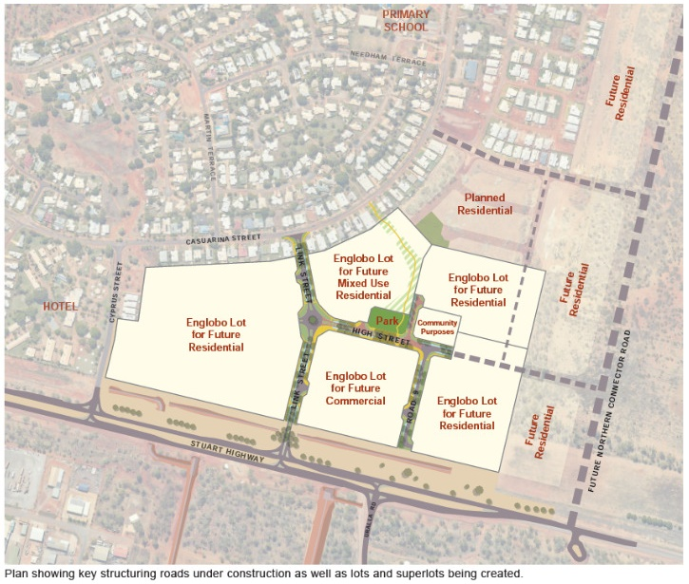
There is potential for the broader Katherine East area to deliver a further 600 dwellings, which accounts for approximately 40 years supply at current baseline take-up rates. It is anticipated that the provision of key strategic urban amenity elements will help foster the delivery of these dwellings in a greater variety of forms.
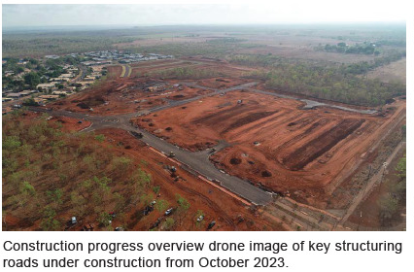

For the purpose of this report it is assumed that development ready land means land with enabling infrastructure, that is ready to sell and/or construct.
Where appropriate and where such zoning and planning does not add to construction costs e.g., through the use of incentives such as density bonuses

