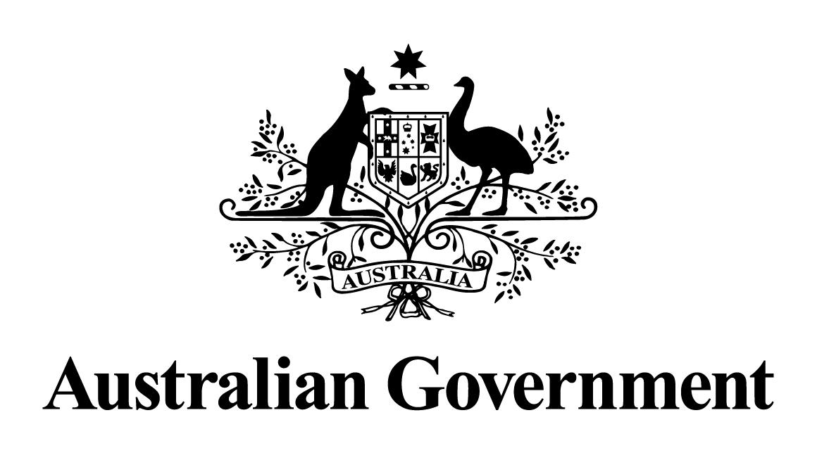
Australian Government response to the
Senate Economics Legislation Committee report:
Inquiry into the Treasury Laws Amendment (Support for Small Business and Charities and Other Measures) Bill 2023
April 2026

Introduction
On 19 October 2023, the Treasury Laws Amendment (Support for Small Business and Charities and Other Measures) Bill 2023 (the Bill) was referred to the Senate Economics Legislation Committee, with a report published on 24 November 2023.
The Bill has 8 schedules that implement a broad range of measures, including support for small business and charities, and changes to superannuation and insurance. The Committee’s report focuses on three schedules:
- Schedule 1 – the $20,000 instant asset write-off which under this Bill allowed small businesses to immediately deduct the cost of eligible assets costing less than $20,000, from 1 July 2023 until 30 June 2024;
- Schedule 2 – the Small Business Energy Incentive which provided small and medium businesses with access to a bonus 20 per cent tax deduction for eligible assets and upgrades supporting electrification and more efficient energy use, from 1 July 2023 until 30 June 2024; and
- Schedule 7 – the amendments to the rules for non-arm’s length expenses for superannuation entities.
The Government thanks the Senate Economics Legislation Committee for its inquiry into this Bill, and thanks those organisations and individuals who made submissions to the inquiry and participated in the public hearing.
The Government’s response to the recommendations made in the additional comments in the Committee’s final report are provided below. In line with the guidelines on Government responses, recommendations that the Bill be passed have not been responded to.
The Bill was passed by the Parliament on 25 June 2024 and received Royal Assent on 28 June 2024.

Response to the recommendations

Coalition Senators’ additional comments
Recommendation 1
Increase the Instant Asset Write-off threshold to $30,000 and expand the eligibility to businesses with aggregated turnover of up to $50 million, which would restore the business investment incentive policy to 2019-20 levels.
Australian Government response
the Government does not support this recommendation.
The Government has improved cash flow and reduced compliance costs for small businesses by legislating the $20,000 instant asset write-off for small businesses from 1 July 2023 to 30 June 2026. Without this change, the instant asset write-off would have reverted to $1,000. Legislation to extend the instant asset write-off for 12 months until 30 June 2026 was passed as part of the Treasury Laws Amendment (Strengthening Financial Systems and Other Measures) Act 2025 which received Royal Assent on 4 December 2025.
Small businesses with aggregated annual turnover of less than $10 million that are in the simplified depreciation regime can claim an immediate deduction for eligible assets costing less than $20,000. The $20,000 threshold applies on a per asset basis, so small businesses can instantly write off multiple assets. Assets costing $20,000 or more can continue to be placed into the small business simplified depreciation pool and depreciated at set rates.

Recommendation 2
The Government review the measure (Schedule 7 – Non-arm’s length expenses of superannuation funds) with consideration given to the alternative solution to the integrity concerns proposed by Chartered Accountants Australia and New Zealand, CPA Australia, Institute of Public Accountants, SMSF Association and The Tax Institute, through amendments to section 109 of the Superannuation Industry (Supervision) Act 1993 that prohibit trustees from conducting transactions not on arm’s length terms.
Australian Government response
the Government does not support this recommendation.
The Government carefully considered the peak industry bodies submission which argued the tax integrity risks presented by arrangements involving non-arm’s length expenses (NALE) could be addressed by relying on existing contribution rules, as well as introducing administrative penalties for trustees of self-managed superannuation funds (SMSFs) and small APRA-regulated funds that breach the NALE rules.
This proposal presented several concerns as it would have involved the repeal of anti-avoidance provisions that have been in place since 2019. Specifically, that the tax integrity concerns with NALE cannot be addressed through contribution rules as these rules cover transactions where there is a clear intention for a contribution to be made.
Further, contributions treatment for NALE arrangements would, at most, involve a one-off excess contribution tax penalty, which may insufficiently address tax advantages involved that may extend to income in future years. In addition, replacing the NALE rules with one-off administrative penalties for trustees would also not be a substantial deterrent from engaging in non-arm's length arrangements.
The Government’s approach in the Bill instead ensures the NALE rules are retained as a targeted and proportionate anti-avoidance measure.

Australian Greens additional comments
Recommendation 1
The Small Business Energy Incentive be extended to operate for three financial years, to expire on 30 June 2026.
Australian Government response
the Government does not support this recommendation.
The Government supported small businesses to electrify and improve their energy efficiency by legislating the Small Business Energy Incentive for small and medium businesses from 1 July 2023 to 30 June 2024.
Businesses with aggregated annual turnover of less than $50 million could claim a 20 per cent bonus tax deduction on eligible assets that support electrification and more efficient energy use. Up to $100,000 of total expenditure was eligible, with the maximum bonus tax deduction being $20,000.
The Small Business Energy Incentive was announced as a time-limited measure, designed to encourage businesses to take advantage of it while it applied. In September 2025, the Government announced Australia’s 2035 target range, Net Zero Plan and six sectoral decarbonisation plans. It also announced the first National Climate Risk Assessment and National Adaptation Plan. These announcements build on significant commitments over recent budgets, which will create new opportunities across the economy, including for small businesses.

Recommendations 2 and 3
Recommendation 2: The exclusion of solar panels from the scheme should be amended to allow for the inclusion of solar PV where it is combined with a package of other energy upgrades and installation.
Recommendation 3: To avoid doubt, the bill should be amended to make clear that any disconnection fees to remove a premises from the gas network should be eligible under the scheme.
Australian Government response
the Government does not support these recommendations.
The Small Business Energy Incentive took a principles-based approach to the categories of assets that were eligible. This means a broad range of depreciating assets as well as upgrades to existing assets were eligible. Examples of eligible assets included assets that support electrification such as heat pumps, assets that upgrade to more efficient electrical goods such as energy efficient fridges and electric heating or cooling systems, and enabling assets such as batteries.
Certain exclusions applied such as assets that can use fossil fuels, renewable electricity generation assets (such as solar photovoltaic panels) and capital works. These exclusions targeted the policy and reflected in part the range of existing support available for renewable energy generation.
The Government’s Net Zero Plan and related initiatives will support the transition to Australia’s renewable energy future and a net zero economy.
Recommendation 4
The Instant Asset Write Off should be extended to operate for three financial years, to expire on 30 June 2026.
Australian Government response
the Government notes this recommendation.
The Government has improved cash flow and reduced compliance costs for small businesses by legislating the $20,000 instant asset write-off for small businesses from 1 July 2023 to 30 June 2026. Legislation to extend the instant asset write-off for 12 months until 30 June 2026 was passed as part of the Treasury Laws Amendment (Strengthening Financial Systems and Other Measures) Act 2025 which received Royal Assent on 4 December 2025.

