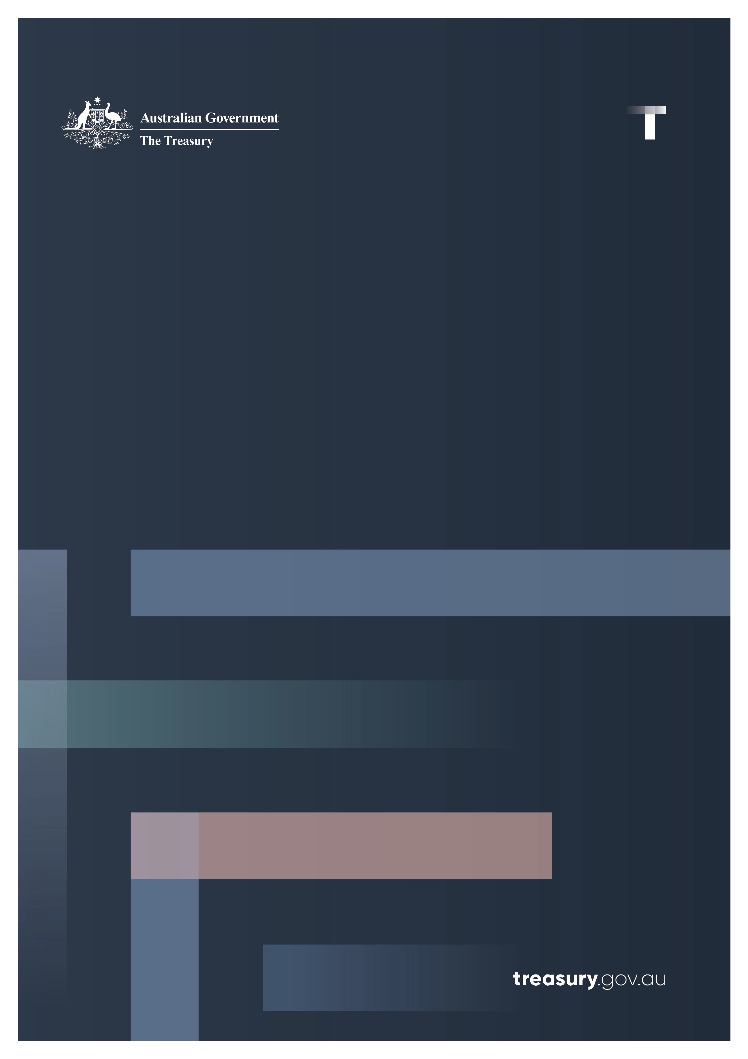

Review of the Australian Office of Financial Management
  - Independent Review led by Guy Debelle
April 2026

© Commonwealth of Australia 2026
ISBN: 978-1-923278-41-7
This publication is available for your use under a Creative Commons Attribution 3.0 Australia licence, with the exception of the Commonwealth Coat of Arms, the Treasury logo, photographs, images, signatures and where otherwise stated. The full licence terms are available from http://creativecommons.org/licenses/by/3.0/au/legalcode.
Use of Treasury material under a Creative Commons Attribution 3.0 Australia licence requires you to attribute the work (but not in any way that suggests that the Treasury endorses you or your use of the work).
Treasury material used ‘as supplied’
Provided you have not modified or transformed Treasury material in any way including, for example, by changing the Treasury text; calculating percentage changes; graphing or charting data; or deriving new statistics from published Treasury statistics — then Treasury prefers the following attribution:
Source: The Australian Government the Treasury.
Derivative material
If you have modified or transformed Treasury material, or derived new material from those of the Treasury in any way, then Treasury prefers the following attribution:
Based on The Australian Government the Treasury data.
Use of the Coat of Arms
The terms under which the Coat of Arms can be used are set out on the Department of the Prime Minister and Cabinet website (see https://www.pmc.gov.au/honours-and-symbols/commonwealth-coat-arms).
Other uses
Enquiries regarding this licence and any other use of this document are welcome at:
Manager
Media Unit
The Treasury
Langton Crescent
Parkes ACT 2600
Email: media@treasury.gov.au

Contents
Contents iii
Executive Summary 4
Review Recommendations 6
Introduction 7
Debt Management Strategy 9
Formulation and Execution of the Debt Management Strategy 10
Description of the Strategy 12
Assessment of Strategy and Execution 17
Process Improvement Recommendations 18
Role of the Advisory Board 20
Capability Assessment of the AOFM 21
Debt Program 21
Investor Relations 22
Securitisation Program 23
Overall Structure and Operational Functions 24
Liquidity Management Strategy 25
Risk Management 28
Governance 29
Conclusion 31
Appendix 32
Appendix 1: AOFM Organisation Chart 32
Appendix 2: Comparative analysis of Debt Office Structures 33

Executive Summary
The Secretary to the Treasury commissioned this independent review into the Australian Office of Financial Management (AOFM) in February 2026. As Australia’s sovereign debt manager, the AOFM is responsible for the management of the Australian government’s debt program. The Review was asked to consider the operations, capability and organisational effectiveness of the AOFM, including whether the agency can deliver upon its intended outcomes for government.
The following key elements of the AOFM’s mandate and operations were focuses of the Review:
- The debt and cash management programs;
- The agency’s capability in executing those programs;
- Risk management frameworks and practices; and
- Governance arrangements.
The Review consulted with a broad range of stakeholders during the Review process. These stakeholders include current and former AOFM officials, banks who deal in Australian Government Securities, fixed income investors, financial industry associations and officials from State debt management offices.
The Review has found that the AOFM’s debt management program is highly respected by participants in the Australian sovereign debt market. The Review’s assessment is that the program is effective at meeting the financing needs of the Commonwealth. The AOFM’s program is administered in a cost-effective manner, while also engaging in activity which promotes the function of fixed income and other financial markets in Australia.
However, the Review has identified a range of risks and opportunities for improvement across the AOFM’s debt and liquidity management programs. The Review observes risks to the agency’s capacity to challenge and adapt its Debt Management Strategy over the medium-term to ensure that it remains best practice. This risk stems from the AOFM’s modest resourcing of the front office and has been amplified by recent staff turnover, which was concentrated among senior officials with deep experience in sovereign debt management.
While the Review is satisfied that the AOFM can continue executing its current program effectively in the period ahead, the Review believes there is a need for greater organisational capacity to ensure appropriate challenge to the debt strategy as well as to bolster capability in times of heightened financial stress. The Review recommends that the AOFM makes changes to ensure this capacity is in place. The Review suggests this could be done through establishing a separate strategy research function led by an externally sourced senior official to provide appropriate challenge to the funding team as well as continually researching and reassessing the appropriateness of the various elements of the debt program.
The AOFM’s Liquidity Management Strategy enables the Commonwealth to have sufficient access to liquid cash to meet the government’s operational needs. While effective at delivering operational requirements, the Review views the liquidity buffer which is maintained by the AOFM as being overly conservative. At the same time, the AOFM should not regard the buffer as a floor and should ensure that is well understood by stakeholders. The AOFM’s cash buffer is to maintain a minimum of four weeks’ worth of liquidity on hand. The Review finds it difficult to contemplate circumstances which would restrict the AOFM from being able to issue Australian Government Securities for such a prolonged period. It also notes that the current slope of the yield curve increases the cost of holding such large liquidity buffers. Relatedly, the Review believes there is greater scope for the AOFM to adjust its term issuance as Budget outcomes deviate from forecasts.
The Review has assessed the AOFM’s governance arrangements, both internal and external. The Review has found that both sets of governance arrangements are generally effective, but that there are opportunities for each of these to be uplifted.
Regarding its internal governance, the AOFM’s new organisational structure – which has introduced two new Senior Executive Service officials – provides better pathways for career mobility, and more appropriate span of control for senior management. The Review notes that this organisational structure remains relatively new and that more time will be required for these changes to mature.
The AOFM’s Advisory Board consists of experienced financial market professionals and provides non-binding advice on the agency’s debt management program to the AOFM and the Treasury Secretary. The Review’s assessment is that the Advisory Board is under-utilised and could play a more prominent role in overseeing both the agency’s debt management program and its internal operations related to debt management. It should move further along the spectrum between advisory and full corporate oversight, though it should not be a decision-making board.
The AOFM’s Audit and Risk Committee, which is responsible for overseeing the management of enterprise risk, adds substantial value to the agency and interacts regularly with the Chief Operating Officer to uplift the AOFM’s enterprise risk management frameworks. The Review has observed evidence of a substantial program of work to improve the agency’s enterprise risk management practices and is comfortable with the AOFM’s capability across this domain.
The Review has observed that financial risk management does not have a clearly defined place within the AOFM’s governance structures. The Review’s assessment is that, while the Audit and Risk Committee should remain aware of emerging risks in this space, such risks are best overseen by the Advisory Board, given the direct overlap with the debt and liquidity management programs and the Advisory Board’s general expertise in this area.
The AOFM’s external governance arrangements primarily concern its relationship with the Department of the Treasury. The Review assesses that the agency effectively manages key communication channels with relevant Treasury officials regarding how the debt program interacts with fiscal policy settings. The Review has also observed effective arrangements between the AOFM and Treasury, recognising that the Memorandum of Understanding between the two is currently being refreshed to ensure accountabilities are well understood and service agreements are well specified. The Review has also determined that adequate channels currently exist for AOFM officials to express grievances, but there are opportunities for these channels to be made more accessible to a wider range of officials.
The Review assessed that the AOFM’s expertise and viewpoints on financial market and macroeconomic conditions could be more effectively utilised by a broader range of Treasury officials, particularly within Macroeconomic Group.
In conclusion, the Review has confidence in the AOFM’s ability to meet its mandate. It is undertaking a range of worthwhile improvements to its internal operations. However, the risks to its ability to continue delivering key elements of its core mandate of debt issuance into the future are heightened, due to a concentration of expertise in a small number of key people.
This Review has identified a range of opportunities to address this risk and considers the AOFM’s response to these opportunities as key to ensuring the agency can continue to deliver its mandate over the long term.

Review Recommendations

- The AOFM should increase its organisational capacity to ensure appropriate challenge to the debt strategy as well as bolster capability in times of heightened financial stress. The Review suggests this could be done through establishing a separate strategy research function led by an externally sourced senior official.
- The Advisory Board’s remit should be expanded to advise on all aspects of the AOFM’s operations that bear on the debt program, including the Financial Risk Management Policy. The Advisory Board should participate in the formulation of the Debt Management Strategy much earlier in the process to help shape it, noting that the Treasury Secretary would continue to provide final approval of the Strategy.
- The AOFM should amend its Financial Risk Management Policy to include a requirement that departures from the agreed Weighted Average Maturity target be explained and justified to the Advisory Board, and in particular be approved by the Treasury Secretary.
- The AOFM should reinstate the formal quarterly Portfolio Strategy meetings at the earliest possible opportunity.
- The AOFM should consider having a lower liquidity buffer.
- The AOFM should continue its indexed bond program.

Introduction
Established in 1999 when it was separated from the Treasury, the Australian Office of Financial Management (AOFM) is responsible for the management of the Australian Government debt program. The AOFM is also responsible for implementing the Government’s mandate for supporting the securitisation market. Its workforce of approximately 45 staff executes the agency’s responsibilities, with these staff based out of offices in Canberra and Sydney.
Organisationally, the AOFM is comprised of two broad areas (see Appendix 1). The front office, which comprises 17 people, is responsible for formulating and executing the debt strategy, managing financial assets (predominantly cash) arising from the debt strategy, conducting investor relations and implementing the agency’s securitisation mandate. The second area consists of the support functions of the AOFM spanning the back office (settlements), data, risk and compliance, and the CFO and HR functions. These operational functions employ around 25 people.
The structure of the AOFM was changed in mid-2025 to introduce two positions at SES level, with these officials overseeing the two areas described above. Under this new structure, the Deputy CEO oversees the front office teams, while the Chief Operating Officer oversees the operational and risk areas of the AOFM. Previously, the heads of the various functions (EL2 officials) reported directly into the CEO. Later in October 2025, there was a significant restructure of the AOFM, which saw a number of experienced staff leave the organisation. The purpose of the restructure was to ensure the AOFM was delivering on its responsibilities efficiently and to position the AOFM appropriately for the future.
The Secretary to the Treasury commissioned this Review in February 2026 to consider the operations, capability and organisational effectiveness of the AOFM following this reorganisation. The review was tasked with focusing on the effectiveness and capability of the AOFM in its:
- Approach to financing the operations of government
- Management of the cash portfolio
- Frameworks for risk management and compliance
- External reporting and governance structures between the AOFM and Treasury.
This report details the findings of the Review. Each of these four areas of focus of the Terms of Reference of the Review are considered in turn below. In addition, there is a section that explicitly assesses the capability of the various areas of the AOFM.
The Review team consisted of Jess Blake and Chris Efklides from the Treasury under the direction of Guy Debelle.
In formulating its findings, the Review team read a range of internal and external AOFM documents. These included papers and minutes prepared for the various internal meetings of the AOFM, including the Advisory Board, the Audit and Risk Committee and the cash meetings, as well as the core strategic documents of the AOFM, namely the Debt Management Strategy and the Liquidity Management Strategy. The ANAO Performance Audit of the AOFM in 2024 was a useful resource.
In addition the Review team interviewed:
- current and former staff of the AOFM;
- all members of the AOFM’s Advisory Board;
- all members of the AOFM’s Audit and Risk Committee;
- the heads of the various state borrowing authorities;
- the Treasury;
- the Reserve Bank of Australia;
- the New Zealand Debt Management Office;
- the Australian National Audit Office;
- the main panel banks who facilitate the AOFM’s borrowing program;
- a range of investors, including asset managers, banks and super funds; and
- financial market industry associations.
The Review thanks all the people that participated in the interviews for their helpful and constructive engagement.

Debt Management Strategy
The core business of the AOFM is issuing Australian Government Securities (AGS) to finance the Commonwealth government and managing the portfolio of outstanding AGS. To govern the performance of this role, the AOFM sets an annual Debt Management Strategy (hereafter the Strategy). At the same time and alongside the Strategy, the AOFM also formulates its Liquidity Management Strategy which is discussed separately below.
The nature of the portfolio of outstanding AGS has changed over time. In particular, the face value of outstanding AGS has grown substantially, due to the cumulative impact of Commonwealth fiscal deficits incurred since the Global Financial Crisis (see Chart 1). The increasing scale of this core function of the AOFM serves as important framing for the setting of the annual Strategy.
Chart 1: AGS on issue ($ billions, face value)
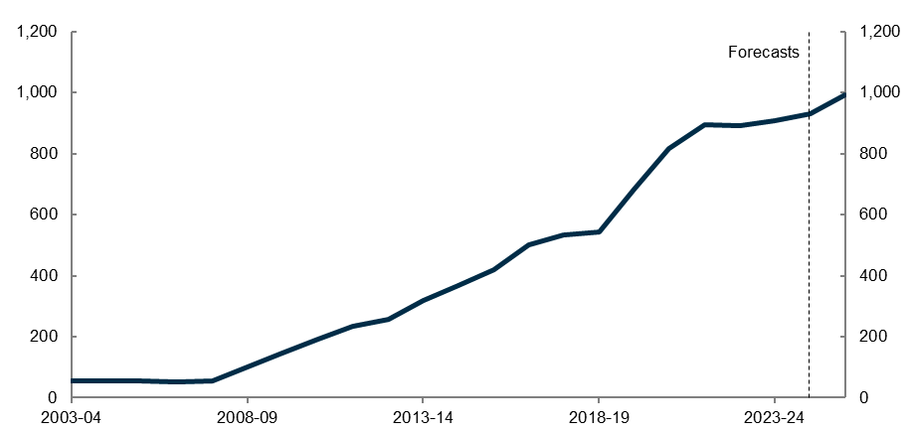
Source: 2025-26 Mid-Year Economic and Fiscal Outlook (historical tables)
The Strategy outlines the AOFM’s approach to issuing AGS for the fiscal year ahead, and is informed by:
- The expected financing task (as contained in the annual Commonwealth Budget);
- Financial market conditions, including the shape of the government bond yield curve and estimated term premia;
- Refinancing requirements as AGS mature and are subsequently rolled over;
- Liaison with stakeholders, including through the AOFM’s Issuance Strategy Survey; and
- The AOFM’s longer-term priorities surrounding the Australian sovereign debt market.
These priorities include the maintenance of a deep, liquid and well-functioning Government bond market. The Government bond market is the risk-free reference rate for financial market pricing in the Australian economy. It is a critical piece of financial market infrastructure.
The AOFM’s other priorities include the establishment and maintenance of new bond lines, support of the bond futures market, extensions of the yield curve to longer-dated instruments, development of the green bond program and support of the index-linked securities market.
The Strategy outlines the mix of securities which the AOFM intends to issue during the fiscal year ahead. This mix of issuance is calibrated to satisfy the financing task, while simultaneously meeting any other strategic priorities that the AOFM may have. Securities issued typically include a mix of:
- Treasury Bonds (a portion of which includes Green Treasury Bonds, whose issuance proceeds are allocated to eligible green expenditures);
- Treasury Indexed Bonds (i.e. inflation-protected securities); and
- Treasury Notes.

Formulation and Execution of the Debt Management Strategy
As a key annual deliverable which governs the AOFM’s core business, the Strategy undergoes multiple quality and clearance checkpoints during its formulation:
- The Strategy is drafted by the Funding Strategy and Research team (“FSR”). This team is responsible for the bottom-up construction of the Strategy. The same team is also responsible for the day-to-day operations of executing tenders and syndications to issue the debt in line with the current Strategy in any given fiscal year.
- The draft Strategy produced by FSR is informed by the team’s assessment of overarching financial market and macroeconomic conditions, as well as the financing task identified in the Commonwealth Budget typically released in May. The Head of FSR takes carriage of producing this draft.
- The Strategy is informed by:
  - a survey of market participants, the annual Issuance Strategy Survey, which is conducted by the AOFM’s FSR team and includes all of the panel banks. The insights from the survey include market participants’ expectations for financial and macroeconomic conditions as well as their anticipated demand for specific instruments, bond lines or programs;
  - peer country analysis and comparisons;
  - quantitative modelling including scenario analysis, which is designed to address and understand the cost versus risk trade-offs in the various scenarios;
  - conversations with the Reserve Bank’s Domestic Markets team.
- The Deputy CEO oversees this process and provides input and challenge to the Strategy. The Deputy CEO is seen as internally accountable for the Strategy.
- The Strategy is then presented to the CEO by the Head of FSR and the Deputy CEO for the CEO’s review and input.
- Once the CEO has cleared the Strategy, it is provided to the AOFM Advisory Board for review. The Secretary to the Treasury chairs the Advisory Board, which also comprises four independent experts with extensive debt and financial market experience. The Advisory Board members provide their views and feedback on the Strategy. While the Board provides feedback on the Strategy, it has no formal authority over the Strategy’s direction or settings.
  - Since 2023, the Advisory Board has gathered two to three times per year. The Advisory Board meetings tend to only last for one hour. The Review observes that:
    - The review of the Strategy happens very late in the Strategy formulation process.
    - The cadence of these meetings, and their timing, is not conducive to setting the direction of the Strategy during earlier stages of its formulation.
    - Accordingly, in the current operating environment, Advisory Board meetings serve primarily as a fatal flaw review.
- After feedback from the Advisory Board has been considered, the Secretary of the Treasury approves the final Strategy. The Secretary’s authority to approve the Strategy resides exclusively in her position as Secretary, rather than in her position as the chair of the Advisory Board (or with the Board itself).
- Once approved, the Strategy is formally implemented by the AOFM over the fiscal year. FSR has responsibility for executing the Strategy following its implementation. This includes enacting detailed plans for issuance throughout the fiscal year and carrying out tenders and syndications according to the issuance plan.
- Decisions on forthcoming bond transactions are made each week during the Thursday issuance meeting, chaired by the Head of FSR. The meeting considers dealer bank feedback and other intelligence from the Investor Relations team, as well as current market conditions. Issuance recommendations are then provided to the CEO. The final decision for the following week’s forthcoming transactions is then published each Friday at 12 noon.
- The Treasury Secretary is provided with a monthly report by the FSR team detailing developments in the debt issuance and a general assessment of bond market developments.
- The AOFM has formal quarterly Portfolio Strategy Meetings each year. These meetings provide an opportunity for officials to:
  - review and assess how the Strategy is progressing in the face of evolving financial market and economic conditions; and
  - engage in discussions of how the Strategy is likely to evolve over the medium-term (compared with the higher frequency discussions which occur at the weekly cash meetings).
- These Portfolio Strategy meetings have been put on hold for the past nine months in the face of the structural changes at the AOFM. The Review notes the weekly cash meetings evaluate the progress of issuance and track parameters of the Strategy.
- A post mortem of the Strategy for the fiscal year is carried out and discussed at the October Advisory Board meeting. This is an important process to ensure that the Strategy is achieving its objectives. The AOFM holds this meeting in response to a recommendation made in the Australian National Audit Office’s 2024 review of the AOFM.

Description of the Strategy
Chart 2: Composition of current stock of AGS on issue, by tenor ($ billions, face value)
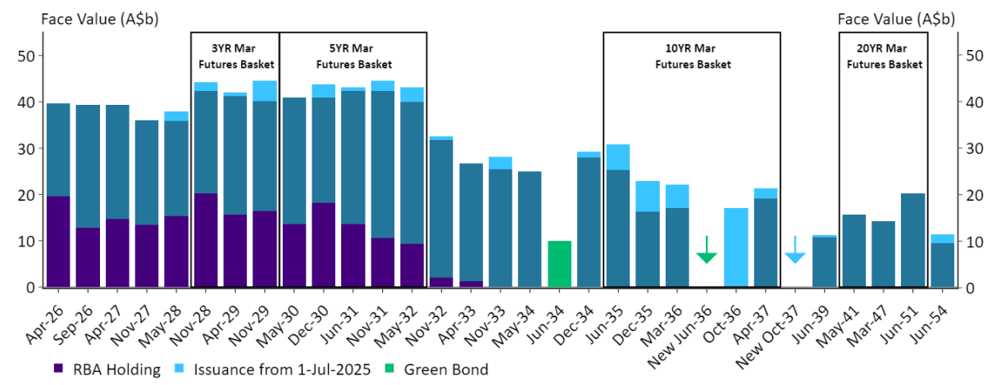
Source: AOFM. As at 09 January 2026.
Treasury Bonds form the vast majority of the AOFM’s bond issuance. In 2024-25, $98.6 billion of Treasury Bonds were issued (representing 97 per cent of the AOFM’s total bond issuance in the year), while the stock on issue averaged $855.7 billion. Treasury Bonds with 3 year and 10 year tenors represent important market benchmarks, forming the reference securities for the key bond futures contracts. As a result, there is strong demand for these securities, particularly when establishing a new bond line to roll down into the futures basket. The composition of the various bond futures baskets are reviewed by the ASX on a regular basis to ensure they remain appropriate as bonds progress toward maturity. These dynamics mean that there needs to be ongoing issuance of bonds with a maturity slightly longer than 10 years to ensure there is an adequate supply of securities in the futures basket.
In December 2023, the Government released the Australian Government Green Bond Framework. AOFM contributed significantly to the development of the Framework and undertook an investor roadshow ahead of the first issuance in June 2024. The AOFM in conjunction with Treasury has ongoing program responsibility, in line with the Comprehensive Sustainable Finance Agenda. The AOFM’s responsibilities include bond issuance, investor relations, representation on the Green Bond Committee and assisting Treasury with the allocation and impact reporting.
To promote the effective functioning of the Australian Commonwealth Government Bond market, the AOFM issues longer-dated securities, being securities with tenors beyond 12 years and out beyond 30 years. The AOFM’s program supports issuance of other longer-dated issuers, including the state borrowing authorities, as well as investors with a natural demand for long-dated instruments such as insurance companies. The AOFM’s issuance of longer-dated securities tends to be relatively small in any given fiscal year, though over time the AOFM takes the opportunity to build up the size of longer-dated lines through repeated issuance into those lines.
Treasury Indexed Bonds represent a much smaller portion of the AOFM’s bond issuance, with $2.9 billion being issued in 2024-25 (representing 3 per cent of total bond issuance), while the stock on issue averaged $41.3 billion. As suggested by the relatively modest quantum of this issuance, the AOFM does not rely on Treasury Indexed Bonds for raising substantial volumes of funds. Instead, the agency issues these securities to maintain a sovereign inflation-linked bond market in Australia. There is a fixed cost of establishing such a market, which the AOFM has already incurred. Hence the Review supports the maintenance of this market. The pool of investors who regularly hold these bonds is relatively limited but other investors will hold them when they perceive them to be delivering value. Given the relatively high costs associated with issuing Treasury Indexed Bonds in recent times, the AOFM has limited issuance to the minimum quantum required to maintain a functional market for Treasury Indexed Bonds.
By maintaining this market, the AOFM enables breakeven inflation expectations to be observed, while also meeting demand among some fixed income investment managers for these securities. With the recent introduction of a monthly CPI by the Australian Bureau of Statistics, the AOFM is undertaking a body of work to integrate the reference to the monthly CPI, which is more aligned with global index-linked bond contracts.
Treasury Notes (or “T-notes”) also form an important part of the AOFM’s issuance program, with the stock on issue averaging $33.6 billion in 2024-25.
T-notes are favoured by ‘buy and hold’ investors given the lower amount of secondary market liquidity for these securities. The AOFM’s T-note program provides the agency with access to short-term liquidity. The program can be scaled up or down to act as a shock absorber to manage the AOFM’s cash balance, in line with its Liquidity Management Strategy. In recent years, T-note issuance has been smaller than the AOFM’s balance of cash held on deposit at the RBA. The T-note program is discussed in more detail in the Liquidity Management section below.
The Strategy specifies a Weighted Average Maturity (“WAM”) target for each fiscal year’s AGS issuance. This WAM target is defined as a range and provides guide posts for the AOFM’s issuance over the fiscal year. By setting an explicit WAM target in its Strategy, the AOFM makes a conscious decision regarding its risk appetite for the fiscal year ahead.
In preparing the Strategy, scenario analysis of annual debt servicing costs under different WAM targets is prepared. This scenario analysis allows the AOFM to understand how different WAM targets will perform in terms of expected funding costs under different financial market conditions.
- When the yield curve is sloping upward, setting a lower WAM target will typically decrease funding costs, as shorter-dated yields will be lower than longer-dated yields. A lower WAM target will also increase the portfolio’s refinancing risk, as issued securities need to be rolled over more frequently.
- Conversely, setting a higher WAM target under these circumstances will reduce refinancing risk, but increase funding costs given the higher yields associated with longer-dated securities.
The AOFM’s WAM target does not strictly bind the agency’s issuance activities. The specification of a range for the WAM target provides reasonable scope for the AOFM to avail itself of this flexibility to aim to minimise issuance costs subject to risk. If financial market conditions rapidly shift, the AOFM has two key degrees of latitude to manage these shifts. These are:
- Alter the WAM of its issuance to take account of movements in the yield curve; and
- Alter the timing of its issuance.
For example, if the steepness of the yield curve were to increase over the fiscal year because of an increase in the term premium, the AOFM could issue more shorter-dated securities such that overall issuance was at the lower end of the WAM target range.
Under the AOFM’s current operating environment, there is no clear requirement for the agency to explain whether, or when, it expects its issuance to deviate from its WAM target. The Review very much supports the AOFM retaining the flexibility to shift its issuance profile in response to evolving financial market conditions. However, the Review recommends an update to the AOFM’s Financial Risk Management Framework to include a requirement that departures from the agreed WAM targets be explained and justified to the Advisory Board, and in particular, be approved by the Treasury Secretary.
The AOFM aims to be transparent and consistent with the market in its communications, including the timing of issuance and avoids making alterations to issuance where possible. If the AOFM believes that temporary market dislocations are sufficiently disruptive, the agency retains flexibility to adjust the pace of issuance according to demand for AGS. The AOFM is also able to exercise this flexibility under normal market conditions, with a view to minimising total financing costs. The AOFM consistently balances any such issuance with its desire to be perceived as predictable by market participants.
The AOFM also needs to take account of the changing fiscal position over the course of the year and adjust its program accordingly. It receives regular updates on revenue and expenditure flows from the Budget Policy Division of Treasury. The AOFM has to be mindful of not signalling changes in the overall budget position from this non-public information through changes in the scale of its issuance. This constraint is mitigated by the update on the AOFM’s issuance program provided after the Mid-Year Economic and Fiscal Outlook (MYEFO). In practice this provides a reasonable degree of flexibility for the AOFM to adjust its pace of issuance.
The AOFM engages regularly with market participants. FSR engages with market intermediaries on a daily basis. Investor outreach is conducted via a dedicated Investor Relations function (discussed in more detail below). This outreach ensures that the Strategy avoids systematic misalignment between AOFM funding decisions and investor preferences. The Review’s opinion is that the AOFM takes appropriate account of market input but is not beholden to it.
The AOFM issues its securities through a mix of public tenders and syndications. Open market tenders account for the majority of the AOFM’s issuance. In 2024-25, approximately 73 per cent of the AOFM’s Treasury Bond issuance was performed by tender, with the remainder occurring via syndication (see Chart 3).
Chart 3: Treasury Bonds – issuance by tender and syndication
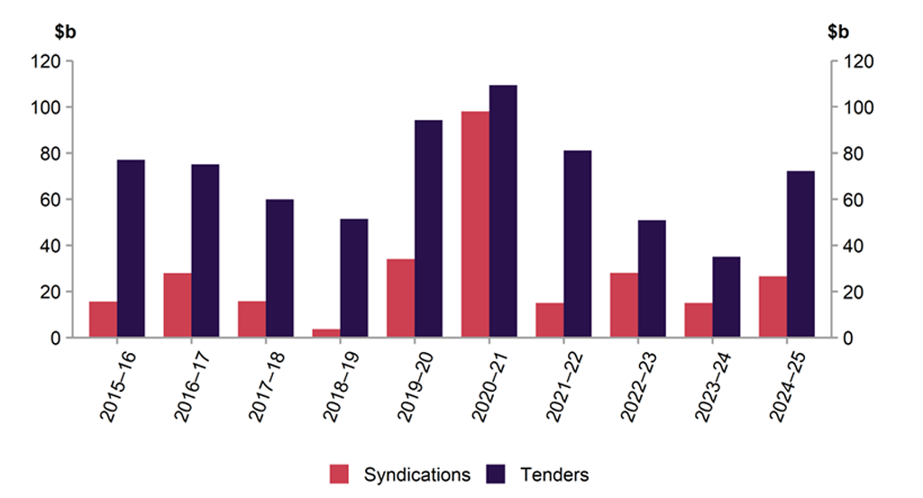
Source: AOFM
Issuing AGS via tender ensures that a competitive bidding process for the bonds takes place, in principle delivering lowest cost issuance. Dealers participate in the AOFM’s tenders, and on-sell the securities they purchase through tenders to investors who hold the securities in their portfolios. The AOFM enjoys strong bidding from the dealer banks participating in these tenders. By paying a (small) premium to purchase securities sold via tender, dealer banks signal the strength of their engagement with the market to the AOFM. This is a factor the AOFM considers when determining which dealer banks will run future syndications.
Syndications are typically used to issue new bond lines in large size or to issue into bond lines with limited secondary market liquidity (such as longer duration bonds or indexed bonds). Issuing AGS via syndications also provides the AOFM with deeper market intelligence, as the full spectrum of investor preferences is revealed during the bookbuild process.
The AOFM pays fees to the banks leading each syndication to access their distribution networks and to compensate for the risks these banks incur in managing the process. The fees are offset to a large extent by the premium paid for securities by dealer banks during the tender processes. As there is a large number of tenders throughout the year, that cost saving is material.
The Review believes that the AOFM’s mix of tenders and syndications is well balanced. It enables the agency to perform its objectives at least cost to the government. It is satisfied that the agency performs adequate assessments of the value-for-money outcomes achieved for the government through the mix of tender and syndication processes. The Review believes that these assessments should continue on a regular basis to ensure these outcomes continue to be achieved. The risk transfer process that occurs during syndications in terms of the distribution of risk between the AOFM and the syndicate banks also needs to be continually reassessed by the AOFM, including to ensure behavioural incentives for the syndicate banks, and particularly the Hedge Manager, are appropriate.
The Review does consider that the AOFM could lower its fees paid on syndications. These fees appear to be at the lower end of those paid by other government debt agencies, although like-for-like comparisons are challenging given the varying nature of the fee processes across debt agencies. There is a risk that if fees were reduced, this would be offset by higher costs in the tender processes if dealer banks are disincentivised from participating. This is ultimately unknowable until it is seen in practice. The Review would observe that the Australian market is well supplied with dealer banks willing to participate in the process, indicating there is potential for a further reduction in syndication fees.
Another consideration the Review examined is whether the AOFM should increase use of tenders rather than syndications in the issuance process. By comparison, the US government issues all of its bonds by tenders, but the stock of US government debt is considerably larger and price discovery in the US Treasury market is the strongest in global financial markets. While this remains a consideration that the AOFM should regularly revisit, the Review is satisfied that the AOFM currently has the mix of tenders and syndications appropriately balanced. Syndications are an effective way to issue a large quantity of a new bond, rather than by a sequence of small tenders, as they deliver liquidity for that bond quickly.
Buybacks of near-to-maturity bonds have historically been part of the AOFM’s Strategy. They are a regular feature of the issuance of indexed bonds where investors can switch out of a near-to-maturity indexed bond into a longer-dated one. Beyond that, buybacks of bonds have not been used by the AOFM in the post-Covid period. In large part, this is because the Australian financial system has had more than ample liquidity due to the Reserve Bank’s quantitative easing program. In the pre-Covid regime (when liquidity was scarcer and the RBA’s balance sheet was smaller), the RBA used to purchase a sizeable quantity of near-to-maturity bonds to manage the liquidity impact of bond maturities. The RBA then often on-sold those bonds to the AOFM (at market prices) and in addition, the AOFM also conducted its own buyback operations. As system liquidity gradually tightens as the RBA’s balance sheets decreases, it is possible that such operations may return.
Beyond this, the AOFM can conduct bond buybacks as part of its Strategy. It indicated its intention to buyback the September 2026 bond as part of the syndication of the April 2037 bond in July 2025. The AOFM did not receive any offers for the buyback. The Review received feedback from market participants that there was a lack of clarity about the buyback operation. The Review believes that the AOFM will need to address this issue in future buybacks.

Assessment of Strategy and Execution
Through extensive consultations and assessment, the Review has concluded that the Strategy is fit for purpose and represents a mature debt program that delivers cost-effective outcomes for the Government and taxpayer. At the same time, the AOFM has delivered on its objective of supporting the overall functioning of the Australian government bond market. Hence the Review’s assessment takes account of the objectives which the AOFM pursues, such as maintaining the indexed bond program and extending the maturity of the yield curve.
It is always possible with the benefit of hindsight to argue that the program could have delivered even lower cost outcomes. The AOFM addresses this appropriately through its annual post mortem which is discussed at the Advisory Board.
In determining its issuance strategy, the AOFM makes a judgement on the extent of refinancing risk as well as the overall financing requirement. Refinancing risk in this context is an assessment of how much issuance the bond market can absorb in a given year. For the most part, that is an assessment of the price impact of a large volume of debt issuance, rather than there being a finite amount of debt the market has the capacity to absorb in a given period. In the Review’s opinion, refinancing risk should be assessed primarily in terms of refinancing cost, rather than the risk that a particular quantity of refinancing cannot occur. This reflects the high likelihood that the AGS market will continue to function effectively and clear at a market price, even under large issuance volumes.
As a mature, highly rated sovereign issuer with a large investor base, Australia is unlikely to face a quantity constraint on issuance unless faced with a significant and highly idiosyncratic event. The appetite of domestic investors is close to fully satiated so, by and large, increases in issuance would be absorbed by offshore investors.
Ultimately, the AOFM is trading off issuing at longer maturities with a higher cost, thereby smoothing the refinancing task, as against issuing more shorter-dated bonds, thereby increasing the shorter term refinancing task and potentially pushing up yields. The AOFM characterises its approach to managing this trade-off as ‘regret minimisation’, which takes account of the very low appetite for funding risk of the government. The aim is to avoid extremely adverse cost outcomes rather than pursuing strategies that may minimise expected costs but come with higher risks.
The Review’s assessment is that the AOFM should not place much weight at all on concerns about the quantum of the issuance task in any given year and instead focus primarily on its assessment of the interest costs of different strategies over the cycle. That is, the AOFM should continue as it currently does to run the scenarios to assess the over-the-cycle interest costs of different issuance strategies, and consider refinancing risk through its interest rate implications, rather than through any quantitative concern. This lends itself to more direct comparisons, rather than introducing a non-linear quantity consideration which the Review does not consider overly relevant. Assessing the program through an interest-cost lens is a difficult assessment to make, as the level and shape of the yield curve are a function of a number of variables of which the quantity of issuance is only one. The construction of a through-the-cycle benchmark portfolio could assist in this regard by providing another structural mechanism to assess the cost of different strategies.
The Strategy is highly regarded by participants in the Australian government debt market and was variously described as “best in class”, “well established” and “predictable” by key stakeholders. The Strategy is constructed and executed by a team of experienced officials within FSR. Recent issuance activity has proceeded without incident, indicating that the team and the agency retain sufficient knowledge to execute core functions.
While there are some elements of the Strategy which could be altered to reduce its overall cost, the Review sees value in maintaining these elements and does not recommend their removal. These elements include:
- The issuance of Treasury Indexed Bonds. Despite higher current finance costs, the Review supports the maintenance of Treasury Indexed Bond issuance. It is appropriate to support those investors who have a need for such a product. Given it is already well-established, the marginal cost of maintaining the program is low relative to the large fixed cost of re-establishing such a program in the future. Moreover, there will be economic circumstances in the future where indexed bonds could be the most cost-effective form of issuance.
- The issuance of ultra-long dated Treasury Bonds. These securities exhibit higher term premia and overall finance costs in the current fixed income market. Issuance of these securities is justified by the fundamental role of the sovereign curve in underpinning longer-dated issuance by other borrowers, as well as meeting the needs of some investors for a longer-dated product of this kind to hedge their liabilities. They bring additional diversity to the investor base and broaden the AOFM’s funding toolkit.
- Issuance which aligns physical market liquidity with futures market maturity buckets. The futures market is an important part of the Australian financial market ecosystem. Supporting this market provides some of the most cost-effective issuance for the AOFM, so this is not a material constraint on their issuance strategy.
Stakeholders made various suggestions about elements of the program the AOFM could consider adjusting within the Strategy. These suggestions were at the margin, with all Review participants being supportive of the agency’s overall Strategy. Through its interactions with market participants, the AOFM is already well aware of these suggestions, with some under active consideration.
However, the Review has identified some risks to the AOFM’s ability to continue performing these functions to the current high quality standard. Some of these risks relate to process, while others relate to capability, which is discussed in more detail in the Capability section.

Process Improvement Recommendations
The Review believes that the AOFM needs to take steps to ensure the appropriate degree of challenge through peer review and analysis is provided during the development of the Strategy. The Review recommends that the AOFM employs additional capacity to address this. While the Review leaves it to the AOFM as to how to address this issue, the Review provides a potential solution below.
The Head of FSR, while eminently capable and experienced, does not receive sufficient peer challenge when producing the Strategy. The lack of other sovereign debt market expertise among the Head of FSR’s peers means that their inputs into the Strategy cannot be adequately debated or contested at-level. Among the other expert officials inside the AOFM who possess significant sovereign debt market experience, the highest degree of contest available to the Head of FSR’s views come from his own direct reports.
The Review’s opinion is that a separate strategy research function could provide necessary challenge to FSR in setting the Strategy. FSR would retain carriage of developing the Strategy and would have sole responsibility for issuing AGS via tenders and syndications according to the Strategy.
Such a structure involving two separate teams was considered during the consultations leading into the AOFM’s 2025 restructure. This proposed structure was rejected, in part because there were concerns that there would be insufficient work available to occupy a separate strategy team. In contrast, the Review believes this type of structure is important. A useful comparison is the role of a Research Department of a central bank, which conducts medium to long-run research as well as providing capacity to be deployed in times of stress.
The Review’s opinion is that there are benefits for an agency like the AOFM possessing a dedicated function to provide such challenge. Maintaining such a function would help provide regular assurance that the Strategy remains fit for purpose, including through regular review and analysis of its elements. The Review sees benefit in this challenge and analysis being offered by officials who are not directly responsible for designing the Strategy, as these degrees of separation assist with objectivity.
In light of the Review’s observations regarding the Strategy, its execution, and the AOFM’s organisational structure, we recommend that the AOFM:
- Reinstate the formal quarterly Portfolio Strategy meetings at the earliest possible opportunity;
- Introduce a dedicated strategy research function led by an EL2 official;
- Expand the agency’s expertise as it relates to sovereign debt management, by hiring externally with a view to reducing key person risk; and
- Engage the Advisory Board more frequently and provide it with greater influence over setting the Strategy each fiscal year.
Reinstating regular Portfolio Strategy meetings would allow officials from across the AOFM to periodically assess the broader macroeconomic environment and its interaction with the Strategy. While a short pause in these meetings is understandable given the AOFM’s recent restructure, the Review does not see a justification for postponing the meetings for such a long period of time. The meetings are an important regular internal process, which the Review recommends be reconvened as soon as possible.
The Review notes that the weekly cash meetings provide officials with the opportunity to consider cash forecasts and actuals and how these interact with the Strategy. However, it is not obvious to the Review that these arrangements allow officials to take a sufficiently broad or long-term view of how conditions are trending, or how shifts in these conditions affect longer-run implications for the Strategy.
Introducing a dedicated strategy research function would enhance the AOFM’s capacity to consider how shifts in conditions could affect the Strategy. Having access to this strategy research function would:
- Allow the agency to better prepare contingencies, enabling the Strategy to quickly pivot under different scenarios (e.g. preparing justification for alternative WAM targets under scenarios where the shape of the yield curve dramatically shifts);
- Provide more internal contestability among experts with senior experience managing sovereign debt programs when setting the annual Strategy; and
- Provide additional depth to the AOFM’s resourcing footprint, improving its ability to manage instances where financial markets are under strain (and how this impacts the Strategy or AGS issuance).
While the AOFM assesses that it is running a mature debt program (and this assessment is held by many of the market participants consulted by the Review), this assessment needs to be continually reviewed and challenged to ensure the program remains fit for purpose as conditions evolve.
The Review further argues that establishing a separate strategy research function would provide extra depth to the AOFM’s technical capacity, ahead of the next financial market or economic crisis. Given the small pool of relevant expertise in sovereign debt management (which is concentrated within dealer panel institutions and some investors), the Review is not convinced that relevant external experience would be readily recruitable at short notice during a crisis.

Role of the Advisory Board
The Review’s assessment is that the AOFM could make more extensive and purposeful use of the Advisory Board when developing the Strategy.
- Members on the Board possess extensive debt and capital market experience, including in managing sovereign debt programs. At present, there are only two Board meetings per year (one in May and another in October), with neither of these being appropriately timed to allow the Board to suggest material changes to the Strategy (see Debt Management Strategy section).
- The Review recommends that the AOFM holds an additional meeting with the Board in February/March, in the initial stages of Strategy formulation, to invite input and challenge from the Board much earlier in the Strategy’s development.
- Additional meetings with the Board should also be considered, including one which focuses on medium-term structural issues affecting the Strategy.
The AOFM Advisory Board currently sits at the more minimalist end of the governance spectrum of such boards. By expanding the role of the AOFM Advisory Board, its role and structure would become more analogous to those of the Boards of state debt authorities and comparable debt management offices overseas (see Appendix 2). This is discussed in more detail in the Governance section.
Engaging the Advisory Board more frequently, purposefully, and in a timelier fashion, represents an opportunity to bring more external scrutiny and expertise to setting the annual Strategy. The timing of recent Advisory Board consultations has not allowed the Board sufficient time to influence the annual Strategy. This has limited the Board’s role to validating the draft Strategy being put forward, rather than challenging and influencing the features of the Strategy.

Capability Assessment of the AOFM

Debt Program
On the basis of the analysis conducted by the Review team, as well as interviews with AOFM staff, market participants and other relevant stakeholders, it is the Review’s assessment that the AOFM has effective capacity to execute its primary task of issuing debt to finance the Australian government. As discussed in the Debt Management Strategy section, the Review’s assessment is that the agency is capable of executing this task in a cost-effective manner.
Much of the AOFM’s core capacity is embodied in the current Head of FSR, which creates key person risk. His expertise and experience in sovereign debt management was recognised and commended universally across the market participants consulted by the Review. There was also acknowledgment of the debt market experience of other senior members of the team.
The AOFM retains sufficient expertise to continue executing its current Strategy in the near-term. However, the relatively small size of the agency elevates the risk of critical expertise being concentrated within a small number of individual officials.
This key person risk has been amplified by recent departures of experienced officials. This turnover has been concentrated at senior levels and has led to the agency losing significant tenured experience in the administration of sovereign debt programs. In addition, some of those who left were involved first-hand in the AOFM’s crisis responses during the Global Financial Crisis and the Covid-19 pandemic. The Review’s opinion is that the concentration of departures in a short period of time has left the AOFM with a deficit of appropriate experience, which will take time to rebuild organically.
Other senior officials at the AOFM possess a variety of debt market experience. Some have experience in government debt markets, while others have a corporate debt market background. There is a number of important differences between managing a corporate debt program and a large government debt program. While senior officials with corporate debt experience have recently been employed, the Review assesses that this does not yet fully compensate for the departed government debt market experience. It will take some time for these officials to develop a deeper understanding of the nuances of government debt markets and provide appropriate internal challenge to the Strategy.
Relatedly, the Review also has concerns about AOFM’s capacity to respond effectively in a crisis. In stressed conditions, key challenges lie in:
- Assessing financial market conditions and adjusting the overall Strategy accordingly. Tenured experience in administering sovereign debt programs is key to navigating these scenarios, particularly given governments will require the option to ease fiscal policy in response to any emerging crisis.
- The ability to navigate interactions with syndicate panel banks and decide the parameters and final outcomes of transactions. While this skill is present in the FSR leadership, the AOFM needs to build the appropriate skill and judgement informed by experience across a broader group of senior staff to deliver these outcomes.
The management of the AOFM has recognised the need to increase the agency’s capacity to execute the debt program. In response to this need, management has prioritised the cross-skilling of members of other teams to enable them to assist with running tenders and overseeing syndications. This provides added depth in the actual execution of the Strategy. It also increases the attractiveness of other roles in the AOFM (and adds to the appeal of working within the agency as a whole), which the Review sees as supportive of staff retention.
The Review recognises these efforts currently underway, but does not believe that the cross-skilling is sufficient to mitigate the AOFM’s key person risk. Despite being responsible for discharging the core business of the agency, the FSR function has modest internal resourcing (relative to other functions within the agency). Given the specialised skillset required to run a sovereign debt program, the Review recommends that the AOFM consider external recruitment focussed on government debt market expertise to bolster the depth and experience available to the agency.

Investor Relations
The AOFM has run an extensive investor relations program for a number of years, and the Review sees this as an important function supporting the delivery of the Strategy. Feedback from the market participants consulted by the Review suggests that the AOFM’s investor relations program is perceived as mature and well constructed. In conjunction with FSR, there is frequent engagement with dealer panel banks to understand current conditions in the Australian government bond market, offshore government bond markets and market conditions more generally.
An important component of the investor relations program is engagement with offshore investors, which hold a material share of Australian government debt. Net of repo, an average of 50.5% of outstanding AGS was held by non-residents in 2024-25. The domestic investor base is very mature. Most domestic investors have a holistic understanding of the AOFM’s debt program and are well informed of the latest developments in government policy and domestic financial conditions. While some of the offshore investor base is similarly familiar with these factors, a sizeable share of offshore investors have only occasional engagement with the Australian government bond market. For some of these investors, investment in AGS may be a small share of their overall sovereign debt portfolio. For others (such as hedge funds), AGS investments may only be held occasionally or irregularly, or remain a prospective investment that is still under consideration. An informed, engaged offshore investor base is critical for a well-functioning and liquid Australian government bond market.
The Review’s assessment is that the AOFM has effective capability in its investor relations team, and that the team runs a mature and broad-based program. The Review sees considerable return on investment being achieved by the AOFM on its investor relations function, though these benefits are not easily quantifiable. It is therefore important for the CEO of the AOFM, the investor relations team, and other senior staff to continue to invest time (and direct travel costs) in executing a well calibrated and comprehensive offshore engagement program. The Investor Forum in Tokyo provides a key example of the agency taking the opportunity to engage with long-standing holders of Australian government debt.
There is also scope for the AOFM to consider how to assess the effectiveness of the investor relations program. The Review acknowledges that it is particularly challenging to link the impact of such a program with quantitative market metrics (such as the size of AGS holdings, interest cost benefits or bid to cover ratios). While these performance indicators can ostensibly be influenced by the quality of a debt management agency’s investor relations program, the Review acknowledges that they will also be influenced by a much broader set of factors. The Review therefore suggests that some qualitative metrics may instead be beneficial in validating the scope and effectiveness of the current program.

Securitisation Program
Market participants and industry bodies recognise the capacity of the securitisation team (Impact Investments) at the AOFM. The staff in this area have a combined long history of experience in securitisation markets. The team has a demonstrated ability to recruit and train more junior staff. On a number of occasions, the junior staff have moved to positions in the private sector on the basis of the quality of the experience and training they have received. The securitisation team recognises that this is to be expected and it has not materially affected their capacity to deliver on their mandate.
In the event of another crisis which affected securitisation markets which saw the mandate of the team increase, it is possible in the short-term to insource additional capacity and expertise from the private sector in the way that is not possible with the government debt program. For example, this occurred in the US in the post-GFC environment, where the New York Federal Reserve engaged Blackrock and others.
In terms of the mandate of the securitisation team, some market participants noted that the legislative mandate still references particular episodes when the securitisation market was stressed, namely the Global Financial Crisis and the Covid period. It was suggested to the Review that the mandate could be adjusted to reference generic periods of market distress, which would provide a flexible channel through which the AOFM could act to support the securitisation market in a crisis. The Review notes that the ABSF is due to be reviewed, providing an opportunity for this to be considered.

Overall Structure and Operational Functions
The Review is supportive of the overall structure of the AOFM, while recommending the establishment of a standalone strategy research function. The introduction of the Deputy CEO and the COO is grounded in sound logic. There is a clear division of responsibility between the two positions and the span of control is appropriate. Now that the structure has been in place for some time and the two incumbents are gaining experience in their roles, this provides the CEO with more bandwidth. In part, this allows her to focus on the outward facing aspects of her role, including the important task of investor relations. It should also give her more time to engage more closely with the core function of debt management.
The Review is satisfied with the capabilities and structure in the operational functions of the AOFM. The COO has achieved a noticeable uplift in activities in this area since her commencement in the role a year ago.
While the operational area has a larger staff headcount than the front office, the Review’s opinion is that this should remain and capacity in the front office should be increased through external recruitment. Establishing a separate strategy research capability would be a better way of redressing this balance, bolstering the depth and capacity of knowledge for the core function of the business, rather than looking for reductions in the operational areas of the AOFM. The Review assesses that there is a much smaller challenge in recruiting for operational functions, as the AOFM is able to source people from other government agencies and benefit from their experience in similar work environments.

Liquidity Management Strategy
The AOFM’s Liquidity Management Strategy (LMS) is designed to ensure the Government can always meet its spending requirements. It does this primarily by holding a sufficient buffer of cash on deposit at the Reserve Bank to meet the expected net outlays of the government over a period of time. In determining the size of this liquidity buffer, the AOFM is taking account of three sources of risk:
- Funding risk, that is the risk that it cannot access funding markets;
- Forecasting risk that takes account of actual net outlays differing from forecast; and
- Refinancing risk which is the inability to fund maturities.
It is worth noting that the latter risk is a quantity which is known well in advance, although the maturities are lumpy relative to other net outlays.
The AOFM’s current assessment is that it needs to hold at least $30 billion at the RBA to cover at least four weeks of government net outlays. This assessment controls for the possibility that the AOFM may be constrained in its funding for up to four weeks because of market dislocation. It is important to note that this funding risk is a statement of quantity rather than price. That is, the risk that is envisaged here is one where the AOFM is unable to issue any reasonable quantity of debt at all or without significantly adding to market dislocation. This risk is not defined by any unwillingness from the AOFM towards accepting a higher interest rate (lower security price) to be able to issue the debt.
Historically, periods of market dislocation that have seen sovereign debt markets shut have been very rare and very short-lived. Hence, this is a risk whose probability is extremely low but whose cost is extremely high.
An important consideration in assessing this risk is the likelihood that there would be some form of central bank support in any prolonged period of market dislocation. Again, it is worth emphasising that such an event would represent a dislocation of quantity, not of price. That is, under this hypothetical risk event, the bond market is supply constrained, rather than the AOFM being unwilling to incur the market price for its issuance. This is an important consideration in terms of concerns around central bank financing of the government.
In the Review’s opinion, assessing the likelihood of central bank support in the event of dislocation in financial markets needs to play an integral part in the AOFM’s assessment of the size of the liquidity buffer. The AOFM, RBA and Treasury conduct ‘wargaming’ exercises to consider such scenarios. The Review recommends that these exercises continue regularly to ensure there is a common understanding amongst these key stakeholders, particularly as the relevant personnel changes through time.
The AOFM is effectively buying a liquidity option through its cash holdings at the RBA. The cost of that option is the difference between the interest the AOFM receives from the RBA on its deposit and the cost of the debt used to fund that deposit. The AOFM receives the average yield on the RBA’s open market operations. Given the RBA’s market operations are conducted in short-term money markets (which are very adjacent to the T-note market), there is normally a relatively small margin between the deposit rate the AOFM receives on its cash and the cost of issuing T-notes. Given the T-note program also has a short maturity, it is unlikely that there will be any material duration mismatch.
Chart 4: Treasury Notes outstanding and deposits with the RBA

Source: AOFM
As noted earlier, in recent years the size of the deposits at the RBA has significantly exceeded the size of the T-note program (see Chart 4). This means that the deposits in excess of the T-note program are funded by the average cost of the wholesale debt program. In 2024-25, when the yield curve was downward sloping, this cost was small and potentially even negative. However, in the current environment of an upward sloping yield curve, the AOFM is incurring a larger cost of running such a high liquidity buffer.
When preparing the LMS, the AOFM calibrates its funding program to government financing requirements as set out in the Budget (and updated at MYEFO). Structural funding requirements are met through term issuance (overwhelmingly through Treasury Bonds). There can sometimes be imbalances driven by differences between Budget forecasts (against which funding programs are calibrated) and Budget outcomes. When the Budget position is better than forecast, the AOFM typically reduces T-note issuance in the first instance while changes in term issuance are more lagged because they are tied to Budget announcements. As a result the AOFM’s deposits at the RBA have exceeded the size of the T-note program in recent years.
The Review’s assessment is that holding a four-week liquidity buffer is conservative even taking account of stakeholder preferences, particularly when the cost of this liquidity option is higher. The AOFM should consider running a lower level of cash deposits at the RBA than it has done in recent years given the cost has increased.
In addition, the Review believes there is greater scope for the AOFM to adjust its term issuance as Budget outcomes deviate from forecasts, rather than relying predominantly on adjusting T-note issuance. This would contribute to lower deposits on average.
At the same time, it would appear that the AOFM has been effectively implementing its cash buffer as a floor rather than a buffer. That is, the cash balance generally is well above the announced buffer, and when cash balances fall towards the buffer they are quickly boosted. Instead, there should be periods of time where the cash balances is below the buffer because of such issues as the unforecastable variability in government expenditure and receipts. Most of the time the intent should be to have the cash balance in close proximity to the desired buffer, otherwise the AOFM is overpaying for its liquidity insurance.
In terms of managing stakeholder perceptions, it would be useful for the AOFM to clarify the intent of its policy in order to remove any perceived stigma associated with the cash balance occasionally dipping into the buffer.
The AOFM aims to not utilise the RBA overdraft facility except as a last resort. The overdraft is up to $10 billion and is to be repaid in no more than one week. The Review believes the overdraft is appropriately configured and the objective appropriately specified to obviate concerns about government financing except in periods of prolonged market dislocation.
At various times in its history, the AOFM has invested its cash balances in instruments other than deposits at the RBA. For a time, the AOFM held state government paper (semis) as part of its cash management. While this can earn a higher yield for the AOFM compared to the deposit at the RBA, it has a number of significant drawbacks:
- Liquidity in semi-government paper is materially less than cash at the RBA. This is particularly the case in times of financial market volatility when the AOFM will want to access the funds.
- There is a difficult question of how the AOFM would allocate its funds across the States. If did it so on the basis of the size of the debt program, that presents the optical problem of being seen to be rewarding the most profligate States.
Bank bills or deposits could also be considered but this would imply additional credit risk for the AOFM and, in the Review’s opinion, unnecessary credit risk. In times of financial market stress that problem would be accentuated. The AOFM would be placed in a difficult position of needing to liquidate its holdings while knowing that in doing so it would be exacerbating the stress on the banking system.
Hence, the Review’s opinion is that the AOFM should continue with its policies of investing its cash at the RBA rather than in other instruments.
The Review believes that the size of the T-note program could be larger without undue cost or market disruption, if that were consistent with the AOFM’s Debt Management and Liquidity Management Strategies. That would allow the AOFM to hold a higher cash balance at lower cost should it so desire (although the Review does not think this is necessary). Depending on the shape of the yield curve, this could lower financing costs without materially increasing refinancing risk as the larger program would be self-sustaining. A larger program should also improve liquidity which may attract more investors.
The Review spoke to a number of investors who would be willing to participate in a larger T-note program. That feedback has also been provided to the AOFM’s Investor Relations team.
A larger T-note program could serve as an effective liquidity management tool for the superannuation sector rather than their current holdings of bank bills. It would entail considerably less credit risk for super funds. Importantly, it would not be disruptive to the banking sector in times of stress, when super funds are likely to be liquidating bank paper at the same time as the banking sector is facing funding pressure. Finally, T-notes are high quality liquid assets, both generally and specifically for banks in terms of APRA’s liquidity policies, and are also easily repoable assets. This is a matter for entities other than the AOFM, but if implemented would have a material effect on AOFM’s Strategies.

Risk Management
In terms of risk governance, the AOFM has its own Audit and Risk Committee (ARC). This Committee is comprised of three members, one of whom is also a member of the Treasury’s Audit and Risk Committee to enable effective continuity between Treasury and the AOFM. This is appropriate as some of the AOFM’s risks are managed by the Treasury (the AOFM’s IT systems are supported by Treasury for example). The ARC meets at least four times a year and can also have out-of-cycle meetings where warranted, including to conduct deep-dives on particular issues of interest to the ARC.
Since her appointment, the Chief Operating Officer has implemented a number of measures to uplift risk management practices at the AOFM. This is not to imply that risk processes were inadequate previously. Rather, given her background and experience, the COO has sought to uplift risk practices to better practice standards in the financial sector. This has included a significant refresh of the Enterprise Risk Framework. Currently there is a program of work underway to update Key Performance Indicators to ensure they are fit for purpose, in response to a recent audit of this area. She has also appropriately focussed on streamlining the number of controls and ensuring they are appropriate and necessary.
Having reviewed the relevant risk documentation, read recent ARC papers and minutes, interviewed the members of the ARC, the COO and members of the AOFM’s risk and finance teams, the Review is comfortable with the capability of the AOFM in terms of risk management. The three lines of defence appear to be well understood and function effectively at the AOFM. The COO has increased the effectiveness of these risk processes since her arrival.
The one area where the Review believes there is scope for improvement is the oversight of the Financial Risk Management Policy. The Policy concerns the financial risks that the AOFM incurs in its debt and liquidity management operations. Effectively the policy describes a framework for balancing the costs of debt management with the risks of the debt program, a number of which have been discussed above. The key elements of the approach are embodied in the DMS and the LMS.
The Review considers that oversight of this policy has tended to fall between the ARC and the Advisory Board. That said, in recent months, the ARC has spent some time scrutinising this policy in more detail. ARC Members sat in on a tender earlier this year to better understand the process and its inherent risks. These developments are welcome and in part reflect the debt market background of a recent appointee to the ARC.
The Review believes that a more natural accountability for the Financial Risk Management Policy would sit with the Advisory Board given that it directly relates to the DMS and the LMS. Moreover, the composition of the Advisory Board provides the requisite skill set for effective scrutiny of the management of this risk. The Review’s opinion is that it would also make sense for a member of Advisory Board to participate in ARC meetings when the Financial Risk Management policy is on the agenda.

Governance
The AOFM’s governance is prescribed by the PGPA Act as a government authority. The AOFM’s external governance arrangements primarily concern its relationship with Treasury. The Review assesses that the agency effectively manages key communication channels with relevant Treasury officials regarding how the debt program interacts with fiscal policy settings. The more bespoke features of governance relate to the role of the Advisory Board and the fact that the Treasury Secretary approves the Strategy each year. The Review has a number of recommendations to enhance the governance of the AOFM.
The primary enhancement is to make more effective use of the Advisory Board. The Review recommends that the Advisory Board’s remit be expanded to include all aspects of the AOFM’s operations that bear on the Strategy. It should participate in the formulation of the Debt Management Strategy much earlier in the process to help shape the Strategy rather than discuss it when it is close to final. This would require the Advisory Board meeting more often and for longer than one hour. By way of comparison, equivalent boards in the state debt agencies meet around 5-6 times a year (see Appendix 2).
In addition, the Advisory Board should consider the AOFM’s Financial Risk Management policies and framework, which currently fall between the agency’s Audit and Risk Committee and the Advisory Board. Financial Risk Management practices include issues such as balancing refinancing risk with the cost of the debt program and risks around the conduct of tenders and syndications. The Review assesses that the Advisory Board can bring relevant experience and useful perspectives to these issues. While recent Audit and Risk Committee meetings have addressed issues falling within this domain, the Review regards it as appropriate for the Advisory Board to have oversight of these matters.
While suggesting that the AOFM Advisory Board’s remit be expanded, the Review does not envision that it should constitute a decision-making board under this expanded mandate. Decision-making accountability should still reside with the CEO of the AOFM in terms of running the AOFM, in accordance with the PGPA Act, and the Secretary of the Treasury in terms of the Strategy.
The ultimate accountability for the Debt Management Strategy sits with the Treasury Secretary when she approves the final strategy each year. The main source of discretion in the Strategy for the AOFM is the WAM target, which was expressed as a range of 9-11 years in 2025-26. The AOFM has the capacity to flex issuance within that range as financial conditions evolve. If conditions warrant, it should take the opportunity to move outside that range. That is, the range should be a target rather than a limit. If the AOFM thought it appropriate, it should seek approval from the Treasury Secretary to depart from the previously agreed WAM target, given her accountability for it.
A refresh of the Memorandum of Understanding between the AOFM and Treasury is currently underway. The Review is supportive of that process. It should ensure that accountabilities and responsibilities are well understood and service agreements are well specified. It should also incorporate the findings from the ANAO Performance Audit of the AOFM in 2024.
The Review’s assessment is that adequate channels currently exist for AOFM officials to escalate concerns, including to senior Treasury officials where required. The AOFM has recently conducted an extensive program to ensure that AOFM staff are fully informed about these. The Review notes that opportunities exist for these channels to be made more accessible to a wider range of officials. For AOFM officials seeking to escalate grievances to Treasury, the current escalation channels are to senior Treasury officials. This may reduce their use by more junior AOFM officials who do not feel sufficiently empowered to approach senior Treasury officials with grievances.
More generally, the Review believes that Treasury should make more use of AOFM expertise, particularly within Macroeconomic Group. In the Review’s opinion, the AOFM is overly separate from the broader Treasury environment. Some degree of separation is appropriate as the AOFM is a semi-autonomous agency. There is an obvious analogy in the RBA’s interactions with Treasury. The Treasury and RBA have regular discussions around the economic conjuncture and outlook, as well as financial market developments. These discussions generate a highly beneficial exchange of information without comprising the independence of the RBA.
The AOFM considers current and expected financial and economic conditions in determining its issuance over the course of the year. That provides an opportunity for a regular exchange of views with Treasury, not only at the senior level but also at a working level, without compromising the AOFM’s ability to decide its issuance within the parameters agreed in the Debt Management Strategy. The Review notes that FSR produces a weekly note on market developments that is circulated to a number of areas of Treasury including the Secretary and other senior officials. That said, there is greater scope for Treasury to use the AOFM’s expertise in financial markets and their knowledge from their daily interaction with markets.
The Review’s assessment is that the AOFM plays an appropriate role in its external engagements. It plays a leadership role across the state borrowing authorities while recognising that they have independent debt programs. AGS are often the entry point for offshore investors into the Australian sovereign market, so the AOFM can and does play a leadership role in engaging with offshore investors. The AOFM could build on its position by providing a portal to a broader set of information about the Australian economy and debt markets on its website, so that offshore investors can find the relevant information in one location. Relatedly, some of the information on the AOFM’s website appears dated. The AOFM’s term premium estimate utilises work done in 2019. There has been a material amount of further research in the economic literature on this subject that the AOFM could draw on to complement its analysis of this variable which is an important input into its Strategy. This is the type of work that a strategy research function could be conducting and publishing on the AOFM website, further bolstering the AOFM’s reputation in the market.
Some of the stakeholders the Review spoke to suggested the publication of the Debt Management Strategy after the end of fiscal year to which it applies. The Review does not feel this is necessary. Much of the relevant content is in the public domain in the AOFM’s Annual Report and in the CEO’s speeches. That said, the AOFM could consider whether more non-market-sensitive material regarding the Strategy could be provided on its website.
In terms of broader leadership in the Australian bond market, the AOFM has also taken a prominent role in issues such as adapting its indexed bond program to incorporate the new monthly CPI, as well as developing a standardised template for reporting bond market turnover. It plays a constructive role on the relevant AFMA committees that address issues relevant to the bond market. It brings its expertise to bear without straying into advocacy.

Conclusion
The Review’s assessment is that the AOFM is delivering its core functions capably. The debt program is achieving low-cost issuance while also delivering on the AOFM’s broader market objectives. The Review has a number of recommendations to ensure the current high standard of execution is maintained in the future. In particular, the Review recommends that the AOFM bolsters its internal challenge capacity and recommends that the AOFM Advisory Board is more involved in all aspects of the AOFM’s Debt Management Strategy.

Appendix

Appendix 1: AOFM Organisation Chart
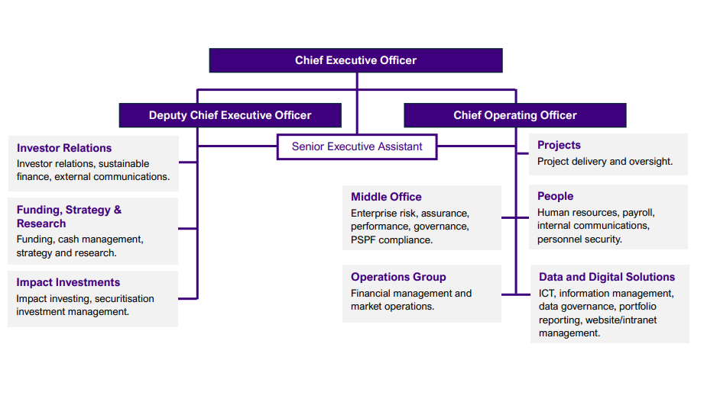
Source: AOFM

Appendix 2: Comparative analysis of Debt Office Structures
International Debt Offices
Dimension | Australian Office of Financial Management (AOFM) | New Zealand Debt Management | Government of Canada Debt Program | United Kingdom Debt Management Office
Institutional location | Non-corporate Commonwealth entity within Treasury under the PGPA Act. | Function of the New Zealand Treasury. | Function of Department of Finance Canada. | Executive Agency of HM Treasury.
Governance | CEO-led Agency accountable to the Treasurer and Secretary to the Treasury; independent Advisory Board. | Direct Treasury control; oversight via Treasury Executive Leadership with external challenge from the Capital Markets Advisory Committee. | Minister of Finance responsible for debt management; no separate debt agency board. | Policy and financial framework of DMO determined by the Chancellor of the Exchequer, with operational decisions and day-to-day management delegated to CEO; Advisory Board.
Delegation & authority | Issuance and risk authorities delegated by Treasurer; strategies approved by Secretary to the Treasury. | Authority exercised directly under Treasury financial authorities. | Authority exercised through Department of Finance. | Annual financing remit determined by HM Treasury and executed by DMO.
Debt strategy release (frequency) | Annual Corporate Plan published online, Annual Debt Management Strategy internal. | Securities Funding Strategy available online and updated at least biannually. | Annual Debt Management Strategy released with the Budget (or fiscal plan) for the coming fiscal year. | Annual remits published in the Debt Management Report prior to the start of the financial year.
In-year updates to borrowing programme | Changes communicated via tenders, market announcements, or syndications. | Formal borrowing programme updates at Half Year Economic and Fiscal Update reflecting revised fiscal outlook. | Issuance adjustments reflected operationally and reported in the Debt Management Report. | Financing remit is revised if required. Changes communicated via DMO Operational Notices and announcements.

Semi Governance Structures:
Organisation | Board Structure & Composition | Cadence of Board Meetings | Advisory / Secondary Boards | Committees & Key Governance Features
TCorp (NSW) | Board of Directors comprised of the Secretary of NSW Treasury, a Senior officer of NSW Treasury, TCorp’s Chief Executive, and 3–7 directors appointed by the NSW Treasurer. | Board met 5 times in 2024–25. | None | - Audit & Risk Committee  - Board Investment Committee  - People & Remuneration Committee
TCV (Victoria) | Board of Directors including the CEO and 5–7 directors appointed by Governor in Council on Treasurer’s recommendation. | Board met 8 times in 2024–25. | None | - Audit Committee  - People and Culture Committee
QTC (Queensland) | QTC has a two-tier governance model with a Capital Markets Board that manages all of QTC’s operations except those relating to certain superannuation and other long-term assets. The Board is composed of a Queensland Treasury ex officio representative and non-executive members. | The Capital Markets Board met 9 times in 2024–25. | The State Investment Advisory Board manages the States long-term investment assets.  The State Investment Advisory Board met 4 times in 2024-25. | Capital Markets Board committees:  - Funding and Markets Committee  - People and Culture Committee  - Risk and Audit Committee  - Advisory and Consulting Committee
WATC (Western Australia) | Board chaired by Under Treasurer, with externally appointed directors (finance and governance expertise). | Board met 5 times in 2024–25. | None | - Audit Committee  - People and Remuneration Committee
TasCorp (Tasmania) | Board chaired by Secretary of Department of Treasury and Finance with independent directors that are non-executive finance and banking experts. | Board met 12 times in 2024–25. | None | - Audit Committee
SAFA (South Australia) | Advisory Board of 5–7 members, including one member from a semi-government authority and one with insurance expertise. | Board met 5 times in 2024–25. | Advisory role to Treasurer / Under Treasurer | - SAFA Risk and Performance Committee

Australian National Audit Office’s 2024 review of the AOFM, available here.
Governance information included in AOFM Annual Report 2024-25, available here.
AOFM Forthcoming Transactions, available here.
Australian National Audit Office’s 2024 review of the AOFM, available here.
According to the AOFM Annual Report 2024-25.
According to End of Month Positions data, available here.
A futures contract references more than one physical bond.
According to the AOFM Annual Report 2024-25.
According to End of Month Positions data, available here.
According to End of Month Positions data, available here.
According to the AOFM Annual Report 2024-25.
The considerations the AOFM uses to determine syndicate banks is available here.
The role of buybacks in the AOFM operations, available here.
Repurchase of the September 2026 Treasury Bond, available here.
According to Ownership of Australian Government Securities data, available here.
The 2025-26 AOFM Audit and Risk Committee Charter is available here.
The operational risks of the debt program are managed through the Enterprise Risk Framework.
Australian Office of Financial Management
New Zealand Debt Management
Government of Canada Debt Program
United Kingdom Debt Management Office
Tcorp Annual Report 2025
TCV Annual Report 2024-25
QTC Annual Report 2024-2025
WATC Annual Report 2025
Tascorp Annual Report 2024-25
SAFA 2024-25 Annual Report

