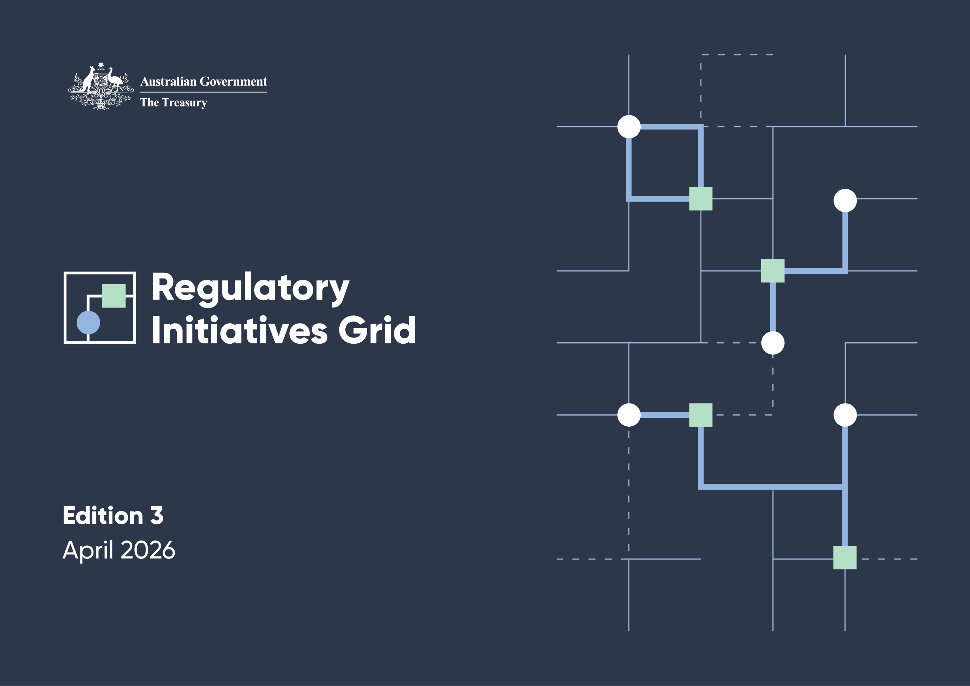
f

© Commonwealth of Australia 2026
ISBN: 978-1-923278-40-0
This publication is available for your use under a Creative Commons Attribution 4.0 International licence, with the exception of the Commonwealth Coat of Arms, the Treasury logo, photographs, images, third party materials, materials protected by a trademark, signatures and where otherwise stated. The full licence terms are available from creativecommons.org/licenses/by/4.0/legal code.
Use of Treasury material under a Creative Commons Attribution 4.0 International licence requires you to attribute the work (but not in any way that suggests that the Treasury endorses you or your use of the work).
Treasury material used ‘as supplied’
Provided you have not modified or transformed Treasury material in any way including, for example, by changing the Treasury text; calculating percentage changes; graphing or charting data; or deriving new statistics from published Treasury statistics – then Treasury prefers the following attribution:
Source: The Australian Government the Treasury, Australian Taxation Office (ATO) Australian Securities and Investments Commission (ASIC), Department of Home Affairs (Home Affairs), Australian Prudential Regulation Authority (APRA), Australian Transaction Reports and Analysis Centre (AUSTRAC), Reserve Bank of Australia (RBA), Australian Financial Security Authority (AFSA) and the Australian Competition and Consumer Commission (ACCC).
Derivative material
If you have modified or transformed Treasury material, or derived new material from those of the Treasury in any way, then Treasury prefers the following attribution: Based on Commonwealth of Australia data.
Use of the Coat of Arms
The terms under which the Coat of Arms can be used are set out on the Department of the Prime Minister and Cabinet website (see www.pmc.gov.au/government/commonwealth-coat-arms).
Other uses
Enquiries regarding this licence and any other use of this document are welcome at:
Manager, Media Unit
The Treasury
Langton Crescent, Parkes, ACT 2600
Email: media@treasury.gov.au
In the spirit of reconciliation, the Treasury acknowledges the Traditional Custodians of country throughout Australia and their connections to land, sea and community. We pay our respect to their Elders past and present and extend that respect to all Aboriginal and Torres Strait Islander peoples.

Contents

Foreword 1
Snapshot of regulatory initiatives 2
Introduction 4
Supporting improved regulatory coordination 5
Sectors 6
Categories 7
Contributing agencies 8
Scope 9
How to read the RIG 10
Feedback 11
Future updates 11
1. Policy development 12
2. Development of legislation, regulations and instruments 17
3. Ongoing program implementation 38
4. Review and evaluation 51
Changes to initiatives included in Edition 3 59

Foreword
The Government is delivering better regulation to lift productivity and support long-term growth.
This third edition of the Regulatory Initiatives Grid (RIG) is an important step in that process, building a stronger, more productive economy supported by regulation that is clear, efficient and fit for purpose.
Good regulation supports investment, innovation and growth. Poorly targeted regulation, on the other hand, can slow activity and add unnecessary cost to businesses and consumers.
That is why improving the quality of regulation remains a central focus of the Government’s economic agenda, and why it was such a consistent message coming out of the Economic Reform Roundtable.
The RIG provides a transparent view of upcoming regulatory initiatives across government and independent regulators, helping industry to plan with greater confidence and engage more effectively. It also assists regulators to coordinate their efforts and reduce duplication.
This edition further embeds the Coordination Principles introduced last year, strengthening collaboration across agencies and helping ensure regulatory activity is streamlined, proportionate and targeted. These improvements support a more efficient regulatory environment and allow both regulators and industry to focus their resources where they will make the biggest difference.
I would like to thank industry and stakeholders for their constructive engagement in shaping and supporting the operation of the RIG.
Better regulation is a long-term commitment, and the Government will continue working with the sector as the RIG evolves and contributes to a more productive and resilient economy.

The Hon Dr Jim Chalmers MP
Treasurer

Snapshot of regulatory initiatives
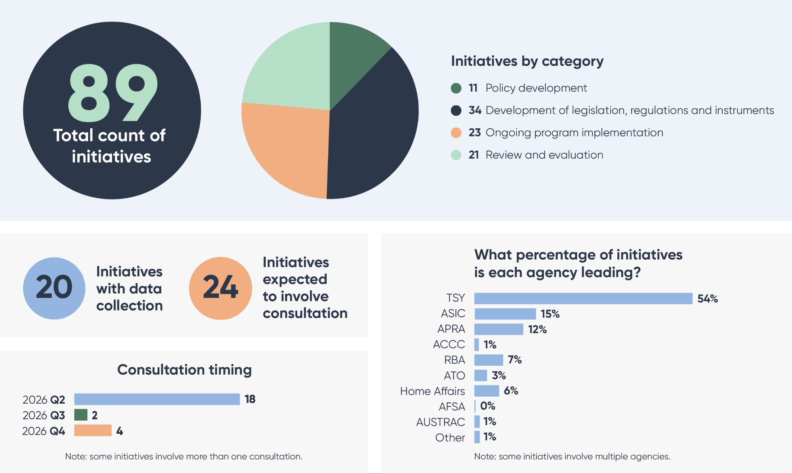
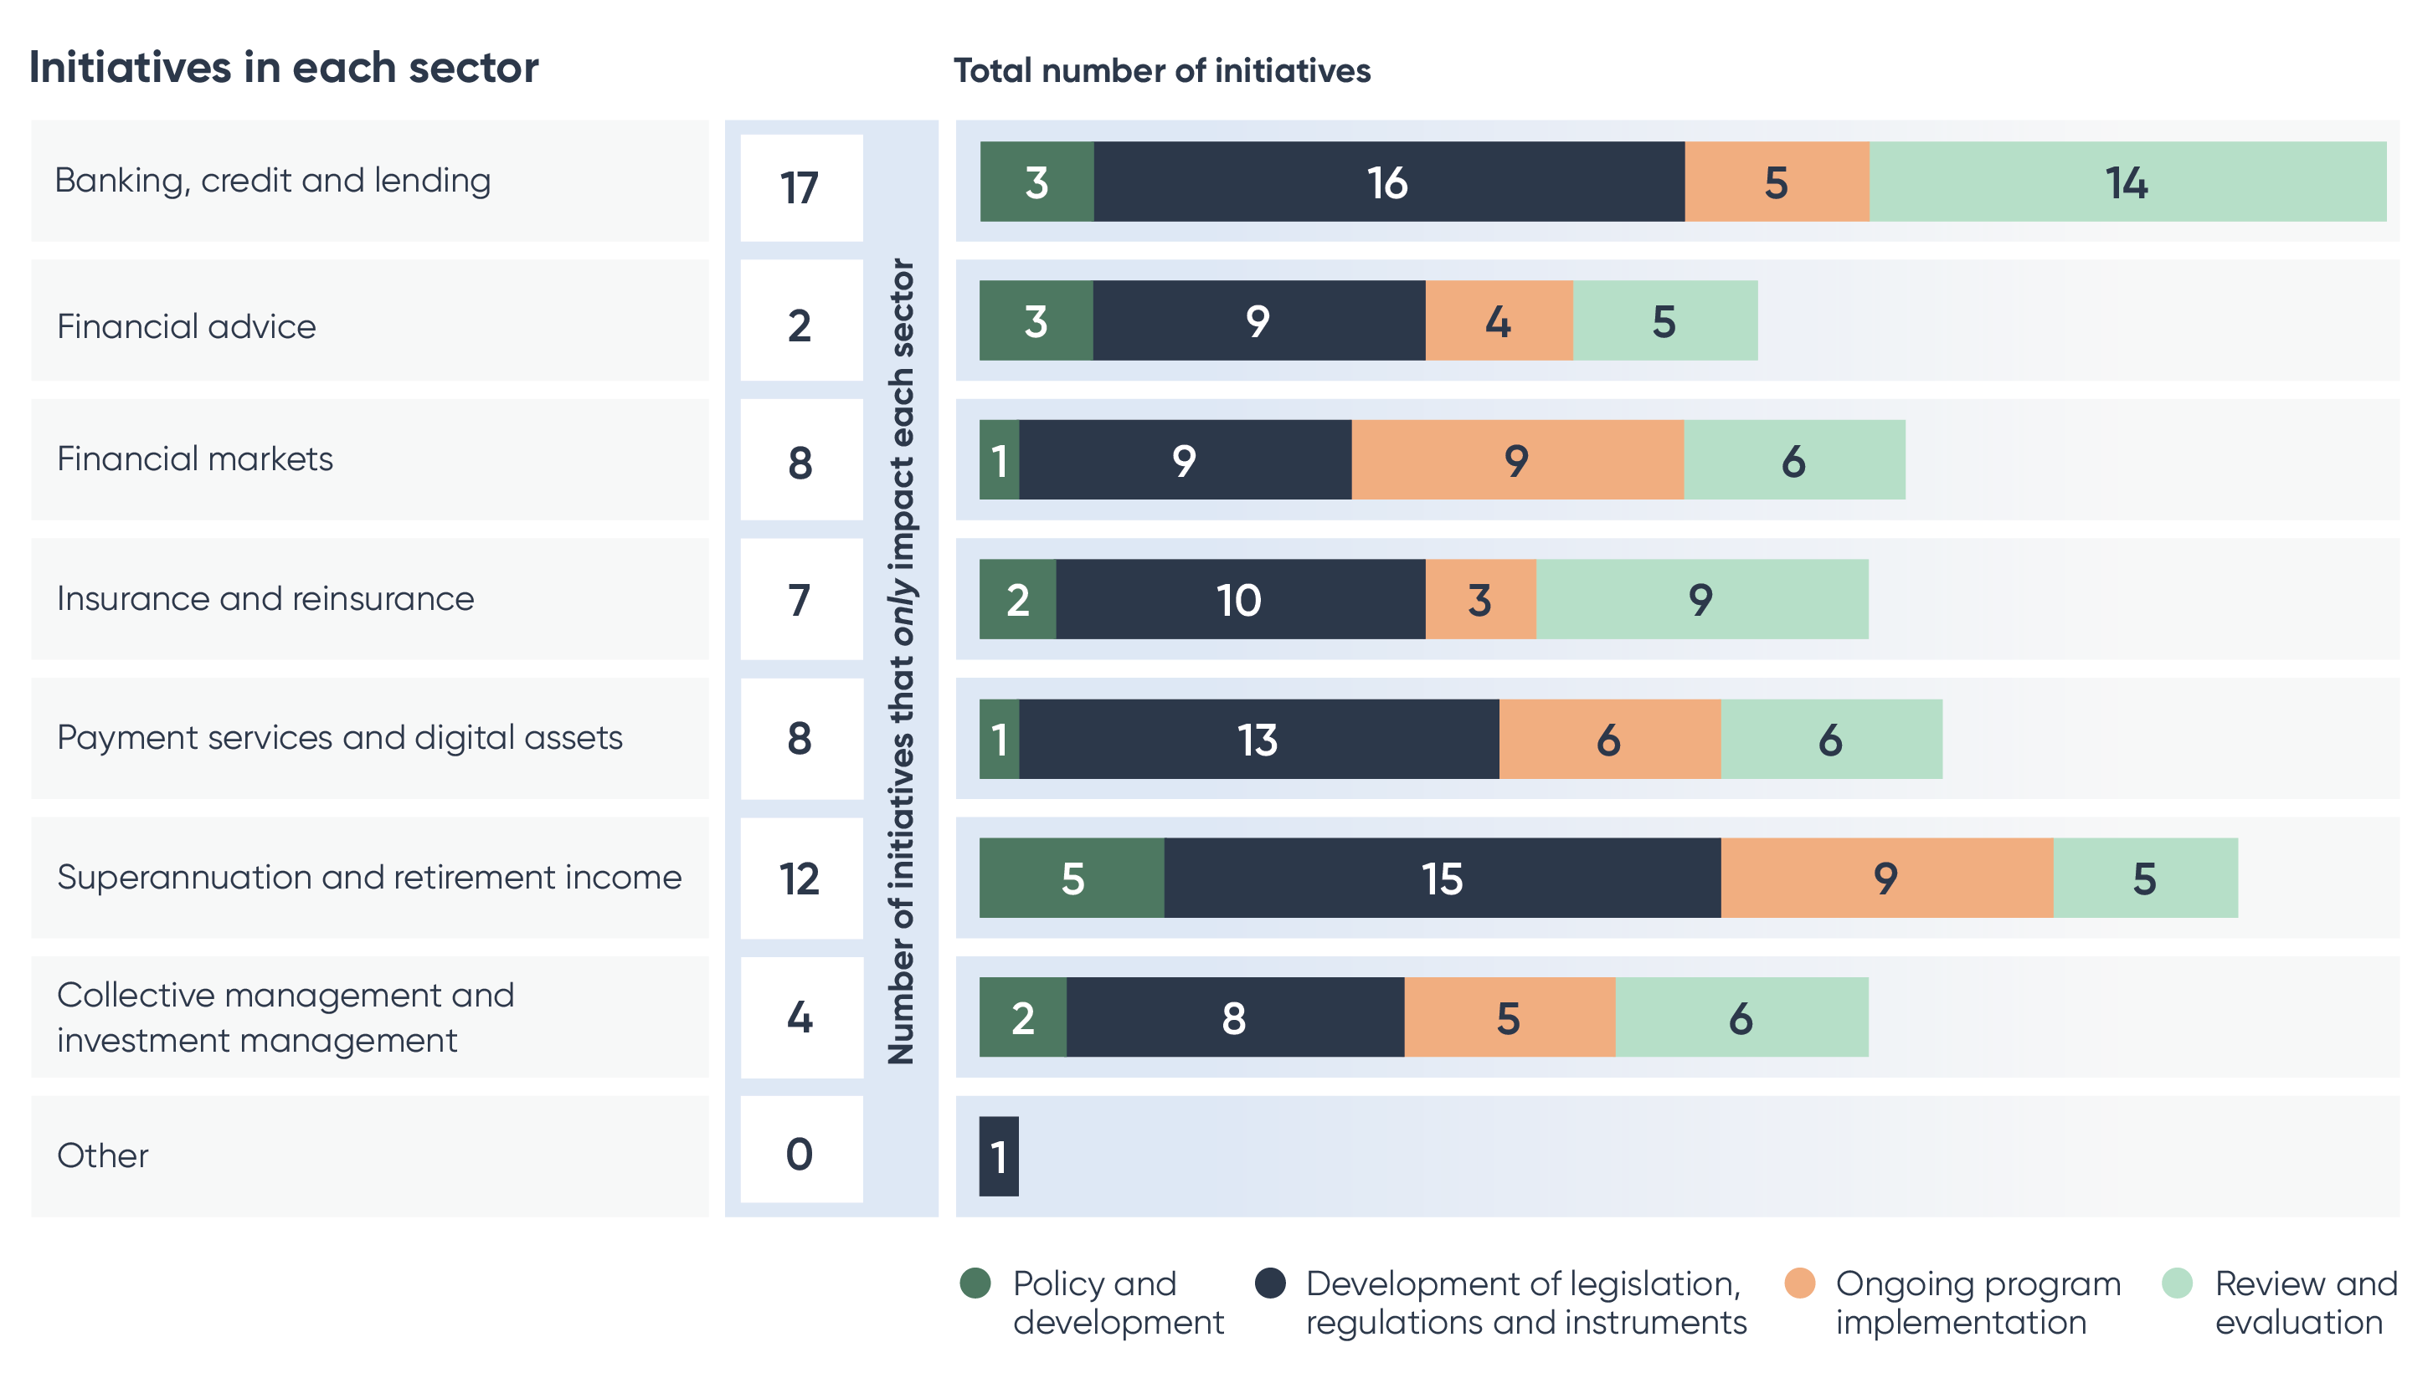

Introduction
The Regulatory Initiatives Grid (RIG) reflects the Australian Government’s commitment to better regulation: reducing unnecessary burden, improving coordination among regulators, and strengthening the effectiveness of oversight in the financial sector. This edition contains the mid-year update, providing details about initiatives and milestones since September 2025. The September version is the substantial update, with more developments on data harmonisation and streamlining to be included.
The RIG is an important part of the Government’s agenda to support productivity and competition. By providing a clear and consolidated view of upcoming regulatory initiatives, it enables more effective engagement between industry, government and regulators. This helps identify shared challenges and opportunities, and supports a more dynamic, resilient and inclusive economy.
The RIG increases transparency of the reform priorities and regulatory initiatives likely to affect the financial sector over the next two years. This visibility assists businesses—particularly smaller firms—to plan with greater confidence and to engage with regulatory processes in a more targeted and timely way.
The second edition of the RIG, released in October 2025, introduced new Coordination Principles to strengthen collaboration among regulators. These principles are intended to help streamline regulatory processes, reduce duplication and avoid unnecessary burden on industry, while ensuring regulatory objectives continue to be met.
This mid-year update of the RIG continues the Government’s focus on better regulation, including through working to embed the Coordination Principles to support a more consistent, system-wide approach to regulatory oversight.

Supporting improved regulatory coordination
Following the Economic Reform Roundtable, the Treasurer asked the Council of Financial Regulators (CFR) agencies, in collaboration with the ACCC, AFSA, the ATO and AUSTRAC (collectively known as CFR Plus) to deepen their work on better regulation, particularly in improving coordination across the financial sector. In response, the CFR Plus has been progressing a structured program of work aimed at reducing unnecessary regulatory burden, improving the sequencing of initiatives, and identifying opportunities to streamline and harmonise data collection and data sharing.
The Coordination Principles support this work by providing a shared framework for planning and engagement across agencies. They help ensure regulatory activity are efficient, transparent and proportionate to risk, while maintaining essential protections for consumers and supporting financial system stability.
The Principles are designed to balance the need for timely regulatory progress with industry’s capacity to engage and implement changes. This helps reduce avoidable peaks in consultation or data requests, while preserving regulators’ ability to act quickly on issues that require urgent attention—particularly matters related to market stability, systemic risk or broader government priorities.
The second edition of the RIG set out how the Coordination Principles build on existing coordination mechanisms, providing specific examples of collaboration across regulators. The tasking by the Treasurer to the CFR Plus works to embed further the Coordination Principles as is evidenced by the joint publication of the CFR Better Regulation Roadmap on the CFR website. The roadmap outlines three streams of work which includes:
- Implementing regulatory reform commitments.
CFR Plus has published an implementation plan covering more than 50 commitments made at the 2025 Economic Reform Roundtable. While individually incremental, these commitments—spanning simplification, removal of duplication, digital enablement and improved regulatory engagement—are expected to collectively deliver meaningful regulatory efficiency gains. Agencies are coordinating sequencing and implementation to minimise cumulative impacts on industry.
- Streamlining data collection and sharing
CFR Plus is undertaking joint work to streamline and harmonise data collections across regulators. In December 2025, APRA and ASIC conducted industry engagements and select sector-specific deep dives to better understand duplication in reporting and to test opportunities for enhanced cross-agency data sharing. This work is being further developed in 2026, with the objective of making data reporting more efficient, transparent and coordinated.
- Identifying priority legislative reforms
Agencies are jointly analysing stakeholder feedback on legislative changes that could improve regulatory outcomes, including submissions received ahead of the Economic Reform Roundtable. This coordinated prioritisation process will support the Government in determining reform options that improve efficiency without compromising key regulatory objectives.

Sectors
The RIG divides the financial system into 8 sectors:
- Banking, credit and lending
- Collective management and investment management
- Financial advice
- Financial markets
- Insurance and reinsurance
- Payment services and digital assets
- Superannuation and retirement income
- Other

Categories
The RIG divides initiatives into 4 categories that reflect policy lifecycle phases:
- Policy development.
- Development of legislation, regulations and instruments.
- Ongoing program implementation.
- Review and evaluation.

Contributing agencies
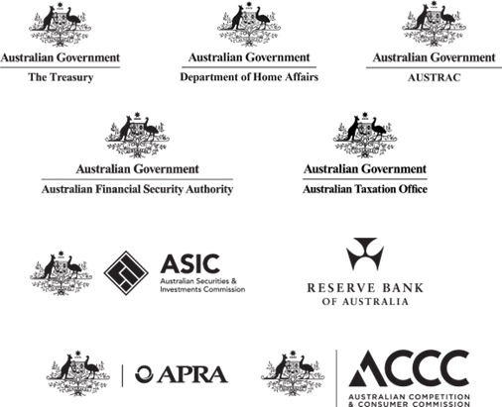
Department of Home Affairs initiatives are limited to matters relating to the regulatory frameworks administered by AUSTRAC.
Australian Taxation Office initiatives are limited to matters relating to the superannuation guarantee and self-managed superannuation funds.
Australian Competition and Consumer Commission initiatives are limited to matters relating to the financial sector.

Scope
The RIG’s scope is limited to publicly communicated initiatives and activities that will materially affect the financial sector in the 24 months from the RIG’s publication date.
The RIG has a strategic focus and is not intended to be exhaustive. It does not include day-to-day work undertaken by regulators. The RIG does not include:
- regulatory investigations relating to significant compliance or enforcement activities
- non-regulatory initiatives and activities (such as undertaking research, strengthening financial literacy, and engaging with the financial sector to explore opportunities to enhance existing systems)
- multi-agency simulation activities to test preparedness and crisis response
- standard or long-standing processes or activities that are well understood by industry stakeholders
- initiatives led by international bodies or international organisations, unless a contributing agency is responsible for implementing measures that satisfy the inclusion criterion.
This information is also in the RIG Terms of Reference at treasury.gov.au/RIG.

How to read the RIG
The RIG Edition 3 includes initiatives publicised prior to 1 April 2026. Initiatives publicised after 1 April are not included in Edition 3.
Each initiative includes the following information.
 | Agency | The agency/ies responsible for progressing the initiative.  The lead agency is listed first in Bold, followed by other agencies involved in the initiative listed in Italic.  ‘Other’ refers to government agencies involved in the initiative that are not ‘Contributing agencies’.
 | Sector | The sector/s that will be materially affected by the initiative.  Initiatives are grouped by sectors in alphabetical order.
 | Initiative | The initiative’s name and high level description. Where available, a hyperlink will be provided for more information. Newly added initiatives are marked as (new).
 | Forward calendar  Q2 2026 – H1 2028 | A breakdown of planned activities over the next 24 months and is presented in quarter year periods from Q2 2026 (April-June). All activities and dates are indicative only and are subject to change by the agency or regulator.  If an initiative has no activities in its forward calendar, it means that specific timeframes have not been publicly communicated at the time of the RIG’s publication.  A * indicates a new milestone for an initiative that was included in Edition 2 where progress on the work has occurred.  A ^ indicates where a milestone has changed from Edition 2 to this Edition. A changes table at the end of this document explains the change.
Information contained in the RIG is subject to change. For example, from shifts in government priorities or financial market conditions.
RIG formats
The RIG is available on the Treasury website at treasury.gov.au/RIG.
It is available in 3 formats: a static report, an interactive dashboard and a Microsoft Excel Workbook.

Feedback
Stakeholder feedback on the RIG’s design is welcome. Please send your feedback to RIG@treasury.gov.au.
Treasury will use stakeholder feedback to inform the RIG’s ongoing design and to support ongoing agency planning considerations for the upcoming period.
Stakeholder feedback on the regulatory landscape provided to Treasury will contribute to agency planning considerations for the upcoming period.
Please indicate in your response whether you agree/do not agree to share the personal data contained in your response (for example, your name and email address) with contributing agencies.

Future updates
Treasury intends to continuously refine the RIG in response to stakeholder feedback. This will help ensure it remains fit for purpose.
Subsequent editions will update the RIG twice a year (as at March and September).

- Policy development
This category includes 11 policy development initiatives. Examples of policy development activities include seeking stakeholder feedback on a proposed policy and formulating policy statements. Initiatives that include both policy development and developing legislation, regulations or instruments are included in the ‘Developing legislation, regulations and instruments’ category.
A * indicates a new milestone for an initiative that was included in Edition 2 where progress on the work has occurred.
A ^ indicates where a milestone has changed from Edition 2 to this Edition. A changes table at the end of this document explains the change.

Forward calendar
Agency | Sector | Initiative | Q2 2026  activity | Q3 2026 activity | Q4 2026 activity | Q1 2027 activity | Q2 2027 activity | H2 2027 activity | H1 2028 activity
TSY | Superannuation and retirement income | Best practice principles- superannuation retirement income solutions  The government has developed voluntary principles to guide super funds in designing and delivering high quality retirement income solutions for their members. The principles outline the steps funds can take to better understand members, design fit-for-purpose solutions, and engage their members on retirement income decisions.  The government published the final set of principles on the Treasury website in February 2026 informed by Treasury’s public consultation which concluded in September 2024.
TSY  RBA  ACCC  ASIC  APRA | Banking, credit and lending | Cash Distribution Regulatory Framework Consultation  The CFR and the ACCC considered a proposed regulatory framework to support the long-term sustainability of the cash distribution system, to ensure that it operates in the public interest. Public consultation on regulating the cash distribution sector was undertaken in July and August 2025.  The Government is currently considering the advice of the CFR and the ACCC.
TSY | Financial advice | Creating a better pathway for financial advisers  The government will reform education requirements for professional financial advisers to create a sustainable pathway for entry into the profession and help address the declining numbers of advisers. Public consultation on the reforms commenced on 17 March 2026. | The Government commenced public consultation on 17 March 2026, with consultation closing on 17 April 2026.
TSY | Collective management and investment management | Enhancing oversight and governance of Managed Investment Schemes (new)  In response to the collapses of Shield and First Guardian, Treasury consulted on enhancing the governance of managed investment schemes and improving ASIC’s visibility of superannuation switching. Consultation on options was completed in February 2026, and options are being considered. Timing of any further work will be announced in due course.
TSY | Financial Advice  Superannuation and retirement income | Curbing Lead Generation Activity (new)  In response to the collapses of Shield and First Guardian, the government is consulting on reforms to strengthen consumer protections against high-risk and harmful lead generation practices in connection with financial advice and superannuation. The timing of next steps will be announced in due course. This consultation will be linked to the consultation on creating a safer framework for superannuation switching. | Public consultation on options for reform will conclude on 22 May 2026.
TSY | Superannuation and retirement income | Enhancing member protections in the superannuation system (new)  In response to the collapses of Shield and First Guardian, the government is consulting on proposals to strengthen consumer protections by creating a safer framework for superannuation switching, and strengthening superannuation trustee governance standards.  This will build on earlier consultation on improving ASIC’s visibility of superannuation switching and will also be linked to the consultation on curbing lead generation. | Public consultation on options for reform will conclude on 22 May 2026.
TSY | Insurance and reinsurance | Insurance standard cover and standard term reforms  Treasury consulted on changes to the standard cover regime and/or implementing standard definitions for several claim related terms in insurance contracts to improve understanding and limit unintentional underinsurance. Timing of any further work will be announced in due course.
TSY  AFSA | Banking, credit and lending | Minimal asset procedure consultation  In 2024, AGD consulted on a potential new personal insolvency option proposed for individuals with less than $50,000 in debts and minimal realisable assets to pay those debts.  Portfolio responsibility for personal insolvency moved to Treasury in May 2025.  Timing of any further work will be announced in due course.
TSY | Superannuation and retirement income | Perpetrators of domestic and family violence accessing victims’ superannuation death benefits  The government is looking at how to stop perpetrators of domestic and family violence accessing victims’ superannuation death benefits. | The Government commenced public consultation on 5 March, concluding 15 April.
TSY | All | Reforms to streamline and strengthen Australia’s foreign investment framework  In late 2025, Treasury consulted on legislative reforms to streamline and strengthen the foreign investment framework. The reforms will seek to ensure Australia remains an attractive destination for global capital, while managing new and evolving risks to the national interest and national security in an increasingly challenging international security environment. The reforms build on the policy and practice reforms announced in 2024.
TSY  ASIC | Superannuation and retirement income  Collective management and investment management | Sustainable investment product labels  The government will establish consistent labels and disclosure requirements for investment products marketed as ‘sustainable’ or similar, including for managed funds and within the superannuation system. The government is targeting 2027 for regime commencement, subject to final policy decisions.  Public consultation on central design elements of the regime closed on 13 March 2026.

- Development of legislation, regulations and instruments
This category includes 34 initiatives. The initiatives in this section cover the development of primary and subordinate legislation, amendments to existing laws and regulations, the development of industry codes and the notification of tax determinations. Initiatives that involve policy development related to developing legislation, regulations and instruments are also included in this section.
The timing of activities to support new legislative measures, such as the development of relevant regulations, legislative instruments and/or regulatory guidance, are subject to the passage of the relevant legislation and ongoing government and regulator consideration. Where there is sufficient certainty that certain activities will be undertaken to support implementation, activities have been identified.
A * indicates a new milestone for an initiative that was included in Edition 2 where progress on the work has occurred.
A ^ indicates where a milestone has changed from Edition 2 to this Edition. A changes table at the end of this document explains the change.

Forward calendar
Agency | Sector | Initiative |  | Q2 2026 activity |  | Q3 2026 activity |  | Q4 2026 activity | Q1 2027 activity | Q2 2027 activity | H2 2027 activity |  | H1 2028 activity
TSY  ATO | Superannuation and retirement income | Access to offenders’ superannuation  The government committed to preventing convicted child sexual abuse offenders from shielding their assets in superannuation to avoid court-ordered compensation for victims and survivors. Exposure Draft legislation was released for public consultation in February 2026. The Treasury Laws Amendment (The Survivors Law) Bill 2026 was introduced into Parliament on 25 March 2026.
TSY | Insurance and reinsurance | Ban on adverse genetic test results in life insurance  On 1 April 2026, the Treasury Laws Amendment (Genetic Testing Protections in Life Insurance and Other Measures) Bill 2025 passed both Houses of Parliament. The Bill introduced a ban on the use of adverse predictive genetic test results in underwriting life insurance. The new law will commence six months after royal assent.
TSY  ATO | Superannuation and retirement income  Financial advice | Better targeted superannuation concessions (Division 296 tax)  The government will ensure the sustainability of superannuation tax concessions by applying an additional 15 per cent tax on earnings attributable to superannuation balances exceeding $3 million and an additional 25 per cent on earnings attributable to balances exceeding $10 million. The Treasury Laws Amendment (Building a Stronger and Fairer Super System) Act 2026 received Royal Assent on 13 March 2026, with a law effect date of 1 July 2026. Public consultation on draft supporting Regulations is occurring in March-April 2026, with the Regulations expected to be in place by 1 July 2026. The ATO intends to issue guidance to assist the implementation of the legislation. |  |  |  | 1 July 2026 new Division 296 tax commences.
TSY  ASIC | Banking, credit and lending | Buy Now, Pay Later reforms  The Treasury Laws Amendment (Responsible Buy Now Pay Later and Other Measures) Act 2024 amended the National Consumer Credit Protection Act 2009 to regulate Buy Now, Pay Later (BNPL) products as a form of consumer credit. Key operative aspects commenced on 10 June 2025.  The National Consumer Credit Protection Amendment (Low Cost Credit) Regulations 2025 commenced on 10 June 2025 and set requirements for inquiries, fees and unsuitability assessments.  ASIC released its related Regulatory Guide (RG281 – Low Cost Credit Contracts) on 8 May 2025 to provide guidance on the implementation of the legislation. |  |  |  |  |  |  |  | The Government has indicated its intent to conduct a non-statutory review, two years after commencement.
TSY  ACCC | Banking, credit and lending | Cash acceptance mandate  On 1 January 2026, the cash acceptance mandate came into force. The mandate requires fuel and grocery retailers that meet certain criteria to accept cash payments for in-person transactions of $500 or less between 7am and 9pm, with exemptions for most small businesses.  The ACCC is responsible for enforcing the cash acceptance mandate and published guidance for industry on 17 March 2026. From 1 July 2026 penalties for non₋compliance with the mandate will apply. |  | Community awareness campaign.* |  | Penalties commence.*
TSY  ACCC | Banking, credit and lending | Consumer Data Right (CDR) redirect to app Data Standards  In June 2025, the Data Standards Chair amended the authentication standards to meet best practice security requirements, align to international security standards, and address identified security and consumer experience concerns raised due to the current use of one-time passwords. This change will enable an alternative authentication flow so that data holders can authenticate customers using their consumer-facing apps. From 10 May 2027, data holders and data recipients are required to implement the new standards. |  |  |  |  |  |  |  | New obligations begin to apply to data holders and data recipients.
TSY | Insurance and reinsurance | Deferred sales model - class exemptions (new)  Treasury consulted on the deferred sales model regime for add-on insurance class exemptions in December 2025 – January 2026. The Government will consider whether the current exemptions should be continued and whether new classes should be exempted ahead of the legislated expiry of the current exemptions in October 2026.
TSY  ASIC  APRA | Financial advice  Insurance and reinsurance  Superannuation and retirement income | Delivering Better Financial Outcomes – tranche two  In December 2023, government announced reforms to enhance the affordability and accessibility of financial advice in response to the Quality of Advice review.  The government has concluded public consultation on exposure draft legislation for three of the five measures in tranche two, with further consultation on remaining measures to be undertaken in due course.  ASIC intends to issue regulatory guidance to assist implementation of the legislation.
TSY  ASIC | Payment services and digital assets | Digital Asset Framework (DAF) reforms  On 1 April 2026 the Corporations Amendment (Digital Assets Framework) Act 2026 passed parliament. The reforms introduce a framework for regulating digital asset platforms to mitigate key risks for consumers so the sector can safely and securely innovate and grow.  The framework will apply to entities that present similar risks to those operating in the traditional financial system.  Following making of regulations, ASIC intends to make standards and issue regulatory guidance to assist implementation. |  | Release of ASIC roadmap for its implementation of the DAF reforms. |  |  |  | ASIC consultation paper on draft standards and guidance. | Final ASIC standards and guidance published. | Licensing regime commences with six month transition period.
TSY | Superannuation and retirement | Enhancements to the innovative income stream regulations  The government will make targeted improvements to the existing innovative income stream regulations to support innovation in quality retirement products, giving members more options that meet their needs.  The changes include allowing funds to offer product features such as money back guarantees and facilitating payment by instalment. The timing of next steps will be announced in due course.
TSY | Banking, credit and lending | Government’s response to the Retail Deposit and Home Loan Price inquiries  In June 2024, the government announced that it will help Australians find and switch to better mortgage deals and get better interest rates on their savings accounts through a range of measures.  The timing of any further legislative work will be announced in due course.
TSY  ASIC | Other  Financial Markets | Licensing exemptions for Foreign Financial Service Providers (FFSPs)  On 1 April 2026, the Treasury Laws Amendment (Genetic Testing Protections in Life Insurance and Other Measures) Bill 2025 passed the Parliament. The Bill amends the FFSPs regime to establish new exemptions to requirements to hold an Australian financial services license (AFSL) for FFSPs. The amendments will also provide greater regulatory oversight of FFSPs.
TSY  ASIC  APRA | Superannuation and retirement income | Mandatory service standards  The government will introduce new mandatory and enforceable service standards for the superannuation industry. The standards will cover death benefits claims handling, insurance claims handling, and communication with members. Treasury will work closely with consumer advocates, regulators and industry to develop the standards. Draft standards will be released for public consultation in due course.
ASIC | Financial markets | Market integrity rules – consultation and amendment  Following consultation, amend provisions of the ASIC Market Integrity Rules (Securities Markets) 2017 and ASIC Market Integrity Rules (Futures Markets) 2017 relating to trading infrastructure, automated order processing and false or misleading appearances.
TSY  ACCC | All | Merger reform  On 28 November 2024, the Treasury Laws Amendment (Mergers and Acquisitions Reform) Act 2024 passed Parliament. The Act introduced a mandatory and suspensory merger control regime.  Following a six-month voluntary transitional period, the new regime formally commenced on 1 January 2026. It requires businesses to notify the ACCC of acquisitions that meet specified thresholds set out in the Competition and Consumer (Notification of Acquisitions) Determination 2025, which was registered in June 2025 and updated in December 2025.  Technical amendments to the primary law are also being progressed, as announced by Assistant Minister Leigh in October 2025. |  | Notification thresholds for the acquisition of assets and voting power thresholds to come into effect on 1 April 2026. *
TSY  ATO | Superannuation and retirement income  Payment services and digital assets | Payday superannuation (ATO guidance reference number 4253)  The Treasury Laws Amendment (Payday Superannuation) Act 2025 was enacted on 6 November 2025. The Act requires employers to align the frequency of the payment of their employees’ superannuation with their salary and wages. Specifically, employers will become liable for the updated superannuation guarantee charge if superannuation contributions are not received by their employees’ superannuation fund within 7 days of ‘payday’. Employer obligations commence on 1 July 2026.  On 18 March 2026, to assist the implementation of the legislation, the ATO issued the following Draft Law Companion Rulings:  - LCR 2026/D1 Payday Super: qualifying earnings  - LCR 2026/D2 Payday Super: eligible contributions  - LCR 2026/D3 Payday Super: calculation and assessment of the superannuation guarantee charge  - LCR 2026/D4 Payday Super: application and transitional provisions. |  | Public consultation on draft ATO public advice and guidance.* |  | 1 July 2026 payday superannuation commences.
TSY  ASIC  ATO | Superannuation and retirement income | Superannuation stapling and advertising ban (new)  The Treasury Laws Amendment (Supporting Choice in Superannuation and Other Measures) Act 2026 passed Parliament and received Royal Assent on 26 March 2026.  The Act includes amendments to the choice of superannuation fund process and imposes a ban on advertising superannuation products (with certain exceptions) during employee onboarding. |  |  |  | 1 July 2026 superannuation advertising ban commences.
TSY  ASIC  APRA | Payment services and digital assets | Payments system modernisation (regulation of payment service providers)  The proposed reforms include a licensing framework for payment service providers (PSPs) and will ensure their regulation is fit for purpose and consistent.  The reforms will be implemented in 2 tranches with the core licensing framework in the first tranche.  Exposure draft legislation for the first tranche was released in two sub-tranches. ASIC and APRA intend to issue joint regulatory guidance to assist implementation of the legislation. |  | Tranche 1 exposure draft legislation consultation.
TSY  AFSA | Banking, credit and lending | Personal insolvency reforms  Reforms to improve the personal insolvency system will ensure a fairer outcome for debtors in the personal insolvency system and reduce the stigma currently associated with entering into bankruptcy.  Portfolio responsibility for personal insolvency moved to Treasury in May 2025.  Timing of any further work will be announced in due course.
TSY  AFSA | Banking, credit and lending  Financial advice  Financial markets  Insurance and reinsurance | Personal Property Securities Amendment (Framework Reform) Bill  Amendments to the Personal Property Securities Act 2009 in response to the 2015 Statutory Review of this Act (the Whittaker Review) are designed to reduce complexity for users of the Personal Property Securities framework.  Portfolio responsibility for personal insolvency moved to Treasury in May 2025.  Timing of any further work will be announced in due course.
Home Affairs  AUSTRAC | All | The Anti-Money Laundering and Counter-Terrorism Financing Amendment Act 2024  The changes to AUSTRAC powers and the new tipping off offence have commenced. New requirements for AML/CTF programs, customer due diligence, travel rule and value transfer provisions commence 31 March 2026. |  |  |  | New obligations for tranche two entities commence 1 July 2026.  Changes to bearer negotiable instruments commence 1 July 2026.  Responses to information gathering notices must be accompanied by a legal professional privilege form if privileged information is withheld.
Home Affairs  AUSTRAC | All | The Transitional Rules under the Anti-Money Laundering and Counter-Terrorism Financing Amendment Act 2024  Transitional rules were made on 31 March 2026, to modify or extend the timeframe for the application of parts of the AML/CTF Amendment Act, to allow entities additional time to comply with their obligations. Two of the transitional rules, the extension of the timeframe for international value transfer service (IVTS) reporting and postponement of the requirement to notify AUSTRAC of a compliance officer, will impact the financial sector.  Initial targeted consultation with peak bodies occurred in July 2025, with ongoing sector specific engagement taking place throughout 2025 and Q1 2026.
Home Affairs  AUSTRAC | All | The Anti-Money Laundering and Counter-Terrorism Financing Amendment Bill 2026 (new)  Proposed reforms to the AML/CTF Act will give the AUSTRAC CEO powers to restrict or prohibit  high-risk products, services or delivery channels, and amend the definition of ‘financing of terrorism’.  Home Affairs consulted on the proposed reforms in December 2025/January 2026.  The reforms were introduced in Parliament on 12 March 2026. |  |  |  |  |  |  | All obligations under the AML/CTF Amendment Bill 2026 will commence by 1 January 2027.
Home Affairs  AUSTRAC | All | The Anti-Money Laundering and Counter-Terrorism Financing Regulations  Amendments to the Anti-Money Laundering and Counter-Terrorism Financing Act 2006 create a new exception to the tipping-off offence that allows for private-to-private information sharing. Home Affairs is currently developing regulations to operationalise this exception.  Home Affairs is also developing regulations associated with the definition of proliferation financing. The AML/CTF regime now permits relevant laws of Commonwealth, state and territories to be prescribed in regulations to assist reporting entities in complying with their obligations under the regime. Home Affairs is currently working through which laws could be appropriately listed.  AML/CTF proliferation financing regulations came into effect on 31 March 2026. |  | The Department of Home Affairs to consult publicly on private-to-private information sharing regulations.* |  | Private-to-private information sharing regulations to be made.*
AUSTRAC  Home Affairs | All | The Anti-Money Laundering and Counter-Terrorism Financing Rules  As part of the reforms to the Anti-Money Laundering and Counter Terrorism Financing Act 2006, development of Anti-Money Laundering and Counter-Terrorism Financing (AML/CTF) Rules will improve the effectiveness of the AML/CTF regime by simplifying and clarifying the existing regime to make it easier for businesses to meet their obligations, and will modernise the regime to reflect changing business structures and technologies across the economy.  New AML/CTF Rules came into effect on 31 March 2026. |  |  |  | AML/CTF obligations commence for Tranche 2 entities on 1 July 2026.
AUSTRAC  Home Affairs | All | The Anti-Money Laundering and Counter-Terrorism Financing (AML/CTF) Rules 2025 (new)  AUSTRAC has amended the Anti-Money Laundering and Counter-Terrorism Financing (AML/CTF) Rules 2025 that were published in August 2025. The amendments to the AML/CTF Rules 2025 are targeted and are required to improve the effectiveness of the Rules as well as correct minor errors that were identified.  On 31 March 2026 amendments to the AML/CTF Rules came into force. |  |  |  | AML/CTF obligations commence for Tranche 2 entities on 1 July 2026.
TSY  APRA | Superannuation and retirement income | Retirement Reporting Framework  The government is developing a new reporting framework on retirement outcomes. The framework will measure industry progress in the retirement phase of superannuation and drive uplift in members’ outcomes by creating greater transparency across industry.  The government published the design of the framework in February 2026.  APRA will collect and publish the data required to give effect to the framework. Consultation on the associated reporting standards will be conducted by APRA in 2026, with data collection to commence in 2027. |  | APRA commenced consultation on proposed implementation of the framework on 23 March.^ |  |  |  |  |  |  | First data collection
TSY  ACCC  ASIC | Banking, credit and lending | Scams Prevention Framework (SPF) – including SPF rules, and sector-specific designation and code for banks  On 21 February 2025, the Scams Prevention Framework Act 2025 was enacted. The banking sector is intended to be a designated sector under the SPF, along with the telecommunication and digital platform sectors. SPF rules and mandatory codes will be developed for designated sectors to prevent, detect, report, disrupt and respond to scams as well as specific governance obligations. ASIC will be the responsible regulator for enforcing the banking code, working with the ACCC as the general regulator for the SPF. |  | Public consultation on SPF Rules and Codes exposure draft.* |  | SPF obligations to apply. |  |  | AFCA to commence accepting SPF EDR complaints.* |  | Intelligence sharing applies.*
TSY  APRA | Superannuation and retirement income | Superannuation Performance Test  The government is consulting on reforms to the performance test to ensure it remains fit for purpose for the long term, while ensuring consumers remain protected from underperformance.  The timing of next steps will be announced in due course.
TSY | Payment services and digital assets | Winding down Australia’s cheques system  The Government released Australia’s Cheques Transition Plan on 18 November 2024, to ensure an orderly and smooth closure of Australia’s cheques system. This includes a 2-step transition timeline for ceasing issuance of cheques by 30 June 2028 and ceasing acceptance of cheques on 30 September 2029. In 25-26 MYEFO the Government provided $88.9 million over five years to enable an orderly transition from the use of cheques across the Australian Government. |  |  |  |  |  |  |  |  |  |  | Issuance of cheques to cease by 30 June.*
TSY | Payment services and digital assets | Crypto Asset Reporting Framework and Domestic Crypto Tax Reporting Regime (new)  The government announced in the 2025–26 MYEFO a new domestic crypto reporting regime to enhance tax transparency. It is intended to apply to crypto asset platforms operating in Australia and would operate alongside the OECD’s Crypto Asset Reporting Framework.  The measure is announced to commence in 2027, for information to be reported to the Australian Taxation Office in 2028.  Treasury will consult on Exposure Draft legislation, subject to legislative priorities. |  |  |  |  |  |  | Expected commencement, subject to legislation.
TSY  ASIC | All | Consolidated financial reporting and audit instruments (new)  Two instruments will be drafted to consolidate 20 of ASIC’s financial reporting and audit-related instruments that affect auditors, and a large number of entities with financial reporting obligations. This includes companies,  registered schemes, super funds and disclosing entities. |  |  |  | Final ASIC instruments made.
TSY | Banking, credit and lending | Extending the small business responsible lending obligations (RLO) exemption (new)  The exemption will be extended for a further 10 years to October 2036. It exempts small business loans from RLOs where they are for a genuine business purpose that is not minor or incidental. Treasury will consult on exposure draft legislation to update the Regulations ahead of the current 3 October 2026 expiry. |  |  |  |  |  | Expected commencement, subject to legislation.
RBA | Payment services and digital assets | Review of retail payments regulation – merchant card payment costs and surcharging (new)  On 31 March 2026, the RBA released a Conclusions Paper to the first phase of its Review into Retail Payments Regulation with the RBA’s final conclusions and proposed revisions to standards. |  |  |  |  |  | Regulation to remove surcharging, lower interchange for domestic cards and certain transparency measures take effect on 1 October 2026. |  | Regulation to lower interchange for international cards and remaining transparency measures take effect from 1 April 2027.

- Ongoing program implementation
This category includes 23 initiatives. The initiatives in this section cover the broad spectrum of activities being administered under existing policy and/or legislative frameworks, including the development of regulatory guidance material, program reconciliation and acquittal activity, the roll out of new portals and software and technology, and thematic surveillances that review compliance by entities with their existing obligations.
A * indicates a new milestone for an initiative that was included in Edition 2 where progress on the work has occurred.
A ^ indicates where a milestone has changed from Edition 2 to this Edition. A changes table at the end of this document explains the change.

Forward calendar
Agency | Sector | Initiative | Q2 2026 activity | Q3 2026 activity | Q4 2026  activity | Q1 2027 activity | Q2 2027 activity | H2 2027 activity | H1 2028 activity
RBA | Payment services and digital assets | Account-to-account payments pricing – annual data collection  The RBA will collect data annually on the wholesale, intermediary and end-user fees associated with the use of BECS, BPAY and the NPP. These data will give the RBA greater visibility of the pricing of account-to-account payments.  This will facilitate the analysis of policy issues relating to account-to-account -payments. |  |  | Data to be  submitted by  reporting  institutions.* |  |  | Data to be  submitted by  reporting  institutions.*
ATO | All | Administration of penalties that apply where employers or superannuation funds fail to comply with event-based reporting obligations – Law Administration Practice Statement (ATO guidance reference number 4200)  Event based reporting regimes were introduced in 2018 for employers (Single Touch Payroll) and for superannuation funds (member account transactions and attributes).  On 12 March 2026, the ATO released the following Draft Law Administration Practice Statements:  - PS LA 2026/D1 Administration of penalties for failure to comply with superannuation member account reporting  - PS LA 2026/D2 Administration of penalties for failure to comply with Single Touch Payroll reporting obligations.  These Practice Statements provide guidance for ATO staff on the administration of penalties that may apply to employers or superannuation funds that fail to meet their reporting obligations. | Public consultation on draft ATO public advice and guidance.*
ASIC | Superannuation and Retirement Income  Collective management and investment management | ASIC review of superannuation investment requirements  ASIC has commenced a targeted review focusing on requirements to disclose stamp duty payments in Regulatory Guide 97 Disclosing fees and costs in PDSs and periodic statements.  The review panel will be led by ASIC and will seek direct submissions from experts and key stakeholders. | Review outcomes published.
RBA  ASIC  TSY | Financial markets | Clearing and settlement facility resolution guidance  The RBA published guidance on 18 February 2026 for clearing and settlement facilities and market participants describing how and when the RBA expects to use the resolution powers provided by the recent financial market infrastructure (FMI) regulatory reforms.
TSY  ASIC  Other | All | Climate-related financial disclosures  The government is implementing mandatory climate-related financial disclosure requirements for large businesses and financial institutions. Legislation received Royal Assent on 17 September 2024 and requirements will phase in for different sized entities, commencing 1 January 2025.  ASIC published Regulatory Guide 280 Sustainability Reporting to help reporting entities comply with the new sustainability reporting obligations and to explain ASIC’s approach to administration of the regime. The AASB released Australian Sustainability Reporting Standards (AASB S2) in support of the new requirements in September 2024. | ASIC to review first round of reports from Group 1 entities. | Obligations commence for Group 2 reporting entities. |  |  |  | Obligations commence for Group 3 reporting entities on 1 July 2027.
TSY  ASIC | Financial advice  Banking, credit and lending  Collective management and investment management | Compensation Scheme of Last Resort (CSLR)  Ongoing work is continuing to facilitate the payment of compensation to eligible consumers who have an unpaid determination from the Australian Financial Complaints Authority (AFCA), primarily due to the insolvency of the relevant financial service provider.  The CSLR Operator released its initial estimate for the 2026-27 annual levy on 17 November 2025. It is now working to complete a revised cost estimate in 2026-27. |  | Issuance of revised 2026-27 levy estimate.*
TSY  ACCC | Banking, credit and lending | Consumer Data Right (CDR) Rules (Non-bank lending Rules and operational enhancements)  Changes to the CDR Rules and standards (through the Data Standards Body) will implement mandatory non-bank lending sector participation, address industry costs and support key use cases.  The Rules were registered on 3 March 2025. The standards were published on 15 July 2025.  Commencement of obligations will proceed in stages from 13 July 2026 to 10 May 2027. For some non-bank lenders and buy now, pay later products, obligations may commence on dates after this period. |  | Product data sharing obligations for non-bank lenders and BNPL products commence. | Consumer data sharing obligations for largest non‑bank lenders and BNPL products commence. |  | Consumer data sharing obligations for smaller non-bank lenders commence.
ASIC | Financial markets | Market integrity rules – regulatory guidance  Contingent on amendments to ASIC’s Market Integrity Rules related to trading, consult on updates to ASIC’s Regulatory Guides, including updating:  - Regulatory Guide (RG) 172 Financial markets: Domestic and overseas operators  - RG 241 Electronic trading  - RG 265 ASIC market integrity rules for participants of securities markets  - RG 266 ASIC market integrity rules for participants of futures markets |  | ASIC to consult on updates to its guidance. |  | Updated guidance published.
ATO | Superannuation and retirement income  Collective management and investment management | Positions in relation to shares or interest in shares – Taxation Determination and Practical Compliance Guideline (ATO guidance reference number 4146)  The Taxation Determination will set out the Commissioner’s view in identifying the relevant shareholdings when applying the integrity rules under Division 1A of former Part IIIAA of the Income Tax Assessment Act 1936.  The Practical Compliance Guideline will outline how the ATO plans to approach compliance and allocate resources when reviewing arrangements where taxpayers use financial derivatives to reduce their economic exposure to Australian shares.
RBA | Payment services and digital assets | Prominent Payment Systems (PPS) oversight regime  The RBA oversees the safety and stability of prominent payment systems. The administrators of the NPP and BECS have agreed to risk-based oversight programs. Following Industry’s decision to remove the 2030 decommissioning date for BECS, the planned program activities will be reviewed.
RBA  Other | Payment services and digital assets | Receipt of Security of Critical Infrastructure (SOCI) Act 2018 annual attestations  Under the SOCI Act, the RBA receives annual attestations of compliance with the Act from operators of critical payment system  assets. The RBA and the DHA maintain an MOU to cooperate and collaborate to promote the effective management of risks in accordance with the SOCI Act’s critical infrastructure risk management obligations.
DSS  ATO  TSY | Superannuation and retirement income | Superannuation on Paid Parental Leave  The government will make Superannuation Guarantee-equivalent payments to recipients of Commonwealth government-funded Paid Parental Leave, for parents of babies born or adopted on or after 1 July 2025.  The Paid Parental Leave Amendment (Adding Superannuation for a More Secure Retirement) Act 2024 legislation commenced 1 July 2025, with payments commencing 1 July 2026. These payments will be made by the ATO directly into recipients’ superannuation accounts annually. |  | Commencement of payments to eligible parents from 1 July 2026.
APRA | Banking, credit and lending  Superannuation and retirement income | System stress test  APRA will undertake a system stress test to understand resilience and risk across the financial system. A summary of findings from Phase 1 was published in November 2025. APRA expects to publish a final detailed report of the findings, incorporating Phase 2 in mid-2026. | Entity engagement and final report published.
ASIC | Superannuation and retirement income | Update of ASIC Regulatory Guidance – Financial reporting obligations  ASIC will update its Regulatory Guides on financial reporting obligations to include registrable superannuation entities, including Regulatory Guide 43 Financial reports and audit relief. | Updated guidance published.*
ASIC | Financial Markets | Update of Regulatory Guide 254 Offering securities under a disclosure document  ASIC will update its Regulatory Guide 254 Offering securities under a disclosure document to reflect the relevant sunsetting instruments that will be remade to assist with the procedural aspects of preparing and lodging a disclosure document under Chapter 6D of the Corporations Act 2001. | Updated guidance published.^
ASIC | All | Update of Regulatory Guide 53 The use of past performance in promotional material and Regulatory Guide 234 Advertising financial products and services (including credit)  ASIC will update 2 disclosure-related guidance documents, following consultation:  Regulatory Guide 53 The use of past performance in promotional material  Regulatory Guide 234 Advertising financial products and services (including credit): Good practice guidance. | Updated guidance published.
TSY  ASIC | Financial markets | Enhanced beneficial ownership disclosure for listed entities  Legislation to strengthen the substantial holding and tracing notice regimes under the Corporations Act 2001 have received Royal Assent and will commence on 4 December 2026. Enhancements include extending substantial holding disclosures to cover additional interests arising from equity derivatives, facilitating simpler disclosures, bringing certain foreign entities into scope of the disclosure regime, improving ASIC’s enforcement toolkit and increasing penalties.  ASIC is consulting on updated regulatory guidance and legislative instruments in preparation for implementation.  The Government will continue policy development work to establish a beneficial ownership register for unlisted companies, aligned with ASIC’s work to stabilise the companies register, and trusts. |  | Final ASIC instrument and updated guidance published.* | The reforms commence on 4 December 2026 (being 12 months after royal assent).*
ATO | Superannuation and retirement income | Update of Law Companion Ruling 2016/9, relating to the transfer balance cap (ATO guidance reference number 4242) (new)  The draft update to Law Companion Ruling LCR 2016/9 Superannuation reform: transfer balance cap was published on 25 March 2026. It further explains proportional indexation of the transfer balance cap and clarifies the status of superannuation income streams subject to a commutation authority. The update also clarifies how the general principles in this Ruling apply in the context of successor fund transfers and reflects the increase in the maximum allowable members made under the Treasury Law Amendment (Self-Managed Superannuation Funds) Act 2021. | Public consultation on draft public advice and guidance.
ASIC | Collective management and investment management | Review of funds management regulatory guidance (new)  ASIC will review key funds management regulatory guides to reflect the findings of ASIC’s recent private credit surveillance.  This work will be completed in stages. The scope and timing of the work will be announced in the coming months. ASIC will consult on substantive changes to guidance prior to publication.
ASIC | Financial markets | Financial market infrastructure (FMI) reforms (new)  To implement the FMI Reforms, ASIC will update:  - Regulatory Guide 172 Financial markets: domestic and overseas operators  - Regulatory Guide 268 Licensing regime for financial benchmark administrators  - Regulatory Guide 249 Derivative trade repositories | Updated guidance published.
ASIC | Collective management and investment management | Review of net tangible assets requirement (NTA) for responsible entities of registered managed investment schemes (new)  ASIC is reviewing the NTA requirement in ASIC Corporations (Financial Requirements for Responsible Entities, IDPS Operators and Corporate Directors of Retail CCIVs) Instrument 2023/647.  In March 2026, ASIC released Consultation Paper 388 Net tangible assets requirement for responsible entities. The paper seeks feedback on increasing the NTA requirements that apply to responsible entities and other fund operators i.e. operators of investor directed portfolio services and corporate directors of retail corporate collective investment schemes. The paper also seeks feedback on the NTA requirements for other categories of licensees as this will inform future ASIC work. |  | ASIC will announce its final position on the NTA requirements for responsible entities and other fund operators.
ASIC | Superannuation and retirement income  Collective management and investment management | Review and update of Regulatory Guide 97 Disclosing fees and costs in PDSs and periodic statements (new)  ASIC will review and consult on potential changes to Regulatory Guide 97 Disclosing fees and costs in PDSs and periodic statements.  Initial consultations will commence in Q4 2026, with the timing of further phases of consultation still to be determined. |  |  | ASIC to commence initial consultation on updates to its guidance.
ASIC | Financial markets | New Regulatory Guide – Pre-hedging (new)  ASIC will consult on a new Regulatory Guide on Pre-hedging to replace guidance in ASIC’s February 2024 open letter to participants. This initiative follows the release of IOSCO’s Final Report on Pre-hedging in November 2025. | ASIC to consult on new guidance. | New guidance published.

- Review and evaluation
This category includes 21 initiatives. The initiatives in this section cover those that relate to the final stage of the policy development cycle, including legislative reviews, policy reviews, reviews of existing prudential standards, government--directed inquiries, audits and reports.
A * indicates a new milestone for an initiative that was included in Edition 2 where progress on the work has occurred.
A ^ indicates where a milestone has changed from Edition 2 to this Edition. A changes table at the end of this document explains the change.

Forward calendar
Agency | Sector | Initiative |  | Q2 2026 activity | Q3 2026 activity | Q4 2026 activity | Q1 2027 activity | Q2 2027 activity | H2 2027 activity | H1 2028 activity
APRA | Banking, credit and lending  Insurance and reinsurance | Additional Tier 1 (AT1) capital  APRA announced it would review and adjust the capital prudential standards to reflect lessons learned from the global banking instability in 2023 to ensure the prudential framework remains fit for purpose. In December 2025, APRA finalised amendments to its bank prudential framework to phase out AT1 capital. Continued engagement with industry will support the transition to the new framework, which will commence on 1 January 2027. |  |  |  |  | Commencement
APRA | Insurance and reinsurance | Capital for annuities  APRA will finalise a proposal to reduce prudential capital requirements for life insurers offering annuity products. The intent of the proposal is to lower the cost to life insurers of providing annuity products. |  |  | Commences
TSY | All | CFR coordination  The Treasurer has tasked the CFR agencies to work together to enhance regulatory coordination in the financial sector consistent with the CFR Review initiative below. This includes identifying opportunities to streamline and harmonise data collection.
TSY | All | Compensation Scheme of Last Resort (CSLR) post-implementation review  On 31 January 2025, the Assistant Treasurer announced a post‑implementation review of the Compensation Scheme of Last Resort (CSLR). As part of the review, the Government is releasing an options paper on CSLR reform options. |  | Public consultation on options for reform will conclude 22 May 2026.*
TSY  ACCC  ASIC  APRA  RBA | Banking, credit and lending | Council of Financial Regulators Review into small and medium sized banks  On 6 August 2025, the Government accepted in‑principle 8 recommendations and welcomed all 9 commitments to action from regulators arising from the CFR Review into Small and Medium Sized Banks. It also committed to consult on Review proposals for enabling a lighter touch framework for very small banks.  The recommendations and actions will improve proportionate regulation, improve, entry, exit, and scale, improve access to funding, and promote competition.  A number of recommendations are covered below with detailed timing. Timing of next steps for the remainder will be announced in due course.
TSY | All | Financial Regulatory Assessment Authority (FRAA) review  The FRAA will review the effectiveness and capability of ASIC and APRA. The Reviews will be completed by June 2028.
APRA | Insurance and reinsurance | General insurance reinsurance: Review reinsurance prudential requirements  APRA will finalise changes to reinsurance settings for general insurance aimed at promoting access to alternative reinsurance. |  | Release final standard and guidance.
APRA | Banking, credit and lending  Insurance and reinsurance  Superannuation and retirement income | Governance  APRA will conduct a broad review of governance requirements to ensure that the prudential framework remains fit -for -purpose. The review will include those requirements set out in:  - Prudential Standard CPS 510 Governance (CPS 510)  - Prudential Standard SPS 510 Governance (SPS 510)  - Prudential Standard CPS 520 Fit and Proper (CPS 520)  - Prudential Standard SPS 520 Fit and Proper (SPS 520)  - Prudential Standard SPS 521 Conflicts of Interest (SPS 521). |  | Consultation – draft standards. |  |  | Release final requirements. |  |  | Standard in effect.*
ACCC | Insurance and reinsurance | Insurance monitoring  The ACCC is monitoring the prices, costs and profits of home, contents, strata, and certain commercial insurance policies, before and after the introduction of the cyclone reinsurance pool.  The ACCC is required to report at least once each calendar year until 30 June 2026. |  | Final report due by 30 June 2026.
APRA | Banking, credit and lending | Internal ratings--based (IRB) approach accreditation process  APRA will finalise changes that aim to simplify and clarify APRA’s accreditation process that allows banks to use internal modelling for regulatory capital purposes. |  | Release final standard and guidance.
APRA | Banking, credit and lending | Liquidity review  APRA will continue its review of the bank liquidity framework. including prudential standard APS 210 Liquidity. It aims to modernise the framework, reflect market changes and ensure it remains fit-for-purpose. |  | Informal consultation. |  | Consultation – draft standards. |  | Informal consultation on reporting standards. | Release final standard. Consult on reporting standards. | Informal consultation.
APRA | Banking, credit and lending | Targeted amendments to standardised credit risk capital framework (new)  APRA will consult on targeted changes to credit risk-weights for certain forms of corporate lending. This aims to make the framework more risk sensitive and better align requirements with the underlying risk. |  | Consultation – draft standards. |  | Release final standard.
APRA | Banking, credit and lending |  | Fundamental Review of the Trading Book (new)  APRA will implement a simplified version of the Basel Committee’s Fundamental Review of the Trading Book (FRTB) standard. |  | Informal consultation. |  |  | Consultation – draft standards.
APRA | Banking, credit and lending | Modernise licensing framework  APRA will review its licensing framework for domestic banks, to support greater clarity and efficiency in licensing processes. |  | Consultation – licensing criteria and supporting guidance. |  | Release final criteria and guidance.
APRA | Banking, credit and lending | Proportionate regulation  APRA will consult on formalising a 3-tier approach in the banking prudential framework, in response to the CFR review into small and medium sized banks.  This project replaces the Significant Financial Institution (SFI) asset threshold review, which was originally scheduled to be completed this year. |  | Release final amendments.*
RBA | Payment services and digital assets  Banking, credit and lending | Review of retail payments regulation  The RBA is reviewing its retail payments regulation to support competition, efficiency and safety in the payments system.  The First phase of the review is complete, with the RBA releasing its Conclusions Paper in March 2026.  The Second phase review activities will take into account the RBA’s expanded remit following the passage of reforms to the Payments Systems (Regulation) Act. |  | RBA to release Issues Paper.* |  | RBA to announce list of priorities.* |  | RBA to release Consultation Paper on prioritised issues.* |  | RBA to release Conclusions Paper.*
TSY | All | Statutory review of enhanced regulatory sandbox (ERS)  The Treasury Laws Amendment (2018 Measures No. 2) Act 2020 (Cth) requires an independent review of the enhanced regulatory sandbox as soon as practicable after September 2021. The review will provide an opportunity to evaluate the effectiveness of the ERS to ensure it is achieving the objective of promoting innovation within the Australian financial technology sector while balancing associated consumer harm and other risks. |  | Review provided to Minister.
TSY | Insurance and reinsurance | Statutory review of the Act enabling the terrorism and cyclone reinsurance pools  The Terrorism and Cyclone Insurance Act 2003 requires that a report that reviews the need for the Act to continue be prepared as soon as practicable after 1 July 2025. Treasury is leading the review and undertook consultation in Q3 and Q4 2025. The review is continuing and a report will be provided to the Government in due course.
TSY | All | Statutory review of the unfair contract terms (UCT) protections (new)  The Treasury Laws Amendment (More Competition, Better Prices) Act 2022 requires a review to be undertaken of the operation of the UCT provisions introduced or amended by that Act in the Competition and Consumer Act 2010 and the Australian Securities and Investment Commission Act 2001. The review will examine the effectiveness of the reforms and any potential changes that should be considered. |  | Review provided to Minister
ASIC | Collective management and investment management | Reviewing CFD product intervention order (new)  Consult on extending ASIC Corporations (Product Intervention Order Extension – Contracts for Difference) Instrument 2022/259 which expires on 23 May 2027. |  |  | Review begins | Consultation | Seek Ministerial approval | Instrument extended or expires
ASIC | Financial markets | Review and update of Regulatory Guide 264 Sell side research (new)  ASIC will review and consult on proposed changes to RG 264 Sell side research to support public markets. Initial stakeholder engagement has commenced. |  | ASIC to consult on updates to its guidance. | Updated guidance published

Changes to initiatives included in Edition 2
This table outlines changes to the initiative name or to milestones between edition 2 and this edition of the RIG.
Initiative | Changes | Reason for the change
Perpetrators of domestic and family violence accessing victims’ superannuation death benefits | Public consultation moved to Q2 2026 | Additional time required to allow for a more comprehensive and considered approach
Removing card surcharges for Australians and Small Businesses | Initiative replaced | The RBA has released the outcome of its Review of retail payments regulation – merchant card payment costs and surcharging.
Sustainable investment product labels | Milestone removed | Removed as it is unclear which quarter the requirements will commence
Cash acceptance mandate | Included ACCC as a supporting agency | ACCC are responsible for enforcing the cash acceptance mandate
Anti – Money Laundering and Counter-Terrorism initiatives | Initiative name changes | All Anti-Money Laundering and Counter-Terrorism initiatives begin with ‘the’ to ensure initiatives are grouped together
Enhanced beneficial ownership disclosure for listed entities | Initiative moved from "Development of legislation, regulations and instruments” to “Ongoing program implementation” | To reflect that it has moved to program implementation following the introduction of the legislation.
Reforms to the Payment Systems (Regulation) Act 1998 | Initiative removed | Initiative completed
Better targeted superannuation concessions (Division 296 tax) | Name change to include “(Division 296 tax)” | Change to reflect updated initiative
Climate-related financial disclosures | Q2-3 2027 milestone changed to H2 2027 | Commencement date provided
Compensation Scheme of Last Resort (CSLR) – exceeding the sub-sector levy cap | Initiative removed | Initiative completed
Consumer Data Right (CDR) Rules (Consent amendments and operational enhancements) | Initiative removed | Initiative completed
Prominent Payment Systems (PPS) oversight regime | Q1 2027 milestone removed | Planned program activities being reviewed
Administration of penalties that apply where employers or superannuation funds fail to comply with event-based reporting obligations | Change to milestone | Additional time required to allow for a more comprehensive and considered approach
Market integrity rules -regulatory guidance | Changes to milestones | Additional time required to allow for a more comprehensive and considered approach
System stress test | Milestone wording updated | More detail provided
Public and private markets – responding to changing market dynamics (ASIC, Markets Hub) | Initiative removed | Initiative completed
Receipt of Security of Critical Infrastructure (SOCI) Act 2018 annual attestations | Q3 2026 milestone removed | Business as usual data collection
Update crypto assets guidance | Initiative removed | Initiative completed
Update Regulatory Guide 168 Product Disclosure Statements (and other disclosure documents) | Initiative removed | Initiative completed
Update of Regulatory Guide 181 Licensing: Managing conflicts of interest | Initiative removed | Initiative completed
Update of Regulatory Guide 183 Approval of financial services sector codes of conduct | Initiative removed | Initiative completed
Review of the 2021 Foreign Investment reforms | Initiative removed | Initiative completed

