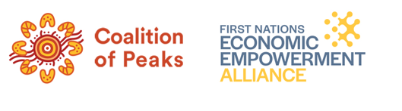
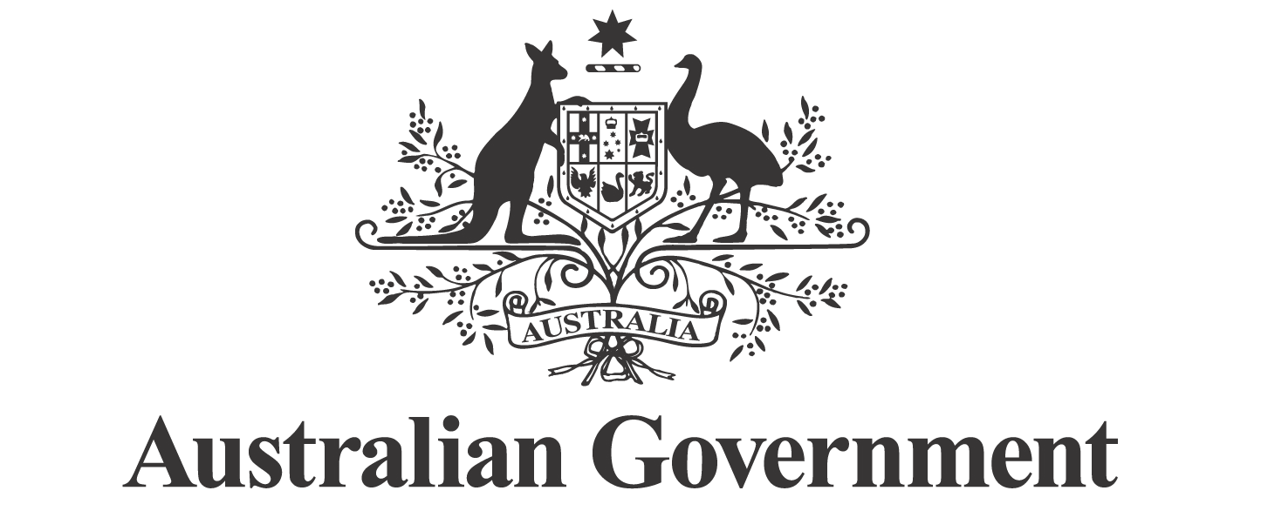
First Nations Economic Partnership Meeting 18 February

Communiqué

The third meeting of the First Nations Economic Partnership (Economic Partnership) was held in Canberra on 18 February 2026. The Partners discussed Working Groups that are being established to advance immediate actions in the Economic Partnership agreement.
The meeting also addressed governance settings and resourcing for Economic Partnership activities. Government provided an update on the $16.9 million allocated to support the Partnership. Partners reviewed funding offers from the Government to enable the equal participation of First Nations Partners in the Economic Partnership.
There was substantial discussion on developing the First Nations Economic Framework which will set out a comprehensive vision for First Nations economic empowerment and include priority pillars to drive coordinated action across the Commonwealth Government. Members expect to continue discussions as a priority, to finalise an approach that supports timely delivery while respecting shared decision-making principles.
The Employment and Career Pathways Working Group’s work schedule was endorsed. The Working Group will be co-chaired by the Coalition of Peaks and the National Indigenous Australians Agency (NIAA). Partners agreed to hold early workshops, in parallel to settling resourcing, to maintain momentum.
Partners progressed the proposed approach and draft work schedule for the Access to Capital and Institutional Arrangements Working Group. The Working Group will be co-chaired by the First Nations Economic Empowerment Alliance and Treasury.
NIAA provided an update on the Indigenous Procurement Policy (IPP). Partners welcomed the briefing and highlighted the need for continued collaboration on strengthening outcomes, improving accountability, addressing exemption practices, and supporting greater participation for First Nations businesses, including in regional and remote areas.
Throughout this meeting First Nations Partners emphasised the importance of ensuring the Economic Partnership was implemented in full, ensuring transparency, and protecting the integrity of the Partnership model. The next Partnership meeting will be held on 20 May 2026.

