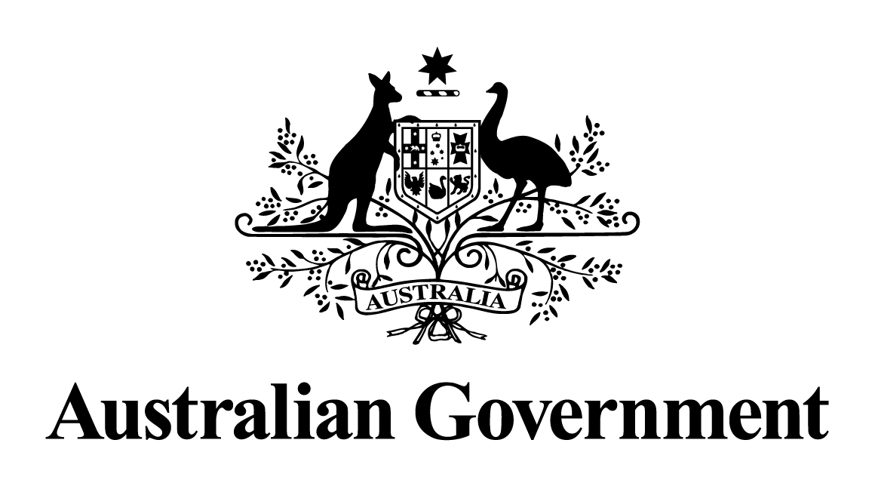
Australian Government response to the Parliamentary Joint Committee on Corporations and Financial Services report:
Ethics and Professional Accountability: Structural Challenges in the Audit, Assurance and Consultancy Industry
February 2026
Australian Government response to the Parliamentary Joint Committee on Corporations and Financial Services report: Ethics and Professional Accountability: Structural Challenges in the Audit, Assurance and Consultancy Industry

Government engagement with consultancy firms
The Government notes Recommendations 1, 29, 30, 31 and 34.
Government Response
Ethical Suppliers
The Government expects its suppliers to conduct themselves with high standards of ethics such that they consistently act with integrity and accountability. The Australian Government has undertaken a range of actions to strengthen supplier integrity and contract transparency.
The Australian Government has developed the Commonwealth Supplier Code of Conduct (Code) as a key measure to strengthen supplier behaviour. The Code sets out the Government’s expectation for suppliers to uphold similar values and behaviours to those expected of public officials in the APS Values. The Code notes that the standards and values expected of public servants are not expressed in terms of public interest.
The Code, which came into effect on 1 July 2024, places obligations on suppliers and their subcontractors to act ethically while under contract with the Commonwealth. In particular, Expectation 1.4 – Emulate the Australian Public Service (APS) Values, states that: “When a supplier is undertaking work on behalf of the Commonwealth, they must uphold similar values and behaviours to those expected of public officials in the APS Values. This is always important, but particularly relevant where a supplier interacts with, or provides services to, the Australian Public”.
The Commonwealth Contracting Suite and ClauseBank include standard clauses for inclusion in Commonwealth contracts, placing contractual obligations on suppliers to meet the expectations set out by the Code. Failure to adhere to the Code may result in remedial action and/or termination in accordance with contractual provisions. Guidance for Commonwealth entities is available on the Department of Finance (Finance) website to assist officials in managing these contractual obligations.
Additionally, the Contract Management Guide, updated in August 2025, reinforces the importance of managing the ethical conduct of suppliers, and ensures officials responsible for managing Commonwealth contracts are aware of the obligations of all parties under the Code.
In relation to PricewaterhouseCoopers Australia (PwC Australia), in mid-2025, Finance completed its review of the ethical soundness of PwC Australia. The final report is available on the Finance website.
Encouraging SMEs
In October 2025, the Government announced amendments to the Commonwealth Procurement Rules to require that Australian suppliers were first approached for certain procurements, including that Small and Medim Enterprises were first approached for any procurement below $125,000 from the Management Advisory Services Panel, People Panel, or any standing offer managed by the Digital Transformation Agency.

Government consultation on the regulation of accounting, auditing and consulting firms in Australia
The Government notes Recommendations 2, 3, 4, 5, 6, 7, 8, 9, 10, 11, 12, 13, 14, 15, 16, 17, 18, 19, 21, 25, 26, 27, 32, 33, 35, 36, 37, 38, 39 and 40.
Government Response
The Government has taken decisive action to strengthen the regulation of accounting, auditing and consulting firms in Australia. This includes legislative changes:
- to strengthen the powers of the Tax Practitioners Board (TPB) to improve regulation and transparency within the tax profession in the Treasury Laws Amendment (2023 Measures No. 1) Act 2023 (Cth)
- to enhance obligations for tax practitioners through the Tax Agent Services (Code of Professional Conduct) Determination 2024
- through the Treasury Laws Amendment (Tax Accountability and Fairness) Act 2024 (Cth) to:
  - amend the promoter penalty laws to strengthen the Australian Taxation Office’s (ATO) enforcement powers and provide a broader range of tools to regulators to identify and discipline those who break the law
  - extend whistleblower protections to eligible whistleblowers who make disclosures to the TPB or the ATO, where the whistleblower considers that the information may assist the TPB in performing its functions or duties.
The Treasury Laws Amendment (Tax Accountability and Fairness) Act 2024 (Cth) broadened the ATO’s enforcement powers by:
- increasing the time the ATO has to bring an application for civil penalty proceedings (to 6 years)
- raising the maximum penalty applicable for firms which promote tax exploitation schemes from $7.8 million to over $780 million
- broadening the scope of key definitions in the law to extend the scope of the promoter penalty laws to all ATO rulings, ensuring that the laws prohibit the promotion of a scheme on the basis of a false assertion that it has ATO endorsement.
Treasury coordinated a whole-of-government response to systemic issues in the regulatory and tax environment. This work considered options to strengthen regulatory frameworks, improve transparency and accountability, as well as incentivise good behaviour and deal with misconduct. To date, the Government has consulted on:
- a review of the sanctions regime that the TPB administers, released on 10 December 2023
- a review of the ATO and the TPB’s respective investigation and information gathering powers, released on 3 May 2024
- a review of the tax practitioner registration requirements, released on 17 July 2024
- a review of the penalty regime that applies to promoters of tax exploitation schemes, released on 4 October 2024
- a review of the secrecy provisions that restrict information sharing by government tax regulators, released on 20 December 2024
- a joint review with the Attorney-General’s Department of the use of legal professional privilege in Commonwealth investigations, released on 23 December 2024
- the regulation of accounting, auditing and consulting firms in Australia in May 2024, which considered the issues outlined in these recommendations, including:
  - the governance and regulation of partnerships, and audit and multidisciplinary firms
  - the provision of non-audit services and potential conflicts of interest
  - the role and enforcement powers of key regulators
  - transparency, public information and reporting issues
  - competition and resilience of the audit sector
  - protections available to whistleblowers.
The Government will continue to consider these matters as part of ongoing policy work. Treasury will also consult publicly on whether the tax and corporate whistleblowing frameworks are working as intended as part of its statutory review of those frameworks.

Government consultation on the merging of the Australian Accounting Standards Board, the Auditing and Assurance Standards Board and the Financial Reporting Council
The Government notes Recommendations 20, 22, 23, 24 and 28.
Government Response
In October 2025, the Government released for consultation exposure draft legislation to combine the Australian Accounting Standards Board, the Auditing and Assurance Standards Board and the Financial Reporting Council into a single body.
There are a number of recommendations from the Parliamentary Joint Committee on Corporations and Financial Services’ report that the exposure draft legislation responded to:
- Treasury will no longer provide a Secretariat function to the standard setting body once it is established.
- The exposure draft legislation would require the Minister, in making appointments to the new combined body’s Governing Council, to have regard to the principle that the Governing Council as a whole, and as an entity that engages in collective decision-making, should contain an appropriate level of representation of persons who are, and are seen to be, independent from Australian auditors. This balanced approach ensures that the new standard setting body can continue to access appropriate expert representation as appropriate at the Governing Council level without enabling strategic decision-making to be controlled or overly influenced by representatives from a particular industry or with a particular financial incentive.
- The exposure draft legislation would supplement the disclosure of interests requirements applying to statutory officeholders under the Public Governance, Performance and Accountability Act 2013 by requiring members to disclose interests as soon as practicable after they become known, to strengthen the Governing Council’s ongoing oversight and management of conflicts of interest.
- The exposure draft legislation would require the Chair of the Governing Council to determine a code of conduct for the new body that applies to members of the Governing Council and standard setting boards (among others).
- The exposure draft legislation would empower the Minister, by legislative instrument, to specify additional functions to be performed by the new body. This will add flexibility to the new institutional arrangements and better position the body to respond to future standard setting needs.

https://www.finance.gov.au/sites/default/files/2025-08/examination-of-pwc-australias-ethical-soundness.pdf

