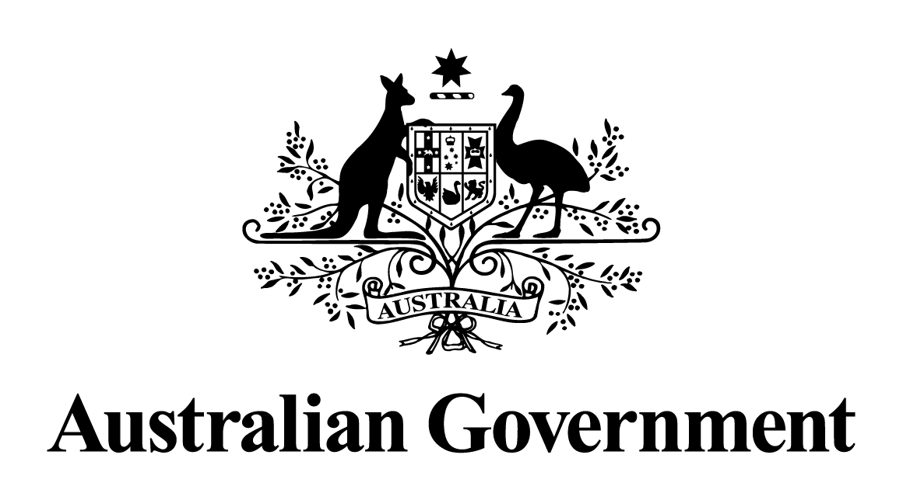
Australian Government response to the
Senate Committee Economics report:
Inquiry into Treasury Laws Amendment (Responsible Buy Now Pay Later and Other Measures) Bill 2024
September 2025

Introduction
The Treasury Laws Amendment (Responsible Buy Now Pay Later and Other Measures) Bill 2024 amends the law relating to taxation, consumer credit, the Medicare levy and federal financial relations in the Treasury portfolio.
The Bill passed both Houses on 29 November 2024 and received Royal Assent on 10 December 2024.
The Government thanks the Senate Economics Legislation Committee for its inquiry into the Bill, and thanks those organisations and individuals who made submissions to the inquiry and participated in the public hearing.
The Government’s responses to the recommendations made in the Committee’s final report are provided below. In line with the guidelines on Government responses, recommendations that a bill or bills be passed, rejected, or amended have not been responded to.

Response to the recommendations made by the dissenting report of Coalition Senators
Recommendation 1
That Treasury conduct a more detailed consultation on delegated legislation that accompanies the Bill, including to address duplicative fee caps and opportunities to harmonise modified responsible lending obligations with New Zealand’s BNPL regulatory framework.
Australian Government response
the Government notes this recommendation.
The Government conducted extensive consultation on the proposed framework for the Buy Now Pay Later sector.
During the period 2022 to 2025, Treasury and the Assistant Treasurer worked closely with Buy Now Pay Later (BNPL) providers, consumer groups, regulators and other stakeholders in relation to the proposed framework. Through this process, stakeholders were given an extensive opportunity to put forward their views, including in relation to fee structures and responsible lending obligations. In particular:
- Treasury conducted consultation on an options paper between 21 November 2022 and 23 December 2022.
- The Government consulted on initial draft regulations, together with draft legislation, from 12 March 2024 to 9 April 2024.
- Following the release of the Senate Economics Legislation Committee report in August 2024, Treasury considered the recommendations of the report.
- Further targeted consultations were undertaken with stakeholders between April 2024 and February 2025.
- Treasury released a subsequent updated version of the draft regulations for consultation from 5 February 2025 to 12 February 2025.
The National Consumer Credit Protection Amendment (Low Cost Credit) Regulations 2025 were registered on 7 March 2025 and commenced on 10 June 2025 concurrent with the main operating provisions of the Treasury Laws Amendment (Responsible Buy Now Pay Later and Other Measures) Act 2024.

Recommendation 3
That the Government should demonstrate why the Smart Energy Council is worthy of DGR status and explain how it has satisfied itself that it does not exist solely for political purposes.
Australian Government response
the Government notes this recommendation.
There are two types of deductible gift recipients (DGR): those endorsed under the general categories set out in the tax law; or those listed by name in the tax law (specific listing). The Smart Energy Council has maintained DGR status under one of the general categories since it was added to the Register of Environmental Organisations in 1998 by the then Howard Government.
The ATO is independently responsible for the assessment of DGR eligibility for environmental organisations such as the Smart Energy Council. The Commissioner of Taxation may revoke DGR endorsement at any time if an organisation is found to be in breach of eligibility requirements outlined in the tax law.
The Government also recognises the important role the Australian Charities and Not-for-profits Commission (ACNC) plays in assessing whether organisations are eligible to be registered as charities, including whether they exist solely for political purposes.
Not for profit entities generally need to be registered as a charity with the ACNC before obtaining DGR status, and the Smart Energy Council is no exception. Registered charities are subject to strict rules and guidelines governing their charity registration and operations. If these rules are contravened, the ACNC may revoke the registration of a charity, which will impact access to tax concessions.

Recommendation 4
That the Government should demonstrate why the International Campaign to Abolish Nuclear Weapons, Australia Inc is worthy of DGR status, and explain how it has satisfied itself that it does not exist solely for political purposes, before a grant of DGR status should be made.
Australian Government response
the Government notes this recommendation.
There are two types of deductible gift recipients (DGR): those endorsed under the general categories set out in the tax law; or those listed by name in the tax law (specific listing). The International Campaign to Abolish Nuclear Weapons, Australia Inc is specifically listed by name in the tax law.
The process for specifically listing an entity as a DGR is intended to only be used by exception where an entity has exhausted all options for DGR endorsement under the general categories in the tax law. Proposals for specific listing are assessed against a range of considerations, including the unique characteristics of the entity and the broad public benefit of their activities.
The Government recognises the important role the Australian Charities and Not-for-profits Commission (ACNC) plays in assessing whether organisations are eligible to be registered as charities, including whether they exist solely for political purposes.
Not for profit entities generally need to be registered as a charity with the ACNC before obtaining DGR status, and the International Campaign to Abolish Nuclear Weapons Australia Inc is no exception. Registered charities are subject to strict rules and guidelines governing their charity registration and operations. If these rules are contravened, the ACNC may revoke the registration of a charity, which will impact access to tax concessions.

Recommendation 5
That the instant asset write-off threshold be increased to $30 000 and be made permanent, to restore the business investment incentive policy to 2019–20 levels.
Australian Government response
the Government does not support this recommendation.
The Government improved cash flow and reduced compliance costs for small business by legislating the $20,000 instant asset write-off for small businesses from 1 July 2023 to 30 June 2025. Without this change, the instant asset write-off would have reverted to $1,000.
Small businesses with aggregated annual turnover of less than $10 million that are in the simplified depreciation regime can claim an immediate deduction for eligible assets costing less than $20,000 in their 2024-25 tax returns. The $20,000 threshold applies on a per asset basis, so small businesses can instantly write off multiple assets. Assets costing $20,000 or more can continue to be placed into the small business simplified depreciation pool and depreciated at set rates.
On 4 April 2025, the Government announced the election commitment to support small businesses by extending the $20,000 instant asset write-off for a further 12 months until 30 June 2026.

