
Review of the Motor Vehicle Service and Repair Information Sharing Scheme
Final Report
February 2026

© Commonwealth of Australia 2026
ISBN: 978-1-923278-33-2
This publication is available for your use under a Creative Commons Attribution 4.0 International licence, with the exception of the Commonwealth Coat of Arms, the Treasury logo, photographs, images, third party materials, materials protected by a trademark, signatures and where otherwise stated. The full licence terms are available from creativecommons.org/licenses/by/4.0/legalcode.
Use of Treasury material under a Creative Commons Attribution 4.0 International licence requires you to attribute the work (but not in any way that suggests that the Treasury endorses you or your use of the work).
Treasury material used ‘as supplied’
Provided you have not modified or transformed Treasury material in any way including, for example, by changing the Treasury text; calculating percentage changes; graphing or charting data; or deriving new statistics from published Treasury statistics – then Treasury prefers the following attribution:
Source: The Commonwealth of Australia.
Derivative material
If you have modified or transformed Treasury material, or derived new material from those of the Treasury in any way, then Treasury prefers the following attribution:
Based on Commonwealth of Australia data.
Use of the Coat of Arms
The terms under which the Coat of Arms can be used are set out on the Department of the Prime Minister and Cabinet website (see www.pmc.gov.au/government/commonwealth-coat-arms).
Other uses
Enquiries regarding this licence and any other use of this document are welcome at:
Manager
Media Unit
The Treasury
Langton Crescent
Parkes ACT 2600
Email: media@treasury.gov.au
In the spirit of reconciliation, the Treasury acknowledges the Traditional Custodians of country throughout Australia and their connections to land, sea and community. We pay our respect to their Elders past and present and extend that respect to all Aboriginal and Torres Strait Islander peoples.

Contents
Executive Summary 1
Chapter 1 – Introduction 4
The scheme 5
The Review 6
Chapter 2 – Promoting competition and consumer choice 8
Competition in repair markets 9
Impact on automotive repair sector 11
Impacts on consumers 15
Chapter 3 – Information access 19
The price of scheme information 20
Information accessibility 33
Chapter 4 – Protecting information 40
Safety information 41
Security information 47
Chapter 5 – The role of intermediaries 49
Accessing and distributing scheme information 50
Impact on intermediaries 51
Chapter 6 – Scope of information 53
Electronic logbooks 54
Telematics 56
Automated driving systems 59
Parts 61
Chapter 7 – Governance and enforcement 63
Role of the Scheme Adviser 63
Enforcement 67
Chapter 8 – Conclusion 76
Key terminology 78
Appendix A – Survey results 79
Appendix B – International frameworks 86
Appendix C – Analysis methodology 90

Executive Summary
The Motor Vehicle Service and Repair Information Sharing Scheme (the scheme) commenced on 1 July 2022 and is Australia’s first ‘right to repair’ law. It is contained in Part IVE of the Competition and Consumer Act 2010 (Cth) and has the primary objective of promoting competition in the Australian market for motor vehicle service and repair.
The scheme achieves this objective by requiring manufacturers’ service and repair information to be made available to independent repairers (and registered training organisations (RTOs) such as TAFEs) at a price not exceeding its fair market value. By doing so, it helps to provide a level playing field for third party repairers to compete with dealerships in the repair market. The scheme also imposes information sharing obligations on certain third party data providers.
The Commonwealth committed to a review of the scheme under Australia’s revitalised National Competition Policy (NCP) and as part of Treasury’s broader Competition Review examining how to improve competition across the economy. NCP is a shared vision amongst the Commonwealth, states and territories to build a more cohesive, vibrant and globally competitive economy. This review examines the extent to which the scheme is achieving its legislated objectives, considers whether the design of the scheme remains appropriate, and assesses its economic impact.
This Final Report of the Review of the Motor Vehicle Service and Repair Information Sharing Scheme finds that the scheme has contributed to a more competitive and productive repair market, supporting the growth of independent workshops and enhancing consumer choice. The scheme has also had a significant positive economic impact and has been associated with a $2.4 billion increase in repairer turnover since its introduction.
The Review identifies several opportunities to improve the scheme’s clarity, alignment with international frameworks, and adaptability to ongoing technological developments within the automotive sector. Consideration of the Review’s findings in consultation with industry will ensure the scheme continues to facilitate a fair playing field between Australian repairers, driving productivity and keeping Australians safely on the road.
The Review makes 11 findings:
Finding 1 | The Motor Vehicle Service and Repair Information Sharing Scheme (the scheme) is broadly realising its legislated objectives by encouraging competition between Australian repairers. The scheme supports consumer choice and has contributed to increased productivity and competition in the automotive repair sector.

Finding 2 | The scheme effectively regulates the price of scheme information, but there are some opportunities for enhancement to ensure information pricing remains accurate and transparent, including in relation to:  - Consistent pricing of information in Australian dollars  - The accuracy of scheme offers  - Factors relevant in determining Fair Market Value

Finding 3 | Where proprietary hardware is required to utilise scheme information, associated cost, functionality and access issues can significantly hamper independent repairers’ ability to compete. Providing tool manufacturers and data aggregators with improved access to scheme information may increase repairer choice of hardware, placing downward pressure on costs and benefiting consumers.

Finding 4 | The scheme generally supports timely access to the information needed by Australian repairers and RTOs. Bolstering access to scheme information in electronic formats and aligning timeframes with the operational realities of making information available with proprietary hardware, would increase certainty for data providers and ensure consistent aftermarket access to information.

Finding 5 | The scheme effectively protects safety and security information. However, the regulation of safety information under the scheme imposes a substantial regulatory burden on vehicle manufacturers, intermediaries and repairers. Alternative approaches which do not require the separation of safety information could provide an equivalent level of protection while improving sector productivity.

Finding 6 | Intermediaries are critical in providing Australian repairers and RTOs with the products and services needed to compete. Aligning their treatment under the scheme with comparable international frameworks is likely to better support the efficient flow of accessible and affordable information, reduce barriers to entry into the Australian automotive repair market and increase repairer productivity. Such an approach would also partly address challenges expressed by stakeholders in navigating OEM portals.

Finding 7 | The adoption of electronic logbooks is an emerging challenge for independent repairers. Regulated access to these records would ensure independent repairers are not disadvantaged in the transition to digital records and enable complete vehicle service histories to be efficiently maintained.

Finding 8 | The emergence of telematics and automated driving systems is not materially impacting independent repairers’ ability to compete at this time. However, continued collaboration across industry is required to ensure the scheme’s early competition and productivity benefits are retained as this technology is deployed further.

Finding 9 | The scheme’s governance arrangements are generally fit-for-purpose. Reducing routine reporting by data providers, while requiring system outage notifications to the Scheme Adviser, would enhance the transparency of scheme operations and reduce the overall regulatory burden imposed on data providers.

Finding 10 | Incomplete compliance with the scheme by some data providers risks undermining confidence in the scheme as a whole. Technical amendments to the scheme, including those aimed at improving regulatory clarity, could allow more timely and proportionate enforcement activities by the Australian Competition and Consumer Commission. More visible public enforcement would also assist in deterring non-compliance.

Finding 11 | The scheme's success to date reflects strong collaboration across the Australian automotive sector. Ongoing effective stewardship of the scheme will require continued industry engagement to ensure the scheme remains responsive to market developments.

- Introduction
Across jurisdictions, the ‘right to repair’ has emerged as a multi-faceted policy response to manufacturer-imposed constraints on the ability to repair goods such as electronics, appliances, motor vehicles, medical equipment and agricultural machinery. Manufacturer control over the information needed to repair and service goods can be used by manufacturers to restrict competition in the market for repairs. This dynamic may reduce opportunities for domestic value creation and result in consumers relying on higher cost authorised repairers. While ‘right to repair’ policy interventions vary globally, they typically aim to lower repair costs, support local repairers, and reduce waste by addressing barriers to entry in the repair sector.
The Motor Vehicle Service and Repair Information Sharing Scheme (the scheme) commenced on 1 July 2022 and is Australia’s first right to repair law. In November 2024, the Commonwealth committed to a review of the scheme under Australia’s revitalised National Competition Policy (NCP). The first tranche of reforms announced under the revitalised NCP had an express focus on relieving cost of living and regulatory burdens, and the Review of the Motor Vehicle Service and Repair Information Sharing Scheme forms part of this tranche.
The Review considered the extent to which the scheme is achieving its legislated objectives as set out in Box 1.1. It also assessed the early economic impact of the scheme and its impact on stakeholders.
Box 1.1: Objectives of the Motor Vehicle Service and Repair Information Sharing Scheme
The objectives of the scheme are to:
- promote competition between Australian repairers of passenger and light goods motor vehicles and establish a fair playing field by mandating access, on fair and reasonable commercial terms, to information used to diagnose, repair, service, modify or dismantle scheme vehicles
- enable consumers to have scheme vehicles diagnosed, repaired, serviced, modified or dismantled safely and effectively by an Australian repairer of their choice
- encourage the provision of accessible and affordable information about scheme vehicles to Australian repairers, and to registered training organisations (for training purposes)
- protect safety and security information about scheme vehicles to ensure the safety and security of consumers, information users and the general public, and
- provide for the resolution of disputes about the application of the scheme.
The capability of agencies, including the Australian Competition and Consumer Commission (ACCC) and Scheme Adviser, to perform functions under or in connection with the scheme, as well as the appointment arrangements for the Scheme Adviser, were not in scope of the Review.
This Final Report builds on the ACCC’s 2017 New Car Retailing Industry market study and the Productivity Commission’s 2021 Right to Repair Inquiry. The Review was also informed by the June 2025 update to the ACCC’s Guidance on the motor vehicle service and repair information sharing scheme for data providers (‘ACCC Regulatory Guidance’). The Review will inform consideration by the Commonwealth, states and territories regarding future directions of right to repair policy in Australia within the NCP framework.

The scheme
The scheme, contained in Part IVE of the Competition and Consumer Act 2010 (Cth) (‘CCA’), supports competition in the market for motor vehicle service and repair. The scheme establishes a fair playing field between Australian repairers by mandating access, on fair and reasonable commercial terms, to information used to diagnose, repair, service, modify or dismantle vehicles to which it applies (‘scheme information’).
The definition of scheme information is broad and captures a range of information that an Australian repairer needs to diagnose, repair, service, modify or dismantle scheme vehicles. This includes:
- manuals, technical service bulletins, wiring diagrams, technical specifications for components and lubricants and testing procedures (including in relation to environmental performance)
- information and codes for computerised systems (such as information that may appear on a scheme vehicle’s on-board display after being plugged into a computer system)
- information about a voluntary or mandatory recalled component of a vehicle and information needed to rectify the issue, and
- software updates, for example where necessary after replacement parts are installed to ensure the vehicle’s electronic systems recognise and accept the new part.
Generally, scheme information is prepared by or for vehicle manufacturers (or related entities) for use in diagnosing faults, servicing or repairing vehicles covered by the scheme.
The Competition and Consumer (Motor Vehicle Service and Repair Information Sharing Scheme) Rules 2021 (Cth) (the Rules), made by the Minister under section 57GE of the CCA, prescribe access criteria and other technical and administrative details necessary to implement the scheme.
Under the scheme, data providers must make information available in the same form for all repairers and RTOs or, if not practicable, in an electronic form that is reasonably accessible (‘main obligation’). Data providers may include:
- a motor vehicle manufacturer
- an Australian subsidiary of an overseas motor vehicle manufacturer
- an affiliated dealership
- an information owner or licensee
- a data aggregator who sells scheme information in its own right
- a scan tool provider providing aggregated scheme information such as diagnostic code interpretation
- an Australian new or used vehicle importer providing scheme information.
The main obligation allows independent repairers to access and use information to service and repair vehicles which may otherwise need to be returned to the dealership or authorised repairer. The scheme is Australia’s first ‘right to repair’ law.
Figure 1.1: Scheme overview
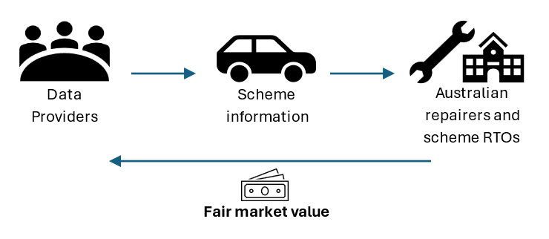
The scheme applies to passenger vehicles and light goods vehicles manufactured on or after 1 January 2002 (‘scheme vehicles’) and captures the majority of vehicles on Australian roads. The scheme does not apply to two- or three-wheeled vehicles, farm, construction or heavy vehicles, motor homes or buses.
Although some stakeholders advocated for expanding the definition of scheme vehicles to include categories such as motorcycles, heavy vehicles, and agricultural equipment, the Review’s primary focus was assessing the operation of the scheme in its application to passenger and light goods vehicles. However, the findings of the Review will complement broader policy work underway to strengthen Australia’s consumer protection and competition frameworks, and insights will inform whole-of-government consideration of future right to repair developments.
The ACCC administers the scheme with the day-to-day operation overseen by the Scheme Adviser, the Australian Automotive Service and Repair Authority (‘AASRA’). AASRA is a joint industry-led body appointed by the Australian Government on 24 February 2022 and reappointed for a period of two years from 1 July 2025. The functions of the Scheme Adviser include facilitating dispute resolution, sharing information about the scheme and reporting to the ACCC and the Minister about the operation of the scheme.

The Review
The Review of the scheme was established in March 2025 as part of Treasury’s broader Competition Review. Public consultation and engagement with industry formed a core part of the Review with Treasury releasing a discussion paper on 30 June 2025 inviting submissions by 4 August. The discussion paper sought views on a range of issues including:
- How effectively the scheme is operating in facilitating the provision of information from data providers to Australian repairers and scheme RTOs.
- The appropriateness of protections applying to safety and security information, and whether any barriers exist to accessing those types of information.
- The impact the scheme has had on stakeholders, including independent repairers, scheme RTOs, dealers and preferred repairers, and consumers of motor vehicle service and repair services.
- Whether the dispute resolution mechanisms available under the scheme are adequate and effective.
Treasury also released a short survey targeted at independent repairers and held an industry roundtable. A description of Treasury’s survey and a summary of the survey results is at appendix A.
Box 1.2: The Competition Review
In August 2023, the Treasurer announced a Competition Review to provide advice to Government on how to improve competition across the economy.
Coordinated by Treasury, the Competition Review is examining competition laws, policies and institutions to ensure they remain fit-for-purpose for the modern economy, with a focus on reforms that increase productivity, reduce the cost of living and/or lift wages.
The Review of the Motor Vehicle Service and Repair Information Sharing Scheme forms part of the Competition Review. More information on the Competition Review is available at treasury.gov.au/review/competition-review-2023.
The Review received 29 submissions in response to consultation and 308 survey responses from a variety of repairers. Submissions were received from a range of stakeholders participating in the scheme, including independent repairers, manufacturers, dealers, and tool makers. No submissions were received directly from RTOs participating in the scheme. The Review benefited from views shared by stakeholders as part of an industry roundtable, and approximately 20 additional bilateral meetings with domestic and international industry stakeholders. The Review has also taken into consideration views provided to Government since the commencement of the scheme, a report provided by the Scheme Adviser to the Minister regarding the operation of the scheme and advice provided by the Competition Review Expert Advisory Panel.
The outcomes of the Review are detailed over the following chapters:
- Chapter 2 – Promoting competition and consumer choice: examines how the scheme has affected competition in the automotive repair sector and enhanced consumer choice.
- Chapter 3 – Information access: explores the pricing and accessibility of scheme information, including practical challenges faced by repairers in obtaining and using information and hardware.
- Chapter 4 – Protecting information: discusses the scheme’s approach to safeguarding safety and security information and the requirements for accessing this information.
- Chapter 5 – The role of intermediaries: analyses the critical role of intermediaries, such as data aggregators and tool manufacturers, in distributing scheme information, and considers opportunities for better alignment with international frameworks.
- Chapter 6 – Scope of information: reviews the breadth of information covered by the scheme, including current exclusions, and assesses the need for future adaptation in response to evolving vehicle technologies.
- Chapter 7 –Governance and enforcement: outlines the governance and enforcement arrangements of the scheme, including the roles of the Scheme Adviser and ACCC, dispute resolution mechanisms, and opportunities for improving transparency and compliance.
- Promoting competition and consumer choice
Key points
- The scheme is broadly achieving its legislated objectives by encouraging competition among Australian repairers, increasing productivity, and supporting consumer choice.
- Since the scheme’s introduction, the automotive repair sector has experienced steady growth in business numbers, employment, and turnover.
- Among users of the scheme, reported benefits include significant improvements in productivity, profitability, ability to service a wider range of vehicles, and customer satisfaction; however, uptake is constrained by inconsistent awareness and barriers that hinder the scheme’s effectiveness.
- Uptake of the scheme varies significantly by firm characteristics, with more sophisticated firms more likely to benefit as they are better able to incorporate scheme information into existing workflows.
- Econometric analysis conducted as part of the Review found that, on average, the scheme has been associated with a 6.7 per cent expansion in industry turnover, equivalent to $2.4 billion in 2024.
- Consumers have benefited from greater choice and convenience, with a notable reduction in vehicles being turned away by repairers using the scheme and increased customer satisfaction reported by participating workshops.
- Despite these improvements, ongoing challenges such as delays in information provision and difficulties navigating manufacturer portals can adversely affect service speed and satisfaction.
Competition strengthens incentives for businesses to act efficiently and produce high quality goods and services that meet the changing needs of consumers at competitive prices. Competition drives efficiency and innovation, benefiting consumers and other businesses through lower prices and workers through higher wages. Over time, competition contributes to higher aggregate output, productivity and real wages.
Competition creates market conditions where firms are incentivised to differentiate their offerings, leading to a broader range of products that cater to diverse consumer preferences. When new businesses are free to enter the market and challenge incumbents, the increase in competitive pressure spurs businesses to improve, providing consumers with greater choice at lower prices. These benefits are central to the Commonwealth-state long-term commitment to a revitalised NCP.
The Review provides an opportunity to examine the impact of the scheme to date. Understanding how repair markets are structured, and the competitive dynamics within them, is an important first step in examining the effectiveness of the scheme and building the evidence base for right to repair policy in Australia. This chapter examines the dynamics of competition in repair markets and the impact of the scheme on the automotive repair sector and consumers.

Competition in repair markets
Secondary markets, or aftermarkets, supply products or services (‘secondary products’) used in conjunction with an existing product that has already been acquired (‘primary product’). In the motor vehicle sector, the primary market involves the sale of vehicles, while the secondary market includes repair and maintenance services. These secondary markets are heavily shaped by the conduct of original equipment manufacturers (OEMs), who exercise control over, and access to, information, parts and tools used in the provision of secondary market goods and services.
Participants in the secondary market fall into two broad categories:
- Authorised entities, such as dealerships, operating within OEM-branded networks and benefiting from direct access to information, parts and tools.
- Independent entities, such as independent service and crash repairers, operating outside these networks and ranging from small owner-operated garages to franchised service chains.
OEMs’ vertical integration provides authorised repairers with certain competitive advantages, including having direct access to product knowledge, technical specifications on how to repair and service vehicles, access to major suppliers of parts and economies of scale from the OEMs’ global footprint. By contrast, the majority of independent repairers provide an ‘all makes and models’ service offering, engaging with a variety of OEMs and aftermarket providers in order to access the inputs needed to service a wide range of vehicles.
Independent workshops account for approximately 60 per cent of total vehicle service and repair activities, and play a critical role in meeting consumer demand. The services provided by independent repairers can be particularly critical in regional areas where access to authorised repairers may be limited. Despite the significance of independent repairers in the secondary market, OEMs may seek to leverage their position in the primary market to restrict competition in the secondary market by limiting access to repair information or controlling supply chains. These practices can raise barriers to entry, lower competition, and reduce consumer choice.
While the sale of vehicles occurs in a relatively competitive environment, the repair and servicing of those vehicles takes places in a secondary market that is often shaped by OEM control. This lack of competitive discipline in the secondary market may result in reduced consumer choice and affordability when seeking repairs.
Pricing in the secondary market can depend on the competitive structure of the primary market. When competition in the primary market is high businesses may lower prices to attract buyers, then offset resultant lower margins by raising prices in the secondary market. This dynamic is known as the ‘waterbed effect’. Analogously, gaming console manufacturers may price consoles competitively, sometimes at a small loss to attract buyers, with the aim of making profits on game sales, subscription services or accessories. In vehicle markets, this could mean competitive vehicle pricing is paired with inflated repair costs, particularly if OEMs restrict access to repair services.
Due to limited information or behavioural biases, consumers may underestimate the total cost of ownership at the point of purchase. This can be exploited by ‘locking-in’ consumers to proprietary products and services in the secondary market at the time of sale. This lock-in can reduce aftermarket competition by increasing the cost, financially or logistically, of switching to independent providers. A less competitive secondary market also has non-price impacts on consumers, and may result in fewer independent repairers, increased repair and travel times, and less choice and convenience for consumers. Figure 2.1 shows a stylised depiction of the waterbed effect where there is limited competition in the secondary market. Here, firms restrict aftermarket competition to increase the price of repairs. Firms also use the increased profits to lower prices of the primary product to attract consumers.
Figure 2.1: Representation of the waterbed effect
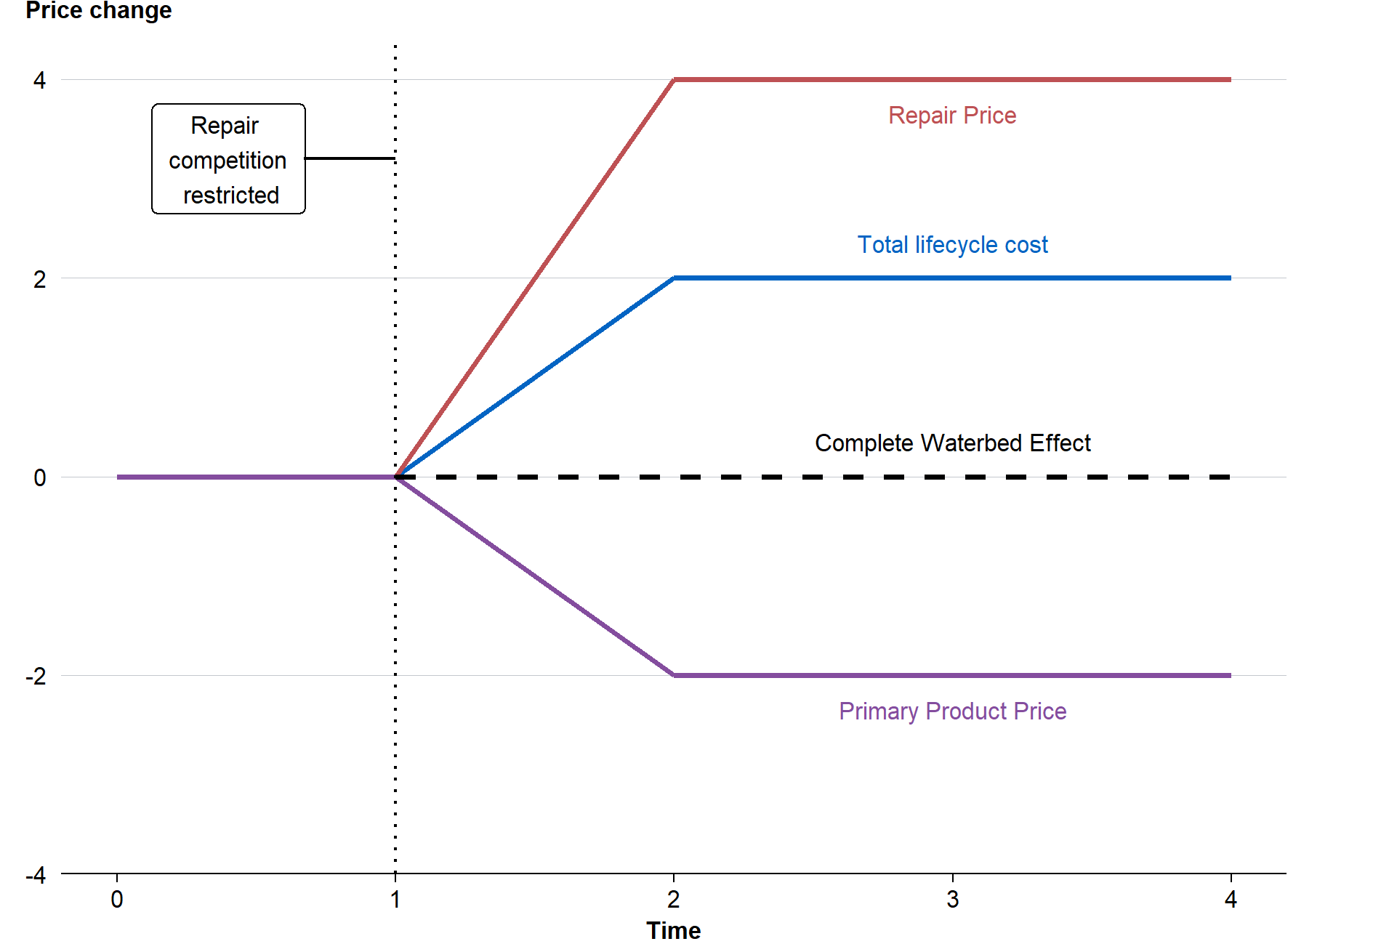
A competitive secondary market places downward pressure on prices so that consumers are protected from potential ‘waterbed’ effects, and facilitates greater consumer choice, control and convenience. A competitive secondary market can also improve service quality, innovation and business dynamism. While specific right to repair policies vary across jurisdictions, these interventions have the common goal of levelling the playing field between authorised and independent entities in the secondary market. In an Australian context, the scheme aims to promote competition in the secondary market by improving access to information used to diagnose, repair and service vehicles for independent repairers and scheme RTOs. The scheme directly targets information asymmetry and OEM control over critical repair information – two mechanisms that would otherwise limit competition in the repair sector.
The effects of right to repair interventions differ across markets. Economic theory suggests that the response of manufacturers to right to repair policies will depend on a number of factors including cost of supplying the product, as well as the (sometimes strategic) trade-offs between pricing, repairability and product lifespan:
- Low production cost goods: Manufacturers often adopt a volume-based strategy. As right to repair laws may reduce the incentive for consumers to replace products, firms may respond by further lowering prices to discourage repair and resale. While lower prices benefit consumers this may also lead to increased waste.
- Intermediate production cost goods: Manufacturers may initially follow a volume-based strategy, but as independent repair costs decline, may switch to raising the purchase price and facilitating repairs, prolonging product life and increasing the use value and resale value of the product.
- High production cost products: Manufacturers have a stronger incentive to ensure the products last longer, so facilitating repair can enhance the product’s value, support resale markets, and justify higher upfront prices.
Motor vehicles have high production costs where product longevity is valued by consumers. As a result, theory suggests right to repair policies are more likely to deliver net positive outcomes. International evidence supports this view. For example, right to repair laws implemented in Massachusetts have been found to have a positive and significant impact on the number and proportion of small motor vehicle repair shops in the market.
The complex nature of secondary markets and the variety of potential market responses to right to repair policies highlight the importance of tailored interventions, stakeholder consultation and sector-specific economic analysis. The following sections examine the impact of the scheme on the local automotive sector and consumers since its introduction.

Impact on automotive repair sector
The automotive repair sector plays a critical role in keeping Australia moving. To understand how the sector has evolved in recent years, and to contextualise the environment in which the scheme was introduced, the following sections examine key trends in business growth, employment, and turnover in the automotive repair sector, followed by an analysis of the scheme’s economic impact.
As of 2024, the automotive repair and maintenance sector comprised of approximately 50,000 businesses, employing 141,000 people nationally, with an average of three employees per firm, and generating a total of $35 billion in turnover. Independent repairers account for the majority of businesses and work undertaken while dealerships dominate warranty servicing and higher-value repairs. In 2024, independent workshops accounted for 60 per cent of all service and repair activities, and are largely small businesses, with the majority of firms being non-employing, or employing between one and four people.
To establish baseline conditions before the scheme was introduced and understand broader industry shifts, Figure 2.2 illustrates changes in business count and turnover over the last decade. The motor vehicle repair industry has experienced steady growth, with the number of businesses increasing 20 per cent, from 41,500 in 2014 to 50,000 in 2024, and total nominal turnover rising by 82 per cent over the same period. Employment has also expanded by approximately 31,000 positions.
Figure 2.2: Trends in automotive repair and maintenance business count and turnover
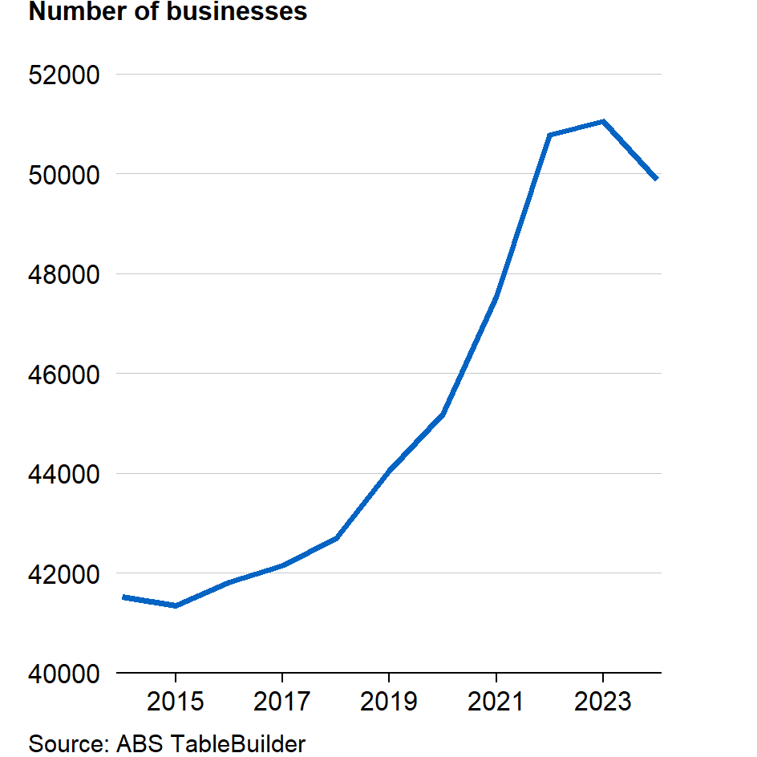  Source: ABS TableBuilder | 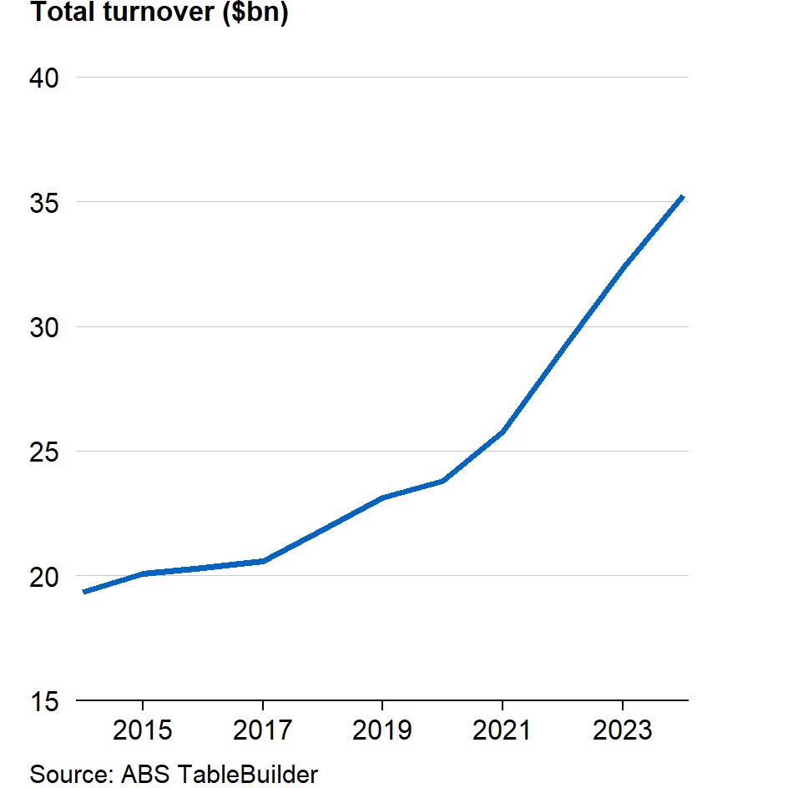  Source: ABS TableBuilder
Growth has not been uniform across all firms. Larger businesses (firms with more than three full time equivalent staff) have outpaced smaller operations in turnover, employment and business count, suggesting that scale and access to capital have enabled these firms to capture growing demand for vehicle maintenance and repair.
Demand for automotive repair services is closely tied to the size and utilisation of Australia’s passenger vehicle fleet. Over the past decade, the number of registered vehicles covered by the scheme increased from 11 million in 2014 to 17.5 million in 2024, while total vehicle kilometres travelled rose by five per cent to approximately 234 billion kilometres (Figure 2.3). Noticeably, while the COVID-19 pandemic caused a temporary dip in kilometres travelled, this primarily impacted metropolitan areas and was relatively short lived, with demand for servicing rebounding strongly as restrictions eased and travel patterns normalised. These trends reflect both population growth and demand for private vehicles for transport. As the fleet of scheme vehicles grows and ages, the need for maintenance and repair increases, further contributing to demand for automotive repair services which are covered by the scheme.
Figure 2.3: Trends in vehicle kilometres travelled and registered vehicles
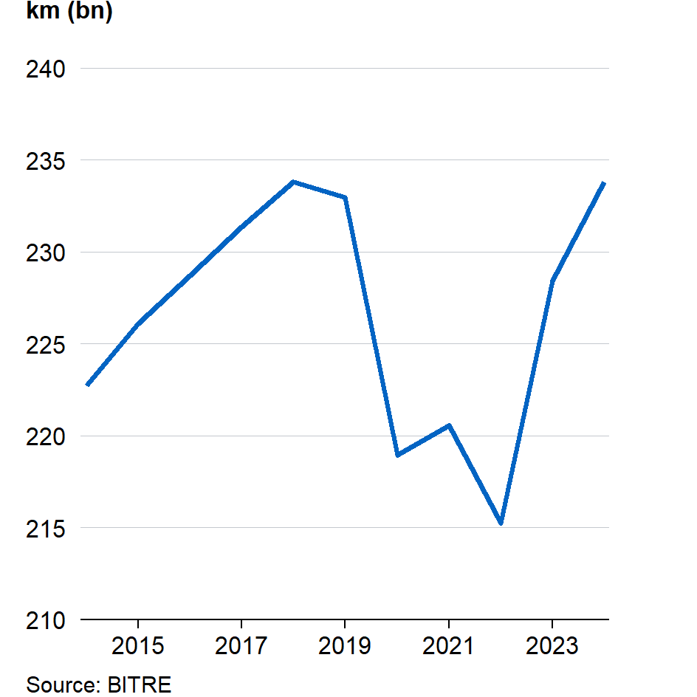  Source: BITRE | 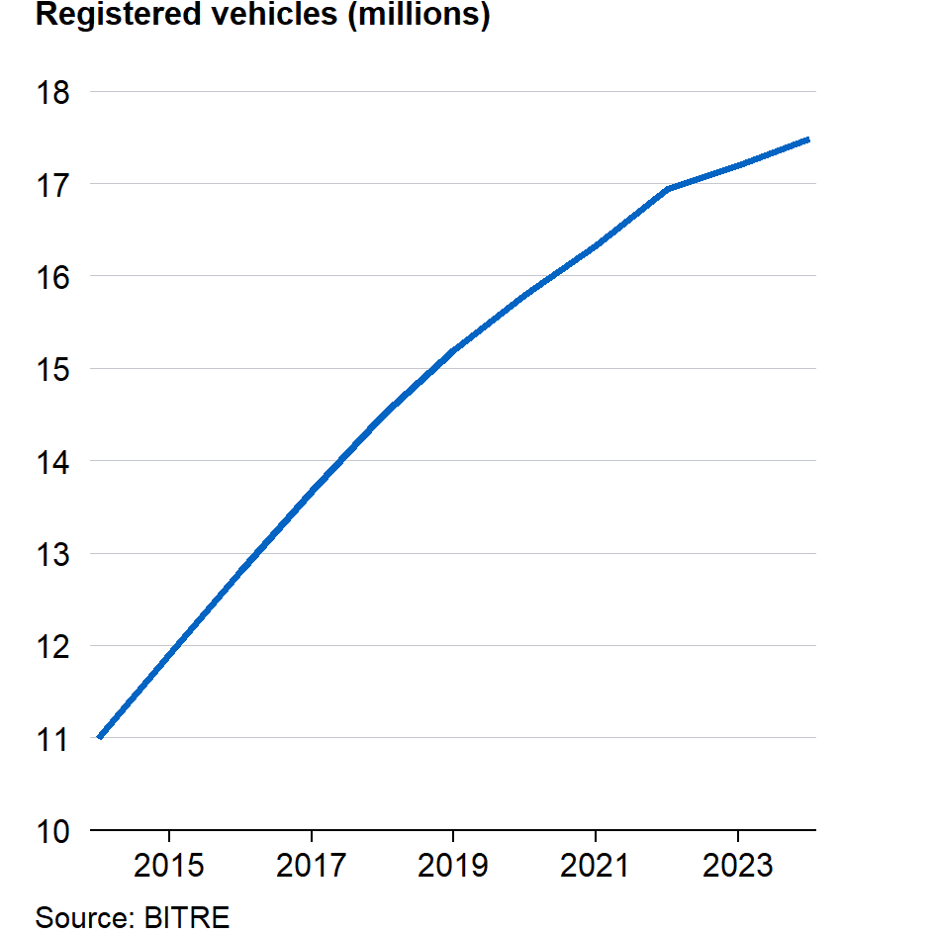  Source: BITRE
Competitiveness in the automotive repair sector is critical for ensuring fair pricing and providing consumers with choice. The Productivity Commission’s 2021 Right to Repair Inquiry examined several high-level competition indicators to assess the state of competition in several repair markets, including market concentration, profit margins, and barriers to entry and exit.
At an aggregated industry level, the motor vehicle repair sector appears to be broadly competitive, with no clear evidence of widespread market power (as measured by the Herfindahl-Hirschman Index, a standard measure of market concentration), similar entry and exit rates to other repair industries, and no sustained increase in profit margins, suggesting limited pricing power. These findings suggest there is no immediate evidence of systemic competition issues at the industry level. However, due to data aggregation at the industry and national level, these metrics may obscure product-specific or regional disparities.
Despite no clear indications of lack of competition from these metrics, it does not mean competition issues are absent altogether. The ACCC’s New Car Retailing Industry market study noted that competition in the supply of aftermarket services for cars is less robust due to several factors:
- The ability of vehicle manufacturers and dealers to control access to inputs and information needed for repair and servicing of vehicles.
- Consumers misunderstanding warranty and servicing requirements.
- High switching costs once consumers have purchased a particular brand of vehicle.
While high level indicators suggest a broadly competitive market, the ACCC’s analysis highlighted deeper structural issues, particularly around access to repair information. These features of the repair industry underpin the rationale for the scheme, which aims to reduce information asymmetries and improve competitive conditions for independent repairers.
Independent repairers, who make up the majority of businesses and perform most repair services across the sector, report mixed but generally positive outcomes from the scheme. A survey conducted by Fifth Quadrant on behalf of the Australian Automotive Aftermarket Association (AAAA) found 87 per cent of workshops are aware of the scheme, yet AASRA membership remains modest relative to the size of the sector’s workforce, at around 3,000 members.
Among users of the scheme, reported benefits include significant improvements in productivity, profitability and ability to service a wider range of vehicles. Amongst firms surveyed by industry, around 60 per cent reported a positive impact on revenue and profitability. However, uptake is constrained by several barriers, detailed in this report, that limit the scheme’s ability to correct for information asymmetries. Information sharing amongst technicians within workshops also complicates assessments of the scheme’s overall reach.
Uptake varies significantly by firm characteristics. The Fifth Quadrant survey found that while 63 per cent of surveyed workshops used the scheme, usage was only 22 per cent amongst ‘Foundational’ firms, compared to 66 per cent and 93 per cent for ‘Developing’ and ‘Leader’ firms respectively. This difference in uptake suggests that the scheme is likely to disproportionately benefit larger and more sophisticated firms who can more effectively incorporate scheme information into their workflows.
Dealerships, by contrast, reported minimal direct impact associated with the scheme. While data providers incur compliance costs for making scheme information available, authorised entities retain advantages in access to information, proprietary tools and training, and are the preferred option for warranty servicing.

Econometric analysis
To assess the impact of the scheme on business, the Review compared business outcomes before and after the scheme’s commencement. The scheme took effect on 1 July 2022, providing a clear point in time to evaluate changes. By controlling for factors that influence demand for vehicle repairs, the analysis sought to isolate the scheme’s effect on business performance.
The Review analysed whether the scheme has been associated with changes in inflation-adjusted business turnover since its introduction, using firm-level data from automotive repair businesses that employed at least one full-time equivalent staff member, and reported quarterly turnover of at least $50,000. The dataset covers 2013–14 to 2023–24 financial years and includes businesses from across Australia.
To estimate the scheme’s average impact of business turnover, the Review employed statistical analysis comparing firm outcomes over time while accounting for differences between firms. This involved comparing firm turnover before and after the scheme’s introduction and controlling for changes in factors such as kilometres driven by vehicles, population growth, gross state product – all of which influence demand for vehicle repair and servicing. The model also controlled for previous levels of capital expenditure by firms and employment to account for prior investment and workforce capacity, which could affect a workshop’s ability to respond to future demand. The analysis also accounted for state-level differences in geography and market conditions across Australia. Additional detail on the modelling approach adopted is at appendix C.
Results of the Review’s econometric analysis suggest that, on average, the scheme is associated with a positive increase in firm turnover. Specifically, the introduction of the scheme is associated with a 6.7 per cent expansion in turnover compared to pre-scheme periods and after controlling for other factors influencing demand for automotive repair and maintenance services. For the automotive repair industry as a whole, this translates to around $2.4 billion per year. Given that small and independent businesses comprise the majority of firms in the industry, and are responsible for most servicing and repair work, it is these businesses who stand to benefit from improved access to vehicle information. With broader access, small and medium sized businesses are better equipped to service a wider range of makes and models, and spend less time locating scheme information, improving efficiency and expanding their customer base.
While this analysis suggests the scheme had a positive impact on aggregate business turnover, it is important to note that the scheme commenced at the same time that COVID-19 travel restrictions were eased. While the chosen econometric specification controls at least partly for the effects of COVID-19 on vehicle usage, it is difficult to entirely separate the scheme’s effect from the broader economic recovery from the COVID-19 pandemic. In addition, it is not possible to identify which specific businesses accessed scheme information, limiting the ability to assess the scheme’s direct effect on firms utilising the scheme compared with those who do not.
These caveats highlight the need for further data and analysis as scheme uptake improves, to better understand its effects on the industry.

Impacts on consumers
Resolving automotive concerns can be particularly challenging for consumers. The scheme aims to assist consumers, by enabling them to have scheme vehicles diagnosed, repaired, serviced, modified or dismantled by a repairer of their choice. The scheme does not encourage consumers to utilise the services of specific Australian repairers, but instead seeks to facilitate consumer choice of repairer, according to whatever factors are most important to them.
In many cases, consumers may be unaware of the information needed to carry out service and repair work and the potential limitations on the ability of an independent repairer to complete such work. If the scheme is operating effectively, it is likely that most consumers would not be aware of its existence. By contrast, if the scheme is not operating as intended, this may manifest in higher prices for repair services, or in independent repairers being unable to provide consumers with the services sought and instead referring consumers to a dealer or authorised repairer, even where the consumer would prefer to engage an independent repairer.
Stakeholders representing independent repairers reflected that the scheme’s impact on consumer choice was broadly positive. The AAAA’s submission to the Review noted that independent repairers who used the scheme have reported positive outcomes for customer satisfaction and improved customer convenience in delivering repair work.
Stakeholders representing manufacturers and dealers noted little to no impact on consumer outcomes. The Federal Chamber of Automotive Industries (FCAI) contended the scheme has had a negligible impact for consumers, including on their ability to choose a preferred repairer. The Australian Automotive Dealer Association (AADA) reported that market dynamics have been fundamentally unchanged since the introduction of the scheme, with the market being highly competitive and having no substantive barriers to consumer choice of repairer.
Feedback received through consultation regarding the scheme’s impact on consumers also noted concerns around overall awareness of the scheme amongst repairers. Improved engagement was posited to be important in driving greater benefits for consumers. A range of stakeholders, including O’Brien and the Queensland Law Society noted that, without greater awareness amongst consumers and repairers of the rights conferred by the scheme, consumers may continue to defer to dealer and preferred repairer networks for fear of compromising their vehicle’s manufacturer warranty, potentially undermining the scheme’s objectives.
The differing stakeholder perspectives on the scheme’s impact on consumers may reflect the multiple ways in which the scheme can affect consumers, and variation across these individual measures, including:
- reduced repair costs due to increased competition in the market for vehicle repairs
- greater choice as a result of reduced barriers to repair, and
- improved service quality due to improved information access.
In relation to the price effects of the scheme, motor vehicle repair prices have continued to broadly track inflation, as outlined in Figure 2.4. Analysis conducted as part of the Review found that motor vehicle repair prices are driven by several factors, including the cost of parts and of labour, and appear linked to the cost of purchasing motor vehicles (see appendix C). A positive relationship was observed between repair prices and the prices of spare parts, of labour, and of new vehicles, indicating that repair costs respond to, and are subject to, broader market dynamics. While no statistically significant impact from the scheme on prices was observed as part of this analysis, the short timeframe since the scheme’s introduction precludes any definitive conclusions being drawn about the long-term impact of the scheme on the price of repairs.
Figure 2.4: Motor vehicle repair Consumer Price Index (CPI) and economy-wide CPI
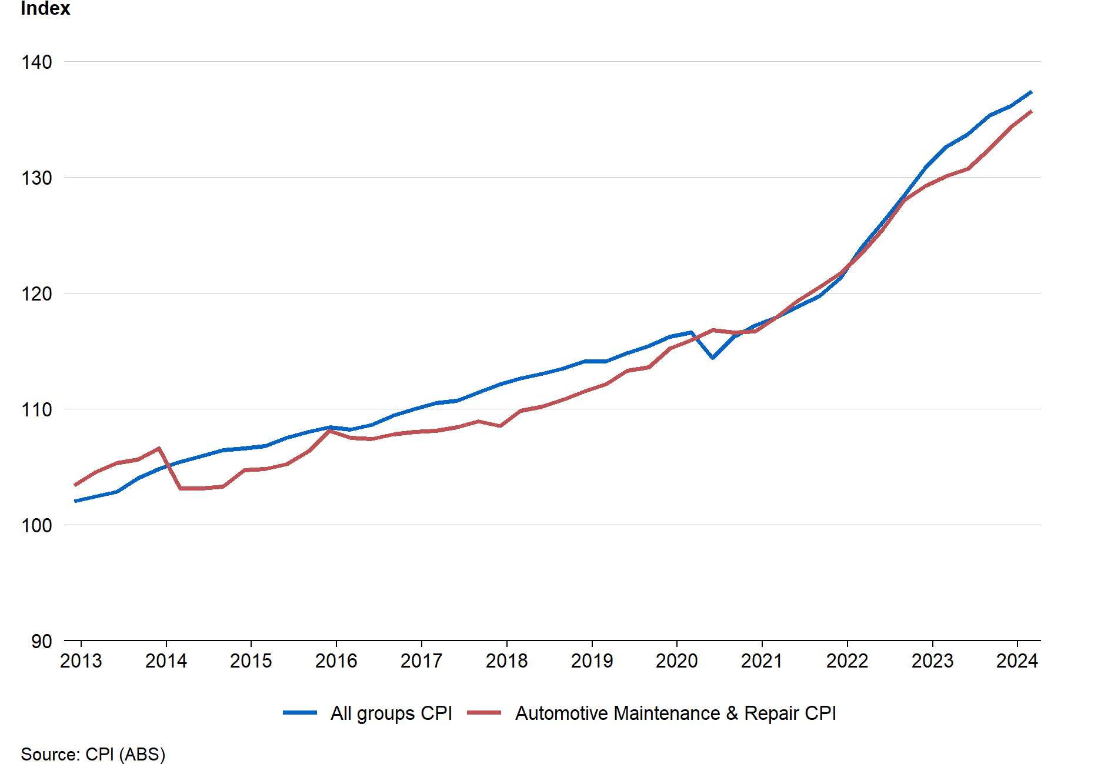
Source: CPI (ABS)
Beyond price, the scheme has played a significant role in expanding consumer choice by reducing barriers to repair and enabling more Australians to access the services they need from a repairer of their choice. Market research conducted by Fifth Quadrant on behalf of AAAA, surveying automotive repairers, reported a 40 per cent reduction in vehicles being turned away by repairers utilising the scheme. Notably, the reduction in the rate of turn-aways was reportedly higher amongst repairers who were not considered to be as technologically engaged or advanced, suggesting that the benefits of the scheme are being realised broadly, and not amongst a narrow group of specialised and technologically engaged workshops. Similarly, responses to Treasury’s survey indicated just 13 per cent of respondents frequently send vehicles to an authorised repairer due to limited access to repair information.
The same research conducted by Fifth Quadrant explored customer satisfaction and convenience, as reported by repairers. Amongst those using the scheme, approximately two thirds reported the scheme has had a positive impact on customer satisfaction (68 per cent) and a positive impact on customer convenience (66 per cent). Feedback to the Review gathered through the Treasury’s survey of repairers frequently highlighted the potential benefits of the scheme, though ongoing challenges with information access, including delays in timeliness of the provision of information and practical challenges in navigating online portals, were linked to slower service and poorer customer satisfaction.

Taken together, evidence obtained as part of the Review suggests that the scheme is benefiting consumers through increased choice of repairer, reduced instances of repairers being unable to service a vehicle, and through improved servicing and convenience by repairers who are engaged with the scheme. While the scheme does not appear to have had an impact on the price of vehicle repairs, it is expected that greater uptake the scheme by repairers over time will continue to deliver benefits to consumers.
Finding 1
The Motor Vehicle Service and Repair Information Sharing Scheme (the scheme) is broadly realising its legislated objectives by encouraging competition between Australian repairers. The scheme supports consumer choice and has contributed to increased productivity and competition in the automotive repair sector.

- Information access
Key points
- The scheme regulates the price of, and access to, scheme information and requires that it be supplied at a price not exceeding fair market value, and in a form reasonably accessible to all Australian repairers and RTOs.
- While the price of scheme information was generally not a major concern for most stakeholders, additional costs incurred to utilise scheme information, particularly in relation to proprietary hardware, can present substantial barriers for repairers.
- High costs, limited availability, and functionality restrictions of proprietary diagnostic hardware pose competitive barriers for independent workshops. Australian repairers and RTOs would benefit from an expanded range of hardware options and improved clarity regarding the scheme’s intersection with proprietary hardware.
- The scheme prescribes specific timeframes for supplying scheme information to repairers; however, stakeholders report persistent delays, particularly for security information and when proprietary hardware is involved.
- Independent repairers report significant challenges in accessing scheme information through multiple OEM portals, which may be ameliorated through modifications to the treatment of intermediaries under the scheme.
The scheme governs a range of matters necessary to promote competition between Australian repairers. These requirements include prescribing the maximum price which can be charged to Australian repairers and RTOs for scheme information, terms and conditions of the supply of that information, and the form in which scheme information is to be provided. The scheme also requires scheme information be made available for varying periods (daily, monthly and yearly) in certain circumstances.
Data providers may provide scheme information subject to reasonable terms and conditions. These terms and conditions cannot prevent, restrict or limit access to the use of the scheme information for the purposes for which it is supplied. The scheme also expressly prohibits certain terms and conditions.
The scheme’s main obligation requires a data provider to offer to supply the same scheme information to all Australian repairers (a scheme offer). The scheme offer must be accessible free of charge and published on the internet in English. Data providers must also provide a copy of their scheme offer, in writing, to the Scheme Adviser and notify the Scheme Adviser of any changes to the scheme offer as soon as possible. These requirements are intended to increase transparency of pricing of information and of associated terms and conditions for Australian repairers and scheme RTOs.
To make use of service and repair information, repairers may need to purchase a number of additional goods and services depending on the brand of vehicle. For example, a repairer may need to subscribe to a manufacturer’s website, purchase additional hardware to access or utilise information from that website or purchase an AASRA membership for vetting purposes. At the time of writing, if a workshop is considering expanding its service offering to include repair services for one of the top ten registered vehicle brands in Australia, additional marginal costs to access initial service and repair information for that brand may exceed $7,000, excluding any required proprietary hardware and diagnostic software.
Figure 3.1: Example of each time a fee might need to be paid to access or utilise information
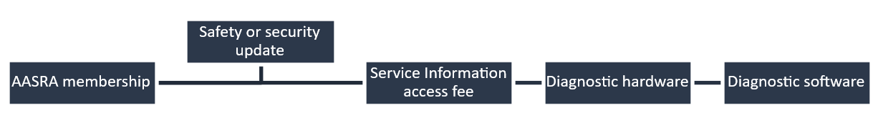
The price of scheme information, which includes proprietary software, is expressly regulated under the scheme, with a non-exhaustive range of factors to which regard may be had in determining its fair market value. The scheme does not directly regulate the cost of other goods and services which may be needed to utilise scheme information; however, requires scheme information be in a form that is reasonably accessible to all Australian repairers and scheme RTOs. As a result, a data provider will breach the main obligation under the scheme where it only supplies scheme information which must be used alongside a range of additional goods and services which, when viewed as a whole, result in the scheme information itself not being reasonably accessible.
This chapter examines issues relating to the pricing of and access to scheme information, including in relation to hardware and additional subscription and software fees. Related issues associated with the separation of safety and security information, and treatment of intermediaries are covered in chapters 4 and 5, respectively.

The price of scheme information
Scheme information must be made available at a price that does not exceed ‘fair market value’. Fair market value is a recognised concept in both Australian law and international contexts and is often described as the price a willing buyer would pay a willing seller in a transaction on the open market.
Limiting the price of scheme information to fair market value aims to allow for data providers to recover costs and retain profitability in line with the value of the associated information, while ensuring that pricing does not become a substantial barrier to accessing scheme information for Australian repairers and scheme RTOs. The scheme describes a range of factors which are relevant to determining fair market value, including:
- the price charged to other Australian repairers and scheme RTOs for that particular make, model and year, or otherwise for a similar make model and year
- the terms on which information is offered
- anticipated demand by Australian repairers and scheme RTOs
- the reasonable recovery of costs
- prices for information in overseas markets, and
- any amount payable to a third party with a proprietary interest.
Where concerns emerge within industry, including in relation to the price of scheme information, these may be resolved through the scheme’s dispute resolution framework (see chapter 7). More broadly, the Scheme Adviser’s functions include providing reports on scheme prices and the ACCC is responsible for enforcing the requirement that scheme information not exceed fair market value.
The price of scheme information was not typically a key concern raised by stakeholders during the Review. Stakeholders were more commonly concerned with accessibility and usability of scheme information. Where views were expressed in relation to the price of scheme information, these varied significantly. Some independent repairers cited concerns with the variability of prices between brands while others flagged ambiguity over the meaning of fair market value, and what factors make up the pricing of scheme information. Other repairers expressed that the pricing of scheme information is transparent and reflects fair market value, and noted the scheme enhances clarity and accountability for costs charged by data providers.

Variability of scheme prices
The Review considered whether reported variations in scheme prices between brands is consistent with the policy objectives of the scheme. While a degree of variability in pricing between data providers is expected, substantial variations may suggest practical access to scheme information provided under the scheme varies by brand.
The average price for daily access to scheme information across all manufacturers at 30 June 2025 was approximately $45, with a median price of $30. Access to information for prestige and low-volume brands, including Aston Martin, Ferrari and Maserati, was significantly more expensive and often exceeded $100 per day. However, the relatively low sales figures for these brands limit market-wide demand for repairs and reduce manufacturer capacity for the reasonable recoupment of costs. As such, these charges are unrepresentative of the broader costs for scheme information faced by Australian repairers and are not necessarily indicative of scheme information being priced above fair market value.
Table 3.1 sets out the prices charged as of 30 July 2025 by the top ten registered passenger vehicle brands in Australia, as of January 2025. These brands represent approximately 75 per cent of registered vehicles in Australia and, consequently, reflect the costs of service and repair information most commonly faced by Australian repairers.
Table 3.1: Daily, monthly and yearly fees for service and repair information, top 10 brands in Australia, 30 July 2025 (AUD)
Manufacturer | Daily fees | Monthly fees | Annual fees
Toyota | 21.00 | 220.00 | 2,200.00
Mazda | 19.95 | 199.00 | 1,999.00
Hyundai | 18.50 | 200.00 | 2,000.00
GM (Holden) | 28.00 | 206.00 | 1,642.00
Mitsubishi | 35.00 | 490.00 | 5,106.00
Ford | 33.77 | 499.92 | 4,153.77
Nissan | 49.95 | 495.00 | 2,995.00
Subaru | 35.00 | 249.00 | 1,949.00
Kia | 25.00 | 275.00 | 2,500.00
Honda | 20.00 | 390.00 | 3,380.00
Average | 28.62 | 322.39 | 2,792.48
Note: Ford scheme offer made in USD; converted to AUD at FX=0.65.
Source: AASRA, Automaker information links.
The price of service and repair information among the top ten brands in Australia varies significantly and for any given time period, the highest price charged may be between 2.5-3.1 times as high as the lowest price. Data contained in Table 3.2 and obtained by AASRA from the National Automotive Service Task Force (NASTF) indicates that this is materially lower than the variation faced by repairers in the United States (US), with the highest price for any given time period in that jurisdiction ranging between 2.0-5.7 times the lowest price available on the market.
While it is not possible to identify whether this variation is indicative of pricing which exceeds fair market value, it does indicate that (i) the reports of significant variation in scheme prices by stakeholders are supported by the data in 2025, and (ii) the level of variability in scheme prices faced by Australian repairers is materially lower than under comparable arrangements in the US.

The evolution of scheme prices
The Review also examined prices of scheme information since the scheme’s commencement and for FY23–24 and FY24–25 for the top ten registered passenger vehicle brands in Australia. As noted above, these ten brands represent approximately 75 per cent of registered vehicles on Australian roads. Figure 3.2 presents the mean, minimum and maximum prices charged for access to daily, monthly and yearly information by the top ten brands in Australia from July 2023–June 2025.
Figure 3.2: Mean, minimum and maximum fees for scheme information for top 10 brands in Australia, July 2023–June 2025 (AUD)
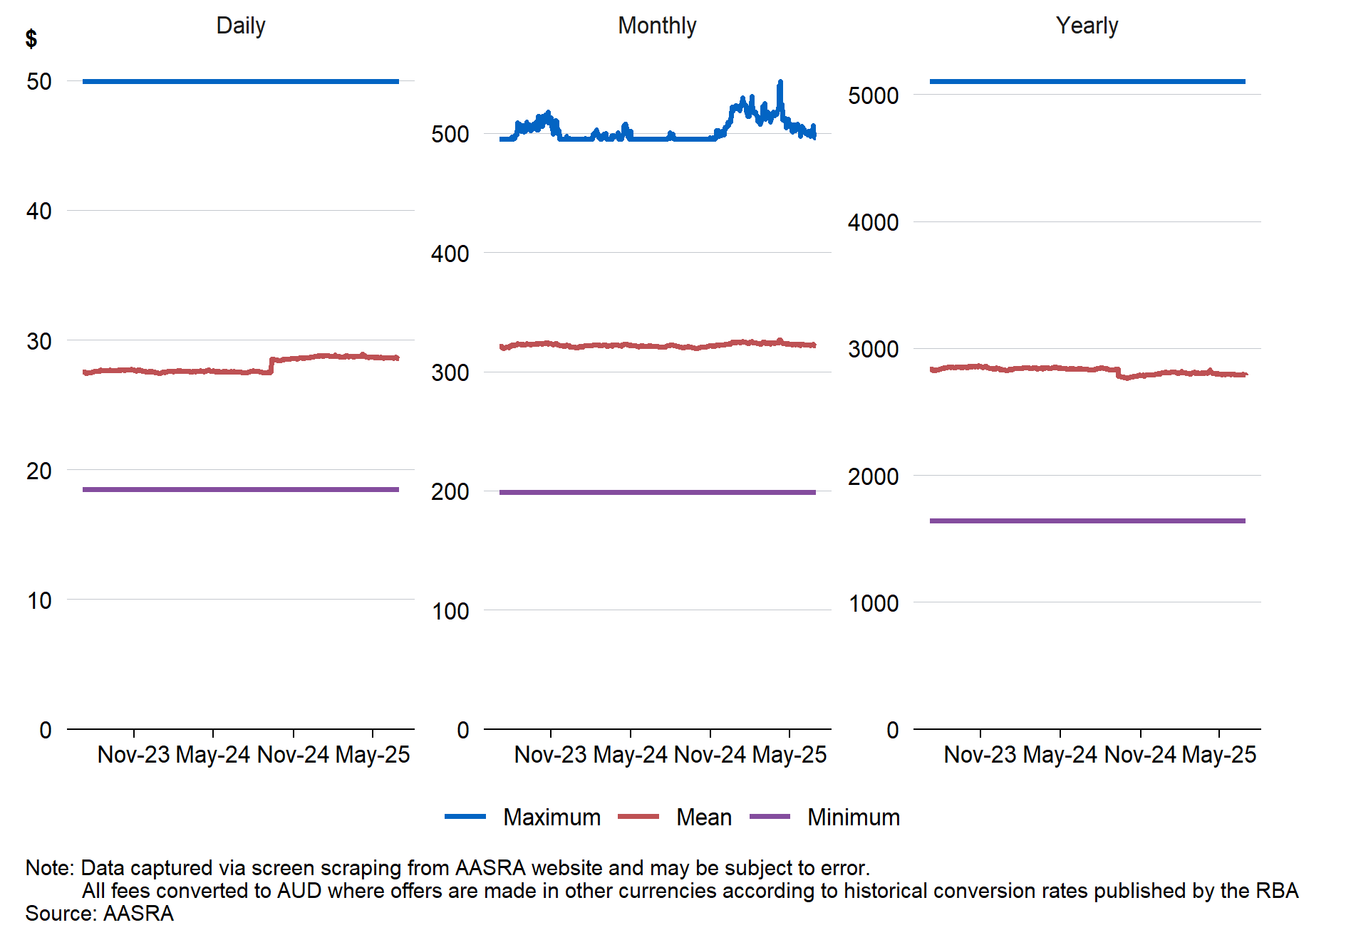
Note: Data captured via screen scraping from AASRA website and may be subject to error. All fees converted to AUD where offers are made in other currencies according to historical conversation rates published by the RBA.
Source: AASRA.
Prices for these brands have been stable over the two years. This suggests that, although stakeholder views received as part of the Review varied in relation to the price of scheme information, this variation is mainly attributable to differences in stakeholder perspectives rather than significant fluctuations in scheme prices over the period of the scheme’s operation. The small degree of variability visible in Figures 3.1 and 3.2 predominantly reflects shifts in the real value associated with manufacturers who list prices in foreign currencies.
Scheme offers are currently listed in a variety of currencies, including AUD, USD, Euro and GBP. A comparison of scheme offer prices to exchange rates reveals that the apparently stable pricing of scheme information obscures variable real costs to repairers. Figure 3.3 compares the pricing of daily scheme information for a selected manufacturer over time, with prices offered in USD, to the AUD-USD exchange rate over the same period. The figure illustrates that fluctuations in exchange rates underly otherwise static scheme prices and mean, for example, that a workshop purchasing the same information in October 2024 would face a different real cost for that same information in February 2025.
Figure 3.3: Daily fees for a scheme offer made in US$ and AU$/US$ exchange rate, July 2023–June 2025
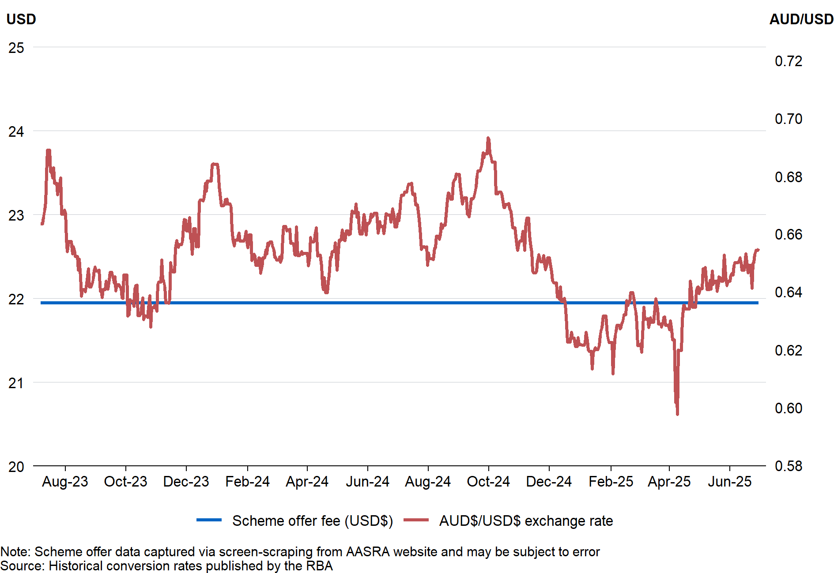
Note: Scheme offer data captured via screen-scraping from AASRA website and may be subject to error.
Source: Historical conversation rates published by the RBA.
Similar patterns are observed for manufacturers presenting scheme offers in other currencies. Fluctuations of this kind may reduce clarity for repairers as to the real cost of scheme information over time. The cost of scheme information may also be obscured where the price of scheme information reflected in scheme offers does not reflect the price of scheme information at the point of purchase via a data provider’s website.
The Review received reports of discrepancies between the prices of published scheme offers on the AASRA website and prices charged through manufacturer portals. Analysis conducted as part of the Review corroborated at least one such instance. While discrepancies appear minor, they represent non-compliance with the scheme and have the potential, over time, to reduce the perceived value of the scheme for independent repairers. Reporting obligations requiring data providers to share with the Scheme Adviser the price at which scheme information is ultimately supplied, have the potential to better address such discrepancies moving forward. Data provider reporting obligations are discussed further in chapter 7.
Continued efforts towards effective administration of the scheme by all entities, including through the provision of accurate scheme offers and clear pricing in Australian dollars are likely to support Australian repairers’ and scheme RTOs’ ability to effectively and efficiently engage with the scheme.

Comparability of scheme prices
As noted above, the scheme utilises comparison as a factor which may be considered in determining the fair market value of scheme information. Two aspects of the scheme’s comparative pricing approach raised as part of the Review related to determining the fair market value by reference to:
- The price of scheme information in relation to a scheme vehicle of a ‘similar make, model and year’ where pricing of scheme information is not already available in relation to a scheme vehicle of that particular make, model and year; and
- The price charged for the supply of information similar to scheme information in overseas markets.
The ACCC noted that considering pricing for a similar make, model and year (where pricing is not available for a vehicle of a particular make, model and year) requires the existence of an appropriate comparator. Given the increasingly complex nature of computerised systems in vehicles requiring proprietary tools to complete repairs, it was argued that this factor is of limited practical utility in illuminating the fair market value of scheme information as such information is not substitutable between brands. However, as this is but one matter to which regard may be had in determining fair market value, the Review considers that its retention remains appropriate to ensure fair market value may be determined having regard to a sufficiently broad range of matters across a variety of circumstances.
In relation to the price of information in other jurisdictions, Table 3.2 sets out data provided by AASRA on the prices charged by the top 10 registered passenger vehicle brands in Australia, as of January 2025, in Australia and the US.
Table 3.2: Comparison between daily, monthly and yearly scheme information fees in Australia and comparable prices for information in US, top 10 brands in Australia, 30 July 2025 (AUD)
 | Daily fees |  |  | Monthly fees |  |  | Annual fees
Manufacturer | Aust. | US | Aust v US | Aust. | US | Aust v US | Aust. | US | Aust v US
Toyota | 21.00 | 38.46 | -17.46 | 220.00 | 146.15 | 73.85 | 2,200.00 | 776.92 | 1,423.08
Mazda | 19.95 | 46.15 | -26.20 | 199.00 | 384.62 | -185.62 | 1,999.00 | 3,461.54 | -1,462.54
Hyundai | 18.50 | 61.54 | -43.04 | 200.00 | 92.31 | 107.69 | 2,000.00 | 923.08 | 1,076.92
GM (Holden) | 28.00 | 33.85 | -5.85 | 206.00 | 258.46 | -52.46 | 1,642.00 | 2,067.69 | -425.69
Mitsubishi | 35.00 | 30.77 | 4.23 | 490.00 | 384.62 | 105.38 | 5,106.00 | 2,307.69 | 2,798.31
Ford | 33.77 | 40.00 | -6.23 | 499.92 | 524.62 | -24.70 | 4,153.77 | 4,361.54 | -207.77
Nissan | 49.95 | 53.85 | -3.90 | 495.00 | 207.69 | 287.31 | 2,995.00 | 1,923.08 | 1,071.92
Subaru | 35.00 | 53.85 | -18.85 | 249.00 | 461.54 | -212.54 | 1,949.00 | 3,846.15 | -1,897.15
Kia | 25.00 | 30.77 | -5.77 | 275.00 | 230.77 | 44.23 | 2,500.00 | 2,307.69 | 192.31
Honda | 20.00 | 46.15 | -26.15 | 390.00 | 230.77 | 159.23 | 3,380.00 | 2,307.69 | 1,072.31
Note: Ford’s Australian scheme offer made, and US prices offered, in USD; converted to AUD at FX=0.65.
Source: AASRA, Automaker information links; National Automotive Service Task Force (NASTF), as provided to the Review by AASRA.

The data presented in Table 3.2 indicates a lack of consistency between scheme pricing in Australia and pricing of comparable information in the US. On average, daily information in Australia is priced $14.92 below comparable information in the US, or approximately 66 per cent of the equivalent price. By contrast, monthly and yearly information in Australia tended to be more expensive and priced at approximately 10 per cent and 15 per cent higher than the equivalent US price, respectively.
Five of the ten brands were consistently priced lower or higher in Australia across all three time periods. The remaining five showed mixed pricing – lower in one period and higher in two.
The inconsistency in pricing across jurisdictions, including among manufacturers from the same region, may reflect a range of factors such as exchange rate fluctuations. However, it remains unclear to what extent manufacturers consider overseas pricing when setting scheme prices Australia. Additionally, the variation in comparative costs across time periods for individual manufacturers suggest that overall market size or relative market concentration is not consistently influential in determining the price of information.
The lack of discernible pattern in the comparative pricing of information across jurisdictions may complicate the use of overseas prices as a benchmark for fair market value in Australia. While the Review’s consideration of scheme prices was limited to a single jurisdiction, on the information available the Review considers there may be a risk that expressly inviting comparisons with overseas pricing could, in an appropriate case, distort the assessment of fair market value in Australia. This risk arises principally due to (i) the low observed consistency with the pricing of scheme information in Australia; and (ii) the lack of enforcement precedents on fair market value globally.
While overseas comparisons may at times assist in assessing fair market value, steps could be taken following appropriate consultation to mitigate this risk. Options may include clarifying that, in order to rely on the price of scheme information overseas as evidence that scheme information made available domestically does not exceed fair market value, a data provider must demonstrate that the information in the relevant overseas market does not itself exceed a fair market value.

Cost recovery and scheme offers
In response to consultation, the FCAI contended that the scheme does not permit vehicle manufacturers to fully cover the costs associated with the preparation of information and ongoing compliance with the scheme. Compliance costs and additional operating costs associated with the scheme, including technical support provided to independent repairers, were identified as particular cost drivers for data providers.
The scheme provides that the fair market value of scheme information is determined having regard to factors including the reasonable recovery of costs incurred in creating, producing and providing scheme information. In this way, the scheme recognises that the provision of scheme information outside of the manufacturer authorised supply chain may result in data providers incurring additional costs which must be recovered to ensure the sustainability of the scheme.
Given the flexibility to cost recover under the scheme, cost recovery outcomes for vehicle manufacturers (or any other data providers) are primarily shaped by individual commercial decisions. Based on information provided, the Review considers the provision made for cost recovery under the scheme remains appropriate.
Finding 2
The scheme effectively regulates the price of scheme information, but there are some opportunities for enhancement to ensure information pricing remains accurate and transparent, including in relation to:
- Consistent pricing of information in Australian dollars
- The accuracy of scheme offers
- Factors relevant in determining Fair Market Value

Hardware
Servicing, repairing, and diagnosing faults in modern vehicles requires the use of a range of electronic devices (collectively referred to as ‘hardware’). In most cases, this means that in addition to accessing scheme information, an Australian repairer must possess compatible hardware to apply that information effectively. Scheme information may also be integrated directly into certain diagnostic platforms such as all-in-one diagnostic tablets that combine software and technical data access to enable coverage across a range of vehicles.
In basic fault detection scenarios, tools such as OBD-II code readers can retrieve Diagnostic Trouble Codes (DTCs) from the vehicle’s Engine Control Unit (ECU). However, more advanced procedures including ECU reprogramming, module coding, and system adaptation require bi-directional scan tools or pass-through devices that support protocols such as SAE J2534. These tools, often comprising a diagnostic platform and Vehicle Communication Interface (VCI), must often interface with OEM portals or aggregator platforms to access scheme information. The diagnostic hardware’s ability to support secure authentication, protocol compatibility, and software integration directly affects a repairer’s capacity to utilise scheme information in practice.
As noted above, the scheme does not directly regulate the cost of the hardware which may need to be used in combination with scheme information to diagnose, service or repair scheme vehicles. However, the scheme does require that scheme information is offered in a form that repairers and RTOs are able to use. The main obligation imposed on data providers under the scheme contains two limbs, and requires data providers to make scheme information available:
- in the same form in which it is supplied or offered to be supplied to all Australian repairers or RTOs, or
- if supply in that form is not practicable or accessible – in an electronic form that is reasonably accessible to all Australian repairers and scheme RTOs.
Relevantly, this obligation requires that where scheme information must be used in combination with hardware, such as a VCI device, the hardware must be made available to any repairer who requests it, or otherwise the scheme information would need to be supplied in another electronic form that is reasonably accessible to all repairers. Reasonably accessible electronic forms include using any computer and a non-proprietary vehicle interface which complies with the SAE J2534, ISO 22900 or equivalent generic pass-through device.
Scheme information may not be considered reasonably accessible where it is made available only in combination with a costly proprietary tool. In addition, the scheme prohibits data providers from requiring that a repairer buy other services or products (for example, tools or spare parts) as a condition of purchasing scheme information. This requirement reflects the scheme’s objective of moderating the market power of data providers in the provision of scheme information and preventing vehicle manufacturers from increasing the cost of access to scheme information through unnecessarily bundling information and hardware. This objective is reflected in the ACCC’s Regulatory Guidance which notes that it is considered good practice for data providers to offer to supply scheme information that is accessible via an alternative means such as a generic pass-through device.
Although the main obligation under the scheme applies to ensure scheme information is reasonably accessible regardless of the form in which it is provided, the Review identified dissatisfaction amongst some repairers regarding access to, and the cost and quality of, proprietary hardware.

Cost, Functionality and Access
Submissions from aftermarket industry stakeholders and survey responses received from repairers highlighted the cost of hardware as a key concern, with many regarding prices charged by data providers for proprietary hardware as prohibitive.
The current arrangements in relation to hardware were described as unsustainable for smaller workshops, with many commenting on the expense of having to purchase or lease specific diagnostic hardware for multiple brands. Repairers expressed that the combination of searching for the appropriate tool and escalating costs can feel disproportionate to the repair at hand, particularly for workshops operating on thin margins. In particular, the AAAA submitted that 62 per cent of surveyed workshops identify tool acquisition and subscription fees as cost prohibitive. Similarly, the AADA noted that dealers also incur costs to access information and to service vehicles according to manufacturer’s specifications, as they may be required to purchase special hardware to undertake some service and repair tasks.
Other issues raised in relation to hardware in response to consultation included:
- limited lease periods, high upfront bond payments, and delays in receiving devices
- a data provider will only sell independent repairers a Vehicle Communication Interface (VCI) – rather than proprietary hardware – which limits access to full diagnostic functionality; and
- the use of system gateways which result in an increasing reliance on proprietary hardware.
System gateways are now a standard feature in many modern vehicles as manufacturers seek to align vehicle design with cybersecurity requirements arising from United Nations Economic Commission for Europe Regulation 155 concerning vehicle cybersecurity. These gateways manage access to the vehicle’s internal systems and data, regulating access to the vehicle and acting as the first line of defence against cyber hacking and unauthorised tampering. When a technician connects a diagnostic tool to the OBD port, or when a manufacturer sends an over-the-air (OTA) update, this connection is effectively mediated by the gateway and acts much like a firewall.
Several submissions to the Review suggested secure gateways are limiting independent repairers’ ability to complete a repair with non-proprietary hardware. For example, one stakeholder noted that recalibrating an advanced driver assistance system (ADAS) after a windscreen replacement can increasingly only be completed with proprietary hardware and that the number of recalibrations able to be undertaken with non-proprietary hardware is expected to significantly decrease over time.
Reflecting on these challenges, several stakeholders, including the ACCC, called for amendments requiring hardware to be made available to independent repairers under the scheme, pointing to similar requirements in the US and European Union (EU). Repairers emphasised the need for the scheme to mandate the provision of an entire diagnostic system, rather than information alone. By contrast, the FCAI noted that OEMs have a right to develop and use proprietary diagnostic hardware and protocols to ensure the integrity of their vehicle’s systems.
“We are charged $45 every time we use the scan tool to diagnose a problem. We try to fix it, but if it faults again, we have to pay and then on-charge this to the consumer”
– Australian repairer on the cost of utilising proprietary hardware
Data providers are entitled to price proprietary hardware in view of their own commercial considerations. However, where scheme information is only able to be used in combination with this hardware, a data provider may breach the main obligation under the scheme if the cost of the hardware means the scheme information itself is not reasonably accessible. This assessment will be context-specific and likely involve consideration of factors including:
- how the cost of the proprietary hardware was determined
- the relative cost of the proprietary hardware to non-proprietary equivalents, and
- the functionality of the proprietary device.
As a result, determining whether the cost of proprietary hardware in any particular case breaches the obligations under the scheme is beyond the scope of the Review. An assessment regarding whether hardware provided with different functionalities is inconsistent with the aim of the scheme to ensure all repairers utilising scheme information enjoy the same functionality also necessarily involves a context-specific assessment.
The centrality of hardware to vehicle diagnosis, repair and maintenance means the second limb of the main obligation is critical in ensuring the effective operation of the scheme. Given this, and in light of submissions received in response to consultation, the Review considers that any steps taken to clarify the operation of the second limb would likely yield practical benefits for independent repairers and provide greater certainty for data providers. This may be provided by clarifying the matters to which a court may have regard in determining whether:
- the supply of scheme information in the same form is ‘practicable or accessible’; and
- whether a particular electronic form is ‘reasonably accessible’.
While the Explanatory Memorandum provides direction in this regard, greater legislative articulation of the matters relevant to limb two of the main obligation may provide improved certainty to industry and result in an uplift of hardware accessibility for repairers. However, other mechanisms may also support repairer access to proprietary hardware.
Mandating that data providers offer proprietary hardware to repairers at a price no greater than its fair market value could directly respond to cost concerns raised by independent repairers during consultation. However, such a requirement would likely impose a significant and unsustainable regulatory burden on data providers. It may also result in excess demand for hardware and a net reduction in overall economic welfare.
This outcome reflects the fundamental differences between hardware and scheme information. For scheme information, which is typically made available in a digital form, the marginal cost of supplying an additional unit (for example, granting portal access to another repairer) is minimal. Consequently, a price cap set at fair market value is not likely to be binding for many data providers.
By contrast, applying a fair market value price ceiling to hardware where the intent is to reduce current market prices would likely be binding. Data providers would be less willing to supply hardware at the capped price, leading to excess demand. If required to meet this demand, providers would incur costs that exceed the regulated sale price, potentially resulting in an unsustainable financial burden. In addition to these economic considerations, mandating the supply of hardware under the scheme would engage with the rights of patent and registered design owners and Australia’s obligations under international agreements.
Australia is party to a number of international agreements with obligations relating to intellectual property rights including patents and registered designs. Under Australia’s intellectual properly laws, patent and registered design owners (and their exclusive licensees) have exclusive rights to prevent third parties from using a certified design or a patented product or process without the consent of the owner or exclusive licensee. Any mandated provision of hardware under the scheme would need to be carefully assessed against the terms of Australia’s international legal obligations, including requirements under exceptions to the exclusive rights of patent and registered design owners.
In this context, the Review considers that options to address access to hardware which do not engage with intellectual property rights not presently addressed by the scheme should be explored in the first instance. Alternative approaches which increase the supply of substitutes for proprietary hardware and place downward pressure on hardware costs without the imposition of price controls are likely preferable.
Some stakeholders submitted that increasing substitutes for proprietary hardware (i.e. expanding the circumstances in which non-proprietary hardware can be used) may be achieved through mandating that scheme information be accessible in combination with a non-proprietary vehicle interface which complies with the SAE J2534 standard.

J2534 Standard
SAE J2534 is a standard developed by the Society of Automotive Engineers (SAE) for vehicle diagnostic tools, enabling them to communicate with the vehicle’s on-board diagnostic system. SAE J2534 provides an interface for diagnostic devices to perform a variety of functions, including diagnostics, software updates, and emissions testing. Figure 3.4 demonstrates how access to a consumer vehicle operates for a user of a SAE J2534 pass-through device.
Figure 3.4: Vehicle communication via J2534
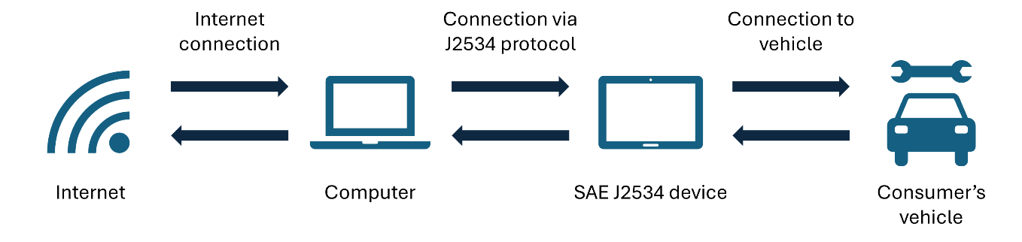
Information which can be accessed utilising any computer and a non-proprietary vehicle interface which complies with the SAE J2534, or equivalent generic pass-through device is ‘reasonably accessible’ within the meaning of the scheme. However, the scheme contemplates that scheme information available in other formats can also be reasonably accessible and does not require information be made available in a J2534 compatible form. Further, ‘reasonable accessibility’ is a standard that is context specific.
Several stakeholders, including industry associations representing the aftermarket and a data aggregator, suggested that the scheme should mandate that data providers offer scheme information using a generic pass-through device using the J2534 Application Programming Interface (API). These stakeholders pointed to similar approaches adopted in the EU, Maine and Massachusetts. Submissions asserted that this would allow better interoperability with diagnostic software, reduce reliance on multiple proprietary tools and lower or eliminate cost barriers for smaller workshops. It was suggested that imposing this standard as part of the scheme would also improve independent repairers’ ability to compete with dealerships.
The FCAI and a data aggregator were critical of proposals to adopt the SAE J2534 as part of the scheme, suggesting that the benefits of such a reform are likely overstated. These stakeholders highlighted the potential for such an intervention to:
- inappropriately intervene in vehicle design, outside the harmonised international framework and Australian Design Rules
- result in worse outcomes for Australian repairers and preclude improvements in the sharing of scheme information which may arise as new technologies develop, and
- provide only limited utility, as independent repairers would still be required to utilise proprietary hardware which provides higher-level functionalities, such as guided diagnostics and dynamic wiring diagrams, which cannot be delivered with J2534.
Imposing an API, such as SAE J2534, can increase standardisation, usability and interoperability. However, a shift to API-based data sharing as part of the scheme would likely impose significant costs on data providers and be inconsistent with industry momentum toward newer technologies.
Information provided as part of the review suggests industry momentum to Diagnostics over Internet Protocol (DoIP), with several OEMs moving beyond the OBD-II interface by incorporating Ethernet connectors. While manufacturer transition timelines vary and DoIP is not yet universally supported, Ethernet offers substantially greater bandwidth, which is better suited to the large volumes of data generated by modern ECUs.

Under the Australian Design Rule 79/03 onwards, passenger and light commercial vehicles are required to be fitted with an OBD-II port for emissions-related diagnostics. However, not all diagnostics are exposed through this interface. The SAE J2534 ‘pass-through’ standard was originally developed to facilitate ECU reprogramming over OBD-II protocols, but it is not the default framework for DoIP. As OEMs transition more diagnostic functionality to Ethernet, there is a risk that mandating the provision of scheme information compatible with the J2534 API would hinder industry momentum towards more efficient means of data transfer, locking in technology which is already beginning to be surpassed. Some tool manufacturers have developed J2534 compliant tools that support DoIP and other protocols, but these are not currently widely adopted.
Box 3.1: International approaches
Standardised protocols such as the SAE J2534 and TMC RP 1210B have been adopted to facilitate access to vehicle repair and reprogramming functions across different jurisdictions:
- In the United States, the Environmental Protection Agency mandates SAE J2534 compliance for emissions-related ECUs in vehicles from model year 2004 onwards, ensuring that independent repairers can use generic pass-through devices with OEM software.
- The Maine and Massachusetts schemes and the US-wide MOU (see appendix B) require manufacturers to provide access to diagnostic software using a SAE J2534 pass-through device (generic hardware) for vehicles from model year 2018 onwards.
- Regulation (EU) 2018/858 (the type-approval framework) requires that reprogramming of control units shall be conducted in accordance with either international standard ISO 22900-2 or SAE J2534 or TMC RP1210B using non-proprietary hardware.
The market for light passenger vehicles has been characterised by significant technological advancement since the introduction of the scheme. Given this, requiring J2534 compliance as a feature of the scheme would likely have negative longer-term impacts on the ability of the scheme to realise its legislated objectives, increasing regulatory burden for data providers and potentially reduced product offerings as OEMs remove non-J2534 compliant vehicles from the market. As a result, the Review considers that the scheme’s current technology neutral approach to ‘reasonable accessibility’ remains appropriate and the objective of decreasing reliance on proprietary hardware may be better pursued through alternative means, such as addressing challenges faced by intermediaries, including tool manufacturers, in engaging with the scheme.
Finding 3
Where proprietary hardware is required to utilise scheme information, associated cost, functionality and access issues can significantly hamper independent repairers’ ability to compete. Providing tool manufacturers and data aggregators with improved access to scheme information may increase repairer choice of hardware, placing downward pressure on costs and benefiting consumers.

Information accessibility
The scheme seeks to ensure that scheme information is practically accessible by prescribing how long it must be made available for, and the timeframes within which it must be supplied. This section examines the operation of these legislated timeframes, as well as practical issues experienced by repairers in navigating manufacturer portals to access scheme information.

Scheme information supply periods
Under the scheme, where the form in which scheme information is supplied allows for variability in supply periods, scheme information must be made available:
- For any period nominated by an Australian repairer; or
- By day, by month and by year.
While the scheme prescribes a minimum level of variability, several manufacturers provide greater variability in the periods for which scheme information is available. Where the form of the scheme information does not allow for variability, the data provider may choose to offer scheme information on a fee-per-request basis. By providing repairers with the flexibility to access scheme information across multiple time periods, the scheme enables repairers to match their investment in scheme information with its expected use.
In response to consultation, stakeholders raised two main concerns regarding scheme information supply periods. Firstly, the FCAI raised that the one-day supply period obligation is poorly adapted to circumstances where a diagnostic solution necessitates the use of proprietary hardware. The FCAI recommended that the requirement for one-day access be removed in these circumstances.
Separately, the ACCC noted that supply periods have been an ongoing compliance issue and recommended legislative clarification that:
- Data providers must offer a time-variable supply period should the form of information allow for variability, even if the dealership is only able to purchase the information for a specific period, and
- Generally, all electronic forms of information can reasonably be expected to allow for variability of the supply period, when appropriate technology is applied and enabled.
The issues raised by the ACCC and FCAI suggest that the scheme may benefit from bolstering the scheme’s information supply periods.

Supply periods and hardware
A substantial portion of Australia’s independent workshops operate outside metropolitan centres. While industry analysis suggests that regional workshops are somewhat less likely to engage with the scheme, data providers packaging and dispatching proprietary hardware in compliance with the scheme will often do so outside of metropolitan areas and, in many cases, this hardware may be shipped over long distances.
Given this, hardware supplied for one-day access may often be made unavailable for supply to other repairers for multiple days, at a cost to data providers. While concerns regarding the one-day supply period will not apply in each circumstance, the views raised by industry support a case for re-examining the one-day supply period requirement in circumstances where:
- scheme information is utilised in combination with proprietary hardware, and
- the Australian repairer acquires the hardware from the data provider, requiring the data provider to send a physical device to the repairer.
The existing timeframes remain appropriate where a repairer obtains a daily subscription to access scheme information and does not also acquire hardware as part of the same transaction.
In considering alternative supply periods appropriate for this circumstance, it is likely that a simple reduction in the range of time periods prescribed in the legislation to only include monthly and yearly options would be inconsistent with the policy intent underlying the existing provisions. Given the increased cost of accessing proprietary hardware over longer periods, such a change may practically result in reduced access to scheme information by independent repairers.
The Review considers that there may be benefit in exploring the feasibility of prescribing a period longer than one day, and less than one month, as the shortest period for the supply of scheme information in these circumstances. Such an approach may better avoid redistributing the apparent existing regulatory burden from data providers onto repairers and enable repairers to continue to align their investment in scheme information with their operational needs.

Form variability
The ACCC’s recommendation to clarify that information supplied in an electronic form is expected to allow for variability in the supply period reflects updates made to the ACCC’s Regulatory Guidance in mid-2025. Specifically, the guidance provides that, when assessing whether the form of scheme information allows for variability in the supply period, the data provider may consider:
- Whether it has previously supplied the scheme information by way of a time limited subscription service
- Whether scheme information for the same vehicle has been offered to independent repairers in overseas jurisdictions in a time limited manner
- Whether the existing form of scheme information already functions to provide variable time limited supplies of scheme information, or whether the data provider can take additional steps to enable the scheme information to be supplied for time limited periods
- If it is feasible for the data provider to take steps to enable the supply of scheme information for time limited periods the form allows for variability in the supply period, in which case the data provider must take those steps to comply with s 57CA(3).
Analysis undertaken as part of the Review suggests that at least eight scheme vehicle manufacturers do not currently provide access to diagnostic software by day, month and year. While identifying whether each of these instances reflects non-compliance is beyond the scope of the Review, the level of variation seen in the periods for which scheme information is made available speaks in favour of providing greater clarity in relation to the operation of s 57CA(3).
The Review considers that enhancing the express alignment between the scheme and the ACCC’s Regulatory Guidance on supply periods would support the provision of accessible and affordable information, consistent with the scheme’s objectives. Any such clarification to supply periods under the scheme would, however, need to recognise the unique considerations applying to circumstances involving the supply of proprietary hardware.

Timeframes for the supply of scheme information
Ensuring scheme information is made available promptly is critical in supporting competition in the market for motor vehicle repair. The scheme prescribes that, depending on the context, scheme information must be supplied to Australian repairers and scheme RTOs either (i) immediately, (ii) within 2 business days, or (iii) within five business days (or an alternative agreed period). The timeframe for supply starts once the repairer has paid, or offered to pay, the scheme offer price or another agreed price. Figure 3.5, from the ACCC’s Regulatory Guidance, summarises the circumstances to which each of the timeframes apply:
Figure 3.5: Timeframes for the supply of scheme information
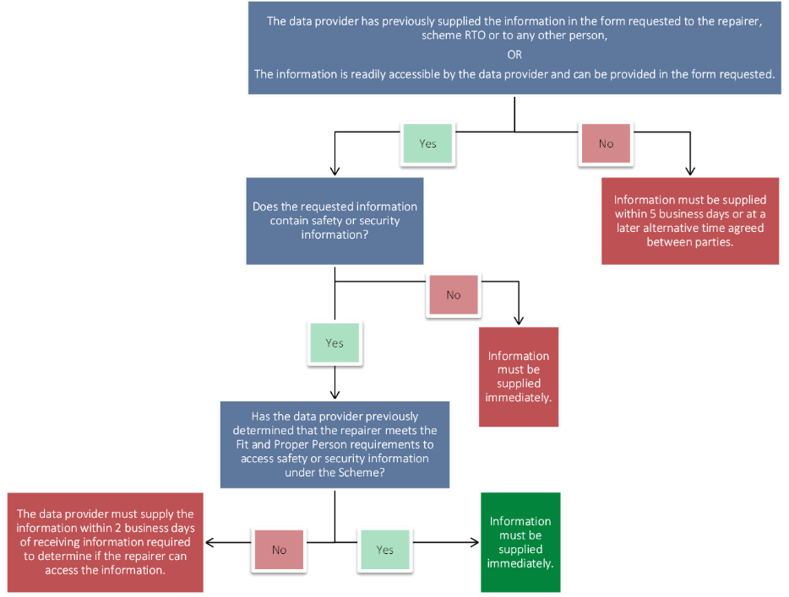
In response to consultation, the AAAA expressed concern regarding compliance with the prescribed timeframes for the supply of scheme information, citing particular difficulties associated with timely access to security information. Survey results reflected these views, with approximately 45 per cent of stakeholders indicating that issues experienced in accessing service, repair and diagnostic information in the last 12 months were due to delays in receiving scheme information.
The Motor Trades Association of Australia (MTAA) submitted that the scheme should be amended to decrease delays in information transfer, by reducing the longest prescribed period for supply under the scheme from five days to 24 hours. Consistent with the theme of ensuring timely access to scheme information, the ACCC separately recommended amendments be made to:
- ensure locksmiths have timely access to security information
- require data providers to set up automated systems for the provision of scheme information, including outside of the data provider’s business hours
- require data providers ensure access to scheme information can take place within minutes rather than hours or days of the request, where information is supplied in an electronic form.
The FCAI emphasised the need for flexibility in legislated timeframes for supply in circumstances where diagnostic solutions include the supply of proprietary hardware.
Taken together, the information provided to the Review suggests that there may be scope to clarify the existing timeframes for the supply of scheme information, particularly in relation to (i) security information, and (ii) scheme information made available with proprietary hardware.
Concerns regarding timely access to security information are most acute in the context of key re-coding. For modern vehicles, where a consumer requires a new vehicle key, for example because all keys have been lost, an independent repairer will need to obtain a security code from a data provider to re-code keys. Being able to service consumers immediately in these circumstances is critical.
Where data providers use automated processes to provide codes to dealerships but manual processes to provide information to independent repairers, this can result in material delays and substantially reduce the independent repairer’s ability to compete. Under the scheme, data providers have up to two days to provide these codes to independent repairers where they have not previously determined the repairer meets the fit and proper person requirements to access security information. However, where the data provider has previously determined the repairer meets these requirements, this information must be provided immediately.
The Review notes the time-critical nature of key re-coding in an ‘all keys lost’ situation means that, where the two-day legislated time-period applies and consumers have access to a dealership alternative, independent repairers’ ability to compete is likely limited. Nevertheless, in the absence of detailed evidence regarding the aggregate impact of this competitive disadvantage, imposing a requirement on data providers which requires the development of new automated systems to facilitate the immediate delivery of scheme information in these circumstances would likely impose an unacceptable and disproportionate regulatory burden on data providers. However, alternative approaches may enhance timely access to security information under the scheme.
A central limitation in improving the timely access to this information where data providers use manual systems is the need for data providers to consider declarations made by repairers confirming they:
- are authorised by the owner of the vehicle to access security information and providing the vehicle’s Vehicle Identification Number (VIN) (‘Consumer Authorisation’), and
- have not been convicted of an offence since the date of their most recent national police check report (‘Conviction Declaration’).
Currently, a data provider must consider both declarations to determine whether security information may be supplied. The Review considers that recalibrating the interaction between the two-day supply period and the declaration requirements may have the effect of reducing the burden on data providers utilising manual systems and that this may, in turn, increase the circumstances in which the immediate provision of security information is possible.
For example, reducing the frequency with which conviction declarations are required, and excluding reference to consumer authorisations as part of the timeframes for the supply of scheme information, may reduce the regulatory burden imposed on data providers utilising manual systems and continue to minimise the risk of misuse of scheme information. Given the potential for unintended consequences, any changes to legislated timeframes intended to facilitate faster access to security information would need to be developed in close consultation with industry. Further nuance could also be considered in the legislated timeframes for circumstances involving the supply of scheme information alongside proprietary hardware.
The analysis in the preceding section regarding the application of the timeframes to circumstances involving the supply of scheme information with physical diagnostic hardware applies equally to the legislated timeframes for the supply of scheme information. The Review considers that all parties may benefit from greater clarity in relation to how the existing timeframes apply in these circumstances, including in relation to the meaning of ‘immediately’ when used in this context. While flexibility in timeframes is practically important for data providers supplying information, this must be balanced against the scheme’s objective of establishing a level playing field for independent repairers.

Compliance with timeframes for the supply of scheme information
Many of the views provided to the Review in relation to delays in receiving scheme information suggest a degree of non-compliance with the timeframes prescribed under the scheme. Enforcement of the scheme is a matter for the ACCC supported by the Scheme Adviser, whose functions include providing reports to the ACCC of systemic non-compliance.
A pecuniary penalty of up to $10 million may be imposed for a contravention of the timeframes for supply of scheme information. This penalty reflects the importance of the timely supply of information to the effective operation of the scheme. To date, no penalties have been imposed for contraventions of legislated timeframes for the supply of scheme information.
Adherence to the legislated timeframes for the supply of scheme information is critical to the success of the scheme and in promoting competition between data providers and independent repairers. Given the apparent non-compliance and disquiet with the timeliness of the provision of scheme information amongst some stakeholders, further sustained work by all parties towards ensuring these objectives are met would likely materially improve the operation of the scheme.
Finding 4
The scheme generally supports timely access to the information needed by Australian repairers and RTOs. Bolstering access to scheme information in electronic formats and aligning timeframes with the operational realities of making information available with proprietary hardware, would increase certainty for data providers and ensure consistent aftermarket access to information.

OEM Portals
Accessing scheme information typically involves Australian repairers and scheme RTOs purchasing daily, monthly or yearly software subscriptions offered by data providers. Once subscribed, scheme information is accessed by navigating to the relevant OEM portal. If a repairer intends to service and repair multiple brands of vehicles, they will likely be required to obtain specific tools and subscriptions for each brand.
Depending on the manufacturer, accessing scheme information may first require authentication through AASRA. AASRA’s portal functions as a centralised ‘landing page’ for repairers and RTOs which are members of AASRA. The aim of this portal is to simplify the process for navigating to each data provider’s system. Once accessed, whether via AASRA or another means, OEM online portals provide access to scheme information and may differ significantly in both presentation and structure. While the scheme requires scheme information to be supplied in a form which is reasonably accessible, it does not prescribe standards on how OEMs present information on their portals.
In response to consultation, repairers operating all makes all models workshops expressed frustrations with the need to have multiple accounts, the costs associated with multiple subscriptions and the differences between online portals offered by data providers.
“Our productivity is low because we spend so much time researching the work to be done, rather than doing it”
– Australian repairer
Beyond the need for multiple subscriptions, a common experience shared by independent repairers as part of consultation was that it can be difficult to navigate various OEM websites and portals. These stakeholders frequently cited this as a practical barrier to accessing information and one of the most frequent challenges they face with the scheme. Nearly half of respondents to the Treasury’s survey flagged that navigating multiple different websites places additional burdens on their business.
Differences in OEM portal architecture were described as limiting users’ ability to easily access the information required and stakeholders noted that different manufacturers often operate on entirely different systems, with different customer account management, communication and authentication methods. Stakeholders also noted that these challenges are exacerbated by factors including slow speeds, general ‘bugginess’ and other accessibility issues, such as users being frequently logged out and server outages. One stakeholder noted that prolonged server outages can materially affect repairers’ ability to access scheme information and that, in some cases, these outages may affect aftermarket access only.
The Review recognises that multiple subscriptions can be costly for repairers to maintain and that these costs must necessarily be factored in by individual business owners in determining the extent of their service offering. While utilising goods and services provided by intermediaries can reduce subscription costs, repairers may still need to consult OEM websites for certain tasks, such as retrieving programming and coding modules, VIN-specific wiring diagrams, or understanding fault code logic and test parameters.
Industry has already taken steps to support repairers engaging with subscription-based offerings from a range of brands. For example, AASRA produces navigation guides to assist repairers navigate participating brand websites to access scheme information. However, both the limitations of guidance materials and the variety of issues surfaced as part of consultation in relation to OEM websites invites consideration as to whether further standardisation may be necessary to ensure the scheme realises its legislated objectives.
The Review is aware of similar challenges in navigating OEM websites being encountered by independent repairers in the EU, following the introduction of that jurisdiction’s information sharing scheme in 2009. In response, the EU mandated that OEMs make information available in a standardised format compliant with International Organisation for Standardisation (ISO) standard 18541 Road vehicles – Standardized access to automotive repair and maintenance information. This standard specifies the minimum set of technical requirements related to a vehicle manufacturer’s repair and maintenance information (RMI) system. ISO 18541 plays an important role in harmonising the structure and accessibility of RMI across OEM portals in the EU, and in enhancing consistency and usability for independent operators.
Given the EU’s reliance on ISO 18541 to mitigate fragmentation and reduce barriers for repairers, adopting a similar approach may address the concerns raised by stakeholders in the Australian context. However, the extent of changes to existing systems which would likely be required across data providers means the implementation of such a standard would impose a significant additional regulatory burden on data providers. Assuming a material rebuild in data provider portals to comply with ISO 18541, Treasury’s preliminary estimates suggest the total additional regulatory burden may be in the order of $20 million.
The Review considers that imposing such an additional regulatory burden on data providers is disproportionate in light of the current level of scheme utilisation. An alternative approach which leverages independent repairers’ preference for intermediaries in providing standardised access to information is likely to deliver similar benefits with reduced regulatory burden. The treatment of intermediaries under the scheme and their potential role in addressing these concerns is discussed further in chapter 5.
While the imposition of standards for OEM portals likely does not represent a proportionate response to the challenges described above at this stage, data providers must ensure that the scheme information continues to be reasonably accessible. What amounts to reasonable accessibility is context specific and may invite consideration of the challenges raised during the Review, particularly where information becomes unavailable or practically unavailable through reliance on outdated software and technology or consistent unplanned server outages. How data provider reporting requirements may be utilised to improve visibility of the latter is discussed further in chapter 7.

- Protecting information
Key points
- The scheme restricts access to safety and security information and requires the separation of this information where practicable.
- The requirement to separate safety information from other information has created significant practical challenges for manufacturers, intermediaries, and repairers, often resulting in increased costs and regulatory burden.
- Adjustments which remove the need to separate safety information from other types of scheme information may be effective in reducing the regulatory burden for data providers and increase productivity for Australian repairers.
- The scheme’s treatment of security information is broadly aligned with international frameworks and is considered appropriate for protecting against misuse, though timely access to security information remains a challenge for some repairers.
- Intermediaries, such as data aggregators and tool manufacturers, face unique challenges in complying with the scheme’s requirements for separating and distributing safety and security information, which can impact the availability of multi-brand diagnostic tools.
- Opportunities exist to clarify definitions and streamline regulatory requirements to better balance safety, security, and accessibility for repairers and intermediaries.
To protect the safety and security of vehicle owners, individuals working for an Australian repairer or scheme RTO and the general public, the scheme restricts access to, and requires the separation of, safety information and security information. To access safety and security information under the scheme, Australian repairers and scheme RTOs must satisfy a ‘fit and proper person’ test. The requirements of the test differ for safety information and security information.
In relation to safety information, data providers must only provide access if an individual can demonstrate they have successfully completed appropriate training in safely working on the relevant systems. To retain flexibility, the scheme does not specify a particular training course that an individual must have undertaken to access this information.
To establish that an individual is a fit and proper person to access security information, an assessment is made having regard to matters including:
- information about the person’s relationship with the repairer or RTO
- a national police check
- a declaration confirming that they are authorised by the owner of the scheme vehicle to access the information and specifying the vehicle identification number for that vehicle.
Safety and security information are widely and regularly used by Australian repairers and scheme RTOs, and ensuring an efficient flow of this information is critical to the operation of the scheme. The following sections examine the operation of the scheme as it relates to each of these categories of information.
Box 4.1: Safety and security information
Safety Information  Safety information is information relating to:  - the hydrogen system, broadly understood to mean a system having one or more hydrogen fuel containers fitted to the vehicle,  - the electric propulsion system, broadly understood to mean a system powered by one or more electric motors or traction motors, or  - the high voltage system, which includes a system that has a hazardous voltage of greater than 60 V and less than 1,500 V direct current (DC) or greater than 30 V and less than 1,000 V alternating current (AC).  Systems connected to the systems outlined above. | Security Information  Security information is information relating to the security of the vehicle, where that information is:  - Unique to the vehicle, and/or  - Only able to be used for a limited period of time  Security information includes information relating to the locking and immobilising of the vehicle e.g. a code used to cut a key that fits a particular vehicle.

Safety information
The regulation of safety information is intended to ensure that appropriate safeguards are placed on accessing information which presents a higher risk to repairer safety, without unduly restricting access to other kinds of scheme information. The proportion of scheme information classified as safety information varies by vehicle. Electric vehicles (EVs) will typically have high proportion of safety information whereas internal combustion engine (ICE) vehicles may have none. While regulating access to security information is common throughout comparable schemes abroad, Australia is the only jurisdiction to regulate safety information and require its separation.
Stakeholder views in relation to the regulation of safety information under the scheme focused on:
- separating safety information from other types of scheme information
- the rationale for regulating safety information as a distinct class of scheme information,
- training requirements, and
- regulatory uncertainty.

Separating safety information
The requirement to separate safety information from other kinds of scheme information has presented significant practical challenges for manufacturers, intermediaries such as data aggregators and tool manufacturers, and Australian repairers.
In response to consultation, the FCAI described that difficulties faced by OEMs in separating safety information from other kinds of scheme information arise due to the integrated nature of information within broader technical documents. These documents may cover multiple vehicle functionalities, systems, and components. From a manufacturer’s perspective, separating this information can be costly and may require preparing bespoke technical documentation for the Australian market. As OEM documentation is developed and managed at a headquarter level for global markets, the FCAI noted that imposing requirements to modify these global resources to isolate specific information could lead to substantial costs, which may be passed on to repairers and consumers. The FCAI recommended that a preferable approach would be to instead focus on managing who can access scheme information and who is qualified to use it, rather than fundamentally altering how vehicle information is structured.
Given the challenges, many data providers consider it is not reasonably practicable to separate safety information from other kinds of scheme information. Where this is the case, Australian repairers and scheme RTOs are required to meet the fit and proper person requirements for safety information to access scheme information which contains non-safety information. Some survey responses raised concerns with obtaining and utilising AASRA membership to meet the fit and proper person requirements to access non-safety information under the scheme (‘AASRA vetting’).
Box 4.2: AASRA vetting
Data providers must ensure that repairers who are accessing either safety or security information meet the associated fit and proper person criteria. Data providers have flexibility in how they conduct this vetting process as long as the requirements under the scheme are met.
AASRA facilitates a vetting process in accordance with the Rules for individuals seeking to access security and/or safety information. This vetting process is not within the Scheme Adviser’s legislated functions.
Data providers who utilise AASRA’s vetting process are “participating brands”. Approximately half (36 brands out of 60 listed on AASRA website) of data providers are participating brands. “Non-participating brands” must still ensure that individuals accessing their information meet criteria.
The vetting process involves repairers becoming members of AASRA and providing the relevant documentation to access scheme information from participating brands, AASRA then assesses this documentation and indicates to data providers that the repairer is eligible to access the information under the scheme. A basic membership currently costs AUD$90+GST per year. Technicians who are members can ‘upgrade’ their membership to access safety and security information at a cost of AUD$50 and AUD$210 per year, per person, respectively.

While the AAAA supports credentialling where appropriate, it regards imposing training requirements related to EVs on repairers working on ICE vehicles as inefficient and an unnecessary use of time and resources.
“Some OEMs are unable to differentiate between EV, hybrid and internal combustion engine (ICE) variants of the same make and model. As a result, technicians are required to complete [safety training] simply to access information about ICE vehicles”
– AAAA submission
As noted in chapter 3, the scheme provides extended timeframes for the supply of safety information. Accordingly, where non-safety information is subject to additional safety-related restrictions, this may present real additional costs and delays for repairers and reduce workshop productivity. Similar feedback on this issue was also received from the ACCC, Victorian Automotive Chamber of Commerce (VACC), AADA and Snap-on Tools.
The challenges with the separation of safety information can be particularly acute for intermediaries, including data aggregators and tool manufacturers. Intermediaries noted they face unique challenges in separating safety information from other types of scheme information due to the:
- form in which the original information is made available to intermediaries by manufacturers,
- complexity and entangled nature of scheme information, and
- costs associated with separation.
As many Australian intermediaries operate internationally, the development and deployment of bespoke solutions for an Australian context may be commercially unattractive. The ACCC has noted that the obligations imposed on intermediaries under the scheme have in some cases resulted in unintended consequences for repairers and that some intermediaries have removed information from multi-brand products in an effort to achieve compliance.
While manufacturers have responded to challenges in separating safety information by mandating compliance with the fit and proper person requirements, due to the nature of their goods and services, intermediaries often have difficulties in establishing that these requirements are satisfied. For example, a tool may provide access to scheme information which includes safety information. In order to access this information under the scheme, a repairer must provide – amongst other things – evidence of their appropriate training or qualifications. The scheme prohibits the supply of scheme information unless the data provider is satisfied that these requirements are met. While in some cases some multi-brand tools will be able to integrate user authentication to meet this requirement, this is not possible in all cases and one major tool manufacturer observed that there may be no clear way to verify who is in possession of a device once that hardware is in use.
Taken together, Australia’s unique approach to regulating safety information has imposed significant practical challenges for manufacturers, intermediaries and repairers. The Review considers that the resolution of these issues represents the single greatest opportunity to uplift productivity under the scheme.

Safety information as a distinct class of scheme information
Stakeholder views in relation to Australia’s unique approach to regulating safety information invite consideration of the marginal benefit of this approach, when viewed in the context of other relevant legal frameworks.
The ACCC submitted that the existing restriction on safety information should be removed, while keeping the restrictions on accessing security information. It was suggested that this would make the scheme more effective, leading to better outcomes for repairers and scheme RTOs. Specifically, the ACCC understands that:
- defining safety information to include any system connected to the hydrogen, high-voltage, or electric propulsion system makes the scope of safety information too broad and ambiguous
- while legitimate safety risks exist relating to EV repair (for example, electrocution, fire, and high-pressure release associated with hydrogen fuel cells), these risks are generally considered low
- the information captured under the scheme’s definition of ‘safety information’ was available to independent repairers prior to the scheme coming into effect, without any reported incidents
- existing work health and safety (WHS) laws already require employers to train workers to perform repairs safely, meaning that additional requirements under this scheme are duplicative.
Similarly, the Electric Vehicle Association (EVA) recommended removing the restriction on safety information, noting that information about electrical systems should not be subject to restrictions under the scheme compared to other types of technical information, suggesting that such measures may unintentionally act as a barrier to access. The EVA consider that electrical systems are not inherently more dangerous than other vehicle components when handled by appropriately trained professionals.
The regulation of safety information under the scheme recognises the importance of ensuring that an individual has the technical competency to safely work on automotive systems which present different risks to traditional ICE engine systems. A key question raised by the ACCC’s submission is, to the extent that the scheme is duplicative of requirements imposed under WHS regulations, whether these requirements should be removed.
All Australian states, territories and the Commonwealth are responsible for making and enforcing their own WHS laws. WHS laws are largely harmonised across Australia through a set of uniform laws (the model WHS laws) which have been adopted (with some variations) by all jurisdictions, except Victoria. Victoria has enacted similar laws under its Occupational Health and Safety Act 2004 (Vic). Under the model WHS laws, a person conducting a business or undertaking (PCBU) (usually the employer), has a primary duty of care to ensure the health and safety of workers and others at the workplace, so far as reasonably practicable. As part of this duty, PCBUs have an obligation to provide workers with the necessary training, instruction or supervision to ensure their health and safety at work, as far as reasonably practicable.
In practice, in order to meet their duties under WHS laws, an Australian repairer is likely already required to provide similar training to their workers as is required under the scheme. Given the training requirements imposed by the scheme are intended to set a minimum standard in order to access safety information, in many cases it is likely that the obligations imposed under the WHS framework, and the scheme will overlap.
While this suggests the marginal benefit of the scheme’s training requirements may in some cases be limited when compared with the obligations which already exist under WHS laws, the training requirements also serve an important function of providing data providers with certainty that information provided under the scheme is only used by suitably qualified repairers. This obligation is central to ensuring data provider trust in the scheme and removing the regulation of safety information entirely may serve to erode this trust.
While the majority of stakeholder submissions did not advocate for removing the restriction on safety information, evidence available to the Review provides a strong case for re-examining the current treatment of safety information within the scheme to address difficulties associated with separating safety information discussed above. In particular, providing a mechanism which removes the need to separate safety information from other types of scheme information while continuing to provide assurance that safety information will be used appropriately would likely enhance productivity through:
- reducing administrative burden
- avoiding costly and time-intensive restructuring of OEM information
- allowing repairers to better align their training with the vehicles they work on
- providing repairers access which is equivalent to overseas schemes
Any changes to the status quo would need to be designed in close consultation with industry and Safe Work Australia. However, models which remove the need to separate safety information from other types of scheme information and recast existing arrangements to mandate use in line with competence, may effectively address existing challenges. For example, one such approach may involve framing the existing requirements as an implied condition in the supply of scheme information which imposes a contractual obligation on repairers to ensure scheme information which contains safety information is only utilised by repairers with suitable qualifications. In considering any alternative regulatory arrangements which may be applied to safety information, and to avoid regulatory dislocation, particular regard would need to be had to regulatory consistency with similar schemes in comparable jurisdictions.

Training requirements
The majority of stakeholder feedback in relation to the fit and proper person requirements applying to safety information concerned the requirement under s 7(2) of the Rules to demonstrate the repairer has undertaken relevant training. As noted above, the scheme provides flexibility in the type of training which can be undertaken and specifies competencies that must be taught as part of the training, rather than prescribing training courses by name. Training can be delivered either through a scheme RTO or directly by or on behalf of a manufacturer.
The most common type of safety information accessed by repairers relates to high voltage systems and electric propulsion systems, or systems connected to one of these systems. In order to access safety information of this kind, repairers must demonstrate that they have successfully completed training that teaches competency in safely depowering, isolating and re-initialising a high voltage battery installed in a scheme vehicle. Where this training is accessed through a scheme RTO, a TAFE course known as AURETH101/001 Depower and reinitialise battery electric vehicles is commonly undertaken. This course provides the minimum competency required to safely undertake work on high-voltage or electric propulsion systems, can be undertaken as a standalone course, and takes around ten hours to complete.
Some submissions advocated for a higher level of competency to be prescribed to perform work on EVs due to the increased risks and dangers associated with repairs. The FCAI argued that the scheme has an opportunity and, arguably, a duty to ensure robust safety standards. Other industry groups and stakeholders, including VACC, considered the current definition and requirements are appropriate.
During the early stages of the scheme’s implementation, some stakeholders expressed concerns about the availability of appropriate training courses, limiting access to scheme information particularly in regional areas. Access to appropriate training in order to access safety information under the scheme was not flagged as a key issue in response to consultation. Since 2022, enrolments in AURETH101/001 have increased by approximately 26 per cent. This growth has been driven primary by increased enrolments in major cities, with enrolments from regional Australia decreasing approximately 2.3 per cent over the same period to 1,275. While the overall trend is positive, it is expected that access to training may continue to be relatively more challenging for those in rural and regional Australia. Additionally, the uptake of training to access safety information is also affected by broader structural skills shortages affecting the aftermarket.
The scheme’s training requirements to access safety information reflect the minimum level of training needed to access high-risk systems across a range of scheme vehicles. As motor vehicles continue to develop and become more complex, the training needed to work on them is likely to evolve. While changes in industry and the operation of the existing training requirements contained in the scheme should continue to be monitored, reforms which are principally directed at ensuring the safety of Australian repairers should generally be progressed through other legislative frameworks.
Consistent with the commitment to promote a single national market by removing barriers to the movement of workers and goods under Australia’s revitalised NCP framework, such work would necessarily be undertaken in collaboration with states and territories. Unilateral Commonwealth action in relation to training requirements would be unlikely to advance the objectives of the scheme and risk further inconsistencies in the legislative landscape applying to this sector. Additionally, the interim report of the Productivity Commission’s Inquiry into building a skilled and adaptable workforce demonstrates that licensing requirements in the motor vehicle repair sector are not strongly correlated with quality and safety metrics and warns against excessive and inconsistent occupational entry regulations.

Connected systems
A number of stakeholders expressed considerable support for refining the definition of safety information to provide greater clarity. In particular, these stakeholders described that paragraph (d) of the definition of safety information, which provides that safety information includes ‘a system connected to the hydrogen system, the high voltage system or the electronic propulsion system’ is unclear and may encompass nearly every system in an EV.
In this context, stakeholders suggested that the scheme should provide greater clarity in relation to the meaning of connected systems to reduce regulatory uncertainty and narrow the range of cases in which safety information must be separated. The practical difficulty of classifying information held in digital diagnostic products as ‘safety’ or ‘security’ information was also raised.
The Rules provide some clarity relating to the definition of ‘connected systems’. For example, the Explanatory Statement to the Rules notes that:
The majority of scheme information about systems in hydrogen and high voltage battery-electric vehicles is effectively prescribed as safety information. Depending on the design of the vehicle there will however still be some scheme information for these vehicles which will not be captured as safety information. For example, tyres, oil changes, air conditioning, suspension, basic sensor replacement and panels not connected to electric sensors, as well as internal components and mechanical systems. This will vary across different vehicle makes and models. In relation to a high voltage system, a connected system would not include for example the wheels of the vehicle, wheel nuts or oil changes.
While the desire amongst some stakeholders for greater clarity regarding the definition of ‘connected systems’ is understandable, the variation between vehicle makes and models means providing an exhaustive definition is not possible. However, based on stakeholder submissions, the Review considers there may be value in the ACCC working together with the Scheme Adviser on options to engage with this issue as part of future updates to the ACCC’s Regulatory Guidance.

Security information
In modern vehicles, security information is generally unique to the vehicle’s VIN or is time limited. Examples of unique information may include a code used to:
- cut a key that fits a particular vehicle
- program an electronic component of the vehicle’s locking or immobilisation system
- allow the operation of a component of a vehicle
Examples of time limited information may include a reset code which changes regularly or system-to-system security management or pass-through technology requiring programming to be completed within certain time limits.
Restricting access to security information is necessary to ensure that information that is unique to a VIN or that is time limited remains secure, reducing the risk of misuse resulting in vehicle theft or associated crimes. The separation and fit and proper person requirement imposed to access security information under the scheme reflect similar requirements in other jurisdictions, including the EU and US.
Submissions received from stakeholders generally supported the scheme’s treatment of security information, noting that it aligns with other jurisdictions and that protecting this information remains vital given the threat of criminal exploitation. Snap-on tools suggested that key cutting services that are required by an existing vehicle owner who presents a master key should be excluded from the definition of security information, as requiring a repairer to satisfy the fit and proper person requirements in this scenario increases wait times and directs consumers to dealers for faster service. Issues concerning the timeframes for delivery of security information, including for locksmiths, are discussed in chapter 3.

The Scheme Adviser has reported that it is aware of anecdotal information concerning independent workshops using a single user registration to access scheme information and which is shared with multiple users within the workshop. When this relates to security information, this practice – if confirmed – has the potential to increase the risk of misuse of security information.
Based on the information provided, the Review considers that the current treatment of security information as a distinct class of information remains broadly appropriate and aligned with comparable frameworks. However, as discussed in chapter 3, there is scope to better facilitate timely provision of security information.
In relation to the reported sharing of credentials, the scheme does not enable penalties to be imposed on Australian repairers and scheme RTOs for the misuse of security information. However, data providers have discretion to supply scheme information subject to reasonable terms and conditions. The Review considers that conditions imposed on the supply of security information which disincentivise the unauthorised sharing of credentials may be effective in addressing this reported practice, particularly when coupled with increased industry education around the consequences of improper use of security information.
Finding 5
The scheme effectively protects safety and security information. However, the regulation of safety information under the scheme imposes a substantial regulatory burden on vehicle manufacturers, intermediaries and repairers. Alternative approaches which do not require the separation of safety information could provide an equivalent level of protection while improving sector productivity.

- The role of intermediaries
Key points
- Intermediaries, including data aggregators and tool manufacturers, play a critical role in providing Australian repairers and RTOs with the products and services needed to compete in the automotive repair sector.
- The scheme treats intermediaries as data providers, imposing the same obligations as vehicle manufacturers.
- Intermediaries face practical challenges in accessing and distributing scheme information, including in negotiating licensing agreements with OEMs, complying with supply period requirements and separating safety and security information.
- Mandating access to scheme information for intermediaries under the scheme, subject to appropriate rights and obligations, would align more closely with comparable schemes in the EU and US and likely improve the availability of scheme information for Australian repairers, supporting competition and enhancing productivity.
Intermediaries play an important role in disseminating scheme information within the Australian repair sector. These intermediaries include:
- Data aggregators who publish vehicle diagnostic, repair and service information obtained from a variety of sources, including vehicle manufacturers. This information is typically standardised and compiled to provide repairers with accessible information and additional practical insights for undertaking vehicle repair, service and maintenance.
- Tool manufacturers who supply tools and software utilising or containing scheme information and that connect to a vehicle’s onboard system to either diagnose or resolve faults.
While business models vary, intermediaries are commonly involved in the aggregation of data from multiple sources for the purpose of integrating this information into hardware. Intermediaries play an important role in facilitating the interoperability of hardware used by repairers outside of manufacturer authorised supply chains. By providing repairers with a means of diagnosing, repairing and servicing a range of vehicles, hardware costs can be reduced.
Figure 5.1: Flow of information – intermediaries to the aftermarket
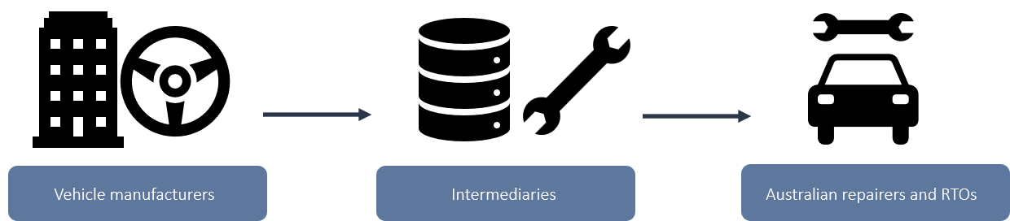
There are approximately 68 motor vehicle brands offering 380 models of vehicle within Australia. As independent repairers typically service all makes and all models, intermediaries play a critical role in facilitating access to affordable standardised information adapted to a variety of diagnostic, repair, service and maintenance tasks. Approximately 65 per cent of Treasury survey respondents indicated they sourced service, repair and diagnostic information from third party information providers or data aggregators within the last 12 months, and this figure was notably higher amongst smaller businesses (those with less than 20 employees) than larger businesses (those with 20 or more employees).
Under the scheme, intermediaries supplying scheme information, whether directly or indirectly, are treated as data providers. As a result, intermediaries are subject to the same obligations imposed on OEMs. The scheme does not require OEMs to provide scheme information to intermediaries and contemplates that access to scheme information by intermediaries and parts manufacturers will continue to be negotiated between parties on commercial terms.
The treatment of intermediaries under the scheme differs from similar schemes abroad, which position intermediaries as data recipients rather than data providers (see appendix B) and was designed with a view to ensuring competitive neutrality between entities supplying scheme information to the Australian market. This approach reflects the intent of NCP as it promotes a more dynamic business environment by reducing information asymmetries and supporting competition while ensuring an equal playing field across businesses. However, stakeholder feedback received as part of the review suggests that the current approach presents a range of practical challenges for intermediaries relating to accessing and distributing scheme information. These challenges are in addition to those relating to the separation of scheme information detailed in chapter 4.

Accessing and distributing scheme information
The scheme does not require OEMs to provide intermediaries with access to scheme information. While some information is reverse engineered, much of the information made available by intermediaries is done so under licence agreements with OEMs. Licence agreements are commonly concluded following extensive contractual negotiations and impose a variety of rights and obligations on parties which may also be impacted by relevant statutory frameworks.
While both intermediaries and OEMs operate globally, negotiations for the distribution of information are often jurisdiction specific. Several intermediaries ascribed difficulties in accessing scheme information through licensing agreements with OEMs in Australia to regulatory differences between the scheme and the equivalent scheme in operation in the EU. These stakeholders highlighted that although the scheme expressly presumes that intermediaries will continue to be able to negotiate access to service and repair information on commercial terms, in practice some OEMs have shown a reluctance to license scheme information in the absence of a statutory requirement to do so.
Existing challenges faced by intermediaries in accessing scheme information may be compounded in the medium term with the anticipated introduction in the EU of more stringent conditions and procedures to access vehicle OBD information (described in appendix B). While uncertainty exists over how these amendments will be implemented and flow through to the Australian market, one intermediary noted there is a risk that these changes may have the effect of ‘locking out’ non-proprietary devices, where intermediaries are not provided with the information necessary to comply with updated authentication and server checks. However, even where intermediaries are not locked out as a result of these changes and are able to access scheme information, a number of intermediaries identified that it is not practicable, within the context of their operations, to offer scheme information for the periods required under the scheme.
As noted in chapter 3, scheme information must be made available by day, month and year, where the underlying form of the information allows for variability. The majority of intermediaries engaging with the review reported that their global business models rely on annual subscriptions or one-off purchases and that it is commercially unviable to amend these models to the Australian market.
The Review was unable to test claims in relation to the viability of short-term subscription periods in the context of intermediaries’ business models. However, it is accepted that short, legislated timeframes for the supply of scheme information may present commercial challenges for intermediaries in some circumstances as:
vehicle-specific scheme information provided by vehicle manufacturers and intermediary goods and services capable of operating across a large number of vehicles are fundamentally different investments
- intermediaries’ value proposition involves value-adding to OEM data and realising a return on this value-add is likely to require customers to be committed for relatively longer periods.

Impact on intermediaries
The challenges described above suggest that there is opportunity for the scheme to better support intermediaries in providing scheme information. Given the extensive utilisation of intermediaries as a source of scheme information in Australia, any improvements to the scheme’s application to this class of data provider is likely to have a material impact on the provision of accessible and affordable scheme information and the productivity of repairers.
While the feedback received in relation to the challenges faced by intermediaries was consistent across stakeholders, views on precisely how intermediaries should be captured within the scheme varied:
- A third of submissions stated that intermediaries should be treated the same or similar to Australian repairers, enabling intermediaries to receive the same information as independent repairers and bringing Australia into line with other jurisdictions.
- A third of submissions, including submissions from the FCAI and some data aggregators, suggested that a new set of rights and obligations should be defined in relation to intermediaries, an approach supported by the Scheme Adviser.
- The balance of submissions varied in their views, which included excluding intermediaries from the definition of data providers, imposing goods faith dealing obligations between data providers and intermediaries and exempting intermediaries from the scheme’s requirements in relation to safety information.
The Review considers that the issues relating to accessing and separating scheme information present the most acute challenges for intermediaries. While matters raised in relation to short-term subscriptions may present significant obstacles in certain commercial contexts, the extent and impact of this issue across intermediaries was less clear.

Evidence suggests that increased emphasis on aligning the treatment of intermediaries under the scheme with comparable frameworks in the EU and US may be beneficial in addressing the practical challenges raised during consultation. This may involve treating intermediaries as recipients of scheme information, rather than providers, and requiring OEMs to supply scheme information subject to newly defined and appropriately calibrated rights and obligations. These rights and obligations may relate to ensuring appropriate use of scheme information and requiring that scheme information is provided to intermediaries in a form which facilitates its efficient transformation and integration into goods and services. The potential benefits associated with such a change may include:
- Increased availability of scheme information for intermediaries, supporting the availability of goods and services incorporating scheme information to Australian repairers and scheme RTOs.
- Enhanced competition amongst intermediaries by reducing barriers to entry through increased alignment with the regulatory settings applying in the EU and US.
- Increased productivity for Australian repairers by expanding the scope of circumstances in which their preferred intermediaries’ goods and services can be used, reducing the need to access proprietary solutions and OEM portals in some instances which have been reported to cause delay.
- Reduced regulatory burden on OEMs associated with supporting repairers navigate and utilise OEM systems, as an increased amount of scheme information would be accessed through intermediary goods and services.
Given the significant complexity and variability of OEM and intermediary operations, realising these benefits would necessarily require extensive industry engagement to minimise any marginal regulatory burden on scheme participants.
Finding 6
Intermediaries are critical in providing Australian repairers and RTOs with the products and services needed to compete. Aligning their treatment under the scheme with comparable international frameworks is likely to better support the efficient flow of accessible and affordable information, reduce barriers to entry into the Australian automotive repair market and increase repairer productivity. Such an approach would also partly address challenges expressed by stakeholders in navigating OEM portals.

- Scope of information
Key points
- The scheme requires data providers to share a wide range of scheme information with Australian repairers and RTOs, subject to a limited set of narrowly defined exceptions.
- Access to electronic logbooks is not currently mandated under the scheme. It will be important to ensure that independent repairers and their customers are not disadvantaged as the use of digital service records grows.
- The existing exclusion of telematics does not currently present significant barriers to the operation of the scheme, however industry momentum towards telematics as a means of data transfer necessitates consideration of the potential competitive impacts for independent repairers in the near term.
- Information related to automated driving systems (SAE Level 3 and above) is excluded from the scheme, reflecting the early stage of deployment in Australia; future consideration may be needed as these technologies become more prevalent.
- The scheme does not apply to physical parts, but access to parts and parts pairing is an emerging issue that may affect repairer competitiveness and insurance costs.
Ensuring that the information captured by the scheme reflects what is required to diagnose, repair, service, modify or dismantle scheme vehicles is critical in driving competition between Australian repairers. Over time, the information necessary to effectively work on modern vehicles is likely to change alongside developments in vehicle technology.
As detailed in chapter 1, the definition of scheme information is broad and captures a range of information that an Australian repairer may need. However, the scheme does not require that all information which may be used in diagnosing faults, servicing or repairing vehicles be made available to all Australian repairers and scheme RTOs. Specifically, scheme information does not include:
- trade secrets
- intellectual property of a person, other than intellectual property protected under the Copyright Act 1968
- a source code version of a program
- automatically generated data created by the vehicle while it is being driven
- global positioning system data
- information used to develop solutions to emerging or unexpected faults
- a commercially sensitive agreement between a data provider and another person, and
- information connected to a vehicle’s automated driving system.
In addition, the scheme excludes information that manufacturers utilise as training material in training their own repairers, as well as electronic or hard copy logbooks.
Feedback received through consultation highlighted the need to ensure the scheme can adapt to future technological developments, including through updates to the scope of scheme information. Electronic logbooks, telematics and automated driving systems were frequently highlighted as possible areas of expansion.

Electronic logbooks
Electronic logbooks are a digital alternative to traditional hard copy logbooks typically provided with the purchase of a vehicle. When used, they can provide consumers a recommended scheduled servicing plan and a means to record work done on their vehicle, incorporating a richer set of data than paper-based equivalents.
A list of tasks, such as a service schedule and record of their completion for a particular vehicle is not scheme information. However, information such as steps involved in performing a scheduled service, technical specifications for components and lubricants, and testing procedures must be made available under the scheme, even if contained within a logbook.
Electronic logbooks can assist repairers by providing information on prior work performed on a vehicle and in some cases allow necessary materials to be pre-ordered, increasing productivity and reducing delays for consumers. Ensuring work completed on a vehicle is consistently recorded in the electronic logbook is particularly important in establishing a complete service history which can influence a vehicle’s resale value.
Stakeholders representing the Australian aftermarket, including the AAAA, AAA and VACC expressed support for the inclusion of electronic logbooks under the scheme. It was noted that a number of vehicle manufacturers are no longer providing hard copy logbooks, placing reliance on electronic logbooks in ensuring vehicle service histories are accurately maintained. VACC noted that the primary concern associated with excluding logbooks from the scheme was the negative impact that incomplete repair records may have on the residual value of a motor vehicle, or on any associated warranties. It was argued, including by the AAA, that this uncertainty produces a competitive advantage for dealerships as consumers may feel obliged to access repair and maintenance services from parties with the most complete set of information about their vehicle. AASRA supports the inclusion of electronic logbooks as part of the scheme, citing the increasing reliance on digital technologies.
The FCAI does not support the inclusion of electronic logbooks under the scheme and does not regard logbook access as a prerequisite for essential repair work. The FCAI raised several concerns including:
- OEM-franchised workshops may seek reciprocal access to independent repairers’ logbook entries
- Repairers may be unaware of which businesses have previously worked on a vehicle
- Logbooks frequently contain personal information, raising privacy concerns.

The FCAI also noted the operational complexity of the sharing of electronic logbooks with independent repairers, including the need to define what information must be included within logbooks, and that providing access may necessitate the development of updated or novel digital platforms as existing platforms may not support ‘write access’ for independent repairers.
Currently, electronic logbook access is relevant to approximately one in ten new vehicles sold in Australia. European manufacturers were highlighted as commonly employing the technology, which is required to be made available to independent repairers under the EU’s information sharing framework. Among manufacturers utilising electronic logbooks, the majority provide aftermarket access in Australia in some form. However, as this access is not governed by the scheme, the terms and conditions of access vary. For example, one survey respondent noted that a manufacturer would only make logbook access available through a one year, cost prohibitive, subscription.
The AAAA expects that the use of electronic logbooks is likely to grow over time as vehicles become more technologically advanced across all market segments. As service schedules and records transition from hard copy to digital formats, the Review considers that barriers to accessing and updating this information in the aftermarket may reduce repairer productivity, increase costs and make maintaining complete records of vehicle repair and maintenance more difficult. Facilitating access to electronic logbooks under the scheme could serve to future proof the framework against these potential challenges, while ensuring those manufacturers continuing to use hard copy logbooks remain unaffected.
Commencing consideration of access to electronic logbooks while adoption remains in its infancy would allow for an appropriately calibrated approach to be settled through consultation with industry and minimise the likelihood of consumer detriment as uptake grows. In considering electronic logbook access, particular regard would need to be had to how the framework operates both between authorised and independent repairers, and between successive vehicle owners, particularly in the second-hand market. Factors requiring detailed consideration are likely to include:
- Ensuring consumer privacy and consent in the sharing of any personal information
- Limiting access to the extent necessary to effectively diagnose, service and repair scheme vehicles and record tasks performed
- Providing flexibility for vehicle manufacturers and minimising regulatory burden.
Given the complexity of these issues, early consideration of electronic logbook access may also provide greater certainty for vehicle manufacturers planning a transition to electronic logbooks.
Finding 7
The adoption of electronic logbooks is an emerging challenge for independent repairers. Regulated access to these records would ensure independent repairers are not disadvantaged in the transition to digital records and enable complete vehicle service histories to be efficiently maintained.

Telematics
There is no universally accepted definition of telematics; however, telematics is commonly understood to refer to the transmission of data from a remote source, such as a motor vehicle, to a control centre, such as manufacturer servers. The use of telematics allows a vehicle to store and wirelessly transmit large volumes of information. This may include, for example:
- Information on shutting down, powering up or idling of the engine
- Information related to vehicle emissions, fuel efficiency, fuel level and battery life
- Driving behaviour such as speed and rates of acceleration and braking
- Real-time vehicle location
- Driver focus metrics, such as eye tracking and blinking intervals
- Reporting of any vehicle malfunctions
Data transferred using telematics to a manufacturer’s server may be relevant to the diagnosis, repair or service task and assist a technician to understand how certain issues have occurred and enable faster malfunction diagnosis. The use of telematics can be particularly helpful in identifying upcoming or preventative maintenance, by highlighting abnormalities in vehicle functioning or patterns in driver behaviour that may contribute to premature wear and tear on components of the vehicle. In Australia, telematics are currently predominantly used in commercials contexts. For example, fleet managers use telematics to optimise repair and maintenance of fleet vehicles. The National Telematics Framework, which focuses primarily on schemes linked to heavy vehicles, also facilitates the use of telematics data by authorities, providers and operators for a range of schemes across jurisdictions.
The information required to be shared under the scheme expressly excludes data automatically generated and transmitted by a vehicle while it is being driven, whether that information is driver-related or is related to vehicle performance. Since the scheme commenced, approaches to regulating telematics in the motor vehicle industry have rapidly evolved across jurisdictions, including through reforms to incorporate telematics as part of comparable right to repair frameworks. These developments highlight the need to balance access to data in secondary markets with privacy and security-related concerns.
Stakeholder views received as part of the Review on expanding the scheme to include telematics varied. The FCAI indicated that privacy concerns continue to outweigh any benefit that might be gained from expansion of the scheme to include telematics. It was also contended that any additional data sharing requirements would increase the complexity of the scheme, and the accompanying regulatory burden placed on manufacturers. Conversely, stakeholders representing independent repairers and the AAA called for amendments to include telematics under the scheme. In voicing support for inclusion of telematics, stakeholders pointed to:
- the growing use of the technology in motor vehicles
- the potential use of telematics in ways that advantage dealers and preferred repairer networks, such as using real-time transfer of data to identify maintenance requirements on a vehicle, pre-emptively notifying the driver and encouraging continued servicing with an authorised repairer
- the importance of telematics in calibrating Advanced Driver Assistance Systems (ADAS), such as autonomous emergency braking systems which are compulsory on all new vehicles sold in Australia from 1 March 2025.
Feedback from data aggregators supported the inclusion of telematics, noting that its inclusion is necessary to future-proof the scheme. The ACCC suggested that a reconsideration of the risks and benefits of the inclusion of telematics was warranted, noting developments to incorporate telematics within similar frameworks in other jurisdictions since the commencement of the scheme (see appendix B).
Given the variety of information capable of being transferred via telematics, privacy risks associated with passenger vehicles equipped with such systems vary considerably and depend both on the type of data transferred and how data transfers occur. Depending on the technology employed, data may be transmitted via the internet to remote manufacturer data servers or via short-range wireless transmission to a locally accessed device, as in the calibration of ADAS systems.
Box 6.1: ADAS Calibration
Accurate calibration of Advanced Driver Assistance Systems (ADAS), such as lane-keeping assist, adaptive cruise control, and autonomous emergency braking, is essential to ensure their safe operation. This calibration process may involve one or both of two phases: static calibration and/or dynamic calibration.
Static calibration is performed while the vehicle is stationary and focuses on aligning sensors using fixed targets and manufacturer specifications. Dynamic calibration, conducted while the vehicle is in motion, is critical for confirming that sensors perform correctly under real-world conditions. Telematics systems are often used in this context, as they enable the real-time transmission of vehicle data, such as speed, steering angle, and sensor feedback, during dynamic calibration.
The transfer of driver-related data presents greater privacy risks than the transfer of vehicle-related information, regardless of the type of transfer. The Australian Information Commissioner has identified the risks associated with data collected by motor vehicles as significant, noting the lack of awareness by consumers of what information is collected, the lack of individual control over that data collection, and the breadth of data points being collected. Research has found that approximately eight in ten drivers are unaware that vehicle data is being collected and transferred.
The use of telematics by vehicle manufacturers is expected to increase in coming years. This reflects, in part, that modern vehicles are increasingly generating data flows which are too large and too complex to manage through traditional OBD-II interfaces.
The Australian Design Rules require that certain information, particularly emissions-related data and diagnostic trouble codes, must be made available via the OBD-II port. While the OBD-II port has traditionally been a critical channel through which information is made available to repairers, a shift towards telematics presents a risk that information relevant to vehicle diagnosis, repair and servicing but which is not required to be made available via the OBD-II port may, over time, become inaccessible.
In the United States, the concern that the use of telematics may result in a reduction in the information available to independent repairers was addressed as part of the 2023 Automotive Repair Data Sharing Commitment (‘the Commitment’) and prohibits manufacturers from using telematics systems to circumvent existing data sharing obligations (detailed in appendix B). The Commitment further provides that, to the extent specific telematic diagnostic and repair data is needed to complete a repair, that data is to be made available to independent repairers and vehicle owners if it is not otherwise available through a tool or third party service information provider.
In Australia, work by government and industry regarding the use of vehicle generated data to support positive road safety outcomes is being conducted through the joint industry-government Vehicle Generated Data Working Group established by the National Transport Commission. This group is building relationships between governments, OEMs and data aggregators regarding the sharing of vehicle and transport data.
Depending on near term industry developments, the increased use of telematics may have significant implications for independent repairers. At the time of writing, the Productivity Commission is considering new pathways to expand data access across the economy. As detailed in its interim report into Harnessing data and digital technology, there are a range of governance approaches to facilitating data access, from regulation-led mandates and standards to industry-led approaches which rely on market forces. The Productivity Commission notes that while regulatory approaches may be appropriate in certain contexts, overly prescriptive mandates may reduce the incentives for participation and undermine innovation. At this time, the Review considers that interventions falling at the mandatory end of this spectrum would likely impose large economic costs disproportionate to the size of the scheme.

The Productivity Commission notes that mandatory obligations are particularly beneficial in kickstarting progress. However, the automotive industry appears to be facilitating access by repairers to telematics data and the trend towards a greater use of telematics does not appear to be negatively impacting the operation of the scheme at this time. For example, even where telematics is critical to support dynamic re-calibration of certain ADAS systems, it appears that this information is currently being made available to independent repairers. While it is possible that changes in market dynamics may eventually necessitate a structured arrangement for the sharing of telematics information related to repair as in some other jurisdictions, the Review considers that an industry-led solution is likely preferable in the first instance. Given the span of industry perspectives on telematics shared with the Review, there would likely be benefit in industry commencing a dialogue around how future developments in this space might influence the realisation of the scheme’s objectives, and what industry-led solutions to these challenges might look like.

Automated driving systems
Scheme information excludes information relating to an automated driving system (ADS). Under the scheme, an ADS is a system which has a level of three or greater under the Surface Vehicle Information Report J3106, published by the Society of Automotive Engineers (SAE) International and as amended from time to time.
The Surface Vehicle Information Report J3016 describes six levels ADS ranging from no automation to full automation. Level one and two systems, such as lane keeping assistance and autonomous emergency braking, involve a licensed human driver remaining in control of the vehicle at all times. Information related to these systems is covered under the scheme. Systems which are rated as level three or greater according to SAE standards are defined as automated driving systems under the scheme and are excluded from the scope of scheme information.
A vehicle may be capable of delivering driving automation at different levels. In such vehicles, the level of automation exhibited in any given instance is determined by the features that are engaged, with an assessment made on system-by-system basis to determine whether or not information is scheme information. For example, service and repair information relating to a vehicle’s traffic jam chauffeur is not included under the scheme, but information needed to repair other features such as a vehicle’s windscreen is included (provided those features are not part of the level three or above automated system).
Vehicles with level three and above capabilities are not currently commercially available on Australian public roads, however trials are underway and this technology has been deployed in other countries, including the US. The Australian Government is working closely with state and territory governments, industry and the research community to prepare Australia for the safe deployment of automated vehicles. For example, infrastructure and transport ministers, through the Infrastructure and Transport Ministers’ Meeting, have agreed on a national approach to regulating vehicles equipped with automated driving systems. A new law, the Automated Vehicle Safety Law (AVSL), will be an important part of this framework. The Australian Government is developing the AVSL in line with the policy paper National in-service safety framework for automated vehicles developed by the National Transport Commission. The AVSL will deliver a nationally consistent regulatory approach to ensure the safe operation of automated vehicles on Australian roads and will be complemented by amendments to state and territory laws.
 Box 6.2: ADS and ADAS
A related term commonly used in this context is Advanced Driver Assistance Systems (ADAS). ADAS may refer to a wide range of features, including driver warnings, such as lane keeping assistance systems, some safety intervention systems, such as automatic emergency braking, as well as convenience features, such as parking assistance features. ADAS encompasses features which are driver aids designed to assist the driver, but ADAS features do not perform the entire driving task. When ADAS features are being used, the driver remains fully responsible for driving, monitoring road conditions and intervening when needed.
ADS systems were not typically a focus for stakeholders during consultation. Where ADS systems were addressed, stakeholders representing independent repairers and data aggregators contended that the existing exclusion limits, or may limit in the future, the ability of independent repairers to effectively service and repair vehicles with ADS technology. It was noted that access to up-to-date service procedures, diagnostic protocols and calibration specifications, including via intermediaries, is necessary for independent workshops to maintain and develop technical expertise and specialisation in advanced systems in anticipation of greater availability of ADS on the Australian market. Stakeholders representing manufacturers support a gradual approach to any sharing of ADS-related information, with manufacturers to retain full discretion during the early stages of the commercialisation and deployment of the technology.
The Bureau of Infrastructure and Transport Research Economics (BITRE) and Ausroads estimate that a small number of vehicles with level three systems and above may enter the Australian market from 2026. BITRE forecast introduction of level four vehicles between 2026 and 2031, with 2.6 per cent of new passenger vehicles to be highly or fully automated by 2030, increasing to around half of all new vehicles by 2046.
As the number of scheme vehicles fitted with ADS at level three or greater increase, so too does the risk that excluding scheme information relating to these systems may have a negative effect on independent repairers’ ability to compete. However, the extent of this risk will be determined through the deployment of this technology in the market. Given the current treatment of ADS information under the scheme does not significantly impact independent repairers and the future availability of automated vehicles in Australia remains uncertain, consideration of any changes to the scheme in relation to ADS is premature. Any future amendments in relation to ADS information would necessarily be informed by both regulatory and market developments associated with ADS technologies.
Finding 8
The emergence of telematics and automated driving systems is not materially impacting independent repairers’ ability to compete at this time. However, continued collaboration across industry is required to ensure the scheme’s early competition and productivity benefits are retained as this technology is deployed further.

Parts
Vehicle parts for a particular brand may be obtained from a range of sources, including from original equipment manufacturers (either original equipment car manufactured parts or automotive supplier branded parts), through parallel imports, or by sourcing recycled, reconditioned and salvaged parts. In most cases, vehicle parts are produced by third party specialist component producers. Australia’s vehicle part and accessory imports totalled approximately $4.8 billion in 2024.
Scheme information does not include information concerning aftermarket parts (whether supplied by a vehicle manufacturer or an aftermarket provider). This is because information relating to a part, such as its dimensions, strength or any relevant warnings are typically supplied with the product at the point of supply or on the product itself. The part is then installed by a repairer using relevant scheme information, such as information relating to how to disassemble the engine to replace a part. The scheme’s focus on the supply of information, rather than parts, aligns with similar schemes in the EU and US.
The ACCC’s 2017 New Car Retailing Industry market study found that vehicle manufacturers and dealers sometimes restrict access to certain parts for legitimate security reasons that may benefit consumers; however, an additional motive for restricting access can be to steer more repair and service work to authorised detailers and preferred repairer networks. The study did not find the practice of restricting parts to be widespread.
Stakeholder submissions to the Review highlighted restrictions on parts access as an emerging challenge which has the potential to undermine the operation of the scheme. For example, the AAAA reflected growing concerns around parts availability, including OEMs not making certain components available to the independent aftermarket, delays in supply, or parts being restricted to authorised dealerships only. The Insurance Council of Australia (ICA) echoed these concerns and highlighted that parts access is the most significant issue that can undermine the scheme’s objectives. The ICA referred to its 2025 Motor Insurance Policy Paper – a road map for reducing rising premiums which reported average vehicle repair times have increased from 38.57 days in 2019 to 61.25 days in 2024, with parts delays contributing to this increase. Limited access to parts, and delays in receiving those parts, can increase insurance claim costs and place upward pressure on premiums. Expanding the scheme to cover parts was also supported by a number of other stakeholders, including VACC and the Garage Network. Relatedly, the ACCC recommended exploring amendments to the Australian type-approval framework to require manufacturers to ensure that parts and scheme information are available for supply to Australian repairers at the time a new vehicle is placed on the market. The FCAI highlighted that it is not aware of any instances where FCAI members may have restricted access to specific parts on security grounds and noted that members have a direct commercial interest in maximising parts sales.
Several stakeholders also highlighted parts pairing as an emerging issue. Parts pairing involves the use of activation codes or software locks by some vehicle manufacturers in order to complete installation of certain replacement parts. This practice may restrict the ability of aftermarket parts distributors to compete, placing upward pressure on the price of repairs.
Other submissions to consultation raised challenges associated with accessing information about parts. For example, eBay Australia and New Zealand highlighted the need for access to fitment information to help enable the identification of parts. While the scheme currently provides access to fitment information for repairers and scheme RTOs, as eBay is an online marketplace it does not have access to this information under the scheme. The Review considers this issue should be examined alongside broader issues relating to the treatment of intermediaries highlighted earlier in this report.
VACC also recommended that the scheme be amended to include electronic parts catalogues (EPCs). EPCs allow repairers to:
- look up parts using VIN-specific information, ensuring compatibility
- visualise exploded diagrams to identify all required components for a specific repair
- avoid incorrect parts ordering and return delays, which are costly for both workshops and customers.
The scheme is principally designed to facilitate the efficient sharing of information, not products. While stakeholder submissions suggest that access to parts and associated information may pose an emerging risk to the effective operation of the scheme, the complexity of the parts supply chain, the diversity of stakeholder perspectives, and the variation in manufacturer practices prevent the Review from drawing firm conclusions about the extent or impact of these issues, and whether a departure from alignment with comparable schemes on the treatment of parts is warranted.
Consideration of including physical parts within the scope of the scheme, the role of parts pairing, and the timing of the supply of parts to the Australian market also raises a range of complex matters, including implications for Australia’s international trade obligations and intellectual property protections. A sufficiently detailed assessment of these issues, necessary to weigh the potential costs and benefits of such an inclusion, is beyond the scope of this Review. However, as the variety of vehicle brands within Australia continues to expand, further examination and consultation on appropriate regulatory settings governing the timeliness of parts and scheme information availability to Australian repairers may be required.
- Governance and enforcement
Key points
- Effective governance and enforcement are key to the operation of the scheme, with the Scheme Adviser and the ACCC playing central roles in administration, oversight, and compliance.
- The Scheme Adviser is responsible for facilitating dispute resolution, reporting on scheme prices and systemic issues, and providing general advice and annual reporting to support transparency.
- Data providers are required to report scheme offers and supply terms and conditions to the Scheme Adviser; however, these arrangements impose a significant regulatory burden.
- The scheme includes structured dispute resolution processes, but most issues are resolved informally, and the level of formal disputation remains low.
- Stakeholders report inconsistent compliance with the scheme’s obligations amongst some data providers, with aftermarket participants expressing concerns about the lack of visible enforcement by the ACCC and its impact on confidence in the scheme.
- Penalties for non-compliance are significant, but expanding the ACCC’s enforcement toolkit to include intermediate options such as infringement notices may uplift compliance and trust.
- Opportunities exist to clarify the application of the scheme to certain business models to ensure responsibilities and obligations are clear.
Effective governance and enforcement are key to the operation of the scheme. This chapter examines aspects of the scheme’s governance, including the respective administrative and enforcement roles of the Scheme Adviser and the ACCC as well as the scheme’s dispute resolution arrangements.
While the review considered the legislated functions and powers of the Scheme Adviser and the ACCC, an assessment of the capability of AASRA in performing the role of Scheme Adviser and the ACCC in undertaking these functions is beyond the scope of the Review.

Role of the Scheme Adviser
The scheme establishes a role for a Scheme Adviser with the following functions:
- Nominating mediators or technical experts for the purposes of dispute resolution
- Reporting to the Minister on
  - Scheme prices
  - Whether particular information is, or should be, scheme information
  - Any other matter relevant to the operation of the scheme
- Reporting to the ACCC about systemic regulatory or enforcement issues relation to the scheme
- Providing general advice in relation to the application of the scheme
- Providing information online about the availability of scheme information
- Publishing annual reports on their website about the number and type of inquiries and disputes, the number and types of disputes for which a mediator was appointed, resolution rates for disputes and anything else relating to the operation of the scheme or requested by the Minister.
The Scheme Adviser is also expected to receive copies of scheme offers published by data providers as well as reports of the terms and conditions, including price, on which scheme information is ultimately supplied to repairers and scheme RTOs. AASRA was appointed the inaugural Scheme Adviser and re-appointed Scheme Adviser for a further 2-year period from 1 July 2025. In undertaking this appointment, AASRA has agreed to performance expectations set by the Minister.
In addition to performing its legislated functions, AASRA provides commercial services to the industry by offering a vetting service. As noted in chapter 4, the vetting service assists data providers which have become members of AASRA ensure repairers meet the fit and proper person requirements. This centralised function also enables data providers domiciled abroad to more easily comply with the requirements under the legislation that sensitive information provided for the purpose of fit and proper person assessments be held within Australia (‘data localisation requirements’). AASRA vetting may be required for approximately 8 out of 10 vehicles registered on Australian roads.
The Review did not receive any evidence which suggests that the existing functions of the Scheme Adviser require amendment. However, AASRA’s dominant market position in the supply of vetting services under the scheme has features characteristic of a natural monopoly. While other data providers could seek an authorisation from the ACCC to implement their own multi-brand vetting arrangements, currently AASRA’s vetting operations are, in practice, subject to a low degree of competitive discipline.
Stakeholder responses to consultation did not indicate widespread industry concerns with AASRA’s fee structure. In addition, the Review considers that – in the absence of AASRA’s vetting service – the cost of each individual manufacturer assessing the fit and proper person requirements and complying with the scheme’s data localisation requirements would likely result in a relatively higher cost being imposed on repairers and scheme RTOs. In this way, AASRA’s commercial operations provide a material net benefit to industry.
However, given the Scheme Adviser’s central position within the scheme, transparency and trust in the Scheme Adviser may be further enhanced were it to adopt a practice of publishing financial statements detailing revenue-generating activities undertaken in connection with the scheme as part of its existing annual reporting arrangements. The publication of these statements may also support consideration as to whether the fees charged for services connected with the scheme by a Scheme Adviser, but which are not regulated by it, require further examination in future.

Reporting to the Scheme Adviser
As noted above, under the scheme data providers must:
- Provide a copy of their scheme offer in writing to the Scheme Adviser
- Provide written notifications to the Scheme Adviser regarding updates to the data provider’s scheme offer
- Notify the Scheme Adviser within two business days following the supply of scheme information about the terms and conditions of the supply, including the price for which the information is supplied (‘post-supply notification arrangements’)
These reporting obligations are intended to provide the Scheme Adviser with effective oversight of the scheme’s day-to-day operations.
The FCAI has noted that the scheme to date has imposed an average ongoing operational cost of $120,000 per annum per brand compared with an average annual revenue of $20,000 from the sale of scheme information. On this basis, the FCAI has emphasised the need for the Review to focus on options to minimise costs associated with the scheme which are ultimately passed onto consumers. The ACCC observed in response to consultation that the requirement to provide a notification within two business days of each supply of scheme information appears to be overly burdensome on data providers, which has led to widespread non-compliance with this obligation.
Based on the information provided, the Review considers amending the existing post-supply notification arrangement would have the likely effect of reducing the regulatory and administrative burden associated with the scheme. For example, enabling data providers to provide aggregated periodic reports relating to the terms and conditions of the supply of scheme information over a period, rather than details of each individual supply, would likely decrease the regulatory burden on data providers and provide AASRA with an information flow more useful in the context of its legislative functions.
The Review considers AASRA would be further supported in performing its legislative functions if data providers were required to provide near real-time reports of server outages which affect independent repairer access to scheme information. When combined with other changes to data provider reporting obligations, it is likely that appropriately calibrated reporting obligations would result in a net reduction in the regulatory burden imposed on data providers and provide insight into the operation and stability of the scheme. It is expected that such reports may also support an effective dialogue between industry participants on maintaining access to scheme information, and a means by which data providers could communicate access interruptions centrally to existing and prospective subscribers.
Given the significant benefit to Australian repairers and scheme RTOs of having a central repository of scheme offers available on the Scheme Adviser website, the Review considers that existing arrangements in relation to the reporting of scheme offers remains appropriate.

Dispute resolution
The scheme includes a structured dispute resolution process which may be used to help resolve disagreements in connection with the scheme. Data providers and repairers can use this process to resolve a dispute regarding a wide range of matters, including in relation to what is or is not scheme information, the timeliness of access to scheme information, and whether the price charged for scheme information exceeds its fair market value.
The Scheme Adviser’s functions include nominating mediators or technical experts for the purposes of dispute resolution and the Scheme Adviser receives reports on mediation outcomes. This function enables the Scheme Adviser to monitor the overall effectiveness of the scheme and maintain visibility of potential issues and disputes.
The dispute resolution process under the scheme is set out in Figure 7.1. Should either party be dissatisfied with the mediation outcome, they may initiate further alternative dispute resolution processes or bring legal proceedings.
Figure 7.1: Dispute resolution process under the scheme
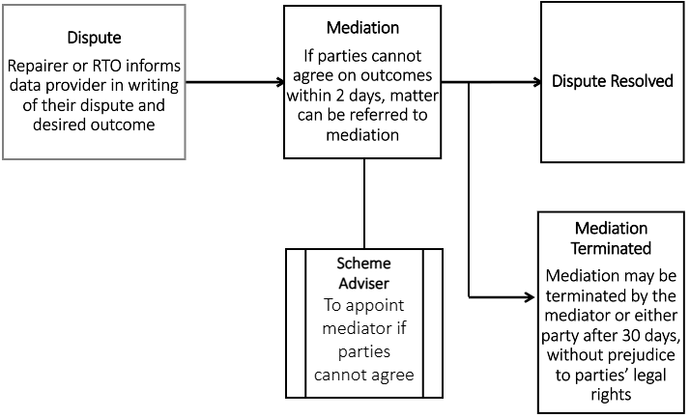
One mediation request between a repairer and a data provider has been lodged since the scheme’s commencement; however, given the other information provided by stakeholders as part of the Review, the number of reported mediations contains limited explanatory power as to the overall operation of the scheme to date.
In many cases, formal dispute resolution processes under the scheme may be too resource-intensive or disproportionate to the scale of individual challenges faced under the scheme. As a result, the majority of issues which arise in the operation of the scheme are resolved either directly between data providers and repairers or informally with the assistance of AASRA.

In 2023–24, AASRA reported 3,546 requests for assistance from independent repairers. During the same period, AASRA received 92 missing information reports from repairers, of which approximately 90 per cent were resolved. While several repairers expressed frustration regarding the effectiveness of the informal dispute resolution process, overall this informal dispute resolution pathway was not a focus of stakeholder feedback.
Although experiences in engaging with the scheme differ between repairers, evidence provided to the Review suggests that the level of disputation in connection with the scheme is generally low. AASRA continues to assist independent repairers to engage with the scheme within the limits of its function and resources and has taken steps over recent years to improve service levels, including through the introduction of a 1300 number.
VACC and the Garage Network suggested that current arrangements may be enhanced through the introduction of a public register, upon which anonymised complaints information and common access issues are posted. In their submission, the Consumer Policy Research Centre (CPRC) also noted several benefits that may flow from publicising complaints data, including improved business practices and enhanced decision making.
The Review notes that AASRA’s annual reports provide details of matters raised by independent repairers. While any changes in the reporting of complaints data is a matter for AASRA, steps to improve the granularity of reporting are likely to support future decision-making in connection with the scheme, particularly in relation to repairer concerns regarding the timeframes for the supply of scheme information (discussed in chapter 3).
Finding 9
The scheme’s governance arrangements are generally fit-for-purpose. Reducing routine reporting by data providers, while requiring system outage notifications to the Scheme Adviser, would enhance the transparency of scheme operations and reduce the overall regulatory burden imposed on data providers.

Enforcement
The ACCC is the statutory authority responsible for administering and enforcing the scheme and investigating reported instances of non-compliance. If required, the ACCC may take action including by implementing administrative resolutions, issuing infringement notices, entering into court-enforceable undertakings and commencing court proceedings.
The ACCC takes a risk-based approach towards its compliance and enforcement obligations which considers the ACCC’s Compliance and Enforcement Policy (‘ACCC C&E Policy’). As the ACCC is an independent Commonwealth statutory agency it takes enforcement action at its discretion.
Stakeholder feedback provided to the Review suggests that while the scheme is generally operating as intended, the degree of compliance with its requirements varies across the sector. Particular challenges shared with the Review related to the timely supply of scheme information as well as compliance with the scheme by newer entrants to the Australian market. Determining whether allegations of non-compliance are substantiated is a matter for a court of competent jurisdiction. However, inconsistent or incomplete compliance with the obligations imposed on data providers hampers independent repairers’ ability to compete and reliably meet the needs of their customers. Throughout consultation stakeholders raised concerns with the lack of public action taken by the ACCC under the scheme. Some stakeholders, including the AAAA, MTAA and the Garage Network suggested that the lack of transparency around ACCC enforcement practices, including in relation to matters referred by the Scheme Adviser, reduces confidence in the operation of the scheme. AASRA has also observed that “a lack of visible enforcement could undermine stakeholder confidence in the legislation” and noted that in the first three years of the scheme’s operation, 17 referrals were made to the ACCC with only one public facing outcome being imposed to date.
Box 7.1: ACCC Enforcement - Honda
0n 16 September 2024, the ACCC reported that Honda had paid a penalty of $18,780 after the ACCC issued an infringement notice for an alleged breach of scheme information sharing requirements.
The ACCC alleged that, from 1 July 2022 to 6 May 2024, Honda had offered access to software captured under the definition of scheme information for a yearly period only, and not also by day and month as required under the scheme.
The ACCC’s enforcement function must be, and be seen to be, carried out independently of Government. While the Scheme Adviser is required to provide reports of systemic non-compliance to the ACCC, the ACCC takes any decisions connected with these referrals independently and in line with the ACCC C&E Policy.
The ACCC’s Regulatory Guidance notes that, consistent with the ACCC C&E policy, it will take into account a number of factors when considering enforcement action, including whether a data provider has:
- made little or no effort to comply with the scheme
- unnecessarily or intentionally withheld or delayed the provision of scheme information
- consistently not complied with the main obligations of the scheme
- engaged in systemic conduct which could result in substantial harm to repairers – in addition to the main obligations, this may include non-compliance with requirements such as to ensure personal information obtained from repairers cannot be stored or accessed outside Australia
- maintained or gained an advantage by not complying with one or more obligations under the scheme.

The ACCC submission to the Review notes unique challenges faced with enforcing a new and novel regulation. The ACCC raised a number of compliance and enforcement barriers preventing the scheme from achieving its full potential, and considers that the scheme cannot achieve this potential unless the following matters are addressed:
- compliance challenges associated with safety information requirements impacting data providers
- the removal of technical information previously available to repairers
- ambiguity of language leading to misinterpretation of the intent of some scheme provisions
- a lack of intermediate penalties for some key scheme provisions, which limits enforcement options.
The ACCC considers that these barriers arise due to the scheme’s safety information requirements, the requirement for intermediaries to comply with the same obligations as data providers, the exclusion of diagnostic hardware from the scheme, and the absence of any provision which requires diagnostic software to be compatible with generic hardware.
That existing enforcement challenges associated with the scheme would be ameliorated in some cases through greater alignment between the scheme and comparable schemes abroad supports other conclusions reached as part of the Review. The following sections consider discrete enforcement issues relating to infringement notices, prohibited terms and conditions, and liability.

Infringement notices
While increased alignment with comparable information sharing schemes can support enforcement activities, in order for enforcement to effectively encourage compliance it is important that the penalties imposed under the scheme are not able to be viewed as ‘the cost of doing business’.
The scheme enables the ACCC to issue an infringement notice if it has reasonable grounds to believe a breach of certain provisions of the scheme have occurred. In October 2025, maximum infringement notice penalties able to be imposed are:
- $198,000 (600 penalty units) for corporations.
- $39,600 (120 penalty units) for individuals.
Currently, the ACCC may not issue an infringement notice for alleged contraventions of the scheme’s main obligation or the requirement that the price of scheme offers not exceed the fair market value (‘fair market value requirement’). The ACCC’s submission notes that “one of the most persistent and systemic compliance issues since the commencement of the scheme relates to the main obligation”.
The scheme’s main obligation to make a scheme offer (s 57CA(2)) and fair market value requirement allow for a civil pecuniary penalty of a maximum of $10 million for a body corporate and $500,000 for an individual. These penalty amounts are necessary and appropriate as compliance by data providers is critical to the integrity of the scheme and the achievement of its objectives.
Litigation can be the most effective way to achieve compliance outcomes. Where used, litigation may produce broader benefits beyond the conduct it addresses through the creation of case law which may be instructive as to the interpretation of the scheme’s principles and the scheme’s application in factually similar scenarios. However, litigation may not always be the most appropriate response to non-compliance with the scheme.
The ACCC submit that it would be more effective for enforcement purposes to also have an intermediate option, in addition to litigation, in relation to the main obligation and the fair market value requirement. A benefit of the infringement notice provisions is that they allow for timely and efficient dispute resolution without the need for litigation. The ability to issue an infringement notice provides the ACCC with flexibility in considering enforcement options in order to deter non-compliance and as an alternative to civil proceedings. The ACCC’s guidance on its use of infringement notices notes that the publication of notices may also have educative and deterrent effects.
Expanding the ACCC’s regulatory toolkit to respond proportionately to instances of non-compliance would not preclude the use of litigation in an appropriate case. The ACCC is less likely to consider issuing infringement notices in certain cases, including where:
- The ACCC considers the concerns are more serious in nature and warrant consideration by the court
- There has been significant detriment arising from the alleged conduct
- The ACCC has concerns that the alleged conduct may be continuing
- There are questions about whether the alleged conduct occurred within the 12-month period in which the ACCC may issue an infringement notice
Perceptions around enforcement appear to have influenced the perceived value of the scheme amongst some independent repairers. The Review considers that expanding the ACCC’s enforcement toolkit would provide the ACCC with greater flexibility and enable proportionate enforcement actions to be taken in a wider variety of circumstances. The public and proportionate use of enforcement powers by the ACCC in response to non-compliance would ensure repairers continue to see value in the scheme and broaden its uptake.

Prohibited terms and conditions
The scheme provides that data providers may make scheme information available subject to reasonable terms and conditions which do not prevent, restrict or limit access to scheme information. The flexibility afforded to data providers is restricted by section 57CC which prohibits data providers from entering into contracts to supply scheme information containing certain terms and conditions, including:
- a term or condition requiring an Australian repairer or scheme RTO to acquire one or more services or products from the data provider or any other person (‘bundling prohibition’)
- a term or condition allowing an increase, after the contract is made, in the price for the supply of the scheme information under the contract
- a term or condition prohibited by the Rules.
The ACCC has observed that making a scheme offer that contains a prohibited term is not a contravention of the scheme and that the current prohibition is only breached when the supply of scheme information occurs subject to a prohibited term. However, a scheme offer that contains a prohibited term can disincentivise independent repairers from taking up a scheme offer. Separately, the ACCC notes that data providers who supply software which is only compatible with proprietary hardware effectively compel repairers to purchase that hardware in addition to purchasing scheme information, undermining the intent of the bundling prohibition. The regulator has also expressed concerns about data providers supplying software with incomplete functionality, unless additional products or services are purchased, potentially also circumventing the bundling prohibition.
In light of these concerns, the ACCC has recommended that the scheme be amended to introduce a new prohibition which prohibits data providers from supplying information in a form that would prevent, restrict or limit the access to, or use of, scheme information. These issues are considered further below.

Pre-contractual conduct
Contracts entered into to access scheme information will, in many cases, be standard form contracts. As a result, the prohibited terms and conditions provisions under the scheme will apply in addition to the unfair contract terms (UCT) protections provided under the Australian Consumer Law. Where at least one of the parties is a small business, the UCT regime prohibits the use of, and reliance on, unfair terms in standard form contracts.
The Review considers that extending the existing arrangements for prohibited terms and conditions under the scheme to prohibit scheme offers which contain prohibited terms and conditions, as recommended by the ACCC, would align with the broader concern for pre-contractual conduct under the CCA. Such an amendment would also enable the ACCC to take action to protect repairers from the harm associated with prohibited terms and conditions before it occurs.

Bundling
The scheme aims to provide data providers with the flexibility to use their existing systems to supply scheme information to repairers and RTOs, helping to reduce compliance costs. In some cases, these systems will necessitate the use of proprietary hardware.
The supply of scheme information which must be used in combination with proprietary hardware is not itself inconsistent with the intent of the scheme, provided scheme information remains reasonably accessible in line with the main obligation. The ACCC’s submission therefore raises the question of how the legislative intent of the scheme as a whole can be reconciled with the breadth of the bundling prohibition.
The bundling prohibition is an important restraint on data providers’ ability to contract and seeks to ensure data providers do not unnecessarily increase the price of scheme information through bundling information with other goods and services. However, the Review considers that data providers and repairers would benefit from clarity regarding the operation of this prohibition in the context of data providers’ legitimate need, in some cases, to make scheme information available in a form which requires a repairer or scheme RTO to purchase additional goods or services. Greater clarity in relation to circumstances where bundling occurs post-supply, as flagged in the ACCC submission, may also support the effective operation of the scheme.

Consideration of any changes to the bundling prohibition would need to be undertaken in consultation with industry. Any changes would also need to strike a balance between facilitating data providers’ right to make goods and services available in the market and the scheme’s objective that all repairers should be able to enjoy access to scheme information with the same functionality as, for example, authorised repairers.

Liability
As noted in chapter 2, the manufacturer authorised supply chain for motor vehicles in Australia can be complex. As a result, the provision of scheme information often arises in the context of complex corporate structures and associated contractual arrangements.
Distributors of vehicles in Australia frequently operate as a separate legal entity from the foreign corporations responsible for vehicle manufacture and which hold the intellectual property rights associated with those vehicles. In many cases, manufacturers may also choose to partner with other entities, such as diagnostic hardware and software manufacturers, in supplying scheme information to the Australian market. While methods of facilitating access to scheme information differ, the scheme seeks to ensure that responsibility for compliance ultimately rests with the entity which controls scheme information, independent of their level of involvement in the supply of that information.
Submissions from both the ACCC and FCAI suggest there is scope to clarify how the obligations imposed under the scheme apply to certain business models and in certain contexts. The ACCC observed that some manufacturers have sought to delegate responsibility for compliance to dealerships or intermediaries, and that certain retailers may also be unintentionally captured by the scheme’s data provider obligations.
The FCAI has advocated for clarification of the application of the scheme to certain types of data providers, including remote diagnostic and technical support services, scan tool providers (examined in chapter 5), and to used vehicle importers.

Data providers
To be a data provider under the scheme, a corporation or person must generally have some level of control or ownership over scheme information. The centrality of ownership or control of scheme information is reflected both in the definition of ‘data provider’ and in the Explanatory Memorandum to the Bill. While regulatory clarity may be enhanced by expressly excluding retailers from the definition of data providers, in many cases retailers would be unlikely to have the requisite degree of control over scheme information under the scheme in order to be considered a data provider.
By contrast, greater uncertainty may arise in situating remote diagnostic and technical support service providers within the scheme. Diagnostic and technical support service providers operate under a number of business models. A common model involves pairing a hardware and remote service offering, typically on a subscription basis. Businesses utilising this model may provide a branded tool which repairers can purchase, and which enables the user to receive remote technical support. This service can play a role in addressing industry-wide skills shortages where on-site expertise is limited or unavailable. In many cases, remote diagnostic and technical support service providers may have a sufficient degree of control over scheme information to fall within the definition of data provider. However, as these businesses also assist repairers to diagnose, repair, and service scheme vehicles, such entities may also be regarded as Australian repairers under s 57BB of the Act.
Under the scheme, entities may be both a data provider and a repairer. For example, a dealership may supply scheme information and also carry on a business of servicing and repairing motor vehicles. While remote service providers themselves did not raise concerns regarding the application of the scheme, the Review considers that subject to appropriate consultation, there may be value in further clarifying the application of the legislation to entities of this kind given their unique position within the market.
While questions in relation to retailers and remote diagnostic and technical support services primarily raise issues of legislative clarity, views raised in relation to used vehicle importers invite consideration of broader policy issues relevant to the operation of the scheme.

Used vehicle importers
Used vehicle imports, like all vehicle imports, are regulated under the Road Vehicle Standards Act 2018 (Cth). The International Transport Forum estimates that between 1988 and 2022, 71,935 used vehicles were imported into Australia, approximately 0.47 per cent of the approximately 15.05 million passenger vehicles registered in Australia in that year.
Where a vehicle is imported into Australia by a used vehicle importer, but that importer does not provide scheme information in relation to the vehicle, obligations under the scheme will not apply. Although the Review expects the majority of used vehicle importers will not be involved in the supply of scheme information, where scheme information is provided by these importers to Australian repairers the used vehicle importer will be treated as a data provider under the scheme. The substantive issue to be considered by the Review in relation to used vehicle importers is therefore whether OEMs should be exempted from providing scheme information in relation to vehicles which they did not import.
The scheme does not obligate OEMs to supply scheme information in relation to scheme vehicles imported into Australia where this information is not currently supplied to Australian repairers or RTOs. However, where the OEM does provide scheme information in relation to a kind of vehicle which has been imported through another arrangement, the legislation does not permit the data provider to withhold scheme information in relation to that particular vehicle on the basis that it was imported outside the manufacturer’s authorised supply chain.
No evidence was provided to the Review which suggests that these current arrangements are impeding the operation of the scheme or imposing a material regulatory burden on vehicle manufacturers. While OEM’s have a legitimate commercial interest in limiting the costs they incur in connection with vehicles imported outside of the authorised supply chain, the scheme only requires manufacturers to provide scheme information where that information is already made available in the Australian market. Given this and noting that scheme information is made available to repairers at a price not exceeding fair market value, the Review estimates that the marginal cost to OEMs of providing scheme information to this class of imported vehicles is limited.

Third party agreements
Information provided as part of the Review suggests that a small number of manufacturers may be seeking to avoid obligations under the scheme through contracting with dealerships and third parties, such as diagnostic hardware and software suppliers. These entities may be engaged to:
- Establish and manage the online platform where dealerships and independent repairers purchase hardware and software
- Supply the diagnostic hardware and software directly to dealerships and independent repairers
- Resolve technical issues with the diagnostic hardware and/or software, including handling complaints or enquiries.
The scheme permits data providers to make arrangements that enable compliance with the scheme, and which suit their operating context. The scheme contemplates that data providers may enter into arrangements with third parties, including within vertically integrated structures and with related bodies corporate, to support the provision of scheme information. In some cases, although an agent may be contractually responsible to the data provider to perform functions necessary to comply with the scheme, the data provider is ultimately liable for compliance.
A manufacturer may choose to outsource certain aspects of scheme compliance to their dealership network, a circumstance expressly contemplated by the scheme. In this case, the main obligation to make a scheme offer available may still apply to the vehicle manufacturer where the dealership is itself an Australian repairer. While contractual arrangements in these circumstances may purport to place sole responsibility for scheme compliance on the dealership, such arrangements do not negate the obligations imposed under the scheme. However, additional clarity may be needed to address the potential for avoidance behaviour involving contractual relationships outside the manufacturer authorised supply chain.
A data provider’s main obligation under the scheme is triggered at the point scheme information is supplied, or offered to be supplied, in relation to one or more kinds of scheme vehicles to one or more Australian repairers or scheme RTOs. Information provided as part of the Review suggests that a data provider may seek to exploit this framing, by entering into an arrangement with a third party, such as a tool manufacturer, to supply scheme information to its domestic dealership network. In this case, the manufacturer may assert that the third party, and not the manufacturer, is the data provider for the purposes of the scheme, and that the manufacturer’s main obligation under s 57CA(2) has not been enlivened.

The Review did not receive evidence of widespread avoidance behaviour of this kind amongst manufacturers. However, if entered into, such arrangements would be contrary to the intent of the legislation and enable vehicle manufacturers to argue responsibility for compliance with the scheme rests with an entity outside the manufacturer authorised supply chain. As third parties necessarily apply their own markup to scheme information under such arrangements, such an outcome would likely impede the realisation of the scheme’s legislated objectives by increasing the minimum price at which scheme information is made available in the market. The Review considers that technical amendments which address the potential for this type of avoidance behaviour may be beneficial, and further strengthen the operation of the scheme.
Finding 10
Incomplete compliance with the scheme by some data providers risks undermining confidence in the scheme as a whole. Technical amendments to the scheme, including those aimed at improving regulatory clarity could, allow more timely and proportionate enforcement activities by the Australian Competition and Consumer Commission. More visible public enforcement would also assist in deterring non-compliance.

- Conclusion
A genuinely competitive market for motor vehicle service and repair services relies on all repairers having fair access to the information they require to safely carry out these tasks on their customers’ vehicles. However, as motor vehicles become increasingly technologically advanced, the information required to safely undertake these tasks increases.
The Motor Vehicle Service and Repair Information Sharing Scheme (the scheme) is Australia’s first ‘right to repair’ law and is designed to support competition in the market for motor vehicle service and repair. The scheme establishes a fair playing field between Australian repairers by mandating access, on fair and reasonable commercial terms, to information used to diagnose, repair, service, modify or dismantle vehicles to which it applies. Since its commencement, the scheme has become an important part of Australia’s automotive landscape.
The Review of the scheme, undertaken as part of Treasury’s broader Competition Review, found that since its introduction the scheme has had a material positive impact on competition, productivity and consumer choice, and has been associated with a 6.7 per cent increase in automotive repair sector turnover. While opportunities for greater engagement with the scheme amongst repairers remain, evidence presented to the Review identified reduced service refusals and improved customer satisfaction among engaged repairers.
Scheme information was found to generally be available at fair prices, though there are some opportunities for enhancement to ensure information pricing remains accurate and transparent. Additional costs associated with hardware may also be increasing the real cost borne by repairers. The Review also identified that the scheme is broadly proving effective in regulating the supply of information. Practical challenges persist however, with minimum supply periods and timeframes for information provision presenting challenges in certain circumstances.
Right to repair frameworks, including in the automotive repair sector, are being progressed in a number of jurisdictions. Increased alignment with these international frameworks may support greater accessibility of information while reducing regulatory burden in Australia. The Review identified opportunities for improved alignment, including regarding the separation and regulation of safety information which is unique to Australia. While intended to safeguard consumers and repairers, stakeholders highlighted difficulties in separating safety information and meeting fit and proper person requirements. Addressing these challenges through targeted amendments could deliver further productivity gains across the sector while maintaining the existing level of protection for information of this kind.
The treatment of intermediaries such as data aggregators and tool manufacturers under the scheme is also unique to the Australian context. Intermediaries play a vital role in disseminating scheme information and the scheme’s unique treatment of these entities increases costs and regulatory burden for businesses operating across borders. Recalibrating their treatment is likely to facilitate greater distribution of scheme information amongst repairers and may reduce the reliance on proprietary solutions and OEM portals which have, in some instances, been reported to cause delays in accessing information.
The scheme’s scope is broad but rapid technological changes in the automotive sector underscore the need for future proof regulatory settings. As the industry moves from hard copy to electronic logbooks it will be important to ensure that independent repairers and their customers are not disadvantaged through continued access to service records. Ongoing evaluation of aftermarket access to other categories of information, including in relation to telematics and automated driving systems, will be necessary to ensure the scheme’s benefits are maintained.
Effective governance by the ACCC and the Scheme Adviser is central to the scheme’s success. While dispute resolution mechanisms are provided under the scheme, the use of these mechanisms and public enforcement outcomes have, to date, been limited. Strengthening enforcement options and adapting reporting obligations may help build further trust in, and ensure consistent and ongoing compliance with, the scheme.
The Review’s findings indicate that Australia’s first right to repair law is broadly realising its legislated objectives. This outcome has been possible because of close engagement with industry in the design and administration of the scheme. The findings of the Review also suggest that the scheme may serve as an appropriate framework for addressing similar challenges experienced across other sectors of the economy when appropriately calibrated to unique market contexts.
Finding 11
The scheme's success to date reflects strong collaboration across the Australian automotive sector. Ongoing effective stewardship of the scheme will require continued industry engagement to ensure the scheme remains responsive to market developments.

Key terminology
Term | Definition
The scheme | Motor Vehicle Service and Repair Information Sharing Scheme established under Part IVE of the Competition and Consumer Act 2010.
Scheme Information | Information required to be shared under the scheme, including repair manuals, wiring diagrams, software updates, and diagnostic codes.
Scheme Vehicle | Passenger and light goods vehicles manufactured on or after 1 January 2002, excluding motorcycles, heavy vehicles, and others.
Scheme Offer | The offer made by a data provider to supply scheme information to Australian repairers and RTOs under regulated terms.
Fair Market Value | The maximum price at which scheme information can be supplied, based on factors such as cost recovery, demand, and international comparators.
Data Provider | A person or corporation that controls or supplies scheme information, including OEMs, intermediaries, and tool manufacturers.
Australian Repairer | A person or business that diagnoses, repairs, services, modifies or dismantles scheme vehicles.
Scheme RTO | A registered training organisation that uses scheme information for training purposes.
Scheme Adviser | The body appointed to oversee day-to-day scheme operations, currently the Australian Automotive Service and Repair Authority (AASRA).
Safety Information | Information relating to hydrogen systems, electric propulsion systems, high-voltage systems, and connected systems.
Security Information | Information unique to a vehicle or time-limited, such as key codes or immobiliser data.
Fit and Proper Person Test | Criteria that must be met to access safety or security information, including training and police checks.
Diagnostic Hardware | Physical tools used to interface with vehicle systems, such as scan tools or pass-through devices.
ADAS | Advanced Driver Assistance Systems – driver support features such as lane-keeping assist and emergency braking.
ADS | Automated Driving Systems – systems rated SAE Level 3 or higher that perform the entire driving task under certain conditions.
OEM | Original Equipment Manufacturer – a company that produces vehicles or vehicle components and supplies them under its own brand name.

Appendix A – Survey results
As part of public consultation, Treasury undertook a survey on the Treasury website. The survey was open from 30 June 2025 to 4 August 2025 and the target audience was automotive repairers. Respondents were given the opportunity to either complete a short survey of eight single and multiple response questions, as well as a final free text response question exploring their experience accessing information under the scheme. Alternatively, respondents were able to elect to skip directly to the free text question. All questions were non-compulsory and able to be skipped by a respondent.
This was a self-selecting survey, and no incentives were offered to respondents to encourage completion, responses are anonymous. No post-survey sampling adjustments were undertaken to improve representation to the total population. Given the self-selecting nature of the sample the existence of a sampling bias cannot be precluded, however given the intention of the survey to support the consultation process and the high number of responses received, Treasury considers it appropriate to draw inferences from the survey in conjunction with other sources of information and feedback.
In total, the Review received 325 survey responses. Of these, 8 responses were excluded from quantitative analyses as respondents fell outside of the target audience. The feedback provided by these responses was still considered as part of the broader analysis conducted by the Review. Of the remaining responses, 9 opted to skip the survey and provide general feedback to the free text question only. These responses provided were considered along with other free-text responses. A total of 308 survey responses were considered as part of quantitative analysis, and the results are presented in the tables below.

Approximately how many vehicles does your business diagnose, repair, service, modify or dismantle each month?
 | Vehicles repaired per month |  | Type of Repairer |  |  | Business size |  |  |  | Location |  | Total
 | Less than 100 | 100 or more | Generalist | Specialist - regional | Specialist - one / limited makes | Owner operator | 1 to 4 employees | 5 to 19 employees | 20 or more employees | Metro | Regional | Total
Less than 100 | 100% | 0% | 56% | 70% | 60% | 92% | 79% | 41% | 34% | 56% | 61% | 59%
100 or more | 0% | 100% | 42% | 30% | 40% | 5% | 20% | 59% | 63% | 44% | 37% | 40%
Don't know / Prefer not to say | 0% | 0% | 1% | 0% | 0% | 3% | 1% | 0% | 3% | 1% | 2% | 1%
Total responses (n) | 169 | 115 | 201 | 37 | 40 | 37 | 85 | 123 | 35 | 154 | 118 | 287

How many scan/diagnostic tools does your business currently have?
 | Vehicles repaired per month |  | Type of Repairer |  |  | Business size |  |  |  | Location |  | Total
 | Less than 100 | 100 or more | Generalist | Specialist - regional | Specialist - one / limited makes | Owner operator | 1 to 4 employees | 5 to 19 employees | 20 or more employees | Metro | Regional | Total
None | 4% | 0% | 1% | 3% | 5% | 8% | 0% | 2% | 0% | 3% | 1% | 2%
1 to 4 | 66% | 43% | 62% | 41% | 44% | 66% | 77% | 48% | 28% | 49% | 62% | 56%
5 to 9 | 22% | 34% | 22% | 49% | 37% | 21% | 17% | 36% | 28% | 29% | 27% | 27%
10 or more | 8% | 23% | 15% | 8% | 15% | 5% | 6% | 15% | 44% | 19% | 11% | 15%
Total responses (n) | 169 | 115 | 204 | 37 | 41 | 38 | 86 | 124 | 36 | 156 | 120 | 291

Where have you sourced service, repair and diagnostic information from in the last 12 months?
 | Vehicles repaired per month |  | Type of Repairer |  |  | Business size |  |  |  | Location |  | Total
 | Less than 100 | 100 or more | Generalist | Specialist - regional | Specialist - one / limited makes | Owner operator | 1 to 4 employees | 5 to 19 employees | 20 or more employees | Metro | Regional | Total
Purchased from a manufacturer | 64% | 70% | 65% | 66% | 67% | 52% | 62% | 69% | 75% | 63% | 71% | 65%
Information from a manufacturer freely available in Australia | 40% | 38% | 36% | 50% | 37% | 43% | 35% | 38% | 47% | 37% | 41% | 38%
Information from a manufacturer available overseas | 33% | 38% | 33% | 55% | 28% | 31% | 36% | 38% | 33% | 39% | 33% | 36%
Purchased from third party information provider / aggregator | 64% | 70% | 71% | 61% | 39% | 62% | 66% | 72% | 44% | 66% | 69% | 65%
From another repairer | 24% | 31% | 27% | 39% | 17% | 24% | 28% | 29% | 22% | 31% | 25% | 27%
From a general internet search | 62% | 67% | 66% | 76% | 46% | 57% | 73% | 68% | 36% | 63% | 67% | 64%
Don't know / Prefer not to say | 3% | 0% | 1% | 3% | 2% | 5% | 2% | 0% | 0% | 1% | 1% | 2%
No external sources in last 12 months | 1% | 3% | 2% | 0% | 7% | 0% | 2% | 3% | 3% | 2% | 2% | 2%
Other | 1% | 0% | 0% | 3% | 2% | 0% | 2% | 0% | 0% | 1% | 0% | 1%
Total responses (n) | 168 | 115 | 213 | 38 | 46 | 42 | 92 | 130 | 36 | 166 | 125 | 306

Have you experienced any issues accessing service, repair and diagnostic information in the last 12 months?
 | Vehicles repaired per month |  | Type of Repairer |  |  | Business size |  |  |  | Location |  | Total
 | Less than 100 | 100 or more | Generalist | Specialist - regional | Specialist - one / limited makes | Owner operator | 1 to 4 employees | 5 to 19 employees | 20 or more employees | Metro | Regional | Total
Yes | 81% | 89% | 85% | 95% | 64% | 63% | 86% | 90% | 77% | 85% | 83% | 82%
No | 16% | 11% | 14% | 3% | 34% | 32% | 13% | 9% | 23% | 13% | 16% | 16%
Don't know / Prefer not to say | 2% | 0% | 1% | 3% | 2% | 5% | 1% | 1% | 0% | 2% | 1% | 2%
Total responses (n) | 167 | 115 | 211 | 38 | 47 | 41 | 92 | 130 | 35 | 165 | 124 | 305

What issues have you experienced accessing service, repair and diagnostic information?
 | Vehicles repaired per month |  | Type of Repairer |  |  | Business size |  |  |  | Location |  | Total
 | Less than 100 | 100 or more | Generalist | Specialist - regional | Specialist - one / limited makes | Owner operator | 1 to 4 employees | 5 to 19 employees | 20 or more employees | Metro | Regional | Total
Delays in receiving information | 52% | 66% | 58% | 61% | 50% | 31% | 61% | 63% | 48% | 58% | 58% | 57%
Information was incomplete or unavailable | 61% | 74% | 65% | 72% | 63% | 58% | 61% | 73% | 59% | 68% | 65% | 66%
Difficulties in navigating manufacturer portals or websites | 64% | 63% | 65% | 61% | 53% | 35% | 71% | 66% | 52% | 62% | 63% | 63%
Cost to access the information was too high | 66% | 55% | 61% | 72% | 47% | 65% | 66% | 59% | 48% | 65% | 55% | 61%
Difficulty in meeting safety or security requirements | 24% | 29% | 29% | 28% | 13% | 35% | 25% | 26% | 30% | 24% | 30% | 27%
Don't know / Prefer not to say | 1% | 1% | 1% | 0% | 3% | 4% | 0% | 1% | 0% | 1% | 1% | 1%
Other | 1% | 0% | 0% | 0% | 3% | 0% | 0% | 0% | 4% | 1% | 0% | 0%
Total responses (n) | 135 | 102 | 178 | 36 | 30 | 26 | 79 | 116 | 27 | 139 | 103 | 250
Note: This question was asked of those who have experienced issues accessing service, repair and diagnostic information in the last 12 months.
How often, if ever, do you need to send a customer vehicle to a dealer or authorised repairer because you can’t access necessary information to complete the work?
 | Vehicles repaired per month |  | Type of Repairer |  |  | Business size |  |  |  | Location |  | Total
 | Less than 100 | 100 or more | Generalist | Specialist - regional | Specialist - one / limited makes | Owner operator | 1 to 4 employees | 5 to 19 employees | 20 or more employees | Metro | Regional | Total
Very frequently | 3% | 3% | 4% | 0% | 0% | 0% | 3% | 3% | 6% | 2% | 2% | 3%
Frequently | 9% | 9% | 9% | 14% | 11% | 5% | 6% | 9% | 29% | 8% | 13% | 10%
Occasionally | 34% | 39% | 40% | 27% | 30% | 41% | 36% | 36% | 29% | 36% | 36% | 36%
Rarely | 14% | 17% | 14% | 19% | 17% | 10% | 15% | 20% | 9% | 17% | 14% | 15%
Very rarely | 25% | 26% | 25% | 30% | 15% | 27% | 28% | 24% | 11% | 25% | 26% | 24%
Never | 13% | 6% | 7% | 11% | 24% | 15% | 12% | 6% | 14% | 10% | 7% | 10%
Don't know / Prefer not to say | 2% | 1% | 1% | 0% | 2% | 2% | 0% | 2% | 3% | 2% | 1% | 2%
Total responses (n) | 163 | 113 | 207 | 37 | 46 | 41 | 89 | 127 | 35 | 162 | 121 | 298

Does your business specialise in certain vehicles?
 | Vehicles repaired per month |  | Type of Repairer |  |  | Business size |  |  |  | Location |  | Total
 | Less than 100 | 100 or more | Generalist | Specialist - regional | Specialist - one / limited makes | Owner operator | 1 to 4 employees | 5 to 19 employees | 20 or more employees | Metro | Regional | Total
Generalist | 68% | 75% | 100% | 0% | 0% | 71% | 68% | 78% | 58% | 68% | 75% | 71%
Regional Specialist | 16% | 10% | 0% | 100% | 0% | 7% | 18% | 13% | 6% | 15% | 10% | 13%
Specialist - one or a few makes | 15% | 14% | 0% | 0% | 100% | 21% | 14% | 9% | 33% | 15% | 15% | 16%
Don't know / Prefer not to say | 1% | 1% | 0% | 0% | 0% | 0% | 0% | 0% | 3% | 1% | 0% | 1%
Total responses (n) | 165 | 113 | 213 | 38 | 47 | 42 | 90 | 129 | 36 | 165 | 120 | 301

Approximately how many people does your business employ?
 | Vehicles repaired per month |  | Type of Repairer |  |  | Business size |  |  |  | Location |  | Total
 | Less than 100 | 100 or more | Generalist | Specialist - regional | Specialist - one / limited makes | Owner operator | 1 to 4 employees | 5 to 19 employees | 20 or more employees | Metro | Regional | Total
Owner operator | 21% | 2% | 14% | 8% | 20% | 100% | 0% | 0% | 0% | 16% | 12% | 14%
1 to 4 employees | 41% | 15% | 29% | 42% | 28% | 0% | 100% | 0% | 0% | 30% | 29% | 30%
5 to 19 employees | 30% | 64% | 47% | 45% | 26% | 0% | 0% | 100% | 0% | 40% | 48% | 43%
20 or more employees | 7% | 19% | 10% | 5% | 26% | 0% | 0% | 0% | 100% | 14% | 11% | 12%
Don't know / Prefer not to say | 1% | 0% | 0% | 0% | 0% | 0% | 0% | 0% | 0% | 1% | 0% | 1%
Total responses (n) | 165 | 114 | 212 | 38 | 46 | 42 | 92 | 130 | 36 | 166 | 122 | 302

Location (What postcode is your business located in?)
Metro or Regional
 | Vehicles repaired per month |  | Type of Repairer |  |  | Business size |  |  |  | Location |  | Total
 | Less than 100 | 100 or more | Generalist | Specialist - regional | Specialist - one / limited makes | Owner operator | 1 to 4 employees | 5 to 19 employees | 20 or more employees | Metro | Regional | Total
Metro | 54% | 60% | 56% | 68% | 58% | 63% | 58% | 53% | 64% | 100% | 0% | 57%
Regional | 46% | 40% | 44% | 32% | 42% | 37% | 42% | 47% | 36% | 0% | 100% | 43%
Total responses (n) | 158 | 111 | 203 | 37 | 43 | 41 | 84 | 126 | 36 | 166 | 125 | 291

State and Territory
 | Vehicles repaired per month |  | Type of Repairer |  |  | Business size |  |  |  | Location |  | Total
 | Less than 100 | 100 or more | Generalist | Specialist - regional | Specialist - one / limited makes | Owner operator | 1 to 4 employees | 5 to 19 employees | 20 or more employees | Metro | Regional | Total
New South Wales | 30% | 29% | 29% | 16% | 42% | 32% | 32% | 29% | 19% | 27% | 33% | 29%
Victoria | 21% | 24% | 22% | 22% | 21% | 20% | 21% | 21% | 33% | 31% | 10% | 22%
Queensland | 30% | 29% | 27% | 43% | 23% | 24% | 29% | 29% | 31% | 25% | 34% | 29%
South Australia | 4% | 5% | 4% | 5% | 5% | 2% | 6% | 5% | 3% | 2% | 7% | 4%
Western Australia | 11% | 9% | 12% | 14% | 5% | 17% | 7% | 12% | 11% | 13% | 8% | 11%
Tasmania | 1% | 1% | 2% | 0% | 0% | 5% | 0% | 2% | 0% | 1% | 2% | 1%
Northern Territory | 2% | 0% | 2% | 0% | 0% | 0% | 2% | 2% | 0% | 1% | 2% | 1%
Australian Capital Territory | 1% | 3% | 1% | 0% | 5% | 0% | 1% | 2% | 3% | 0% | 3% | 1%
Other Territories | 1% | 0% | 0% | 0% | 0% | 0% | 1% | 0% | 0% | 0% | 0% | 0%
Total responses (n) | 159 | 111 | 204 | 37 | 43 | 41 | 85 | 126 | 36 | 166 | 125 | 292

Appendix B – International frameworks
In recent years the right to repair movement has gained significant momentum internationally. Many jurisdictions, including the United States (US), the European Union (EU) and Canada have introduced right to repair policies aimed at making repairs easier, more affordable, and more accessible. For example:
- France and Belgium have both introduced a repairability index for certain goods,
- Canada progressed amendments to its:
  - Copyright Act in 2024 to enable digital lock circumvention for the purpose of repair and to enable interoperability between devices and software, and
  - Competition Act in 2025 to prevent manufacturers from refusing to provide diagnosis and repair information or related products to a person under certain conditions, and
- Colorado has enacted legislation providing access to parts, tools, documentation and software for electric wheelchairs.
For passenger vehicles, the EU and some states in the US have mandated that OEMs provide access to repair and service information to independent repairers and, in some circumstances, to consumers. The degree of alignment between the Australian, US and EU frameworks was a consistent theme throughout the course of the Review. The following sections set out key aspects of the EU and US motor vehicle information sharing arrangements.

European Union
Since 2009, vehicle manufacturers in the EU have been required to ensure that independent operators (repairers) have unrestricted and standardised access to vehicle repair and maintenance information (RMI) under Regulation 715/2007. The framework permits manufacturers to charge reasonable and proportionate fees for access to RMI and requires information to be made available on a daily, monthly and yearly basis.
This regulation, which forms part of the EU’s broader type approval framework for motor vehicles, facilitates access to RMI for ‘independent operators’. RMI is similar in scope to scheme information and includes:
- VIN
- Service handbooks
- Technical manuals
- Component diagnosis information
- Diagnostic trouble codes
- Information provided concerning, and delivered by means of, proprietary tools, and
- Data recorded information and two-directional monitoring and test data.
‘Independent operators’ is broadly defined and, in contrast to the Australian scheme, provides access to scheme information for entities including publishers of technical information and manufacturers or distributors of repair equipment, tools or spare parts.
Other key differences between the scheme and EU arrangements include that OEMs must provide access to:
- reprogramming capabilities using standardised or publicly documented interfaces
- diagnostic and other equipment or tools, including the complete references and available downloads of any applicable software.
It is expected that the EU landscape will change through forthcoming amendments to Annex X of the Type Approval Regulation 2018/858 ‘Access to Repair and Maintenance Information’. This amendment aims to establish technical requirements and procedures for the access to vehicle OBD information and RMI regardless of a vehicle’s powertrain type. Updates include:
- extended rights of access to OBD information and the vehicle data stream, subject to authentication of the workshops
- offering independent operators, the same level of access as authorised dealers and repairers
- references to the EN ISO 18541 standard which defines the structure and content of OEM websites used to disseminate RMI
- specific provisions for accessing vehicle security features, requiring independent operators to meet authorisation criteria.
It is expected that the amendments will address long-standing concerns about the fragmented and inconsistent availability of RMI data across OEMs, which has posed challenges for independent operators in that market.

United States
Currently, Massachusetts (2012) and Maine (2023) have enacted legislation similar to the scheme requiring motor vehicle manufacturers to supply repair and service information to vehicle owners and repairers.
The Massachusetts right to repair law mandates open, standardised access to vehicle diagnostic and repair information, including telematics, for independent repairers and vehicle owners. Specifically, it requires OEMs to provide:
- vehicle owners and independent repairers with access to the same diagnostic and repair information made available to the manufacturer’s dealers
- diagnostic repair information to each aftermarket scan tool company and third party service information provider with whom the manufacturer has relevant licensing, contractual or confidentiality agreements.
The Massachusetts scheme became the basis for a national private Memorandum of Understanding (MoU) between vehicle manufacturers and the automotive aftermarket, signed in January 2014. The MoU extended the scope of the right to repair law and strengthened several aspects of access to service information, tools and software needed to work on computerised vehicles made from 2018 onwards. It applied the Massachusetts law’s provisions nationwide on a voluntary basis, ensuring that independent repairers would receive the same diagnostic and repair information as franchised dealers.
Currently a Federal Bill, the Right to Equitable and Professional Auto Industry Repair Act (REPAIR Act) is in both Houses of Congress. If passed, the Bill would require OEMs to provide consumers, independent repairers, parts manufacturers, and aftermarket service providers access to the diagnostic data, tools, and software necessary to perform vehicle repairs and maintenance. The Bill requires this information be made available at a fair, reasonable, and non-discriminatory cost.
Table B.1: Comparison of key features of automotive right to repair frameworks in Australia, EU and US
 | Consumer right to access data | Parts and hardware | J2534 pass-through mandate | Treatment of intermediaries | Telematics sharing mandate
Australia | Consumers themselves are not provided the right to access information under the scheme. | If data providers require use of proprietary hardware to access certain information under scheme, hardware must be made available for purchase or hire.  Parts not included. | Scheme information must be offered in an electronic form that is reasonably accessible to all repairers. A reasonably accessible form may utilise the J2534 API, but scheme information may be supplied in other forms provided they are reasonably accessible. | Obligation to provide information to Australian repairers. Access to information by intermediaries not regulated, subject to contractual negotiation. | Telematics is excluded from the definition of scheme information in s 57BD(2).
European Union | EU 2018/858 does not have an active role for consumers in the provision of information; however, the consumer remains responsible for granting access to third parties under Data Act (telematics). | Art 61 of EU 2018/858 requires access to diagnostic and other equipment, tools including the complete references, and available downloads, of the applicable software.  Parts not included. | OEMs must provide access to reprogramming capabilities using standardised or publicly documented interfaces (Euro 5/6). In many cases OEMs voluntarily support J2534 due to US mandates. | EU 2018/858 Art 61 requires independent operators to be provided with non-discriminatory access. | Reforms to Regulation 2018/858 are expected to impose an obligation on manufacturers that any means of vehicle access that are made available to dealer and authorised repairers for repair purposes, including wireless local area networks, are also made available to independent repairers. Further, the Data Act, which applied from September 2025, enables consumers of connected products, including motor vehicles, to access the data that is created by those products through their use.
United States | Section 2 of the 2014 MoU provides that manufacturers must make information available to independent repairers and owners for purchase (subject to restrictions). In relation to telematics in Massachusetts only, consumers have a role in granting access to that data for independent repairers. | Section 2 of Massachusetts scheme requires OEMs to make all diagnostic repair tools available to owners and independent repairers for purchase. This expansive requirement is reflected in section 2(b)(i) of nationwide MoU.  Parts not included. | Mandated through s 2 of the Massachusetts scheme which has been adopted in nationwide MoU between Auto Alliance, Automotive Aftermarket Industry Association, Global Automakers and Coalition for Auto Repair Equality. Also mandated by EPA and California Air Resources Board that OEMs provide J2534-compliant reprogramming tools for emissions-related systems. | Under s 2 of the legislation OEMs must provide diagnostic and repair information to each aftermarket tool company and intermediaries with whom they have appropriate licensing arrangements for the purpose of building third party service information publications. This is also included in para 2(b)(i) of MoU. | The Massachusetts scheme requires that consumers of vehicles manufactured from 2022 onwards and which utilise a telematics system are given the right to access all data generated by the vehicle through a mobile application. Maine has mandated a similar approach, as of January 2025, for vehicles to be equipped with a standardised and owner-authorised platform to allow access to data emanating from the vehicle.  If enacted, the proposed Right to Equitable and Professional Auto Industry Repair Act, would impose a national framework for the handling of telematics data, at the time of writing it has not progressed.

Appendix C – Analysis methodology

Automotive repair sector analysis
The following fixed effects model for firm $i$, in quarter $t$, in state $s$, was estimated using ordinary least squares.
$$y_{ist}=β_{1}Post_{t}+β^{'}X_{ist}+Time_{t}+δ_{i}+ϵ_{ist}$$
The variables are tabulated below. $β_{1}$ is the coefficient of interest and shows the average impact of the scheme on real firm turnover after implementation, compared to before. $β_{1}$ is expected to be positive. The model also includes time fixed effects to control for any seasonal and macro-economic trends, and firm fixed effects to control for any time-invariant characteristics of firms. Individual dummy variables for each state are also included to capture time-invariant differences between states, such as their geography.
Variable | Description
$$y_{ist}$$ | Log of quarterly real firm turnover, deflated by state Consumer Price Index for the expenditure class ‘maintenance and repair of motor vehicles’.
$$β_{1}$$ | Average effect of the scheme on businesses.
$$Post_{t}$$ | Policy dummy variable. $Post=1$ from 1 July 2022 onwards.
$$β^{'}$$ | Vector of coefficients corresponding to each control variable
$$X_{ist}$$ | Vector of controls to account for supply and demand for vehicle servicing, including number of km travelled by vehicles, population, gross state product, and previous levels of employment and capital expenditure of firms.
$$Time_{t}$$ | Time fixed effects
$$δ_{i}$$ | Firm fixed effects
$$ϵ_{ist}$$ | Idiosyncratic error
The analysis is subject to a number of limitations which may reduce the accuracy and confidence of results.
- Demand for repair services rebounded following travel restrictions placed on individuals during the COVID-19 pandemic. The implementation of the scheme coincides with the easing of travel restrictions. Due to lack of firm-identification and having to use average industry outcomes, part of the result attributed to the scheme could be due to this pent-up demand.
- Firm level data allows us to control for state-level heterogeneity for impact of lockdowns and travel habits. Though there is an identification issue in that all firms in the cohort are impact together, meaning there is no control/treatment cohorts to compare. We can only compare average outcomes before and after scheme implementation.
- The nature of the dataset also presents two identification issues:
  - Unable to identify which firms in the sector were accessing scheme information.
  - Unable to identify which firms are independent or authorised repairers.

Consumer price analysis
The following fixed effects model for price index of repair of motor vehicles, in quarter $t$, was estimated using ordinary least squares.
$$Repair_{t}=α+γ_{1}MVIS Dummy_{t}+β_{1}Parts_{t}+β_{2}WPI_{t}+β_{3}Motor Vehicle_{t}+\sum_{k=1}^{4}{β_{k}Vehicle Imports_{t-k}}+\sum_{k=1}^{4}{Repair_{t-k}}+ϵ_{t}$$
The variables are tabulated below. $γ_{1}$ is the coefficient of interest and shows the average impact of the scheme on real firm turnover after implementation, compared to before. $γ_{1}$ is expected to be positive.
Variable | Description
$$Repair_{t}$$ | Price index for repair of vehicles
$$Parts_{t}$$ | Price index for spare parts and accessories for Motor Vehicles
$$MVIS_{t}$$ | Dummy = 1 from 2022Q3 onwards.
$$WPI_{t}$$ | Wage Price Index for ‘Other Services’
$$Motor Vehicles_{t}$$ | Price index for motor vehicles
$$Vehicles Imports_{t}$$ | Repair demand proxy through lagged value of motor vehicle imports (all vehicles are imported). Given as a value but converted to an index to match other variables.
$$γ_{1}$$ | Average effect of the scheme on repair prices of vehicles.
$$ϵ_{t}$$ | Idiosyncratic error
The analysis is subject to a number of limitations may reduce the accuracy and confidence of results.
- The data uses CPI sub-indexes that are highly correlated and exhibit relatively little within-series variation in values. Together, these characteristics of the data lower the power of the statistical model.
- There is limited data available following the introduction of the scheme (12 quarters), which limits the ability to reliably identify post-implementation effects.
- Relatively limited uptake of the scheme by repairers may reduce the visible impact in aggregate indicators, such as CPI sub-indexes.
- Increases in business turnover linked to the scheme may not be reflected in changes to consumer prices, as the scheme’s benefits may be unevenly distributed, leading to shifts in market share rather than uniform price changes.

Competition and Consumer Act 2010 (Cth) s 57BD (‘CCA’).
Explanatory Memorandum, Competition and Consumer Amendment (Motor Vehicle Service and Repair Information Sharing Scheme) Bill 2021 9, [1.27] (‘MVIS Bill’).
CCA (n 1) s 57CA.
Ibid s 57BA.
Ibid s 57FB.
See, e.g., J Hambur & O Freestone, How Costly are Mark-ups in Australia? The Effect of Declining Competition on Misallocation and Productivity, Commonwealth Treasury, 21 August 2025.
‘Authorised’ means a manufacturer has authorised the supply of a good or service to the Australian market under their brand name, while ‘independent’ means the supply to the Australian market which has not been authorised by a manufacturer.
Australian Automotive Aftermarket Association (AAAA), ‘Automotive Aftermarket Industry Thriving‘ [media release], AAAA, 29 July 2024, accessed 21 October 2025.
P Davis, L Coppi & P Kalmus, ‘The Economics of Secondary Product Markets’, United Kingdom Office of Fair Trading, 12 December 2012.
Adapted from Productivity Commission (PC), ‘Right to Repair Inquiry Report‘, PC, 2021, accessed 22 October 2025.
C Jin, L Yang, & C Zhu, ‘Right to repair: Pricing, welfare, and environmental implications’, Management Science, Management Science, 69(2), 2012, 1017-1036.
L Kahane, ‘The impact of the Massachusetts 2012 right to repair law on small, independent auto repair shops’, Applied Economics Letters, 29(10), 2012, 873-879.
Productivity Commission (PC), ‘Right to Repair Inquiry Report‘, PC, 2021, accessed 21 October 2025.
ACCC, ‘New Car Retailing Industry – Market Study‘, ACCC, 2017, accessed 21 October 2025.
Three workshop groups were identified in the data (Foundational, Developing, or Leaders); these categories reflect workshop willingness to invest in future trends and technologies.
These thresholds were chosen to focus the analysis on active, mature firms and are necessary to ensure insights are not skewed by dormant and non-revenue generating firms.
Business Longitudinal Analysis Data Environment (BLADE), 2024, ABS DataLab. Findings are based on use of BLADE data.
Consumer Policy Research Centre (CPRC), ‘Detours and roadblocks‘, CPRC, 31 October 2023, accessed 11 September 2025.
C Brunton, ‘Consumer experiences of buying, servicing and repairing new cars‘, ACCC, May 2017, accessed 11 September 2025, 65.
CPI measures price changes experienced by households over time across a variety of product groups. For further information about the CPI, see the ABS Consumer Price Index: Concepts, Sources and Methods.
CCA (n 1) s 57CC.
Ibid s 57CC(2).
Ibid s 57CA(6).
Ibid s 57CA(7).
Service and repair information is data utilised to service and repair a motor vehicle and is a subset of scheme information, which may include software programs needed to diagnose and service motor vehicles.
Ibid s 57CA(5).
MMAL Rentals Pty Ltd v Bruning [2004] NSWCA 451.
The Review examined scheme prices at various points in time and over the period of the scheme’s operation. While Treasury considers the point in time analysis to be representative, the choice of time periods was constrained by data availability across data sources in some cases.
These brands are Toyota, Mazda, Hyundai, GM (Holden), Ford, Mitsubishi, Nissan, Subaru, Honda, and Kia.
Bureau of Infrastructure and Transport Research Economics (BITRE), Road Vehicles Australia January 2025: Bureau of Infrastructure and Transport Research Economics Statistical Report, BITRE, Australian Government, 2024, accessed 29 September 2025.
CCA (n 1) s 57CA(5)(a)(ii).
Ibid s 57CA(5)(e).
CCA (n 1) s 57CA(5)(d).
Explanatory Memorandum, MVIS Bill (n 2) 15, [1.59].
CCA (n 1) s 57CA.
Explanatory Memorandum, MVIS Bill (n 2) 15, [1.62].
CCA (n 1) s 57CC(2)(a).
ACCC, ‘Motor Vehicle Service and Repair Information Sharing Scheme – Guidance for data providers‘, ACCC, 2025, 12 (‘ACCC Guidance’).
United Nations Economic Commission for Europe, UN Regulation No 155 – Cyber Security and Cyber Security Management System, 22 January 2021.
Explanatory Memorandum, MVIS Bill (n 2) 15, [1.60].
SAE International, Recommended Practice for Pass-Thru Vehicle Programming J2534-1_5_00, On-Board Diagnostics for Light and Medium Duty Vehicles Subscription, SAE website, 2022, accessed 8 October 2025.
Explanatory Memorandum, MVIS Bill (n 2) 15, [1.62].
Regulation (EU) 2018/858 of the European Parliament and of the Council of 30 May 2018 on the approval and market surveillance of motor vehicles and their trailers, and of systems, components and separate technical units intended for such vehicles, [2018] OJ L151/1, art 6(4).
CCA (n 1) s 57CA(3).
ACCC (n 38) 18.
G Gibson et al, ‘Study on the Operation of the System of Access to Vehicle Repair and Maintenance Information: Final Report’, European Union, October 2014, 42-49.
International Standardisation Organization (ISO), ‘ISO 18541-1:2021 – Road vehicles – Standardized access to automotive repair and maintenance information (RMI)’, June 2021.
CCA (n 1) s 57DA.
Competition and Consumer (Motor Vehicle Service and Repair Information Sharing Scheme) Rules 2021 Explanatory statement, 7.
Ibid 7.
Competition and Consumer (Motor Vehicle Service and Repair Information Sharing Scheme) Rules 2021 s 7.
Model Work Health and Safety Act s 19.
AURETH101 superseded AURETH001 in 2020.
National Centre for Vocational Education Research, ‘DataBuilder 2025‘, website, accessed 7 October 2025.
Australian Automotive Aftermarket Association, ‘AAAA State of the Industry 2024 Summary‘, webpage, 2024, accessed 7 October 2025.
Productivity Commission, ‘Building a skilled and adaptable workforce Interim Report‘, Publication, 2025, 61.
Competition and Consumer (Motor Vehicle Service and Repair Information Sharing Scheme) Rules 2021, Explanatory statement, 8.
Federal Chamber of Automotive Industries (FCAI), ‘About FCAI‘, webpage, accessed 8 October 2025.
See appendix A: Survey Results.
CCA (n 1) s 57BE.
Explanatory Memorandum, MVIS Bill (n 2) 15, [1.54].
CCA (n 1) s 57BD(2)(d).
Explanatory Memorandum, MVIS Bill (n 2) 15, [1.28-9].
Explanatory Memorandum, MVIS Bill (n 2) 15, [1.29].
J Mulach , ‘VFACTS 2024: New vehicle sales hit record high, but slump expected soon‘ [media release], CarExpert, 6 January 2025, accessed 21 October 2025.
Regulation (EU) 2018/858 of the European Parliament and of the Council of 30 May 2018 on the approval and market surveillance of motor vehicles and their trailers, and of systems, components and separate technical units intended for such vehicles, amending Regulations (EC) No 715/2007 and (EC) No 595/2009 and repealing Directive 2007/46/EC, [2018] OJ L 151/1, Annex X, cl 2.5.2.
Transport Certification Australia (TCA), ‘National Telematics Framework‘, website, TCA, 18 September 2024, accessed 12 September 2025.
CCA (n 1) s 57BD(2)(d).
This distinction has been considered in the United States as part of the Massachusetts Data Access Law. The National Highway Traffic Safety Administration (NHTSA) has withdrawn earlier opposition to the law on the understanding that manufacturers are able to provide independent repair facilities with vehicle system access through short-range wireless protocols, such as Bluetooth.
C Kind, ‘UNSW Privacy & Security Regulation for Connected Cars Workshop‘ [speech], Office of the Australian Information Commissioner, 2 May 2025, accessed 12 September 2025.
AAAA, ‘Government Should Act on ‘Hidden’ Telematics – Consumers Agree‘ [media release], AAAA, 24 February 2021, accessed 7 October 2025.
O Burkacky, J Deichmann & J P Stein, ‘Automotive Software and Electronics 2030‘ [report], July 2019, McKinsey & Company, accessed 12 September 2025.
M McCarthy, M Seidl, S Mohan, J Hopkin, A Stevens & F Ognissanto, ‘Access to In-vehicle Data and Resources Final Report‘, European Commission, May 2017, 42.
Automotive Service Association, ‘Society of Collision Repair Specialists & Alliance for Automotive Innovation‘, Automotive Repair Data Sharing Commitment, July 2023.
National Transport Commission (NTC), ‘Vehicle Generated Data‘, Vehicle Generated Data Working Group.
PC, ‘Harnessing Data and Digital Technology: Interim Report‘, 2025, 46.
CCA (n 1) s 57BD(3).
Explanatory Memorandum, MVIS Bill (n 2) 15, [1.37].
National Transport Commission (NTC) , ‘What is an automated vehicle?‘, Department of Infrastructure, Transport, Regional Development, Communication and the Arts, 2024, accessed 25 September 2025.
NTC, Automated vehicle safety reforms, Department of Infrastructure, Transport, Regional Development, Communication and the Arts, 2024, accessed 25 September 2025.
BITRE, Forecasting uptake of driver assistance technologies in Australia, BITRE, 2021, accessed 25 September 2025.
ACCC (n 14) 136.
Department of Foreign Affairs and Trade (DFAT), Country and commodity pivot table 2006 to 2024, DFAT, 2025, accessed 20 October 2025.
ACCC (n 14) 139.
Ibid.
Insurance Council of Australia (ICA), Motor Insurance Policy Paper – a road map for reducing rising premiums, ICA, 2025, accessed 20 October 2025.
CCA s 57BD(1); Explanatory Memorandum, MVIS Bill (n 2) 15, [1.25].
CCA (n 1) s 57FB.
Ibid s 57DD.
BITRE, Road Vehicles Australia January 2025: Bureau of Infrastructure and Transport Research Economics Statistical Report, BITRE, Australian Government, 2024, accessed 7 October 2025.
CCA (n 1) s 57CA(7)(a).
Ibid s 57CA(7)(b).
Ibid s 57CB(4).
In practice, the Scheme Adviser provides a short list of appropriate mediators to the Australian Small Business and Family Enterprise Ombudsman.
Australian Automotive Service and Repair Authority (AASRA), ‘Annual Report 2023–2024‘, AASRA, 2025, accessed 8 October 2025.
ACCC, Honda pays penalty for alleged breach of car service and repair information sharing scheme [media release], ACCC, 16 September 2024, accessed 1 October 2025.
ACCC (n 38). Motor vehicle service and repair information sharing scheme: guidance for data providers
CCA (n 1) s 57GB item 5; Crimes Act 1914 (Cth) s 4AA.
CCA (n 1) s 57CA(4), Crimes Act 1914 (Cth) s 4AA.
ACCC, ‘Infringement notices – Guidelines on the use of infringement notices by the Australian Competition and Consumer Commission‘, ACCC, 2020, 9.
CCA (n1) s 57CC(1).
CCA (n 1) s 57CC(2).
Ibid sch 2 Pt 2-3.
Explanatory Memorandum, MVIS Bill (n 2) 15, [1.59].
Ibid 15, [1.60].
CCA (n 1) s 57BE(a).
Explanatory Memorandum, MVIS Bill (n 2) 15, [1.20].
International Transport Forum, ITF Used Vehicle Registration Database, version 1.2, OECD, 2024, accessed 21 October 2025.
Concessional RAV entry approval is a pathway for entering certain vehicles on the Register of Approved Vehicles (RAV) that have concessions against the national road vehicle standards but are otherwise suitable for use on public roads in Australia. A concessional RAV entry approval is also taken to be an import approval for that vehicle. This allows vehicles from overseas to be imported into Australia and entered on the RAV.
Explanatory Memorandum, MVIS Bill (n 2) 15, [1.23].
Ibid 15, [1.22].
CCA (n 1) s 57CA(1).
CCA (n 1) s 57CA(2).
Explanatory Memorandum, MVIS Bill (n 2) 15, [1.23].
Government Bill (House of Commons) C-59 (44-1) – Royal Assent – Fall Economic Statement Implementation Act, 2023 – Parliament of Canada.
2017, Regulation (EC) No 715/2007 of the European Parliament and of the Council of 20 June 2007 on type approval of motor vehicles with respect to emissions from light passenger and commercial vehicles (Euro 5 and Euro 6) and on access to vehicle repair and maintenance information, the European Parliament and The Council of the European Union, accessed 8 October 2025.
Bill 3 (LD 1677). ‘An Act Regarding Automotive Right to Repair’, Maine Legislature, https://legislature.maine.gov/bills/getPDF.asp?paper=IB0003&item=1&snum=131
Bill H.4362, ‘An Act Protecting Motor Vehicle Owners and Small Businesses in Repairing Motor Vehicles’, Massachusetts Legislature, https://malegislature.gov/Bills/187/H4362
H.R.906 – 118th Congress (2023-2024): REPAIR Act

