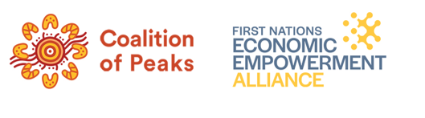
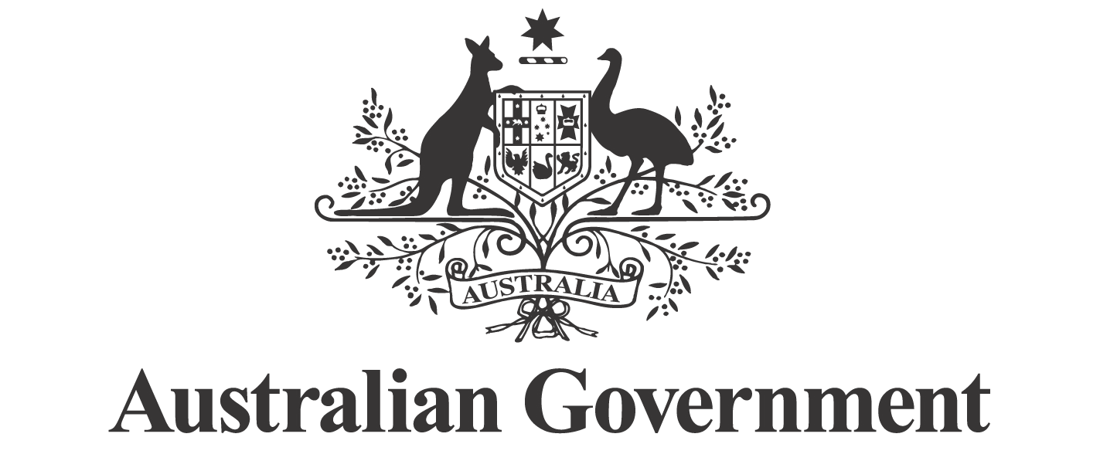
First Nations Economic Partnership Meeting 8 December 2025

Communiqué

The second meeting of the First Nations Economic Partnership (Economic Partnership) was held on Ngunnawal and Ngambri Country in Canberra on 8 December 2025.

The Economic Partnership met to strengthen collaboration between First Nations partners and the Commonwealth in advancing economic empowerment. The meeting focused on governance, strategic priorities, and initiatives that support sustainable economic participation for First Nations peoples.

On 21 October 2025, partners agreed to establish three Working Groups, and the Terms of Reference were subsequently endorsed on 8 December 2025. The Working Groups will advance policy priorities in the following areas:

- Economic Framework
The Economic Framework working group will co-design a comprehensive Economic Framework. This Framework will set out a national roadmap for economic empowerment, aligning with the National Agreement on Closing the Gap and the United Nations Declaration on the Rights of Indigenous peoples. It will include priority pillars to drive coordinated Commonwealth action, informed by research, stakeholder engagement, and previous reports.
- Access to Capital and Institutional Arrangements
The Working Group will make policy recommendations to the Economic Partnership on ways to improve Indigenous access to capital and optimise institutional arrangements to support economic empowerment, self-determination and wealth creation. The Working Group will make tangible and practical recommendations to accelerate the growth and long-term sustainability of First Nations businesses and boost economic opportunities for First Nations communities.
- Employment and Career Pathways
The Employment and Career Pathways Working Group will provide policy advice to the Economic Partnership on two key priorities under the Partnership Agreement: establishing Economic Inclusion Zones and developing funded programs that create secure employment opportunities in the community-controlled sector.

As part of the Agreement, partners also discussed mechanisms for a transparent, consensus-based process for onboarding new partners, members, and experts. The Economic Partnership looks forward to regular engagements with First Nations interests, and the private and civil sectors in 2026 to inform its activities.

The meeting included a presentation from the National Native Title Council on the development of an improved funding package for Native Title Prescribed Bodies Corporate (PBCs) following on from the Prime Minister’s announcement of new funding of $75 million. This funding aims to help PBCs unlock economic opportunities and strengthen negotiations with key stakeholders. The Partnership will continue to engage with Government on longer-term native title reforms, including responses to the Future Acts review.

At the next Partnership meeting, Government officials will provide an update on current and future initiatives to support First Nations economic empowerment.

The next meeting of the Economic Partnership is scheduled for 18 February 2026.

