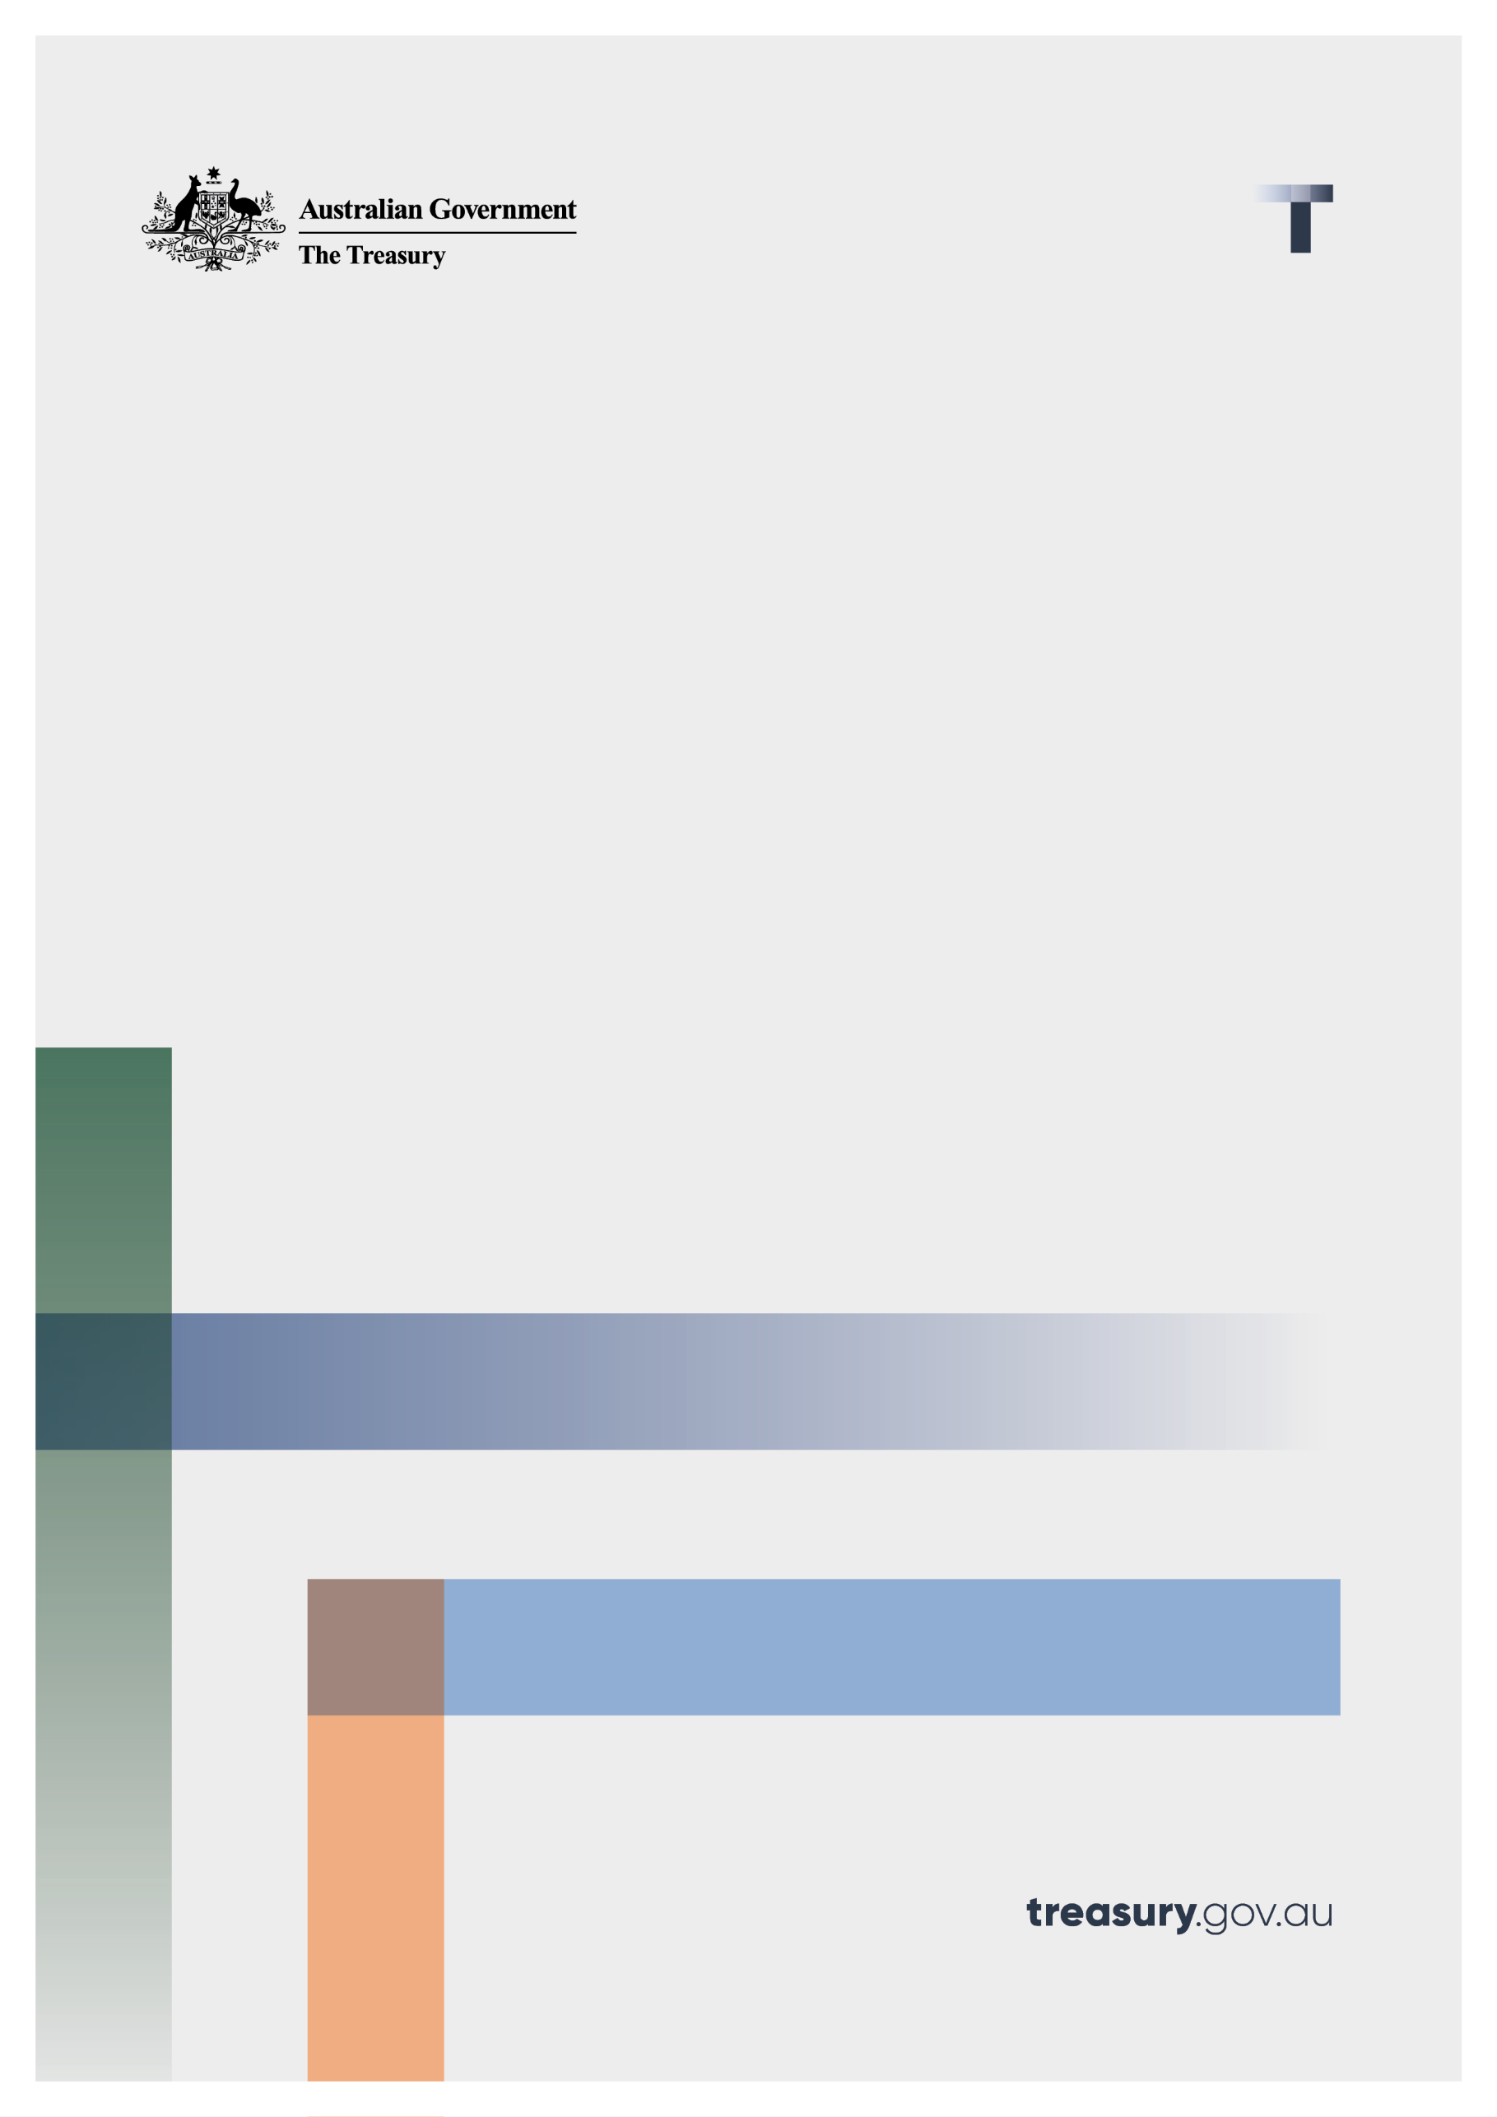
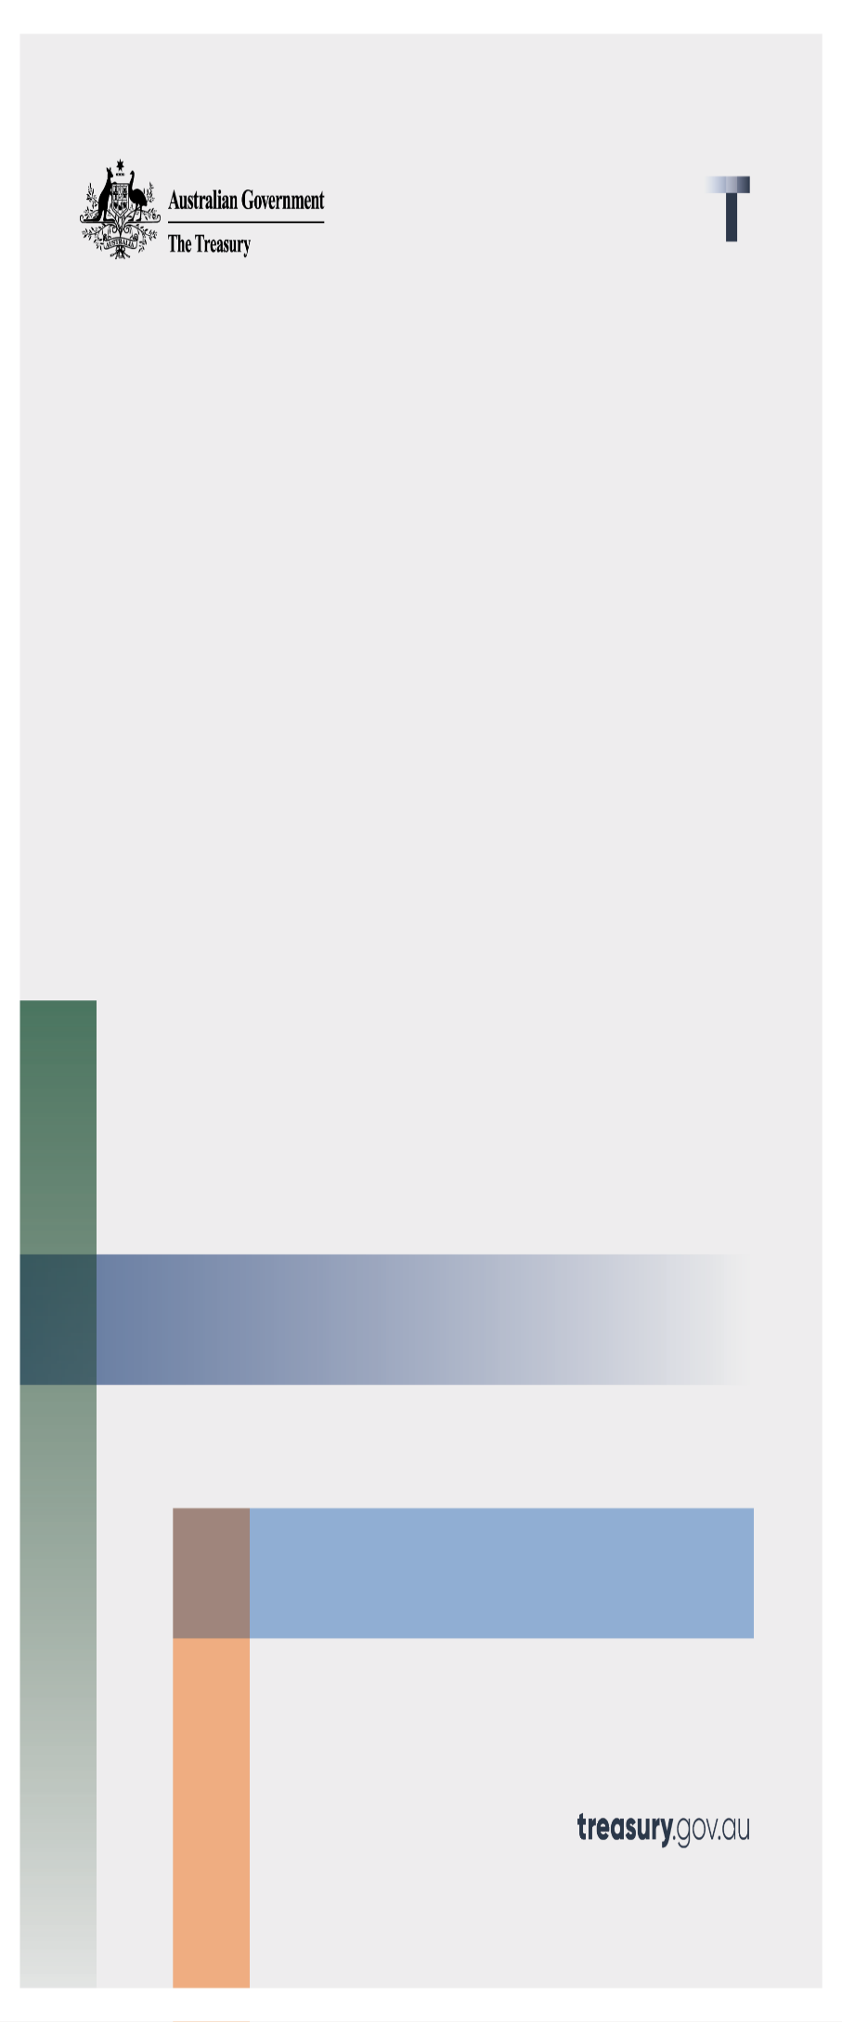
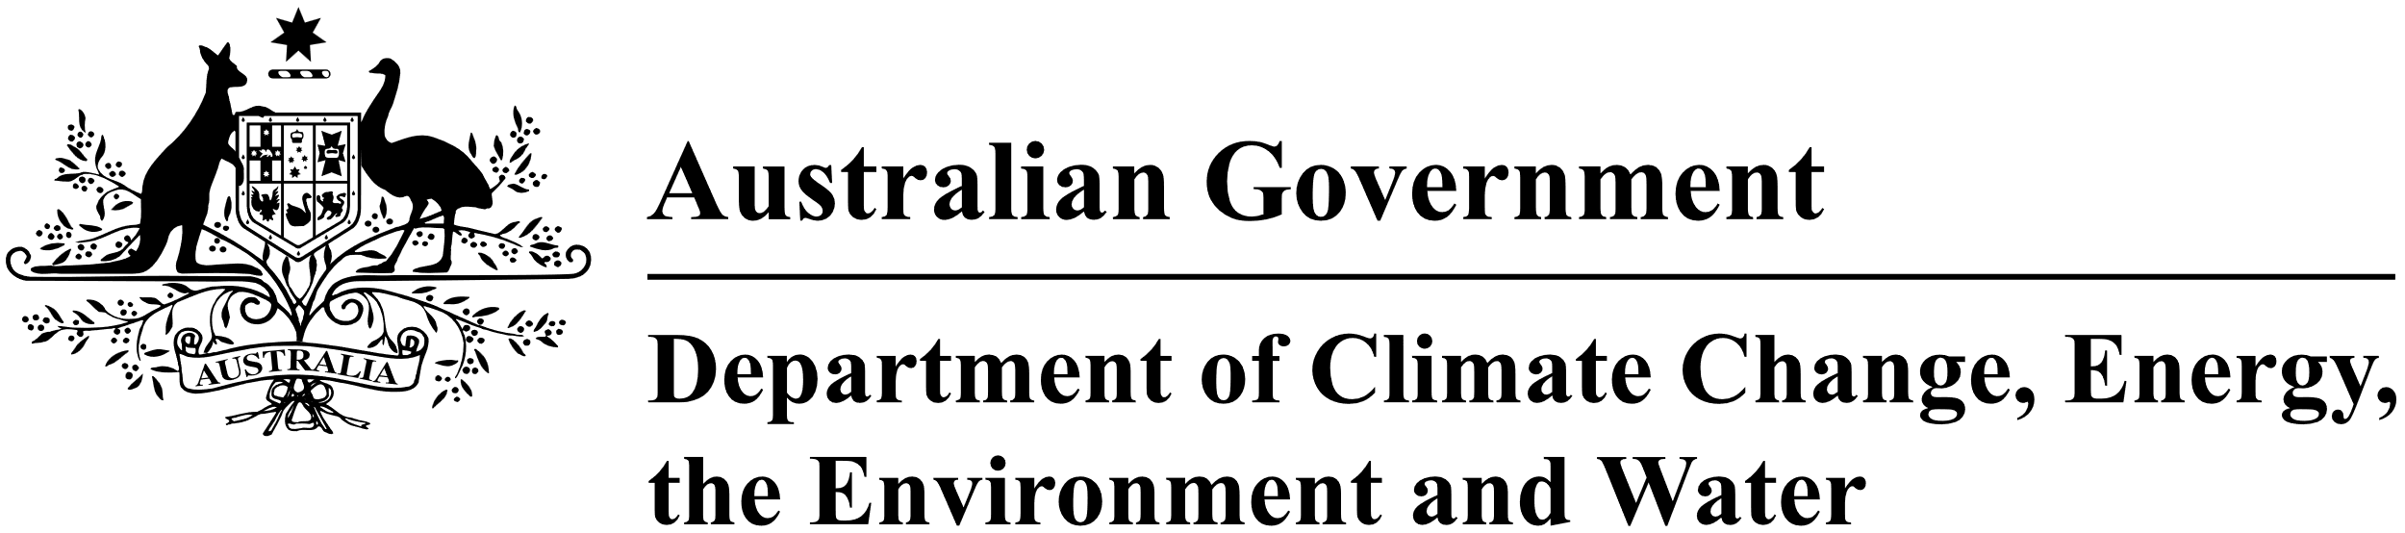

Review of the Electric Car Discount
Terms of reference and guidance for submissions
December 2025

© Commonwealth of Australia 2025
This publication is available for your use under a Creative Commons Attribution 4.0 International licence, with the exception of the Commonwealth Coat of Arms, the Treasury logo, photographs, images, third party materials, materials protected by a trademark, signatures and where otherwise stated. The full licence terms are available from creativecommons.org/licenses/by/4.0/legalcode.
Use of Treasury material under a Creative Commons Attribution 4.0 International licence requires you to attribute the work (but not in any way that suggests that the Treasury endorses you or your use of the work).
Treasury material used ‘as supplied’.
Provided you have not modified or transformed Treasury material in any way including, for example, by changing the Treasury text; calculating percentage changes; graphing or charting data; or deriving new statistics from published Treasury statistics – then Treasury prefers the following attribution:
Source: The Commonwealth of Australia.
Derivative material
If you have modified or transformed Treasury material, or derived new material from those of the Treasury in any way, then Treasury prefers the following attribution:
Based on Commonwealth of Australia data.
Use of the Coat of Arms
The terms under which the Coat of Arms can be used are set out on the Department of the Prime Minister and Cabinet website (see www.pmc.gov.au/government/commonwealth-coat-arms).
Other uses
Enquiries regarding this licence and any other use of this document are welcome at:
Manager
Media and Speeches Unit
The Treasury
Langton Crescent
Parkes ACT 2600
Email: media@treasury.gov.au
In the spirit of reconciliation, the Treasury acknowledges the Traditional Custodians of country throughout Australia and their connections to land, sea and community. We pay our respect to their Elders past and present and extend that respect to all Aboriginal and Torres Strait Islander peoples.

Terms of reference
The Treasury Laws Amendment (Electric Car Discount) Act 2022 (the Act) was introduced to encourage greater take-up of electric cars by Australian road users to reduce Australia’s carbon emissions from the transport sector. The Act requires a review to be undertaken of the operation of the electric car discount. The electric car discount consists of a fringe benefits tax (FBT) exemption and an exemption from tariffs on eligible electric cars.
The review will establish a fact base on the electric car discount to improve understanding of its operation and the outcomes it is delivering for Australians, in the context of other related Government programs and initiatives, for example the National Electric Vehicle Strategy and the New Vehicle Efficiency Standard Act 2024.
The Government has asked the Australian Centre for Evaluation, at the Australian Treasury, and the Department of Climate Change, Energy, the Environment and Water to conduct the review, working closely with relevant Commonwealth agencies. The Australian Centre for Evaluation is well placed to conduct this review given their experience and capabilities conducting high-quality evaluations of Government policies and programs.
Consistent with the requirements in the Act, the review will consider:
- the first 3 years of the electric car discount’s operation, since its commencement on 1 January 2023, and in particular, the effectiveness of the electric car discount in encouraging the uptake of cars that are zero or low emissions vehicles,
- whether the electric car discount should continue, and, if so
- what types of vehicles should attract the electric car discount.
Furthermore, the review will take into account:
- the role of the electric car discount in supporting early adoption of electric vehicles,
- changes in the electric car market, including price, choice and availability of new and second-hand electric vehicles,
- changes in electric vehicle charging infrastructure and support services,
- the cost of the electric car discount in achieving its objectives; and
- consumer acceptance of electric vehicles.
The review will invite public submissions relevant to the review and have regard to those submissions in its evaluation.

Additional information on the electric car discount
Information on the electric car discount is available from the following sources:
- Treasury Laws Amendment (Electric Car Discount) Act 2022
- The Explanatory Memorandum to the associated Bill
- Customs Tariff Proposal (No. 5) 2022
- The Summary of Alterations for the Customs Tariff Proposal (No. 5) 2022
- Australian Customs Notice No. 2022/23
- The following Budget measures: ‘Powering Australia – Electric Car Discount’ (October 2022-23 Budget) and ‘Powering Australia – Amendment to the Electric Car Discount’ (2023-24 Budget).

Public submissions
The review invites written submissions that respond to the terms of reference above. In particular, the review would welcome evidence or analysis that helps to address the following questions.
- Were the tax exemptions (from FBT and import tariffs) effective in encouraging the uptake of zero or low emissions vehicles? What was the role of the tax exemptions compared to other factors that influenced the uptake of electric vehicles? The review is particularly interested in the impacts on early adopters, and how support of the market may have had flow-on impacts such as the development of charging infrastructure, or the broadening and deepening of the electric vehicle market.
- How did the eligibility criteria in relation to vehicle type impact the uptake of zero or low emissions vehicles?
This could include responses that go to the type of vehicle eligible.
- Other evidence relevant to the future operation of the electric car discount for eligible electric cars.

Request for feedback and comments
Submissions must be lodged electronically.
All information (including name and address details) contained in submissions may be made available to the public on the Treasury website unless you indicate that you would like all or part of your submission to remain in confidence. Automatically generated confidentiality statements in emails are not sufficient for this purpose. If you would like only part of your submission to remain confidential, please provide this information clearly marked as such in a separate attachment. As this is a joint review, Treasury will share all submissions received with the Department of Climate Change, Energy, the Environment, and Water (including any submissions provided on a confidential basis and any submissions containing personal information).
Legal requirements, such as those imposed by the Freedom of Information Act 1982, may affect the confidentiality of your submission.
For more information refer to Treasury’s Privacy Policy.

Closing date for submissions: Friday 06 February 2026

Email | evaluation@treasury.gov.au
Mail | Manager  Australian Centre for Evaluation  The Treasury  Langton Crescent  PARKES ACT 2600
Enquiries | Enquiries can be initially directed to evaluation@treasury.gov.au
Phone | 1800 020 008  Please contact manager or an assistant director of the impact evaluation unit.

https://www.legislation.gov.au/C2022A00086/latest/text
https://classic.austlii.edu.au/au/legis/cth/bill_em/tlacdb2022464/memo_0.html
Customs Tariff Proposal (No. 5) 2022 – Parliament of Australia
Summary of Alterations - Customs Tariff Proposal (No.5) 2022 – Parliament of Australia

