

Asymmetries and habit formation in price elasticities in the Australian aviation sector

Robert Breunig, Adrian Domazet, Christina Lim, Omer Majeed

© Commonwealth of Australia 2025
ISBN: 978-1-923278-32-5
This publication is available for your use under a Creative Commons Attribution 4.0 International licence, with the exception of the Commonwealth Coat of Arms, the Treasury logo, photographs, images, third party materials, materials protected by a trademark, signatures and where otherwise stated. The full licence terms are available from creativecommons.org/licenses/by/4.0/legalcode.
Use of Treasury material under a Creative Commons Attribution 4.0 International licence requires you to attribute the work (but not in any way that suggests that the Treasury endorses you or your use of the work).
Treasury material used ‘as supplied’
Provided you have not modified or transformed Treasury material in any way including, for example, by changing the Treasury text; calculating percentage changes; graphing or charting data; or deriving new statistics from published Treasury statistics – then Treasury prefers the following attribution:
Source: The Commonwealth of Australia.
Derivative material
If you have modified or transformed Treasury material, or derived new material from those of the Treasury in any way, then Treasury prefers the following attribution:
Based on Commonwealth of Australia data.
Use of the Coat of Arms
The terms under which the Coat of Arms can be used are set out on the Department of the Prime Minister and Cabinet website (see www.pmc.gov.au/government/commonwealth-coat-arms).
Other uses
Enquiries regarding this licence and any other use of this document are welcome at:
Manager
Media Unit
The Treasury
Langton Crescent
Parkes ACT 2600
Email: media@treasury.gov.au
In the spirit of reconciliation, the Treasury acknowledges the Traditional Custodians of country throughout Australia and their connections to land, sea and community. We pay our respect to their Elders past and present and extend that respect to all Aboriginal and Torres Strait Islander peoples.

Contents
Abstract 4
1. Introduction 6
2. Background 7
Australian Research 7
International Elasticity Estimates 8
Table 1: Estimates of price elasticity of demand 9
3. Data 11
Figure 1: Proportion of passengers by fare type 11
Table 2: Summary statistics and airport codes 12
Figure 2: Discount economy fare (real) and passenger trends, selected routes 12
4. Methodology 13
Short-run elasticity 14
Long-run elasticity 14
Restricted and Unrestricted models 14
5. Results 15
Table 3: Elasticity of demand for discount economy fare (Top 100 routes, price per km travelled, weighted by passenger volumes) 16
Figure 3: Average elasticity estimates: all carriers 18
Table 4: Elasticity of demand for the discount economy fare type (all carriers) 18
Table 5: Elasticity of demand for the discount economy fare type (Qantas only) 21
Figure 4: Average elasticity estimates: Qantas 23
Comparison of our modelling approach to the standard approach 24
Broader implications for competition and consumer welfare 24
6. Conclusion 25
References 27
Appendix 29
Table A.1: Elasticity of demand for discount economy fare (Top 100 routes, price per km travelled, weighted by passenger volumes) [Robustness checks for Table 3] 29
Table A.2: Elasticity of demand for the discount economy fare type (all carriers): OLS estimates [Robustness check for Table 4] 30
Figure A1: Average elasticity estimates: all carriers [statistically significant estimates only] 32
Table A.3: Elasticity of demand for the discount economy fare type (Qantas): OLS estimates [Robustness check for Table 5] 32
Figure A2: Average elasticity estimates: Qantas [statistically significant estimates only] 35

Abstract
We provide estimates of short- and long-run price elasticities for discount economy airfares. We allow for asymmetries by treating routes as unidirectional and employ a dynamic demand model that accounts for habit formation. We find short-run elasticities of -0.49 on average across all routes and long-run elasticities of -2.47. We combine our estimates with estimates of the impact of competition on airfares to show that adding one additional airline on every route in Australia would result in 6.9 to 13.8 million additional passengers per year in the long run, facilitating labour mobility and enhancing business dynamism and growth.
Key points
Airfare elasticity is critical for policy: Understanding how passenger demand responds to fare changes is essential for designing effective aviation and competition policies in Australia.
Competition reduces prices, but demand response was unknown: While prior research (e.g., Majeed, Breunig and Domazet, 2024) shows that competition lowers airfares, this study fills a gap by quantifying how passengers respond to those price changes.
First use of dynamic demand modelling in aviation: The paper applies Breunig’s (2011) dynamic demand model—accounting for habitual travel behaviour—to estimate both short-run and long-run airfare elasticities across Australian routes.
Elasticities align with expectations and vary by route type: The estimates confirm a consistent negative relationship between price and demand, with long-run elasticities exceeding short-run ones. Effects are especially pronounced on tourist routes.
Significant demand response to lower fares: On average, a 1% decrease in fares leads to a 0.5% increase in passenger numbers in the short run and 2.5% in the long run. This suggests strong cumulative effects of lower fares over time.
Competition can drive millions of additional passengers: Based on these elasticities, a 5-10% fare reduction (from added competition) could result in 6.9 to 13.8 million more passengers annually across all Australian routes.
Direction of travel matters: The analysis accounts for unidirectional flows, recognizing that passengers flying from smaller towns to major cities may be transiting, while the reverse direction often marks the journey’s end — affecting demand sensitivity.

- Introduction
The aviation sector facilitates the diffusion of ideas, supports labour and capital mobility, and enhances economic growth and business dynamism. Aviation is also a crucial input to other industries, from tourism to high value added manufacturing and agriculture (Athukorala, Talgaswatta, and Majeed, 2017; Australian Trade and Investment Commission, 2024). For Australia, air transport has been extremely important for the country’s integration into global value chains. For a country as vast as Australia, economic and social inclusion in remote areas and families’ connections across the country depend in large part on a well-functioning and affordable aviation sector.
Understanding how passenger volumes respond to changes in price is essential for understanding consumer and producer behaviour in the aviation sector and shaping good aviation policy. While strong evidence suggests that competition lowers prices both in the Australian aviation sector (see Majeed, Breunig and Domazet, 2024) and internationally (e.g. Kwoka, Hearle and Alepin, 2016), a significant gap persists in our knowledge of how passengers respond to price changes. If lower airfares encourage more people to fly, then policies that support competitive markets not only save consumers money but can also drive broader economic benefits. Governments have renewed focus on aviation competition policy, focused on the benefit of lower prices (Competition Bureau Canada, 2025; Australian Government, 2024).
This paper improves our understanding of how passengers respond to price changes by estimating airfare elasticities on twenty of Australia’s busiest routes between its largest cities — Sydney, Melbourne, Brisbane, Adelaide, Perth and the capital, Canberra. Further, we include six routes to and from key remote and tourism destinations — Darwin, Cairns and Hamilton Island. We provide the first comprehensive route-specific estimates of price elasticity of demand for Australia.
The question we address is: when prices change, to what extent does passenger demand respond? To answer this, we use the dynamic demand model of Breunig (2011), who incorporates the slow evolution of unobservable habits — such as slow-changing, regular travel routines — into single-equation dynamic demand models. Ignoring habit formation and persistent can lead to biased estimates, which we seek to avoid by applying Breunig’s (2011) model. To our knowledge, we are the first to implement this model for estimating elasticities in the aviation sector.
Using this framework and drawing on detailed Official Airline Guide (OAG) data covering over a decade of air travel in Australia, we estimate both short-run and long-run elasticities of demand. We find that on average across Australian routes, a 1% increase in airfares leads to a 0.5% decrease in passenger volumes in the short run (one month) and a 2.5% decrease in the long run (one year).
Majeed et al. (2024) found that an additional airline on a route reduces fares by 5% to 10%. Our estimates imply that this price reduction will result in a corresponding increase in passenger demand of 2.5% to 4.9% in the short run and 12.5% to 25% in the long run. Applying these effects to 2023 discount economy passenger volumes suggests that the addition of one additional airline on every route in Australia would add an additional 114,000 to 229,000 passengers per month or 6.9 to 13.8 million more passengers annually across all Australian routes.
An important feature of our analysis is the asymmetry in demand by direction of travel. Some airports act as transit hubs, meaning passengers flying from smaller towns to major cities are often connecting to other flights, while those flying in the opposite direction are more likely to be ending their journey. These differences affect the purpose and sensitivity of travel, so we use fares and passenger volumes on unidirectional routes to estimate elasticities in both directions between two airports (e.g. Sydney to Melbourne is different than Melbourne to Sydney) to better capture how demand responds to price changes in each direction.
Our findings provide valuable guidance for policymakers seeking to strengthen competition policy, while also reinforcing the case for broader reforms to promote and enhance competition. Consumers benefit from lower airfares, and these lower prices can lead to substantial increases in passenger volumes, amplifying the overall consumer and economic gains from competition.
The paper proceeds as follows. Section 2 reviews what we know about airfare elasticities in Australia and internationally, and why they matter for policy. Section 3 describes the data. Section 4 sets out our methodology. Section 5 presents our results, highlighting how lower prices drive higher passenger numbers. Section 6 concludes with key results and insights for policymakers.
- Background

Australian Research
The only other recent paper that we are aware of that estimates the price elasticity of airfares for the Australian aviation sector is Bureau of Infrastructure and Transport Research Economics (BITRE) (2024). They estimate an overall long-run elasticity of -0.241 for the Australian market and airport-specific elasticities which range from -0.12 (Cairns) to -0.617 (Coolangatta). They find short-run elasticities for domestic passenger movements that are either very small or statistically insignificant. They use an error-correction model and internal BITRE data from 1985 to 2023 for Australia’s 70 largest routes. They do not estimate route-specific elasticities as we do.
There are other elasticity estimates for Australia. Battersby and Oczkowski (2001) estimate elasticities for four major Australian domestic routes using quarterly data from quarter one 1992 through quarter two 1998. Collins et al. (2008) estimate one national price elasticity using data on 46 routes served by multiple airlines in one year, 2006-2007. They do not estimate route-specific elasticities as we do.
BITRE (1995) provides estimates of demand elasticities for air travel to and from Australia and provided detailed analysis by type of travel (leisure or business) and country of origin and destination. They find higher elasticities for leisure travel than for business travel. Hamal at al. (1998) undertake a similar analysis for long haul international travel.
Other papers focus on the determinants of fares or the behaviour of airlines. Mitchell (2019) estimates a model of the determinants of air fare per kilometre and explains the differences across routes. He finds a role for competition and scale economies but that there are important unexplained differences in prices across different routes with some routes appearing to have high mark-ups and others lower mark-ups.
The Bureau of Transport and Communications Economics (now the Bureau of Infrastructure and Transport Research Economics (BITRE)) found that, after industry deregulation in October 1990, increasing the number of airlines on routes lowered airfares (BITRE, 1991), but they did not undertake extensive econometric analysis. De Roos, Mills and Whelan (2010), using data that they gathered from Qantas, Virgin and Jetstar, examined the interaction between competition and pricing dynamics in Australia between 2003 and 2006. They examined the nature of price dispersion in the lead up to a flight, and how it varies according to the class of ticket, number of days between booking and travel, and competition from other airlines on a route. Price setting behaviour in the Australian domestic market is examined by Ma, Wang, Yang, and Zhang (2019), who find the likelihood of Qantas entering a price war increases when their market share drops below 50 per cent. Majeed et al. (2024) examine the impact of competition on prices and show strong impacts on price of additional airlines operating on Australian routes.
Honsombat and Lei (2014) examine the behaviour of Qantas and its low-cost affiliate Jetstar. They find that Jetstar is used to fight against low cost carrier rivals in route entry decisions and pricing. Wang, Tsui, Li, Lei and Fu (2020) also explore strategic economic behaviour of Qantas and Jetstar, in their decisions to enter the Trans Tasman market.

International Elasticity Estimates
InterVISTAS Consulting Inc. (2007) provides an extensive review of estimated airfare elasticities from a wide range of countries from the 1990s and early 2000s. Gallet and Doucouliagos (2014) provide a more recent systematic review of the income elasticity of air travel. They find smaller income elasticities when airfare is included in a dynamic specification of demand such as the one that we use in this paper.
Many recent overseas studies examine the price and income elasticities of demand in the aviation sector. In the United States, Escañuela Romana et al. (2023) found that the average price elasticity of demand is -0.70. Their study highlights the stability of elasticities across routes and time periods. Kopsch (2012) shows that aggregate demand for domestic air travel in Sweden is fairly elastic in the short-run and more elastic in the long-run.
Brons et al. (2002) conducted a meta-analysis on the price elasticity of airfares from 37 studies, covering 204 estimates. The overall mean price elasticity from these observations was below unity at -1.146, the lowest was -3.20 and the highest is positive at 0.21. Kattavenaki, Pagoni, and Yannis (2023) also undertook meta-analysis on 258 estimates of price elasticity of demand from 44 international studies. The overall mean price elasticity for these observations was -0.97.
In the Asia-Pacific region, Perera and Tan (2019) found that elasticities vary significantly with market conditions, competition, and seasonality. Using a two-stage least squares (2SLS) approach to account for endogeneity, they find markets with higher competition have higher elasticities. Their findings also suggest that airports serving as major regional hubs exhibit more elastic demand due to increased airline presence and route options.
Table 1 below provides a summary of selected estimates from the literature. We focus on Australian studies, recent international studies and meta-studies.

Table 1: Estimates of price elasticity of demand
Study | Elasticity | Method | Data
Battersby and Oczkowski (2001) | Discount 0.04 to -0.59  Economy -0.21 to -1.68  Business -0.10 to -1.11 | Demand model using ordinary least squares (OLS) | Four major Australian domestic routes from Australian Bureau of Transport Economics and Australian Bureau of Statistics
Castelli, Ukovich, and Pesenti (2003) | By route: -0.75 to -1.62 | OLS and multilevel analysis | Air Dolomiti (Italy) for 9 routes
InterVISTAS Consulting Inc (2007) | Short run: -0.36 to -1.30  Long run: -0.86 to -2.90  ***************************  Route/market level: -0.84 to -1.96  National level: -0.48 to -1.23  Pan-national level: -0.36 to -0.92  Varies by region | OLS for short-run elasticities and Auto-regressive distributed lag (ARDL) model for Long-Run elasticities | US DOT DB1B and US Bureau of Labor;  UK International Passenger Survey; IATA’s Passenger Intelligence Service
Collins, Hensher, and Li (2008) | -1.19 | Passenger demand model, air fare model, competition model, flight supply model | Data on 46 routes served by multiple airlines in 2006-2007 from Australian Bureau of Infrastructure, Transport and Regional Economics (BITR)
Granados, Gupta, and Kauffman (2012) | 0.73 to -1.64  Varies by channel | Log-linear air travel demand model, using OLS | Database of industry bookings sold by travel agencies through global distribution systems
Granados, Kauffman, Lai and Lin (2012) | Leisure: -0.26 to -0.74  Business: -0.42 to -0.74  Varies by channel and bundle type | Multiplicative, log-linear functional form for air travel demand estimation models | Data from a large international airline
Kopsch (2012) | Short run: -0.82  Long run: -1.13 | OLS | Swedish Transport Agency and Statistics Sweden
Mumbower, Garrow, and Higgins (2014) | By departure day/time: -1.10 to -2.81  By booking day: -0.57 to -3.21  By promotion: -1.20 to -1.59  Varies by price point | OLS and two-stage least squares (2SLS) instrumental variable model | Automated web client robots collected data for JetBlue flights in four transcontinental markets
Morlotti et al. (2017) | By booking day: -0.61 to -1.31  By departure day/time:  -0.63 to -1.13  By route: -0.54 to -1.92  (-0.02 to -0.07 for leisure)  By month: -0.670 to -0.81 | OLS and 2SLS | Internet fare for all easyJet flights departing from the Amsterdam Schiphol airport
Escobari (2017) | -1.43 (Air Canada) to – 2.75 (United) | Random-coefficient logit model | Ticket-level revealed preference data on travel from the New York City area to Toronto on five airlines
Perera and Tan (2019) | OLS: -0.15  2SLS: -1.16 | OLS and 2SLS | Booking data and ticketing data for a major Asia-Pacific carrier
Canadian Airports Council (2021) | lost passenger demand resulting from a 25% increase in the price of air travel is 20% (elasticity of -0.8) | Not stated in paper | Canadian airports
Escañuela Romana, Torres-Jiménez, and Carbonero-Ruz (2023) | -0.70 | Quasi-experimental method | US Bureau of Transportation Statistics (BTS)
Elasticity estimates are one estimate for both short- and long-run elasticity except where otherwise indicted

- Data
We extract passenger movement and price data from the OAG Traffic Analyser. The data include monthly observations from February 2010 to December 2019 (before COVID-19) at an airline-route level. The data contain information on airlines operating between origin-destination pairs of airports, including the average fare paid across a range of fare classes, and the number of passengers travelling in each fare class for a given month.
As we want to focus on the marginal passenger, we focus on Discount Economy fares. This excludes flexible/fully refundable economy and business/first class fares. Previous Australian studies (Battersby and Oczkowski, 2001) and some international studies have found higher elasticities for economy prices than business prices. Passengers purchasing economy fares are more price sensitive than business travellers who typically have larger budgets and less flexibility when travelling. An overwhelming majority of passengers travel on a Discount Economy fare, with nearly 89% of passengers using this fare class in 2019, as shown in Figure 1. We thus focus on discount economy fares.

Figure 1: Proportion of passengers by fare type
For the purposes of this analysis, we define routes as directional pairs of airports and only direct routes between two Australian airports are considered. We do not consider any international routes. We estimate elasticities for 26 routes for 13 city pairs. We examine routes between Australia’s major cities (Sydney, Melbourne, Brisbane, Adelaide, Perth and the federal capital Canberra) to capture business travel and routes to the important tourism destinations of Darwin, Cairns, Coffs Harbour and Hamilton Island.
In addition to estimating an elasticity for each direction, we estimate an elasticity for the city pair which combines travel in both directions. In 2019, these 26 routes comprised 44 per cent of all domestic air travel for the discount economy fare. For the full list of routes analysed, see the presentation of results in Tables 4 and 5. Table 2 provides descriptive statistics for our analysis sample. The number of observations represents the number of route/month/airline observations. We use data over 119 months for 26 routes. We exclude 846 route-month combinations have missing data for either fare or passenger numbers. Airfares and city income are deflated by the quarterly consumer price index (CPI).

Table 2: Summary statistics and airport codes
Variables | N | mean | sd | min | max
Discount economy fare (real) | 5,593 | 196.7 | 75.45 | 10.07 | 1,434
Discount economy passengers | 5,593 | 42,807 | 48,483 | 484 | 253,024
Number of airlines (per route) | 5,593 | 3.285 | 0.811 | 2 | 5
Total income (both cities, real) [$billion] | 5,593 | 284.5 | 77.87 | 114.7 | 517.8
ADL: Adelaide; BNE: Brisbane; CBR: Canberra; CFS: Coffs Harbour; CNS: Cairns;
DRW: Darwin; HTI: Hamilton Island; MEL: Melbourne; PER: Perth; SYD: Sydney
Note: Statistics are based on airline route month observations.
Total income is city population multiplied by city median income and summed over arriving and departing city. Incomes and fares are deflated by quarterly CPI

Figure 2: Discount economy fare (real) and passenger trends, selected routes
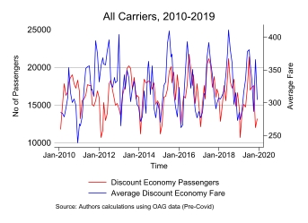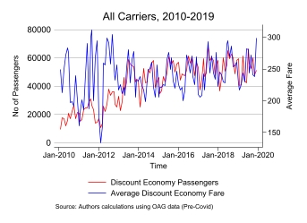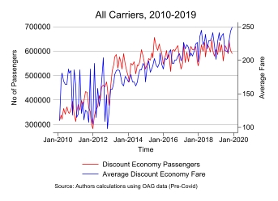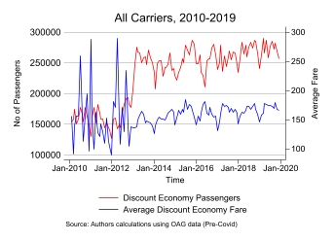
(C) Melbourne – Cairns
(A) Melbourne – Sydney
(B) Sydney – Brisbane
(D) Sydney – Darwin
We observe several stylised facts from Figure 2, which highlights passenger fare and traffic movements over time for select routes. First, the Sydney–Melbourne route shows a significant increase in passenger traffic over time, highlighting strong and growing demand. While all routes exhibit fluctuations, the degree of variation differs — some routes, like Sydney–Brisbane, display high volatility in passenger movements, whereas Sydney–Melbourne does not. Additionally, seasonality is evident in all routes and particularly pronounced on certain routes. The seasonality on the Melbourne–Cairns and Sydney–Darwin routes are likely driven by holidays and peak tourist seasons. Volatility on all routes was much higher pre-2014. This is driven by a large amount of entry and exit of low cost carriers and high passenger volatility on low cost carriers before 2014 (see Majeed et al. 2024).
This demonstrates that incorporating a 12-month lag in ARIMA models and allowing for monthly effects through monthly indicator variables will be essential for accurate elasticity estimation. Further examination of the data indicates that some routes are more price-sensitive than others, with busier, business routes maintaining relatively stable demand even as fares fluctuate. This suggests that it will be important to estimate route-specific elasticities.
Another important consideration in our analysis is that certain airports serve as transit hubs. For instance, passengers traveling from smaller towns to major cities may be doing so as part of a longer journey, either to connect to another domestic route or to travel internationally. In contrast, those flying from a major city to a smaller destination are more likely to be ending their journey at that location. This asymmetry implies that travel direction matters: the nature and purpose of travel can differ significantly depending on the origin and destination. This further reinforces the need to estimate direction-specific, route elasticities.
- Methodology
For our econometric analysis, we follow the methodology of Breunig (2011), applying a single-equation dynamic demand model to estimate price elasticity. Breunig (2011) writes down a model of habit formation following Houthakker and Taylor (1996) to create a dynamic demand model that can account for the gradual adjustment of unobservable habits that influence consumption behaviour over time. The model which allows for the persistence of habits and preferences includes moving-average terms to capture serial correlation in the error structure, which, if ignored, can bias elasticity estimates and render ordinary least squares (OLS) estimation inappropriate. This framework is particularly relevant in the context of aviation demand, where persistent factors — such as habitual travel behaviours (e.g. from business routines), low rates of switching providers induced by customer loyalty schemes, route-specific characteristics, and the lagged effects of shocks (e.g., regulatory changes or macroeconomic conditions) — can influence passenger volumes beyond immediate price changes.
To account for these dynamics, we specify an autoregressive moving average (ARMA) model with 12 autoregressive lags and one moving average term, as shown in Equation (1). This structure allows us to model both the lagged effects of past demand and prices, as well as serial correlation in the error terms, improving the accuracy of elasticity estimates. The model is estimated using maximum likelihood estimation, which provides consistent parameter estimates in the presence of these dynamic relationships.
The model is specified as:
$$\begin{aligned}\ln\left(v_{t}\right)=γ_{0}+\sum_{j=1}^{12}{γ_{pj}\ln\left(p_{t-j}\right)}+γ_{Δ_{p}}Δ\ln\left(p_{t}\right)+\sum_{j=1}^{12}{γ_{vj}\ln\left(v_{t-j}\right)}+γX_{t}+\sum_{k=0}^{1}{u_{t-k}}\#\left(1\right)\end{aligned}$$
where $v_{t}$ is the number of discount economy passengers, $p_{t}$ is the real price of a discount economy fare, and $Δp_{t}$ is the change in prices from the previous month $X_{t}$ is a vector of additional covariates which includes total median income of arriving and departing city and individual month dummies to capture the seasonality described above in section 3. $u_{t}$ captures all other unobserved effects. Median income is sourced from Australian Bureau of Statistics (2023) and is measured at the Statistical Area 4 (SA4) level.
Using equation (1), we estimate elasticities for individual routes. We also estimate an Australia-wide elasticity by collapsing all airline-route combinations to a single observation for each time period. For the Australia-wide estimates, we use the per kilometre average discount economy airfare weighted by passenger volumes. City incomes are weighted by population. When we collapse all routes to a single observation for each time period, we need to account for route distance hence per km average fares are taken.

Short-run elasticity
The coefficient on $Δ\ln\left(p_{t}\right)$ gives the short-run elasticity.

Long-run elasticity
Breunig (2011) shows that we can estimate the long-run elasticity by summing the statistically significant coefficients (at the 10% level) of the lagged dependent variables (representing the cumulative effect of past demand changes) and dividing by the sum of the coefficients on the autoregressive terms (representing the persistence of effects over time). Thus long-run elasticity comes from:
$$\begin{aligned}ϵ_{LR}=\frac{\sum_{j=1}^{n}{γ_{pj}}}{1-\sum_{j=1}^{m}{γ_{vj}}}\#\left(2\right)\end{aligned}$$
In circumstances where there are no statistically significant coefficients to produce an elasticity, we estimate the elasticity using the first lag of prices. Where all of the estimates for lagged volume are statistically insignificant, we set them equal to zero in equation (2).

Restricted and Unrestricted models
Following Breunig (2011), we estimate both unrestricted and restricted versions of the ARMA demand model. The unrestricted specification includes the full set of lagged price and volume terms needed to capture the dynamic adjustments in demand and to estimate short-run and long-run elasticities. However, as Breunig (2011) highlights, the inclusion of a large number of lags can introduce multicollinearity and reduce the precision of elasticity estimates if many coefficients are statistically insignificant.
To address this, we estimate a restricted version of the model in which coefficients on lagged terms with low statistical significance (p-values above 10%) are excluded from the elasticity calculations. This restriction aims to balance model complexity with estimation accuracy by reducing noise from insignificant coefficient estimates while preserving the key behavioural adjustments over time.
To formally assess whether the restricted model provides a more parsimonious and appropriate fit, we apply a likelihood-ratio test comparing the restricted and unrestricted specifications. If the test fails to reject the null hypothesis that the excluded coefficients are jointly insignificant, we prefer the restricted model on both statistical and practical grounds. In the last column of the Tables of results, we indicate whether the estimated elasticities are based upon the restricted or unrestricted model. Where we use the restricted model, we further indicate which lags of price and volume from the estimate of equation (1) are used in calculating the long-run elasticity using equation (2).
For some models where the statistical approach described above leads us to prefer the unrestricted model but where the elasticity estimates are implausibly large and statistically insignificant, we also estimate a simple, parsimonious model with one lag of price and one lag of volume. This provides a check on whether the implausible elasticity estimates arise because the model is over-specified. In no case do these simpler models provide a statistically different estimate. These are included in the tables of results.
For two routes, we observe structural breaks in passenger movements coinciding with the significant increase of new capacity. To account for these breaks, we include a dummy variable covering the period of each break. For regressions with all airlines, this includes SYD-BNE, and for Qantas only regressions this is SYD-HTI route.
- Results
We first present aggregate results for the price elasticity of discount economy airfares Australia-wide using two different approaches. We then turn to estimating uni-directional and bi-directional, route-specific elasticities for 13 key routes in Australia. In line with Breunig (2011) and existing literature, our findings confirm that the short-run and long-run elasticities of demand are (mostly) negative, as expected, with short-run demand being less responsive to price changes than long-run demand.
Table 3 presents the short-run and long-run elasticities of demand estimated across the top 100 routes for discount economy fares. This represents 84.4% of all passenger movements. We estimate this using all available data which provide prices and airfares for 9 airlines across 547 routes. We estimate equation (1) using average monthly prices that are created by weighting the price per km travelled for each airline/route combination by passenger volumes and summing these up to provide one monthly price for the entire country. In addition to providing an estimate for all airlines, we provide separate estimates for Qantas, which accounts for almost 60 per cent of passengers on these routes. The dominance of Qantas in the Australian aviation market and how its behaviour differs from that of other airlines are documented in the literature cited above in section 2.
In the short run, across all carriers, we find no statistically significant response of passenger movements to price changes. We find a 1.3% decrease in response to a 1% increase in price per km travelled in the long run (over 12 months). For Qantas, the corresponding elasticities are -0.06% and -12.37%, respectively, but neither are estimated with much precision. In both cases, the higher magnitude of long-run elasticity compared to short-run elasticity aligns with theoretical expectations — travellers have more time to adjust their behaviour in response to price changes over a longer period.
Appendix Table A.1 provides a variety of robustness checks for these estimates. We estimate both weighted and unweighted models. We estimate models where we include a dummy variable for the period of high volatility pre-2014 which is visible in Figure 2 above. The appendix also contains OLS estimates of the models for all airlines and Qantas by OLS. What comes through clearly is that elasticity estimates can differ wildly based on model, time period and whether individual airline prices are weighted by passenger volumes. This highlights the importance of theory in choice of model and, as described above, we prefer the results using the ARIMA modelling, an empirical strategy that explicitly incorporates habit persistence and its evolution.
Our preferred estimates are the route-specific ones presented below in Tables 4 and 5. Particularly for Qantas, when we estimate route-specific elasticities we mostly get precise and theoretically predicted elasticity estimates, but they vary substantially across routes. Trying to estimate one pooled elasticity for the entire Qantas network (and similarly for all airlines) is misleading as it combines routes with very different behaviour. The high standard errors on the pooled estimates reflect the variability of the elasticities across individual routes and the imprecision that is introduced by pooling these distinctly different markets.

Table 3: Elasticity of demand for discount economy fare (Top 100 routes, price per km travelled, weighted by passenger volumes)
Model Estimated | Short-run elasticity | Long-run elasticity | Lags used in preferred model (see equation (1)
All carriers | 0.12  (0.14) | -1.30*  (0.70) | Unrestricted
Qantas | -0.06  (0.16) | -12.37  (16.92) | p: 1  v: 1
Average Elasticities calculated from 26 uni-directional results (See Tables 4 and 5 below)
[Statistically significant results only, simple average]
All carriers | -0.70^ | -2.16^
Qantas | -0.35^ | -0.80^
Average Elasticities calculated from 26 uni-directional results (See Tables 4 and 5 below)
[All results including statistically insignificant ones, simple average]
All carriers | -0.49 | -2.47
Qantas | -0.23 | -0.85
Robust standard errors in parentheses
*** p<0.01, ** p<0.05, * p<0.1
^Averages of statistically significant estimates
p: significant lags of the price variable
v: significant lags of the volume variable
Unrestricted indicates that the model uses all 12 lags of prices and volumes per equation (1)
Source: Authors calculations using OAG and ABS data
The second and third panels of Table 3 present the average elasticities from the route-specific, uni-directional estimates presented below in Tables 4 and 5. First we take the simple average of all of the statistically significant (at the 10 per cent level) estimates. On average, a one per cent increase in price produces a 0.7% decrease in short-run passenger demand and a 2.16% decrease in long-run passenger demand across all carriers. The corresponding elasticities for Qantas are -0.35% and -0.8% respectively. The elasticities across all carriers are larger than the estimates in the top panel of Table 3 which is intuitive given that we are only including statistically significant estimates. The last panel of Table 3 shows the average of all of the estimated elasticities including the statistically insignificant ones. Whether we use the averages from the statistically significant elasticities only or from all of the elasticities, including the insignificant ones, the overall impression we get of the size of the elasticities and the relationship between the short- and long-run elasticity does not change.
Table 4 and Figure 3 present results for route-specific elasticity estimates. We present uni-directional estimates and combined, bi-directional estimates for 13 pairs of Australia cities. We estimate the short- and long-run demand elasticities for the discount economy fare and combine all carriers. For transparency, we present all results including some unexpected (positive) and statistically insignificant elasticities. None of the small number of positive elasticities are statistically significant. In the last column, we indicate whether the estimated elasticities are based upon the restricted or unrestricted model. Where we use the restricted model, we further indicate which statistically significant lags of price and volume from the estimate of equation (1) are used in calculating the long-run elasticity using equation (2).
In a small number of cases where the unrestricted model gives a positive long-run elasticity, we also present the results from a simple, parsimonious model with only one lag each of price and volume. In all cases, that simple model produces a statistically insignificant estimate, consistent with our hypothesis testing that confirmed that the unrestricted model was the preferred model. Given that the unrestricted model involves 24 total lags, we do this as a check that the model is not over-specified. We take this as confirmation that, for some routes, we are unable to obtain statistically significant results even with very different models.
Table 4 highlights variation in route-specific elasticities. In some cases, precise estimation of route-specific elasticities is a challenge with only 119 monthly observations. For example, all of the elasticities between Adelaide and Sydney and Perth and Sydney are statistically insignificant and jump around between positive and negative values.
In general, however, we find that higher prices lead to lower demand, as expected, and long-run elasticities are larger than short-run elasticities. This corresponds to our expectation that travellers have more time to adjust to changing prices over longer time horizons.
Figure 3 groups the results by three categories: “big cities” (routes between major capital cities excluding Canberra); “tourism” (routes to and from the four tourism destinations); and “Canberra” (routes between Canberra and major Australian cities). Appendix Figure A1 shows the same graph using only the statistically significant estimates — the results are broadly similar. Examination of the results in Table 4 and Figure 3 reveal several stylised facts:
- For all three groupings, long-run elasticities are larger than short-run elasticities. This is true if we consider all elasticities or just the statistically significant ones.
- For the big city routes, most estimates of both short- and long-run elasticities are statistically insignificant. Nine of the twelve short-run elasticities are statistically insignificant and eleven of the twelve long-run elasticity estimates are statistically significant.
- The average short-run elasticity is very small (about -0.3) and the long-run elasticity is just under unity, on average. This may be a result of relatively inflexible business travel which cannot be shifted on short notice.
- The tourism routes have high short-run elasticities (around -0.7) and very high long-run elasticities (above 2). This is consistent with the discretionary nature of travel to these destinations.
- Canberra has similar short- and long-run elasticities, -0.77 and about -0.9 on average, respectively. This indicates some flexibility in demand to and from Canberra, but not much difference between that flexibility in the short and long run. This could be due to the nature of travel to and from Canberra which often involves conducting business with the federal government.

Figure 3: Average elasticity estimates: all carriers
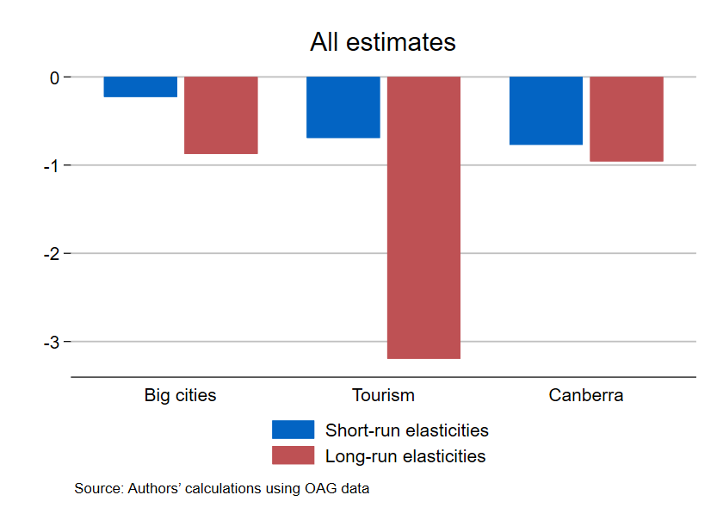
Big cities: all routes connecting SYD, MEL, BNE, PER, ADL
Tourism: routes to and from DRW, CFS, HTI, CNS
Canberra: Big city routes to and from Canberra
We omit the SYD-MEL outlier from Figure 3

Table 4: Elasticity of demand for the discount economy fare type (all carriers)
Route | Short-run elasticity | Long-run elasticity | Lags used in preferred  model (see equation (1)
SYD – BNE | -0.33***  (0.10) | -1.17***  (0.27) | Unrestricted
BNE – SYD | -0.42**  (0.20) | -0.61  (0.71) | Unrestricted
SYD – BNE (bi) | -0.28**  (0.13) | -1.10  (1.55) | Unrestricted
SYD – ADL | 0.11  (0.10) | -1.92  (2.46) | p: 12  v: 2, 5
ADL – SYD | -0.11  (0.23) | 0.92  (0.71) | Unrestricted
 | -0.18  (0.20) | -2.56  (4.88) | Simple (p:1, v:1)
SYD – ADL (bi) | 0.10  (0.17) | 7.93  (39.00) | Unrestricted
SYD - PER | 0.00  (0.27) | -1.97  (1.71) | Unrestricted
PER – SYD | -0.26  (0.25) | -0.47  (0.33) | Unrestricted
SYD – PER (bi) | -0.05  (0.28) | 7.38  (14.75) | Unrestricted
DRW - SYD | -0.34**  (0.17) | 3.39  (4.97) | Unrestricted
 | -0.11  (0.18) | -2.10  (2.41) | Simple (p:1, v:1)
SYD - DRW | -0.39**  (0.18) | -2.36***  (0.62) | Unrestricted
DRW - SYD (bi) | -0.39**  (0.17) | -3.46**  (1.39) | Unrestricted
CFS - SYD | -0.86***  (0.24) | -1.11***  (0.33) | Unrestricted
SYD - CFS | -0.61***  (0.12) | -5.84*  (3.42) | p: 1  v: 1
CFS - SYD (bi) | -0.85***  (0.20) | -2.14***  (0.51) | p: 1, 5, 7  v: 1, 2, 3, 8
SYD - HTI | -1.15**  (0.42) | -12.30  (15.52) | Unrestricted
HTI - SYD | -1.06***  (0.38) | -3.20*  (1.68) | Unrestricted
SYD - HTI (bi) | -1.20***  (0.34) | -1.51*  (0.77) | Unrestricted
SYD – CBR | -0.58*  (0.32) | -0.98***  (0.22) | p: 1  v: -
CBR – SYD | -1.13***  (0.34) | -0.71  (0.57) | Unrestricted
SYD – CBR (bi) | -0.61***  (0.16) | -3.29  (4.03) | p: 1  v: 1, 2, 3, 10, 11, 12
BNE – CBR | -0.84**  (0.34) | -0.80**  (0.37) | Unrestricted
CBR – BNE | -0.59**  (0.28) | -4.78  (7.09) | Unrestricted
BNE – CBR (bi) | -0.16  (0.24) | 0.48**  (0.23) | Unrestricted
 | -0.00  (0.22) | -1.82  (3.01) | Simple (p:1, v:1)
MEL – SYD | -0.18  (0.20) | -0.14  (0.26) | Unrestricted
 | -0.41*  (0.21) | -0.79  (4.91) | Simple (p:1, v:1)
SYD – MEL | -0.09  (0.15) | 158.61  (4778.4) | Unrestricted
 | -0.11  (0.21) | 3.31  (6.18) | Simple (p:1, v:1)
MEL – SYD (bi) | 0.07  (0.15) | 0.31  (0.20) | Unrestricted
 | -0.06  (0.18) | 0.95  (3.83) | Simple (p:1, v:1)
MEL – CBR | -0.81***  (0.27) | 3.79  (8.74) | Unrestricted
 | -1.21***  (0.26) | -16.57  (20.60) | Simple (p:1, v:1)
CBR – MEL | -0.67***  (0.22) | -2.27  (6.20) | Unrestricted
MEL – CBR (bi) | -1.10***  (0.26) | -1.09  (1.05) | Unrestricted
MEL – BNE | -0.46  (0.35) | -3.00**  (1.18) | Unrestricted
BNE – MEL | -0.43  (0.32) | -0.32  (0.30) | Unrestricted
MEL – BNE (bi) | -0.96**  (0.44) | -0.75  (0.60) | Unrestricted
MEL – PER | -0.33**  (0.16) | -0.44  (0.66) | p: 1  v: 2
PER – MEL | -0.23  (0.25) | -0.49  (0.36) | Unrestricted
MEL – PER (bi) | 0.10  (0.15) | -2.81  (2.12) | p: 4, 6, 9, 11  v: 1, 6, 7
MEL – CNS | -0.07  (0.56) | -0.95*  (0.52) | Unrestricted
CNS – MEL | -1.06***  (0.32) | -24.03  (25.38) | p: 1  v: 1
MEL – CNS (bi) | -0.46  (0.41) | -0.77  (0.71) | p: 1  v: 1, 2
Robust standard errors in parentheses
*** p<0.01, ** p<0.05, * p<0.1
p: significant lags of the price variable
v: significant lags of the volume variable
Unrestricted indicates that the model uses all 12 lags of prices and volumes per equation (1)
(bi) indicates elasticity estimates treating both directions as one route
Source: Authors calculations using OAG and ABS data
Qantas makes up the majority of our passenger volumes and routes. As many papers have noted (De Roos et al., 2010; Ma et al., 2019; Majeed et al., 2024; Honsombat and Lei, 2024; and Wang et al., 2020), Qantas appears to engage in strategic pricing behaviour and has market power on some routes. For this reason, we also provide elasticity estimates using only Qantas data in Table 5.

Table 5: Elasticity of demand for the discount economy fare type (Qantas only)
Route | Short-run elasticity | Long-run elasticity | Lags used in preferred  model (see equation (1)
SYD – BNE | -0.61***  (0.12) | -3.13**  (1.37) | p: 1  v: 1, 2, 10, 11, 12
BNE – SYD | -0.42***  (0.11) | -3.15***  (1.18) | p: 1  v: 1, 10
SYD – BNE (bi) | -0.57***  (0.10) | -3.47**  (1.45) | p: 1  v: 1, 2, 10, 11, 12
SYD – ADL | -0.06  (0.10) | -0.25  (0.26) | Unrestricted
ADL – SYD | -0.02  (0.16) | -0.27**  (0.12) | Unrestricted
SYD – ADL (bi) | -0.08  (0.12) | 0.18  (0.24) | Unrestricted
SYD - PER | -0.36**  (0.16) | 2.01*  (1.09) | Unrestricted
 | -0.26**  (0.13) | -5.45  (3.95) | Simple (p:1, v:1)
PER – SYD | -0.34**  (0.17) | 2.09  (1.53) | Unrestricted
 | -0.40***  (0.11) | -7.63  (4.93) | Simple (p:1, v:1)
SYD – PER (bi) | -0.30**  (0.13) | -15.14**  (7.09) | p: 1, 3, 11  v: 1, 8, 12
DRW - SYD | -0.36***  (0.12) | -4.68  (6.68) | Unrestricted
 | -0.32**  (0.13) | -0.79**  (0.39) | Simple (p:1, v:1)
SYD - DRW | -0.43***  (0.10) | -0.66**  (0.33) | p: 1, 11  v: 1, 4, 7, 11, 12
DRW - SYD (bi) | -0.43***  (0.14) | -0.60*  (0.35) | Unrestricted
CFS - SYD | -0.10  (0.18) | -0.13  (0.18) | Unrestricted
SYD - CFS | 0.08  (0.15) | 0.08  (0.37) | Unrestricted
 | -0.02  (0.12) | -0.82  (1.45) | Simple (p:1, v:1)
CFS - SYD (bi) | -0.10  (0.16) | -1.65  (1.73) | p: 1  v: 1
SYD - HTI | 0.05  (0.36) | 2.53***  (0.94) | Unrestricted
HTI - SYD | -0.62  (0.69) | -0.97  (2.04) | Unrestricted
SYD – HTI (bi) | -0.37  (0.67) | 4.20**  (1.91) | Unrestricted
SYD – CBR | -0.35**  (0.16) | -2.03**  (0.88) | p: 1  v: 3, 12
CBR – SYD | -0.32**  (0.15) | 1.42  (2.30) | Unrestricted
SYD – CBR (bi) | -0.39**  (0.19) | -0.60  (0.39) | Unrestricted
BNE – CBR | -0.25**  (0.11) | -0.64*  (0.35) | p: 1  v: 1, 2
CBR – BNE | -0.20**  (0.09) | -0.42***  (0.15) | p: 1, 6  v: 1, 2, 3
BNE – CBR (bi) | -0.21*  (0.11) | 2.94  (9.43) | p: 1  v: 1, 2
MEL – SYD | -0.16  (0.11) | -0.27**  (0.14) | Unrestricted
SYD – MEL | -0.07  (0.15) | -0.33  (0.21) | Unrestricted
MEL – SYD (bi) | -0.07  (0.13) | -0.83**  (0.35) | Unrestricted
MEL – CBR | -0.09  (0.18) | -0.05  (0.21) | Unrestricted
 | -0.15  (0.15) | -3.08  (3.55) | Simple (p:1, v:1)
CBR – MEL | -0.22  (0.14) | -1.08  (1.01) | p: 1  v: 1, 2, 3
MEL – CBR (bi) | -0.17  (0.16) | -0.07  (0.18) | Unrestricted
MEL – BNE | -0.28**  (0.12) | 2.91  (7.60) | Unrestricted
 | -0.29***  (0.10) | -4.72  (3.71) | Simple (p:1, v:1)
BNE – MEL | -0.34**  (0.14) | -0.34*  (0.19) | Unrestricted
MEL – BNE (bi) | -0.36***  (0.14) | -0.63  (0.43) | Unrestricted
MEL – PER | -0.28***  (0.10) | 112.58  (1896.79) | Unrestricted
 | -0.19**  (0.09) | -2.56  (2.68) | Simple (p:1, v:1)
PER – MEL | -0.26  (0.19) | -0.38**  (0.20) | Unrestricted
MEL – PER (bi) | -0.38***  (0.14) | -1.09***  (0.30) | Unrestricted
MEL – CNS | 0.10  (0.12) | 0.47  (0.36) | Unrestricted
CNS – MEL | -0.07  (0.10) | -14.00  (266.42) | p: 10  v: 1, 4
MEL – CNS (bi) | 0.10  (0.13) | 2.44  (2.91) | p: 1  v: 2, 3, 5, 10, 12
Robust standard errors in parentheses
*** p<0.01, ** p<0.05, * p<0.1
p: significant lags of the price variable
v: significant lags of the volume variable
Unrestricted indicates that the model uses all 12 lags of prices and volumes per equation (1)
(bi) indicates elasticity estimates treating both directions as one route
Source: Authors calculations using OAG and ABS data

Figure 4: Average elasticity estimates: Qantas
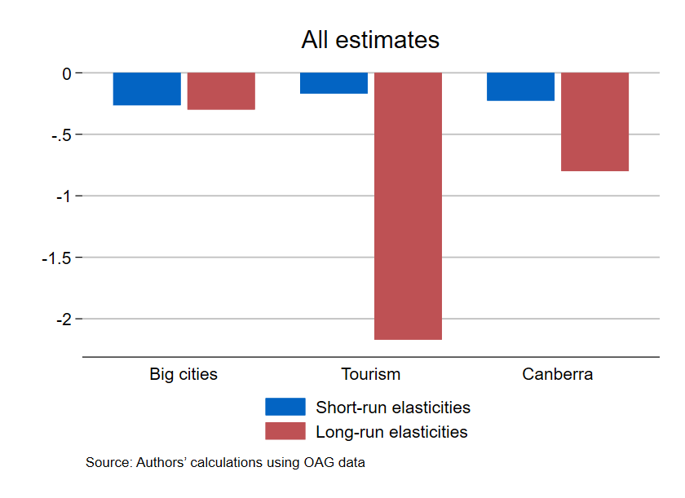
Big cities: all routes connecting SYD, MEL, BNE, PER, ADL
Tourism: routes to and from DRW, CFS, HTI, CNS
Canberra: all routes to and from “Big cities and Canberra”
We omit the MEL-PER outlier from Figure 4
For the big cities, we find small short-run elasticities (-0.26 on average) and small long-run elasticities (-0.3 on average). Again, these could reflect the inflexible nature of business travel between these cities. Qantas, as discussed above, is viewed as exercising market power on many routes across Australia. These low elasticities are consistent with that and highlight the value of that market power. Interestingly, many more elasticities — 8 of 12 for short-run and 5 of 12 for long-run — are statistically significant.
For the tourism routes, the short-run elasticities are quite small on average (-0.17) but we again find large average long-run elasticities consistent with the discretionary nature of travel on these routes.
For Canberra, we see a very similar long-run elasticity (-0.80) to what we found for all carriers. The short-run elasticities are now much smaller (-0.23) on average. Again, the majority of results are statistically significant. Qantas has a very strong market share of the Canberra-Melbourne and Canberra-Sydney routes and is often viewed as exercising market power on these routes, particularly for those conducting business with the federal government. Their ability to exercise market power is consistent with these inelastic demands, particularly in the short-run.

Comparison of our modelling approach to the standard approach
The results from Tables 4 and 5 implement a dynamic demand model which is grounded in a theory of slowly evolving unobservable habits. This dynamic model implies the existence of moving average terms which need to be accounted for in estimation; see equation (1) and section four above. Most studies ignore this dynamic component of demand and estimate something akin to equation (1) by ordinary least squares (OLS) and simply ignoring the moving average terms, $\sum_{j=1}^{12}{γ_{vj}\ln\left(v_{t-j}\right)}$. Ignoring these terms in estimation will lead to biased elasticity estimates.
In Appendix Tables A.2 and A.3, we reproduce Tables 4 and 5 using OLS estimation and ignoring the dynamic component of demand formation. We provide this as a check on whether the use of a dynamic demand model produces substantively different results than the standard approach.
The results between the two approaches are different but it is difficult to summarise them succinctly. The dynamic demand approach is more likely to produce statistically significant short-run elasticities. Both approaches produce a mix of negative and positive long-run elasticities (the latter are rarely statistically significant in either case) but the sign of the elasticity is not consistent across approaches. The OLS estimates have smaller standard errors in some cases, but again this is not consistent across routes and it is difficult to discern a clear pattern. If the dynamic model is correct, this precision in the OLS estimates will be spurious.

Broader implications for competition and consumer welfare
Majeed et al. (2024) found that in Australia, the presence of an additional airline on a route leads to airfares that are 5 to 10 per cent lower. As an approximation, combining this result with the average elasticity estimates that we find across all routes in Australia, the presence of an additional airline on a route could lead to passenger demand increasing by 12.5% to 25% in the long-run.
In terms of passenger movements, we can apply the above estimated change to discount economy passenger movements in 2023. A 5 to 10 per cent decrease in prices as a result of one additional competitor being added to every route in Australia would lead to around 6.9 million to 13.8 million more discount economy passengers per year in the long run.
This may not fully quantify the benefit of more competition as we are only considering discount economy passengers and fares. In practice, more competitive pressure will likely lead airlines to reduce fares across a broad range of fare classes — not just the lowest tier. As a result, passengers in other fare categories may also respond to lower prices, implying that the total increase in air travel demand could be significantly larger than our estimates suggest.
The low elasticities on business routes, including on routes to and from the federal capital to conduct business with government, likely generate negative flow-on effects for business customers. Low elasticities allow airlines to exercise market power and raise prices. Higher prices result in less connectivity, higher costs for businesses and lower business dynamism. In an era of stagnating productivity, it is particularly important to generate more competition and lower prices which will have positive effects on overall economic growth.
The impact of increased competition is likely to be particularly strong for tourism and there are likely to be large spillover effects. According to the Australian Trade and Investment Commission (2025), Australians mostly travel for tourism or to visit family and friends and they spend more on each of accommodation, food, and retail than transport. More airline competition will flow on to these other sectors. Combined with the results of Majeed et al. (2024), our results suggest an additional airline on a tourist route would increase passenger demand by 29 to 58 per cent.
- Conclusion
This paper provides new insights into airfare elasticities in Australia by providing estimates of both short-run and long-run demand responses to price changes across a diverse set of domestic routes. Consistent with economic theory and prior research, we find that passenger movements exhibit a negative price elasticity, with demand being less responsive in the short run but significantly more elastic in the long run. These results underscore the gradual adjustment of consumer behaviour over time as passengers react to fare changes with increased flexibility in their travel plans.
In addition to being of interest to Australian consumers and policymakers, our study is novel in two dimensions. First, we apply a dynamic demand model grounded in a theoretical model of habit persistence. We believe this is the first time this approach has been applied to the estimation of airfare elasticities. Our estimates show that moving average terms are important in the specification of the dynamic demand equation and that the model provides substantially different estimates to the standard approach using OLS. Much of the elasticity literature has overlooked the role of habit formation in shaping demand. Breunig (2011) shows that omitting these dynamics risks bias. OLS estimates that ignore habits may appear credible, but diverge sharply from results that account for persistence in behaviour. The ARIMA framework is grounded in theory and the reality of routines and habits in airline travel that can impact demand. Credible estimates of demand elasticities must be based on models that capture these behavioural underpinnings of travel decisions.
Second, we estimate uni-directional elasticities, treating routes as different based upon direction. In practice, this produces important difference in elasticity estimates compared to those estimated by combining estimates for both directions between two cities, as is done in most studies. For several routes (e.g. Cairns-Melbourne), the elasticities in one direction are quite different from those found for the other direction. This may be due to relationships with other routes. Nearly all passengers flying from Melbourne to Cairns would be staying in Cairns or the surrounding area. Passengers flying from Cairns to Melbourne could be connecting onto an international flight.
These findings highlight variations in elasticity across different routes, reflecting the distinct characteristics of business hubs, tourism destinations, and transit airports. Notably, routes serving major leisure destinations, such as Cairns (CNS), Coffs Harbour (CFS) and Hamilton Island (HTI), exhibit more elastic demand, suggesting that discretionary travel is particularly sensitive to price changes. Conversely, routes dominated by business travel, such as Sydney (SYD) to Canberra (CBR) for Qantas and routes between Australia’s major business cities, Adelaide, Brisbane, Melbourne, Perth and Sydney, show lower price sensitivity, reinforcing the expectation that business travellers have more inelastic demand due to schedule constraints, employer-funded travel and a lack of substitutes. If work takes one to Brisbane, it is hard to replace that with a trip to Melbourne or to postpone it.
Our results reinforce previous research suggesting that Qantas has a particularly strong dominance in the market between the federal capital, Canberra, and major Australian cities. Very low short-run elasticities and a long-run elasticity below unity allow for market power to exist and be profitable.
Importantly, when combined with prior research on competition in the Australian aviation sector (Majeed, Breunig and Domazet, 2024), our estimates suggest that the entry of an additional airline on a route — shown to reduce fares by 5 to 10 percent — could increase passenger demand by 0.5% to 1.0% in the short run and 12.5% to 25% in the long run. Combining and applying these elasticity estimates to 2023 discount economy passenger volumes implies that if every route added one additional competitor, an additional 114,000 to 229,000 passengers would fly each month in the short run. Over a full year, the long-run elasticity translates to an increase of approximately 6.9 to 13.8 million discount economy passengers across all routes in Australia.
This finding reinforces the broader economic implications of fostering a competitive airline market: not only does competition reduce prices for consumers, it also stimulates air travel. Our estimated elasticities suggest that greater competition would lead to more tourism flights (more elastic) and lower costs of business flights (less elastic). Tourism and visiting family and friends are the most frequent reason for travel in Australia and such travellers spend substantial amounts in other sectors of the economy such as hospitality and retail. Increasing competition on routes used for tourism is likely to have important spillover effects.
For policymakers, these results provide empirical support for competition-enhancing policies in the aviation sector. Ensuring a competitive and efficient market will be key to achieving affordability, connectivity, and sustainability in Australia’s air travel landscape.

References
Athukorala, P. C., T. Talgaswatta and O. Majeed (2017). Global production sharing: Exploring Australia’s competitive edge. The World Economy, 40(10): 2172–2192.
Australian Bureau of Statistics (2023). Personal Income in Australia, ABS Website, accessed 21 July 2025. https://www.abs.gov.au/statistics/labour/earnings-and-working-conditions/personal-income-australia/latest-release
Australian Bureau of Statistics (2025). Consumer Price Index, Australia. ABS. https://www.abs.gov.au/statistics/economy/price-indexes-and-inflation/consumer-price-index-australia/latest-release.
Australian Government (2024). Aviation White Paper: Towards 2050. Available at: https://www.infrastructure.gov.au/sites/default/files/documents/awp-aviation-white-paper.pdf
Australian Trade and Investment Commission (2024). Australian Trade and Investment Commission website, accessed 28 May 2024, https://international.austrade.gov.au/en/do business with australia/sectors/tourism and the visitor economy#ref0
Australian Trade and Investment Commission (2025). Domestic Tourism Statistics Results, June Quarter 2025. Available at: https://www.tra.gov.au/en/domestic/domestic-tourism-statistics-results#ref3
Battersby, B, and E. Oczkowski (2001). An econometric analysis of the demand for domestic air travel in Australia, International Journal of Transport Economics/Rivista internazionale di economia dei trasporti, 28(2): 193-204.
Breunig, R. V. (2011). Should single-equation dynamic gasoline demand models include moving average terms? Transportation Research Part D: Transport and Environment, 16(6), 474-477. https://doi.org/10.1016/j.trd.2011.04.006
Brons, M., E. Pels, P. Nijkamp, and P. Rietveld (2002). Price elasticities of demand for passenger air travel: a meta-analysis. Journal of Air Transport Management, 8(3): 165-175.
Bureau of Transport and Communications Economics (BITRE) (1991). Report 73: Deregulation of Domestic Aviation – The First Year, Australian Government Publishing Service Canberra.
Bureau of Infrastructure and Transport Research Economics (BITRE) (2024). Australian aviation forecasts – 2024 to 2050, Research Report 157, Canberra, ACT.
Castelli, L., W. Ukovich and R. Pesenti (2003). An airline-based multilevel analysis of airfare elasticity for passenger demand. In The Conference Proceedings of the 2003 Air Transport Research Society (ATRS) World Conference, Volume 2.
Collins, A., D.A. Hensher and Z. Li (2008). Regional airports and opportunities for low cost carriers in Australia. Institute of Transport and Logistics Studies (ITLS) Working Paper. University of Sydney. ILTS-WP-80-14. Available at: http://hdl.handle.net/2123/19571
Competition Bureau Canada (2025). Elevating Airline Competition. Available at: https://competition-bureau.canada.ca/sites/default/files/documents/market-study-airline-industry-2025-06-19-V2-e.pdf
De Roos, N., G. Mills and S. Whelan (2010). Pricing dynamics in the Australian airline market. Economic Record, 86(275): 545–562.
Escañuela Romana, I., M. Torres-Jiménez, and M. Carbonero-Ruz (2023). Price Elasticity of Demand for Domestic Air Travel in the United States: A Robust Quasi-Experimental Estimation, Atlantic Economic Journal, 51(2): 149-67.
Escobari, D. (2017). Airport, airline and departure time choice and substitution patterns: An empirical analysis, Transportation Research Part A: Policy and Practice, 103: 198-210.
Hamal, Krishna, Australia Bureau of Tourism Research and Australian Tourism and Hospitality Research Conference., (1998). (1998). Australian outbound holiday travel demand : long-haul versus short-haul / Krishna Hamal. Canberra : Bureau of Tourism Research
Honsombat, W. and Z. Lei (2014). Competitive effects of the airlines-within-airlines strategy: Pricing and route entry patterns. Transportation Research Part E Logistics and Transportation Review, 63: 1-16. 10.1016/j.tre.2013.12.008.
Houthakker, H.S. and L.D. Taylor (1966). Consumer Demand in the United States 1929-1970: Analyses and Projections. Cambridge, MA: Cambridge University Press.
Granados, N., A. Gupta and R.J. Kauffman (2012). Online and offline demand and price elasticities: Evidence from the air travel industry, Information Systems Research, 23(1): 164-81.
Granados, N., R.J. Kauffman, H. Lai, and H-C Lin (2012). À la carte pricing and price elasticity of demand in air travel, Decision Support Systems, 53(2): 381-94.
InterVISTAS Consulting Inc. (2007). Estimating air travel demand elasticities: Final report. Prepared for the International Air Transport Association (IATA). Strategic Transportation & Tourism Solutions. Retrieved from https://www.iata.org/en/iata-repository/publications/economic-reports/estimating-air-travel-demand-elasticities---by-intervistas/
Kattavenaki, K., I. Pagoni and G. Yannis (2023). Meta-analysis of the ticket price elasticity for air travel demand. 11th International Congress on Transportation Research. Available at https://www.nrso.ntua.gr/geyannis/wp-content/uploads/geyannis-pc516.pdf.
Kopsch, F. (2012). A demand model for domestic air travel in Sweden. Journal of Air Transport Management, 20:46-48.
Kwoka, J., Hearle, K. and Alepin, P., 2016. From the fringe to the forefront: Low cost carriers and airline price determination. Review of Industrial Organization, 48, pp.247–268.
Ma, W., Q. Wang, H. Yang and Y. Zhang (2019). An analysis of price competition and price wars in Australia's domestic airline market. Transport Policy, 81: 163-172.
Majeed, O., R. Breunig and A. Domazet (2024). How competition impacts prices: The Australian aviation sector. Australian Treasury Working Papers. Retrieved from How competition impacts prices: The Australian aviation sector
Mitchell, D. (2019). An empirical analysis of route-based differences in Australian air fares. Australasian Transport Research Forum 2019 Proceedings. Available at: https://australasiantransportresearchforum.org.au/wp-content/uploads/2022/03/ATRF2019_resubmission_65.pdf
Morlotti, C., M. Cattaneo, P. Malighetti and R. Redondi (2017). Multi-dimensional price elasticity for leisure and business destinations in the low-cost air transport market: Evidence from easyJet, Tourism Management, 61(C): 23-34.
Mumbower, S., L.A. Garrow and M.J. Higgins (2014). Estimating flight-level price elasticities using online airline data: A first step toward integrating pricing, demand, and revenue optimization, Transportation Research Part A: Policy and Practice, 66: 196-212.
Perera, S., and D. Tan (2019). In search of the “right price” for air travel: First steps towards estimating granular price-demand elasticity. Transportation Research Part A: Policy and Practice, 130:557-569.
Wang, K., W.H.K. Tsui, L.B. Li, Z. Lei and X. Fu (2020). Entry pattern of low-cost carriers in New Zealand-The impact of domestic and trans-Tasman market factors. Transport Policy, 93:36–45.

Appendix

Table A.1: Elasticity of demand for discount economy fare (Top 100 routes, price per km travelled, weighted by passenger volumes) [Robustness checks for Table 3]
Model Estimated | Weights | Short-run elasticity | Long-run elasticity | Lags used in preferred model
All carriers | Weighted | 0.12  (0.14) | -1.30*  (0.70) | Unrestricted
All carriers 1 | Weighted | 0.12  (0.15) | -1.25*  (0.68) | Unrestricted
All carriers 2 | Weighted | -0.01  (0.26) | -0.79*  (0.47) | Unrestricted
All carriers | Unweighted | -0.19  (0.29) | -3.04*  (1.57) | Unrestricted
All carriers 1 | Unweighted | -0.19  (0.30) | -2.98*  (1.55) | Unrestricted
All carriers 2 | Unweighted | 0.01  (0.15) | 0.03  (0.95) | p: 3, 6, 7, 12  v: 5
Qantas | Weighted | -0.06  (0.16) | -12.37  (16.92) | p: 1  v: 1
Qantas 1 | Weighted | -0.06  (0.18) | 29.41  (582.60) | p: 1  v: 1, 2, 3
Qantas 2 | Weighted | 0.41**  (0.17) | -0.30  (0.30) | Unrestricted
Qantas | Unweighted | -0.11  (0.15) | -0.56  (0.35) | Unrestricted
Qantas 1 | Unweighted | -0.10  (0.11) | 5.70  (36.24) | p: 1  v: 1, 2, 3, 10, 12
Qantas 2 | Unweighted | (0.08)  (0.13) | -0.16  (0.10 | Unrestricted
OLS | Weighted | 0.15  (0.16) | 0.28  (0.86) | Unrestricted
OLS1 | Weighted | 0.13  (0.16) | 5.02  (15.97) | Unrestricted
OLS2 | Weighted | -0.01  (0.23) | 0.52  (0.95) | Unrestricted
Robust standard errors in parentheses
*** p<0.01, ** p<0.05, * p<0.1
1 model includes a dummy variable for the high-volatility 2010-2013 period
2 model estimated using shorter time period: 2013-2019
p: significant lags of the price variable
v: significant lags of the volume variable
Unrestricted indicates that the model uses all 12 lags of prices and volumes per equation (1)
Source: Authors calculations using OAG and ABS data

Table A.2: Elasticity of demand for the discount economy fare type (all carriers): OLS estimates [Robustness check for Table 4]
Route | Short-run elasticity | Long-run elasticity | Lags used in preferred  model (see equation (1)
SYD – BNE | 0.03  (0.14) | -0.08  (0.51) | Unrestricted
BNE – SYD | -0.71***  (0.13) | 0.77  (0.62) | p: 11  v: 1, 3, 6, 10, 12
SYD – BNE (bi) | -0.08  (0.16) | 0.31  (0.44) | Unrestricted
SYD – ADL | 0.18  (0.13) | 1.15  (0.86) | p: 1  v: 1, 5
ADL – SYD | -0.12  (0.17) | -0.04  (5.31) | Unrestricted
SYD – ADL (bi) | 0.05  (0.15) | -0.69  (0.80) | Unrestricted
SYD - PER | -0.25  (0.25) | -6.33  (6.09) | p: 1, 5, 9  v: 1, 2, 4, 6, 11
PER – SYD | -0.15  (0.19) | -0.72  (1.58) | p: 6, 7  v: 1, 2, 6, 9
SYD – PER (bi) | -0.03  (0.25) | -0.19  (1.76) | Unrestricted
DRW - SYD | -0.16  (0.19) | 11.80  (28.91) | Unrestricted
SYD - DRW | -0.21*  (0.11) | -0.97**  (0.47) | p: 3  v: 1, 12
DRW - SYD (bi) | -0.29**  (0.12) | 7.99  (10.23) | p: 3, 6, 10  v: 1, 3
CFS - SYD | -0.89***  (0.18) | -0.90*  (0.53) | p: 1, 5, 7, 11, 12  v: 1, 3
SYD - CFS | -0.74***  (0.15) | -1.42***  (0.16) | p: 1  v: 1, 2, 10
CFS - SYD (bi) | -0.84  (0.17) | -1.21  (0.27) | p: 1  v: 1, 2, 5, 7
SYD - HTI | -0.75*  (0.41) | -5.63*  (2.62) | Unrestricted
HTI - SYD | -0.89**  (0.43) | -17.95  (86.83) | Unrestricted
SYD - HTI (bi) | -0.78  (0.48) | -0.25  (1.52) | Unrestricted
SYD – CBR | -0.65***  (0.22) | -1.08***  (0.23) | p: 1  v: -
CBR – SYD | -1.04***  (0.24) | -0.83***  (0.27) | p: 1  v:1
SYD – CBR (bi) | -0.81***  (0.18) | -0.91***  (0.22) | p: 1  v: 3, 7, 10, 12
BNE – CBR | -1.04***  (0.23) | -1.75***  (0.58) | p: 1  v: 1, 2, 4, 5, 7
CBR – BNE | -0.67***  (0.25) | -1.11*  (0.62) | Unrestricted
BNE – CBR (bi) | -0.23  (0.25) | -0.24  (0.47) | Unrestricted
MEL – SYD | 0.01  (0.13) | 0.76  (0.88) | p: 1  v: 1, 4, 6, 11, 12
SYD – MEL | -0.03  (0.13) | 0.24  (0.61) | Unrestricted
MEL – SYD (bi) | 0.00  (0.14) | 0.00  (0.41) | Unrestricted
MEL – CBR | -0.87***  (0.23) | 0.17  (1.76) | p: 1, 9  v: 1, 3, 4, 7, 9
CBR – MEL | -1.09***  (0.16) | -0.11  (1.00) | p: 1, 2  v: 1, 3, 4
MEL – CBR (bi) | -0.94***  (0.18) | 0.01  (1.59) | p: 1, 9  v: 1, 3, 9, 12
MEL – BNE | -1.13***  (0.29) | -0.97*  (0.57) | Unrestricted
BNE – MEL | -0.44  (0.29) | -6.59  (6.71) | Unrestricted
MEL – BNE (bi) | -1.05***  (0.36) | 2.10**  (0.99) | Unrestricted
MEL – PER | -0.28  (0.18) | -2.43  (17.57) | Unrestricted
PER – MEL | -0.57**  (0.23) | -1.00***  (0.29) | p: 1, 7, 8  v: 1, 4, 12
MEL – PER (bi) | -0.09  (0.23) | 26.34  (224.72) | Unrestricted
MEL – CNS | -0.24  (0.30) | -9.47  (11.03) | p: 7, 12  v: 1, 3, 10
CNS – MEL | -1.02***  (0.28) | -4.57  (4.56) | p: 1  v: 1, 3
MEL – CNS (bi) | -0.30  (0.32) | -0.60  (2.72) | p: 1  v: 1, 3, 10

Figure A1: Average elasticity estimates: all carriers [statistically significant estimates only]
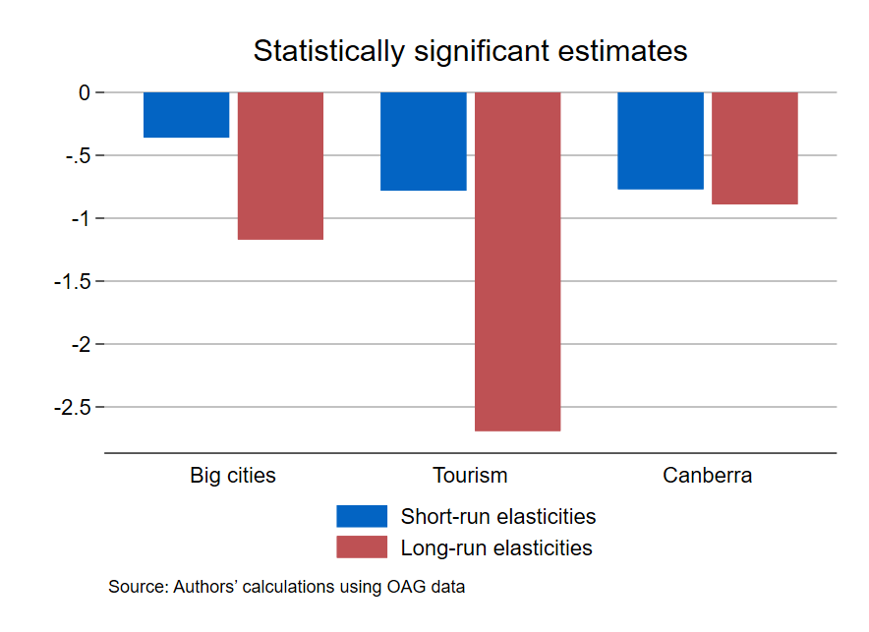
Big cities: all routes connecting SYD, MEL, BNE, PER, ADL
Tourism: routes to and from DRW, CFS, HTI, CNS
Canberra: all routes to and from “Big cities and Canberra”
We omit the SYD-MEL outlier from Figure A1

Table A.3: Elasticity of demand for the discount economy fare type (Qantas): OLS estimates [Robustness check for Table 5]
Route | Short-run elasticity | Long-run elasticity | Lags used in preferred  model (see equation (1)
SYD – BNE | -0.61***  (0.14) | -0.35**  (0.16) | Unrestricted
BNE – SYD | -0.46***  (.12) | -0. 57***  (.12) | p: 1  v: 1, 10
SYD – BNE (bi) | -0.55***  (0.12) | -0.57***  (0.13) | p: 1, 10  v: 1, 10
SYD – ADL | 0.07  (0.08) | 0.36  (0.32) | p: 11, 12  v: 1, 3
ADL – SYD | -0.08  (0.13) | -0.47  (0.29) | Unrestricted
SYD – ADL (bi) | 0.11  (0.09) | -0.49  (0.55) | p: 7, 12  v: 1, 3
SYD - PER | -0.20  (0.13) | -0.25  (0.25) | Unrestricted
PER – SYD | -0.30**  (0.11) | 0.08  (0.38) | p: 1, 7  v: 1, 2
SYD – PER (bi) | -0.24  (0.15) | -2.39  (1.89) | Unrestricted
DRW - SYD | -0.29***  (0.12) | -0.02  (0.30) | p: 4, 5  v: 1
SYD - DRW | -0.32**  (0.12) | -0.20  (0.31) | p: 1  v: 1, 2, 11
DRW - SYD (bi) | -0.44***  (0.15) | -0.16  (0.38) | Unrestricted
CFS - SYD | -0.16  (0.11) | -0.23  (0.33) | p: 1  v: 1, 2
SYD - CFS | 0.01  (0.09) | 0.84**  (0.32) | p: 9  v: 1, 3, 4
CFS - SYD (bi) | -0.03  (0.13) | -0.10  (0.27) | Unrestricted
SYD - HTI | 0.36  (0.39) | 2.16  (2.05) | p: 1  v: 1
HTI - SYD | -0.76*  (0.40) | -2.03  (7.17) | Unrestricted
SYD - HTI (bi) | -0.59  (0.70) | -0.16  (3.39) | Unrestricted
SYD – CBR | -0.35**  (0.14) | -1.22***  (0.30) | p: 1  v: 1, 3, 12
CBR – SYD | -0.57***  (0.18) | -0.53  (0.34) | Unrestricted
SYD – CBR (bi) | -0.37*  (0.19) | -0.90  (0.55) | Unrestricted
BNE – CBR | -0.21**  (0.09) | -0.85**  (0.37) | p: 1  v: 1, 3
CBR – BNE | -0.12  (0.10) | -0.91**  (0.44) | p: 1  v: 1
BNE – CBR (bi) | -0.16  (0.10) | -0.78**  (0.36) | p: 1  v: 1
MEL – SYD | -0.23*  (0.12) | -0.05  (0.26) | Unrestricted
SYD – MEL | -0.02  (0.11) | -0.95**  (0.41) | p: 1  v: 1, 3
MEL – SYD (bi) | -0.09  (0.11) | -1.49***  (0.57) | p: 1, 3, 12  v: 1, 3
MEL – CBR | -0.06  (0.09) | 1.35  (3.96) | p: 3, 8  v: 1, 2, 3, 5, 10
CBR – MEL | -0.20*  (0.10) | 49.02  (1098.84) | p: 3  v: 1, 2, 3, 7, 10
MEL – CBR (bi) | -0.19*  (0.10) | 5.81  (36.88) | p: 3, 8, 11, 12  v: 1, 2, 3, 5, 10
MEL – BNE | -0.34***  (0.10) | -0.77***  (0.20) | p: 1  v: 1
BNE – MEL | -0.40***  (0.10) | -1.60*  (0.94) | p: 1  v: 1, 11
MEL – BNE (bi) | -0.37***  (0.10) | -1.03***  (0.32) | p: 1  v: 1, 11
MEL – PER | -0.25**  (0.12) | -0.07  (0.52) | Unrestricted
PER – MEL | -0.29*  (0.14) | 1.34  (1.57) | Unrestricted
MEL – PER (bi) | -0.38***  (0.14) | -2.91  (5.43) | Unrestricted
MEL – CNS | 0.12  (0.11) | -3.11  (2.84) | p: 1, 3, 5  v: 1, 5
CNS – MEL | 0.11  (0.15) | 0.65  (0.43) | p: 1  v: 1
MEL – CNS (bi) | 0.09  (0.15) | 0.58*  (0.35) | Unrestricted

Figure A2: Average elasticity estimates: Qantas [statistically significant estimates only]
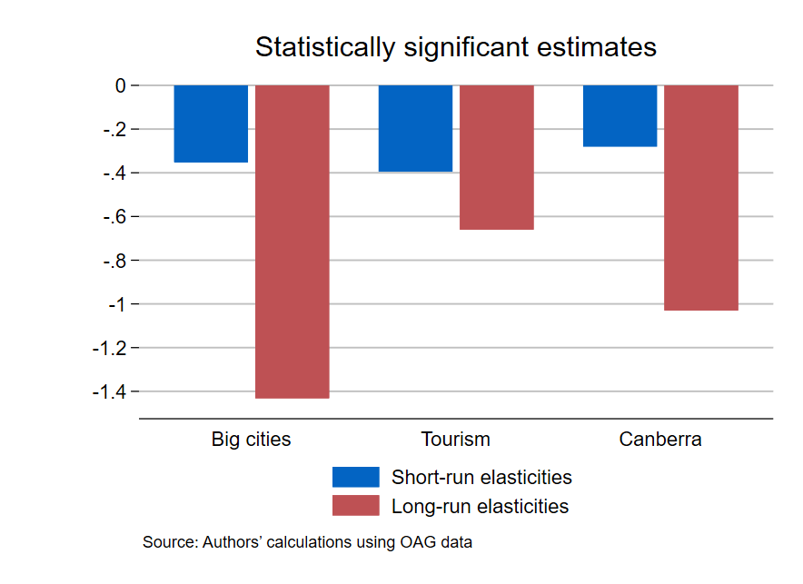
Big cities: all routes connecting SYD, MEL, BNE, PER, ADL
Tourism: routes to and from DRW, CFS, HTI, CNS
Canberra: all routes to and from “Big cities and Canberra”
We omit the MEL-PER and SYD-HTI outliers from Figure A2

For example, Sydney (SYD) – Brisbane (BNE) is separate from BNE – SYD.
Real prices calculated by adjusting nominal fares with quarterly CPI, taken from Australian Bureau of Statistics (2025).
For the large cities we use Greater Capital City Statistical Area population. For smaller cities, including Canberra, we use SA4 population. This reflects that these large cities serve multiple SA4s.
We exclude the very odd estimates over 100 for SYD-MEL in Table 4 and MEL-PER in Table 5.
We omit the results for routes between Sydney and Hamilton Island because they are nearly identical to what is found in the unrestricted model.
In the 2023 calendar year, there were 56 million discount economy domestic passengers.

