

Australia’s Net Zero Transformation:
  - Treasury Modelling and Analysis
September 2025

© Commonwealth of Australia 2025
ISBN: 978-1-923278-29-5
This publication is available for your use under a Creative Commons Attribution 4.0 International licence, with the exception of the Commonwealth Coat of Arms, the Treasury logo, photographs, images, third party materials, materials protected by a trademark, signatures and where otherwise stated. The full licence terms are available from creativecommons.org/licenses/by/4.0/legalcode.
Use of Treasury material under a Creative Commons Attribution 4.0 International licence requires you to attribute the work (but not in any way that suggests that the Treasury endorses you or your use of the work).
Treasury material used ‘as supplied’
Provided you have not modified or transformed Treasury material in any way including, for example, by changing the Treasury text; calculating percentage changes; graphing or charting data; or deriving new statistics from published Treasury statistics – then Treasury prefers the following attribution:
Source: The Commonwealth of Australia.
Derivative material
If you have modified or transformed Treasury material, or derived new material from those of the Treasury in any way, then Treasury prefers the following attribution:
Based on Commonwealth of Australia data.
Use of the Coat of Arms
The terms under which the Coat of Arms can be used are set out on the Department of the Prime Minister and Cabinet website (see www.pmc.gov.au/government/commonwealth-coat-arms).
Other uses
Enquiries regarding this licence and any other use of this document are welcome at:
Manager
Media Unit
The Treasury
Langton Crescent
Parkes ACT 2600
Email: media@treasury.gov.au
In the spirit of reconciliation, the Treasury acknowledges the Traditional Custodians of country throughout Australia and their connections to land, sea and community. We pay our respect to their Elders past and present and extend that respect to all Aboriginal and Torres Strait Islander peoples.

Foreword
The global transition to net zero is a golden economic opportunity for Australia.
The Albanese Labor Government has a clear and credible net zero plan to carefully manage and maximise the benefits of this economic transformation, helping Australia to attract investment, lift wages, grow living standards, and create jobs and spread economic opportunity around the country.
This Modelling and Analysis Report by the Treasury analyses three different net zero scenarios to provide insight into the scale and size of the economic opportunity under different pathways to net zero.
Treasury’s modelling report makes five key conclusions:
- Australia can be a primary beneficiary of the global net zero transformation if we continue to take decisive action on climate change
- Cheaper, cleaner energy will strengthen Australia’s international competitiveness
- Clear and credible climate action will lead to more jobs, higher wages and better living standards for Australians
- Our orderly net zero plan gives businesses the clarity and certainty they need to invest in Australia with confidence
- A disorderly transition would mean fewer jobs, less business investment, lower wages, lower living standards and higher power prices in a smaller economy.
The world is changing, and the pace of change is accelerating as we move to a future powered by cheaper, cleaner energy.
We can make ourselves the primary beneficiaries of that change if we harness our unique combination of geological, meteorological, geographical and geopolitical comparative advantages.
Together we recognise our future economic growth prospects lie at the intersection of our industrial, resources, skills and energy bases and our attractiveness as an investment destination.
Our net zero plan and the release of this modelling will help give investors the certainty and clarity they need, and help Australia attract the private capital to finance this transformation.
We thank the Treasury team and officials from across the Government who put this modelling together, their colleagues across the government who contributed and the non-government stakeholders and experts for their perspectives and collaboration.

The Hon Jim Chalmers MP
Treasurer

Contents
Acknowledgements 1
Executive summary 2
1. Introduction 5
2. Modelling scenarios and framework 9
2.1 Modelling scenarios 9
2.2 Modelling framework 11
2.3 Treatment of uncertainty 12
3. Emissions reduction pathways 16
3.1 Decarbonising Australia’s electricity system 17
3.2 Enabling electrification and energy efficiency 19
3.3 Enabling fuel switching and take‑up of abatement technology 22
3.4 Deploying gas efficiently 25
3.5 Scaling up carbon removals 26
3.6 Abatement outcomes under a disorderly transition 28
4. Economic impacts 30
4.1 Maintaining economic growth 30
4.2 Adjusting to structural change 31
4.3 Attracting and deploying investment 34
4.4 Broader benefits of the net zero transformation 37
4.5 The costs of not pursuing net zero 42
References 46

Acknowledgements
The modelling and analysis outlined in this report was undertaken by the Department of the Treasury (Treasury), and it has benefited significantly from collaboration with a range of government and non-government stakeholders and experts. Their contributions have been invaluable.
We recognise the expertise and commitment of Treasury staff who undertook the modelling, analysis, and drafting. Their work forms the foundation of the report’s findings. The work by Treasury’s Climate and Industry Modelling Branch was led by Alex Heath and Rebecca Cassells. Team members are: Freya Carlton, Kevin Cox, Linus Gustafsson, Melissa Hinson, Jamie Iredale, Fraser Jones, Yoonseo Lee, Tara Naidu, Marvin Ng, Kim Ngo, William Palmer, Sebastian Porter, Ken Quach, Ben Ralston, Alexander Robinson, Mary-Anne Sadleir, Martin Stevenson, Harvey Thompson, Yongle Ting, Nathan Walsh, Sophia Witte, Richard Yan, William Young, Andrew Yung and Thomas Zahn. We also recognise the contributions of former staff, including Rebecca Colquhoun, Belle Dare, Yael Jacoby, Jack Jaensch, Gerard Hawkins, Michael Kouparitsas, Charlotte Kwong, Charlotte Lyon, Nicholas Marinucci, Indra Muthukkaruppan, Jon Regan-Beasley, Claudia Stow, Agrata Verma and Anne Yang who were part of the team during the development of this work.
Within Treasury, we are very grateful for the support and advice provided by Treasury Secretary Jenny Wilkinson, Dr Angelia Grant and Damian Mullaly.
We acknowledge the inputs of colleagues across other government department and agencies who have all been extensively involved in supporting sectoral analysis, providing data inputs and collaborating on modelling and scenario assumptions. This includes the Department of Climate Change, Energy, the Environment and Water (DCCEEW), the Department of Industry, Science and Resources (DISR), the Department of Infrastructure, Transport, Regional Development, Communications, Sport and the Arts (DITRDCSA), the Australian Bureau of Agricultural and Resource Economics and Sciences (ABARES), the Department of Agriculture, Fisheries and Forestry (DAFF) and the Commonwealth Scientific and Industrial Research Organisation (CSIRO).
We are grateful to external reviewers and subject matter experts, including Professor Frank Jotzo, Dr Steve Hatfield-Dodds, Professor Warwick McKibbin, Dr Ken Henry, Dr Steven Kennedy, Meghan Quinn, Blair Comley, Dr David Gruen and Drew Clarke who generously provided their time and insights. Their feedback has helped ensure that the modelling and conclusions reflect the best available evidence and international practice.

Executive summary
This report examines the impact of the net zero transformation on Australia and provides insights into the economic opportunities from different pathways. It uses scenario modelling to provide insights into how Australia can efficiently achieve emissions reductions over time, in the context of the global net zero transformation. The scenarios highlight the implications for the economy of different pathways and how to maximise opportunities.
The world is continuing to move towards net zero and countries are transforming their energy systems and economies. Australia’s major trading partners, including China, Japan and the Republic of Korea, have committed to the Paris Agreement. The emissions gap between current global policies and the Paris goal has narrowed over time. Global energy intensity and carbon intensity have declined.
Technological change has reduced the cost of renewable energy and batteries, enabling a significant increase in renewable electricity generation. Over the past decade, around half of the increase in global electricity generation has been met by solar and wind. Structural shifts are expected to continue, with renewables dominating new electricity generation capacity in more economies and the continued advancement in electrification of transport and industry.
Australia is making substantial progress in reducing emissions. Over the past decade, annual emissions have fallen by almost 100 Mt CO₂‑e and the share of renewable electricity generation has more than doubled. In 2020, just five years ago, it was estimated that Australia’s emissions in 2030 would be 22 per cent below 2005 levels. The most recent estimates indicate that emissions will be around 43 per cent lower by 2030. Key policies to support the emissions reduction pathway are now in place, including the Safeguard Mechanism, the 82 per cent renewable electricity target underpinned by the Capacity Investment Scheme, and the New Vehicle Efficiency Standard. Significant additional action will be required for Australia to achieve net zero emissions by 2050.
This report models three scenarios to compare potential transition pathways to net zero for Australia. Two of the scenarios broadly reflect the Government’s Net Zero Plan, which provides more investment certainty by establishing a 2035 target range and sector transition pathways. The Baseline Scenario presents an efficient pathway consistent with existing policies and the expected availability of abatement technologies. The Renewable Exports Upside Scenario additionally considers the upside if Australia realises its potential in emerging renewable energy export markets. By contrast, the Disorderly Transition Scenario assumes Australia does not set a credible 2035 emissions reduction target, but resumes a trajectory towards net zero in 2050 from 2040 onwards. A disorderly transition increases the cost of capital, reduces access to technology and limits businesses’ ability to plan for future investment. Across all scenarios, global mitigation action is assumed to be sufficient to ensure global temperatures are kept well below 2°C by the end of this century.
Strong investment in renewable energy remains foundational to Australia’s efficient transition, and emissions reduction will be required across all sectors. The modelling finds that expanding the supply of renewable energy continues to be the most cost‑efficient abatement opportunity, reducing emissions in the electricity sector directly and enabling broad‑based decarbonisation through electrification. Fuel switching and efficient use of energy will become increasingly important over time, enabled by improving abatement technologies, and scaling up carbon removals will be required to offset residual emissions later in the transition.
An orderly transition will place downward pressure on wholesale electricity prices, improving Australia’s economic competitiveness. Firmed renewables will continue to be the cheapest form of new generation and put downward pressure on electricity prices. Greater reliance on ageing coal-fired power stations and more expensive gas-fired generation under a disorderly net zero transition would put upwards pressure on electricity prices. The Disorderly Transition Scenario is projected to increase wholesale electricity prices by 17 per cent on average during the 2030s and up to 54 per cent in the 2040s, relative to the Baseline Scenario. In contrast, investing in Australia’s renewable exports potential could unlock broader competitiveness and help reduce cost‑of‑living pressures on households by reducing wholesale electricity prices by around 20 per cent by 2050, relative to the Baseline Scenario. In the long-term, wholesale electricity price levels under the orderly scenarios are projected to be around 10 per cent below the 10-year real historical average wholesale electricity price, consistent with the Australian Energy Market Commission’s 10-year forecast.
Electrification is a key source of low‑cost emissions reductions, particularly for transport, the built environment, and some industrial manufacturing processes. Where electrification is not a cost‑effective or technically viable option, fuel switching and approaches that support take‑up of abatement technologies are projected to support emissions reductions in the medium term. Low‑carbon liquid fuels are expected to offer an increasingly cost‑effective decarbonisation pathway over time. Australia’s access to these technologies is expected to be more limited under a Disorderly Transition Scenario, increasing the cost of abatement to business at all stages of the net zero transition.
Australia’s ambitious and achievable plan to reduce emissions will support continued economic growth, higher living standards and employment. Under the Baseline Scenario, the economy is projected to be 28 per cent larger by 2035 and 81 per cent larger by 2050, relative to current levels. In dollar terms, the economy is expected to be $2.2 trillion bigger by 2050, relative to current levels. Real GDP per capita is projected to be $12,000 higher in 2035 and $36,000 higher in 2050, compared to current levels. Employment is projected to increase by 5.1 million people by 2050. Australia’s exports are projected to grow over time, with declining global demand for fossil fuels counterbalanced by the emergence of new renewable energy export markets. Manufacturing and construction activity are projected to grow as Australia replaces ageing energy infrastructure and realises new industrial opportunities.
Credible targets and policies are critical for investment certainty and growth. Australia’s Net Zero Plan provides businesses with the certainty required to invest efficiently. Under the orderly transition scenarios – Baseline and Renewable Exports Upside – investment is projected to grow by 79-84 per cent between 2025 and 2050. With clear foresight around Australia’s emission reduction pathways, businesses and households are able to replace existing capital, as it depreciates, with lower-emission upgrades in a way that positions Australia’s economy to decarbonise efficiently and realise new industrial opportunities. A disorderly approach would ultimately lead to a more costly and less efficient transition.
Leveraging Australia’s comparative advantages in renewable energy will deliver broad‑based benefits to Australians and help grow our exports. The Renewable Exports Upside Scenario projects Australia’s green exports could be $68 billion higher in 2050 than in the Baseline Scenario, including critical minerals, renewable hydrogen and green metals exports. Under this scenario, the economy is projected to be 84 per cent larger by 2050, relative to 2025. Similarly, real GDP per capita is projected to be $38,000 higher in 2050. Wholesale electricity prices are projected to be around 20 per cent lower in 2050 if Australia realises its renewable energy exports potential. Households that electrify their home and vehicles, and install solar and a battery, could reduce their energy costs by around 40 per cent to 2050. This scenario also sees Australia make a greater contribution to global abatement, with the global emissions displaced by Australian low‑emission exports in 2050 projected to be greater than Australia’s total net emissions in 2025.
A disorderly approach will cost investment, jobs and the economy. Under the Disorderly Transition Scenario, the economy is projected to be up to a cumulative $2 trillion smaller by 2050, compared to orderly scenarios. Real wages are projected to be up to 4.0 per cent lower in 2050 leading to lower participation and employment. Per capita GDP is projected to be $2,100 lower in 2050, compared to the Baseline Scenario, and $4,500 lower compared to the Renewable Exports Upside Scenario. Cumulative investment is expected to be half a trillion dollars lower than under the Baseline Scenario.
The economic costs to Australia of not pursuing net zero would be significant and consequential and exceed those modelled in the Disorderly Transition Scenario. A scenario where Australia does not pursue net zero has not been modelled in this report. However, this modelling finds that climate policy uncertainty reduces investment, increases energy costs for households and risks capital scrapping. Not pursuing net zero by 2050 risks lower economic growth, reduced investment, missed export and employment opportunities, and higher electricity prices. These outcomes would flow from several channels, including heightened policy uncertainty, increased borrowing costs on global markets and the loss of potential new export markets. The 2021 Long‑Term Emissions Reduction Plan estimated that the economy‑wide capital risk premium could increase by 100 basis points if Australia did not adopt a net zero target. It found that this could reduce investment by an average of 5.5 per cent from 2021 to 2050 and that gross national income could be $625 lower per person. Research by the Organisation for Economic Co-operation and Development (OECD) also concludes that climate policy uncertainty has a significant negative impact on business investment. By contrast, the Government’s Net Zero Plan outlines an orderly pathway to net zero in 2050 which supports ongoing investment and economic growth.

- Introduction
The global net zero transition represents one of the largest structural transformations since the Industrial Revolution. Widespread commitments to global decarbonisation have resulted in significant technological developments, policy innovation and green investment, reducing the projections of global emissions over time. A clear global commitment to net zero has unlocked increased investment in decarbonisation internationally. Clear and credible climate action will be required to attract investment to Australia and position Australians to benefit from the global net zero transformation.
Australia committed to achieving net zero emissions by 2050 in 2021, recognising the importance of action to prevent global warming and safeguard Australia’s prosperity. While there remains an emissions gap between current global policies and the Paris goal, the gap has narrowed. Prior to the Paris Agreement, modelled scenarios suggested global temperature increases of approximately 4°C by 2100 (Chart 1.1). Under current policies this trajectory has fallen to around 3°C and with full implementation of nationally determined contributions (NDCs) submitted as of 2023, projected warming is estimated to be in the range of 2.1–2.8°C (UNFCCC 2023).
Chart 1.1: Global emissions trajectories
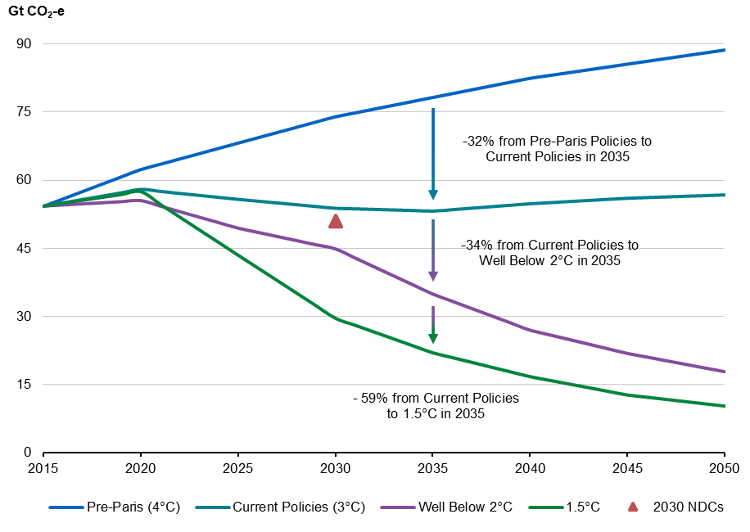
Note: 2030 NDCs represent the level of global emissions in 2030 if all unconditional and conditional NDCs are achieved. The Pre‑Paris, Current Policies, Well Below 2°C and 1.5°C pathways use IPCC emissions scenarios to represent temperature outcomes.
Source: Treasury analysis of Byers et al. 2022; IPCC 2022; UNEP 2024; UNFCCC 2023
The world is continuing to move towards net zero and countries are transforming their energy systems and economies. Australia’s major trading partners, including China, Japan and the Republic of Korea, have committed to the Paris Agreement. Today, 165 countries, accounting for around 80 per cent of global gross domestic product (GDP), are covered by national net zero commitments (DCCEEW 2025a). Globally, there is twice as much energy investment in clean energy as fossil fuels (Chart 1.3). China, in particular, has rapidly accelerated investment in renewables to reduce its reliance on imported energy.
Global energy intensity (energy use per unit of GDP) declined by an average of 2 per cent per year between 2010 and 2019 and by 1.2 per cent per year from 2020 to 2023 (IEA 2025a). Similarly, carbon intensity (carbon dioxide emissions per unit of energy) fell on average by 0.3 per cent per year from 2010 to 2019 (IPCC 2023). This reflects structural changes in the global energy system, including a shift from coal to gas, improved energy efficiency and an increase in the use of renewable energy.
Over the past decade, global electricity generation has grown by an average of 2.6 per cent per year – around double the growth in the demand for energy – reflecting an increased reliance on electricity (Energy Institute 2025). Around half of this increase has been met by solar and wind, which accounted for almost 15 per cent of total generation in 2024, up from just under 4 per cent in 2014 (Chart 1.2).
Chart 1.2: Wind and solar generation as a share of total global electricity generation, 1992 to 2024 | Chart 1.3: Global energy investment, 2015 to 2025
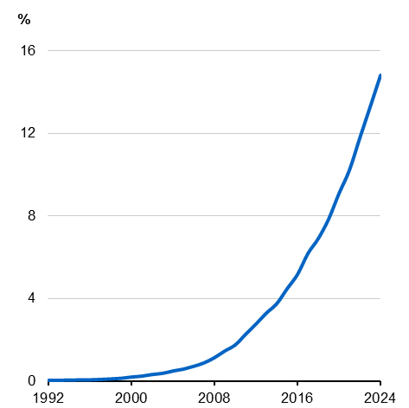  Source: Energy Institute 2025 | 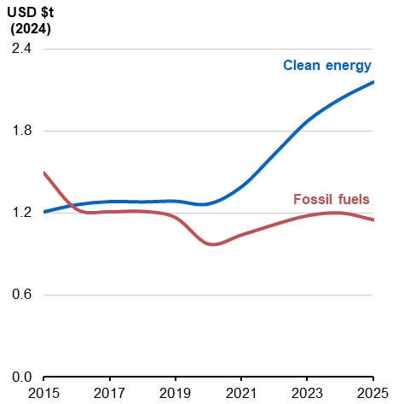  Note: Clean energy includes: Clean Fuels, Direct Air Capture, Transitional fossil fuels, Nuclear, Renewable power, Battery storage, Electricity networks, Fossil fuels: with CCUS, Other clean power and End-use. Other end-use includes: Electrification, renewables for end-use, Hydrogen and industry CCUS. Bunker fuels are only accounted for at the World level. 2025 data is estimated.  Source: IEA 2025b
Technological change has contributed significantly to these developments. From 2010 to 2023, the cost of solar photovoltaic (PV) electricity decreased by 90 per cent, while the cost of wind electricity also declined (IRENA 2024). Battery storage costs also fell by around 90 per cent over this period, enabling increased adoption of electric vehicles and energy storage technologies (IRENA 2024). Investment in clean energy infrastructure, efficiency and electrification has increased since 2021 and is projected to reach USD2.2 trillion in 2025, around double that of investment in fossil fuel projects (Chart 1.3).

China is expected to continue to drive global energy transition investment, with Chinese investment outpacing the combined investment of the United States, European Union and United Kingdom in 2024 (BloombergNEF 2025a). Global momentum is also expected to continue at subnational levels (including in the United States) and within the private sector (E3G 2025; IEA 2025b). Structural shifts are expected to continue, with renewables dominating new generation capacity in more economies and the continued advancement of electrification of transport and industry (IEA 2024a; IEA 2024b).
As global climate action ramps up, patterns of global trade in energy and resources will change to meet shifting demand and align with emerging comparative advantages. Carbon‑intensive production methods and carbon‑intensive energy sources are expected to experience declining demand. At the same time, global demand for green commodities is projected to increase.
The global net zero transition could present a significant economic opportunity for Australia (Treasury 2024). Australia is a significant resources exporter – it is currently the world’s largest exporter of iron ore and alumina. The success of the resources sector is underpinned by large reserves of mineral commodities, strong trade partnerships, fair and competitive markets, commitment to open trade and international investment, and proximity to key markets in Asia.
Australia could become an important producer and exporter of clean energy embedded products as the world decarbonises. Australia has a substantial endowment of low‑cost renewable energy resources, a key input into the production of clean energy embedded products (Chart 1.4). It also has significant reserves and an existing footprint in the production of minerals that are likely to be in demand in a net zero world – including critical minerals like lithium, nickel and cobalt along with iron ore, bauxite and alumina (Chart 1.5). Critical minerals, which are essential for electric vehicles and grid‑scale batteries, are projected to experience strong demand growth to support renewable technologies.
Chart 1.4: Estimated renewable electricity costs by country relative to Australia, 2050 | Chart 1.5: Australian production and reserves of key mineral commodities, 2023
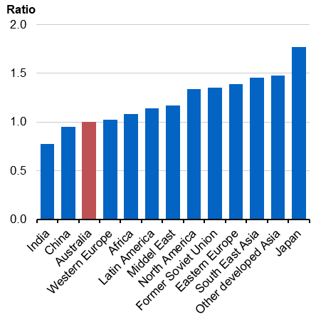 | 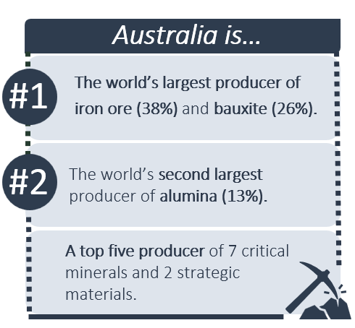
Source: Graham and Havas 2023 (from Treasury 2024). | Source: Geoscience Australia 2025

Treasury’s climate modelling assesses the economic opportunities from the global net zero transformation for Australia and demonstrates the impact of different pathways to net zero on investment, economic growth, living standards, jobs and the structure of the economy. Other modelling exercises explore different questions. For example, the Climate Change Authority (CCA) has undertaken modelling, working with the Commonwealth Scientific and Industrial Research Organisation (CSIRO), to understand the potential impact of different 2035 targets.
This report is structured as follows. The opening section provides an overview of the modelling scenarios and framework, including the key dynamics of the global net zero transformation that underpin all three scenarios. The third section discusses the key drivers of modelled abatement for Australia. The fourth section presents economic projections for Australia across the three scenarios. The report concludes with technical appendices that describe the modelling approach and key assumptions in detail.

- Modelling scenarios and framework
Scenario modelling has been undertaken to provide insights into how Australia can efficiently achieve emissions reductions over time. The scenarios highlight the implications for the economy of different pathways and how to maximise opportunities.
Modelling the domestic and global net zero transformation requires consideration of a wide range of factors, including the likely availability of abatement technologies, the interaction of abatement pathways across industries, and the expected behaviour of Australian households and businesses. Developing a whole‑of‑economy perspective on these factors requires combining a range of datasets and models, capturing the connections between the global and domestic economies, changes in Australia’s industrial structure and industry‑specific details.
Modelling long‑term structural change also involves significant uncertainty. For this reason, a scenario‑based approach is used to understand cost‑effective emissions reduction sources for Australian industries and households, and their potential economic impacts.
This section provides a summary of the modelling scenarios and framework and discusses the uncertainty that exists in climate modelling through case studies on technology and land‑based sequestration. More details on the modelling approach and key assumptions are in Appendices B-D.
  - Modelling scenarios
Three scenarios are modelled to compare different potential transition pathways for Australia. Two of the scenarios broadly reflect the Government’s Net Zero Plan (DCCEEW 2025a):
- the Baseline Scenario illustrates an efficient domestic pathway consistent with existing policies and the expected availability of abatement technology, and a global economy that achieves emissions reductions consistent with keeping average temperature increases to less than 2°C.
- the Renewable Exports Upside Scenario presents the same domestic pathway and additionally considers the upside if Australia realises more potential in emerging clean energy export markets.
Both these scenarios achieve Australia’s legislated commitments to reduce emissions by 43 per cent compared to 2005 levels by 2030 and net zero emissions by 2050. They also achieve emissions reductions in 2035 of 65 per cent compared to 2005 levels, which is consistent with the Government’s 2035 target range.
These two scenarios are contrasted against a Disorderly Transition Scenario, where it is assumed that Australia does not set a 2035 emissions reduction target or does not set a credible 2035 target. Under this scenario, stalled climate policy action between 2030 and 2040 results in heightened policy uncertainty, which leads to less investment and a more costly abatement path to meet net zero in 2050.
A detailed description of the modelling scenarios is in Table 2.1.
Table 2.1: Summary of modelling scenarios
Scenario | Description
Baseline Scenario | Australia builds on existing climate and energy policies, to achieve emissions reduction targets and net zero by 2050 via an orderly and efficient transition pathway.  Cornerstone policies such as the Safeguard Mechanism, 82 per cent on-grid renewable electricity target, Capacity Investment Scheme, Future Made in Australia agenda, and New Vehicle Efficiency Standard are in place and drive significant reductions in emissions. Beyond existing policies, the scenario identifies where cost‑efficient emissions reduction opportunities – in the form of direct abatement or land-based sequestration – are likely to come from across the economy. Australia achieves 65 per cent emissions reductions by 2035. Exports of clean energy embedded products commence, but new, globally competitive export industries do not rapidly build to scale.
Renewable Exports Upside Scenario | Australia follows the same domestic transition pathway as the Baseline Scenario but is additionally successful at leveraging its comparative advantages in renewable energy to capture a larger share of growing global demand for clean energy embedded products.  This scenario is consistent with the Baseline Scenario, including the achievement of 65 per cent emissions reductions by 2035. Additionally, Australia captures a significant share of global clean energy embedded product markets. This scenario assumes increased domestic hydrogen production in line with National Hydrogen Strategy targets, supporting production of clean energy embedded ammonia and green metals, which are primarily exported.
Disorderly Transition Scenario | Australia delays further climate action, resulting in increased costs over time from a transition path that is more uncertain and disorderly.  Existing climate policies remain in place, but Australia does not set a 2035 emissions target or does not set a credible 2035 target, and does not undertake further climate policy action until the 2040s. Australia makes minimal progress on economy‑wide emissions reduction throughout the 2030s, needing to accelerate emissions reductions from 2040 to achieve net zero by 2050. Prior to 2040, policy uncertainty is heightened, resulting in lower and misallocated investment.

The Baseline Scenario shows what the economy could look like under a net zero transition that is supported by a clear and credible net zero plan that enables cost‑effective emissions reductions across sectors and over time. This environment allows households and businesses to plan ahead and make well‑informed decisions. It is aligned with the Government’s legislated 2030 target, 2035 target range and net zero in 2050, existing Government policies, and broadly reflects the Government’s Net Zero Plan. It makes relatively conservative assumptions about Australia’s contribution to new clean energy embedded export markets.
The Renewable Exports Upside Scenario assumes broadly the same domestic transition pathway as the Baseline Scenario but additionally assumes that Australia’s relative cost advantages in producing renewable energy allow for increased production of clean energy embedded exports. Specifically, it is assumed that Australian exports of green iron and green ammonia reach about 120 million tonnes (Mt) and 35 Mt respectively in 2050, supported by renewable hydrogen production of 15 Mt. This is significantly higher than under the Baseline Scenario. It demonstrates the potential of Australia’s Future Made in Australia agenda and provides insight into realising Australia’s potential in clean energy embedded commodity production to build new sources of competitiveness.
The Disorderly Transition Scenario considers what could occur if there is heightened policy uncertainty due to the absence of long‑term credible targets and policy settings. This scenario shows what the economy could look like under a net zero transition that is less certain and timely, where emissions reductions are not sequenced to allow the economy to transition along a pathway that minimises costs. This could result from not setting a 2035 target or not setting a credible 2035 target. The results show businesses are more reluctant to invest, delaying the achievement of the 43 per cent emissions reduction target, and insufficient early emissions reductions require rapid, and more costly, decarbonisation in the decade to 2050. Australia emits more cumulative emissions to 2050 than in both the Baseline Scenario and Renewable Exports Upside Scenario.
Appendix C contains further details on the key differences across the scenarios. A number of factors are held constant across the different scenarios to enable comparison of the implications of different potential pathways for Australia to achieve net zero.
Across all scenarios, global mitigation action is assumed to accelerate such that global temperatures are kept well below 2°C by the end of this century. The global scenario is aligned with the Intergovernmental Panel on Climate Change (IPCC) Illustrated Mitigation Pathway with over 67 per cent probability of limiting warming to below 2°C, and the International Energy Agency’s (IEA) Announced Pledges Scenario. These global pathways are closely aligned in their assumptions and outcomes, and provide a sense of how much additional action is required to reach global net zero targets. Small deviations in global mitigation action are unlikely to impact the overall trends identified.
The scenario modelling does not consider physical climate risks, geopolitical risks, alternative global pathways or other significant sources of uncertainty. Other modelling exercises, including analysis in the 2023 Intergenerational Report, have shown significant economic costs are likely if Australia, and the world, fail to reduce emissions and limit future temperature increases (Australian Government 2023; NGFS 2024).
The modelling scenarios are projections rather than forecasts and are broadly consistent with the long‑term modelling approach in the Intergenerational Reports. They do not represent a full update of Treasury’s long‑run economic projections. Each scenario makes a range of technical assumptions that do not reflect Government policy decisions, and these assumptions should not be interpreted as detailed prescriptions for specific policies to 2050. However, policy will need to evolve over time to support the significant additional action that will be required to put Australia on track for net zero emissions by 2050.
  - Modelling framework
Treasury’s climate modelling framework is made up of a set of interconnected models that capture the dynamics of different parts of the economy (Chart 2.1). Global economic and technology assumptions, a domestic whole‑of‑economy model and detailed models for sectors critical to the transition are deployed in an integrated way to provide a coherent whole‑of‑economy perspective.
This approach is similar to the frameworks used in the CSIRO’s Pathways to Net Zero Emissions (2023a), ClimateWorks Centre Decarbonisation Scenarios 2023: Paris Agreement alignment for Australia (2023a), and the Long‑Term Emissions Reduction Plan (DISER 2021).
Chart 2.1: Treasury’s modelling framework
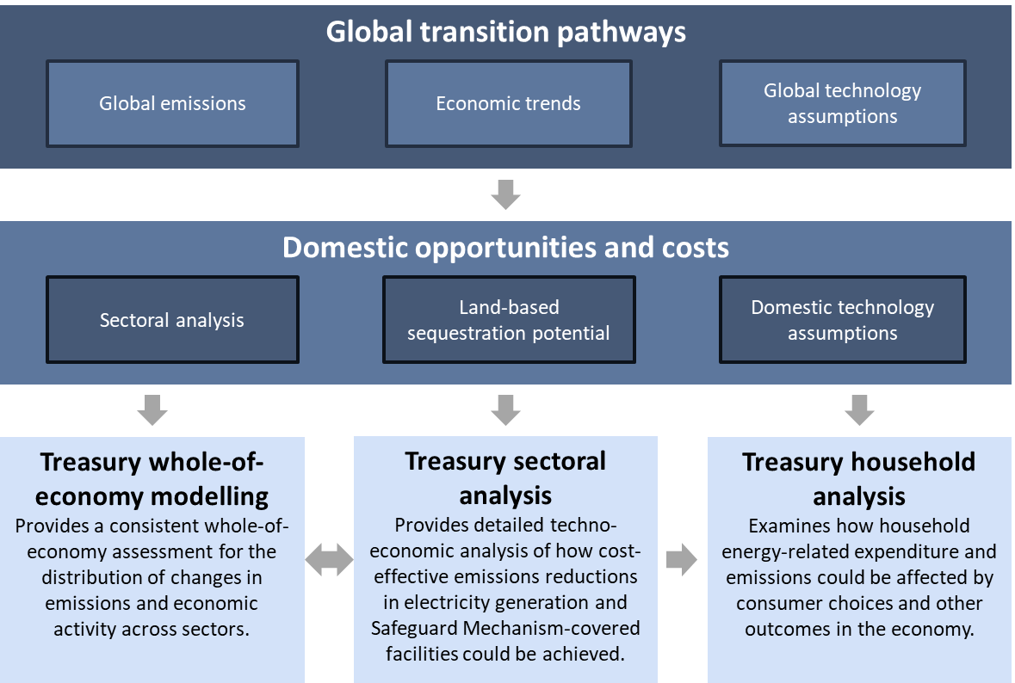
  - Treatment of uncertainty
The future of climate change and the net zero transformation is uncertain and will be affected by many interrelated and evolving factors. Changes in available technology, economic, and geopolitical conditions will affect the composition and timing of efficient abatement. For example, Russia’s invasion of Ukraine increased global energy prices and accelerated investments in renewable energy and energy efficiency. Recent policies introduced by the United States Administration have also increased geopolitical and economic uncertainty, but long-term trends in adoption of lower-cost renewable energy technologies have continued (IEA 2025c).
Policy uncertainty, and its implications for economic outcomes, is a key issue for governments and for the investment decisions required to achieve the transition. The Disorderly Transition Scenario illustrates some of the costs of policy uncertainty.
The long‑term costs and availability of decarbonisation technologies are critical assumptions for modelling of net zero transition pathways. The case study below considers this uncertainty in more detail and its potential implications for modelling outcomes.

Case study: Technology uncertainty
Examining past climate modelling exercises shows that specific technology costs are difficult to predict, but that innovation overall has delivered lower-cost abatement opportunities than anticipated. As a result, climate modelling has generally underestimated cost declines and subsequent take‑up of new technologies.

Declining costs of renewable energy
Treasury last undertook a large transition modelling exercise for the 2011 Strong Growth Low Pollution report (Treasury 2011). In that modelling, it was projected that solar photovoltaic (PV) would contribute 3 per cent of electricity generation by 2024. The actual figure was about 17 per cent (Chart 2.2). The underestimation was due to larger-than-predicted declines in solar PV costs, which fell by 75 per cent in the 5 years to 2014 (IRENA 2015), alongside generous feed‑in tariff support and government subsidies.
In addition, previous Treasury modelling did not include either electric vehicles or batteries as feasible decarbonisation options. Electric vehicles accounted for 20 per cent of global vehicle sales in 2024, and applications for battery projects are higher than any other generation type on the National Electricity Market (NEM). On the other hand, the role of geothermal, solar thermal, and biomass generation was predicted to be higher than actual outcomes.
Modelling exercises by leading international agencies have faced similar challenges. The IEA, for example, has significantly underestimated investment in solar PV (Chart 2.3).
Chart 2.2: Australian generation share by renewable technology, 2024  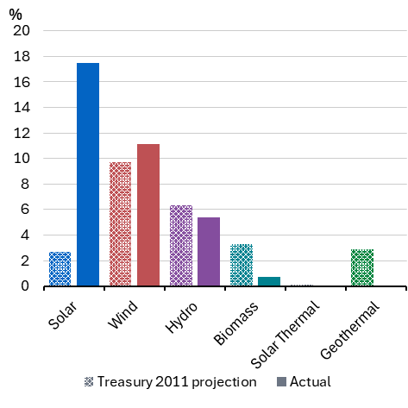 | Chart 2.3: Global solar installed capacity, IEA  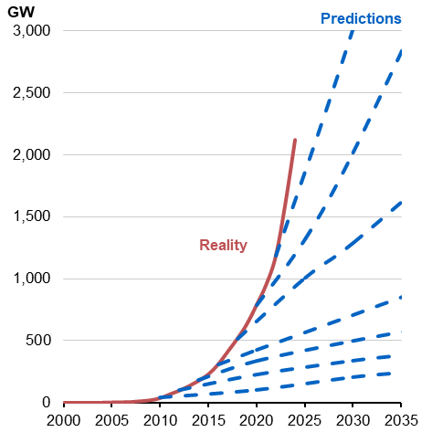
Source: Treasury 2011 and DCCEEW 2024a | Note: IEA World Energy Outlook’s Stated or Current Policies Scenarios taken biannually from 2010 to 2022.  Source: IEA 2024a

Improved understanding of the role of hydrogen
Hydrogen is another example of how information and assumptions have evolved since previous climate modelling exercises.
Australia’s first National Hydrogen Strategy in 2019 set out a pathway to build an Australian industry, capitalising on global momentum (DCCEEW 2019). The Strategy noted the potential for broad use cases across industrial decarbonisation, electricity generation, heating homes and as a transport fuel. It also identified the potential for a large‑scale Australian export sector.
The work of the Strategy, and other sources, informed the outlook for hydrogen in the 2021 Long‑Term Emissions Reduction Plan (DISER 2021). The Plan projected a decline in hydrogen production costs from around $4.60/kg in 2021 to $1.10/kg in 2050. Other leading organisations, including the International Renewable Energy Agency (IRENA) and the IEA, also forecast strong declines (IRENA 2021; IEA 2021).
Understanding of the economics of hydrogen production has evolved since this initial work, shaping understanding of what role hydrogen is likely to play in a net zero economy.
With forecast costs higher than anticipated in 2021 (Chart 2.4), hydrogen is now considered a viable option primarily where decarbonisation via electrification is not possible, such as for chemical feedstocks, hard‑to‑abate industrial processes, or certain long-haul transport applications. Where possible, electrification is more efficient as an energy carrier. For example, electric vehicles have half the efficiency losses of hydrogen cell vehicles (Chart 2.5), but electrification may not be well suited to all transport tasks.
Views have also shifted around the likely future role of hydrogen in global export markets. Due to challenges in transporting hydrogen in its raw form, it is now expected that hydrogen is more likely embodied in other export products, such as green iron, steel and ammonia. Australia’s hydrogen policy supports, such as Hydrogen Headstart and innovation support through the Australian Renewable Energy Agency, are designed for compatibility with any potential export vector that emerges.
Chart 2.4: Hydrogen cost projections  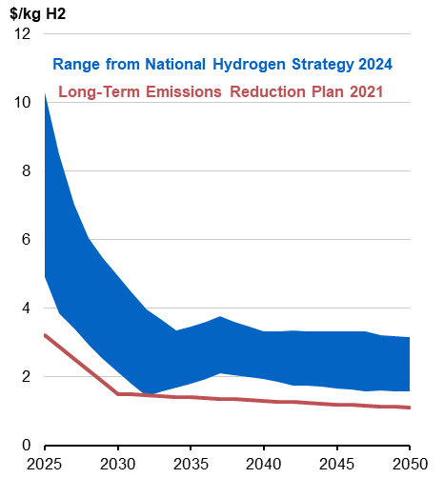  Source: DCCEEW 2024b & DISER 2021 | Chart 2.5: Input energy lost, by vehicle type  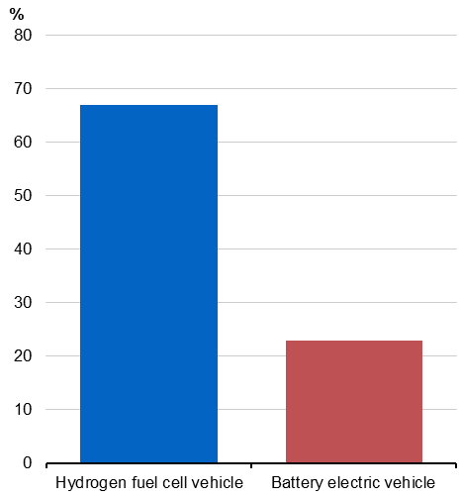Source: Transport and Environment 2024

Interactions with land‑based sequestration
The use of land to support the net zero transition is another key uncertainty within modelling. This uncertainty stems from both the cost and availability of land‑based abatement and the costs of other abatement technologies.
There is considerable uncertainty around the scale and composition of land‑based sequestration required for Australia to achieve net zero. The sources of uncertainty include analytical and data constraints about the carbon sequestration potential of different land types, and uncertainty about the revenue landowners need to repurpose their land.
Credible estimates of the land‑based sequestration that may be available for a given revenue vary widely, by a factor of more than 20. For example, for a revenue of $100/tonne of carbon dioxide (t CO₂), the Global Biosphere Management Model (GLOBIOM) estimates land‑based carbon removals of 6.5 million tonnes of carbon dioxide (Mt CO₂) while Roxburgh et al. (2020) estimate carbon removals of 171 Mt CO₂ (IIASA 2024). Another leading model, Land Use Trade‑offs Model (LUTO), sits in the middle‑to‑upper end of this range at higher carbon prices (CSIRO 2023b).
Abatement technology development over the next 25 years will also influence the level of land‑based sequestration. If abatement technologies develop faster than projected, for example, demand for land‑based sequestration will be lower. As a stylised example, increasing the amount of abatement achievable through technology by 25 Mt CO₂-e in 2050 would reduce the need for additional land‑based sequestration by around 20 per cent.

- Emissions reduction pathways
Australia has made substantial progress in reducing emissions. Renewables now provide over 40 per cent of electricity in Australia’s two major grids, up from just over 10 per cent a decade ago (Open Electricity n.d.), and are putting downward pressure on electricity prices. The most recent estimates indicate that emissions will be around 43 per cent lower by 2030 and 51 per cent lower by 2035, based on current policies.
Key policies to reduce emissions are now in place, including the Safeguard Mechanism, 82 per cent renewable electricity target supported by the Capacity Investment Scheme, and the New Vehicle Efficiency Standard. Households are also taking opportunities to reduce emissions and lower energy costs. More than one in three homes now have rooftop solar, there has been a strong early response to the Cheaper Home Batteries Program, and electric vehicles reached 10 per cent of light vehicle sales in 2025, up from 0.8 per cent five years ago (Federal Chamber of Automotive Industries n.d.; Electric Vehicle Council n.d.).
The scenario modelling shows that continued decarbonisation of Australia’s electricity system and improvements in energy efficiency support emissions reductions in the near‑term (Chart 3.1). Further out, fuel switching and the take‑up of new abatement technologies across sectors, the efficient use of gas, and scaling up of carbon removals will also be key actions to support emissions reductions.
Chart 3.1: Projected emissions reductions, by Sector, Baseline Scenario
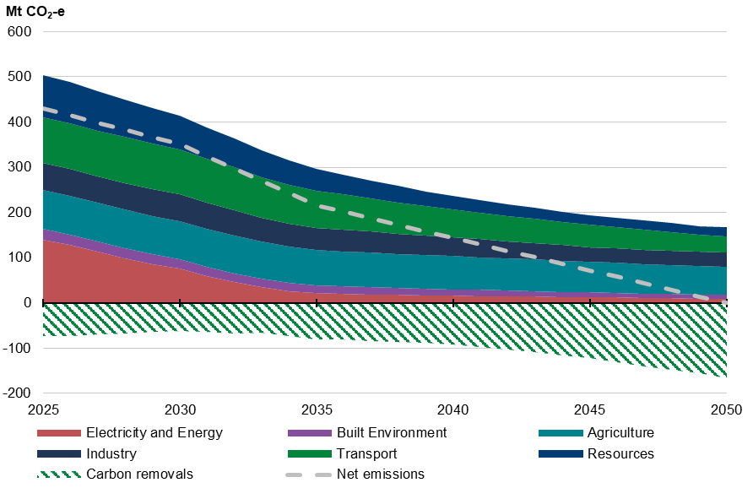
Note: For interpretability, agriculture and land have been split in the above figure. Emissions reductions from land‑use change have been incorporated within carbon removals. Carbon removals refer to removing carbon dioxide from the atmosphere and storing it in land‑based ecosystems, such as forests and soils.
Source: Treasury modelling.
Australia’s strong renewable energy resources are foundational to driving an efficient transition. The scenario modelling shows that the most cost-efficient abatement opportunity at scale is to expand the supply of renewable energy. Renewables reduce emissions in the electricity sector directly and enable broad‑based decarbonisation through electrification. Appropriately sequencing abatement to effectively manage critical dependencies – such as building out the renewable energy network to support electrification – can benefit cost efficient abatement opportunities for all sectors.
Over the medium‑term, cost‑efficient electrification, energy efficiency, fuel switching and other abatement technology opportunities in sectors like transport, industry and resources are expected to expand. Technology adoption is most cost-effective when it aligns with planned turnover or expansion of capital, highlighting the importance of credible long‑term policy settings that allow businesses to time investment decisions effectively. Gas is projected to support the delivery of renewable energy and become more focused on higher‑value and non‑substitutable use cases over time.
Longer term, emerging technologies are anticipated to become available for hard‑to‑abate industrial processes and agriculture, as well as increased use of land‑based carbon removals. Innovation and capacity building will be important in these areas to ensure Australia’s competitiveness as the global economy transitions to net zero. As outlined in the Net Zero Plan, appropriate policy settings and support for research, development and adoption of technology are important to help broaden options for cost‑effective abatement for sectors currently lacking suitable abatement options. This can help bring the availability of new technologies forward.
The sequencing of abatement is broadly consistent across the Baseline Scenario and Renewable Exports Upside Scenario. By contrast, delayed renewable energy rollout and technology availability under the Disorderly Transition Scenario constrains some sources of cost‑efficient economy‑wide abatement. This results in increased transition costs and economic disruption (see 4. Economic impacts).
  - Decarbonising Australia’s electricity system
The modelling shows that decarbonising Australia’s electricity system is already a cost‑efficient way to achieve large‑scale abatement. Ongoing investment in renewables ensures access to reliable and least‑cost energy and enables subsequent least‑cost abatement through electrification.
Australia’s electricity system requires ongoing investment regardless of the net zero transition. Most of Australia’s coal‑fired power capacity is over 40 years old and is due to retire in the next decade. Several coal plants are already operating beyond their original lifespan. They are becoming increasingly unreliable as they age, with rising energy security and price risks. The CSIRO’s analysis has identified firmed renewable generation as the lowest cost source of new generation (CSIRO 2025).
Disorderly coal plant closures have already had significant impacts on electricity supply and prices. For example, the unexpected retirement of the Hazelwood power station in March 2017 triggered a sharp and sustained rise in wholesale electricity prices. Hazelwood was over 50 years old with safety compliance issues and a prohibitive cost of repairs (AER 2018). More recently, an explosion at Callide C in Queensland in May 2021 caused around half a million customers to lose power (Pollard 2021) and left a unit out of service for 3 years (CS Energy n.d.). The wholesale electricity forward market reacted quickly to the Callide incident and the Q2‑2021 quarter forward price jumped by more than $30/megawatt hour (MWh) to $95/MWh (Ros and Daley 2021).
Annual emissions in the electricity sector declined by 52 million tonnes of carbon dioxide (Mt CO₂-e) between 2010 and 2024. Under all modelling scenarios, decarbonisation of the grid is assumed to continue in the near‑term, consistent with recent trends in the take‑up of renewables and the Australian Energy Market Operator’s (AEMO’s) Integrated System Plan (ISP). The generation mix is assumed to reach 82 per cent on‑grid renewable energy by 2030 across all scenarios, driven by state, territory and Australian government policies. Under the Disorderly Transition Scenario, the roll out of new renewable energy capacity is assumed to continue in the near-term, underpinned by existing policies, but slow beyond 2030.
The Baseline Scenario and Renewable Exports Upside Scenario demonstrate the value of decarbonising the electricity grid. Under both scenarios, renewable generation continues to expand beyond 2030 to support economy‑wide electrification and decarbonisation (Chart 3.2). Australia’s mix of electricity generation is expected to shift significantly to 2050, consistent with AEMO’s Step Change scenario. Renewables are projected to ultimately reach 97–99 per cent of generation in the National Electricity Market (NEM) by 2050 (Chart 3.3). These higher renewable scenarios are associated with lower wholesale prices than the Disorderly Transition Scenario which has greater reliance on ageing coal-fired generators and more expensive gas-fired generation.
Chart 3.2: Generation by technology type in the NEM, Baseline Scenario
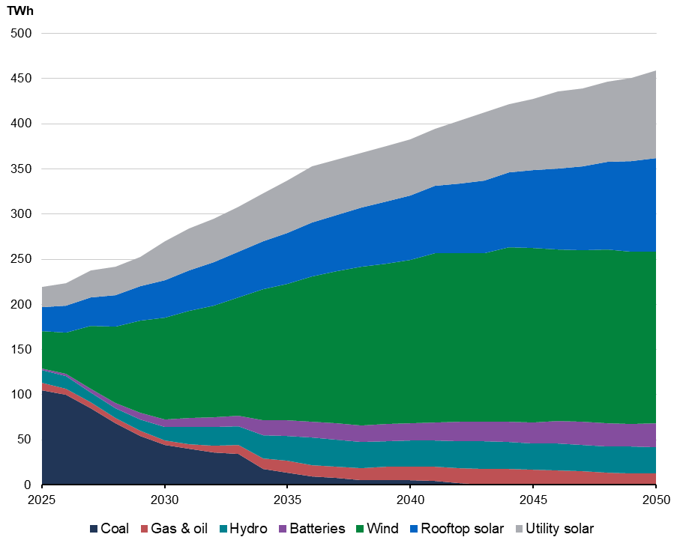
Note: Includes storage dispatch. Hydro includes conventional hydro generation and pumped hydro dispatch.
Source: Treasury EMM modelling.
Coal‑fired generation is projected to mostly exit Australia’s electricity system by 2035 consistent with the AEMO Step Change scenario (Chart 3.4). Replacing coal‑fired electricity generation with firmed renewables is a cost‑effective abatement opportunity. Consistent with AEMO’s Step Change scenario, gas‑fired generation (which uses natural gas as an input to produce electricity) plays an important role in firming renewable generation, particularly in winter, and as a critical backstop to ensure energy reliability, especially as coal exits the system.
The Renewable Exports Upside Scenario also considers the implications of Australia achieving its renewable exports potential. It finds that higher and more flexible hydrogen production helps reduce the need for more expensive flexible sources of generation, including gas generators, and contributes to renewables reaching a projected 99 per cent of NEM generation by 2050.
Chart 3.3: Renewable electricity share, NEM | Chart 3.4: Coal capacity, NEM
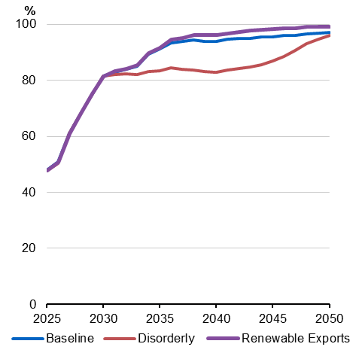 | 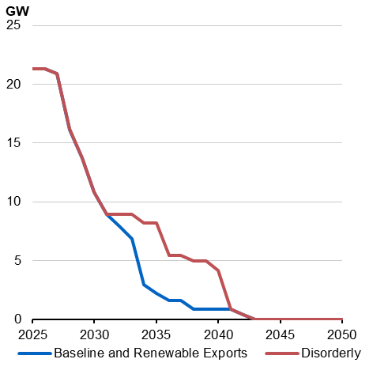
Source: Treasury EMM modelling. | Source: Treasury EMM modelling.
In the Disorderly Transition Scenario, a lack of clear policy direction after 2030 slows the build‑out of new renewable generation. Coal plants are required to operate for longer, increasing the risks of outages and failures, and gas generation is more heavily relied upon. Given that gas generation continues to have a higher cost than renewable generation, wholesale electricity prices are projected to be higher under the Disorderly Transition Scenario. The additional nearly 2,000 petajoules (PJ) of natural gas used in the NEM under the Disorderly Transition Scenario is projected to increase pressure on east coast gas demand and increase costs for industrial facilities, through higher gas and electricity prices.
  - Enabling electrification and energy efficiency
The modelling finds that electrification is a key source of low‑cost emissions reductions, particularly for transport, the built environment, and some industrial manufacturing processes. Improvements in energy efficiency are also a significant contributor to reducing energy costs as electricity demand increases.
Electrification is projected to play a large role in decarbonising the transport sector across all scenarios. Take‑up of passenger electric vehicles (EVs) is already cost effective in some use cases due to lower total ownership costs and assumed improvements to EV charging infrastructure.
Under the Baseline Scenario and Renewable Exports Upside Scenario, emissions from passenger transport are projected to decrease from 42 Mt CO₂-e to 4 Mt CO₂-e between 2025 and 2050 (Chart 3.5). Electrification of non‑passenger vehicles (including heavy road, maritime, aviation, and rail) is projected to progress at a slower pace, supported by the switch to low‑carbon liquid fuels.
Across scenarios, emission reductions in the built environment occur gradually, as relative energy costs incentivise a switch from gas to electric appliances for residential and commercial buildings. Between 2025 and 2050, emissions from the residential sector are projected to decrease by 10 Mt CO₂-e, while emissions from the commercial sector decrease by 4 Mt CO₂-e (Chart 3.6). Translating this to a representative household level, Treasury’s modelling finds that, under the Baseline Scenario, a fully electrified household with solar and a home battery, alongside EVs, reduces household total emissions by 130 t CO₂-e, compared to a non‑fully electrified household from 2030 to 2050.
Chart 3.5: Commercial transport and passenger transport emissions, Baseline Scenario | Chart 3.6: Built Environment emissions, Baseline Scenario
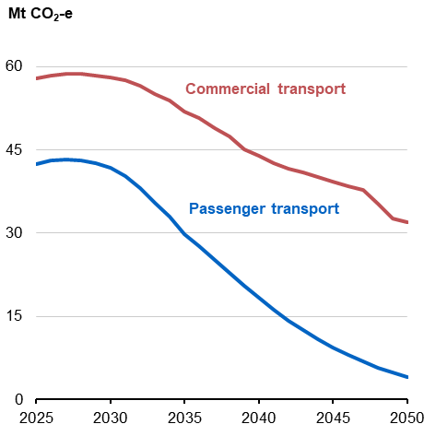 | 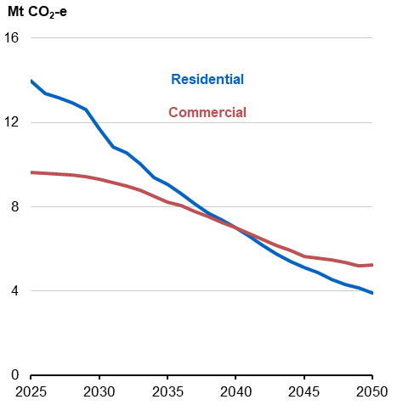
Source: Treasury modelling. | Source: Treasury modelling.
Between 2025 and 2050, total energy use within residential buildings and the services sectors is projected to remain relatively flat, despite increased economic activity, due to improvements in energy efficiency (Chart 3.7). The shift towards electrification is projected to reduce emissions associated with gas use by 64 per cent in the built environment. Economy‑wide, between 2025 and 2050, improvements in energy efficiency are assumed to reduce the energy required to produce a given amount of output by 45 per cent.
The modelling also finds many production processes within the industry and resources sectors can be cost‑effectively decarbonised through electrification, supported by improvements in energy efficiency. Early‑use applications may include battery electric vehicles in mining and use of heat pumps in low temperature heat processes.
For example, under the Baseline Scenario, the iron and steel, and alumina and aluminium manufacturing sectors are projected to shift from relying on coal and gas as energy sources towards electricity and renewable hydrogen. These sectors reduce their emissions from around 20 Mt CO₂-e to around 2 Mt CO₂-e between 2025 and 2050 (Chart 3.8).
Under the Renewable Exports Upside Scenario, production of green iron is expected to be five times larger than the Baseline Scenario, underpinned by strong demand from trading partners.

Chart 3.7: Energy use and emissions intensity for residential buildings and the services sector, Baseline Scenario | Chart 3.8: Projected emissions for selected industrial sectors, Baseline Scenario
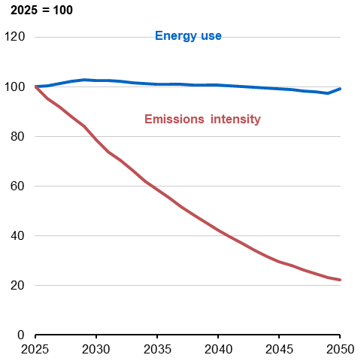 | 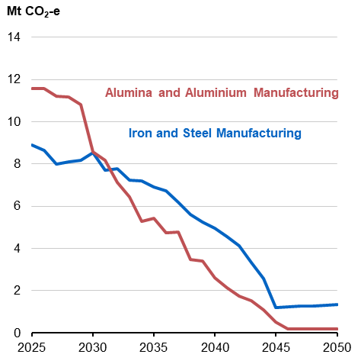
Source: Treasury modelling. | Source: Treasury modelling.

Economy‑wide electrification is projected to result in substantial growth in electricity consumption across all three scenarios, consistent with the AEMO’s ISP Step Change scenario. Under the Baseline Scenario, large grid electricity consumption is projected to more than double from 2025 levels to 2050 (Chart 3.9). This growth is driven primarily by electrification, with some additional demand resulting from the establishment of new industries such as hydrogen and data centres.
Improvements in energy efficiency reduce the amount of new electricity generation needed to support continued growth in electricity demand, including demand from electrification. For example, under the Baseline Scenario, NEM demand would be over 20 per cent higher by 2050 without energy efficiency improvements. Reduced demand from energy efficiency helps relieve supply pressures to build renewables and firming capacity, and augment electricity networks.
Small and off‑grid electricity consumption depends on the scale of new clean energy embedded export sectors. For example, small and off‑grid electricity consumption for renewable hydrogen production is projected to increase from zero in 2025 to 130 terawatt hours (TWh) and 481 TWh in 2050 under the Baseline Scenario and Renewable Exports Upside Scenario, respectively.
These demand increases are projected to more than offset declines in demand from other off‑grid generation sources, such as gas extraction, liquid natural gas (LNG) and coal mining. Declines in emissions from these sources are driven by projected changes in global demand for fossil fuels and take‑up of new technologies.
Chart 3.9: Projected electricity generation, 2025 and 2050
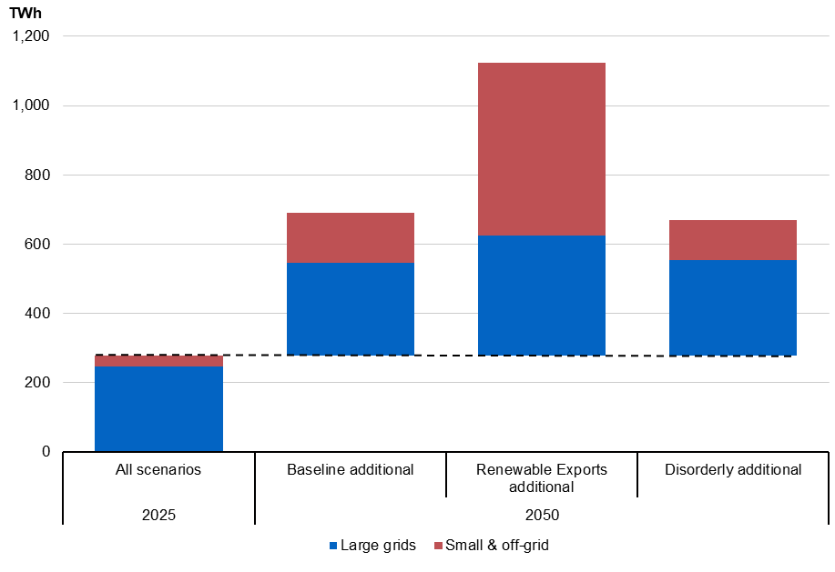
Note: Excludes storage dispatch such as batteries and pumped hydro.
Source: Treasury modelling.
  - Enabling fuel switching and take‑up of abatement technology
Electrification may not be a cost‑effective or technically viable option for some processes. In these cases, fuel switching or approaches that support take‑up of abatement technology are projected to support emissions reductions in the medium‑term.
Low‑carbon liquid fuels are expected to offer an increasingly cost‑effective decarbonisation pathway over time. Studies by CSIRO and others have found that while low‑carbon liquid fuels are currently more expensive than their unabated fossil fuel counterparts, costs are expected to decrease over the medium‑term as technology and scale improves.
The modelling projects a steady increase in switching to low carbon liquid fuels across relevant sectors from the mid‑2030s. Between 2035 and 2050, emissions associated with the use of diesel and aviation fuel, for example, are projected to decline by 32 Mt CO₂-e and 5 Mt CO₂-e, respectively.
Large emitting industrial facilities, which currently account for around 30 per cent of Australia’s emissions, are another sector where electrification options are more limited. These facilities face substantial trade‑offs as they sequence abatement, meet policy obligations and manage the cost of reaching net zero. They also face varying abatement technology options, depending on their product and geographic location. The extent to which Australia will reduce the emissions‑intensiveness of traditional products and adjust the mix of production is uncertain and depends on global factors, including changes in global fossil fuel demand.
The Safeguard Mechanism incentivises low‑cost decarbonisation for covered industrial emitters. The Safeguard Mechanism delivers abatement by incentivising investments in technology and carbon credit trading to efficiently sequence abatement between sectors and across time. Flexibility to use land‑based abatement allows facilities to meet emissions reductions on a net basis.
Consistent with this, the modelling finds emissions reductions at large industrial facilities are driven by a combination of factors in the Baseline Scenario. They include global demand‑driven declines in fossil fuel production (49 per cent), uptake of abatement technology (18 per cent), the purchase of Australian Carbon Credit Units (ACCUs) (18 per cent), and improved energy efficiency (15 per cent) (Chart 3.10).
Chart 3.10: Abatement from large emitters, Baseline Scenario
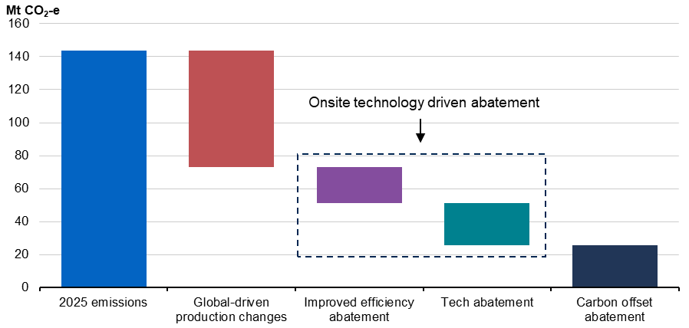
Source: Treasury MIRA modelling.

Box 3.1: Estimating Australia’s potential impact on global abatement
Treasury finds that Australian production of green commodities can support abatement in other jurisdictions. International abatement would be additional to Australia’s domestic targets and contributes to global emissions reductions.
Estimating the potential impact of Australian green products on global abatement requires making assumptions about what would otherwise happen in the global economy. For this analysis, low‑carbon Australian production is assumed to displace carbon‑intensive production or use overseas on a one‑for‑one basis. The impact of green iron, green ammonia and lithium is considered due to clearer links between Australian production and global abatement.
Under the Renewable Exports Upside Scenario, Australia’s production and exports of green iron, green ammonia and lithium could contribute 466 Mt CO₂-e to global emissions reduction in 2050. This level is equivalent to 1.2 per cent of global emissions and more than Australia’s net emissions in 2024.
Decarbonisation could come from green iron exports displacing 188 Mt CO₂-e of emissions from coal‑based steel production, green ammonia exports displacing 55 Mt CO₂-e of emissions from energy, fuel and conventional ammonia and lithium could help to displace 222 Mt CO₂-e of emissions from carbon‑intensive transport and electricity generation.
Chart 3.11: Australia’s impact on global abatement, selected products, Renewable Exports Upside Scenario
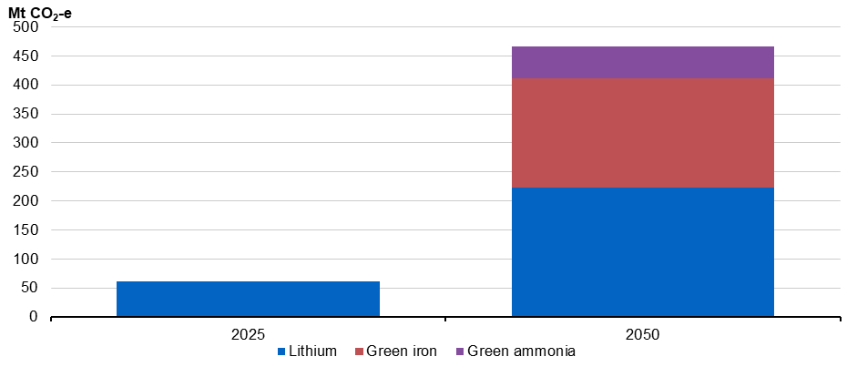

Note: Green iron is assumed to displace traditional steelmaking. Green ammonia is assumed to have mixed use across fertiliser production, ‘co‑firing’ at coal‑fired power, and as an alternative to oil‑derived fuels. Lithium is assumed to help replace internal combustion vehicles and gas peaking generation, with its share of that abatement based on the embedded value of lithium in those products. See Appendix D for further information.
Source: Treasury modelling.

  - Deploying gas efficiently
The modelling projects that emissions from gas use decline by 70 per cent to 2050 under the Baseline Scenario (Chart 3.12). Natural gas use is projected to shift towards higher‑value and non‑substitutable use cases.
Australia currently accounts for a fifth of global LNG trade and will remain a reliable trading partner as the world transitions to net zero and emissions associated with Australian gas production are abated or offset by 2050. Global demand for LNG is forecast to decline, consistent with global action to limit warming to 2°C.
Domestic use of gas also declines in the Baseline Scenario. Efficient use of gas in the electricity sector can support emissions reductions and gas is expected to continue to play a role in electricity generation to 2050. Some gas generation is modelled to be a cost‑effective critical backstop to ensure reliable electricity supply under emissions reduction targets. This role includes risk management of low frequency but high impact events on the grid when other options have been exhausted, such as in extended periods of low renewables output and high demand during winter.
Energy efficiency, electrification and fuel switching technologies are expected to reduce gas demand by industrial users and households over time, as capital stock turns over and electric appliances become more cost efficient. Off‑grid electricity generation, particularly in the mining sector, is also projected to shift from gas to renewables.
In some hard‑to‑abate use cases, such as where gas is used for high temperature heat or chemical processes, the extent of residual gas use in 2050 will depend on technological progress. Use of abatement technologies such as carbon capture and storage are expected to contribute to reductions in the emissions‑intensity of gas production and use over time. Access to new abatement technologies is delayed under the Disorderly Transition Scenario, reflecting reduced engagement in the net zero transition and reduced incentivisation during the 2030s.
There are other industries – such as steel and alumina – where gas is expected to be used as a less emissions‑intensive alternative to coal during the 2030s, before making the transition to renewable electricity and hydrogen by 2050. Technology take‑up often depends on when existing assets reach end of life. For these industries, credible long‑term policy settings and clear forward guidance is highly valuable, as it allows firms to make well‑informed investment decisions and avoid capital scrapping.
Outcomes of the Gas Market Review, currently underway, are not accounted for in this modelling. The Review is intended to ensure that domestic industrial gas users have access to sufficient affordable gas.
Chart 3.12: Projected emissions from domestic gas use by industry grouping, Baseline Scenario
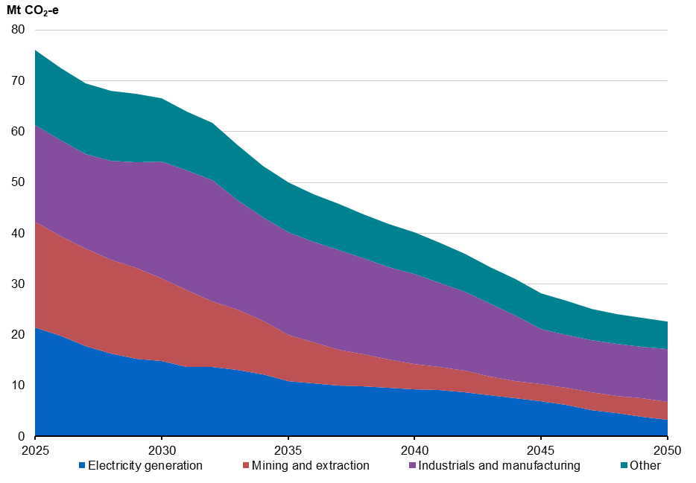
Note: ‘Other’ includes agriculture, built environment, and transport industries. Some emissions reduction from the use of gas is achieved via carbon capture and storage technologies.
Source: Treasury modelling.
  - Scaling up carbon removals
Cost-efficient abatement solutions are not expected to be available to all activities, so carbon removals will be required to abate residual emissions. The Intergovernmental Panel on Climate Change (IPCC) has identified carbon removals as essential if the world is to meet net zero.
The modelling projects that carbon removals become increasingly important closer to 2050, once cost-efficient abatement opportunities have been widely adopted. Carbon removals refer to processes for removing carbon dioxide from the atmosphere, for example by storing it in land‑based ecosystems, such as forests and soils. This can be achieved through a variety of methods including reforestation, afforestation (planting trees on land previously not forested), improving soil health and engineered removals.
Residual emissions are projected to be most significant in the agriculture sector, where abatement technology options are most nascent. Under both the Baseline Scenario and Renewable Exports Upside Scenario, 167–168 Mt CO₂-e of residual emissions are projected to remain in the economy in 2050 (Chart 3.13). Agriculture is projected to contribute the largest proportion of this at 62 Mt CO₂-e, reflecting lower projected availability of cost‑effective abatement technologies. Land‑based carbon removals are projected to become a significant revenue opportunity for landholders.
Chart 3.13: Projected residual emissions in 2050, by sector, Baseline Scenario
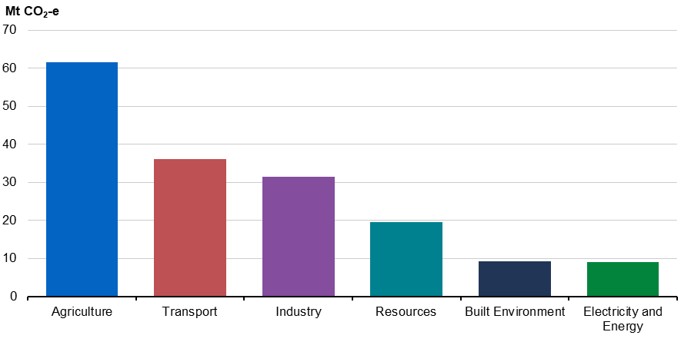
Source: Treasury modelling.

For Australia, the most prospective carbon removal option is currently land‑based sequestration (Chart 3.14). This modelling projects that land‑based abatement could increase modestly by 9 per cent to 2035, and that reforestation is currently expected to be the most scalable source of land‑based abatement in 2050. However, estimates of the cost‑efficiency of different approaches vary significantly. Other opportunities, like engineered direct‑air‑capture, may become more cost‑effective over time, but this is uncertain given limited projects currently operating at scale.
Chart 3.14: Projected sources of land‑based sequestration, 2025 to 2050, Baseline Scenario
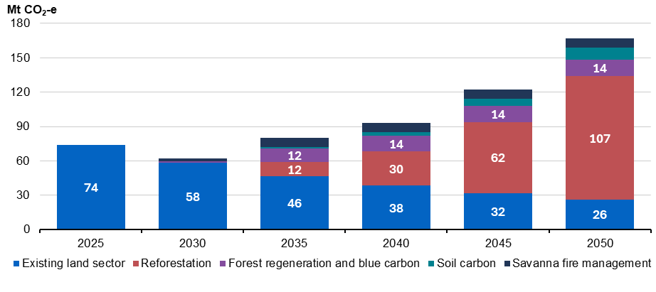
Note: The ‘Existing land sector’ category refers to the existing net sink, including emissions reductions and sequestration being generated from existing ACCU projects. The decline in this category reflects the ageing of existing vegetation and the related decline in the ability to sequester carbon. The category does not include the sequestration from new sequestration projects incentivised through the Safeguard Mechanism. The sequestration volumes for reforestation, forest regeneration and blue carbon, soil carbon, and savanna fire management represent new sequestration projects in the Baseline Scenario.
Source: Treasury modelling.
  - Abatement outcomes under a disorderly transition
The Climate Change Authority assessed in December 2024 that current policies put Australia within reach of its 2030 target of 43 per cent emissions reduction on 2005 levels. However, significant further action is required to reduce emissions to net zero by 2050.
If maintained, current policies are expected to reduce emissions by nine percentage points more by 2035, reducing emissions to 51 per cent. The Baseline Scenario and Renewable Exports Upside Scenarios present pathways where further steady policy action reduces emissions to 65 per cent by 2035. In contrast, the Disorderly Transition Scenario demonstrates that if existing policies remain in place, but further steady action is not taken during the 2030s, emissions reduction would need to occur at a much faster pace during the 2040s.
The total difference in emissions between scenarios peaks in 2039 with emissions 112 Mt CO₂-e higher under the Disorderly Transition Scenario, before action resumes in 2040 (Chart 3.15). Cumulative emissions are 803 Mt higher to 2050 under the Disorderly Transition Scenario, compared to the Baseline Scenario and Renewable Exports Upside Scenario.
Chart 3.15: Net emissions, 2025 to 2050
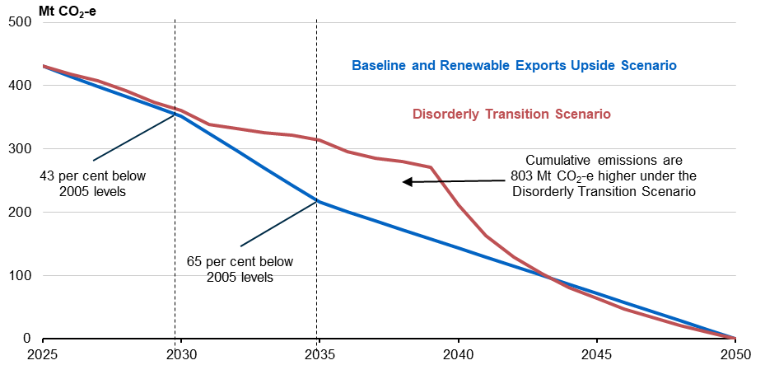
Source: Treasury modelling.

Under this scenario, investment uncertainty slows the rollout of renewables through the 2030s, increasing the reliance on natural gas and coal. Emissions in the electricity sector are projected to be 37 Mt CO₂-e higher than in the Baseline Scenario in 2039. Gas use in the NEM is projected to be nearly 2,000 PJ higher in the Disorderly Transition Scenario, which has implications for the supply for industrial users and export partners, and for gas prices.
Electrification across the economy also slows in the Disorderly Transition Scenario, leading to higher emissions for the built environment (2 Mt CO₂-e) and transport (17 Mt CO₂-e) sectors in 2039, compared to the Baseline Scenario.
Under the Disorderly Transition Scenario, large emitters are assumed to have delayed availability of low‑cost decarbonisation technology due to businesses being reluctant to invest and a lack of policy action. This delay contributes to emissions being 34 Mt CO₂-e higher in 2039 for the industry and resources sectors than the Baseline Scenario.
Credible and ambitious targets and policies are critical to an efficient net zero transition, as they enable businesses and investors to have confidence in Government policies and anticipate how the economy will transform to achieve net zero emissions by 2050. A lack of policy signalling restricts the availability of cost‑effective abatement, such as land‑based sequestration, which requires time for the physical growth of biomass.

- Economic impacts
Australia’s natural resource endowments, renewable energy potential, skilled labour force and reputation as a trusted and reliable trading partner, position the economy well. Continuing to take credible policy action will enable Australia to harness the opportunities of the net zero transformation and other structural shifts in the economy.
Australia has already made significant progress on reducing emissions over the past three years as a result of policy action, including renewables delivering over 40 per cent of electricity in Australia’s two major grids. At the same time, inflation has returned to the Reserve Bank of Australia’s target, unemployment has remained low and positive economic growth has been achieved. However, there are headwinds, including global economic volatility, and there is further work to do to manage the long‑run challenges of making the economy more resilient and productive.
The modelling in this report shows how Australia’s economy can continue to respond to the global net zero transformation. An orderly, well‑signalled transition to net zero can support economic growth, investment, jobs and living standards through a period of significant structural change.
  - Maintaining economic growth
The strong fundamentals of the Australian economy have underpinned its adaptability and resilience to shocks over recent decades, including the Global Financial Crisis and the COVID‑19 pandemic. Australia has also historically been able to capitalise on the opportunities presented by changes in the global economy, such as the mining commodities boom during the 2000s, and improvements in technology to boost living standards and economic growth.
Setting credible, long‑term targets to reduce emissions and transition to net zero is critical for growth and economic prosperity. Treasury’s modelling illustrates that an orderly transition to net zero will support investment in energy and new industries and enable new export opportunities to be realised. This will support growth and job creation.
Under the Baseline Scenario, the Australian economy is projected to be 28 per cent larger by 2035, relative to current levels, the equivalent of $12,000 per capita (Chart 4.1). Annual GDP growth is projected to average 2.5 per cent over 2025–35, and 2.4 per cent over 2035–50, broadly consistent with the 2023 Intergenerational Report. This translates to the Australian economy being 81 per cent or $2.2 trillion bigger by 2050, compared to 2025 – the equivalent of $36,000 per capita.
Chart 4.1: Real GDP per capita | Chart 4.2: Real GDP, per cent deviation from Baseline Scenario
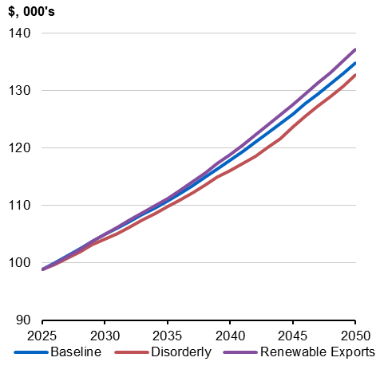 | 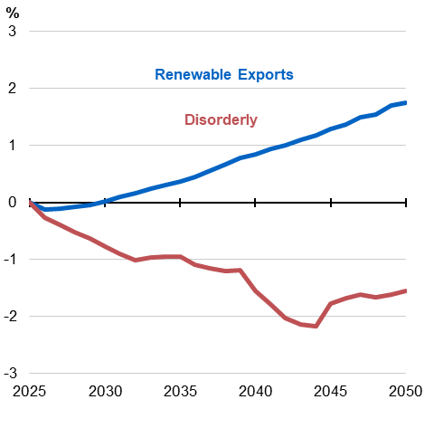
Source: Treasury modelling. | Source: Treasury modelling.
The global net zero transformation presents an export economic opportunity for Australia. Economic growth is projected to be higher from 2030 onwards, relative to the Baseline Scenario, if Australia is successful at realising its clean energy exports potential (Chart 4.2). The Renewable Exports Upside Scenario results in the economy being an additional $85 billion bigger by 2050, compared to the Baseline Scenario, and real GDP per capita increases by $38,000 over the 25 years to 2050.
By contrast, a disorderly approach to the net zero transformation will have significant adverse economic consequences. Under the Disorderly Transition Scenario, heightened policy uncertainty is projected to reduce investment. It also results in capital misallocation as businesses invest without clear direction and are forced to adjust their investment plans – and rapidly abate – in the 2040s, leading to capital shallowing. Additionally, lower investment in renewable energy constrains activity in new clean energy embedded export industries. For these reasons, a disorderly transition is projected to result in average annual GDP growth being 0.1 percentage points lower between 2025 and 2050. This results in cumulative real GDP being $1.2 trillion lower than the Baseline Scenario and $2 trillion lower than the Renewable Exports Upside Scenario over the 25 years to 2050.
  - Adjusting to structural change
The structure of the Australian economy is constantly evolving. As highlighted in the 2023 Intergenerational Report, the Australian economy is expected to undergo further structural change, due to the adoption and diffusion of new technologies such as artificial intelligence, the net zero transformation, ageing of the population, geopolitical tensions and growing demand for care economy services (Australian Government 2023).
Over the past half‑century, Australia’s economy has shifted increasingly towards services. The contribution of services to overall economic output has risen almost five‑fold in the past 40 years, rising from around 70 per cent of GDP in 1982 to around 80 per cent today (Australian Government 2023). The corollary of this is that the share of the goods sector has declined over this period, barring a short‑term pause through the COVID‑19 pandemic. These high‑level trends are projected to continue in the scenarios modelled in this report. The services sector is projected to reach 86 per cent of Australia’s GDP in 2050 across all scenarios. Underlying these high‑level trends are substantial changes to the industrial mix as the economy adjusts to the net zero transformation. The transition to net zero emissions by 2050 will change the demand for products, and how different goods and services are produced, sold and consumed.
As the global energy transformation accelerates to meet Paris Agreement goals, the patterns of global energy and resource trade will change, which will in turn affect the structure of the Australian economy. Use of coal is projected to decline from 24 per cent of the global energy mix in 2025 to around 7 per cent in 2050 (Chart 4.3). Under a well below 2°C-aligned global scenario, renewables are expected to provide the majority of global energy by 2050, driven mainly by solar, wind, and modern bioenergy.
Chart 4.3: Global energy mix, under a well below 2°C scenario, 2010 to 2050 | Chart 4.4: Global demand for commodities, under a well below 2°C scenario, 2025 to 2050
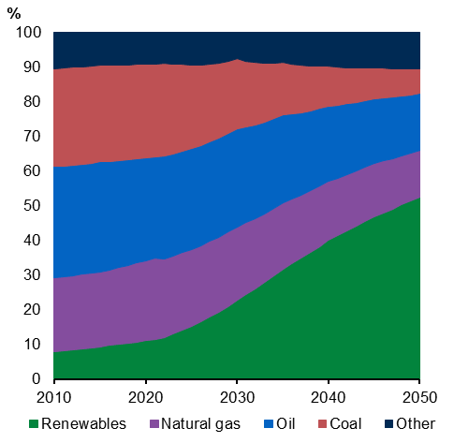 | 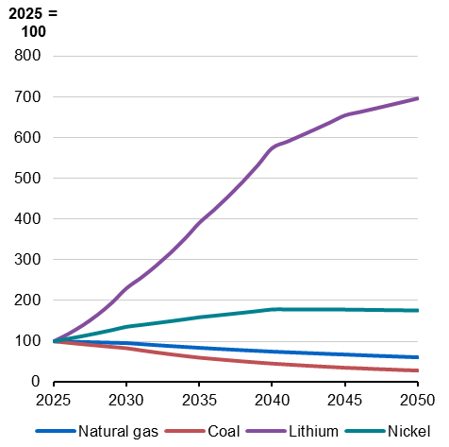
Source: IEA 2023 | Source: IEA 2023; IEA 2024c
Australia’s high degree of global trade integration is a source of prosperity and resilience. For example, in the 2000s, increases in international demand for commodities generated strong growth in mining investment, which is estimated to have increased real per capita household disposable income by 13 per cent (Tulip 2014). Between 2010 and 2022, investment of over $398 billion in the oil and gas sectors supported the development of an LNG export industry, demonstrating Australia’s ability to adapt to new opportunities (DISR 2024). Additional sources of growth – particularly in emerging clean energy embedded industries – are projected to emerge as the domestic and global economies evolve.
Around one‑third of Australia’s goods exports in 2024 were fossil fuels and these exports are projected to decline as trading partners implement their net zero commitments (DFAT 2025a). This has implications for Australia’s terms of trade because declining demand pushes down prices of fossil fuel commodities.
On the basis of IEA forecasts, Australia’s coal production is projected to decrease by at least 42 per cent to 2035 and 71 per cent to 2050 across all scenarios (Table 4.1). While global demand for LNG is forecast to decline more slowly than coal, Australian gas and LNG production is projected to decline by 66 to 68 per cent by 2050, alongside changes in global demand. Australian iron ore production is projected to decline by 17 to 18 per cent to 2050, reflecting the assumed redirection of some output to the domestic iron and steel manufacturing sector to support clean energy embedded iron production, as well as some declines in global demand. Actual outcomes will depend on the emissions reduction pathways adopted by Australia’s trading partners, and the success of Australian industries at reducing emissions intensity and improving competitiveness in this environment.
Table 4.1: Change in output for selected sectors, across scenarios, from 2025
 | Baseline Scenario |  | Renewable Exports Upside Scenario |  | Disorderly Transition Scenario
Sector | To 2035 | To 2050 | To 2035 | To 2050 | To 2035 | To 2050
Agriculture | 14% | 32% | 13% | 31% | 16% | 33%
Coal | -47% | -72% | -51% | -74% | -42% | -71%
Gas and LNG | -27% | -67% | -29% | -68% | -24% | -66%
Iron Ore Mining | -11% | -18% | -13% | -17% | -12% | -18%
Construction | 21% | 71% | 22% | 74% | 20% | 70%
Services | 34% | 94% | 34% | 95% | 33% | 92%
Hydrogen and Ammonia | 520% | 993% | 736% | 3,648% | 278% | 754%
Renewable hydrogen | 2 Mt | 4 Mt | 3 Mt | 15 Mt | 1 Mt | 3 Mt
Green ammonia | 6 Mt | 8 Mt | 8 Mt | 35 Mt | 2 Mt | 5 Mt
Iron and Steel Manufacturing | 40% | 119% | 107% | 419% | 27% | 98%
Green iron | 7 Mt | 23 Mt | 27 Mt | 120 Mt | 2 Mt | 15 Mt
Australia is well placed to respond to rising global demand for the commodities needed to support the net zero transition, given its abundant natural and renewable energy resources. Demand for critical minerals such as lithium and nickel, essential for electric vehicles and energy storage technologies, is expected to experience strong growth by 2050 under a well below 2°C-aligned global scenario (Chart 4.4). This provides an opportunity for Australia to expand its critical mineral exports. Australia’s critical minerals processing output is projected to increase by more than 170 per cent to 2050 across all scenarios, making Australia a key part of global clean energy supply chains.
Additional opportunities are presented by other new‑growth sectors critical to the net zero transition. The total value of Australia’s green exports – which includes green ammonia, green iron, alumina, aluminium and critical minerals – is projected to reach $80–93 billion in 2035 and $109–178 billion in 2050 under the Baseline and Renewable Exports Upside scenarios, supporting an increase in total exports (Chart 4.5). These trends reflect assumptions about the output of the hydrogen and ammonia sectors that are projected to increase by over 250 per cent to 2035 across all scenarios, with Australia producing 15 Mt of hydrogen in 2050 under the Renewable Exports Upside Scenario (in line with the National Hydrogen Strategy’s base production target).
Chart 4.5: Projected value of Australian exports, 2025 to 2050
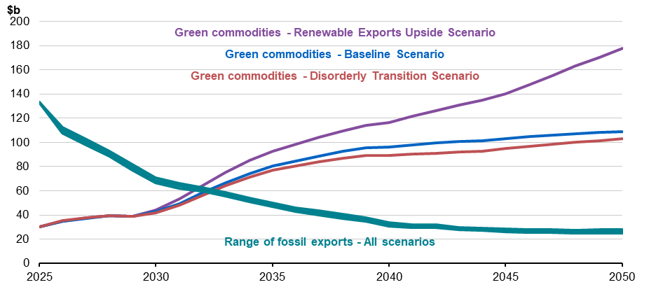
Note: Fossil fuels include coal and LNG. Green commodities are those which are broadly covered by the Future Made in Australia agenda. These include green ammonia, green iron, alumina and aluminium, and raw and refined critical minerals. These projections reflect an assessment of Australia’s export potential based on a range of sources.
Source: Treasury analysis.
In response to the projected increase in global demand for green exports, manufacturing’s share of production is projected to grow from 5.8 per cent today to 6.2 per cent in 2050 in the Renewable Exports Upside Scenario. This growth is supported by the establishment of new clean energy embedded industries. Some of this increase also reflects the projected redirection of mined critical minerals and iron ore to support domestic manufacturing, away from export.
Total export growth across the scenarios is also supported by increased production in other export‑facing sectors like agriculture. Agriculture output is projected to increase by at least 13 per cent to 2035 and by 31 per cent to 2050 across all scenarios, supported by growth in crops and horticulture in particular.
  - Attracting and deploying investment
Investment in clean energy infrastructure, efficiency and electrification globally is already approaching USD2.2 trillion each year, which is almost double the combined investment in new oil, gas and coal supply (IEA 2025b). In Australia, investment in utility-scale renewable energy construction exceeded $8 billion in 2023–24, with an additional $13 billion investment in other electricity-related assets, including transmission and infrastructure (ABS 2024).
Under an orderly transition to net zero where the direction of policy is clear, businesses will find it easier to plan the investments they need to modernise processes and reduce their carbon emissions as part of their regular capital replacement program. This is particularly relevant in sectors of the economy where productive assets are long‑lived. Under the Baseline Scenario and Renewable Exports Upside Scenario, investment is projected to grow by 79–84 per cent between 2025 and 2050. The projected increase under the Renewable Exports Upside Scenario is similar to growth in investment during the mining boom of the early 2000s.
Clear and credible emissions reduction targets and policies are critical for increasing investor certainty, and for unlocking more investment across the economy. The economic cost of uncertainty is considered in the Disorderly Transition Scenario through an increase in the cost of capital through higher risk premia. As a result, investment is persistently lower in this scenario than in the Baseline Scenario (Chart 4.6), and cumulative investment is projected to be half a trillion dollars lower over the 25 years to 2050.
In the 2030s, investment in emerging clean energy sectors is projected to be lower in the Disorderly Transition Scenario, compared to the Baseline Scenario. Without clear signals to drive investment in clean energy, there will be an over-investment in fossil fuel sectors in the 2030s, compared to the Baseline Scenario. This leads to fossil fuel firms ‘scrapping’ up to 8 per cent of their capital stock over the 2040s, as they are forced to transition to net zero in just one decade, well before the optimal replacement date for their long‑lived assets. This equates to a cumulative $41 billion of capital scrapped over the decade to 2050. Further, under the Disorderly Transition Scenario, there is projected to be 20 per cent less cumulative investment in hydrogen, ammonia, iron and steel over the 25 years to 2050, relative to the Baseline Scenario. As a result, output and exports in these sectors do not reach the same scale as the Baseline Scenario, even in 2050.
Chart 4.6: Investment, per cent deviation from the Baseline Scenario
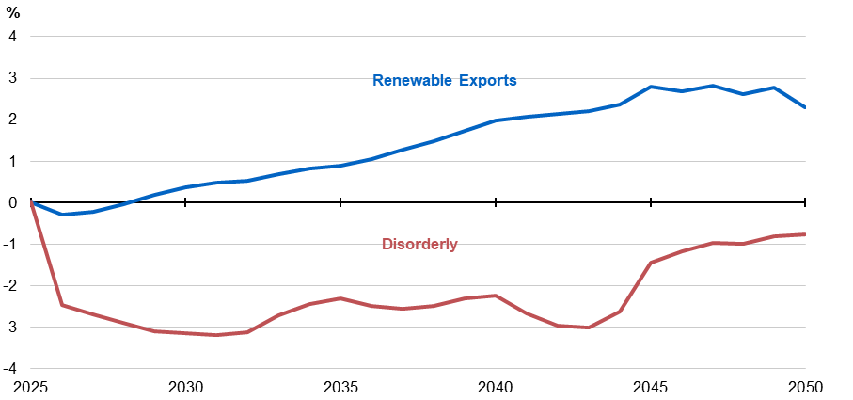
Source: Treasury modelling.

Electricity investment
Greater policy certainty is particularly important for electricity sector investment, because long-term investment in new renewable generation and storage underpins a cost-efficient net zero pathway for the whole economy. Investment in new generation capacity is required over coming decades in all scenarios as most of Australia’s coal‑fired power capacity is over 40 years old and is due to close in the next decade.
Scenario analysis shows that increased investment in renewable energy under the Baseline Scenario is projected to lower energy costs for domestic industries and consumers compared to the Disorderly Transition Scenario.
Under the Disorderly Transition Scenario, investment in renewable energy generation in the 2030s is projected to be around 45 per cent lower than the Baseline Scenario. Under this scenario, greater reliance on gas-fired generation is projected to require nearly 2,000 PJ more gas to 2050, which is similar to the total volume of natural gas used by Australia’s manufacturing sector over the past five years (Chart 4.7). Higher reliance on gas and ageing coal plants results in higher wholesale electricity prices, which are projected to be 17 per cent higher on average during the 2030s and up to 54 per cent higher in the 2040s, than under the Baseline Scenario (Chart 4.8). These impacts could be compounded by failing to realise benefits from a more flexible grid, with prices projected to be up to 70 per cent higher in the Disorderly Transition Scenario than the Renewable Exports Upside Scenario.
Greater reliance on ageing coal plants under the Disorderly Transition Scenario also increases the risk of plant failures, posing a significant upside risk to wholesale prices. For example, the failure of two of the oldest coal‑fired generation units in 2032 would be expected to increase the wholesale electricity price by a further 13 percentage points on average in the early 2030s, resulting in wholesale electricity prices that are up to 30 per cent higher than projected to be under the Baseline Scenario.
Realising Australia’s renewable export potential is projected to improve Australia’s broader competitiveness by putting significant downward pressure on wholesale electricity prices. Under the Renewable Exports Upside Scenario, greater flexibility from industrial capacity is projected to reduce wholesale electricity prices by around 20 per cent by 2050, relative to the Baseline Scenario. This reflects the broader economic benefits of energy‑intensive industries such as green metals, through additional flexibility in the electricity grid.
In the long-term, wholesale electricity price levels under the orderly scenarios are projected to be around 10 per cent below the 10-year real historical average wholesale electricity price, consistent with the Australian Energy Market Commission’s (AEMC’s) 10-year forecast. The decline in wholesale electricity prices is driven by greater use of firmed renewable electricity and reduced reliance on ageing coal-fired generation. Long-term price levels are consistent with the costs of firmed renewables in 2050 reported by CSIRO’s GenCost 2024–25 Report (CSIRO 2025).
Projections of relative wholesale electricity prices across the three scenarios modelled have been compared to existing wholesale electricity price projections by independent bodies, including the AEMC and Endgame Analytics. These exercises show similar wholesale price trajectories for equivalent scenarios and consistent drivers of changes. The projection of lower wholesale electricity prices is attributed to the rapid renewable buildout to achieve the 82 per cent renewable electricity target, as outlined in AEMO’s Integrated System Plan. The AEMC anticipates lower wholesale electricity prices will flow through to lower retail prices over time.
Chart 4.7: Gas powered generation in the NEM | Chart 4.8: Wholesale price relative to the Baseline Scenario, NEM
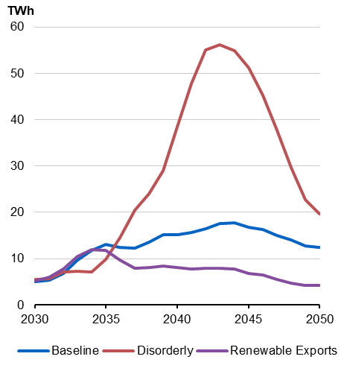 | 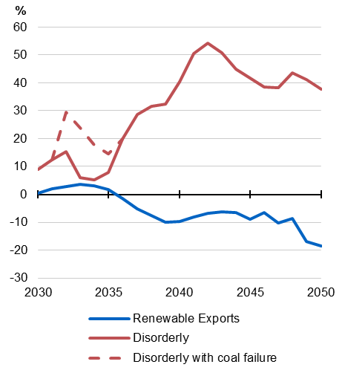
Source: Treasury EMM modelling. | Source: Treasury EMM modelling.
  - Broader benefits of the net zero transformation
An efficient and well‑signalled transition to net zero is projected to provide broad benefits to Australians, both directly through downward pressure on energy costs and indirectly through higher incomes over time. By contrast, a disorderly transition is projected to create additional costs for many households. The exact experience of the net zero transformation will vary across households and communities.

Living standards and wages
An orderly transition to net zero can support sustained increases in living standards. Real wages are projected to increase by 10 per cent over the 10 years to 2035, and 31 per cent over the 25 years to 2050, under the Baseline Scenario (Chart 4.9). Under the same scenario, real GDP per capita is projected to increase by 12 per cent to 2035 and by 36 per cent to 2050. The additional economic activity generated through the increased production of clean energy embedded products under the Renewable Exports Upside Scenario provides an added boost, with real wages projected to be around 1.6 per cent higher in 2050, compared to the Baseline Scenario (Table 4.2). Similarly, real GDP per capita is projected to be 1.7 per cent higher in 2050, compared to the Baseline Scenario.
Table 4.2: Per cent difference in real wages and GDP per capita, relative to Baseline Scenario
 | Renewable Exports Upside Scenario |  | Disorderly Transition Scenario
 | 2035 | 2050 | 2035 | 2050
Real wages | 0.8% | 1.6% | -1.6% | -2.5%
Real GDP per capita | 0.4% | 1.7% | -0.9% | -1.6%

By contrast, increased uncertainty and lower economic growth dampens real wage growth under the Disorderly Transition Scenario throughout the period to 2050. Real wages are projected to be 2.5 per cent lower in 2050, compared to the Baseline Scenario, and 4.0 per cent lower relative to the Renewable Exports Upside Scenario. This results in significantly lower consumption, with cumulative real household consumption projected to be $1.6 trillion lower to 2050, compared to the Baseline Scenario (Chart 4.10). Real GDP per capita in 2050 is projected to be 1.6 per cent lower under the Disorderly Transition, compared to the Baseline Scenario, which equates to $2,100 less per person in 2050. Compared to the Renewable Exports Upside Scenario, real GDP per capita is projected to be $4,500 lower in 2050 under the Disorderly Transition Scenario.
Chart 4.9: Growth in real wage, 2025‑2050 | Chart 4.10: Cumulative consumption difference from Baseline Scenario, 2025‑2050
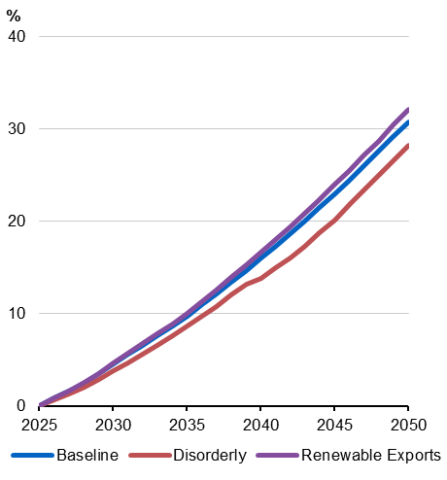 | 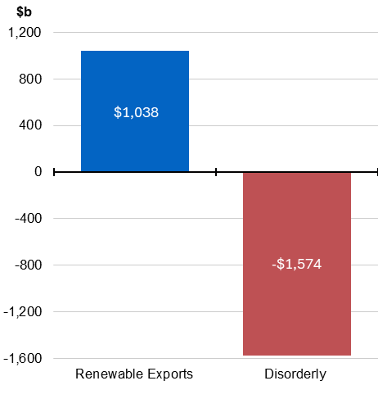
Source: Treasury modelling. | Source: Treasury modelling.

Employment outcomes
Under the Baseline Scenario, 2.3 million more people are projected to be employed in 2035, and 5.1 million more in 2050, compared to 2025. This increase in employment is larger under the Renewable Exports Upside Scenario, with 5.3 million more people employed in 2050, compared to 2025.
The distribution of employment across sectors largely follows the economy’s broader structural shifts through the net zero transformation. As new clean energy embedded product sectors are established, for example, they increase their demand for labour. Hours worked in the hydrogen and ammonia sector and iron and steel manufacturing sectors under the Baseline Scenario increase by more than 300 per cent and by 79 per cent respectively from 2025 to 2050.
The services sector is projected to continue to employ the largest proportion of the workforce to 2050, across all scenarios. The construction sector is also projected to experience solid growth in hours worked across all scenarios, partly because it employs labour to support the build and operation of new clean energy related projects.
Mapping high‑level sectors to their occupations provides additional detail on potential shifts in the composition of the Australian workforce through the net zero transformation. The analysis presented in Chart 4.11 disaggregates occupations projected to be increasingly in demand as new clean energy embedded industries are established and expand – particularly under the Renewable Exports Upside Scenario. This includes automotive and engineering trades workers, and machinery and stationary plant operators who are required to support the increased manufacture of hydrogen, ammonia, green iron and alumina and aluminium.
Chart 4.11: Occupation growth relative to the Baseline Scenario in 2050, Clean energy embedded industries only
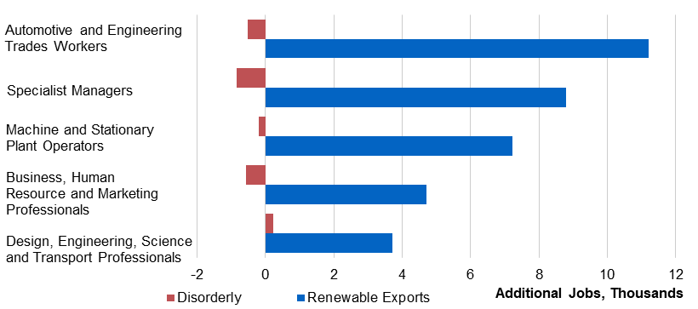
Source: Treasury modelling.

Household energy costs
Household benefits come through the long‑run savings that can be made by electrifying homes and vehicles and installing solar panels and home batteries. Energy costs are a significant proportion of household spending, at around 5 per cent of disposable income. This proportion more than doubles to 11 per cent for households in the bottom 20 per cent of incomes.
Electrification technologies can reduce household running costs. For example, a typical household could reduce their energy costs by around $1,000 per year by electrifying their household appliances, hot water systems and space heating, even accounting for up‑front costs (Chart 4.12).
Households who also purchase a solar panel, home battery and electric vehicles could reduce their energy costs by around 40 per cent or $4,300 per year, after accounting for upfront and financing costs. The upfront costs and projected saving in energy costs will depend on individual households.
Chart 4.12: Modelled benefits of electrification, Baseline Scenario
Note: Annualised real costs from 2030 to 2050, including upfront, financing and ongoing costs. Assumes a typical two-to-three-person household with two vehicles, average consumption for home heating, cooking and hot water, and purchases a 10.6kW solar system and 10.0kWh battery. For more detail, see Appendix D: Key assumptions.
Electric vehicles
Electrifying vehicles can save households $1,785 per year and reduce emissions by X%
Home batteries

Home batteries can save households $X per year and reduce emissions by X%

Households that are not fully electrified are still projected to benefit under both the Baseline Scenario and Renewable Exports Upside Scenario compared to the Disorderly Transition Scenario. Higher wholesale energy prices from lower renewables investment and greater reliance on ageing coal and gas generators under the Disorderly Transition Scenario increase energy costs for all households. Electrified households with solar and battery are less impacted by changes in energy prices as they rely less on the grid.

Regional outcomes
While the modelling cannot be disaggregated by region, it is important to acknowledge that the net zero transformation will have distinct regional impacts (DCCEEW 2025a; Australian Government 2023).
Around 1.1 per cent of the Australian workforce is employed in sectors directly exposed to the net zero transition (coal mining, coal‑fired power, oil and gas, and downstream fossil‑fuel activities), and most of these people work in regional areas (JSA 2023). In addition, around 4 per cent of the workforce is employed in emissions‑intensive sectors, with around one‑quarter of these people working in emissions‑intensive manufacturing (metals, chemical manufacturing, and cement) (JSA 2023). Many regional areas, especially those economically reliant on fossil fuel industries, face significant structural change as emissions‑intensive activities like coal mining and coal‑fired power generation decline (Edwards et al. 2022)
An orderly and well‑signalled net zero transition provides the best chance for regional Australia to harness the opportunities of emerging clean energy embedded industries. The abundant renewables resources in regional areas mean they are well‑positioned to benefit from large‑scale renewable energy and transmission projects in green hydrogen, critical minerals and green metals (CCA 2024). The Net Zero Economy Agency was established to support regions, communities and workers significantly affected by the net zero transition so that they can share in the benefits of a net zero economy.

  - The costs of not pursuing net zero
The economic costs to Australia of not pursuing net zero are expected to be significant and consequential, and exceed those modelled in the Disorderly Transition Scenario. Not pursuing net zero by 2050 risks lower economic growth, reduced investment, missed export and employment opportunities, and higher energy prices. These costs would flow from several channels, including heightened policy uncertainty, increased borrowing costs on global markets and the loss of potential new export markets. Additionally, inaction domestically and globally will exacerbate physical climate risks, resulting in higher costs from adapting to and managing these.
While this modelling focuses on pathways to net zero and does not specifically model a scenario where there is no further policy action, other exercises illustrate the potential costs of policy inaction. For example, the latest scenario modelling by the Network for Greening the Financial System (NGFS) that assumes no further policy action globally and global temperatures reach 3°C by 2100, projects Australia’s GDP could be 14 per cent lower by 2050. This translates to an estimated $6.8 trillion reduction in GDP over the next 25 years (IGCC 2024).
Avoiding the many costs of not pursuing net zero by 2050 through an orderly, well‑signalled transition will result in better economic outcomes for Australia. Australia committed to net zero by 2050 in October 2021, having previously joined 194 other parties in signing the Paris Agreement, and has enshrined this commitment in legislation. It has also legislated an emissions reduction target of 43 per cent compared to 2005 levels by 2030. These emissions targets, underpinned by policy settings, have provided more policy certainty and supported investment by households and businesses in activities consistent with an orderly transition. The 2035 emissions reduction target range adds further certainty to the direction of climate policy in Australia.

Heightened uncertainty constrains investment
History shows that heightened uncertainty leads to less investment. The Productivity Commission has estimated that businesses managed heightened uncertainty following the Global Financial Crisis by increasing the risk premium they use to assess new projects by 2.3 percentage points on average (Fontenay et al. 2024). A recent OECD study provides evidence that climate policy uncertainty has an immediate and material impact on business investment decisions, and more capital-intensive and pollution-intensive firms are disproportionately affected (Berestycki et al. 2022). The study finds that a 37 per cent increase in uncertainty about climate policy, equivalent to one standard deviation in their Climate Policy Uncertainty Index, reduces investment by around 4 per cent for the average business.
Under the Disorderly Transition Scenario, it is assessed that a lack of medium‑term policy certainty would suppress and delay investment, increase the likelihood of capital scrapping and delay the net zero transition. In this scenario, this has been modelled as a risk premium of up to 75 basis points for the 2030s, which results in cumulative investment being half a trillion dollars lower in 2050 compared to the scenarios that assume an orderly and well‑signalled transition. Abandoning net zero would create significantly greater uncertainty, which implies higher costs associated with investment uncertainty, than captured in the Disorderly Transition Scenario.
Uncertainty around climate policy is particularly problematic and consequential for energy investment. Not pursuing net zero by 2050 would be expected to reduce energy investment by reducing near‑term demand for low‑emissions energy, lowering confidence in the future competitiveness of energy‑intensive industries and creating significant regulatory policy uncertainty. Australia’s coal plants are ageing and need to be replaced regardless of net zero goals. Not replacing coal in an orderly manner increases the risk of outages and extended periods of higher prices.
Under the Disorderly Transition Scenario, delayed investment in electricity generation is projected to have a pronounced impact on wholesale electricity prices. A scenario of more significant energy policy uncertainty would be expected to have wholesale electricity price increases that exceed the 54 per cent increase in the Disorderly Transition Scenario, relative to the Baseline Scenario.

Increased cost of capital in global financial markets
Australia is likely to face a higher cost of capital in international financial markets if it does not pursue net zero. Australia is deeply integrated with international financial markets and will need to access international capital to support ongoing investment. At the same time, global investors have continued to increase the capital they are allocating towards net zero‑aligned investments (AIGCC 2025). The IEA notes that capital is flowing more readily into jurisdictions with clear transition plans and stable consistent policy that supports long‑term decision making (IEA 2025b).
Together, this indicates that any increase in uncertainty about climate policy in Australia, including commitments to the net zero target, is likely to be detrimental when other countries are taking action. China, for example, continues to invest heavily in clean energy and set records for its levels of renewable energy capacity installed (Energy Watch 2025). This has led to China surpassing its 2030 renewable energy targets in mid‑2024 (IEA 2025b). Similarly, the United States has more than tripled its renewable energy capacity over the past decade (Bird et al. 2025). A record $386 billion was invested globally for new renewable energy development in the first half of 2025 (BloombergNEF 2025b).
The 2021 Long‑Term Emissions Reduction Plan assessed that the economy‑wide capital risk premium could increase by 100 basis points if Australia did not adopt a net zero target in the context of a global economy that was acting to transition to net zero (DISER 2021). The modelling found that this increase in the risk premium could reduce investment in Australia by an average of 5.5 per cent from 2021 to 2050. GDP was estimated to be 0.9 per cent lower, declining to 0.5 per cent in 2050. GDP per capita was similarly estimated to be $650 lower, and gross national income (GNI) per capita $625 lower, in 2050. The 2021 modelling additionally found that the impact of adopting and deploying advanced technologies and increased hydrogen production, along with the avoided capital risk premium, translated to an increase in GNI per person of $2,000 in 2050.
The Reserve Bank of Australia has emphasised that failing to pursue net zero in a credible and orderly way risks limiting Australia’s access to sustainable capital markets and increasing financial costs for businesses (Debelle 2021). This would reduce the capacity for the economy to invest in renewable energy projects and increases the risks of divestment. This, in turn, risks Australia’s energy security and competitiveness in global markets.

Loss of potential clean export markets
Australia is deeply integrated into global supply chains and risks having less access to emerging trade opportunities if it does not effectively leverage its comparative advantages in clean energy production. New green supply chains will develop as countries with commitments to net zero implement policies to achieve their climate targets. This includes over 90 per cent of Australia’s export partners (DFAT 2025b). As noted in the Net Zero Plan, the development of policies such as the European Union’s Carbon Border Adjustment Mechanism will be particularly favourable for low‑emissions imports. In this global context, Australia’s potential as an exporter of clean energy products would be placed at risk if there was no further action on climate change.

Less global climate ambition increases the cost of physical risks
The costs of physical climate risks from unabated carbon emissions are already apparent (Australian Government 2023; ACS 2025). Global policy inaction on reducing emissions will significantly increase the costs of adapting and responding to the consequences of physical climate risks.
Physical climate impacts affect economic activity through damage to physical capital, lower productivity, and disruption to supply chains. As the impacts of climate change are global, the Australian economy will also experience indirect economic effects of physical risks resulting from temperature increases across the globe. This will affect the trade of goods and services, the flow of capital and public and private investment, and the redistribution of economic opportunities and populations.
Physical climate risks present a headwind to productivity growth by reducing capital stock, decreasing the return on these investments and diverting capital and labour from other investments. Data on insured losses over the past 40 years illustrates the extent of this headwind, showing a steady increase in natural disaster related payouts, particularly since the turn of the century (Chart 4.13).
Chart 4.13: Normalised value of insured losses caused by selected natural disasters, 1985 to 2025
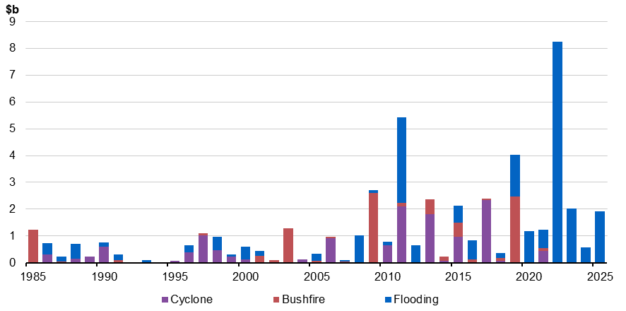
Source: Insurance Council of Australia 2025

The implications of physical climate risk for productivity in sectors highly exposed to the effects of climate change were explored in the 2023 Intergenerational Report (Australian Government 2023). In this Report, the direct impacts of higher temperatures on labour productivity were estimated to reduce Australia’s economic output by between $135 billion and $423 billion to 2063. In the absence of adaptation measures, Australian crop yields were also estimated to be up to 4 per cent lower by 2063 in a scenario where global mitigation does not keep temperature increases below 3°C this century.
There is a wide range of additional channels through which physical climate risks will affect the value of capital and productivity in the Australian economy over the next 40 years and beyond, including biodiversity loss, storm surge, sea level rise and health impacts. These will present significant costs, beyond those discussed above, for people, communities, businesses and the broader economy.
The National Climate Risk Assessment finds that increasing levels of global warming pose significant risks to Australia (ACS 2025). Time spent in drought across most of the country will increase, bushfire risk will increase in forested areas, and sea level rise will increasingly threaten Australia’s coastlines. As these physical risks to Australia increase, so too will the number of compounding, cascading and concurrent hazards.
Estimates of the costs of physical climate risk have typically increased over time, as new data and methodologies have been developed. The NGFS projects global GDP could be between 7–15 per cent lower by 2050 under a future in which global temperatures remain on track to increase by 3°C by 2100, which is consistent with no further policy action (NGFS 2024). Australia was found to be at the higher end of these estimates. Recent extensions on the NGFS analysis, which incorporate the impacts of global weather changes as well as local weather changes, see larger impacts. These extensions estimate that global GDP could be 40 per cent lower in 2100 under a high‑emissions scenario compared to a low‑emissions scenario (Neal et al. 2024). Potential impacts on Australia were again found to be at the upper end of global outcomes.

References
ABS (Australian Bureau of Statistics) (2017) Household Expenditure Survey, Australia (HES) [data set], ABS Website, accessed 19 May 2025.
ABS (2024) Value of renewable energy construction, June 2024 [data set], ABS Website, accessed 12 September 2025
ABS (2025) Australian System of National Accounts [data set], ABS Website, accessed 12 September 2025.
ACS (Australian Climate Service) (2025) Australia’s national climate risk assessment, ACS, accessed 15 September 2025.
AER (Australian Energy Regulator) (29 March 2018) Wholesale electricity prices higher since Hazelwood exit [news release], AER, accessed 12 September 2025.
AIGCC (Asia Investor Group on Climate Change) (2025) State of investor climate transition in Asia 2025 [PDF], AIGCC, accessed 12 September 2025.
Australian Government (2023) Intergenerational Report 2023, Australian Government, accessed 12 September 2025.
Berestycki C, Carattini S, Dechezleprêtre A and Kruse T (2022) Measuring and assessing the effects of climate policy uncertainty, OECD Economics Department Working Paper No. 1724, OECD, accessed 12 September 2025.
Bird L, Light A and Goldsmith I (2025) US clean power development sees record progress, as well as stronger headwinds, World Resources Institute, accessed 12 September 2025.
BloombergNEF (2025a) Energy Transition Investment Trends, BloombergNEF, accessed 12 September 2025.
BloombergNEF (2025b) Global renewable energy investment still reaches new record as investors reassess risks, BloombergNEF, accessed 12 September 2025.
Byers E, Krey V, Kriegler E, Riahi K, Schaeffer R, Kikstra J, Lamboll R, Nicholls Z, Sanstad M, Smith C, van der Wijst K, Al Khourdajie A, Lecocq F, Portugal-Pereira J, Saheb Y, Strømann A, Winkler H, Auer C, Brutschin E, Gidden M, Hackstock P, Harmsen M, Huppmann D, Kolp P, Lepault C, Lewis J, Marangoni G, Müller-Casseres E, Skeie R, Werning M, Calvin K, Forster P, Guivarch C, Hasegawa T, Meinshausen M, Peters G, Rogelj J, Samset B, Steinberger J, Tavoni M and van Vuuren D (2022) AR6 Scenarios Database hosted by IIASA, International Institute for Applied Systems Analysis, accessed 12 September 2025.
CCA (Climate Change Authority) (2024) Sector Pathways Review, CCA, accessed 12 September 2025.
Clean Energy Council (2025) The impact of a delayed transition on consumer electricity bills [PDF], Jacobs.
Clean Energy Investor Group (2025) The cost of no renewables: The unaffordable alternative [PDF], Clean Energy Investor Group.
Climateworks (2023a) Climateworks Centre Decarbonisation Scenarios 2023, Climateworks, accessed 12 September 2025.
CS Energy (n.d.) Callide Unit C4 recovery, CS Energy Website, accessed 12 September 2025.
CSIRO (Commonwealth Scientific and Industrial Research Organisation) (2023a) Pathways to Net Zero Emissions – An Australian perspective on rapid decarbonisation, CSIRO, accessed 12 September 2025.
CSIRO (2023b) Land Use Trade-Offs Model, CSIRO, accessed 12 September 2025.
CSIRO (2023c) Sustainable Aviation Fuel Roadmap, CSIRO.
CSIRO (2025) GenCost: cost of building Australia’s future electricity needs, CSIRO, accessed 12 September 2025.
CSIRO (unpublished) Australian Carbon Dioxide Removal Roadmap, CSIRO, Australian Government.
DCCEEW (Department of Climate Change, Energy, the Environment and Water) (2019) Australia’s National Hydrogen Strategy [PDF], DCCEEW, accessed 12 September 2025.
DCCEEW (2024a) Australian Energy Statistics, DCCEEW, accessed 12 September 2025.
DCCEEW (2024b) National Hydrogen Strategy 2024, DCCEEW, accessed 12 September 2025.
DCCEEW (2024c) Australia’s emissions projections 2024, DCCEEW, accessed 12 September 2025.
DCCEEW (2025a) Net Zero Plan, DCCEEW, accessed 18 September 2025.
DCCEEW (2025b) Australian Energy Update 2025, DCCEEW, accessed 12 September 2025.
Debelle G (2021) Climate risks and the Australian financial system, Reserve Bank of Australia, accessed 12 September 2025
DFAT (Department of Foreign Affairs and Trade) (2025a) Trade statistical pivot tables: Country and commodity pivot table 2006 to 2024 [data set], DFAT, accessed 12 September 2025.
DFAT (2025b) Trade statistics – Trade time series data: Australia’s direction of goods and services trade – calendar years from 2007 to present [data set], DFAT, accessed 12 September 2025.
DISER (Department of Industry, Science, Energy and Resources) (2021) Australia’s Long-Term Emissions Reduction Plan: Modelling and Analysis, Australian Government, accessed 12 September 2025.
DISR (Department of Industry, Science and Resources) (2024) Future Gas Strategy, DISR, accessed 12 September 2025.
Edwards GAS, Hanmer C, Park S, MacNeil R, Bojovic M, Kucic-Riker J, Musil D and Viney G (2022) Towards a just transition from coal in Australia? The British Academy, accessed 12 September 2025.
Electric Vehicle Council (n.d.) Electric Vehicle Council [website], accessed 12 September 2025.
Energy Institute (2025) Statistical Review of World Energy 2025, Energy Institute, accessed 12 September 2025.
Energy Watch (2025) China has already reached 2030 renewable energy targets, Energy Watch, accessed 12 September 2025.
E3G (2025) Beyond headlines: The role of markets and states in the U.S. energy transition, E3G, accessed 12 September 2025.
Federal Chamber of Automotive Industries (n.d.) Federal Chamber of Automotive Industries [website], accessed 12 September 2025.
Fontenay CD, Evans S, Kamil J, Thiris J and Lipp J (2024) Why are investment hurdle rates so high? Risk or market power?, Productivity Commission, accessed 12 September 2025.
Geoscience Australia (2025) Australia’s Identified Mineral Resources 2024, Geoscience Australia, accessed 12 September 2025.
Graham PW and Havas L (2023) Comparing and ranking the global cost of green industrial electricity [PDF], CSIRO.
IEA (International Energy Agency) (2021) Global Hydrogen Review, IEA, accessed 12 September 2025.
IEA (2023) World Energy Outlook 2023 Extended Dataset [data set], IEA, accessed 12 September 2025.
IEA (2024a) World Energy Outlook 2024, IEA, accessed 12 September 2025.
IEA (2024b) Renewables 2024, IEA, accessed 12 September 2025.
IEA (2024c) Global Critical Minerals Outlook 2024, IEA, accessed 12 September 2025
IEA (2025a) Global Energy Review, IEA, accessed 12 September 2025.
IEA (2025b) World Energy Investment 2025, IEA, accessed 12 September 2025.
IEA (2025c) Electricity Mid-Year Update 2025, IEA, accessed 12 September 2025.
IGCC (Investor Group on Climate Change) (2024) $6.8 trillion GDP hit if renewable energy transition is delayed, IGCC, accessed 12 September 2025.
IIASA (International Institute for Applied Systems Analysis) (2024) Global Biosphere Management Model (GLOBIOM), IIASA, accessed 12 September 2025.
Insurance Council of Australia (2025) Data hub [data set], Insurance Council of Australia, accessed 12 September 2025.
IPCC (Intergovernmental Panel on Climate Change) (2022) Sixth Assessment Report. Working Group III: Mitigation of Climate Change, IPCC, accessed 12 September 2025.
IPCC (2023) AR6 Synthesis Report: Climate Change 2023, IPCC, accessed 12 September 2025.
IRENA (International Renewable Energy Agency) (2015) Renewable Power Generation Cost in 2014, IRENA, accessed 12 September 2025.
IRENA (2021) Renewable Power Generation Costs in 2020, IRENA, accessed 12 September 2025.
IRENA (2024) Renewable Power Generation Costs in 2023, IRENA, accessed 12 September 2025.
JSA (Jobs and Skills Australia) (2023) The clean energy generation, JSA, accessed 12 September 2025.
Neal T, Newell BR and Pitman A (2025) ‘Reconsidering the macroeconomic damage of severe warming’, Environmental Research Letters, 20(4):044029. doi:10.1088/1748-9326/adbd58.
NGFS (Network for Greening the Financial System) (2024) NGFS long-term climate scenarios: High-level overview [PDF], NGFS, accessed 12 September 2025.
Open Electricity (n.d.) An open platform for tracking Australia’s electricity transition, Open Electricity website, accessed 12 September 2025.
O’Sullivan CA, Mishra A, Mueller S, Nadeem H and Flentje W (2025) Opportunities and Priorities for a Low Carbon Liquid Fuel Industry in Australia, CSIRO, accessed 12 September 2025.
Pollard E (26 May 2021) ‘Queensland blackout to be investigated after fire at Callide Power Station cuts power to large parts of the state’, ABC News, accessed 12 September 2025.
Ros J and Daley C (2021) Callide C Catastrophic Failure, Energybyte, accessed 12 September 2025.
Roxburgh S, England J, Evans D, Nolan M, Opie K, Paul K, Reeson A, Cook G and Thomas D (2020) Potential future supply of carbon offsets in the land sector in Australia, CSIRO, doi:10.25919/h4xk-9r08.
Simshauser P and Gilmore J (2025) The Counterfactual Scenario: are renewables cheaper? [PDF], Griffith University.
Transport and Environment (2024) The State of European Transport 2024, Transport and Environment, accessed 12 September 2024.
Treasury (2011) Strong Growth Low Pollution – modelling a carbon price, Treasury, accessed 12 September 2025.
Treasury (2024) Future Made in Australia – National Interest Framework supporting paper, Treasury, accessed 12 September 2025.
Tulip P (2014) The Effect of the Mining Boom on the Australian Economy, Reserve Bank of Australia, accessed 12 September 2025.
UNEP (United Nations Environment Program) (2024) Emissions Gap Report 2024, UNEP, accessed 12 September 2025.
UNFCCC (United Nations Framework Convention on Climate Change) (2023) Outcome of the first global stocktake, UNFCCC, accessed 12 September 2025.

For this analysis, upper bound of ‘well below 2°C’ refers to IPCC scenarios where the median warming stabilises at around 1.6°C in 2100, with a likely chance (>67 per cent) of staying below the 2°C threshold. Similarly, the IEA’s Announced Pledges scenario is consistent with limiting warming to 1.7°C. See Appendix C: Modelling scenarios for more detail on the global scenario.
Provided by the Australian Bureau of Agricultural and Resource Economics and Science (ABARES). The curves for GLOBIOM, LUTO and Roxburgh et al. (2020) are based on mapping prices and quantities over time. These are not strictly supply curves.
Simshauser and Gilmore (2025), Clean Energy Investor Group (2025), and the Clean Energy Council (2025) all find links between stronger renewable investment and better price outcomes for consumers.
Light vehicles include passenger vehicles and sports utility vehicles (SUVs).
Energy efficiency refers to process or technology improvements that allow for less energy to be used while producing the same amount of output. See Appendix D for more details on energy efficiency assumptions.
Refers to the National Electricity Market (NEM) covering the eastern states and South Australia, and the Wholesale Electricity Market (WEM) which covers the south-west area of Western Australia. The remaining electricity generation is included as a part of small and off-grid.
CSIRO’s Sustainable Aviation Fuel Roadmap (2023c) and Opportunities and Priorities for a Low Carbon Liquid Fuel Industry in Australia (O’Sullivan 2025) report finds the levelised cost of production for a unit of fuel could decrease by between 10 per cent to 56 per cent (depending on the feedstock used) over the period to 2050.
Figure 16 in Australia’s emission projections 2024 (DCCEEW 2024c): Safeguard business-as-usual, gross emissions, on-site emissions reductions and net demand for units in the Baseline Scenario, 2025 to 2040, Mt CO₂-e.
Large industrial emitters are those facilities with emissions over 100,000 t CO₂-e per year are typically subject to emissions reduction obligations in the Safeguard Mechanism.
Residual emissions are those greenhouse gas emissions that remain after all economical or technically feasible abatement options have been exhausted (IPCC 2022).
“The deployment of carbon dioxide removal (CDR) to counterbalance hard-to-abate residual emissions is unavoidable if net zero CO₂ or GHG emissions are to be achieved.” (IPCC 2022).
Current estimates by CSIRO place the cost of direct-air capture technology, for example, at around $500‍-‍1,000 t/CO₂-e abated, falling to around $400 t/CO₂-e in 2050 (CSIRO unpublished).
See also Appendix A: Additional outputs.
This ‘Services’ sector in this table refers to the industry in the Treasury Industry Model (TIM), rather than the ABS definition which also includes industries such as construction and transport. Construction is captured as its own separate industry within TIM.
See Appendix A: Additional outputs.
Recognising that investment in lower-emissions buildings, plant, equipment and technologies will occur as part of regular investment cycles, investment in emissions reduction technologies cannot be readily distinguished from broader investment in the economy across the scenarios.
Depreciation data from the ABS suggest that the time required to turn over the capital stock is around 15 years for the mining sector, 10 years for the agriculture and manufacturing sectors, and 20 years for the transport, postal, and warehousing sector.
The comparison is based on analysis of Australia’s gross fixed capital formation, which increased by 87 per cent between 1999–2000 and 2014–15 (ABS 2025).
Strong renewable investment is consistent with AEMO’s Integrated System Plan Step Change scenario, which identifies the net present value of new electricity infrastructure as $122 billion to 2050.
All results in this section are for the NEM unless noted otherwise.
Australia Energy Statistics, Table F (DCCEEW 2025b).
Under all scenarios, employment increases, reflecting underlying population growth. Total hours worked in the Baseline Scenario are aligned with the 2023 Intergenerational Report. Total hours worked can deviate from this in other scenarios as labour force participation responds to deviations in the real wage between scenarios. In the Treasury Industry Model, the substitution effect can dominate the income and wealth effects at different points in time. As a result, labour force participation is higher in the Renewable Export Upside Scenario than the Baseline Scenario.
Analysis of the ABS’s 2015-16 Household Expenditure Survey (ABS 2017).
Estimated based on Berestycki et al. (2022).
More than 70 per cent of China’s energy investment from 2023–2025 went to clean energy sources (IEA 2025b).

