
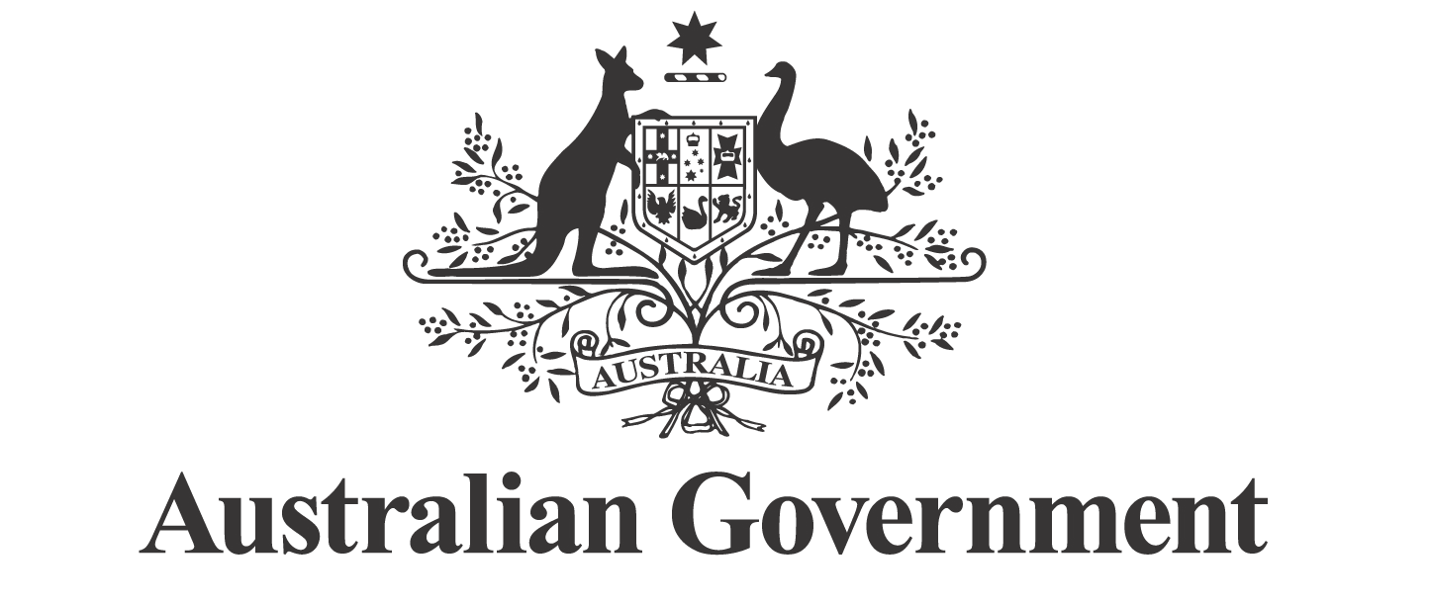
First Nations Economic Partnership Meeting 21 October 2025

Communiqué

The inaugural meeting of the First Nations Economic Partnership was held on Ngunnawal and Ngambri Country in Canberra, following the signing of the Partnership Agreement on 29 September 2025.

The Partnership brings together the Coalition of Peaks, the First Nations Economic Empowerment Alliance, and the Australian Government in a shared commitment to advancing First Nations economic empowerment.

This first meeting had a strong focus on the establishment of the Partnership with agenda items covering the proposed annual workplan, establishing Working Groups to advance policy priorities, the mechanism for onboarding of new partners, members and experts, funding arrangements and governance processes.

Considerable discussion occurred on the 2025/26 annual workplan which will guide the implementation of reform priorities and include identified immediate priority actions.

Partners agreed on the establishment of three initial Working Groups to advance priorities identified in the Workplan. These will focus on access to capital and institutional arrangements, employment in the community-controlled sector and the development of an overarching First Nations Economic Framework. The terms of reference for these Working Groups, including scope and deliverables will be agreed at the next meeting.

The next meeting of the Partnership is scheduled for 8 December 2025.

