The power of microdata to shape better competition policy and regulation
Owen Freestone ∗ Jonathan Hambur † Nu Nu Win ‡ Sarah Davies §
Yun Jiang ¶ Omer Majeed ‖

May, 2025

Abstract
Empirical evidence is critical in identifying and advocating for policy change, especially in highly contested policy spaces. In Australia, the recent expansion in administrative and other longitudinal unit record data (or ‘microdata’) has transformed policy advisers’ capacity to bring empirical evidence to bear in the policy decision-making process. This is especially true in the area of competition policy and other microeconomic reform areas where microdata are a powerful tool for identifying economic benefits that are spread thinly across a large number of consumers and workers, or where the impacts vary with individual characteristics of businesses and workers. Unlike the reviews of previous decades, Australia’s current Competition Review has benefited from the now-extensive and detailed suite of microdata assets, as demonstrated by the Review’s use of data in areas such as the Aviation White Paper and merger reform. This paper provides a framework for thinking about the value of microdata in policy decision-making, the key microdata assets in Australia, followed by a number of case studies related to competition, in each case identifying the policy problem, the microdata used, and the value of the analysis for policy.

∗Department of Treasury.
†Reserve Bank of Australia
‡Department of Treasury
§Department of Treasury
¶Department of Treasury
‖Department of Treasury. The views expressed in this paper are those of the authors and not necessarily those of the Commonwealth Treasury or Reserve Bank of Australia or the Australian government.

Introduction
Empirical evidence plays a central role in shaping public policy and regulatory action, including in the area of competition. This occurs both directly by influencing policymakers’ decisions in government and indirectly by influencing stakeholder views and broader public opinion, which over time shapes government policy.
Although data of all types have potential value in policymaking, microdata specifically often provides unique insights that would not be possible using time series or other aggregated data. Microdata encompasses raw data (for example, a count of the number of businesses operating in a market to inform a competition assessment), statistical regressions (for example, to identify how much non-compete clauses suppress wages by worker tenure), and calibrating economy-wide models (for example, using firm-level turnover data to calibrate market concentration by industry to examine competition issues). These different forms of microdata can be compelling for different audiences and at different points in the policy decision-making process. The most effective approach is often to use all these different forms of microdata together.
Empirical evidence plays a role throughout the entire policy cycle, including context-setting and framing issues, identifying reform opportunities, informing policy design, advocacy, implementation and communication, and finally evaluation. Empirical evidence can also inform ongoing regulatory settings and actions. Microdata is often more useful than other data types in many policy contexts. For example in regulatory settings, using microdata, agencies can track the impact of a policy on particular businesses or classes of businesses over time.

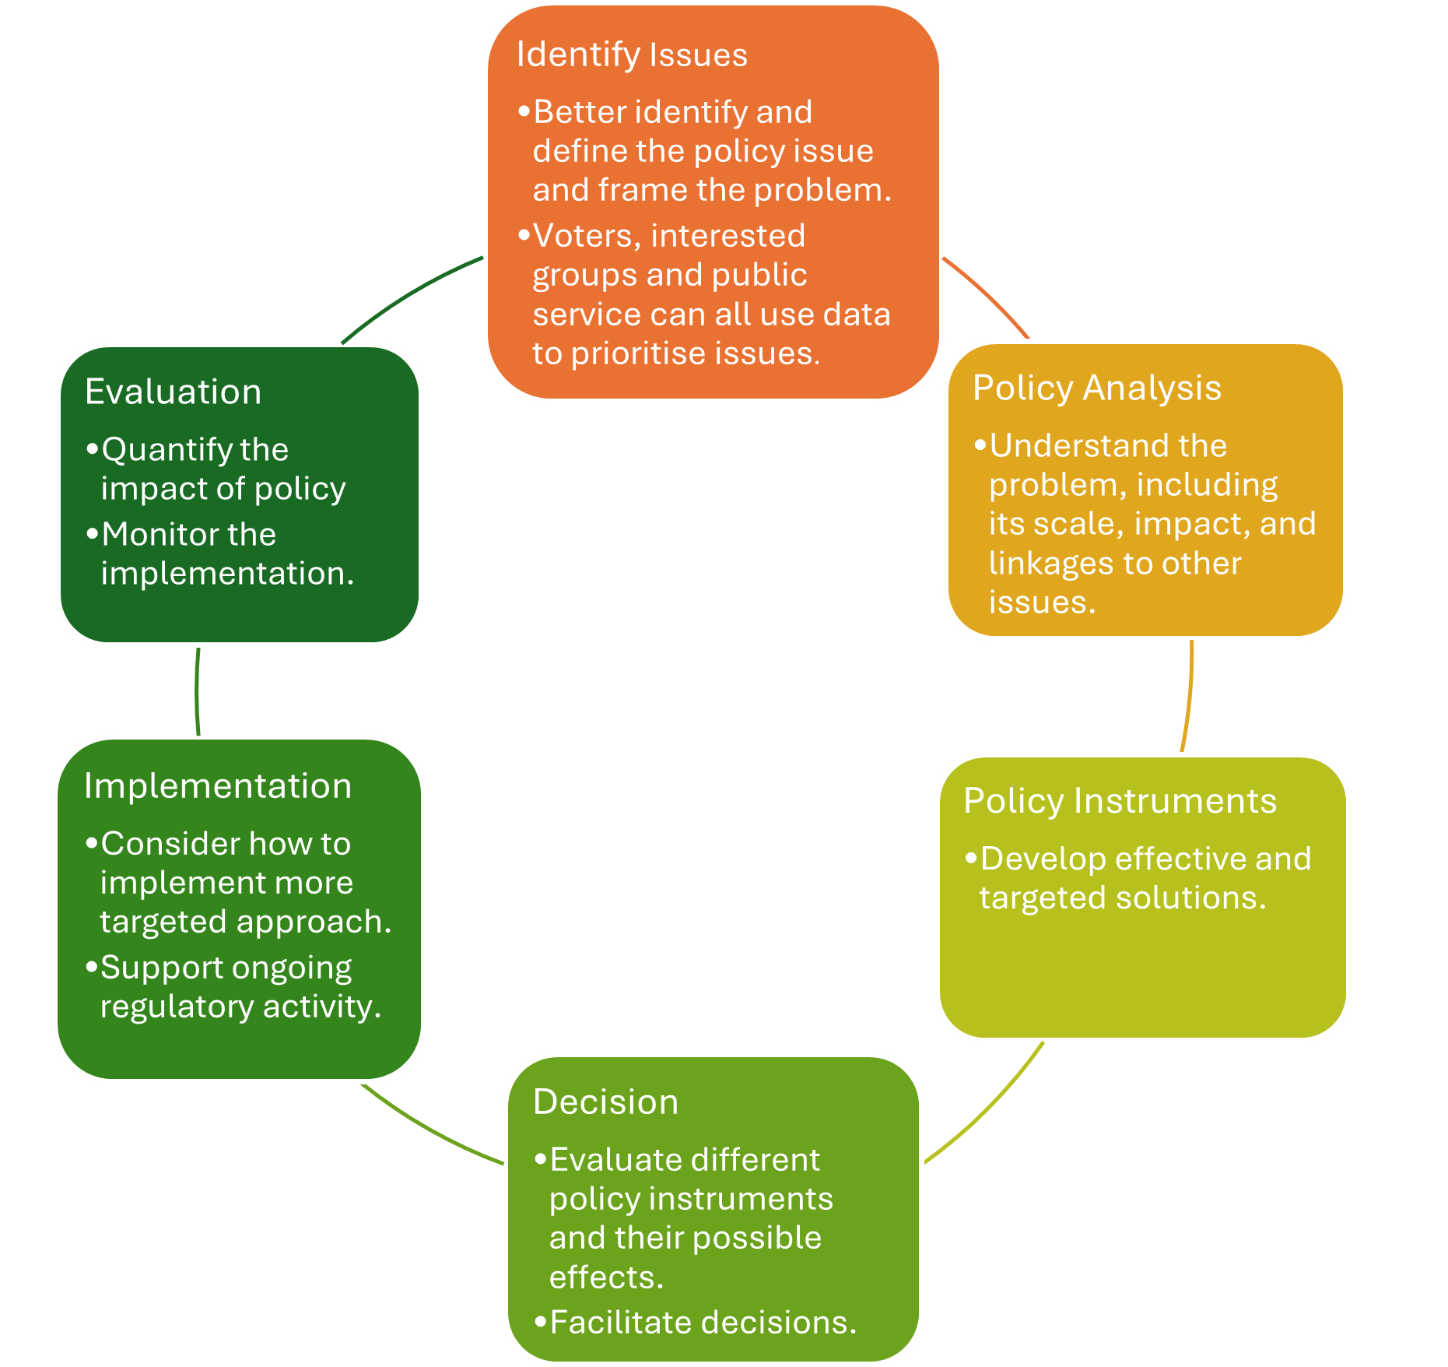
Figure 1: Data’s role in policy cycle

The microdata landscape
In recent years, the Australian Bureau of Statistics (ABS) and the Australian Tax Office (ATO) have released several powerful integrated administrative and related microdata datasets to Government and researchers, placing Australia at the global frontier of data availability (Gruen (2022)). This rapid growth in the availability of integrated microdata assets has significantly increased the scope for evidence-based policy-making in Australia across a number of policy areas, including competition policy.¹
Microdata is particularly valuable in understanding competition dynamics. At its core, competition is about the interaction between individuals or firms with suppliers or consumers, within given markets and industries. Microdata on individual firms, workers, consumers, and prices are therefore crucial in understanding competition dynamics and how they differ across markets and sectors, allowing for better targeting of policies. Moreover, microdata are well suited to identifying the causal impact of certain policies or behaviours, as they allow us to compare outcomes across ‘treated’ and ‘untreated’ firms.
Two administrative datasets are of particular note. The first is the Business Longitudinal Analysis Data Environment (BLADE). This is a business-level dataset containing anonymised administrative tax fillings for the near universe of Australian firms. The data are integrated with several ABS surveys and other administrative data such as firm patents and trade data.
The use of Australian microdata, such as from BLADE, is the next frontier in refining macroeconomic models to analyse competition policy. Microdata captures firm- and individual-level nuances that aggregate data cannot capture, such as market power, pricing, and the impact of restraint clauses on wage and labour mobility. This allows models to more accurately simulate how alternative competition policies affect firm and industry outcomes, giving policymakers sharper insights into their broader economic impacts.
The second dataset is the Person Level Integrated Data Asset (PLIDA). This is a person-level dataset containing anonymised integrated tax, social services and other administrative and survey data for the near universe of Australian residents. Importantly, through PLIDA, employees can be linked to their employer in BLADE using their tax data. The ability to link employees with their employers is necessary to analyse how competition policy can affect employment, wages and worker movements. In addition, such linking can help policy makers infer corporate mergers and restructures by tracking firm worker flows.
In addition to these datasets, there are ongoing efforts to integrate new administrative and other data in order to provide richer insights into competition dynamics. Some of these examples are discussed below in the case studies, and they include firm-level prices data (Fink et al. (2023)), surveys of non-compete clauses,
¹See Fink et al. (2023) for some discussion.

and administrative mergers filings. Ongoing investment will continue to unlock the value of these assets.

In addition to the increased availability of data, significant investments have been made in data analysis capabilities, which is a prerequisite to gaining insights from these rich data (Hambur et al. (2022)). In particular, the Competition Taskforce established a dedicated data and evaluation team – the first of its kind to be attached to a real-time reform process – to supply analysis and the evidence base for reform. As discussed below, continued investment in these capabilities across the APS and relevant agencies, as well as the leveraging of such capabilities outside the APS (for example, in academia and think tanks), will be important for making the most of these assets.
Policy reforms, especially those related to microeconomic reform, need to be well-targeted to be effective. This includes in the competition context, where policy responses often need to take into account variation among businesses, such as productivity, size, and cost structure. In order to do so, evidence based on microdata is essential. The Competition Taskforce has used microdata in this way in areas like merger reform.
Microdata is also used in applications beyond competition policy and in broader microeconomic contexts. For example, Treasury’s earliest use of single touch payroll data was during the pandemic to assist in monitoring the macroeconomic impact of the pandemic and the associated policy response.

Building the case for reform

Documenting competition indicators and firm level performance
Much of the initial Australian work on competition analysis focused on assessing whether declining competition was an issue for the Australian economy, and building the case for reforms. This work informed our understanding of competition in Australia, and built the evidence base to support reform efforts, including establishment of the Competition Taskforce.²
In particular Hambur (2023) documented that a number of measures of competitive pressures had declined. Industries had become more concentrated, the largest firms had become more entrenched, and estimates of markups had increased. Moreover, this reflected broad-based increases in markups across a large number of firms that could not be accounted for by increasing fixed or other costs, suggesting it reflected a decrease in competition rather than ‘winner takes all’ dynamics or technology changes. This is a key difference to US developments, where these more benign aspects appear to have played a larger role (De Loecker et al. (2020, 2021)).

²For an expanded overview of this work, see Duretto et al. (2022).

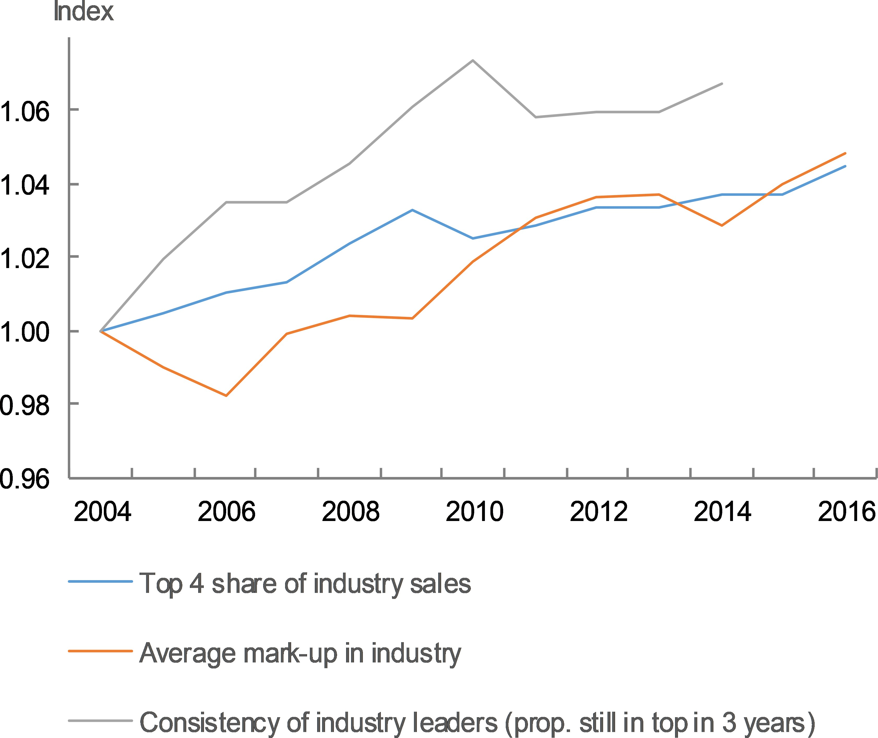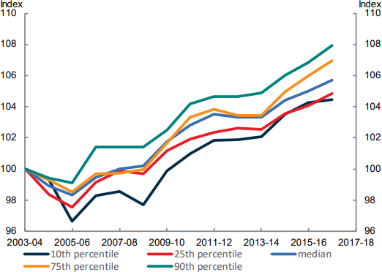
Figure 3: Distribution of Firm-level Markups
Figure 2: Indicators of Market Power

In addition to documenting the apparent decline in competition, several papers have also highlighted the potential negative implications of such decline for productivity growth. In particular, Hambur (2023) and Hambur and Andrews (2023) documented that reallocation of labour and capital resources from less to more productive firms had slowed more in industries sectors where competition had declined, suggesting less pressure for small firms to shrink and exit and free resources for better firms. They estimate that this had a sizeable negative effect on productivity growth, but note their quantification is simple and partial. Majeed et al. (2021) documents a marked decline in high-growth firms – these firms had historically contributed disproportionately to innovation and sales and employment growth. Their reduced prevalence has therefore contributed to a broader slowdown in economic dynamism and innovation.
Similarly, Andrews et al. (2022) documented that in industries where competition was declining, firms converged to the productivity frontier more slowly, suggesting less imperative to improve and adopt world- leading technologies and processes. Again, this would weigh on productivity growth. Andrews et al. (2023)) found evidence that increases in concentration were associated with lower rates of firm entry in the future, linking declining competition with declining firm dynamism. And finally Majeed and Breunig (2023) find evidence that the level of competition has important implications for the amount and nature of innovation undertaken by Australian firms.
While this evidence is suggestive, the analytical approaches for assessing trends in competition across the economy are continuing to be refined in a way that takes full advantage of the increasingly rich micro datasets. For example, research by Rivera-Padilla (2023) in the US uses firm microdata to more closely correlate movements in indicators of market power with market outcomes. These new approaches can make findings around trends in competition more reliable and precise, and of greater use to policymakers.

A recent Treasury working paper (Majeed et al. (2024)) further underscores the importance of competition for consumer welfare. Drawing on the aviation sector as a case study, the paper shows that increased competition – such as through the entry of additional carriers – has led to significant reductions in airfares and helped curb the rate of price growth over time. These gains have translated into direct benefits for consumers, including lower travel costs and increased air travel (Breunig et al. (2025), forthcoming). The analysis highlights how competition disciplines pricing behaviour, prevents excessive market power, and ensures that benefits flow to consumers.

Bringing microdata to macroeconomic models
The previous works have been influential in making a prima facie case that competition has declined and in identifying the potential correlates of this decline at the firm level, such as productivity. Nevertheless, one weakness of this type of empirical work is that it is partial and ignores supply chain links, and is therefore not entirely well suited to estimating the true macroeconomic costs of declining competition. While Hambur (2023) and Hambur and Andrews (2023) attempted to quantify some of the costs using simple, back-of-the-envelope approaches, these are inherently partial equilibrial and limited in scope.
Better understanding the macroeconomic costs is important for two reasons. First, it can help to strengthen the case for reform. Second it can help us to understand, for example, how much the slowdown in productivity observed over past decades might be due to declining competition. Third, from this, it may provide some insights as to what might happen in the future.
Current work is addressing this issue, using a general equilibrium model to assess the costs of declining competition. In particular, Hambur and Freestone (forthcoming) calibrate the seminal general equilibrium model from Edmond et al. (2023) to the Australian economy. Their preliminary findings suggest that Australia’s productivity and output would have been around 1-3 per cent higher, if the economy were at mid-2000s level of competition. This GDP effect is large even after accounting for the fact that part of the rise in markups reflects increasing fixed costs, for example, from the rising cost of IT systems. The range of estimates suggests that declining competition significantly dragged on aggregate productivity and living standards over the period.
According to their model, while this historical decline in competition has lowered the level of productivity and output, it is not expected to have impacts on the future growth of productivity and potential output – unless competitive pressures decline further. If competition improved, productivity and potential output would experience a level shift upwards.

Identifying reform opportunities: Case studies
As the need for competition reform became clear, more work has focused on specific reform areas, barriers, and policy options. Below is a summary of several case studies where detailed data analysis has been used to inform and develop policy.³ For each of these case study, we discuss the policy problems and information gaps, the microdata used, and the impact of the data on policy outcomes.

Mergers
Mergers and acquisitions can have beneficial effects, allowing firms to create synergies and providing incentives for early investment and business creation. But they can also have negative effects if they lessen competition. To properly understand the costs and benefits of different merger proposals, it is helpful to assess the effects of past mergers, which relies on a comprehensive database of mergers. This has been a priority at the Competition Taskforce.
Until the new merger control regime that will come into effect from 2026, Australia’s mergers regime uses voluntary notification: firms are meant to notify Australian Consumer and Competition Commission (ACCC) if the merger activity may result in a substantial lessening of competition. As a result, regulators and researchers have only partial visibility of mergers and acquisitions that have occurred in Australia, which limits the possible policy analysis and research on mergers, for example, research on the effect of mergers on labour movements, productivity and business dynamism.
While some commercial databases are available, these are not comprehensive. In addition, linking to other relevant business information is also difficult with commercial databases. Recent work by Win, Crighton, Hambur and Hansell (forthcoming) has addressed these gaps by building the first mergers and acquisitions database in Australia, using administrative datasets in the ABS secure Datalab. It is a more comprehensive and representative dataset, as it is based on administrative data. Moreover, as it is linked to other administrative data on firms and workers, it has enormous potential for research on the consequences of mergers and
³The results of these studies are based, in part, on data supplied to the ABS under the Taxation Administration Act 1953, A New Tax System (Australian Business Number) Act 1999, Australian Border Force Act 2015, Social Security (Administration) Act 1999, A New Tax System (Family Assistance) (Administration) Act 1999, Paid Parental Leave Act 2010 and/or the Student Assistance Act 1973. Such data may only used for the purpose of administering the Census and Statistics Act 1905 or performance of functions of the ABS as set out in section 6 of the Australian Bureau of Statistics Act 1975. No individual information collected under the Census and Statistics Act 1905 is provided back to custodians for administrative or regulatory purposes. Any discussion of data limitations or weaknesses is in the context of using the data for statistical purposes and is not related to the ability of the data to support the Australian Taxation Office, Australian Business Register, Department of Social Services and/or Department of Home Affairs’ core operational requirements.
Legislative requirements to ensure privacy and secrecy of these data have been followed. For access to PLIDA and/or BLADE data under Section 16A of the ABS Act 1975 or enabled by section 15 of the Census and Statistics (Information Release and Access) Determination 2018, source data are de-identified and so data about specific individuals has not been viewed in conducting this analysis. In accordance with the Census and Statistics Act 1905, results have been treated where necessary to ensure that they are not likely to enable identification of a particular person or organisation.

acquisitions activity, including productivity, innovation, labour movements and prices.

This work is still ongoing, but it has already had significant impacts on our understanding of mergers. It has highlighted that very large firms (500+ employees) are much more likely than other firms to undertake acquisition, and that their share of acquisitions has risen moderately over recent years. It also identified that a moderate portion of mergers, potentially around 5-10 per cent, appear to be serial acquisitions, where a single acquirer has bought up multiple different small firms over time.
Of the 61 serial acquirers across these top ten ANZSIC classes, around 40% were in the top 10 of their ANSZIC class by turnover in the year of the acquisition.

Rank ANZSIC class

    - Q-8710-Child Care Services
    - Q-8601-Aged Care Residential Services
    - Q-8511-General Practice Medical Services
    - Q-8531-Dental Services
    - G-4110-Supermarket and Grocery Stores
    - M-7000-Computer System Design and Related Services
    - H-4512-Takeaway Food Services
    - G-4271-Pharmaceutical, Cosmetic and Toiletry Goods Retailing
    - H-4400-Accommodation
    - H-4520-Pubs, Taverns and Bars

Table 1: Top 10 ANZSIC classes for same-industry, serial acquisitions by number of years with acquisitions

Such results suggest the need to monitor these types of behaviours, which might not be captured by standard approaches focusing on acquisitions on a case-by-case basis. More generally, this work has been instrumental in informing proposals for changes to the merger regime, providing insight into the number of acquisitions that involve firms of differing sizes.

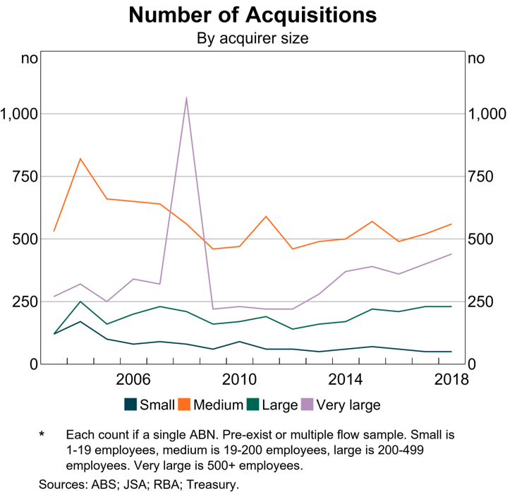
Figure 4: Mergers by Acquirer Size

The Government’s announcement that it will explore a data-driven screening tool to support the ACCC to administer the new merger system provides another example of where BLADE can be used to inform competition regulatory activity. The first step will involve developing a methodology for detecting competition ‘hot-spots’ across the economy, using information on business counts, turnover and worker location by detailed industry code.

Aviation
As a small open economy with dispersed populations across a vast landmass, aviation is particularly important for Australia. While it is well documented that competition has transformed the US and European airline industries, evidence for Australia is lacking.
Using comprehensive microdata, Majeed et al. (2024) are the first to examine the evolution of aviation competition in Australia and its impact on domestic airfares. They find increases in the number of airlines on a route has reduced airfares significantly. This effect is strongest when competition is starting from a low base.
Such results provide concrete evidence that greater competition can deliver significant cost of living benefits to Australian consumers through price reductions. It shows that at a time when cost of living has become a

concern for Australians, focusing on increasing competition could be one of the solutions.

The research find increased competition has benefited passenger welfare. Competition in the aviation sector is estimated to have saved consumers $27.2 billion to $35.2 billion (in 2023 dollars) over the 14-year period to 2023. When a route is serviced by a monopoly, airfare per kilometre is around 40 cents (in real terms); for a duopoly, this falls to less than 30 cents and continues to decline as more airlines are added. The results suggest that the presence of an additional airline on a route leads to airfares that are 5 to 10 per cent lower, falling further with additional airlines. Further, even just the threat of competition is associated with lower airfares. Competition can also reduce price growth, where having more airlines on a route led to lower airfare growth.
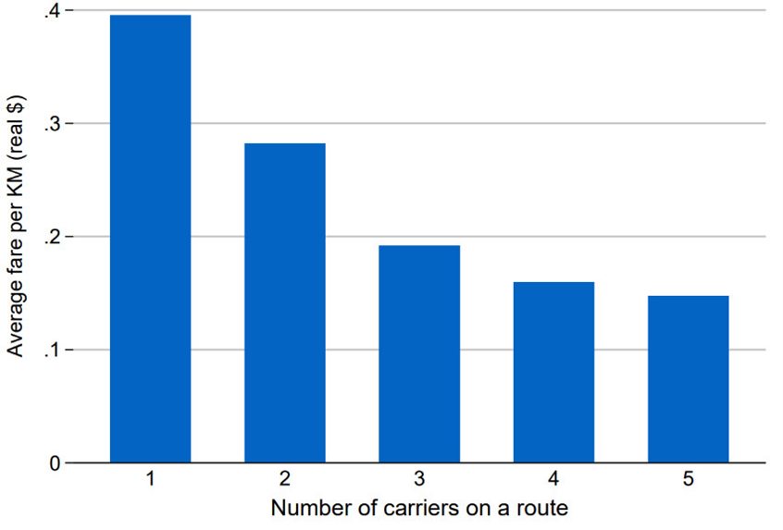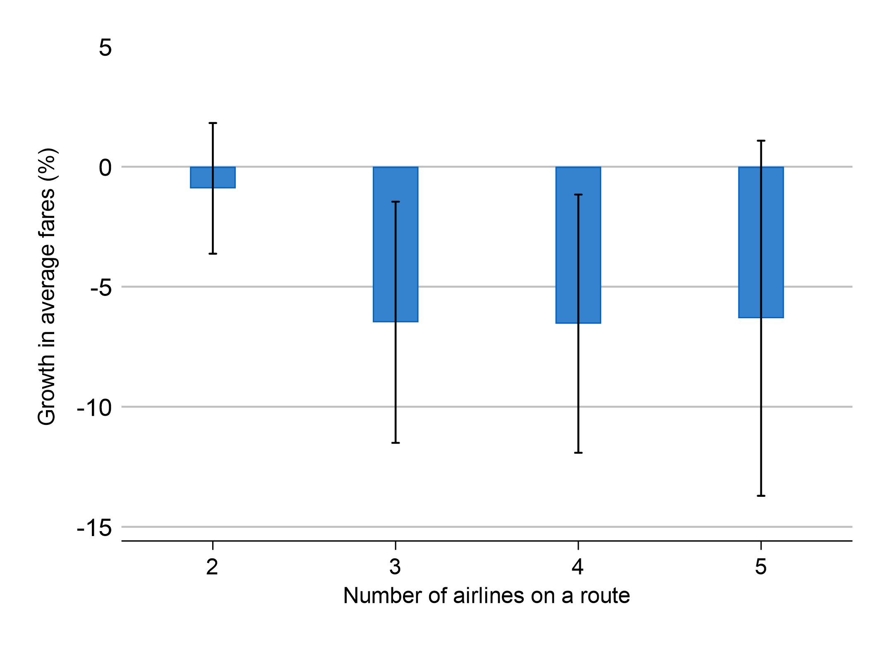

Figure 5: Average fare per km decreases as more carriers service a route (Australia, 2010 to 2023, all routes)
Figure 6: Increasing the number of airlines suppresses airfare price growth (Australia, pre- COVID, all routes)

In analysing airfares, their results suggest that Qantas raises prices when Jetstar, an affiliated airline, enters the market, indicating the presence of Jetstar allows Qantas to exercise a greater degree of price discrimination. But overall, the entry of Jetstar lowers average airfares and provides consumers with more options.
This research has contributed to the government’s Aviation White Paper. Further, as Australians increased their travel post-COVID, airfares have become more prominent in consumers’ mind. This research has been noticed by media and contributed to public discussion about airfare in Australia.

Non-competes
Non-compete clauses (NCs) by nature restrict competition in the labour market. They can significantly limit the opportunities available to workers and undermine the talent pool available to businesses, potentially restricting competition and dynamism (Rothstein and Starr (2022)). Yet at the same time, they can create incentives for training.

A key policy question is whether it is possible to distinguish between NCs that make a net-positive contribution to economic outcomes, from those that have overall negative impacts. Despite much evidence on NCs overseas, especially in the US, Australia’s unique labour market characteristics mean that any policy on NCs should be informed by the Australian context. However, until recently, evidence of their impact in Australia has been lacking.
In order to build evidence around non-competes in the Australian context, recent work in the Competition Taskforce has matched data on NC usage from the Short Survey of Employment Conditions with each business’s tax records within ABS BLADE (Australian Bureau of Statistics (2023)). This allows exploration of the relationship between NC use and a business’s average wage paid, productivity, R&D expenditure, turnover growth and capital expenditure. We see that:
- NCs are prevalent across the economy. They are used in firms of all sizes and industries, including those with generally lower labour productivity and wages.
- There are some cases where NCs are associated with higher wages. However, this does not mean that workers are being compensated for signing these non-competes: such clauses can often make their way into employment contracts without the knowledge of the worker, or may be presented as part of a take-it-or-leave-it contract.
- The presence of such clauses in low-wage jobs seems inconsistent with employees being compensated for signing a non-compete, which aligns with other measures of low bargaining power among this group.
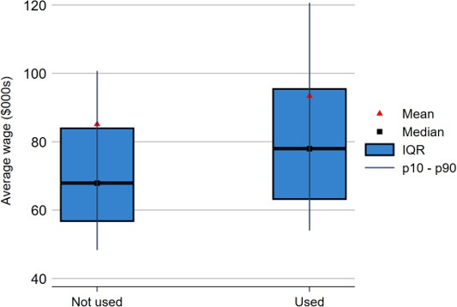
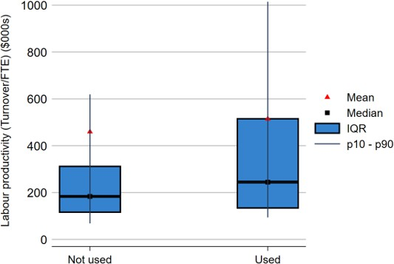

Figure 7: Comparison of average wage between firms with and without non-compete clauses
Figure 8: Comparison of labour productivity between firms with and without non-compete clauses

Combined with recent research by the e61 Institute showing that non-competes reduce the wages of lower- skilled workers, this study has supported policy thinking around potential non-compete reform in a few ways. First, it has confirmed that NCs are widespread across the labour market and commonly used in a

surprisingly diverse set of industries, occupations and skill levels. This suggests that they are not uniformly well-targeted. Second, there is some early evidence that usage by larger, higher-paying firms may be more selective, and tied to specific use cases.
While further work is underway, these early findings suggest any reforms should at least address over-usage among lower skilled workers, where the lock-in effects of non-competes are most likely to be suppressing wages. For higher skilled workers, further research is needed on the job mobility impact of non-competes and how this might flow-on to the performance of the wider industry and economy, including the dispersion of innovation that comes through job movements.

Occupational licensing
Occupational entry regulations (OER) are legal requirements that people need to meet to enter certain professions, such as undertaking training, becoming a member of a professional body or obtaining a licence. OER can protect consumers by ensuring service providers have a minimum level of training. But evidence from a number of countries has shown that they can hinder new workers from entering a profession and for new firms to open and grow, thus leading to negative effect on productivity and competition.
Although OER apply to around one in five workers in Australia, until recently no one has estimated the costs to the Australian economy using Australia-specific information. This reflected a lack of consistent data on OER across the country, as well as a lack of information on firm dynamism. Recent work by Bowman et al. (2024) addresses this by constructing a database of OER stringency across a large range of occupations in New South Wales, Queensland, and Victoria. The research looks at measures of economic dynamism in more and less restrictive occupations and industries.
They found that OER in Australia were more stringent compared to the least stringent OECD countries. They also tended to be more stringent than the average OECD country, especially for business services.

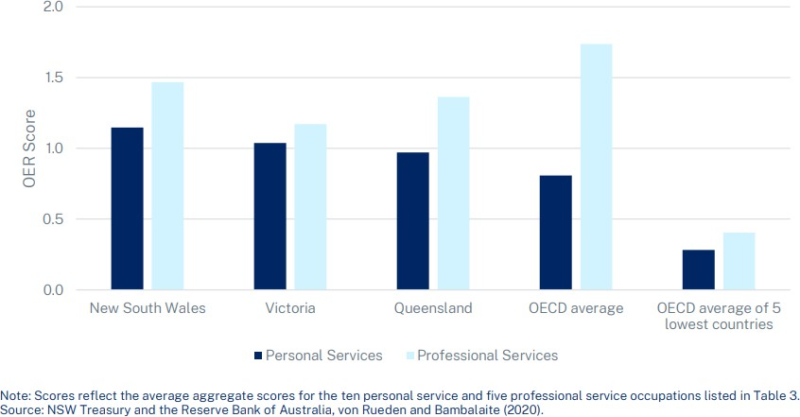

Figure 9: Occupational Entry Regulation Stringency Scores

From this database, the authors also estimated the effects of more stringent OER on economic dynamism to help better understand the costs of these policies. They found that more stringent OER tend to be associated with less firm entry and exit, and slower reallocation of resources towards high productivity firms. Further, it can exacerbate skill shortages, which can lead to higher prices for consumers and firms, thus contributing to cost of living pressures in Australia.
These findings help to quantify the costs of OER and show that they can lower productivity by weakening competition, preventing effective reallocation of resources, and overall lowering productivity. However, they do not necessarily suggest OER should be removed, as they can have important benefits. The study helps to support ongoing efforts to reform and simplify OER to best balance the costs and benefits, including mutual recognition and more broadly National Competition Policy.

Conclusion
Microdata is a powerful tool to make policies targeted, impactful and accountable. It allows the policymakers to examine the heterogeneity in the market, test policy directions, and continuously improve decision making. It is useful across the entire policy cycle.
The power of microdata is especially demonstrated for a complex policy space like competition. The above examples show that microdata and econometric evidence can fill crucial information gaps, make policies robust, and shape public and government narratives. The aviation study, for example, highlighted how

microdata can shape the debate at the national level.

While international evidence can be suggestive, it is essential to develop an evidence base specific to Australia, so that our policies can be tailored to the Australian context and that we can consider reforms that are the priorities of the Australian people, rather than following the priorities of foreign governments or institutions. Embedding microdata capability across the broader public service would support more effective policy development by better identifying areas for reform, improving internal and public communication on the value of reform, and evaluating policies.
The broadening of microdata capability will be costly and time-consuming – projects can often take months. Embedding microdata within the public service will require capability building, motivated leaders, cultural change, and investment in data assets. But the above examples show that when done, the benefits of microdata based evidence can be significant and far outweigh the costs.

References
Andrews, D., Dwyer, E. and Triggs, A. (2023). The State of Competition in Australia – e61 Institute.
URL: https://e61.in/state-of-competition/

Andrews, D., Hambur, J., Hansell, D. and Wheeler, A. (2022). Reaching for the stars: Australian firms and the global productivity frontier, number 2022-01, Treasury Working Paper.
Australian Bureau of Statistics (2023). Short survey of employment conditions faq’s.
URL: https://www.abs.gov.au

Bowman, J., Hambur, J. and Markovski, N. (2024). Examining the macroeconomic costs of occupational entry regulations.
Breunig, R., Domazet, A. and Majeed, O. (2025). Price elasticity: The australian aviation sector.

De Loecker, J., Eeckhout, J. and Mongey, S. (2021). Quantifying market power and business dynamism in the macroeconomy, NBER Working Paper 28761.
De Loecker, J., Eeckhout, J. and Unger, G. (2020). The rise of market power and the macroeconomic implications, The Quarterly Journal of Economics 135(2): 561–644.
Duretto, Z., Majeed, O. and Hambur, J. (2022). Overview: Understanding productivity in australia and the global slowdown.
URL: https://treasury.gov.au/sites/default/files/2022-10/p2022-325290-overview.pdf

Edmond, C., Midrigan, V. and Xu, D. Y. (2023). How costly are markups?, Journal of Political Economy
131(7): 1619–1675.

Fink, M., Hambur, J. and Majeed, O. (2023). Using new data sources to understand and monitor changes in prices, wages and incomes.
Gruen, D. (2022). Realising the potential of data in government.
URL: https://www.abs.gov.au/about/our-organisation/australian-statistician/speeches/realising-potential- data-government
Hambur, J. (2023). Product market power and its implications for the australian economy, Economic Record
99(324): 32–57.

Hambur, J. and Andrews, D. (2023). Doing less, with less: Capital misallocation, investment and the productivity slowdown in australia, RBA Reserch Discussion Paper 2023-03.

Hambur, J., Montaigne, M., Parsons, S. and Whalan, E. (2022). Looking under the lamppost or shining a new light: New data for unseen challenges.
Majeed, O., Balaguer, A., Hansell, D., Hendrickson, L., Latcham, A. and Satherley, T. (2021). What drives high growth? characteristics of australian firms, Economic Record 97(318): 350–364.
Majeed, O. and Breunig, R. (2023). Determinants of innovation novelty: evidence from australian adminis- trative data, Economics of Innovation and New Technology 32(8): 1249–1273.
Majeed, O., Breunig, R. and Domazet, A. (2024). How competition impacts prices: The australian aviation sector.
Rivera-Padilla, A. (2023). Market power, output, and productivity, Economics Letters 232: 111318.

Rothstein, J. and Starr, E. (2022). The impact of non-compete clauses on wages and worker mobility, Journal of Labor Economics 40(3): 567–589.

