Contents
Session II: Adapting Competition Regulation to a Changing Economy 2
1. Introduction 2
2. The economic context 3
2.1. The opportunity: on the cusp of an (AI-fuelled) productivity boom? 3
2.2. Why are we concerned and why now for competition policy? 4
3. Regulating the frontier: ex ante regulation of competition in digital markets 4
3.1. The case for ex ante regulation in digital markets 4
3.2. Practical considerations 5
4. Injecting a dose of dynamism into domestic markets 6
4.1. Administrative microdata: an enabler of structural reform 6
4.2. Restraint clauses: prevalence and impacts 6
4.3. Policy options to restrict worker restraint clauses 8
References 11

Session II: Adapting Competition Regulation to a Changing Economy
By: Dan Andrews

Introduction
- This session grappled with two key policy questions. First, how do we regulate (ex-ante) the activities of innovators at the global frontier, where market power concerns loom large? And second, how do we improve the quality of evidence-based structural policy advice to inject a dose of (productivity-enhancing) dynamism into domestic markets? At first glance, these may appear to be distinct policy issues. But they are very much related: countries attitudes to frontier innovation will likely shape the diffusion of leading the technologies domestically, while frictions in domestic product and labour markets may blunt the incentives for domestic firms to adopt frontier technologies.
- I suspect that the ways in which Australian policymakers deploy regulatory policy to grapple with these two questions will carry first order consequences for productivity growth. To be sure, the conference had a strong undercurrent of the “reform age”, noting that National Competition Policy – which lay dormant for 15 years – was reinvigorated soon after by the Treasurer’s announcement of a $900 million reform package. But the nature of the policy challenge is now arguably different to the 1980s and early 1990s. During the reform age, economic policy could be guided by textbook thinking given the large economic distortions that prevailed. By the turn of the century, however, much of this low hanging fruit had been harvested and structural reform momentum in Australia slowed. What followed was a pronounced slowdown in productivity growth. But the sudden emergence of economic research using administrative microdata sets diagnosed the sickness – namely, a pervasive decline in economic dynamism – and contended that structural reforms to improve competitiveness of Australian markets was part of the cure.
- This paper summarises my conference remarks, noting that my role was to Chair and be lead discussant of Session 2: Adapting Competition Regulation to a Changing Economy. I am deeply grateful to the Australian Treasury for facilitating my participation in what turned out to a conference of the highest quality. To place the Session into economic policy context, the next Section frames the opportunity and challenge associated by the AI revolution that is currently taking place at the global technological frontier. Section 3 tackles a common theme of the papers by Gina Cass-Gottlieb and Margarida Matos Rosa: how do we regulate (ex-ante) the activities of innovators at the global frontier, where market power concerns loom large? Reflecting on some key issues raised by Jonathan Hambur (and the Competition Taskforce) and Margarida Matos Rosa, Section 4 discusses how structural policy can inject a more dynamism into domestic markets, with a special focus on the regulatory policies to promote competition in labour markets.

The economic context

The opportunity: on the cusp of an (AI-fuelled) productivity boom?
- Given the title of the Session – Adapting Competition Regulation to a Changing Economy – it is important to understand the economic policy context. The economy is clear changing, as the 4Ds – demography, digitalisation, decarbonisation and deglobalisation – reshape patterns of economic activity. While these forces will entail disruption and need to be carefully managed, they will also present tremendous opportunities. The Artificial Intelligence (AI) revolution is a case in point – policymakers worrying about the potential impacts of AI on market competition but the prospect of an AI-fuelled surge in total factor productivity (TFP) growth is real. A recent OECD study estimates that the AI revolution could boost annual US TFP growth of 0.25-0.60 percentage points over the next 10 years (Filippucci et al 2024). But this estimate is arguably conservative as it does not allow for the possibility for AI to raise the productivity of research and development or be further integrated with robotics technology. And once an allowance for the latter is made, for example, the estimated growth impacts of AI become commensurate with that of the information and communication technology (ICT) revolution, which contributed an estimated 1-1.5 percentage points to annual US TFP growth during the 1995-2004 period (Byrne et al, 2013).
- While there remains much uncertainty over the economic consequences of AI, a body of OECD research suggests that three key ideas seem plausible. First, AI could boost US TFP growth by as much as the mid-1990s ICT boom. Second, the size of the productivity gains in other countries will depend upon the speed and extent of adoption. Third, much will depend upon policy vis-a-vis societies attitudes toward frontier innovation, the extent of frictions in product and labour markets as well as human capabilities.
- If one needs of the reminder of the importance of structural policies in promoting the diffusion of new technologies, then look no further to Australia in the mid-1990s. While the market-based reforms that Australia undertook over the 1980s and 1990s directly boosted productivity, they also aided the rapid diffusion of ICT, which required new firms and a reallocation of resources to implement and scale new business models. The story of the mid-1990s was that those economies with less stringent product market regulations (PMR) – such as Australia – rode the wave of the ICT, while other (continental European) economies lagged (Figure 1, Panel A). And the results were impressive in terms of what followed in Australia: TFP in Australia grew by more in the second half of the 1990s than over the next 20 years.
Figure 1. The mid-1990s productivity boom and product market regulations
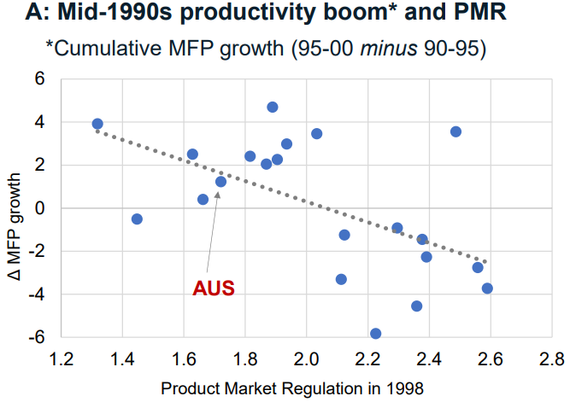
Sources: Authors calculation based on the OECD Economic Outlook database and the OECD Product Market Regulation database.

Why are we concerned and why now for competition policy?
- Is Australia as well-positioned today to reap the productivity dividends of the AI revolution as it was during the mid-1990s with respect to the ICT boom? While it is difficult to predict the future, there are reasons for concern. First, the productivity slowdown – which has been underpinned by decline in economic dynamism – raises questions about whether the Australian economy’s agility and capacity to adapt to new circumstances has declined. Second, the pace of structural reform in Australia declined significantly over the past 20 years, with Australia’s ranking on the OECD’s PMR indicator falling significantly overtime (Figure 1, Panel B). Third, the ICT boom coincided with rapid growth in the (quality adjusted) human capital stock in Australia, but the pace of human capital accumulation slowed dramatically after 2006, potentially accounting for one-sixth of the TFP slowdown (Andrews, Egert and de La Maisonneuve, 2024).
- It is against this backdrop that the work of the Competition Taskforce – and this conference in particular – takes place. Indeed, the question of whether Australian regulatory settings remain fit for purpose to supply a sufficient degree of competition is strongly motivated by empirical evidence, which documents a decline in the efficiency of resource reallocation, particularly in those sectors where indicators of market competition has deteriorated more (Andrews and Hansell, 2021; Hambur 2021). But competition policy is also a central pillar of economic reform. To illustrate, a former Val Koromzay – a former Director of the OECD Economics Department – once asked: how can you spot a true economic reform, as opposed to an arbitrary change in policy? According to Koromzay (2004):
“An economic reform is a policy change directed at improving static or dynamic efficiency in an economy. But at its essence this involves taking away rents that have built up in the economic system or, to broaden the concept somewhat, to reduce or modify acquired rights… And a strengthening of competition policy, broadly defined, is perhaps the most obvious example”.

Regulating the frontier: ex ante regulation of competition in digital markets

The case for ex ante regulation in digital markets
- Both Gina Cass-Gottlieb and Margarida Matos Rosa stressed that in rapidly evolving digital markets characterised by “winner-take-all dynamics” and scalable intangible assets, ex post enforcement measures may be too cumbersome: that is, the damage – in the form of further entrenchment of market power – may already done before the Competition Authorities can take effective action. To be sure, there is much empirical evidence to suggest “winner-take-all” dynamics have been a relevant feature of the global economy over the past 15 years. For example, my work on “The Best versus the Rest” (with OECD colleagues Chiara Criscuolo and Peter Gal) showed that the aggregate productivity slowdown that first emerged in the mid-2000s concealed a stark divergence in the productivity performance between firms at the global frontier and laggard firms within industries (Figure 2, Panel A). With we argue that this pattern was symptomatic with of slowing technological diffusion, it is also consistent with increasing potential of digital technologies to create global winner-takes-all dynamics (Brynjolfsson and McAfee 2011), noting that frontier firms disproportionately increased their performance gap against laggards in ICT services (computer programming, software engineering, data storage, and so on; Figure 2, Panel B).
Figure 2. Firm-level labour productivity divergence
Panel A: Business sector  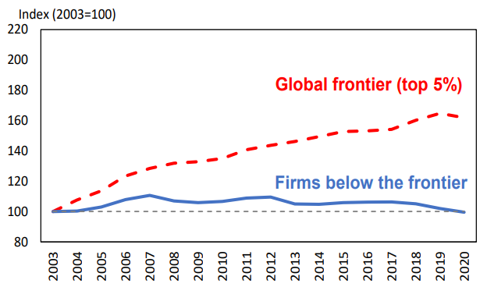 | Panel B: ICT-intensive services  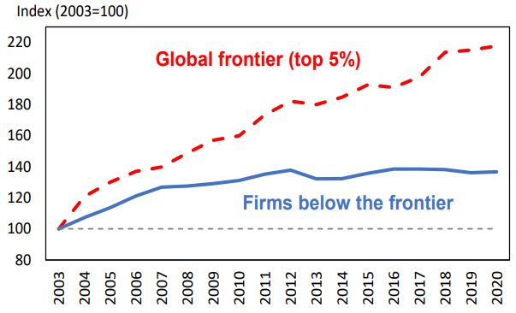
Note: Updated version of Andrews, Criscuolo and Gal (2016).

Practical considerations
- While both authors make the forceful prima facie case for ex ante regulation in digital markets, they had less to say about what this looks like in practice. On this front, more discussion on the various approaches to ex ante regulation would have been useful. This could include drawing a distinction between the “Rules-based models”— most notably characterised by the EU Digital Markets Act (DMA) – and the so-called “Flexible approaches” such as the UK model whereby the regulator applies firm-specific codes that supposedly provides greater scope to incorporate new technologies. There also little discussion of the potential compliance issues and unintended consequences with respect to ex ante regulation. In terms of the latter, recent research contends that GDPR (a Big Data Privacy Law; EU 2018) increased the fixed costs of data storage costs significantly for EU firms, putting smaller firms at a disadvantage, stifling innovation and increasing concentration (see: Garicano 2024; Johnson et al 2023; Peuker et al, 2022; Janssen et al, 2022; Aridor et al, 2023).
- To kick-off the discussion, two participants shared their contrasting views on ex ante regulation of competition in digital markets. One participant broadly endorsed the views of Gina Cass-Gottlieb and Margarida Matos Rosa, noting that the key issue in deciding whether ex ante regulation is needed or not is the degree of market power the parties have. To establish precedent, the participant noted that: i) electricity network assets are monopolies and so the general consensus is to apply ex ante regulation; and ii) when competition was introduced to Telstra, ex ante access regulation was preferred to the use of Section 46 of the CCA. It thus follows that in the digital space, where “Google has 95% of search and a stranglehold on the ad tech market, while Apple and Google control the app markets on their phones, ex post competition enforcement will not allow competition to occur, only ex ante regulation will. It can also curb the excessive use of market power. The aim of ex ante regulation must be to promote dynamic markets.”
- The other participant’s scepticism of ex ante regulation rested on two key points. First, ex ante regulation with appeals will not be a short cut. The rules will still be interpreted by the Courts and the Court decisions will determine the path of regulation. While more conduct will be per se illegal for designated businesses, history shows that per se offenses often are not clear cut anticompetitive (which is why general competition law has broadly reduced the number of per se offenses over time). Second, ex ante regulation with limited appeals of regulatory decisions will lead to more regulatory activity, more errors and regulators who avoid scrutiny. It may stop more anticompetitive – and pro-competitive – activity. The participant concluded by noting that ex ante regulation raises business uncertainty because they face a fallible regulator who oversees their decisions when trying to run their business.

Injecting a dose of dynamism into domestic markets

Administrative microdata: an enabler of structural reform
- A key theme of the paper by Jonathan Hambur and the Competition Taskforce (henceforth JHCT) is the potential for research based on administrative microdata to inform structural policy in the competition space. JHCT previewed an impressive body of microdata research, which illustrates that: i) linked employee-employer data shows that the actual amount of merger and acquisition (M&A) activity in the Australian economy is much higher than previously thought, with many mergers flying under the radar; ii) airfares on key routes decline as new players enter, reminiscent of the classic paper by Austin Goolsbee and Chad Syverson (2008) which showed that the meagre threat of entry by Southwest airlines led to material declines in airfares; iii) the macroeconomic costs of market power – based on a structural analysis on firm-level price-to-cost mark-ups – is significant; and iv) occupational licensing and worker restraint clauses can have economic effects.
- Overall, I strongly endorsed the approach and analysis of JHCT. Before undertaking a deep dive into the prevalence and impacts of worker restraint clauses, I made two related comments. First, I argued that efforts to improve access to – and capacity to analyse – administrative microdata is, in itself, a structural reform, noting that the intellectual origins of the Competition Taskforce can be partly traced to an effort of a few Australian economists to use microdata to uncover the sources of the productivity slowdown. Second, applied research that connects policy frictions to the micro-drivers of productivity slowdown – notably declining job mobility and firm entry – is key. Recent evidence suggests that the productivity slowdown may reflect a “death by thousand cuts” phenomenon, whereby the rising burdens of occupational licensing, non-compete clauses, stamp duty and (size contingent) policy changes to labour market regulation and payroll tax may have accumulated to sap the economic vitality of the Australian economy. This body of empirical evidence is crucial given we are now in a very different situation to 40 years ago, when structural reform could be solely guided by textbook economics due to the large economic distortions that prevailed.

Restraint clauses: prevalence and impacts
- Non-compete clauses – which prevent workers from joining (or starting) a competing firm – are typically justified on the basis of protecting legitimate business interests (e.g. trade secrets; Figure 3). But there are increasing concerns that they are being deployed to restrict job mobility and competition, with adverse consequences for productivity and wages. While much of the evidence pertains to the United States, an e61 Institute report in June 2023 revealed that 22% of Australian workers – including many low wage workers – were subject to NCCs, while one-half of the workforce was bound by some form of restraint clause (Andrews & Jarvis, 2023). These results were later confirmed by a large firm-level survey run by the ABS, which amongst other things showed that the prevalence of NCCs in the Australian economy has risen over time.
Figure 3. Two views on non-compete clauses (NCCs)
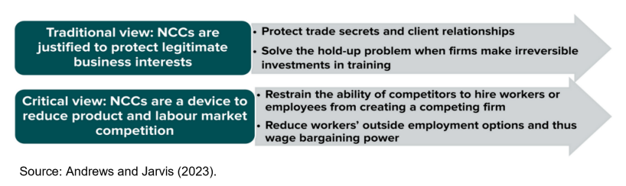
- In a recent paper with e61 Institute researchers Jack Buckley and Ewan Rankin, we provided the first Australian evidence on the potential impacts of NCCs on job mobility and wages. To do so, we exploited differences in outcomes between firms that use different types of clauses, for instance firms that only employ NDAs with firms that employ NDAs and other restraints such as NCCs (see Figure 3 for how Australian firms combine NDAs and NCCs). This provides a more reliable comparison if it effectively nets out selection into the use of any restrictions: if firms have some valuable to protect (e.g. trade secrets, IP), then their first response will be to deploy some form of restraint, but that they may well be neutral to the exact instrument or combination of instruments. Three key results emerged from our analysis:
- Increased use of NCCs is associated with a subsequent decline in job mobility, including for job switches to firms within the same industry (Figure 3). By contrast, increased use of non-disclosure agreements (NDAs) — an alternative method for firms to protect trade secrets — is not associated with a significant decline in job mobility.
Figure 4. Non-compete clauses: prevalence and impacts
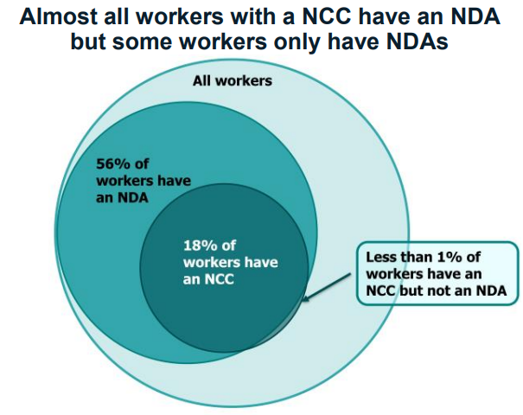 | 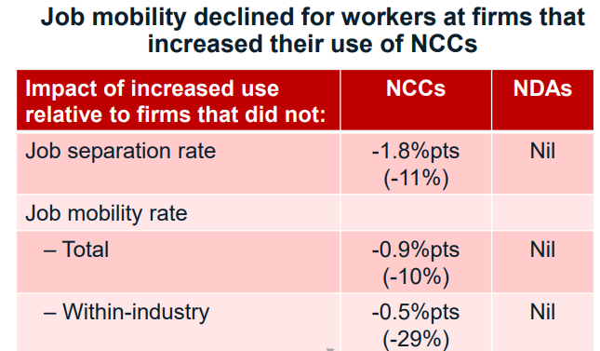
Source: Buckley, Rankin and Andrews (2024).
- Workers at firms that use NCCs extensively are paid 4 per cent less on average than similar workers at similar firms that only use NDAs, which is broadly consistent with US evidence (Balasubramanian, Starr and Yamaguchi, 2024). Workers at these two groups of firms start out with similar wages, but workers at NCC using firms experience slower wages growth over the first few years of their employment (Figure 4).
- NCCs have different associations for high- and low-skill workers. Low-skill workers see larger declines in job mobility and wages, while high-skill workers spend more time in between jobs when leaving an NCC using firm.
Figure 5. Firms use of worker restraints and wage-tenure profiles
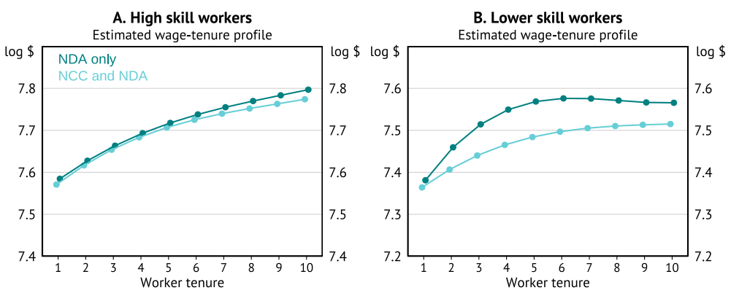
Source: Buckley, Rankin and Andrews (2024).
- Overall, our findings are consistent with the notion that NCCs may reduce worker bargaining power by distorting labour market competition. This finding is particularly significant in light of US evidence which suggests that a combination of NDAs and NCCs does not protect trade secrets any more than NDAs alone (Cowgill, Freiberg and Starr, forthcoming). It also raises the prospect that there may be less distortionary tools to protect trade secrets than NCCs.

Policy options to restrict worker restraint clauses
- The above evidence brings into closer focus the case to regulate or curtail the use of non-compete clauses and no-poach agreements. As with National Competition Policy in the 1990s, the presumption should be in favour of competition: the burden should thus be on proponents of such restraints to explain why they should exist, as opposed to on those advocating reform (Andrews, Brennan and Buckley, 2024). This matters now more than ever given emerging empirical evidence that points to a potential decline in competition in the Australian economy over the past 15 years (Andrews et al., 2023; Hambur, 2021). If there is a strong case to restrict non-compete clauses, then how do we do this in practice? Accordingly, this section discusses the merits of various policy responses – including an outright ban, a ban for low wage workers or enforced monetisation – as well as policy considerations pertaining to no poaching agreements.

Non-compete clauses
- During the discussion, I shared my views on these policy options, noting that the Federal Government subsequently announced their intention to ban NCCs for low wage workers from the 2027, along the lines of a reform Austria in 2006 (see: Andrews and Garnero, 2025). Restricting NCCs for low wage workers is attractive for equity reasons – for example, the idea that a childcare worker should be bound by a NCC rarely “passes the pub test” – and is sensitive to the idea that there may be some high paying roles where NCCs can be deployed to protect legitimate business interests (e.g. trade secrets, IP etc). Such as reform is also attractive from a practical implementation perspective: it can be readily executed via an amendment to the Fair Work Act (FWA), noting that a high-income threshold already exists that limits the eligibility of employee’s earning above $175,000 to be protected from unfair dismissal under the terms of the FWA.
- While restricting non-competes for low wage workers is now stated policy preference of the Federal Government, what would be the case for a more broad-based ban? First, a key argument is that NCCs both reduce the bargaining power of low skilled workers and hamper productivity growth by restricting the mobility of high skilled labour. While many commentators support restricting NCCs for low wage workers, they are more circumspect when it comes to executives (Starr, 2023). But Shi (2023) makes the case that optimal policy – for executives – is close to a complete ban, due to the harm to other firms, workers and consumers who are not at the table when the NCC is being negotiated. Put simply, other firms may value the executive more than the initial employer, implying that non-compete may generate a socially costly misallocation of labour. Proponents of a broad-based ban on NCCs emphasise that the adverse effects of non-competes on labour productivity – via the channels of job mobility, business dynamism and knowledge diffusion – outweigh any positive impacts on investment (see: Johnson, Lipsitz and Pei, 2023). They also note that firms have at their disposal other tools to protect trade secrets that are effective and less distortionary than NCCs, such as NDAs (see above).
- I also explored the potential for the regulation of NCCs to interact with the design of unfair dismissal laws, which has received little attention to date. A key starting point is productivity-enhancing job mobility can arise from both productive workers departing unproductive firms and productive firms shedding unproductive workers. From a regulatory perspective, the lack of restrictions on the use of NCCs may inhibit the former while stringent unfair dismissal regulation can hinder the latter. It is important to note in the United States, firms can essentially fire workers at will. When the Federal Trade Commission announced a near outright ban of NCCs in April 2024, it potentially reduced a policy asymmetry: US workers gained an ability to depart their employer on their own terms, noting that the firms always possessed ability to dismiss workers at will.
- In Australia, the situation is complicated by the fact that workers earning below the high-income threshold have much stronger protections from unfair dismissal than for higher income workers. Accordingly, Figure 5 illustrates how current and future policy changes to restrict NCC could interact with dismissal regulations to affect job mobility. A reform that restricted the use of NCCs for low- and middle-income workers could potentially boost worker bargaining power, given that such workers already benefit from relatively strong unfair dismissal regulations (see: Andrews and Buckley, 2023). All else equal, a policy reform that restricted NCCs for all workers could boost job mobility by reducing the policy asymmetry that higher income workers in Australia currently face as they are relatively easy to fire but also more exposed to NCCs (Figure 5).
- A final reform option relates to monetisation, noting that Norway introduced requirements for monetary compensation and duration limits with respect to non-compete clauses in 2016 (Andrews and Garnero, 2025). But as of 2023, evidence from Norway (Menon Economics and Hjort 2023) questioned the effectiveness of such a policy response for at least three reasons: i) the prevalence of NCCs was little changed; ii) two-thirds of businesses still provided no compensation; and iii) one-third of firms report that their clauses still included no time limits or had durations beyond the statutory limit of one year.
Figure 6. Potential interactions between non-compete and dismissal regulations: stylised example
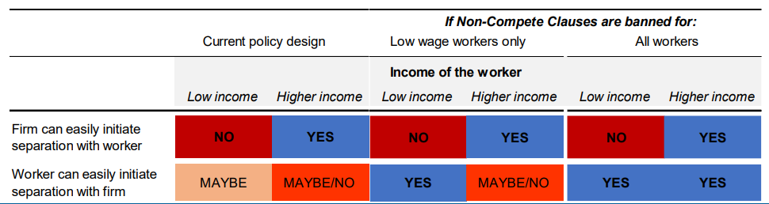
Note: Under the Fair Work Act, workers earning above the high-income threshold (of $175,000) receive much weaker protection from unfair dismissal than workers earning below the threshold. The table shows that under the policy design prevailing at the time of the Conference (i.e. November 2024), it was easier for firms to separate with a higher income worker than a lower income worker, while higher income workers encountered more difficulty initiating a separation with a firm (given they are more likely to be bound by NCCs; see Andrews and Jarvis 2023). A policy reform that restricted NCCs for workers below the high-income threshold (i.e. low-income workers) would interact with existing unfair dismissal protections to enhance worker bargaining power for low- and middle-income workers. Meanwhile, a reform that banned NCCs for all workers would also reduce the mobility that asymmetry that high-income workers face.

No-poaching agreements
- My remarks also addressed the regulation (or lack thereof!) of no poaching agreements (NPAs) in the Australian context. In almost all OECD countries, Margarida Matos Rosa noted that “NPAs are illegal from a competition law perspective”, which pertains to firm-to-firm agreements not to poach each other’s staff. But Australia is an outlier: Part IV of the Competition and Consumer Act 2010 contains exemptions for anti-competitive agreements spanning Acts done or any provision of a contract, arrangement or understanding to the extent that it relates to the remuneration, conditions of employment, hours of work or working conditions of employees. In my view, the carve-out for labour in the CCA is problematic for a few reasons:
- The available data suggests that workers are potentially unaware that they are subject to horizontal (firm-firm) no poaching agreements and the attendant (adverse) consequences for their wages. Firm-level estimates from the ABS suggests that up to 23% of Australian workers are potentially subject to NPAs but worker-level data suggests that only 7% of workers have an agreement with their employer not to poach any (former) colleagues when they depart their employer (Andrews and Jarvis, 2023).
- NCCs may amplify the impacts of NPAs: while one party can always renege in a (firm-to-firm) NPA, this threat may be diminished in an environment where NCCs are highly prevalent (such as Australia), since firms have additional tools to restrict worker mobility.
- In the context of the March 2025 Budget, the Federal Government announced that they will close loopholes in competition law that currently allow businesses to: i) fix wages by making anti-competitive arrangements that cap workers’ pay and conditions, without the knowledge and agreement of affected workers; and ii) use ‘no-poach’ agreements to block staff from being hired by competitors.

References
Andrews, D and J. Buckley (2023), No Free Lunch: The Economic Consequences of Job Dismissal Laws e61 Institute.
Andrews, D., M. Brennan and J. Buckley (2024), The ties that bind: five facts on post-employment restraints, e61 Research Note No. 12.
Andrews, D, J. Buckley and R. Lee, (2024) A Counterproductive Tax Cut: How Size-Based Payroll Taxes Can Create a Roadblock to Firm Growth e61 Institute.
Andrews, D., C. Criscuolo and P. Gal (2016), “The Best versus the Rest: The Global Productivity Slowdown, Divergence across Firms and the Role of Public Policy”, OECD Productivity Working Papers No. 5.
Andrews, D., B. Égert and C. de La Maisonneuve (2024), “From decline to revival: Policies to unlock human capital and productivity”, OECD Economics Department Working Paper No. 1827.
Andrews, D and A. Garnero (2025), “Five facts on non-compete and related clauses”, OECD Economics Department Working Papers No. 1833, OECD Publishing, Paris, https://doi.org/10.1787/727da13e-en..
Andrews, D. and D. Hansell (2021), “Productivity-enhancing labour reallocation in Australia”, Economic Record 97(317), pp. 157-169.
Andrews, D and B. Jarvis (2023), The Ghosts of Employers Past: how prevalent are non-compete clauses in Australia?, e61 Institute.
Aridor, Guy, Yeon‐Koo Che, and Tobias Salz. "The effect of privacy regulation on the data industry: empirical evidence from GDPR." The RAND Journal of Economics 54, no. 4 (2023): 695-730.
Australian Bureau of Statistics (2024), Restraint Clauses, Australia, 2023, https://www.abs.gov.au/articles/restraint-clauses-australia-2023
Balasubramanian, N., Starr, E., & Yamaguchi, S. (2024). Employment Restrictions on Resource Transferability and Value Appropriation from Employees. Strategic Management Journal.
Bowman, J., J Hambur and N. Markovski, (2024); Examining the Macroeconomic Costs of Occupational Entry Regulations Reserve Bank of Australia Research Discussion Paper No. 2024-09.
Byrne, D. M., S. D. Oliner and D. E. Sichel (2013). "Is the Information Technology Revolution Over?," International Productivity Monitor, Centre for the Study of Living Standards, vol. 25, pages 20-36, Spring.
Cowgill, B., Freiberg, B., & Starr, E. (n.d.). Clause and effect: A field experiment on noncompetes, knowledge flows, job mobility, and wages. Forthcoming
Decker, R and J. Haltiwanger (2024), “Surging Business Formation in the Pandemic: A Brief Update” Mimeo.
Filippucci, F., P. Gal and M. Schief (2024), “Miracle or Myth? Assessing the macroeconomic productivity gains from Artificial Intelligence”, OECD Artificial Intelligence Papers, No. 29, OECD Publishing, Paris, https://doi.org/10.1787/b524a072-en.
Garvin, N, G La Cava, A Moore and A. Wong (2024); Stepped on by stamp duty: The effect of housing transfer taxes on home purchases and people movement e61 Institute.
Goolsbee, A, and C Syverson (2008), “How Do Incumbents Respond to the Threat of Entry? Evidence from the Major Airlines.” The Quarterly Journal of Economics 123, no. 4: 1611–33. http://www.jstor.org/stable/40506218.
Hambur, J (2021), “Product Market Power and its Implications for the Australian Economy”, Australian Treasury Working Paper.
Janßen, Rebecca, Reinhold Kesler, Michael E. Kummer, and Joel Waldfogel. 2022. "GDPR and the Lost Generation of Innovative Apps." NBER Working Paper No. 30028. Cambridge, MA: National Bureau of Economic Research. https://www.nber.org/papers/w30028.
Jia, Jian, Ginger Zhe Jin, and Liad Wagman. 2021. "The Short-Run Effects of the General Data Protection Regulation on Technology Venture Investment." Marketing Science. Published March 1, 2021. https://doi.org/10.1287/mksc.2020.1271.
Johnson, Garrett A., Scott K. Shriver, and Samuel G. Goldberg (2023) "Privacy & market concentration: Intended & unintended consequences of the GDPR" Management Science, 69(10): 5695-5721.
Koromazy, V (2004), “Why change is so difficult Some reflections on the political economy of reform” OECD Observer No 243.
Menon Economics and Hjort (2023), Konkurransebegrensende avtaler i arbeidsforhold, Menon-Publikasjon Nr. 53/2023.
Peukert, C., Bechtold, S., Batikas, M. and Kretschmer, T., 2022. “Regulatory spillovers and data governance: Evidence from the GDPR.” Marketing Science, 41(4), pp.746-768.
Shi, L. (2023). Optimal Regulation of Non-compete Contracts. Econometrica, 91(2).
Starr, E. (2023). Noncompete Clauses: A Policymaker’s Guide through the Key Questions and Evidence. https://eig.org/noncompetes-research-brief /

Dan Andrews is the Head of Growth, Competitiveness and Regulation Division in the OECD Economics Department. The views reflect those of the author and should not be reported as representing the official views of the OECD or of its member countries.
See: Jim Chalmers (2024) “Treasurers advance national economic reforms | Treasury Ministers.”
A durable surge in new business formation in the United States is also consistent with an acceleration in underlying productivity growth going forward (Decker and Haltiwanger, 2024)
A related concern is that since accounting standards do not allow firms to recognise most intangible assets as assets, thousands of acquisitions of intangible-intensive firms fall under the threshold and thus escape regulatory review (Kepler et al 2024).
We also found two additional facts consistent with “winner-take-all dynamics”. First, global frontier firms increased their market share. Second, MFP divergence was more pronounced, both between frontier and laggard firms and within the global frontier, where the productivity of the most elite firms (top 2%) rose relative to top 5% frontier firms.
Recent research have used microdata to investigate the link between policy-induced frictions and weaker economic dynamism, with respect to: non-compete clauses (see Section 4,2); occupational licensing (Bowman, Hambur and Markovski, 2024); stamp duty (Garvin et al, 2024); labour market regulations (Andrews and Buckley, 2023); and payroll taxes (Andrews, Buckley and Lee, 2024).

