|  |  |
| --- | --- |
|  | Overview of the marine insurance market  Report to the Reinsurance Pool Taskforce  30 June 2022 |

Document classification: Confidential

|  |
| --- |
| **ACN** 087 047 809  **ABN** 29 087 047 809  www.taylofry.com.au |
| Taylor Fry Pty Ltd |

Table of contents

Table of contents 3

1 Executive summary 4

1.1 Introduction 4

1.2 Background 4

1.3 Analysis 4

1.4 Observations 4

1.5 Response to key questions raised 5

2 Introduction 7

2.1 Background 7

2.2 Scope 7

2.3 Outline of the report 8

3 Marine insurance overview 9

3.1 Introduction 9

3.2 What is marine insurance? 9

3.3 Insured marine assets and exposure 10

3.4 Insurance market data 14

3.5 Limitations 16

4 Cyclone risk modelling 17

4.1 Introduction 17

4.2 Cyclone risk pricing in marine policies 17

4.3 Methodology and assumptions 18

4.4 Summary of results 19

5 Conclusions and recommendations 25

5.1 Summary of observations 25

5.2 Response to key questions raised 26

Appendix A Survey for insurers 28

Appendix B Commercial marine insurance market participants 29

B.1 Insurers 29

B.2 Underwriters 29

# Executive summary

## Introduction

The Commonwealth Department of the Treasury, on behalf of the Reinsurance Pool Taskforce, has engaged Taylor Fry to produce a market summary report for the Australian marine insurance market with particular focus on small business marine property insurance. This report sets out the results of our review.

## Background

On 9 February 2022, the Federal Government introduced legislation into Parliament to implement a reinsurance pool (the pool) for cyclone and related flood damage to commence from 1 July 2022. It is intended that the pool will improve the affordability and accessibility of insurance for households, strata and small businesses in areas subject to high cyclone risk, mainly located in northern Australia.

On 3 December 2021, the Government announced that coverage for small business marine property insurance policies would be further developed and included in the pool from 1 July 2023. In response, a Treasury-led Taskforce was established to develop and consult on the expansion of the pool to include small business marine property insurance.

## Analysis

Limited publicly available data exists in relation to small business marine insurance risks. We have combined data from various sources to develop a general overview of the marine market in Australia and interviewed a selection of insurers to gain deeper insight into the manner in which marine insurance risks are underwritten and priced.

With the assistance of Aon, cyclone modelling was performed to assess the average annual losses (AAL) and tail risk at all Australian ports. This required assumptions to be made about the distribution of commercial vessels’ location and sum insured. As vessels are mobile, and likely to move out of harm’s way during a cyclone, the modelling results represent an ‘upper bound’ on pricing. Model results showed a total AAL of $4.6 million for the cyclone component of commercial marine insurance. Expected losses are geographically concentrated, with losses at the following four ports making 70% of the AAL: Townsville, Dampier, Mackay and Cairns. In light of the high concentration of risk, we note that targeted risk management actions at these locations is likely to be more effective at reducing losses than pooling.

## Observations

The Australian commercial marine market is relatively small, covering only around 24,000 Australian vessels primarily used for commercial purposes.

Tropical cyclone risk and other risks (such as accidental damage and theft) impact marine insurance premiums. Based on our analysis, we understand that cyclone risk is not a major driver of insurance or reinsurance premiums for marine insurance. Insurer feedback was that cyclone risk is not separately identified when pricing marine insurance, with cover typically provided on a global or regional basis. While there are no hard and fast rules, one underwriter interviewed suggested that a loading for cyclone risk of around 3% to 4% (i.e. an additional 3% to 4% on the risk premium) for a geographically spread and diverse portfolio of marine insurance products would be a reasonable rule of thumb.

Discussions with insurers also indicated that they consider the marine insurance market to be price competitive. Insurer feedback is that premiums are not unaffordable, cover is widely available and that unreasonable restrictions are not being placed on the limit of cover. In short, no evidence of market failure was found.

The assumptions and limitations in the analysis have consequences for any incorporation of this risk into the pool. First, without large datasets on vessels’ actual location histories during cyclone events, it is only possible to calculate an upper bound on expected losses. The pool administrator would therefore struggle to calculate a cost neutral premium, and ongoing pricing and reserving for a marine pool would be complex. Second, as marine insurers do not incorporate highly calibrated amounts for cyclone risk into premiums, it will be very difficult for them to remove cyclone risks from premiums on a basis that is consistent with what the pool might charge. In other words, it would be very difficult to direct or monitor the distribution of any savings to policyholders generated by the pool. Third, given that the allocation of reinsurance costs for marine insurance are often only undertaken on a regional basis, it is likely that insurers will not have a significant reduction in their cost of reinsurance should the cyclone risk be removed and included in the pool.

In summary, the data limitations, imprecise insurer pricing (with respect to cyclone risk), and mobile nature of marine assets mean that extending the pool to incorporate marine assets is highly problematic. In combination with the lack of evidence found for a market failure in the commercial marine insurance market, our view is that the costs of extending the pool to include commercial marine insurance are likely to outweigh any benefits to policyholders.

## Response to key questions raised

### What impact would intervention via inclusion of select marine insurance policies in the reinsurance pool have on this market?

We consider that inclusion of the select marine market in the reinsurance pool would have a negligible impact on the market, and potentially a negative impact. This conclusion is based on the following key elements:

* The component of marine insurance policies related to cyclone risk is relatively small (even for policies in high cyclone risk areas)
* Small commercial marine risks are substantially different to standard small commercial property risks. The key difference is that most marine assets (e.g. vessels) can move out of the way of the cyclone or alter their exposure to the cyclone risk. For obvious reasons, the standard property risk is unable to move out of harm’s way.
* The mobility of marine risks makes it difficult to determine the likely exposure to cyclone risk. For example, it is known that a number of boats with Fremantle as their home port (and, in theory, subject to very low cyclone risk) spend considerable time on the north-west coast. That said, they are also less likely to be in that region during high-risk cyclone periods.
* We consider that the modelling outlined in Section 4 is likely to represent an upper bound, or worst-case scenario for small commercial marine risks, including small marinas.

### Would the impact be lessened by having voluntary participation in the pool or mandatory?

We consider that mandatory participation is unlikely to have a material impact on the small commercial marine industry. On that basis, we are fairly confident that voluntary participation would result in little or no impact on the small commercial marine industry.

### What impact would this have on adverse selection?

It is unclear what impact the introduction of the pool for small commercial marine would have. Any impact would be highly dependent on how the cost would be attributed. For example, would any charge be based on home port, whether or not the vessel could be in a cyclone risk area, the quality of the vessel’s cyclone risk plan? It is unlikely that there would be any explicit adverse selection risk, but if charges are based on home ports then it is likely that risks would seek home ports (or whatever else works to reduce premiums) that are outside of the cyclone risk areas.

### Does the size of the portfolio affect the ability to transition into the pool?

Yes. The portfolio in question is relatively trivial compared to the land-based property risk already in the pool. This is evidenced by APRA industry statistics shown in Figure 1. In general, the larger the risk pool, the more predictable and stable the premiums can be. The small size of the portfolio, in combination with the geographic concentration of AAL, and challenges to setting a cost neutral price for cyclone risk (summarised in Section 5.1) mean that there would be significant challenges bringing commercial marine insurance into the pool.

### Is pricing the cyclone component on a cost neutral basis through the pool likely to improve affordability and accessibility?

We consider that pricing the cyclone component on a cost neutral basis through the pool would be very complex and unlikely to improve affordability and accessibility (with the possible exception of less than a handful of risks). The analysis summarised in in Section 5.1 highlights the reasons why a pool is not expected to have a material impact.

### Do the policy decisions made in respect of pool coverage for small businesses make sense for marine?

Yes and no. A maximum sum insured cap of $5 million seems reasonable in light of feedback that 90%-95% of commercial vessels have a sum insured under $5 million. However, the geographic limitations on pool coverage do not make sense for marine as vessels are mobile and their actual location may cross several cyclone risk zones over a year. For example, a fishing vessel with a home port of Fremantle may spend the majority of time in waters off the North-West shelf of Australia.

### Alternative risk mitigation actions

Our analysis has not delved into alternative risk mitigation actions. This is largely because many appropriate risk mitigation actions are already in place. For example, all licensed domestic commercial vessels are required to have a safety management system (SMS) that demonstrates and documents how a vessel meets the mandatory general safety duties. For those operating in cyclone exposed areas this includes having a plan for dealing with a cyclone event in order to meet licensing requirements. The risk management requirements placed on marine-based businesses are far more extensive than typical commercial property insurance policyholders.

Insurers also discussed the lack of moral hazard in the commercial marine market. The highest risk locations with respect to cyclone risk for marine business are well known. As a general rule, businesses operating in these areas minimise the risk of their property being exposed to cyclone events given that their livelihoods are dependent on having an operating vessel. Moral hazard is expected to be much lower in the commercial marine insurance market than other insurance markets.

Finally, however, we note that the geographic concentration of risk exposure suggests that targeted risk management actions (such as upgrading infrastructure in high risk locations to be ‘cyclone-proof’, or assertive and targeted safety warnings for vessels in specific geographic regions at risky times of year) may be more effective than pooling.

# Introduction

## Background

On 9 February 2022, the Federal Government introduced legislation into Parliament to implement a reinsurance pool (the pool) for cyclone and related flood damage to commence from 1 July 2022. It is intended that the pool will improve the affordability and accessibility of insurance for households, strata and small businesses in areas subject to high cyclone risk, mainly located in northern Australia.

On 3 December 2021, the Government announced that coverage for small business marine property insurance policies would be further developed and included in the pool from 1 July 2023. In response, a Treasury-led Taskforce was established to develop and consult on the expansion of the pool to include small business marine property insurance. Such a pool would continue to be:

* Administered by the Australian Reinsurance Pool Corporation
* Designed to provide a reduced reinsurance premium per property based on the property’s risk profile, where higher risk properties receive higher discounts
* Cost-neutral to Government over the long-term, with shortfalls funded through a $10 billion annually reinstated Government guarantee.

The Taskforce commissioned this report to assess the costs and benefits of adding small business marine property insurance into the pool, and to investigate the design and development of the coverage.

In terms of undertaking analysis of the marine insurance sector we note that publicly available data from the Australian Prudential Regulation Authority (APRA) is of limited benefit given that all forms of marine insurance are combined **and** they are also combined with aviation insurance.

## Scope

In line with the draft parameters of the small business marine property insurance pool, the scope of this report considers the risk of cyclone and related flood damage to small business marine property. Marine property that is used non-commercially (such as pleasure craft) and perils other than tropical cyclones (and related flood) are not in scope.

This paper provides analysis of the marine insurance market in Australia with a particular focus on:

* The operation of the small business marine property insurance market (businesses with sums insured less than $5 million)
* Areas which are at higher risk of cyclones.

The purpose of the analysis is to assist the Taskforce in answering the following questions:

1. What, if any, are the affordability or accessibility issues present in the small business marine property insurance market?
2. What issues are caused by cyclone and related flooding?
3. Would the inclusion of certain marine insurance policies in the cyclone reinsurance pool assist in solving these issues?
4. What are the risks from adding marine insurance to the pool?
5. Would other policy interventions be more suitable?

## Outline of the report

Our analysis and observations are provided in the remainder of this report as follows:

* **Section 3** provides an overview of the Australian commercial Marine insurance overview including the market participants, an overview of the insured marine assets and exposure, product coverage, distribution channels, underwriting practices and risk rating, risk management frameworks, reinsurance and access and affordability of insurance
* **Section 4** provides results showing the relative importance of cyclone risk to marine insurance premiums, cyclone risk and expected and tail loss results at all ports in Australia
* **Section 5** provides our conclusions, summarising answers to the questions posed by the Taskforce, and our resulting recommendations.

# Marine insurance overview

|  |
| --- |
| *This section covers: The operation of the marine insurance market including the market participants, what marine insurance products are offered including the policy terms and geographical coverage, what insurance lines of business cover marine property, the level and sophistication of data typically maintained by insurers to write the business, and the pricing methods and cost pressures.* |

## Introduction

Marine insurance makes up a relatively small proportion of the Australian commercial insurance market, accounting for only 5% of all premiums for commercial lines[1]. This is shown in Figure 1.

Figure 1: Shares of commercial insurance premiums by line of business, 2017

Pie chart representing the share of Personal lines (64.5%) versus Commercial lines (35.5%). This 35.5% of Commercial lines is then broken down in a pie chart by line of business. 
Property, commercial accounts for 30.7%
Motor, commercial accounts for 16.8%
Marine accounts for 5.1%
Liability accounts for 40.5%
and Others account for 6.9%.

Source: APRA, Swiss Re Institute 

Based on the information above, commercial marine insurance represents less than 2% of the Australian general insurance market.

## What is marine insurance?

### Insured assets

Marine insurance covers property that moves with the “rise and fall of the tide”. Covered property includes:

* Vessels (which can be split into tourist charter, ferries, workboats, tug & barge, fishing)
* Pontoons
* Other floating infrastructure.

Cargo and liability insurance are also provided, with insurance limits dependent on the nature of the commercial operations.

In this report we focus on **commercial vessels**. Commercial vessels account for the majority of marine insurance in terms of sum insured and have the most comprehensive data available.

We note that the focus on commercial vessels **excludes** pleasure craft and we do not consider the availability, affordability and/or competition in the pleasure craft market.

### Products

The products offered to commercial organisations in in the Australian marine insurance market consist broadly of:

* Business Package covering stock of private watercraft dealers
* Wharves, piles and jetties covering pontoons, jetties, walkways etc.
* Boat Dealer covering stock of watercraft on land or afloat
* Commercial hull covering commercial vessels
* Marine transit and cargo (covering goods that are static and in transit)
* Carriers’ insurance.

Several industrial special risk (ISR) products are also available in the marine sector (for ports, marinas and ship building businesses). These offer bespoke insurance for business property and continuity.

### Major differences to commercial property

Marine insurance covers property that moves with the “rise and fall of the tide”, such as vessels, and floating property such as pontoons. It does not strictly cover property for marine sector businesses on land, such as club houses, boat houses, dry docks or marine repair workshops on land.

Therefore certain “marine” risks may already be eligible for coverage in the pool from 1 July 2022 under the coverage for commercial property policies (subject to the $5 million total sum insured limit).

We suggest marine policies strictly be defined as for property that moves with the rise and fall of the tide. This would provide clear delineation between property on land (such as a sailing clubhouse) that in certain cases will already be eligible for coverage in the pool from 1 July 2022.

## Insured marine assets and exposure

### Domestic commercial vessels fleet

As noted above, we focus on Australian domestic commercial vessels (DCVs) because they account for the majority of marine insurance in terms of sum insured and have the most comprehensive data available.

The main data source on DCVs can be obtained from the Australian Maritime Safety Authority (AMSA) datasets including the Australian General and International Shipping Register (AGISR).

#### Domestic commercial vessel fleet profile

There are approximately 31,000 active DCVs operating in Australia as at May 2021. This includes approximately 7,000 human powered and sail vessels[2]. These vessels are excluded from the remainder of this report as they are exempt from a unique vessel identifier and are used in connection with recreational (rather than commercial) activities. We focus on the approximately 24,000 DCVs used in connection with commercial activities.

AMSA classifies as Passenger (Class 1), Non-passenger (Class 2), fishing (Class 3) and hire & drive (Class 4). Non-passenger (Class 2) represents the largest proportion of vessels in the DCV fleet, followed by fishing (Class 3) vessels. Figure 2 shows the distribution by type of vessel.

Figure 2: Distribution of DCV fleet by vessel class (May 2021)

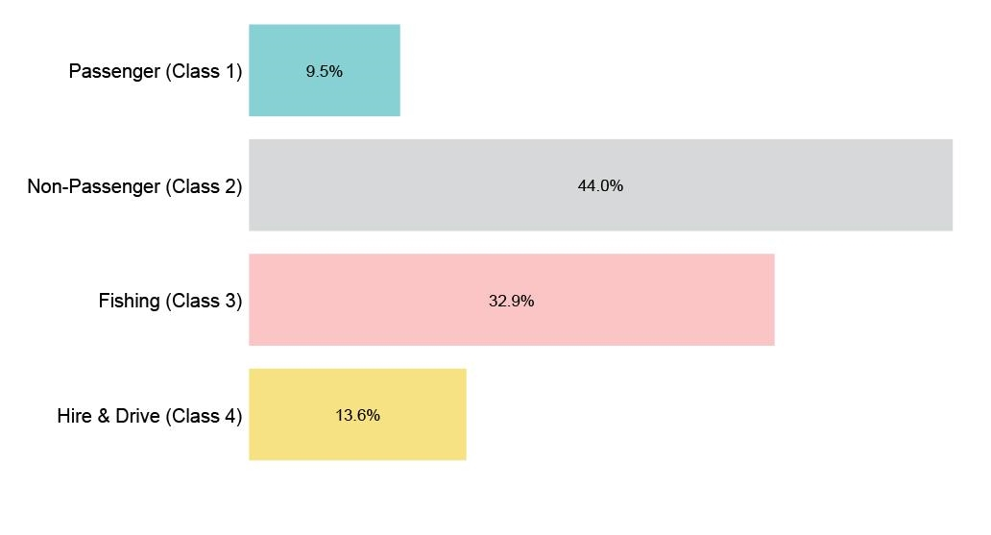

1. Source: https://www.amsa.gov.au/domestic-commercial-vessels-fleet-profile

The largest proportion of the DCV fleet with a certificate is located in Queensland (35.3%%) followed by New South Wales (26.7%) and Western Australia (11.2%), as shown in Figure 3.

Figure 3: Distribution of DCV fleet by State

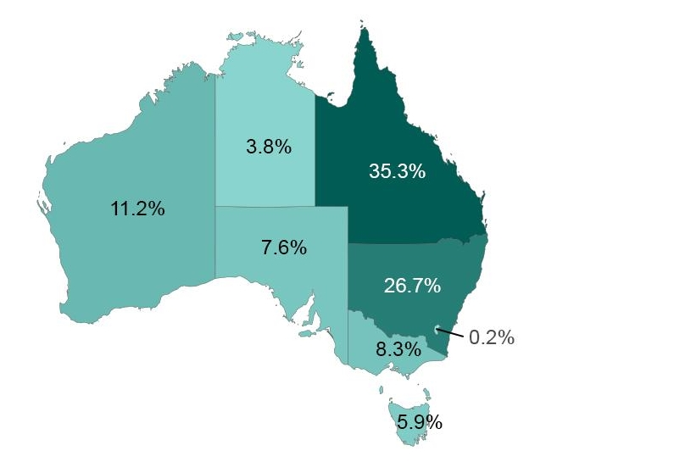

1. Source: https://www.amsa.gov.au/domestic-commercial-vessels-fleet-profile

#### Registered ships

A ship is required to be registered on the AGISR if it is an:

* Australian owned commercial vessel, 24 metres or over in tonnage length, capable of navigating the high seas
* Australian vessel, of any size, sailing to a foreign port[3].

At present only 11,511 of the total 24,000 DCVs are registered on the AGISR. For each registered ship we have data on:

* Ship Name (and Official Number)
* Length
* Year of Completion
* Type
* Home Port.

Table 1: Details of registered domestic commercial vessels

|  |  |  |
| --- | --- | --- |
| Length (tonnage metres) | Number | Registered ships |
| 0-7.5 | 128 | 1% |
| 7.5-12 | 3,970 | 34% |
| 12-24 | 6,377 | 55% |
| 24-35 | 675 | 6% |
| 35-45 | 129 | 1% |
| 45+ | 234 | 2% |
| Total | 11,513 | 100% |

As shown in Table 1, DCVs under 7.5m in length are under-represented on the AGISR.

Market value (sum insured)

Reliable data on the distribution of market value of DCVs was not readily available. Discussions with insurers suggested that:

* 90%-95% of DCVs are worth less than $5 million
* The average sum insured of insured DCVs is around $550,000.

### Ports and marinas overview

#### Marinas

Data on marinas was obtained from three primary sources:

* Publicly available reports on the “Size and Characteristics of the Australian Marina Sector[4]”
* Open-source information from the [Port Booker](http://www.portbooker.com/en/) website on the location and number of moorings at all marinas in Australia
* Open-source information from OpenStreetMap confirming the location of marinas in Australia.

Marinas have been defined in this report as recreational marinas including club and commercial marinas with 20 or more on-water boat storage spaces. There are around 350[5] marinas in Australia, offering around 39,000 moorings for private and commercially owned vessels. In terms of the geographic distribution of marinas:

* New South Wales accounts for 41%-44% of all the marinas in Australia
* Queensland with 17%-19%
* Victoria, Western Australia and South Australia all around 10%.

Figure 4 shows the home port of registered ships (green dots) as well as all marina locations (red dots) in Australia.

Figure 4: Home port location of registered ships (green dots) as well as all marina locations (red dots)

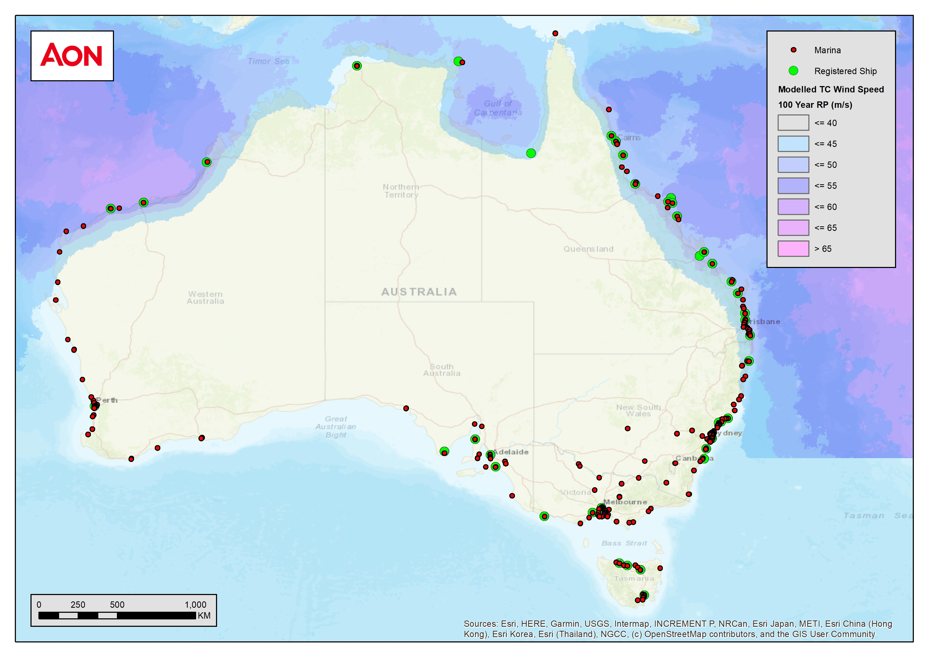

Data relating to marinas is less reliable than data on DCVs, and it has been assumed that DCVs spend very little time moored at commercial marinas.

## Insurance market data

A survey of insurers was designed and reviewed by Treasury. A copy of the survey is in Appendix A. To meet project deadlines, it was decided to directly interview insurance executives to obtain timely and comprehensive information in line with the survey questions. Executives from five insurers were interviewed. We estimate that the insurers interviewed underwrite roughly 70% of the commercial marine insurance market (<$5 million sum insured) in Australia. A more complete list of market participants is provided in Appendix B.

### Product coverage

Most insurers consulted only offer subsets of the full set of marine products. For the insurers interviewed:

* One insurer’s portfolio comprises mainly of charter/tourism vessels, some heavy commercial dredges and day passenger vehicles
* Another specialises in small-to-medium fishing vessels
* Another has seen its fleet transition from a large commercial hull fleet to a fleet with greater focus on pleasure craft and small commercial policies.

The points above highlight that the target markets and types of exposure differ considerably across the various insurers.

Treasury’s preliminary consultations revealed a similar theme, with one insurer specialising in Cargo insurance and another in commercial hull.

The insurers consulted noted that insurance for marinas was rarely below $5 million sum insured, and often insurance for marinas is offered on a proportional basis, with several insurers taking a share.

### Market share

From our research, the commercial marine insurance market is somewhat concentrated, with three insurers having a roughly 70% market share. The market also predominantly comprises vessels with sum insured less than $5 million, with 90%-95% of policies being below this threshold. The information obtained from insurers was anecdotal and “off the cuff”. We have not been provided with reliable statistics in terms of the numbers of vessels insured and the approximate market share.

### Distribution channels

Brokers play a major role in the commercial marine insurance market. Several of the major commercial marine insurers underwrite policies either via underwriting agencies or via brokers. Our understanding is that the majority of risks will initially present via a broker and may renew directly although any material change in premiums will typically lead to the insured seeking advice from their broker (noting that this is most likely to be instigated by the broker if they are aware of the availability of better terms.

We are not aware of the existence of parametric cover designed specifically for small commercial marine policies. However, in 2021 Australia’s first retail parametric cyclone insurance product for Northern Australia - [Redicova](https://redicova.com.au/) - was launched. Redicova can be purchased online. It should be noted that because parametric insurance does not indemnify actual loss incurred, it is should only ever by used as part of a company’s insurance cover. Its benefits are that payouts are triggered automatically once a pre-defined threshold of an index (e.g. wind speed index) is reached. Policyholders get paid quickly because they do not need to complete an insurance claim and loss adjustment process.

### Underwriting practices and risk rating

Insurers typically use historical logs of a vessel’s actual trip or location history over a past period for underwriting purposes. This is because most DCVs spend time moored across several ports (i.e. not just their home port). For example, many tourist and fishing vessels are registered with a home port of Fremantle but spend the majority of their time on the waters off the North-West of Australia.

Several insurers stated that geographical factors are important for a range of reasons, not just cyclone risk. For example, geographical factors are important given the much higher cost of arranging and carrying out repairs in remote locations. Similarly, a grounding of a vessel on the Great Barrier Reef will incur significant removal costs to ensure minimal impact on the reef environment.

It was noted that there may be some marinas where cyclone risk is the major risk faced, but it was unclear how much of that risk related to commercial property and marine insurance (i.e. property subject to the rise and fall of the tide).

Home port is used in this report as a guide to estimate an “upper bound” on cyclone risk and expected losses from cyclones. This is because (a) most commercial vessels will move out of harm’s way if they can and (b) losses tend to be larger for ships moored in ports or marinas during a cyclone event, than for comparable ships out at sea or “heading south” during a cyclone event.

### Risk management frameworks

We were unable to extract detailed information on risk management frameworks specific to a particular insurer. It was noted, however, that all licensed domestic commercial vessels are required to have a safety management system (SMS) that demonstrates and documents how a vessel meets the mandatory general safety duties. For those operating in cyclone exposed areas this includes having a plan for dealing with a cyclone event in order to meet licensing requirements. The risk management requirements placed on marine-based businesses are far more extensive than typical commercial property insurance policyholders.

Insurers also discussed the lack of moral hazard in the commercial marine market. As DCV owners rely on the vessels to generate their income – they almost always take very good care of the vessel and take steps to minimise damage during cyclones.

Internationally, some insurers include a ‘Named Tropical Storm Clause’. This is more relevant for non-commercially operated vessels because the owner is often a long distance from the vessel and does not have the ability to take action when a Tropical Cyclone warning is released. Feedback from our consultation indicated that this is rarely the case for DCVs because owners’ livelihood and income depends on the insured vessel, so they take action to protect it.

### Reinsurance

While the structure of reinsurance arrangements differs across insurers, it was evident from our discussions that the cyclone catastrophe component of the reinsurance premium for marine insurance was small and not explicitly calculated. Reinsurance for cyclone will typically be underwritten on a whole of portfolio basis meaning that:

* For multi-line insurers, the costing of cyclone reinsurance will be undertaken across all potential cyclone risks (including marine)
* For mono-line insurers, the costing of cyclone reinsurance will typically be undertaken on a global basis with the allocation of premiums, in many cases, being allocated to the country or region (e.g. Asia-Pacific) rather than allocation based on cyclone exposure.
* As a general rule, **the cyclone element of reinsurance for marine insurance is not separately identified**. There are a number of perils which impact marine insurance and, while the risks in southern Australia are different to those in northern Australia, the frequency and magnitude of those risks is not considered to be materially different.

Although pricing includes a component of reinsurance cost, typically reinsurance does not drive individual pricing.

### Access and affordability of insurance

Discussions with insurers indicated that they consider the market to be a price competitive market. By extension, their view was that premiums are not unaffordable, cover is widely available and that unreasonable restrictions are not being placed on the limit of cover.

Further, none of the insurers interviewed considered that marine insurance was placing any “pressure” on their reinsurance arrangements.

Interestingly, insurers indicated that there were limited geographic restrictions placed on underwriting with the exception that premium rates were typically higher for remote areas. As noted previously, this relates to the cost of repatriating and repairing vessels in remote locations. Thus, while this might relate to regions in norther Australia, it does not relate to cyclone risk.

We note that some insurers indicated that cyclone risk is not specifically considered when assessing reinsurance arrangements for their marine exposures.

The points above lead to the conclusion that there is not a sufficient market “gap” which needs to be addressed by a cyclone risk pool.

This report excludes detailed consideration of the pleasure craft market and marine assets with sum insured over $5 million. However, some insurers indicated that it was likely that some owners of pleasure craft were having issues with the availability and/or affordability of insurance. In addition, insurers noted that there are two large marinas that were unable to place 100% of their risk in recent times. That said, we understand that they placed over 80% of the risk – meaning that the two marinas are co-insuring at most 20% of their risk. These individual risks might benefit from some level of support but we consider that they are by no means indicative of market failure.

## Limitations

Publicly available data and the information insurers shared in our discussions was limited and somewhat uncertain. We note that reliable data is not available on:

* Underwriting information, namely data on the actual historic travel and location of DCVs over a typical annual period
* Costs such as brokerage and profit margins
* Claims, by product and cause
* The distribution of market value of ships across each port/location in Australia (we have assumed the same average sum insured per vessels in all ports)
* The location of ships that are not registered
* The movement of vessels and how this impacts the premiums charged.

# Cyclone risk modelling

|  |
| --- |
| *This section covers: modelling of the cyclone risk based on available data and the operation of cyclone pricing in marine policies including whether marine policies incorporate a high cyclone component in the premium and whether pricing the cyclone component on a cost neutral basis through the pool could affect affordability and accessibility*. |

## Introduction

This section summarises the operation of cyclone pricing in marine policies, including whether marine policies incorporate a high cyclone component in the premium, and provides estimates of pricing for the cyclone component of marine policies on a cost neutral basis.

## Cyclone risk pricing in marine policies

Table 2 summarises the typical split of the risk premium for $1 sum insured of property insurance in a handful of jurisdictions, expressed as a percentage. The risk premium is the expected loss cost per $1 sum insured (or unit of exposure). The risk premium is only sufficient to cover claims costs i.e. the “break-even” cost for the insurer. Total premiums are made up of the risk premium with an overlay based on underwriting judgement, the state of the market, other business costs (such as expenses and cost of capital) and target profit margin. We use the risk premium as it provides a clear view of the relative importance of cyclone risk to other perils and to non-peril risks (e.g. accidental damage, theft).

Table 2 splits the risk premium for property at five locations into non-peril premiums, and premiums for cyclone, storm, flood, bushfire and hail. Importantly, Table 2 highlights that there are very significant differences in the premium components across geographic regions. For example, cyclone risk accounts for 83% of the “All Perils” premium in Townsville, but only 23% of the All Perils premium in Manjimup and 0% in Bourke, Adelaide Hills and North Sydney. Similarly, flood risk and bushfire risk only make material contributions to premiums in some regions.

Table 2: Example of risk premium components by peril for property insurance

|  |  |  |  |  |  |  |  |
| --- | --- | --- | --- | --- | --- | --- | --- |
| Town | Non-Perils Premium | All Perils Premium | Cyclone Rate | Storm Rate | Flood Rate | Bushfire Rate | Hail Rate |
| Townsville (QLD) | 0.18 | 0.26 | 0.21 | 0.02 | 0.02 | 0.00 | 0.00 |
| Manjimup (WA) | 0.18 | 0.13 | 0.03 | 0.04 | 0.00 | 0.05 | 0.01 |
| Bourke  (NSW) | 0.18 | 0.24 | 0.00 | 0.03 | 0.18 | 0.00 | 0.03 |
| Adelaide Hills  (SA) | 0.18 | 0.16 | 0.00 | 0.04 | 0.00 | 0.11 | 0.01 |
| North Sydney  (NSW) | 0.18 | 0.05 | 0.00 | 0.02 | 0.00 | 0.00 | 0.02 |

Compared to property insurance, the all perils premium for marine insurance is likely to reflect only the cyclone rate. This is because the risk of losses from other perils – such as storm, flood, bushfire and hail – is generally immaterial for marine assets. While the example in Table 2 relates to property insurance, the geographic relativity in the cyclone rate is expected to be similar for stationary marine risks since the relativity is based on the underlying cyclone hazard.

Though there are no hard and fast rules, one underwriter interviewed suggested that a catastrophe loading (or all perils premium) of around 3% to 4% for a geographically spread and diverse portfolio of marine insurance products would be a reasonable rule of thumb.

Finally, we note that the non-peril component of a marine premium is expected to be more dominant than for property (because of the reduced influence of perils on the premium).

## Methodology and assumptions

In order to undertake modelling of the total cyclone risk to commercial marine property with the data available to us, it was necessary to make some assumptions about the location and sum insured (or market value) for DCVs.

### DCV location

First, all vessels needed to be assigned a fixed location for the estimation of damages from a cyclone. For vessels on the AGISR, the registered home port location was used. As noted in Section 3.3.1.2, however, only 11,511 of the 24,000 DCVs of interest are registered on the AGISR (with a home port). To assign a home port to the 12,489 DCVs not on the AGISR we derived a jurisdiction specific scaling factor by dividing the total number of DCVs by the total number of registered DCVs in each jurisdiction.

Table 3: Scaling factors used to assign a location to DCVs not on the AGISR

|  |  |  |  |
| --- | --- | --- | --- |
| State/Territory | Number of registered vessels | Total number of commercial vessels | Scale Factor |
| Western Australia | 1,470 | 2,721 | 1.9 |
| Tasmania | 745 | 1,433 | 1.9 |
| Northern territory | 631 | 923 | 1.5 |
| New South Wales | 2,776 | 6,486 | 2.3 |
| Queensland | 3,986 | 8,575 | 2.2 |
| Victoria | 1,268 | 2,016 | 1.6 |
| South Australia | 635 | 1,846 | 2.9 |
| Total | 11,511 | 24,000 | - |

The scaling factors in Table 3 were applied to gross-up the number of DCVs registered at each of 42 possible home ports. The underlying assumption is that the approximate location of registered and unregistered vessels is the same.

For the purposes of cyclone modelling, all domestic commercial marine exposure was assumed to be located at its home port (one of the 42 home ports across Australia).

As noted above, the use of home port is likely to result in an estimate which represents an “upper bound” of cyclone risk and the expected losses from cyclones. This is because (a) most commercial vessels will move out of harm’s way if they can and (b) losses tend to be larger for ships moored in ports or marinas during a cyclone event, than for comparable ships out at sea.

### DCV sum insured

The replacement cost of each vessel was assumed to be $500,000. This replacement cost was multiplied by the number of assumed vessels located at each port to generate a total exposure value at each port. The underlying assumption here is that the geographic distribution of the sum insured of all DCVs is roughly evenly spread around all port locations.

### Methodology

The base modelling of marine cyclone risks was undertaken by Aon with supporting information provided by Taylor Fry. Key elements of the methodology are:

* The RMS v18 Australia Tropical Cyclone model was used.
* All vessels were run through the RMS v18 Australia Tropical Cyclone model with the occupancy code of '57' which represents 'Boats, Moored, 26-60 ft, motor'. All boat-related occupancies (54-60) are identical in RMS from a damage perspective with respect to cyclone – i.e. the choice of occupancy code does not influence the model outcome.
* No insurance limits or deductibles were assumed in modelling meaning that losses are provided on a 'ground-up' basis.

We note that the results (i.e. losses) produced by commercial catastrophe models, such as RMS, are validated on a regular basis against historic claims data. This validation exercise, however, is usually only for property losses. The calibration of RMS for losses to marine assets in the event of a cyclone is likely to draw heavily on historic international claims. While marine losses are unlikely to be calibrated locally for Australia, we do not consider this is have a material influence on our conclusions given that losses for marine are arguably more standard across jurisdictions – for example, they are not as impacted by the building structure (i.e. code to which it was built) and the relative impact of cyclone-related flood.

## Summary of results

### Risk rate and annual average loss

Figure 5 summarises the cyclone rate at all home port locations around Australia. The cyclone rate removes the influence of exposure and provides a view of the annual loss cost for marine vessels per dollar of value, expressed as a percentage. As shown below, cyclone risk is only greater than or equal to 0.1% p.a. in 12 ports: Port Hedland, Townsville, Dampier, Mackay, Broome, Hayman Island, Hamilton Island, Gove Harbour, Mourilyan, Cairns, Port Douglas and Abell Point.

Figure 5: The cyclone rate at all home port locations around Australia

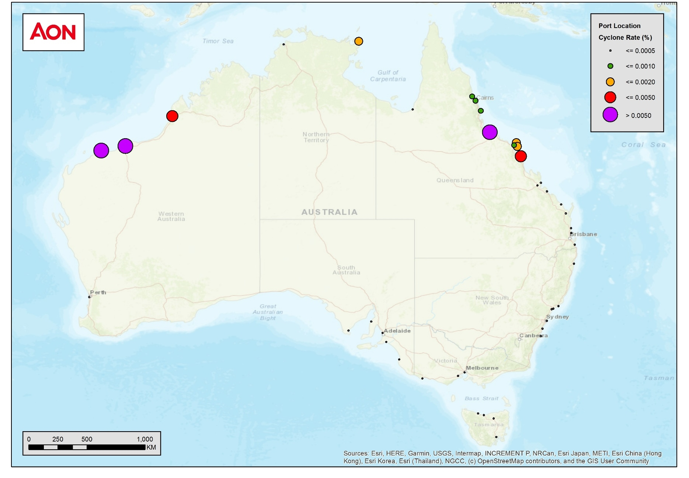

The cyclone rate multiplied by the exposure provides the average annual losses (AAL). The AAL, also called “pure premium” or risk premium, is the annualised loss that is expected (on average) each year over the very long term. This AAL value is provided at each port given the assumed exposure present. Figure 6 summarises the AAL caused by cyclones at all home port locations around Australia. The ports with the highest AAL have **both** high cyclone risk and a relatively large number of vessels assumed to be located at the port. As shown below, the AAL due to cyclones is only greater than or equal to $500,000 p.a. in 2 ports: Townsville and Dampier. Three ports have an AAL greater than $200,000 but less than $500,000: Mackay, Cairns and Brisbane.

Figure 6: The average annual losses caused by cyclones at all home port locations around Australia

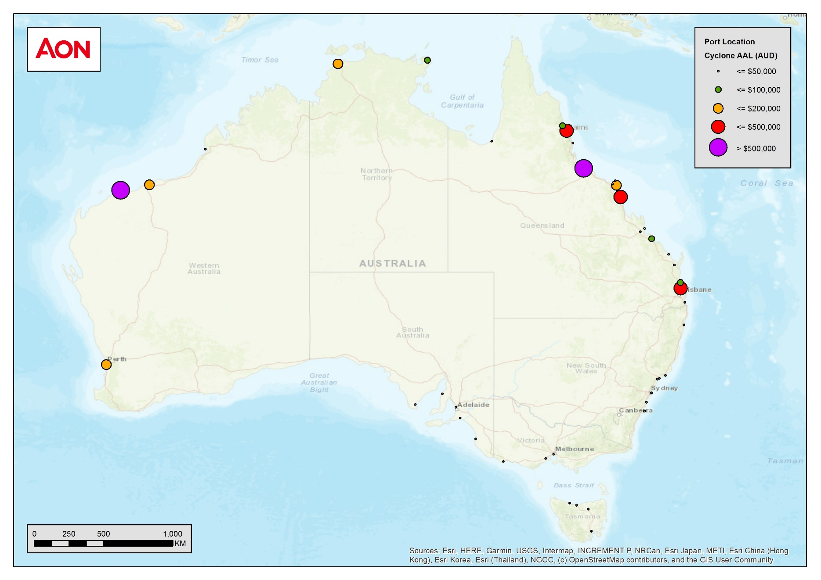

Table 4 summarises the cyclone rate and AAL at all port locations (ranked in order of cyclone rate).

Note that 18 of the 42 ports are geographically outside of cyclone-prone areas and therefore have zero cyclone risk and zero AAL. Table 4 only shows the 24 ports with cyclone exposure.

Table 4: Cyclone rate and Average Annual Loss (AAL) at port locations, ranked by cyclone rate

|  |  |  |  |  |  |  |
| --- | --- | --- | --- | --- | --- | --- |
| Port | State | Total SI ($m) | No. of DCVs exposed | Cyclone rate (% p.a.) | Cyclone AAL ($m) | % of total AAL |
| Port Hedland | WA | 20.5 | 41 | 0.77% | 0.2 | 3% |
| Townsville | QLD | 291.5 | 583 | 0.59% | 1.7 | 38% |
| Dampier | WA | 108.5 | 217 | 0.56% | 0.6 | 13% |
| Mackay | QLD | 102.0 | 204 | 0.32% | 0.3 | 7% |
| Broome | WA | 5.5 | 11 | 0.26% | 0.0 | 0% |
| Hayman Island | QLD | 19.5 | 39 | 0.16% | 0.0 | 1% |
| Hamilton Island | QLD | 122.5 | 245 | 0.16% | 0.2 | 4% |
| Gove Harbour | NT | 45.5 | 91 | 0.13% | 0.1 | 1% |
| Mourilyan | QLD | 5.5 | 11 | 0.08% | 0.0 | 0% |
| Cairns | QLD | 704.5 | 1,409 | 0.07% | 0.5 | 10% |
| Port Douglas | QLD | 88.0 | 176 | 0.06% | 0.1 | 1% |
| Abell Point | QLD | 49.5 | 99 | 0.05% | 0.0 | 1% |
| Gladstone | QLD | 159.0 | 318 | 0.04% | 0.1 | 1% |
| Rosslyn Bay | QLD | 28.0 | 56 | 0.04% | 0.0 | 0% |
| Karumba | QLD | 4.5 | 9 | 0.03% | 0.0 | 0% |
| Darwin | NT | 416.0 | 832 | 0.03% | 0.1 | 3% |
| Rockhampton | QLD | 35.5 | 71 | 0.03% | 0.0 | 0% |
| Brisbane | QLD | 1,744.5 | 3,489 | 0.02% | 0.4 | 8% |
| Mooloolaba | QLD | 328.0 | 656 | 0.02% | 0.1 | 1% |
| Fremantle | WA | 1,226.0 | 2,452 | 0.01% | 0.2 | 4% |
| Bundaberg | QLD | 137.5 | 275 | 0.01% | 0.0 | 0% |
| Maryborough | QLD | 88.0 | 176 | 0.01% | 0.0 | 0% |
| Southport | QLD | 378.5 | 757 | 0.01% | 0.0 | 1% |
| Yamba | NSW | 146.0 | 292 | 0.00% | 0.0 | 0% |

The total AAL across all exposed ports is approximately $4.6 million. This amount is very small compared to the approximate AAL of onshore property in the reinsurance pool of circa $900 million.

Furthermore, there is a clear concentration of expected losses with four ports (Townsville, Dampier, Mackay and Cairns) accounting for around 70% of the total AAL.

### Tail risk and losses under extreme cyclone events

The previous section discussed the commercial marine insurance losses that are expected in an ‘average’ year. However, there is large variability year-to-year in cyclone frequency and intensity. It is therefore also important to consider the range of losses possible during extreme cyclone events[6].

Table 5 provides total loss estimates for a range of cyclone event of specific intensities. The intensity of the cyclone is expressed as a return period. The return period associated with tropical cyclones refers to an annual probability in which an event is expected to surpass a given loss threshold. For example, a 500-year cyclone loss event has a 1/500 (0.2%) annual probability of occurrence. Each row illustrates the total expected loss impact of a cyclone event of a specific intensity.

Table 5: Total loss estimates for a range of cyclone event of specific intensities

|  |  |
| --- | --- |
| Return period (1 in x years) | Total expected loss ($m) |
| 10,000 | $1,151.7 |
| 5,000 | $599.6 |
| 1,000 | $320.1 |
| 500 | $297.0 |
| 250 | $291.5 |
| 200 | $274.0 |
| 100 | $109.2 |
| 50 | $46.9 |
| 25 | $17.5 |
| 10 | $3.0 |
| 6 | $0.6 |

As shown in Table 5, a very extreme event is required before the expected loss exceeds $320 million (a 1,000-year event or more extreme). It takes at least a 10,000-year cyclone, the limit of what is theoretically possible from a cyclone, to occur for expected commercial marine losses to be of in order of the average annual losses for property in the pool (i.e. $1,152 million vs $900 million).

Even if there is an extreme cyclone event, it is expected that losses will remain geographically concentrated at a small number of locations. That is partly because cyclones generally follow a fixed path and a single event will never impact all commercial vessels located on either the western, northern or eastern coastlines of Australia. As shown in Figure 7, expected losses remain concentrated at ports where **both** high cyclone risk and a relatively large number of vessels assumed to be located at the port. For example, in a 200-year event, losses are only expected to exceed $10 million at four ports: Townsville, Dampier, Mackay and Cairns.

Figure 7: Expected losses caused by a 200-year cyclone at all home port locations around Australia

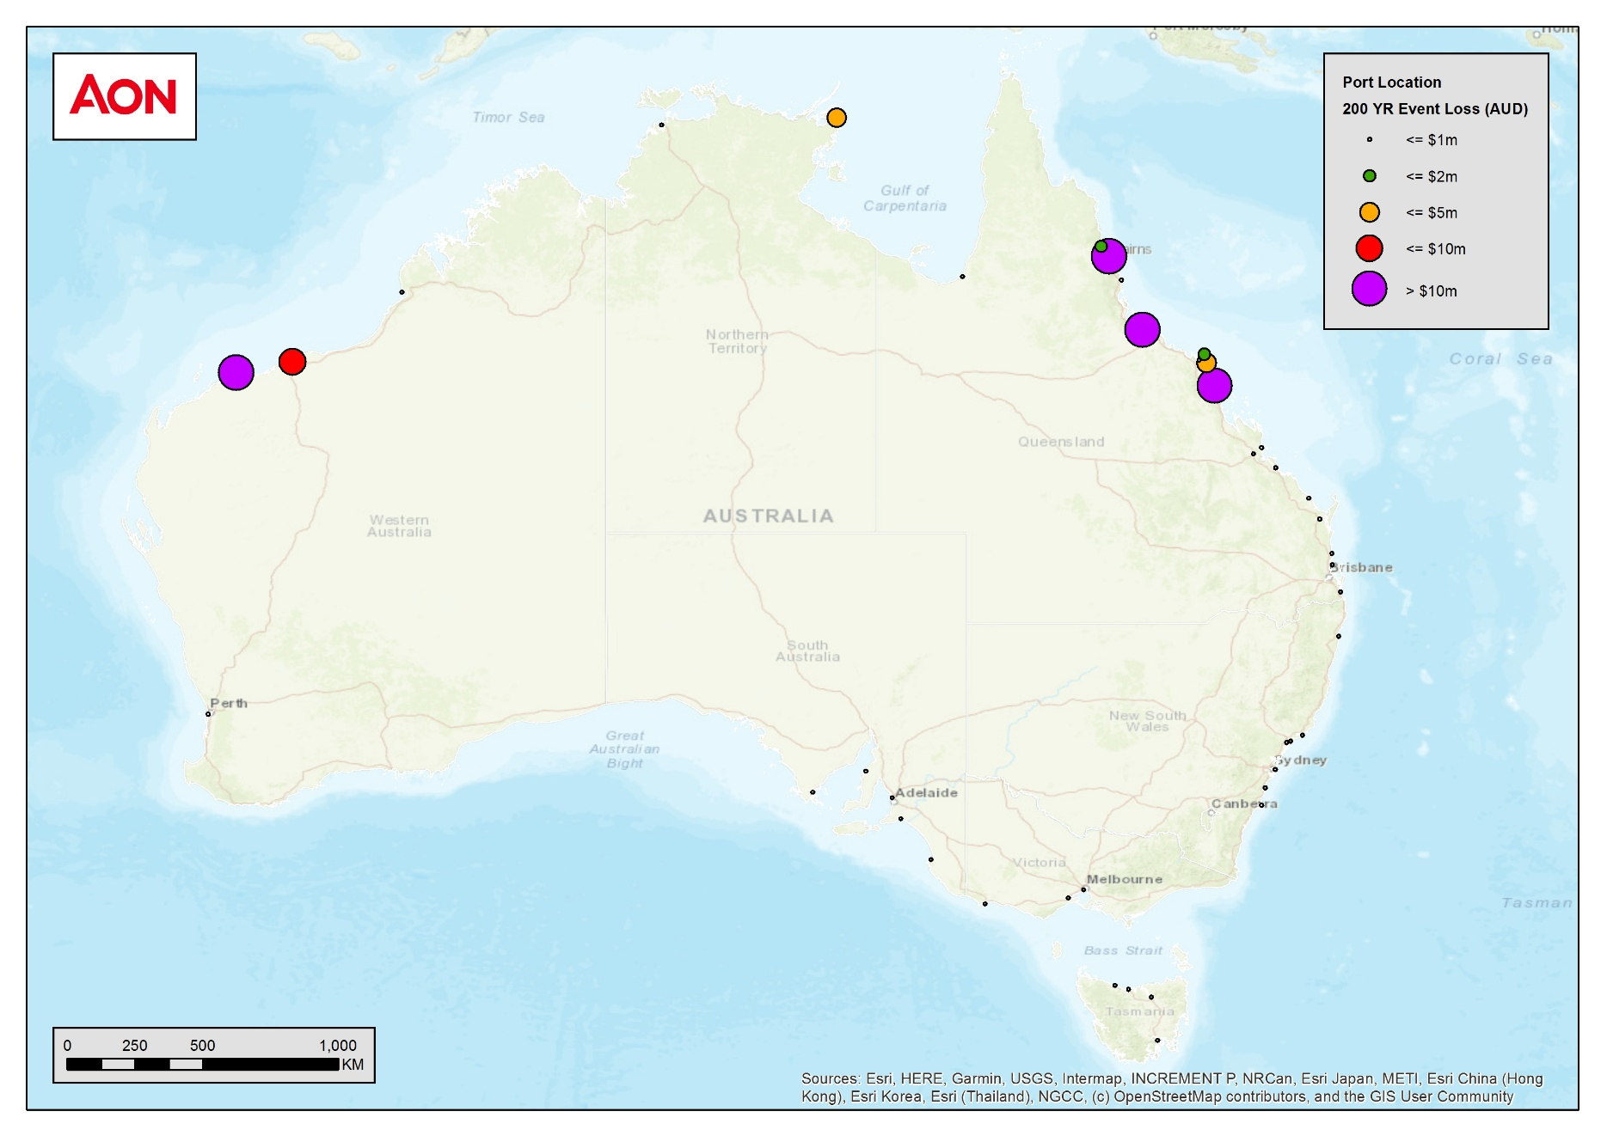

Finally, it is important to note that noting these are very conservative loss estimates, likely to be an upper bound, and that only a very small proportion of the loss would be expected to be uninsured (or underinsured).

There is some chance that there are more extreme scenarios for the property loss for larger marinas, with sum insured in excess of $5 million, however those assets were not in scope for this analysis.

# Conclusions and recommendations

|  |
| --- |
| *This section covers:*   * *The effect of marine policy coverage design options on the reinsurance pool, including implications for the pool’s premium settings and industry transition, and what level of standardisation or adjustment to reinsurance and insurance contracts may be required*. * *The size and distribution of potential marine insurance premium reductions (which may include questions on interaction with insurer retentions, insurance levies, GST and any cross subsidisation) as well as estimates of the Average Annual Loss (AAL) and Probable Maximum Loss (PMLs) for marine policies*. * *Funding arrangements, particularly what impact cross-subsidisation - such as across different areas with varying risk-levels - could have on the ability of the pool to deliver premium reductions*. * *What impact the market intervention would have on the marine insurance and reinsurance market*. |

## Summary of observations

The Australian commercial marine market is relatively small, covering only around 24,000 Australian vessels primarily used for commercial purposes.

Tropical cyclone risk and other risks (such as accidental damage and theft) impact marine insurance premiums. Based on our analysis, we understand that cyclone risk is not a major driver of insurance or reinsurance premiums for marine insurance. Insurer feedback was that cyclone risk is not separately identified when pricing marine insurance, with cover typically provided on a global or regional basis. While there are no hard and fast rules, one underwriter interviewed suggested that a loading for cyclone risk of around 3% to 4% (i.e. an additional 3% to 4% on the risk premium) for a geographically spread and diverse portfolio of marine insurance products would be a reasonable rule of thumb.

Discussions with insurers also indicated that they consider the marine insurance market to be price competitive. Insurer feedback is that premiums are not unaffordable, cover is widely available and that unreasonable restrictions are not being placed on the limit of cover. In short, no evidence of market failure was found.

Cyclone modelling was performed to assess the average annual losses (AAL) and tail risk at all Australian ports. This required assumptions to be made about the distribution of commercial vessels’ location and sum insured. As vessels are mobile, and likely to move out of harm’s way during a cyclone, the modelling results represent an ‘upper bound’ on pricing. Model results showed a total AAL of $4.6 million for the cyclone component of commercial marine insurance. Expected losses are geographically concentrated, with losses at the following four ports making 70% of the AAL: Townsville, Dampier, Mackay and Cairns. In light of the high concentration of risk, we note that targeted risk management actions at these locations is likely to be more effective at reducing losses than pooling.

The assumptions and limitations in the analysis have consequences for any incorporation of this risk into the pool. First, without large datasets on vessels’ actual location histories during cyclone events, it is only possible to calculate an upper bound on expected losses. The pool administrator would therefore struggle to calculate a cost neutral premium, and ongoing pricing and reserving for a marine pool would be complex. Second, as marine insurers do not incorporate highly calibrated amounts for cyclone risk into premiums, it will be very difficult for them to remove cyclone risks from premiums on a basis that is consistent with what the pool might charge. In other words, it would be very difficult to direct or monitor the distribution of any savings to policyholders generated by the pool. Third, given that the allocation of reinsurance costs for marine insurance are often only undertaken on a regional basis, it is likely that insurers will not have a significant reduction in their cost of reinsurance should the cyclone risk be removed and included in the pool.

In summary, the data limitations, imprecise insurer pricing (with respect to cyclone risk), and mobile nature of marine assets mean that extending the pool to incorporate marine assets is highly problematic. In combination with the lack of evidence found for a market failure in the commercial marine insurance market, our view is that the costs of extending the pool to include commercial marine insurance are likely to outweigh any benefits to policyholders.

## Response to key questions raised

In this section we provide direct responses to key questions raised by the review.

### What impact would intervention via inclusion of select marine insurance policies in the reinsurance pool have on this market?

Based on the analysis outlined in Section 4 we consider that inclusion of the select marine market in the reinsurance pool would have a negligible impact on the market, and potentially a negative impact. This conclusion is based on the following key elements:

* The component of marine insurance policies related to cyclone risk is relatively small (even for policies in high cyclone risk areas)
* Small commercial marine risks are substantially different to standard small commercial property risks. The key difference is that most marine assets (e.g. vessels) can move out of the way of the cyclone or alter their exposure to the cyclone risk. For obvious reasons, the standard property risk is unable to move out of harm’s way.
* The mobility of marine risks makes it difficult to determine the likely exposure to cyclone risk. For example, it is known that a number of boats with Fremantle as their home port (and, in theory, subject to no cyclone risk) spend considerable time on the north-west coast. That said, they are also less likely to be in that region during high-risk cyclone periods.
* We consider that the modelling outlined in Section 4 is likely to represent an upper bound, or worst-case scenario for small commercial marine risks, including small marinas.

### Would the impact be lessened by having voluntary participation in the pool or mandatory?

As noted in Section 5.2.1, we consider that mandatory participation is unlikely to have a material impact on the small commercial marine industry. On that basis, we are fairly confident that voluntary participation would result in little or no participation in the pool.

### What impact would this have on adverse selection?

It is unclear what impact the introduction of the pool for small commercial marine would have. It is highly dependent on how the cost would be attributed. For example, would any charge be based on home port, whether or not the vessel could be in a cyclone risk area, the quality of the vessel’s cyclone risk plan? It is unlikely that there would be any explicit adverse selection risk but it is likely that risks would seek home ports (or whatever else works to reduce premiums) that are outside of the cyclone risk areas.

### Does the size of the portfolio affect the ability to transition into the pool?

Yes. The portfolio in question is relatively trivial compared to the land-based property risk already in the pool. This is evidenced by APRA industry statistics shown in Figure 1. In general, the larger the risk pool, the more predictable and stable the premiums can be. The small size of the portfolio, in combination with the geographic concentration of AAL, and challenges to setting a cost neutral price for cyclone risk (summarised in Section 5.1) mean that there would be significant challenges bringing commercial marine insurance into the pool.

### Is pricing the cyclone component on a cost neutral basis through the pool likely to improve affordability and accessibility?

We consider that pricing the cyclone component on a cost neutral basis through the pool is unlikely to improve affordability and accessibility (with the possible exception of less than a handful of risks). The analysis summarised in in Section 5.1 highlights the reasons why a pool is not expected to have a material impact.

### Do the policy decisions made in respect of pool coverage for small businesses make sense for marine?

Yes and no. A maximum sum insured cap of $5 million seems reasonable in light of feedback that 90%-95% of commercial vessels have a sum insured under $5 million. However, the geographic limitations on pool coverage do not make sense for marine as vessels are mobile and their actual location may cross several cyclone risk zones over a year. For example, a fishing vessel with a home port of Fremantle may spend the majority of time in waters off the North-West shelf of Australia.

### Alternative risk mitigation actions

Our analysis has not delved into alternative risk mitigation actions to any degree. This is largely because much of the appropriate risk mitigation actions are already in place as discussed in Section 3.4.5. For example, all licensed domestic commercial vessels are required to have a safety management system (SMS) that demonstrates and documents how a vessel meets the mandatory general safety duties. For those operating in cyclone exposed areas this includes having a plan for dealing with a cyclone event in order to meet licensing requirements. The risk management requirements placed on marine-based businesses are far more extensive than typical commercial property insurance policyholders.

Insurers also discussed the lack of moral hazard in the commercial marine market. The highest risk locations with respect to cyclone risk for marine business are well known. As a general rule, businesses operating in these areas minimise the risk of their property being exposed to cyclone events given that their livelihoods are dependent on having an operating vessel. Moral hazard is expected to be much lower in commercial marine than other insurance markets.

Finally, we note that the geographic concentration of risk exposure suggests that targeted risk management actions (such as upgrading infrastructure in high risk locations to be ‘cyclone-proof’, or assertive and targeted safety warnings for vessels in specific geographic regions at risky times of year) may be more effective than pooling.

##### Survey for insurers

The following questions were proposed to be sent via a survey to insurers. For a range of reasons it was agreed that the survey would not be sent and that a select number of insurers would be interviewed with the following questions covered in an informal interview.

* 1. What is your estimated share of the commercial marine industry insurance market?
  2. What distribution channels do you use for marine industry policies?
  3. What products do you offer to small businesses in the marine industry (e.g. commercial hull, yacht and pleasure craft, marinas, manufacturers, repairers)?
  4. Approximately how many policies of each type (or in aggregate) do you have in total and by region?
  5. Are you able to provide a rough split of gross written premium by product line?
  6. Are you able to provide information on sum insured by product line including:
     1. Average sum insured
     2. Proportion of policies with SI < $5m?
  7. Do you underwrite marine industry cover policy by policy (custom solutions) or do you have a broad framework for accepting risk based on sum insured?
  8. Do you include an explicit cyclone loading in premiums? If not, how do you include the cost of cyclones (including reinsurance costs) in premiums?
  9. Do you have any geographic restrictions on underwriting marine industry cover?
  10. Do you have a defined risk management framework or risk mitigation actions to mitigate cyclone risk (e.g. a “Named Tropical Storm Clause” or other requirement on vessel owners to take or arrange for preparation steps such as securing and protecting vessels or moving vessels out of harm’s way)?
  11. For the categories of products you identified in question 3, what are the total marine industry sums insured?
  12. What are your perceptions of the access and affordability trends in the commercial marine industry insurance market for policies with cyclone risk? Are there particular product lines where the issues are highest?

##### Commercial marine insurance market participants

This Appendix provides a list of participants in the Australian commercial marine market. The list contains the main market participants but is not expected to be a complete list.

###### Insurers

* AIG Australia
* AM&T (a company of Allianz)
* Chubb
* Club Marine
* Coast Insurance
* Liberty
* Nautilus Marine
* New Wave Marine
* NEPIA (trading as Sunderland Marine in Australia)
* NTI
* Oceanic Marine Risks
* QBE
* Tudor Insurance
* Vero
* Zurich

###### Underwriters[7]

* Berkshire Hathaway Specialty Insurance Company
* HDI Global Specialty SE
* Lloyd's
* Zurich

[www.taylorfry.com.au](http://www.taylorfry.com.au)

1. See p. 5 here: https://www.swissre.com/institute/research/topics-and-risk-dialogues/economy-and-insurance-outlook/australian-commercial-insurance-market.html
2. https://www.amsa.gov.au/domestic-commercial-vessels-fleet-profile
3. Ships not meeting this criterion are permitted to be registered if:

   * more than half of the total 64 shares are owned by Australian nationals, or
   * it is less than 12 metres in length overall and wholly owned or operated by Australian residents or by Australian nationals and residents together, or
   * it is on demise charter to an Australian based operator, commercially operated and 24 metres or more in tonnage length.

  
4. See: https://www.marinas.net.au/documents/item/74
5. Numbers from publicly available reports on Australian Marinas were cross-checked against current data scraped from [Port Booker](http://www.portbooker.com/en/)
6. Considering the range of losses possible during extreme cyclone events also provides a very rough guide as to what losses might look like if climate change increases the frequency and/or intensity of cyclones.
7. We note some insurers act as underwriters for some products, and vice versa.