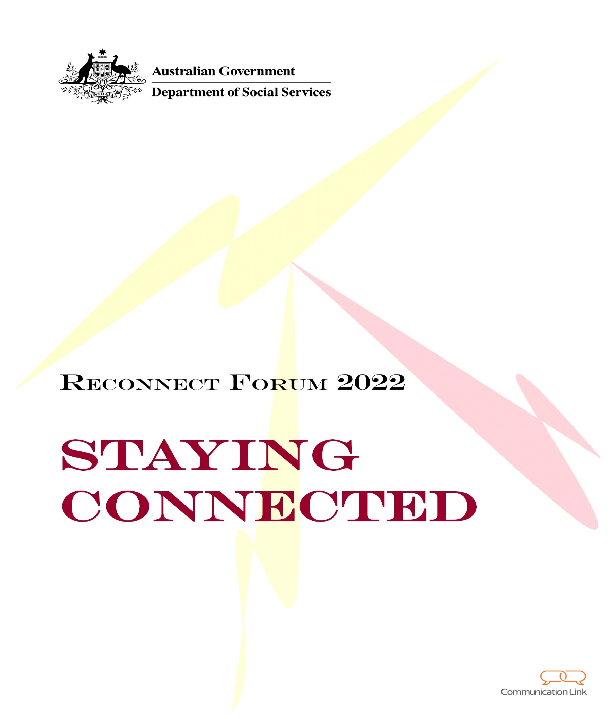

Contents
Reconnect Forum Report 1
1. Introduction 3
2. Reconnect Forum Day 1 4
2.1 Working with LGBTIQA+ Young People Presentation 4
2.2 Case Studies 4
2.3 Networking 6
3. Day 2 11
3.1 Safe and Supported Presentation 11
3.2 DEX Q&A 11
3.3 Reconnect into the Future 11
4. Feedback on Reconnect Forum 2022 15
4.1 Case Studies 15
4.2 Agenda Topics 16
4.3 Future Reconnect National Forums 17
5. Conclusion 18

- Introduction
The Reconnect Forum 2022 (the Forum) was hosted in March 2022 to provide opportunities to share information and foster connections between Reconnect service providers, funding agreement managers and departmental staff.
To maintain accessibility noting the current COVID health requirements the Forum was held online using Microsoft Teams. The Forum was held over two half days and in recognition of different time zones across Australia – there was a morning and afternoon group. Day 1 for groups 1 and 2 occurred on the mornings of 15 and 17 March 2022 respectively, and Day 2 on 22 and 24 March 2022.
The forum consisted of presentations from guest speakers, delivery of case studies and networking opportunities for the participants. Presentation topics covered were:
- Working with LGBTIQA+ young people;
- Safe and Supported: The National Framework for Protecting Australia’s Children 2021-2031;
- Data Exchange (DEX) Question and answer session; and
- Reconnect into the Future.
On Day 1, a series of different case studies were shared to encourage exchange of information and knowledge sharing.
To replicate the networking and discussions that often occur at in-person forums, online small group discussions and breakout groups were used.
Following the Forum, participants were invited to provide feedback through an online evaluation survey.
This report provides an overview of the presentations, areas of discussion and evaluation survey results.

- Reconnect Forum 2022 - Day 1
This section provides an outline of the presentations and activities undertaken on the first day of the Forum.
  - Working with LGBTIQA+ Young People Presentation
Twenty10 and Open Doors discussed the environments and experiences youths in the LGBTIQA+ community confront and provided advice on ways to ensure an inclusive and safe space for young LGBTIQA+ people. Topics covered included the creation of safe spaces, using inclusive language and understanding how to communicate with sensitivity.
Discussions in Group 1 noted how heavily gender is ingrained into society, which often leads to young members of the LGBTIQA+ community feeling unwelcome and unable to engage effectively. Spaces and conversations can be altered in order to welcome young LGBTIQA+ members, examples included how conversations are had within classrooms to avoid singling out individuals and creating spaces where young LGBTIQA+ members feel safe.
Group 2 discussed the availability of services in regional and rural areas in Australia and how limited access to services can leave young LGBTIQA+ members feeling unsupported. Conversations suggested that more work could be done to activate inclusive groups in these areas to ensure these young people have a space that belongs to them and provides a supportive environment.
  - Case Studies
A feature of Day 1 of the Forum was the presentation of several case studies. These were presented in a small-group format allowing for interaction, discussion and knowledge sharing with case study presenters. Table 1 provides a summary of the case study presentations.

- Reconnect Forum Case Study Presentations
Group | Title | Presenting organisation | Case study overview
1 | Resilience Program | Mission Australia Gold Coast (QLD) | The recognition of a lack of programs provided to young teens around resilience led to Mission Australia creating a three-week early intervention program for building resilience. The program was provided to year 7 and 8 students and results from week 1 and week 3 showed improvement in all participants.  Further information on this program is available from  Chris Coutlis, Youth and family worker, coutlisc@missionaustralia.com.au

Group | Title | Presenting organisation | Case study overview
1 | Bourke Youth Van | CatholicCare Wilcannia-Forbes (NSW) | In response to some young people in Bourke partaking in risk taking and anti-social behaviour CatholicCare created Youth Van. The purpose of the Youth Van is to provide home-cooked meals and meaningful activities that create a soft-entry point to Reconnect services.  Further information on this program is available from  Christine L’Estrange, Cultural Engagement Manager, CatholicCare, clestrange@cccwf.org.au.
1 | Group Work and Partnership with Schools | Uniting Reconnect Southwest Sydney (NSW) | South West Sydney’s Reconnect group work has worked to develop stronger partnerships with schools. Students have benefitted from the Renavigating Anger and Guilty Emotions (RAGE) program based on feedback regarding students’ desired outcomes. Further group discussion focused on how schools identify which students would benefit from the RAGE program.
1 | Working Creatively and Therapeutically with Young People | The Association for Services to Torture and Trauma Survivors (ASeTTS) | To assist young people of refugee backgrounds and the trauma they may have experienced, ASeTTS created the Circle of Courage program. The design of the program allows for participants to feel a sense of ownership over the program’s outcomes including through the initial Preparation and Activity Day.
1 | Building Connections with Community | GAP Youth and Community Centre (NT) | Building community connections in Central Australia is difficult due to barriers created by the communities’ remote locations. This case study explored what could assist in improving services and families’ wellbeing in Central Australia.
2 | Equine Therapy Program | Youth Transition Services (QLD) | This program was created with the desire to create an innovative program that provided young people with both emotional support and fun activities to enrich their personal experience. The program has achieved positive outcomes such as a soft entry for young people into Reconnect programs, and increased engagement by building rapport and trust in participants.
2 | Working Alongside Aboriginal Health and co-facilitating the Yorga’s Yarning Circle | Albany Youth Services Association (AYSA) (WA) | The Yorga’s Yarning Circle provides a safe space, co-facilitated by Aboriginal Health and AYSA, to discuss women’s health and family assistance. This case study shared the story of contact initiated at the Yorga’s Yarning Circle, leading to AYSA assisting a 17-year-old indigenous female in navigating life and family after experiencing tough family difficulties in a short time span.

Group | Title | Presenting organisation | Case study overview
2 | A Client’s Journey Through Reconnect: Moving Reconnect into the Future | MercyCare (WA) | MercyCare collaborated with Australian Childhood Foundation to create a framework that ensures consistent service delivery and documentation across all cases. The client’s journey was assessed from triage to exit. This breakdown of the service guided discussion towards how the service delivery can be improved to match the complex needs of clients and the changing landscape of the service.
2 | Supporting Aboriginal Youth In Remote Locations | Waltja Tjutangku Palyapayi Aborinigal Corporations (NT) | The Waltja programs look a bit different to other Reconnect programs because of the locations and conditions that communities must deal with. The case study focused on a young woman from  Mt. Liebig and the challenges she faced due to gaps in the services in the area. She was forced to move between locations due to domestic violence. Waltja assisted in finding her accommodation where needed and helped her finally return home to a safe environment.
  - Networking
Day 1 included a networking session in which participants were broken into small groups and invited to discuss the following question.

What are the key, emerging trends you are seeing with respect to early intervention and the prevention of homelessness?
The networking session consisted of a breakout group, that did not include an official facilitator, to allow for group members to focus on speaking to one another rather than to one person. Feedback from the networking sessions were captured after each session through an online polling tool called Slido. The themes were similar across both groups, with very few being surprised by what they heard and a majority seeing similar trends across all group participants. The results of this polling are captured below.

What did you talk about? What was the key emerging trend you discussed?
Group 1
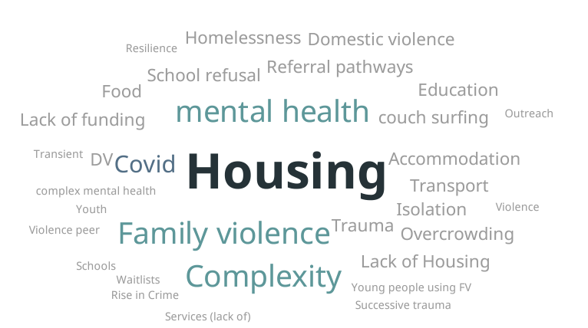

Group 2
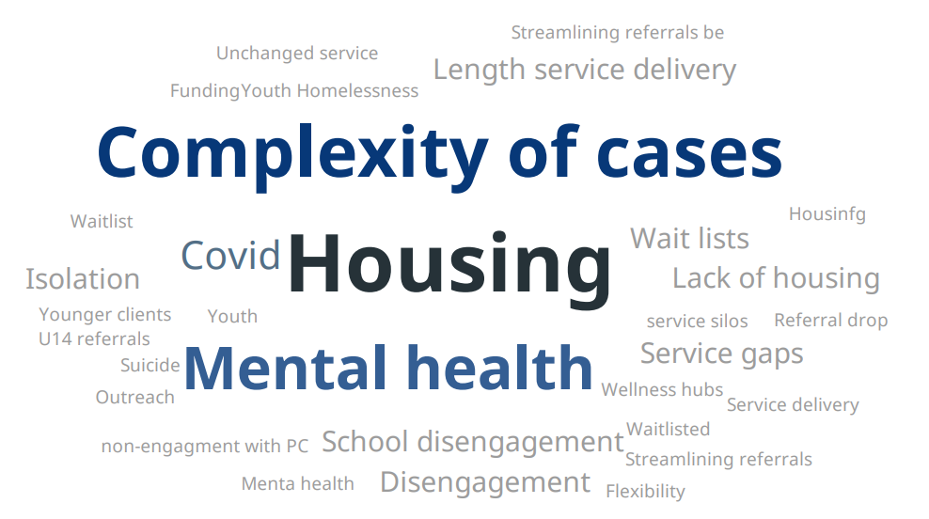

When you discussed the emerging trends did you find that:
Group 1
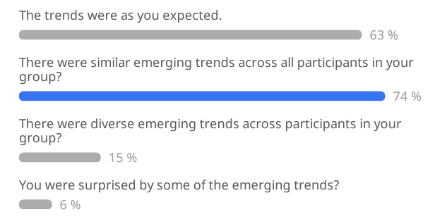

Group 2
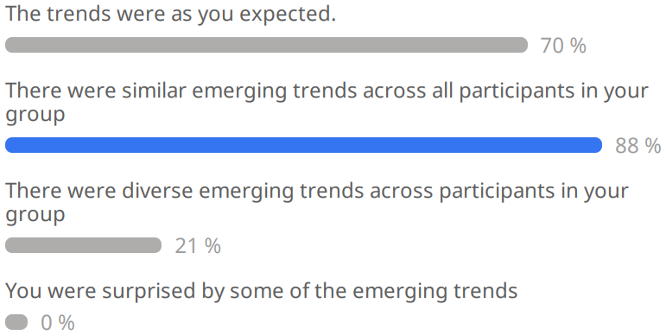

What topics would you like to discuss further (at future Fora)?
Group 1 | Group 2
Linkage with early intervention with homeless program.  Look again at Policy Re youth working collaboratively with other agencies in regard to providing support to youth coming from refugee like and asylum seeking background  Linkage with early intervention with homeless program.  Engage with parents, sustainability of Reconnect program  Getting young people back into school after COVID.  Resources for drug and alcohol programs in remote areas  Look again at Policy re youth homelessness  Building ties again with Centrelink, new system online not helpful  More housing options for youth  More mentors available for youth  How do you stay in a 3 to 4 months support period?  Resilience building  Solutions or suggestions for some of the issues that were raised e.g. funding for mental health support  Funding for additional workers  How we can advocate for housing to support First Nations People  Connectivity/collaboration between programs at local level  How to problem solve and use the time productively, rather than just complain about how difficult things are  Early intervention vs crisis  How services can work collaboratively to assist YP's well being  How to maintain early intervention approach  How we can get innovative in the housing sector.  Housing for youth.  Housing options for young people  Services that will support complex presentations  Support period length, training resources to upskill staff in group work, true early intervention  What are emergency housing options in your area?  Addressing family conflict earlier  Solutions for crisis housing youth  How can we connect our clients, to reduce isolation and increase access?  Support payments from Centrelink for students to help with school fees, where parent refuses to pay  Gaps in Reconnect regions  How to find early indicators of homelessness  Long term service delivery opportunities for young people  Regional housing for young people  Mental health and commitment to young people  Innovative  Housing opportunities for young people 11-16  Mental health availability for young people  Sustainability of Reconnect  Working more closely with schools  Advocacy for housing for youth  Housing solutions  More affordable housing!  More focus on Mental health support  Better relations with child protection  Parental engagement  More funding  How agencies can work collaboratively to support young people  Early intervention rather than when clients are in crisis  Innovative practice  Parental engagement  Basic life skills programs  How we can advocate for better housing for youth homelessness | What we can do rather than focusing on barriers which are always there  Coordination and collaboration  Development of the DEX reporting portal to better suit program needs  Availability and increased access to resources as its limited  Innovative approaches such as the Geelong project  Funding  Increased funding to address needs that are more complex over longer term.  DEX reporting of groups too  Accessing accommodation for young people who live in an area with minimal options.  Future of reconnect as it is shrinking staff  More staff  Increasing service provision - 3 months is difficult  More part time workers due to decreasing funds  Youth mental health  The lack of housing for young people in rural and remote areas  Future of Reconnect funding and growth  Government approach to decreased funding with increased need  Whether the Geelong Project has been scaled up for urban regions?  Housing pathways and practice issues and strategies as we emerge from COVID  How limits on Youth services create harm and access issues for our youth  Length of service delivery  Funding for Reconnect programs  Solutions  Future of Reconnect  Different ways to engage with young people  Housing  Isolation  Disengagement from school  Re engagement

- Day 2
This section provides an outline of the presentations and activities undertaken on the second day of the Forum.
  - Safe and Supported Presentation
The Safe and Supported: The National Framework For Protecting Australia’s Children 2021 – 2031(the National Framework) presentation provided a report on the efficacy of the current National Framework in reducing child abuse and neglect. Findings suggest that substantial and sustained reduction has not been achieved.
It was recognised that the development of the National Framework needed to consider priority groups such as children and families with multiple and complex needs, and children and young people and/or parents/carers with disability experiencing disadvantage or who are vulnerable. Defining these groups helps to ensure that groups that might sometimes be overlooked are receiving beneficial support.
The presentation explained the two 5-year Action Plans created in partnership with Aboriginal and Torres Strait Islander to support systematic change for children, young people, and families. The expected steps to be taken on the National Framework includes information on the Action Plans, Outcomes Framework, and Performance and Evaluation Strategy. The new commitments of Closing the Gap, the Grandparent Adviser Line, and National Children’s Commissioner were highlighted to provide context for the ways in which the National Framework will be structured.
  - DEX Q&A
Participants in Day 2 were provided an opportunity to ask questions and see a demonstration of the Reconnect Data Exchange presented by Susan Sancbergs, Director, DEX Policy and Operations.
  - Reconnect into the Future
The final topic for Day 2 was Reconnect into the Future, which featured a presentation from Katey Dugale of data analytics on the Reconnect Program. Following the presentation, participants were placed into breakout rooms and asked the following.

Think about what Reconnect might look like into the future for the
client, workers and the organisation.
Discussion was guided by a Department of Social Services (DSS) facilitator, and participants were given 15 minutes in their groups before re-joining the larger group to share the results of their discussion. Slido was used to collate the data from group discussions and the results were as follows.

What is the most important change or improvement needed for Reconnect CLIENTS?
Group 1 | Group 2
Working with young people under 12  More Mental health support & education options coming out of COVID pandemic  Carer/parent participation  Indigenous Education Officers  Transport  Funding for greater multidisciplinary teams  Affordable housing  Drop age requirement to 10 years  Accommodation options  Long term housing, not stop gap emergency accommodation  Mental health support and understanding  Housing that can be accessed more quickly  Housing options  Support for parents  Earlier intervention  Schools to allow connections with Services offering support for youths  Increase the engagement period  Expand to cover greater areas  Multidisciplinary team  Supported accommodation for both long term and short term for young people  Earlier intervention/referral before it becomes a crisis  Mental health specific  Mentorship  Financial support  Supported accommodation  Collaboration with other agencies, unskilled practitioners to help support YP  Mental health support  Housing  More access to specialist services and accommodation | Flexible number of sessions per client  Flexible area of service  Under 16 services  More formal resources/support for those who support clients with temporary accommodation  Include Grade 6 students to help with transition to high school  AOD services for under 16s  More funding and flexibility  Provide trauma informed info to couch hosts.  Brokerage allocation to support clients  Under 16 housing options  Funding for more skilled staff  Longevity of funding  Funding for case management  No service time/region limits  Time frame  Consistent allied health access - mental health AOD etc  More time for service  Funding  Flexibility in service delivery options and length of service  Support couch hosts with resources/vouchers.  More accommodation services  Supported accommodation options  Wider age range  Housing  Increased and more flexible funding  Additional time in service  More housing  More accommodation  Flexible support

What is the most important thing YOU need to deliver outcomes for your Reconnect client?
Group 1
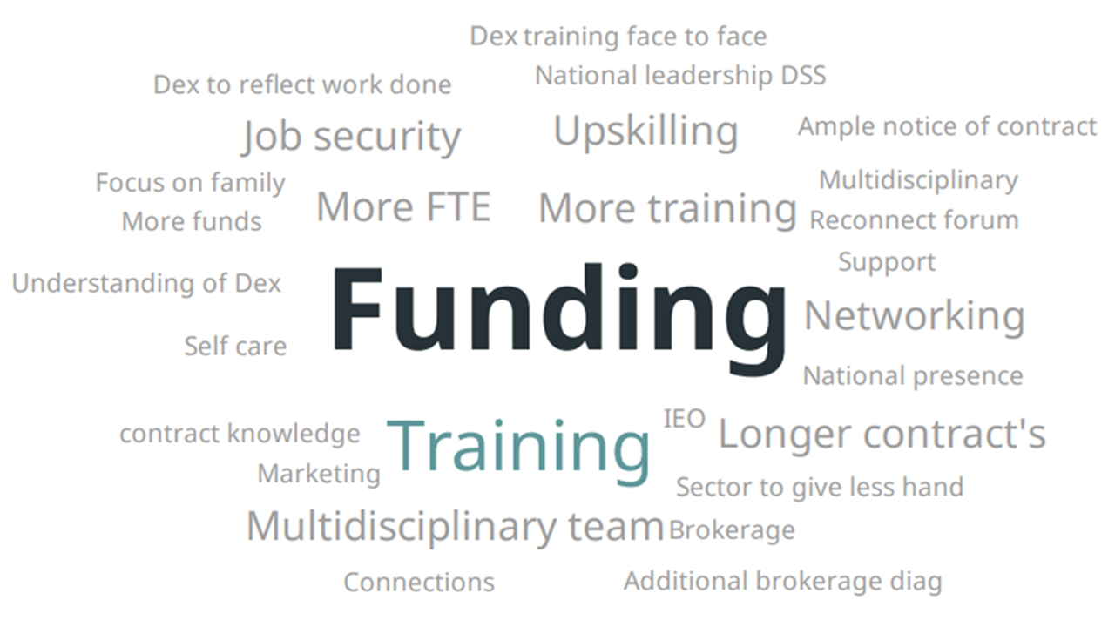
Group 2
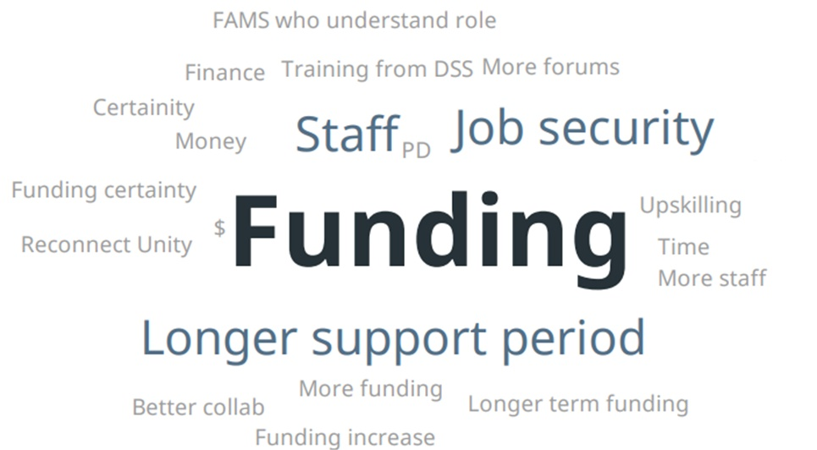

In addition to more funding, what would help your ORGANISATION to deliver Reconnect services?
Group 1 | Group 2
Review service need areas  Resources  Multidisciplinary teams  Networking and training  Housing availability  More staff and resources to provide service to more clients  Services that will diagnose mental health issues for free  Employing AOD specialists, youth workers, GP, extending catchment regions  Multidisciplinary team  Training networking  More funding for additional staff  More staff  One on one discussion  Workers only supporting reconnect clients  Extra staff  Supervised housing options in regional towns  More staff within Reconnect  Extend regions or increase out of catchment, additional qualified staff  Working collaboratively with other service providers  Accommodation options  Increased catchment areas  More staff, multidisciplinary teams  Networking  Support for workers not to burn out | More programs outside reconnect in rural and remote that we can refer to, when YP don’t fit our criteria.  Link into other services - connections  More resources for understanding younger clients  Cultural training  Stability of allocated FAM  Staff with good understanding of Reconnect program  Experienced staff  Skilled staff to address complex issues  FAMs with good understanding of Reconnect Program  Less criteria to accept clients  Less time spent reporting  Consistent and appropriate supervision  Funding security  Retaining staff  More staff  Extra staff  Clearly articulated expectations  Staff

- Feedback on Reconnect Forum 2022
Following the Reconnect Forum, participants were invited to complete a post-event evaluation survey. 42 participants completed the survey. The results are outlined below.
  - Case Studies
Feedback from the Day 1, group 1, case studies was overall positive and it was suggested that more time could have been allocated to discussion. Others commented that the presenters seemed poorly prepared as the conversation was very location specific and more effort could have been made to summarise the discussion.

- Feedback on the Day 1 case studies

Feedback from Day 1, group 2, case studies was positive. Some participants found the online format created some technical difficulties, such as distracting noises and lack of visuals for the presentation.

- Feedback on the Day 2 case studies

  - Agenda Topics
The Day 1 agenda topics were viewed positively by most. A couple of participants found the information included in the Working with LGBTIQA+ session basic and could have included more practical information and how to work within a family context. Another comment suggested the networking session should have been held first to ensure the breakout rooms were set up correctly.

- Feedback on Day 1 agenda

The Day 2 agenda topics had mostly positive feedback, similarly to Day 1. It was suggested that some agenda topics were ‘not very engaging’, such as the Safe and Supported presentation. Some highlighted that they would have appreciated more information about changes and sources for future funding for Reconnect services.
Participants appreciated being able to input their own answers onto the screen during the last activity.

- Feedback on Day 2 agenda

  - Future Reconnect National Forums
The forum and its topics were received well, many comments showed support for the strategies employed. Most feedback regarding the online platform said that they would prefer a face-to-face setup but understood the necessity of online meetings due to COVID-19 and appreciated the information that was made available through the forum. Some stated that the technology hindered communication in certain areas, as it made it harder to be involved and limited collaborative ability.
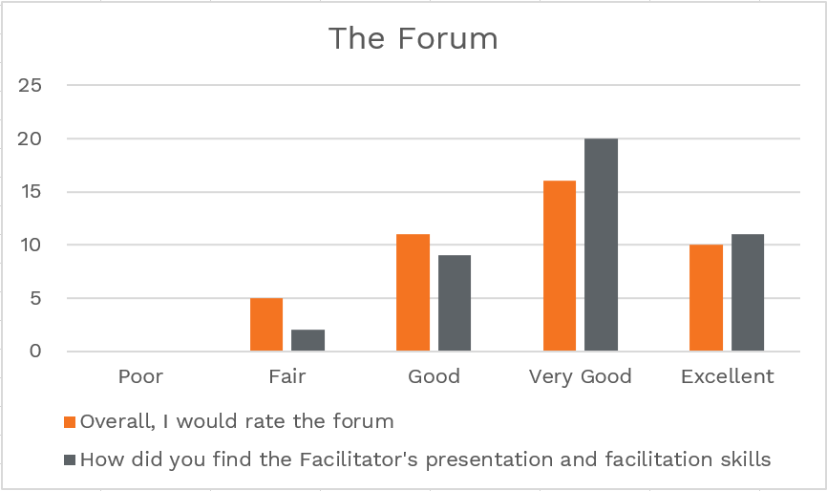
- Overarching feedback on the Forum

The two half days event format was met with positive feedback, however there was a few comments that suggested Day 1 was a lot more engaging and Day 2 lacked opportunities for participants to share their thoughts. One comment suggested that case studies be included in both days to increase participation. It was noted again that face-to-face would be preferable but would require more activities and presentations to make travelling worthwhile. Email communications made it difficult to follow as some didn’t receive the necessary links.
Most participants supported holding a national Forum once a year as shown in Figure 6 below.
Participants were asked to select from some further topics and there was an even split between the four options, with a slight preference towards case studies and housing. Other topics suggested by participants included family support, education, funding, support for workers, presentations by health services, and a larger focus on Good Practice Principles.

- Feedback on frequency and content of the Forum

- Conclusion
The National Reconnect Forum 2022 was successful in achieving its goals of bringing people together to network and share ideas. It provided a useful opportunity to discuss the future of Reconnect.
While many participants expressed a preference for the Forum to be held in person, it appears that the on-line format was successful. Attendance was strong throughout each session and participant feedback was very positive. Formal post-Forum evaluation showed that presentation topics included in the Forum were considered informative and useful by the participants in creating better outcomes for Reconnect service clients. The case studies were met with positive feedback, with requests for additional time to achieve more in-depth conversations about the cases.
There is strong support for a regularly scheduled National Forum in the future, noting suggestions that Forum be held in-person. Most participants were interested in having the Forum held annually although over a third were interested in the forum being held biannually. This interest in future events reflects participants’ positive experience and interactions during the National Reconnect Forum 2022.

