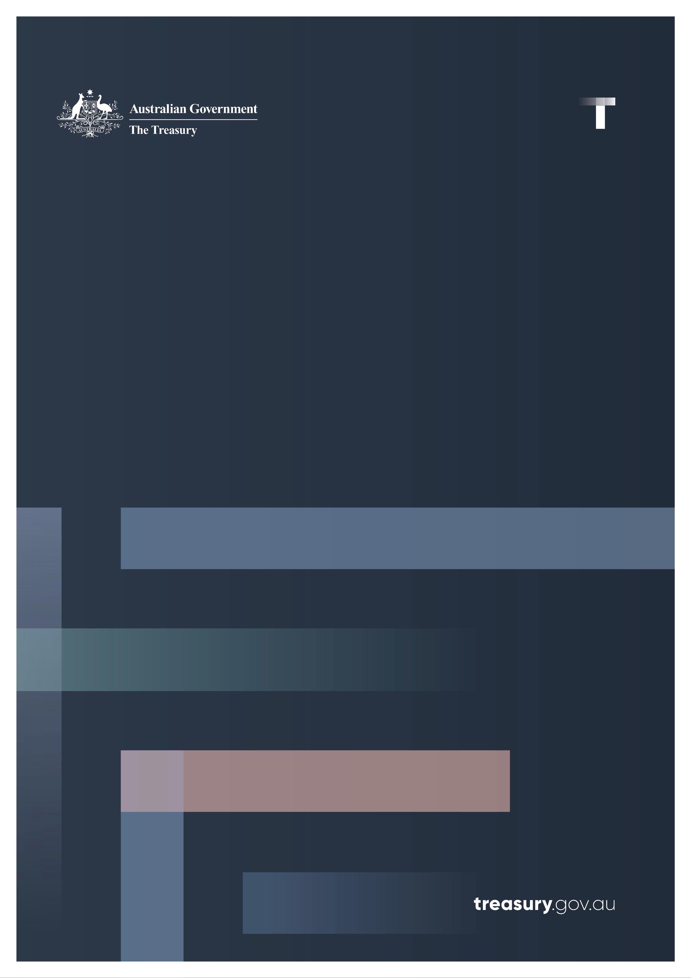

Statement on Developing an Innovative Australian Digital Asset Industry

March 2025

**Statement on Developing an Innovative Australian Digital Asset Industry**

The Government is working with industry, regulators and the broader community to make Australia a leader in the global digital asset ecosystem. Digital assets are a rapidly evolving part of the economy, offering opportunities for new products and productivity gains. The potential benefits of these assets are far reaching, from streamlining payments systems to transforming how we invest and do business.

Our approach will help industry to identify opportunities and manage risks, unlock innovation, protect consumers and uphold market integrity. By aligning with international best practice, Australia can boost the global competitiveness of our digital asset sector.

The Government’s reforms will spur innovation and increase competition by providing certainty to industry. Our legislative reforms will extend existing financial services laws to key digital asset platforms, but not to all of the digital asset ecosystem. This approach is informed by action in jurisdictions such as the European Union (EU) and Singapore.

The Government is also working with the Australian Securities and Investments Commission (ASIC) to ensure there are appropriate transitional arrangements ahead of the Government’s legislative reforms coming into effect.

This statement outlines the Government’s approach to reform, progress to date and the forward workplan.

The four primary elements to Australia’s approach to digital asset reforms are:

* a framework for Digital Asset Platforms (DAPs), which are online platforms that hold digital assets, such as crypto, for consumers;
* a framework for payment stablecoins, which will be treated as a type of Stored‑Value Facility (SVF) under the Government’s Payments Licensing Reforms;
* undertaking a review of Australia’s Enhanced Regulatory Sandbox; and
* a suite of initiatives to investigate ways to safely unlock the potential benefits of digital asset technology across financial markets and the broader Australian economy.

## Australia’s new approach to digital assets

The Government’s approach will provide effective settings for digital assets that balance innovation with consumer protection. The approach is informed by public consultation on proposals for DAPs and payment stablecoins.[1]

The Government’s legislative framework will focus on the operators of DAPs. The new DAP regime will not impose a new regulatory burden on digital asset issuers themselves, or on businesses that create or use digital assets for non‑financial purposes. The aim is to mitigate key risks for consumers so the sector can safely and securely innovate and grow.

In parallel, the Government is working on a comprehensive framework for payments service providers (PSPs).[2] The Payments Licensing reforms will revise the existing licensing regime for non‑cash payment facilities and ensure it appropriately covers the wide range of payment products and services now provided in Australia. These reforms will cover the holding of monetary value for making payments – whether in traditional account‑based SVFs or in payment stablecoins. As payment stablecoins are functionally similar to other SVFs, they will be subject to substantially the same requirements as SVFs.

The DAP and PSP reforms will both leverage the existing Australian Financial Services Licence (AFSL) regime. They will require businesses providing these services to comply with certain existing financial services obligations, together with tailored obligations to address the unique characteristics of these products.

## Entities captured by the Digital Asset Platforms (DAP) regime

### Who will be included?

* DAPs providing common digital products, where there is an underlying custody arrangement. These include trading platforms, custody products and some brokerage arrangements.
* Businesses, including foreign entities, providing specified services, such as operating and dealing in DAPs and issuing and redeeming tokenised SVFs. Providing advice on using DAPs will be included.

### Who will not be included?

* The reforms will adopt the same exclusions and exemptions that apply under the existing financial services laws, where appropriate.
  + Where the current arrangements result in disproportion regulation, changes to existing laws will be considered.
* The reforms are targeted to mitigate the risks associated with custody arrangements (e.g. liquidity risk, counterparty risk, operational and fraud risk and cyber risk). Examples of activities not captured under the reforms include:
  + creating non‑financial product digital assets,
  + developing software used by others to create or engage with digital assets, and
  + contributing to the maintenance of certain types of digital asset infrastructure.
* Businesses that assist customers acquiring non‑financial product digital assets will be excluded from obligations in specified circumstances.
* Small‑scale and start‑up digital asset platforms that do not meet the relevant size thresholds will be exempt from full obligations but may be subject to tailored compliance requirements.

### Obligations

* Businesses covered by the reforms will have to comply with well‑understood ‘general obligations’ imposed on all financial service providers (e.g. providing services honestly, fairly, and efficiently, avoiding conflicts of interest, meeting minimum capital adequacy, etc).
* Additionally, businesses operating DAPs or issuing Tokenised SVFs will have to comply with:
  + rules for safeguarding customer assets (based on existing ‘client monies’ rules and the existing ‘minimum standards custodial and depository services)’, and requirements for the redemption of stored value represented by tokens; and
  + new obligations tailored to address the unique risks of DAPs and Tokenised SVFs (e.g. tailored disclosure rules for digital assets without issuers, disclosure of information about composition of reserves, etc).

## Transition process

The commencement dates for the reforms will be set through legislation. The Government will invite stakeholder feedback on the commencement dates and methods to support a smooth transition, including relief from licencing requirements that would conflict with the intent of the reforms.

ASIC is currently considering stakeholder feedback on its proposed updates to Information Sheet 225 (INFO 225). Feedback from ASIC’s consultation will help inform the proposed DAP and SVF reforms.

The Government intends to release draft legislation in 2025 for public consultation.

### Interactions with the financial markets licence regime

Under our reforms, businesses will not need a financial markets licence just to provide certain stablecoins and wrapped tokens. Dealing or secondary market trading in these products will be not treated as a dealing activity, and platforms where they are traded will not be treated as operating a market simply because of that trading activity. The Government is considering transitional relief to ensure these businesses will not have to restructure temporarily during the transition to the reforms.

## De‑banking

The Government recognises that de‑banking, which occurs when a bank declines to provide banking services or withdraws banking services from existing customers, is a global challenge. The digital asset sector is a key sector affected by de‑banking.

De‑banking can have a devastating impact on de‑banked businesses and individuals. It can also stifle competition and innovation in the financial services sector, and negatively impact Australia’s economy.

The Government’s proposed licensing frameworks for digital asset industry participants and payments providers will help improve the risk management capability of businesses within the sector.

In response to the Council of Financial Regulators (CFR) paper “Potential Policy Responses to De‑banking in Australia”, the Government agreed to recommendations aimed at providing a better understanding of the extent and nature of de‑banking and improving transparency, consistency and fairness for affected customers.

The Government has been working with stakeholders to ensure the implementation of these agreed recommendations is effective and achievable. This includes supporting transparency and fairness measures where possible and working with the four major banks to understand the extent and nature of de‑banking.

The Government will continue to engage with stakeholders on de-banking issues going forward.

## Future work streams

In addition to the immediate focus on DAPs and tokenised SVFs, the Government’s forward‑looking agenda aims to identify opportunities for innovation. The agenda includes:

### Crypto Asset Reporting Framework (CARF)

The Government is considering stakeholder feedback from the recent consultation paper (November 2024 – January 2025). Over 60 jurisdictions have committed to implement the CARF, to help address tax evasion by providing an international framework (and standard) for revenue authorities to exchange information on users’ crypto tax transactions.

### Enhanced Regulatory Sandbox

The Government will commence reviewing the Enhanced Regulatory Sandbox (ERS) in 2025.

The ERS provides an environment for businesses to test new financial products and services or credit activities without needing an AFSL or credit license.

Research suggests that sandboxes are becoming a core feature of the innovation agenda in many international jurisdictions and could play a greater role in facilitating new products and business models in Australia.

### Central Bank Digital Currencies

Treasury is working with the RBA to explore the feasibility and potential benefits of an Australian dollar central bank digital currency (CBDC).

The RBA and Treasury released a joint paper on 18 September 2024 summarising research on CBDC.[3] The report highlights that while a clear public interest case is yet to emerge to issue a retail CBDC, issuing a wholesale CBDC could play an important role in enhancing the functioning of wholesale markets in Australia.

### Tokenisation

Tokenisation involves creating digital assets by connecting rights or other entitlements to digital tokens (including rights of ownership to real world assets). Markets for tokenised assets may be able to increase automation, reduce settlement risk, lessen reliance on multiple financial intermediaries, simplify trading processes, reduce transaction costs, and provide broader access to traditionally illiquid assets.

In collaboration with the Digital Finance Cooperative Research Centre (DFCRC), Treasury, ASIC and the Australian Prudential Regulation Authority (APRA) are working with the RBA to trial the use of tokenised money (including CBDCs and stablecoins) to facilitate the settlement of transactions in wholesale tokenised asset markets.

### Decentralised Finance (DeFi)

DeFi refers to finance applications or products that operate without traditional intermediaries – instead using software to facilitate transactions between unknown parties. DeFi products include lending, borrowing, trading, and payments – often without a centralised entity capable of controlling or interfering with transactions between users.

Treasury continues to monitor international approaches to DeFi, including the EU and the US, to assess the suitability of their approaches for adoption in Australia.

## Conclusion

The Government is developing a fit for purpose digital asset regime to help build a more dynamic and competitive economy.

We want to seize these opportunities and encourage innovation at the same time as making sure Australians can use and invest in digital assets safely and securely with appropriate regulation.

1. Treasury, [Regulating digital asset platforms](https://treasury.gov.au/consultation/c2023-427004), October 2023
2. Treasury, [Payments System Modernisation (Regulation of Payment Service Providers)](https://treasury.gov.au/consultation/c2023-469663), December 2023
3. Reserve Bank of Australia and Treasury, [RBA and Treasury Joint Paper on Central Bank Digital Currency and the Future of Digital Money in Australia,](https://www.rba.gov.au/media-releases/2024/mr-24-17.html) September 2024