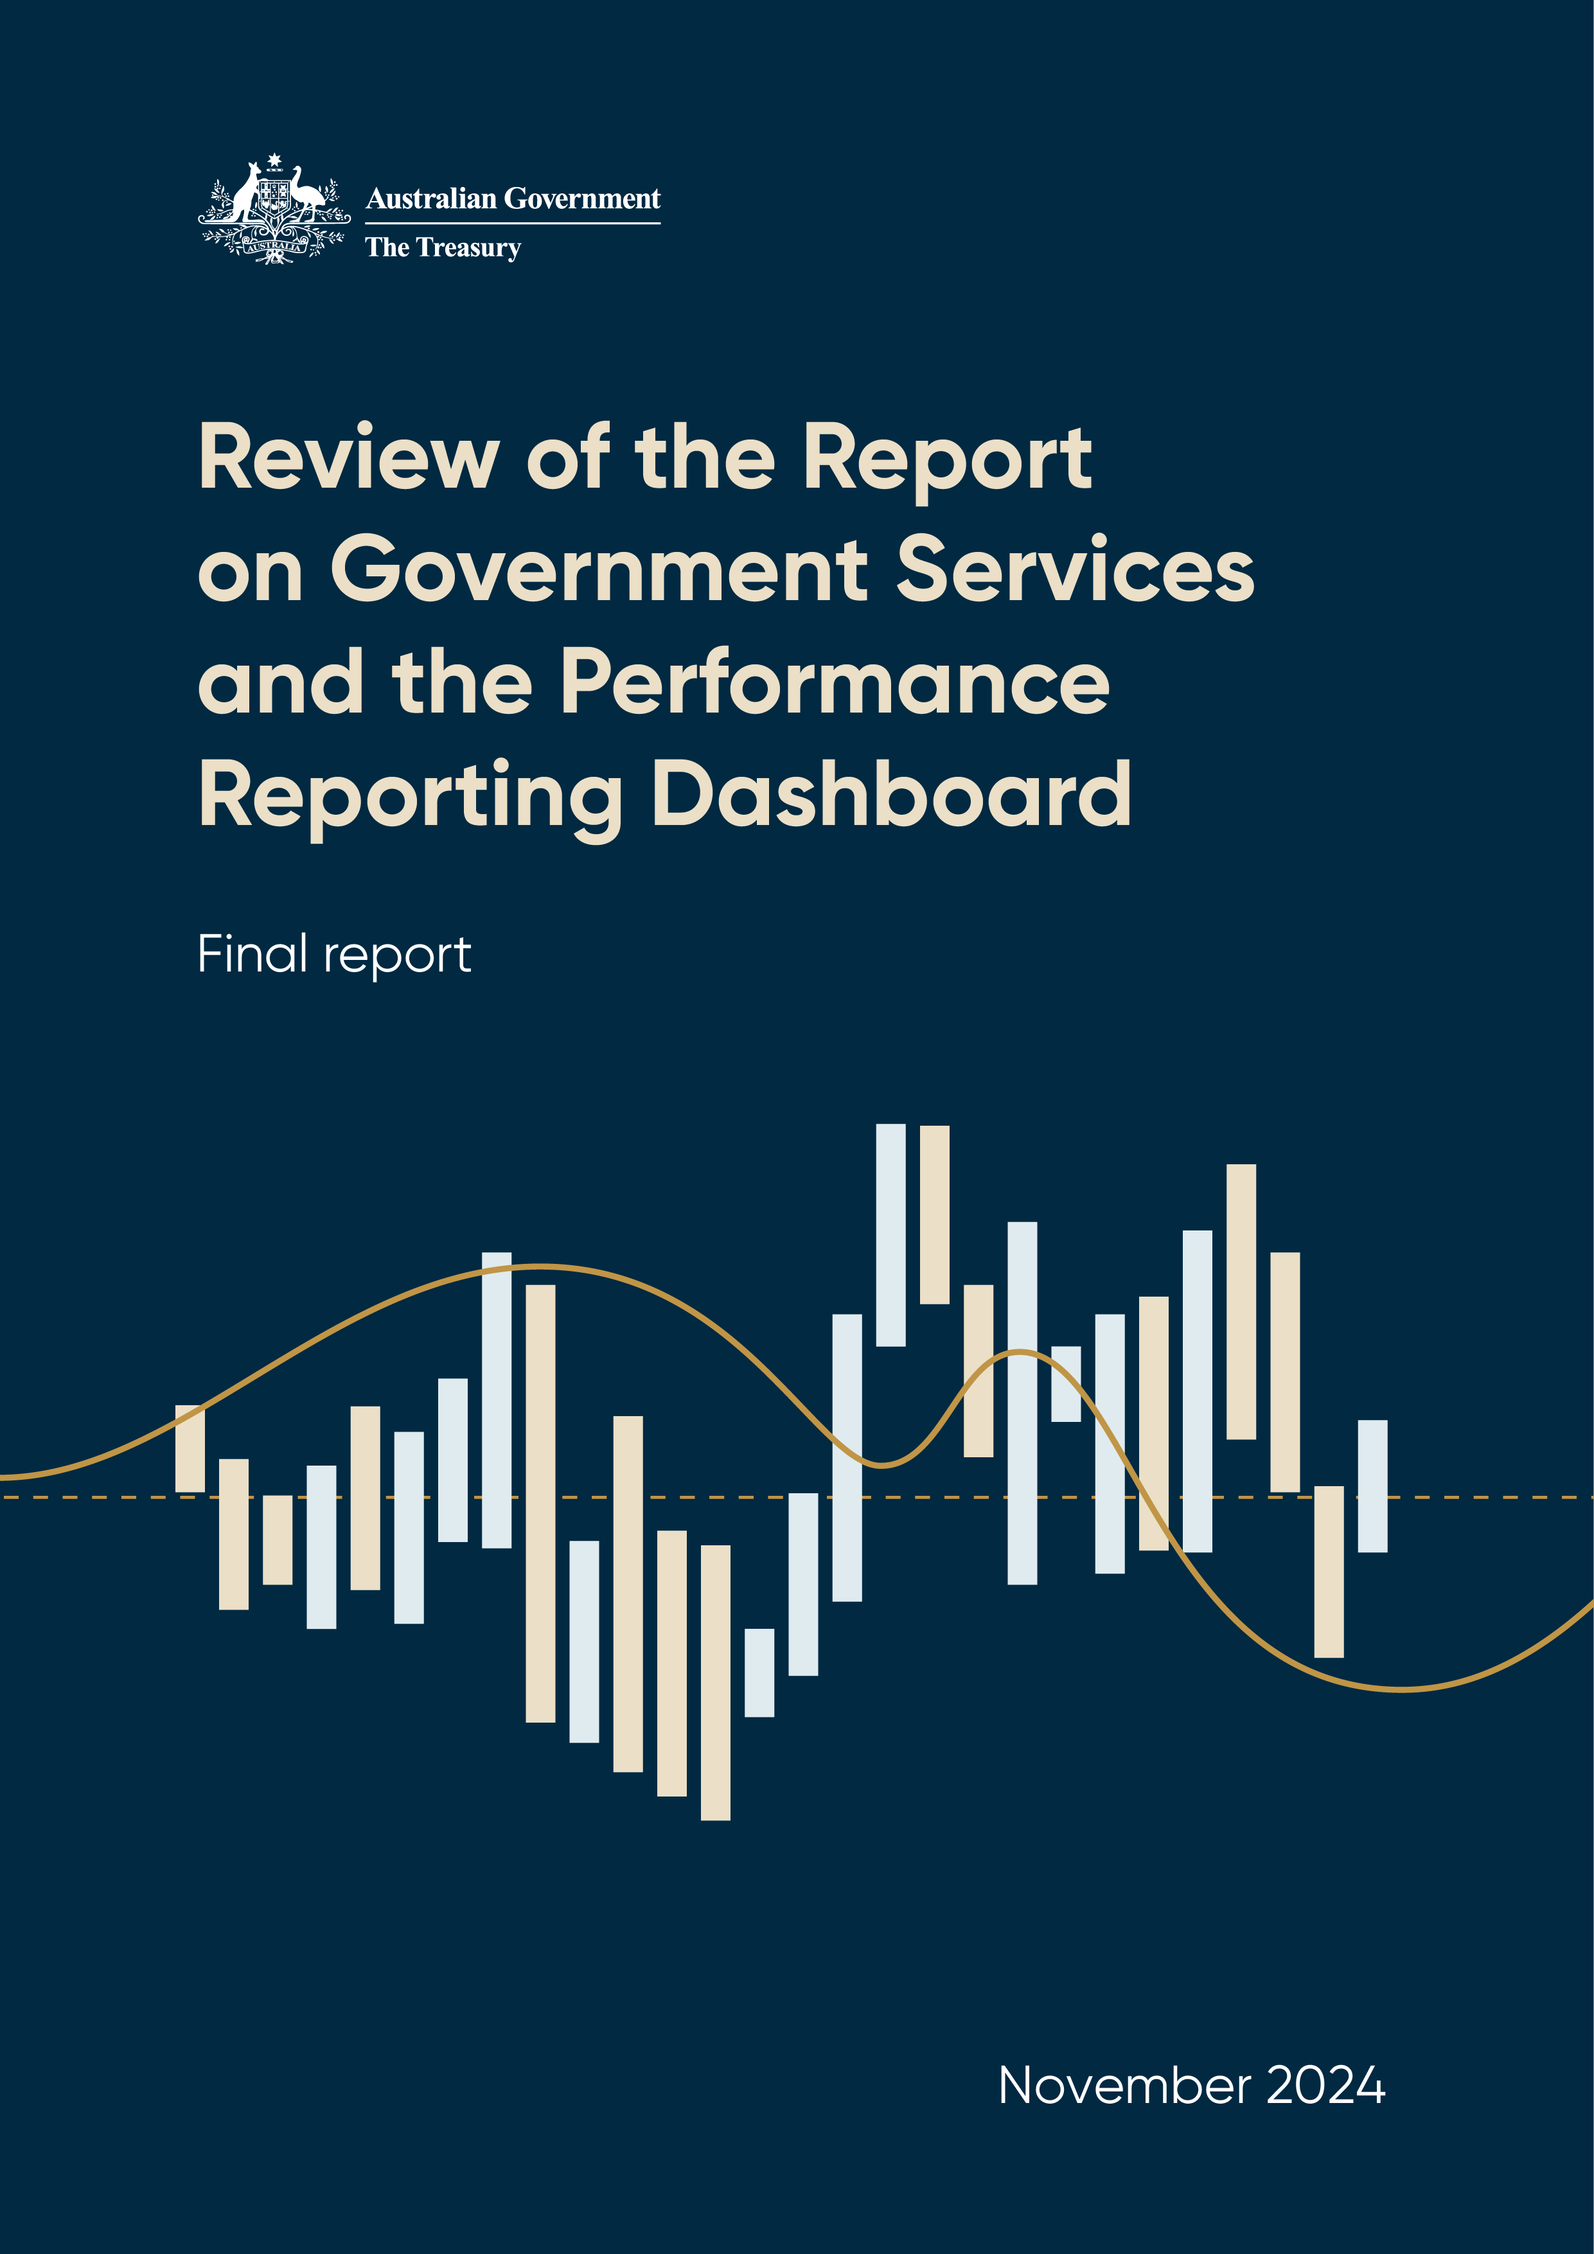

© Commonwealth of Australia 2024

ISBN: 978-1-923278-06-6

This publication is available for your use under a [Creative Commons Attribution 4.0 International](https://creativecommons.org/licenses/by/4.0/) licence, with the exception of the Commonwealth Coat of Arms, the Treasury logo, photographs, images, third party materials, materials protected by a trademark, signatures and where otherwise stated. The full licence terms are available from [creativecommons.org/licenses/by/4.0/legalcode](https://creativecommons.org/licenses/by/4.0/legalcode).

Creative Commons attribution licence 3.0 icon. 

Use of Treasury material under a [Creative Commons Attribution 4.0 International](https://creativecommons.org/licenses/by/4.0/) licence requires you to attribute the work (but not in any way that suggests that the Treasury endorses you or your use of the work).

**Treasury material used ‘as supplied’**

Provided you have not modified or transformed Treasury material in any way including, for example, by changing the Treasury text; calculating percentage changes; graphing or charting data; or deriving new statistics from published Treasury statistics – then Treasury prefers the following attribution:

Source:The Commonwealth of Australia.

**Derivative material**

If you have modified or transformed Treasury material, or derived new material from those of the Treasury in any way, then Treasury prefers the following attribution:

Based on Commonwealth of Australia data.

**Use of the Coat of Arms**

The terms under which the Coat of Arms can be used are set out on the Department of the Prime Minister and Cabinet website (see [www.pmc.gov.au/government/commonwealth–coat–arms](http://www.pmc.gov.au/government/commonwealth-coat-arms)).

**Other uses**

Enquiries regarding this licence and any other use of this document are welcome at:

Manager  
Media Unit  
The Treasury  
Langton Crescent   
Parkes ACT 2600  
Email: [media@treasury.gov.au](mailto:media@treasury.gov.au)

In the spirit of reconciliation, the Treasury acknowledges the Traditional Custodians of country throughout Australia and their connections to land, sea and community. We pay our respect to their Elders past and present and extend that respect to all Aboriginal and Torres Strait Islander peoples.

# Contents

Contents iii

Executive summary 1

Findings and recommendations 3

Chapter 1: About this Review 6

Chapter 2: Overview of the reporting products 8

Chapter 3: The approach to performance reporting 19

Chapter 4: The usefulness and accessibility of the information 35

Chapter 5: The broader data and reporting ecosystem 49

Appendix 1: Review terms of reference 56

Appendix 2: Data analysis methodology 57

Appendix 3: Consultation process 68

Appendix 4: Stakeholder suggestions to strengthen performance indicators 70

Appendix 5: References 71

# Executive summary

In 2023, National Cabinet asked the Council on Federal Financial Relations (CFFR) to review the Report on Government Services (the RoGS) and the Performance Reporting Dashboard (the Dashboard) to identify opportunities to improve these performance reporting arrangements. Any changes should help drive reform and lift productivity (see *Appendix 1: Review terms of reference*).

The RoGS and the Dashboard show how governments are doing in delivering their services. They seek to help governments improve services and outcomes for Australians.

Each year the RoGS provides information on the equity, efficiency and effectiveness of government services. The 2024 RoGS reported against 185 output and 51 outcome indicators across education, justice, emergency management, health, community services, and housing and homelessness services delivered in Australia.

The Review found that the RoGS is a valued, trusted and consistently used source of information on government services. There is widespread support for its continued production. Governments use the RoGS to evaluate and compare their performance relative to other jurisdictions and over time. Non‑government and community groups also use it to advocate for change, and highlight areas where services are not meeting community needs or expectations. The ongoing effectiveness of the RoGS relies on active engagement from the Commonwealth, State and Territory governments to provide data and implement improvements.

The Steering Committee which produces the RoGS includes senior officials from all jurisdictions and is supported by a Secretariat in the Productivity Commission (PC). It is a valued group for engaging and building consensus across governments. The Steering Committee has more than 30 years of experience in measuring how governments are performing. This expertise has been drawn on, including in developing National Agreements, but its use has not been systematic.

The Steering Committee has significantly enhanced the RoGS since it was introduced. It has improved both the quality of performance measurement and the accessibility of data. However, the continuous improvement process can be slow. It depends on reaching consensus and action by relevant jurisdictions. Some indicators are not complete and comparable, which is a concern. Also, the needs and perspectives of the community, including First Nations people, are not directly included in the governance arrangements and production process of the RoGS.

A central objective of the RoGS is to facilitate improvements in service delivery, efficiency and performance. While officials use it in developing policy, allocating resources, and identifying where services could be improved, the Review found it difficult to identify where the RoGS had been a key input to reform. The RoGS includes limited quantitative and qualitative material and analysis. It does not discuss which programs, policies and strategies are working, or highlight areas of service improvement and innovation.

Stakeholders find the depth and breadth of the RoGS to be a strength. However, they find that the number and presentation of indicators can make it difficult for users to navigate, interact with and analyse the data. For example, First Nations data is spread across service areas rather than being presented together. Non-government users also reported that the RoGS does not always include timely information, relevant outcomes, and what they consider to be key measures of government performance. Stakeholders wanted to see more focus on the relationship between sectors, better reporting on equity groups and more quantitative and qualitative analysis.

The Dashboard provides a high-level overview of progress on key policy commitments in housing, education, skills, healthcare, enhancing quality of life and community participation for people with a disability, closing the gap in Indigenous disadvantage, infrastructure and legal assistance services. The Dashboard covers 52 indicators, including benchmarks and targets.

The Dashboard’s simple interface and presentation style is easy for users to understand but it has become less relevant over time. When it was first released, the Dashboard measured progress against performance benchmarks and targets in priority areas, as agreed by the then Council of Australian Governments (COAG). However, some government priorities and how they are measured have naturally changed. The Dashboard has not always kept pace with these changes. Current government priorities are outlined in the major Commonwealth-State funding agreements, including the 5 major National Agreements, the *Land Transport Infrastructure Projects Agreement*, and the *National Legal Assistance Partnership*. Unlike the RoGS, the Dashboard does not have a clear objective, effective governance arrangements or a program of continuous improvement.

The RoGS and the Dashboard are not formally connected to any key decision-making body. This potentially limits opportunities for performance reporting to contribute to conversations on cross‑jurisdictional reform.

Broadly, the RoGS and the Dashboard operate in a crowded data and performance reporting environment. A range of different bodies publish information on Australian government performance across different policy areas. This information can overlap with the RoGS and the Dashboard, confusing users. New technologies could provide opportunities to better understand people’s experience of services and produce actionable insights.

The Review makes 10 practical recommendations to enhance the current performance reporting arrangements. These recommendations build on the strong foundation of the RoGS and the Dashboard and seek to:

* reinvigorate the approach to performance reporting
* increase the usefulness and accessibility of the information
* enhance connections with the broader data and reporting ecosystem.

These recommendations will modernise and strengthen the RoGS and Dashboard, provide better information for users, and help improve the way government services are delivered.

The Review recommends a broad direction and includes implementation suggestions. It recognises that the expertise of the Steering Committee means they are likely to be better placed to determine implementation specifics.

The Review consulted with relevant providers and users of reporting products in preparing this report (see *Appendix 3: Consultation process*).

The following pages outline the key findings and recommendations identified during this Review, which can be implemented within existing Secretariat resources. However, these recommendations will need to be phased in over time.

# Findings and recommendations

## The approach to performance reporting

|  |
| --- |
| Findings   1. The RoGS is a trusted source of information for governments and the public that relies on active engagement from all jurisdictions. 2. The Steering Committee has made significant progress in improving the RoGS over time, but more can be done to ensure it remains fit for purpose into the future. 3. The Dashboard is a clear and concise way of presenting progress on selected government commitments in major Commonwealth-State funding agreements at a point in time, but it doesn’t reflect current priorities and lacks a clear objective and effective governance structures. 4. The Steering Committee provides a valuable forum for interjurisdictional engagement but without a connection to an external decision-making body, opportunities for performance reporting to contribute to national policy and reform may be missed.   Recommendations   1. **Reinvigorate the approach to performance reporting**    1. CFFR to publicly endorse the RoGS, including its contribution to transparency and accountability and reaffirm all jurisdictions’ commitment to engaging in the process.    2. The Steering Committee to prioritise action on continuous improvement in the RoGS, particularly in relation to indicator completeness and comparability.    3. The Steering Committee to assume responsibility for the Dashboard and update it to cover major Commonwealth-State funding agreements by 2027–28.    4. CFFR to assume oversight of the RoGS and the Dashboard and the Chair of the Steering Committee to report annually from 2026 to Heads of Treasuries on performance in government service delivery and major Commonwealth-State funding agreements. |

## The usefulness and accessibility of the information

|  |
| --- |
| Findings   1. The RoGS performance reporting methodology is robust but does not extend to qualitative or quantitative analysis, which appears to limit the RoGS’ practical contribution to service delivery improvement. 2. Users outside of governments appreciate the RoGS as a transparency mechanism and an official source of data but it doesn’t fully meet their needs due to difficulty accessing and understanding the information. 3. The governance and production of the RoGS do not directly include and benefit from the community perspectives, including First Nations people. Performance indicators at times do not reflect what these groups consider to be key measures of government service delivery.   Recommendations   1. **Increase the usefulness and accessibility of the information**    1. The Productivity Commission to include additional quantitative, cross-sectoral and qualitative analysis in the RoGS, including with an initial focus on case studies of innovative or high-impact policies and programs in government services, to encourage improvements in delivery and effectiveness from 2026.    2. The Steering Committee to revamp the presentation of the RoGS indicator data by 2027 and enhance engagement with the community, drawing on relevant Australian and international examples.    3. The Steering Committee to engage more closely with the Australian community in the governance and production of the RoGS and, where appropriate, the Dashboard by 2026, to ensure it better reflects their needs and perspectives. Engagement with First Nations people and organisations should be prioritised. |

## The broader data and reporting ecosystem

|  |
| --- |
| **Findings**   1. The RoGS and the Dashboard operate in a crowded environment for data and reporting and more could be done to join up different processes and products to reduce confusion for users. 2. Linked datasets could improve the measurement of government service performance and reduce the reporting burden on jurisdictions. 3. The Steering Committee has significant expertise in performance measurement that could be better used across governments.   **Recommendations**   1. **Enhance connections to the broader data and reporting ecosystem**    1. The Steering Committee to expand its formal connections to other technical experts to help reduce duplication, and better use other data sources and technological developments.    2. The Steering Committee to explore new opportunities for linked datasets to improve measurement and reduce the burden on data providers for the RoGS and the Dashboard.    3. The Steering Committee to be consulted in the development of performance reporting frameworks for new major Commonwealth-State funding agreements negotiated from 2025 where parties agree. |

# Chapter 1: About this Review

## Review context

In 2023, National Cabinet asked the Council on Federal Financial Relations (CFFR) to review the Report on Government Services (the RoGS) and the Performance Reporting Dashboard (the Dashboard). The terms of reference broadly required the Review to:

* consider the objectives, scope, use and effectiveness of the RoGS and the Dashboard
* identify opportunities to streamline and improve these performance reporting arrangements to improve government service delivery and drive productivity enhancing reform
* consult with relevant providers and users of products
* provide CFFR with a mid-year update and a final report in December 2024 (for full terms of reference see *Appendix 1*: *Review terms of reference*).

Much has changed since the last review of the RoGS in 2009 and the 2017 inception of the Dashboard, meaning a review to ensure the RoGS and Dashboard remain fit for purpose is timely. Key developments include:

* changes to the Federation architecture
* technological advancements
* updated government priorities (including via new Commonwealth-State funding agreements)
* society-wide shifts, such as low productivity and greater emphasis on non-economic wellbeing.

## Changes to the Federation architecture

The federal architecture changed with the dissolution of the Council of Australian Governments (COAG) and the establishment of National Cabinet and the *Federation Funding Agreements Framework* (the Framework) in 2020. National Cabinet provides the Prime Minister, Premiers and Chief Ministers with a forum to work collaboratively on issues of national significance. The Framework recognises that States and Territories have primary responsibility for many areas of service delivery, but that coordinated action is necessary to address Australia’s economic, fiscal and social challenges. The Framework provides States and Territories with budget autonomy and flexibility, where practical, to deliver services and infrastructure in a way that they consider will most effectively and efficiently improve outcomes for Australians. The Framework acknowledges the importance of promoting accountability and transparency through reporting on outcomes achieved and effectiveness of money spent (CFFR 2020). The introduction of these new intergovernmental arrangements presents an opportunity to review current mechanisms for reporting against performance in the delivery of government services.

## Technological advancements

Data and digital technologies already used widely across the economy and in delivering government services and will continue to grow in importance. Governments — in Australia and internationally — are increasingly focused on unlocking the potential of government-held data to design and administer policies and programs. This data can contribute to more effective research and evaluation to assess the effectiveness of programs and policies (Commonwealth of Australia 2023a). Further, through ‘open data’ policies, governments have agreed to share public sector data by default to support policy development, service delivery, and decision-making (OECD 2022).

## Citizen wellbeing and productivity

The services reported on through the RoGS and Dashboard affect the wellbeing of all Australians and contribute to economic growth in a number of ways. For example, the skills and health of the workforce are affected by the provision of health, education and housing services, which in turn affect productivity. The services covered by RoGS reporting receive significant government funding — approximately $348 billion in 2021–22. This is around 70 per cent of government recurrent expenditure and is equivalent to around 15 per cent of gross domestic product (GDP) (Steering Committee 2024a). At a time when productivity in government-funded services, and the non-market sector more broadly, is declining, ensuring that both the RoGS and Dashboard are fit for purpose to assist governments in delivering better quality outcomes alongside better value for money is particularly important (PC 2024a).

## The value of government performance reporting

International and Australian research and experience finds that performance reporting can enhance the effectiveness and efficiency of the delivery of government services (Phillips 2018). However, this research acknowledges that measuring outcomes in the public sector can be challenging. Challenges include the absence of market prices, different government objectives, and delays between implementing policies and being able to measure their impact.

Good performance reporting provides the public with meaningful information on what governments have done and the results achieved (Australian National Audit Office 2023). It helps improve outcomes for users, decision-making and performance, increases accountability, openness and transparency, and helps build trust in the public sector (Controller and Auditor-General of New Zealand 2016). The RoGS and Dashboard pursue, or support the pursuit of, all these objectives.

# Chapter 2: Overview of the reporting products

## The Report on Government Services

The RoGS provides information on the equity, efficiency and effectiveness of government service delivery in Australia. The first RoGS was released in 1995.

The RoGS is produced by the Steering Committee for the Review of Government Service Provision (the Steering Committee) which was established by COAG in 1993 (Steering Committee for Review of Commonwealth/State Service Provision 1995).

Since 1997, the RoGS has been released in late January and early February each year. A mid-year release around May was introduced in 2020, and provides updated data for a subset of indicators on education, justice, and housing services.

### Scope and coverage

The first RoGS in 1995 reported against 94 indicators across 10 service sectors, which accounted for 9 per cent of Australia’s GDP at the time (Steering Committee for Review of Commonwealth/State Service Provision 1995). It was not practical to cover all significant government services in the early years of the RoGS. The coverage of the 1995 RoGS was based on the size of sectors, how easy it was to monitor and influence performance improvement, and the ability to create appropriate quantitative indicators. The 1995 RoGS encouraged jurisdictions to collect better information about their performance, and encouraged the Steering Committee to expand the Report to cover additional areas of government expenditure (Steering Committee for Review of Commonwealth/State Service Provision 1997). Over time, the RoGS has expanded its scope. In 2024 the RoGS included 236 indicators across 6 sectors and 17 service areas. Together this accounted for 15 per cent of gross domestic product (GDP) and around 70 per cent of recurrent government expenditure (Steering Committee 2024a).

### Performance reporting model

Performance indicators form the basis of the measurement approach in the RoGS. This is underpinned by a common performance indicator framework which is tailored to each service area. The RoGS performance indicator framework is based on a program logic model that links government objectives to inputs, outputs, and outcomes. Outputs are grouped under the 3 overarching dimensions of service delivery performance — equity, effectiveness and efficiency (*Figure 1*).

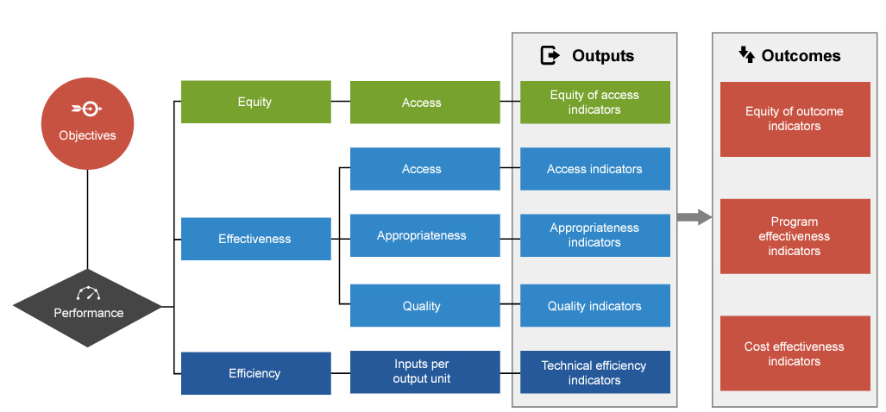

Figure 1: RoGS performance indicator framework

Source: (Steering Committee 2024a)

Of the 236 indicators in the 2024 RoGS, 185 measure outputs and 51 measure outcomes.

A focus of the RoGS is measuring the comparative performance of government services across jurisdictions. This allows governments to reflect on their relative performance and potentially learn from each other. In the 2024 RoGS, more than half of the indicators are nationally comparable:

* 130 indicators are nationally comparable across jurisdictions where most recent data for all measures is comparable and complete
* 15 indicators are nationally comparable where most recent data for at least one measure is comparable and complete.

The RoGS also has a set of guiding principles for reporting performance across service sectors. For example, data should be meaningful, timely, accurate, understandable, streamlined, and comparable across jurisdictions and over time (Steering Committee 2024a). The Steering Committee uses criteria for reviewing existing service areas and selecting new service provision areas (Information Box 1: Criteria for selecting service areas in the RoGS).

|  |
| --- |
| Information Box 1: Criteria for selecting service areas in the RoGS  Services included in the RoGS either:   * have common or similar objectives across jurisdictions, lending themselves to comparative performance reporting; or if jurisdiction-specific   + are of such community or economic significance to the national context in its own right that time series analysis in RoGS is appropriate   + make a significant contribution to the outcomes of services provided by other governments   + are part of a suite of services delivered across government * or make an important contribution to the community and/or economy, such that there is a significant public interest in the effectiveness and efficiency of service provision.   Significance to the community may be indicated by the recognition of a service as a National Cabinet priority or other measures of national interest. Significance to the economy may be indicated by the level of government expenditure or by the direct or indirect economic impact of a service.  Source: (Steering Committee 2024a) |

### Presentation

The RoGS presents indicator results primarily through data-rich formats, including downloadable raw data (Excel data tables and CSV datasets) and interactive Tableau charts (*Figure 2*).

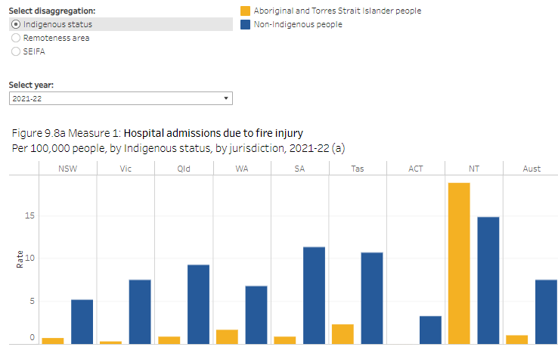

Figure 2: Hospital admissions due to fire injury, 2021–22 – Tableau interactive chart

Source: (Steering Committee 2024a)

Each service sector’s Overview section includes information on scope, expenditure, sector flows and relevant sector-wide indicators. The Context section for each service area within a sector includes information on the objectives, roles and responsibilities, funding, and size and scope of the services. The interpretation of data is largely left to users. The RoGS does not currently identify or provide any analysis on areas of improved performance or innovation, including which local programs, policies and strategies drove those improvements.

### Governance

The Steering Committee continues to produce the RoGS and has operational support from the Review of Government Service Provision Secretariat (RGSP Secretariat) within the PC (Steering Committee 2024a). It currently operates under a terms of reference endorsed by COAG in 2010 (Information Box 2: RoGS terms of reference).

|  |
| --- |
| Information Box 2: RoGS terms of reference  **Outputs and objectives**   1. The Steering Committee will measure and publish annually data on the equity, efficiency and cost effectiveness of government services through the Report on Government Services (ROGS). 2. The ROGS facilitates improved service delivery, efficiency and performance, and accountability to governments and the public by providing a repository of meaningful, balanced, credible, comparative information on the provision of government services, capturing qualitative as well as quantitative change. The Steering Committee will seek to ensure that the performance indicators are administratively simple and cost effective. 3. The ROGS should include a robust set of performance indicators, consistent with the principles set out in the Intergovernmental Agreement on Federal Financial Relations, and an emphasis on longitudinal reporting, subject to a program of continual improvement in reporting. 4. To encourage improvements in service delivery and effectiveness, ROGS should also highlight improvements and innovation.   **Steering Committee authority**   1. The Steering Committee exercises overall authority within the ROGS reporting process, including determining the coverage of its reporting and the specific performance indicators that will be published, taking into account the scope of National Agreement reporting and avoiding unnecessary data provision burdens for jurisdictions. 2. The Steering Committee will implement a program of review and continuous improvement that will allow for changes to the scope of the ROGS over time, including reporting on new service areas and significant service delivery areas that are jurisdiction specific.   **Reporting to COAG**   1. The Steering Committee will review the ROGS every three years and advise COAG on jurisdictions’ compliance with data provision requirements and of potential improvements in data collection. It may also report on other matters, for example, ROGS’s scope, relevance and usefulness, and other matters consistent with the Steering Committee’s terms of reference and charter of operations.   Source: (Steering Committee 2024b) |

The Steering Committee includes senior officials from Commonwealth, State, and Territory central agencies and is chaired by the Chair of the PC.[1] It meets 3 times per year. Cross-jurisdictional working groups support the Steering Committee by providing expert advice on the development, improvement and reporting of performance indicators and related contextual material. This assists communication between the Steering Committee and service areas and improves data comparability. The Steering Committee also receives technical advice from the Australian Bureau of Statistics (ABS) and the Australian Institute of Health and Welfare (AIHW).

RoGS governance arrangements combine ‘top down’ authority from the Steering Committee with the ‘bottom up’ expertise line agency working groups provide. This design helps balance the strategic direction and intent of the report, sector‑specific knowledge and a practical understanding of relevant data collections.

The RoGS has had no formal reporting relationship with external bodies since the dissolution of COAG in 2020 but continues to be overseen by the Steering Committee (*Figure 3*).

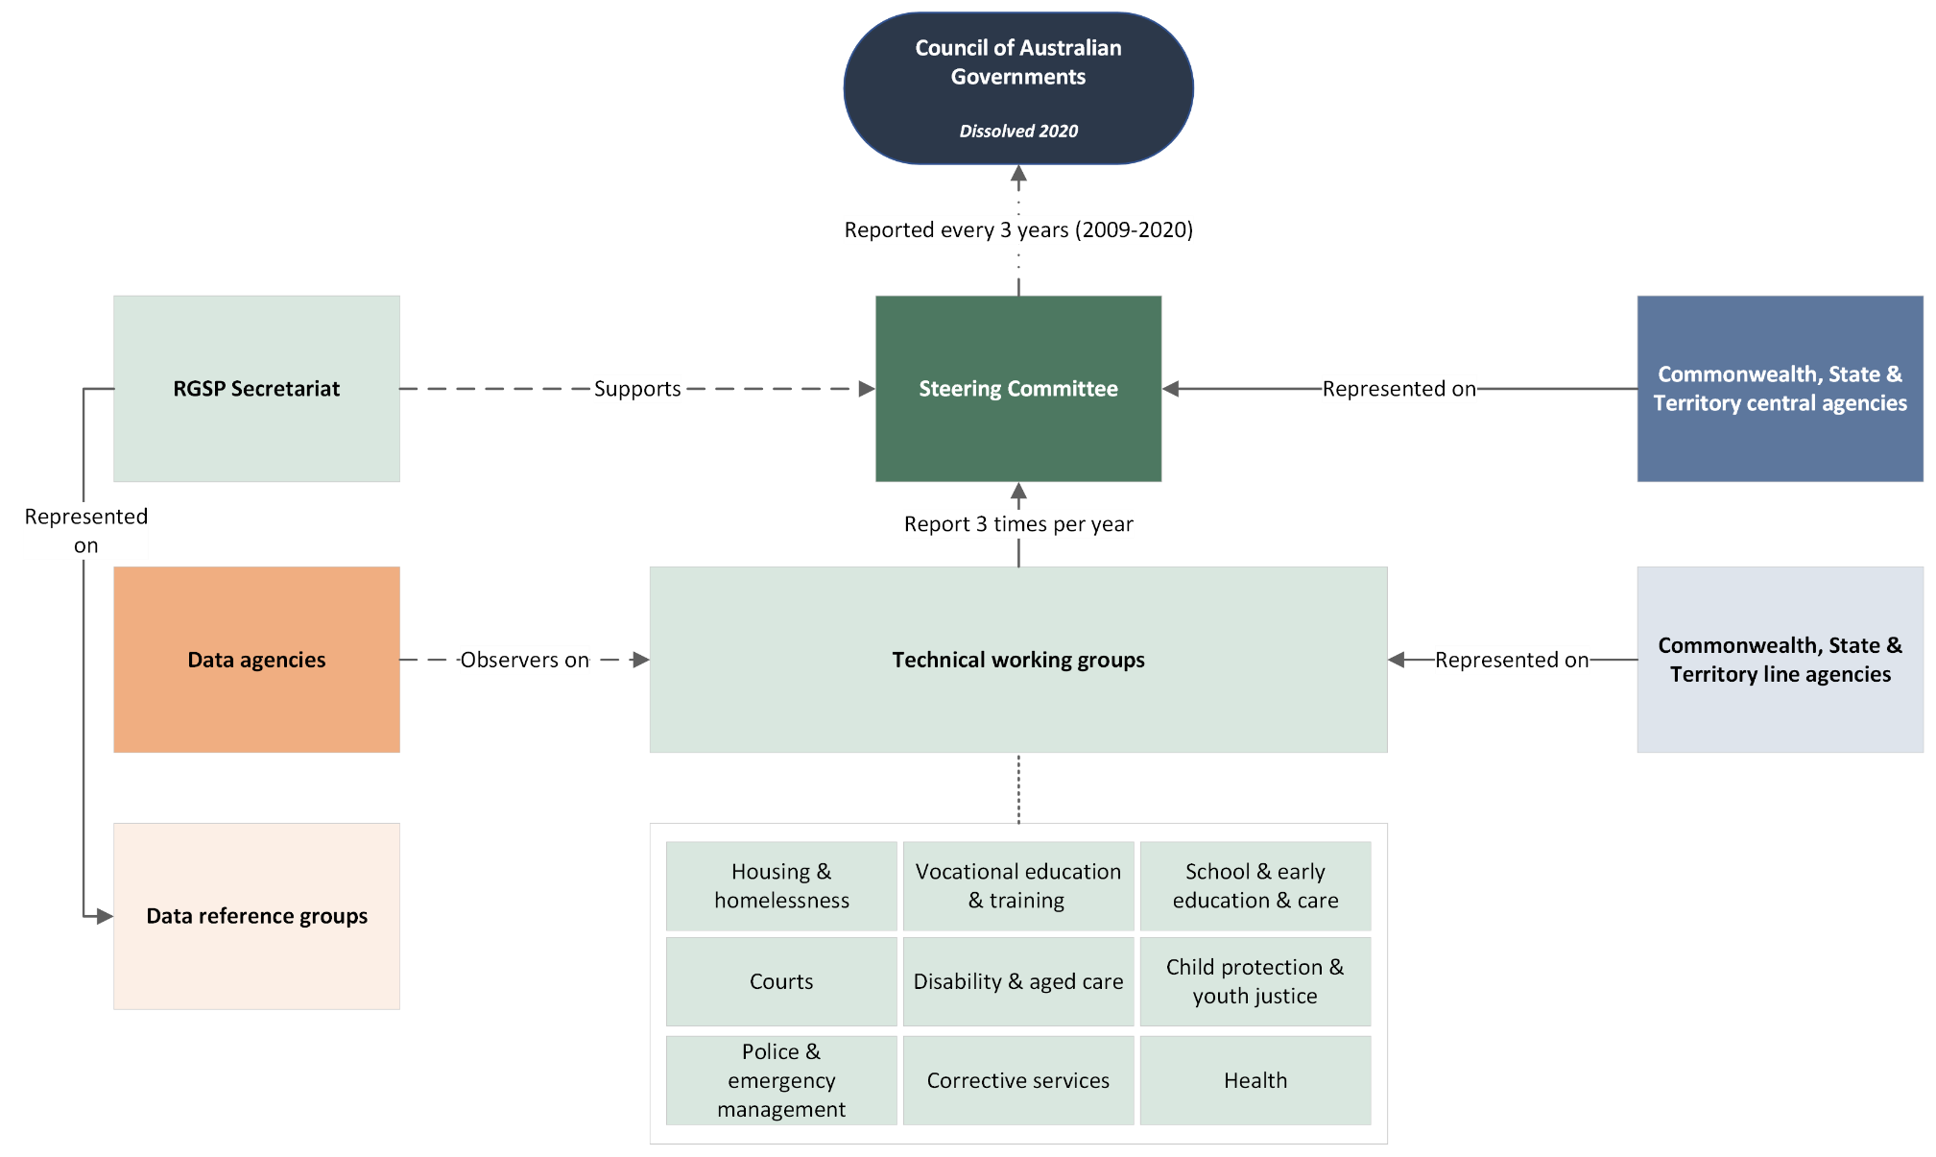

Figure 3: RoGS governance structure

Source: Analysis undertaken by the Review

### Previous reviews

In 2008, COAG asked a combined Senior Officials/Heads of Treasuries working group to undertake a review of the RoGS as part of its reform agenda. This covered an assessment of its relevance and usefulness. This review was completed in 2009 and recommendations included:

* streamlining its presentation and making it more accessible to the public
* reinforcing the culture of continuous improvement
* highlighting improvements and innovation through case studies
* reviewing its operation and reporting to COAG every 3 years
* undertaking a separate review of the performance indicator framework and individual performance indicators (Senior Officials/Heads of Treasuries Working Group 2009).

The separate review of the performance indicator framework was completed in 2010. It made 8 recommendations, including to consider how targeted consultation with non-government organisations (NGOs) could inform reporting and access (Independent Reference Group 2010).

The Steering Committee has made improvements to the RoGS in the years since the reviews, including in relation to streamlining, reporting timeliness and the comprehensiveness, comparability, and quality of data.

## The Performance Reporting Dashboard

### Scope and coverage

The Dashboard reports on progress in housing, education, skills, healthcare, enhancing quality of life and community participation for people with a disability, closing the gap in Indigenous disadvantage, infrastructure, and legal assistance against a range of economic, health and social indicators. These policy areas and indicators were identified by COAG in 2017 from National Agreements and National Partnership Agreements. The Dashboard covers 52 indicators across 9 National Agreements and 7 National Partnership Agreements. The Dashboard is released annually (PC 2023a).

### Presentation

In many areas, the Dashboard assesses progress towards meeting benchmarks. This is typically set at a national level, by a particular point in time (*Figure 4*). For example:

By 2018, increase by five percentage points the proportion of Australian adults at a healthy body weight from 2009.

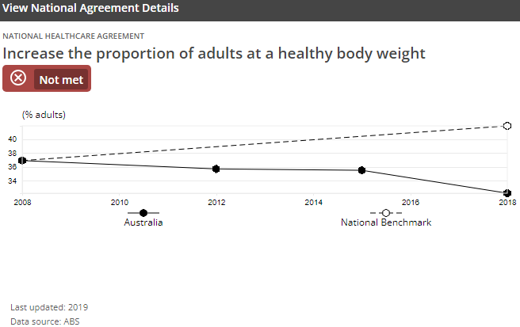

Figure 4: Example of benchmark indicator in the Dashboard

Source: (PC 2023a)

In other areas, the Dashboard monitors performance over time (*Figure 5*). For example:

The proportion of VET [vocational education and training] graduates with improved employment status after training

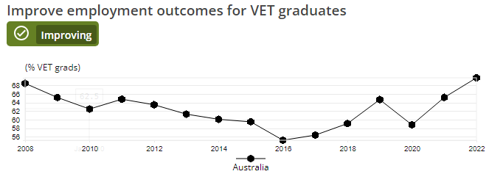

Figure 5: Example of monitoring over time in the Dashboard

Source: (PC 2023a)

## Performance reporting and the role of COAG Reform Council

The COAG Reform Council (the CRC) was responsible for assessing the performance of governments against National Agreements before the introduction of the Dashboard in 2017. This was undertaken in accordance with *Schedule C: Public Accountability and Performance Reporting* of the *Intergovernmental Agreement on Federal Financial Relations* (IGA FFR). *Schedule C* required the assessment of high-level performance indicators for each National Agreement along with a comparative analysis of performance information that:

* focused on the high-level National Agreement performance indicators
* highlighted examples of good practice
* highlighted contextual differences between jurisdictions which are relevant to interpreting the data
* outlined the contribution of both levels of government to improving performance against outcomes and reform directions (COAG Reform Council 2014).

From 2010 to 2014, the CRC provided annual public reports to COAG. The Steering Committee was responsible for providing performance data to the CRC. The CRC was required to present its report to COAG within 3 months of receiving the data. The CRC was also required to formally consult with jurisdictions on this report before it was released to COAG (Commonwealth of Australia and Australian States and Territories 2022). The CRC assessed performance using a range of information sources. These included progress reports from jurisdictions, independent research on legislative and regulatory activities of governments, and additional information requested by the CRC.

The CRC’s role was to help COAG drive its national reform agenda by strengthening accountability for results. The CRC was funded by all governments but was independent of individual governments and reported directly to COAG (COAG Reform Council 2014).

The CRC faced significant challenges with reporting on National Agreements. In its reports to COAG, the CRC advised that major improvements were needed to the performance reporting framework, particularly in 2 areas:

* Some indicators were not closely connected to the objectives and outcomes of the agreements.
* Adequate data for reporting progress against performance indicators and benchmarks was not available (PC and Forum of Federations 2012).

### Governance

The Dashboard was initially maintained by the Department of Prime Minister and Cabinet, but responsibility was transferred to the PC in the 2017–18 financial year. The Dashboard was developed in partnership with Data61, which is the data and digital specialist arm of the Commonwealth Scientific and Industrial Research Organisation (CSIRO) (PC 2023b).

The Dashboard does not have a terms of reference that describes its objectives and governance in the same way as the RoGS. However, the COAG Report on Performance — which the Dashboard functionally replaced — did describe its purpose and intended audience (*Information* Box 3: Purpose of the COAG Report on Performance) (Department of the Prime Minister and Cabinet 2016).

|  |
| --- |
| Information Box 3: Purpose of the COAG Report on Performance  This report aims to:   1. **Provide timely, transparent feedback** to First Ministers on the progress of Australian governments in advancing key COAG commitments and so **facilitate meaningful reflection on overall performance and areas for improvement.** 2. **Promote greater accountability of Australian governments to the general public** by providing a simple, straightforward assessment of their progress towards achieving their commitments. 3. **Support a culture of continuous improvement**, whereby **Australian governments acknowledge and learn from the performance of their peers** to deliver better outcomes for all Australians.   Source: (COAG 2016) |

Following the dissolution of the CRC in 2014 and the establishment of the new intergovernmental relations architecture in 2020, not all COAG’s reporting responsibilities were assumed by other bodies. CFFR is responsible for overseeing the financial relationship between the Commonwealth and State and Territory governments under the IGA FFR. The actual performance assessment, monitoring and reporting for National Agreements and National Partnership Agreements is spread across different bodies. Ministerial Councils and data agencies play varying roles for different agreements, such as the AIHW under the *National Health Reform Agreement*. Some National Agreement performance indicators are also captured in the RoGS, where consistent with its methodology.

The PC is not required to formally report on the Dashboard to CFFR, or another body. In the absence of supporting governance arrangements, a clear authorising environment and resourcing beyond 2020–21, the PC has maintained the Dashboard in line with its initial structure in 2017. The initial targets and subset of indicators selected for the Dashboard have remained, and agreements have only been updated for similar replacement agreements, such as housing in 2018 and education in 2019. While relevant data is updated annually by the PC, the Dashboard does not reflect contemporary major Commonwealth-State funding agreements. The Dashboard has not been reviewed since it was introduced.

## Costs

For the 2024–25 financial year, the direct cost to the PC of producing the RoGS is around $2.25 million. This does not include shared corporate functions and costs to other data providers and government agencies.

Government departments and agencies across jurisdictions also incur costs in collecting data, providing and commenting on material and participating in the Steering Committee and working groups. The Review has not been able to accurately estimate these costs, but the total cost is likely to be much higher than direct costs.

When responsibility for the Dashboard was transferred to the PC in 2017-18, the Budget provided non-ongoing funding until 2020–21. Since 2021–22, costs associated with maintaining the Dashboard have been absorbed by the PC. These costs were around $81,000 in 2023–24, which included approximately $39,000 in direct staffing costs and $42,000 to engage an external contractor to host the Dashboard and update its data.[2]  In 2024, the PC transitioned web hosting and maintenance of the Dashboard in-house.

## Timeline of key developments

*Figure 6* presents a summary of the key developments over the lifetime of the RoGS and Dashboard.

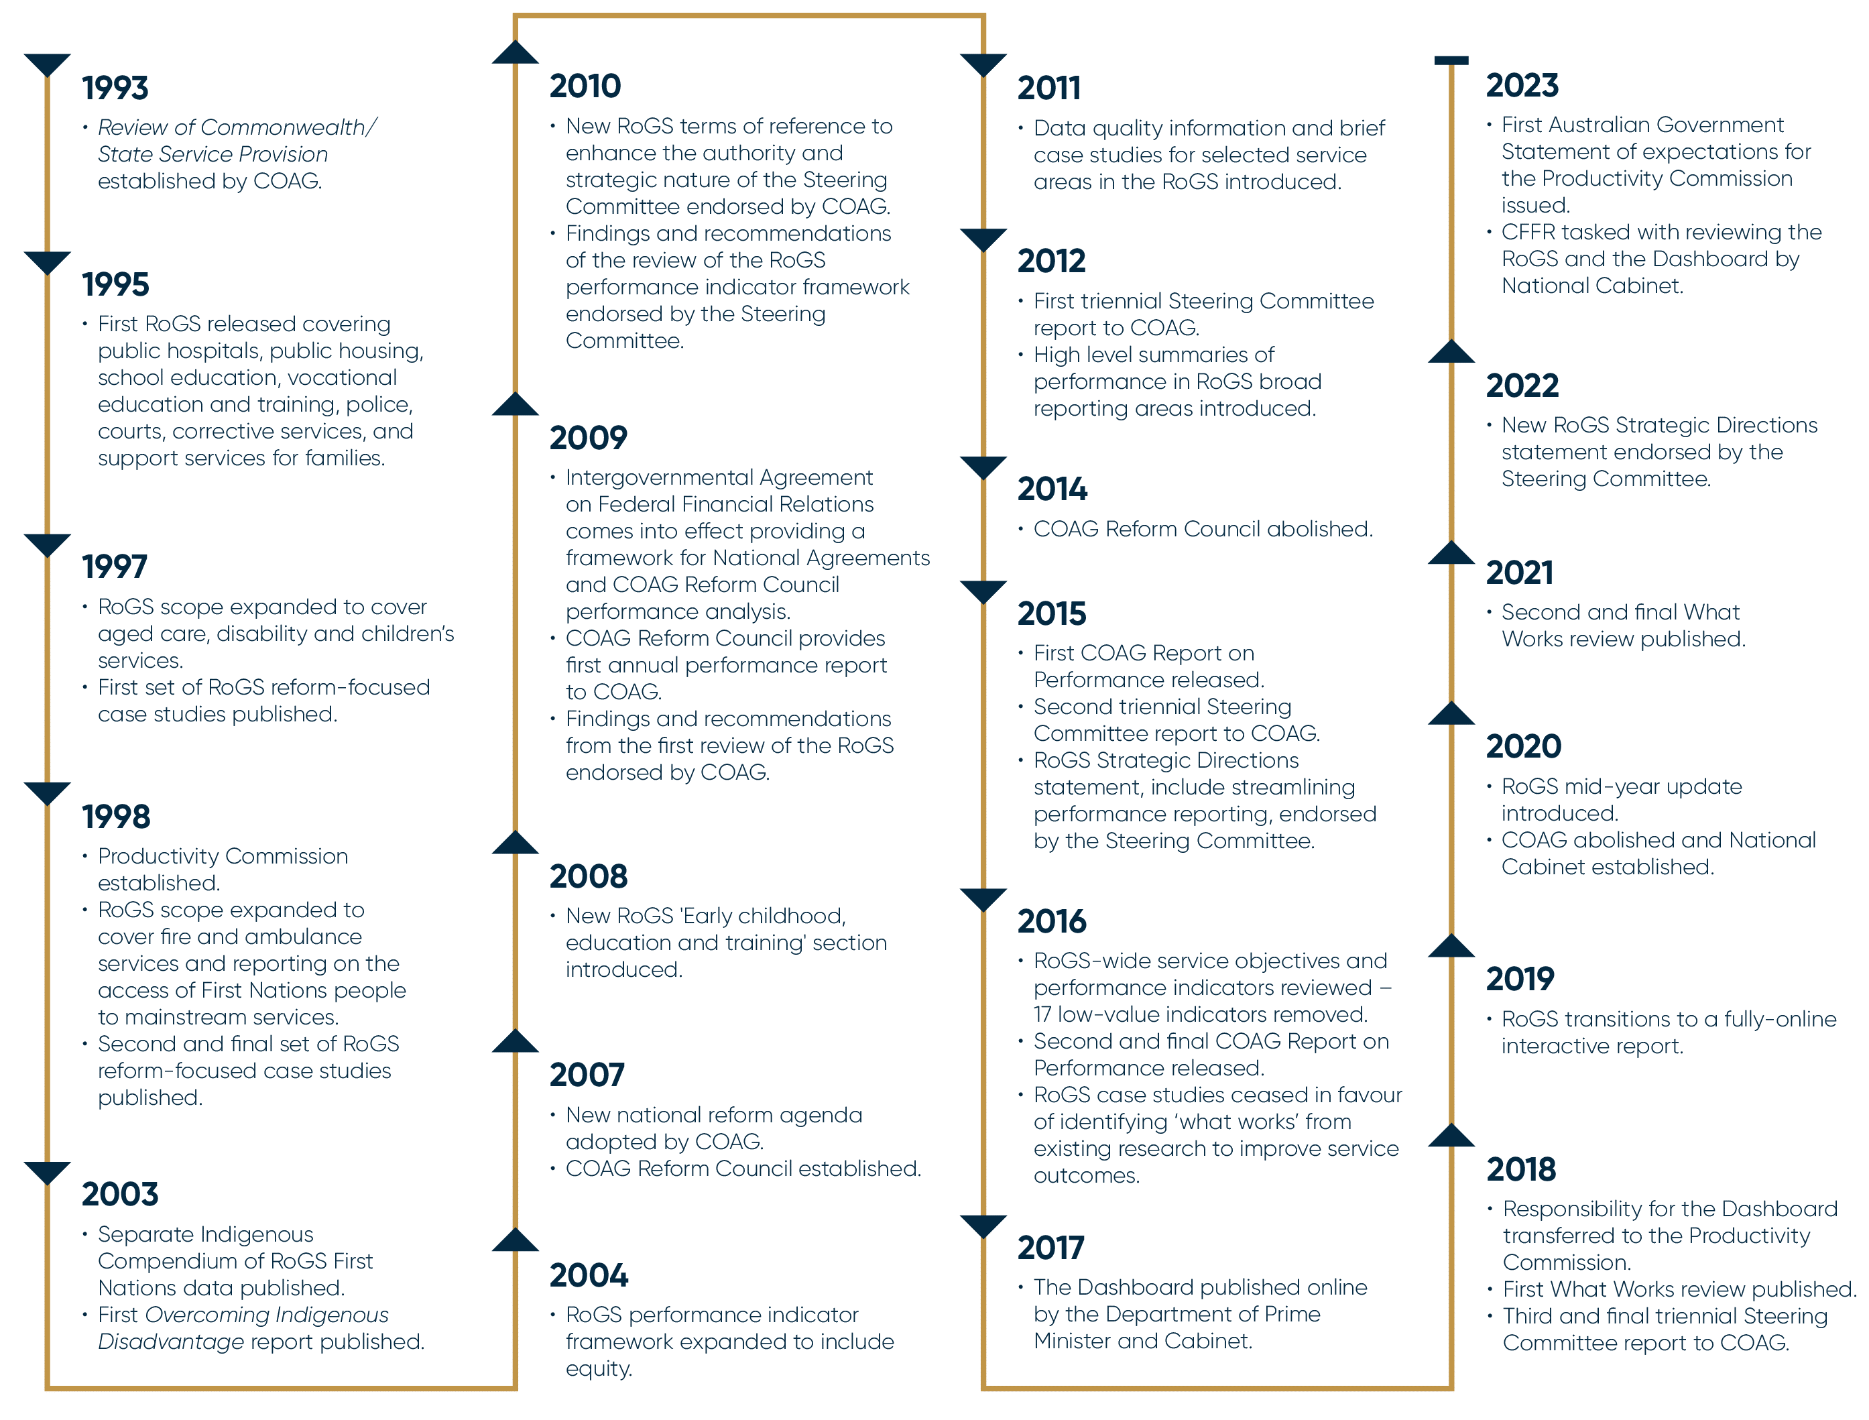Figure 6: Timeline of key developments in the RoGS and the Dashboard

Source: Analysis undertaken by the Review

# Chapter 3: The approach to performance reporting

## The Report on Government Services

### A valued and trusted source of information

As laid out in the RoGS terms of reference (*Chapter 2: Overview of the reporting products*), the key objective of the RoGS is to facilitate improved service delivery and accountability to governments and the public by highlighting government performance, improvements and innovation. The terms of reference set out roles for both governments and the public as users of the RoGS data (Steering Committee 2024b).

The first release of the RoGS, almost 3 decades ago, was seen as a new way of understanding how effectively Commonwealth and State and Territory governments delivered services to the public. The first edition of the RoGS notes that it represented a ‘significant departure from past practice in this country’ by seeking to make comparisons ‘beyond the cost of delivering services’ (Steering Committee for Review of Commonwealth/State Service Provision 1995). It also aimed to comprehensively consider ‘the outputs and outcomes of government service provision’ across ‘all the relevant governments in the service areas identified’ (Steering Committee for Review of Commonwealth/State Service Provision 1995). This approach aimed to improve transparency of performance and accountability, clarify and define objectives and responsibilities, and assist governments to improve their service delivery through ‘yardstick competition’ (Steering Committee for Review of Commonwealth/State Service Provision 1995). Almost 15 years on from its first release, the 2009 review of the RoGS found that even though ‘significant refinements’ were needed:

The core reason for the establishment of the ROGS remains enduring; that is, to enable the comparison of the efficiency and effectiveness of government service delivery.(Senior Officials/Heads of Treasuries Working Group 2009)

Since the last review, changes have impacted government service delivery and assessment (*Chapter 1: About this Review*). The Review has considered the impact of these changes on the continued value of the RoGS, including how the costs involved with producing the report weigh against its usefulness for stakeholders.

Broadly, stakeholders told us that the RoGS is a valued and trusted source of information on government services for both governments and the public, and that their understanding of government performance would be poorer in its absence.

Government representatives said that they used the RoGS to compare the efficiency and effectiveness of their service delivery with other jurisdictions. They used this to inform senior officials and ministers about government performance. State and Territory Treasuries and First Ministers departments also use the RoGS to strategically manage budgets, including to allocate funding. The substantial time-series data in the RoGS (30 years in some service areas) supports short- and long-term trend analysis, which was considered valuable for policy development and implementation. Representatives from governments also find significant benefit in the collaborative processes in developing the RoGS each year, led by the Steering Committee.

Non-government stakeholders use the RoGS for research, analysis and advocacy purposes. As an ‘official’ source of data, they find it more influential when engaging with governments. These stakeholders highly value the RoGS reporting on smaller jurisdictions and on information that is not available elsewhere, such as expenditure.

Since the last review, stakeholders observed an overall increase in the volume of data and reporting, as well as advances in analytical techniques. This has led to more information sources that can be used for developing policy or advocating for change. However, stakeholders did not necessarily consider these new sources of information to be replacements for the RoGS. For example, the granular and real-time data on services available to State and Territories cannot replace the   
cross-jurisdictional comparison of the RoGS.

Stakeholders also cautioned that the overall increase in the availability of information is not true for all sectors covered by the RoGS. Some service delivery areas are well covered at a national level by different reporting bodies, including the AIHW and the ABS. Other sectors have less-developed national reporting and place increased value on the RoGS as the central source of national performance information (*Information* Box 4: Value of the RoGS for nationally under-reported sectors).

|  |
| --- |
| Information Box 4: Value of the RoGS for nationally under-reported sectors  In comparison to sectors like health and housing and homelessness, the emergency management and youth justice sectors have relatively limited national reporting frameworks.  Separate to the RoGS, youth justice performance reporting is supported by the Youth Justice National Minimum Data Set. This is an annual collection of information on young people under youth justice supervision, both in the community and in detention. This dataset looks at the characteristics of young people and the following aspects of their supervision:   * numbers and rates of young people under supervision * time under supervision * supervision history and trends in supervision.   However, the RoGS is the primary source of comparable information on the performance of youth justice services. It contains 13 indicators not published elsewhere, covering:   * education and training attendance * deaths, assaults, self-harm and attempted suicide in custody * escapes and absconds from unescorted leave * group conferencing agreements and case plans prepared * completion of community‑based orders * expenditure data — cost per young person subject to community-based supervision, cost per young person subject to detention-based supervision and cost per group conference.   Outside of the RoGS, the emergency management sector does not have a national dataset that the public or governments can access to easily assess government performance. Data for the 9 RoGS emergency management indicators are collected directly from State and Territory governments, supplemented by AIHW fire injury hospitalisations data and contextual Commonwealth expenditure data from the National Emergency Management Agency.  Indicators reported in the RoGS, but not reported on a national level elsewhere, cover:   * response times for fire events * accidental residential structure fires * confinement of structure fires to room/object of origin * workforce sustainability * financial data — expenditure per person and value of asset losses * injuries and deaths.   Sources: (AIHW 2024a; Steering Committee 2024a) |

### A consistently used resource

Website access and media engagement statistics are consistent with stakeholders’ observations. Between 2018 and 2024, the RoGS website attracted around 150,000 views annually. Corrective services, child protection services and early childhood education and care had the highest number of total views in this period. Access peaks around the early- and mid-year data release dates (*Figure 7*). Given access statistics are not able to track ‘off-site’ data use, such as where a user downloads a dataset at a fixed point and analyses it in their own environment, the true number of interactions with the RoGS output is likely higher.

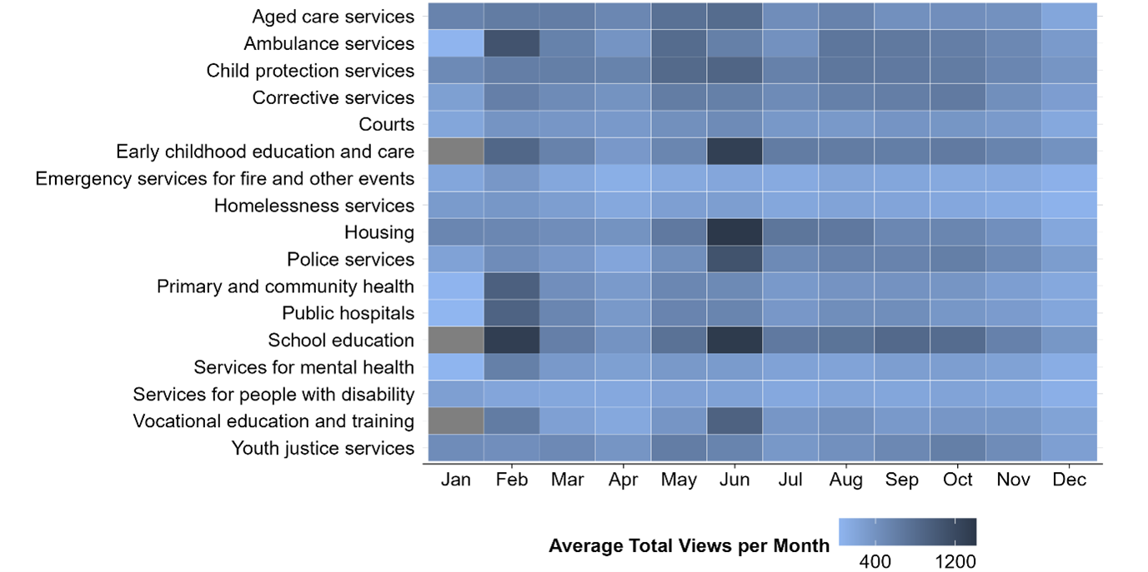

Figure 7: RoGS average total views by month and service area, 2022 to 2024[3]

Source: Analysis undertaken by the Review

The RGSP Secretariat advised that media coverage declined between 2023 and 2024. Analysis between October 2023 and October 2024 identified 654 unique references to the RoGS (*Appendix 2: Data analysis methodology*). These references are concentrated around the main data release in January and February (*Figure 8*). Common issues addressed by the media include emergency service response times, hospital wait times, crime rates, police funding and school attendance.

Figure 8: Media references to the Report on Government Services, October 2023 to October 2024

Source: Streem

### Supporting, rather than driving, policy

The Review sought to assess how much the RoGS has contributed to improvements in service delivery and effectiveness. Government officials reported that they use the RoGS to develop policy, allocate resources, and identify opportunities to improve services. Despite this, the Review found it difficult to locate evidence of where the RoGS had been a key input to reform. However, the RGSP Secretariat told the Review that the RoGS has been used to support recent reviews and inquiries, including an in‑depth clinical review of perinatal deaths in Queensland (Fentiman 2024).

As the RoGS does not include analysis or recommendations that link government policy to measurable indicators, the Review considers its *current* value lies in providing supporting evidence that highlights the need for change, rather than as a central facilitator of reform. The RoGS may be one of many sources of information used to identify opportunities for further analysis or areas for reform, particularly in the context of low productivity and rising fiscal pressures.

The Review considers there is a strong case for the RoGS continuing to be produced. It has significant support from stakeholders as an accountability and transparency tool, and it has the potential to support change. The Review finds that the expected benefits to governments and the public outweigh costs of producing the RoGS, including the costs incurred by the PC and State and Territory governments. That said, there are opportunities for the RoGS to be more effective, which will be explored further in this, and subsequent, chapters.

## A trusted tool that needs a boost

Governments have long played a key role in establishing and supporting performance reporting. COAG itself created the RoGS to better understand how government services perform and how well they meet the needs of recipients (Steering Committee for Review of Commonwealth/State Service Provision 1995). In the 21st century, COAG continued to back the RoGS by publicly adopting the recommendations of the 2009 review. COAG emphasised RoGS ‘important role for policy makers’ and its significance in ‘informing the Australian community about government service delivery performance’ (COAG 2009). All Australian governments have committed to performance reporting through the IGA FFR, which aims for ‘improvements in the quality, efficiency and effectiveness of government service delivery’ (Commonwealth of Australia and Australian States and Territories 2022). This is delivered by enhancing ‘public accountability through simpler, standardised and more transparent performance reporting by all jurisdictions’ (Commonwealth of Australia and Australian States and Territories 2022).

The Review considers that a public recommitment from all jurisdictions to the purpose and value of the RoGS would give a boost to the product. More generally, it would reaffirm State, Territory and Commonwealth support for the principles of transparency and accountability. Such a commitment would also show the public how governments place significant value on being publicly accountable for the services they deliver. It would also re-energise Commonwealth, State and Territory officials’ participation through the Steering Committee and working groups.

### Continuous improvement

#### The Steering Committee’s role

The Review considers that the ongoing effectiveness of the RoGS relies on active engagement from the Commonwealth, State and Territory governments. This relates both to providing data and implementing improvements to the RoGS, such as developing new data sources for indicators.

To illustrate, in the 2024 RoGS States and Territories were the third most common source of data, after the AIHW and the ABS (*Figure 9*). The proportion of data in the RoGS sourced from States and Territories has remained steady since the last review, but has fluctuated significantly between years (*Figure 10*).

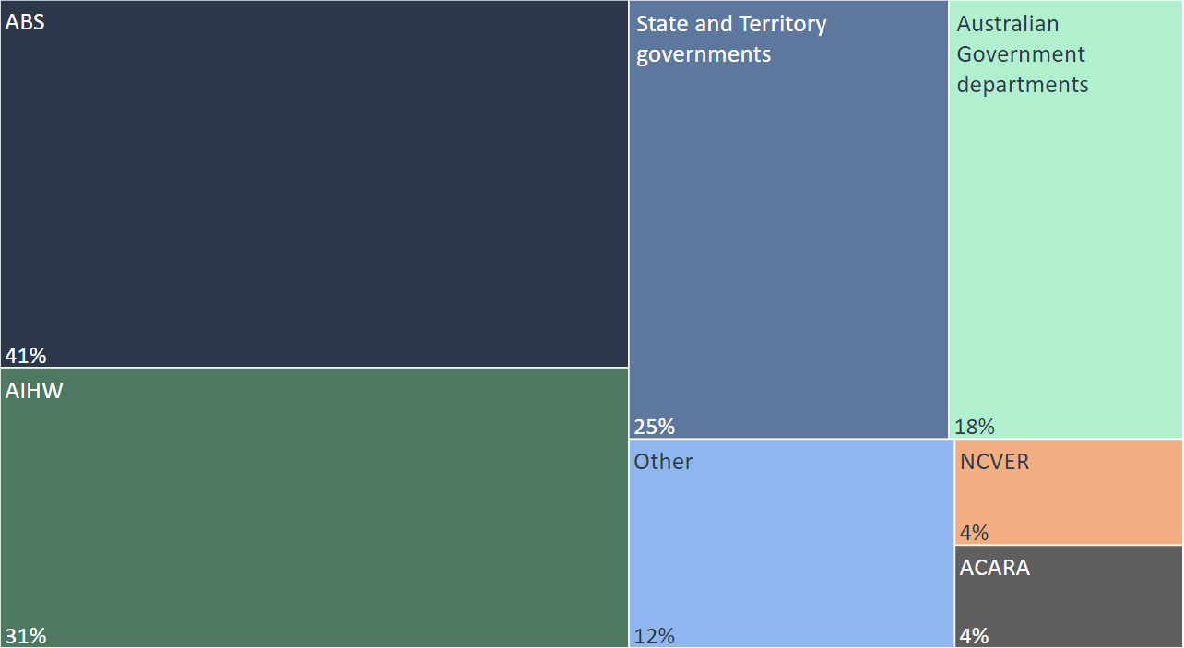  
  
Figure 9: Data sources in the RoGS including percentage of data tables referencing that source, 2024

Source: Analysis undertaken by the Review

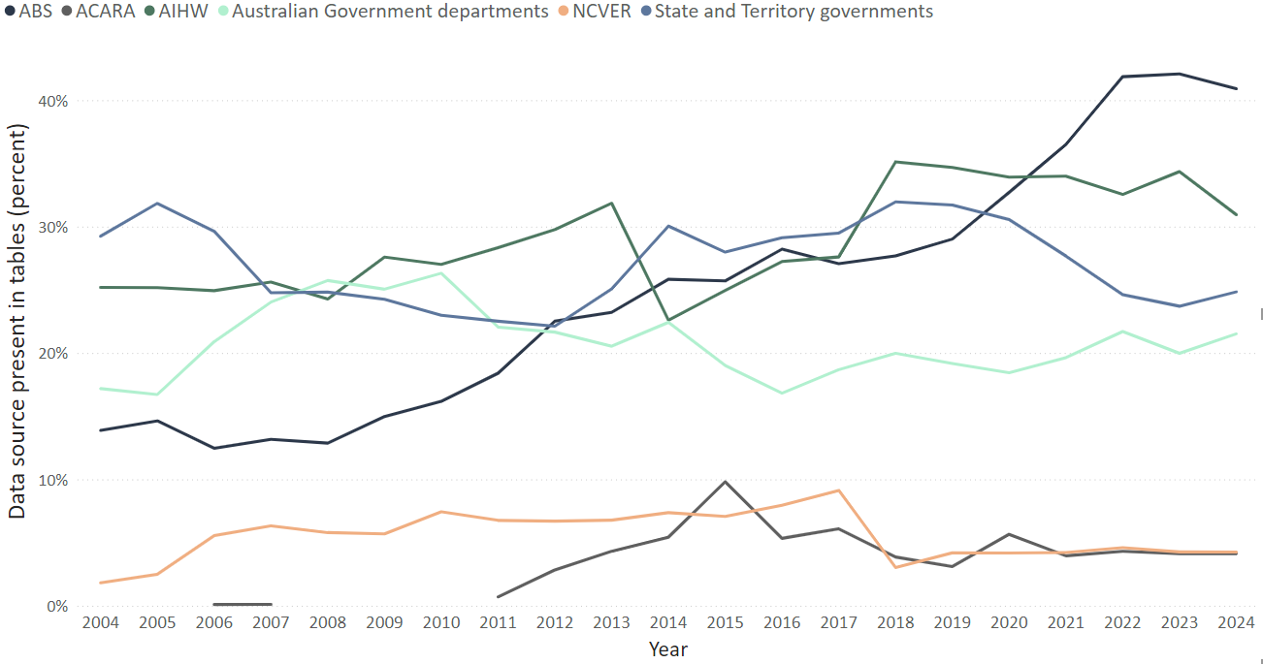

Figure 10: RoGS data sources by percentage of data tables referencing that data source, 2004 to 2024

Source: Analysis undertaken by the Review

The Steering Committee is a valuable group for cross-government decision-making and collaboration, including to progress improvements to the RoGS. The 2009 review noted the intention was for Steering Committee members to be ‘sufficiently senior’ to ‘make decisions on behalf of their jurisdictions’ and ‘carry forward decisions in their jurisdiction’ (Senior Officials/Heads of Treasuries Working Group 2009).

The Steering Committee holds more than 30 years of experience in measuring government service performance and has worked hard to enhance the RoGS since it was first published. For example, between 2016 and 2017 the Steering Committee conducted a significant streamlining exercise to reduce its overall size but retain relevant content with the strongest links to performance. This exercise resulted in the removal of low-value indicators, the consolidation of similar indicators, and the reclassification of other indicators to contextual data (PC 2024b).

Figure 11 is an illustration of this process in the ambulance services sector.

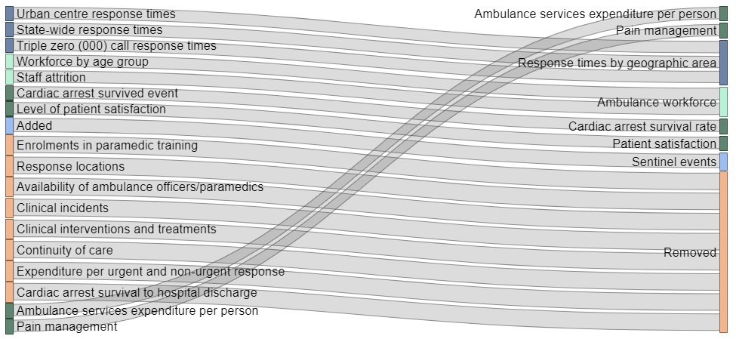

Figure 11: Changes in Ambulance Services indicators between 2016 and 2018

Source: Analysis undertaken by the Review

To improve the accessibility of the RoGS, the Steering Committee:

* oversaw the transition to an online-only product with a navigation aid (‘How to find what you need in RoGS’) in 2016
* introduced interactive Tableau visualisations in 2017
* consolidated downloadable data files (including in machine-readable CSV format) into a single location in 2024 (Steering Committee 2024a).

Implementing improvements to the RoGS requires Steering Committee consensus and action by relevant jurisdictions. Incremental progress and areas of ongoing focus for improvement are not readily visible to the public. Stakeholders, particularly those outside of government, observed that the continuous improvement process appeared slow. Following a recommendation of the 2009 review, the Steering Committee was required to report to COAG on the RoGS every 3 years. Among other things, these reports tracked improvements in data quality, timeliness and accessibility — including the 2016–2017 streamlining exercise — and indicated future improvements (PC 2024b). However, these reports were not published, potentially contributing to a perception of stasis in the RoGS among stakeholders.

#### Completeness and comparability

Despite the Steering Committee’s efforts, improving the completeness and comparability of indicators remains a challenge. Stakeholders strongly identified a need for greater comparability of data for all service sectors covered by the RoGS. The Review’s analysis of RoGS indicator characteristics supports this view.

For context, there are 4 categories that describe the status of RoGS indicators:

1. Most recent data for all measures is comparable and complete.
2. Most recent data for at least one measure is comparable and complete.
3. Most recent data for all measures is either not comparable and/or not complete.
4. No data reported and/or no measures yet developed (Steering Committee 2024a).

For many indicators, their completeness and comparability status changes from year to year. However, for some indicators there are long periods of time where complete and comparable data is not available. In the 2024 RoGS, 28 indicators have not had fully comparable and complete data for 10 years or more, and 8 indicators have had no data reported and/or no measures yet developed for 10 years or more, with the community services sector having the most indicators with persistent data limitations (*Table 1*). Four indicators with no data reported and/or no measures yet developed are outcome indicators.

|  |  |  |  |  |
| --- | --- | --- | --- | --- |
|  | No data reported and/or no measures yet developed | | Not all measures complete and comparable | |
| Service sector | 5+ years | 10+ years | 5+ years | 10+ years |
| Community services | 12 | 4 | 18 | 12 |
| Early childhood, education & training | 1 | – | 1 | 1 |
| Emergency management | – | – | 3 | 1 |
| Health | 5 | 2 | 3 | 2 |
| Housing & homelessness | 3 | 1 | 9 | 8 |
| Justice | 3 | 1 | 4 | 4 |
| **Total** | **24** | **8** | **38** | **28** |

Table 1 RoGS indicators with long-standing completeness and comparability issues

Source: Analysis undertaken by the Review

Further, between 2019 and 2024, 19 indicators experienced a reduction in their level of completeness and comparability (*Figure 12*). The reduction in status for 7 of these indicators was limited to one or 2 years before they returned to full completeness and comparability. However, there were 6 indicators for which this reduction persisted for more than 2 years and has not improved as of 2024.

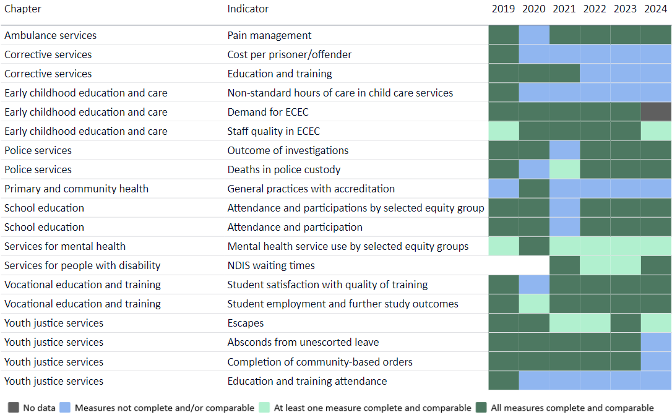Figure 12: RoGS indicators with reduced levels of completeness and comparability between 2019 and 2024

Source: Analysis undertaken by the Review

Limited indicator comparability is problematic for State and Territory governments, many of which raised concerns about the presentation of non-comparable indicators. They were concerned that the presentation might lead casual users to make inappropriate comparisons, where data is acknowledged to not be comparable. Government stakeholders suggested presentation changes could resolve this issue by more clearly separating non-comparable data. However, the Review considers such adjustments are superficial fixes as they would not address the underlying need for comparable data.

#### Outcomes, timeliness and coverage

Both government and non-government stakeholders were eager to see more outcome indicators reported in the RoGS. The Steering Committee and the RGSP Secretariat are actively working to develop more outcome indicators where appropriate. Many outcomes are difficult to measure, and indicators are complex to develop. This work is also limited by differences in data availability.

Stakeholders also noted that the timeliness of data is an issue for some indicators. For some service areas the most recent data reported in the RoGS are from the previous financial year. For others, data can be lagged by one to 2 financial years due to the complexity of data collection and validation. The Steering Committee is conscious of this limitation and in 2020 introduced a mid-year update to improve the timeliness of information reported in the RoGS. Stakeholders did not raise any specific suggestions with the Review on how data lags could be further reduced.

The Review tested with stakeholders whether the coverage of the RoGS remains appropriate. The breadth of the RoGS coverage is notable — internationally, government and non-government bodies tend to report more narrowly (*Information* Box 5: International government performance reporting).

|  |
| --- |
| Information Box 5: International government performance reporting  Unlike Australia, Canada and New Zealand, report performance information on individual sectors rather than in a consolidated way. Some independent think tanks report performance indicators across sectors, but usually on fewer areas or indicators. For example, the United Kingdom’s Institute for Government and the Chartered Institute of Public Finance & Accountancy publishes an annual performance tracker that covers education, heath, justice and community services.  The United Kingdom previously provided data on the performance of government services under the Performance Platform until 15 March 2021. It provided service dashboards on a range of government service areas, including community services, education, health, justice, immigration and transport.  The OECD Serving Citizens Framework was designed to measure and improve service quality and citizen satisfaction. It includes 35 indicators covering healthcare, education, justice and administrative services. The OECD’s criteria for selecting indicators are: adequacy (that is, indicators represent the concept being measured); policy relevance; data availability and coverage; and data interpretability.  Sources: (Controller and Auditor-General of New Zealand 2021; Hoddinott et al. 2023; OECD 2023a; Government of the United Kingdom 2021) |

Some stakeholders noted that services with significant Commonwealth responsibility, such as disability and aged care, might be less relevant for the purposes of cross-jurisdictional comparison. However, among stakeholders there was no strong support to increase or decrease the coverage of these sectors in the RoGS.

#### Taking continuous improvement forward

Overall, government stakeholders spoke favourably about the Steering Committee process and the performance frameworks it uses. Despite some of the concerns raised above, there was general support for the methods and collaboration used to develop the RoGS.

The Review considers that the Steering Committee, supported by the RGSP Secretariat, has the right expertise to continue producing the RoGS. This includes determining its coverage and developing and maintaining performance measures. A public recommitment from governments to the RoGS process, recommended earlier in this chapter, would provide a renewed mandate for the Steering Committee’s decision-making authority. However, the Steering Committee must use its expertise and authority to address long standing data comparability and completeness issues.

The 2009 review recommended a separate reconsideration of the RoGS performance indicator framework and individual performance indicators (Senior Officials/Heads of Treasuries Working Group 2009). Evidence available to the Review shows that it is not necessary to repeat this work. The Review’s opinion is that such a recommendation would undercut the Steering Committee’s existing power to make its own improvements. However, the Review recommends that the Steering Committee prioritise action on continuous improvement. This should particularly focus on indicator completeness and comparability, but also user engagement which will be explored later in this report (*Chapter 4: The usefulness and accessibility of the information*). This approach would improve the usefulness of the data in the RoGS over time.

If successful, this would also work to increase the focus on outcomes, given that 4 of these have sat in the ‘No data reported and/or no measures yet developed’ category for a significant period. Effective progress on this matter may require the Steering Committee to play a more active role in data development. The Review understands work is already underway for patient safety measures for mental health services (PC 2024b).

The Steering Committee should also consider other potential improvements to strengthen reporting that were raised by stakeholders during the Review, including the development of new indicators and refinements to existing indicators (*Appendix 4: Stakeholder suggestions to strengthen performance indicators*).

The Review agrees with stakeholders that timely data is crucial for the RoGS to be relevant for policymaking and accountability purposes. However, it has not been possible to find any practical solutions that would not substantially increase administrative and resourcing burden on data providers. The Review does not make any specific recommendations to improve timeliness but suggests that this matter should form part of the Steering Committee’s continuous improvement agenda. Improving connections between the Steering Committee and data and digital experts could help reduce data lags in the future, especially as technologies to capture and share data continue to develop (*Chapter 5: The broader data and reporting ecosystem*).

Similarly, the Review considers the current coverage of the RoGS is appropriate. This should continue to be assessed by the Steering Committee in line with the terms of reference and its own frameworks.

## The Performance Reporting Dashboard

### An opportunity to realise this tool’s potential

The Dashboard and the RoGS have similar goals, aiming to promote accountability, transparency, and service delivery improvements.

The Dashboard has many benefits as a transparency tool. Government and non-government stakeholders appreciated its presentation style, including the use of benchmarks, targets and a simple interface. Stakeholders also found it easy to access and understand progress against the selected priorities. Based on this feedback, it is likely the Dashboard enhanced accountability on these key government commitments when it was first released.

Currently, the Dashboard captures many legacy measures that do not reflect how agreements and priorities have changed. For example, the Review’s analysis found that only 13 of the indicators currently on the Dashboard exist in later versions of the agreements.[4] Similarly, indicators for the *National Indigenous Reform Agreement* are still reported on the Dashboard, despite it being replaced by the *National Agreement on Closing the Gap* and the subsequent development of the *Closing the Gap Information Repository* (PC 2023a).

Stakeholders criticised the Dashboard for presenting an incomplete picture of performance. The Review’s analysis found that around half of the agreements in the Dashboard had 10 or more performance indicators but only some of these indicators were included in the Dashboard by COAG.

Stakeholders had low awareness and use of the Dashboard. This is reflected in its website access statistics, which show annual Dashboard views steadily decreasing from around 80,000 to 50,000 between 2018 and 2023. More than 90 per cent of the Dashboard webpages were viewed by 5 or fewer users per month (*Figure 13*).

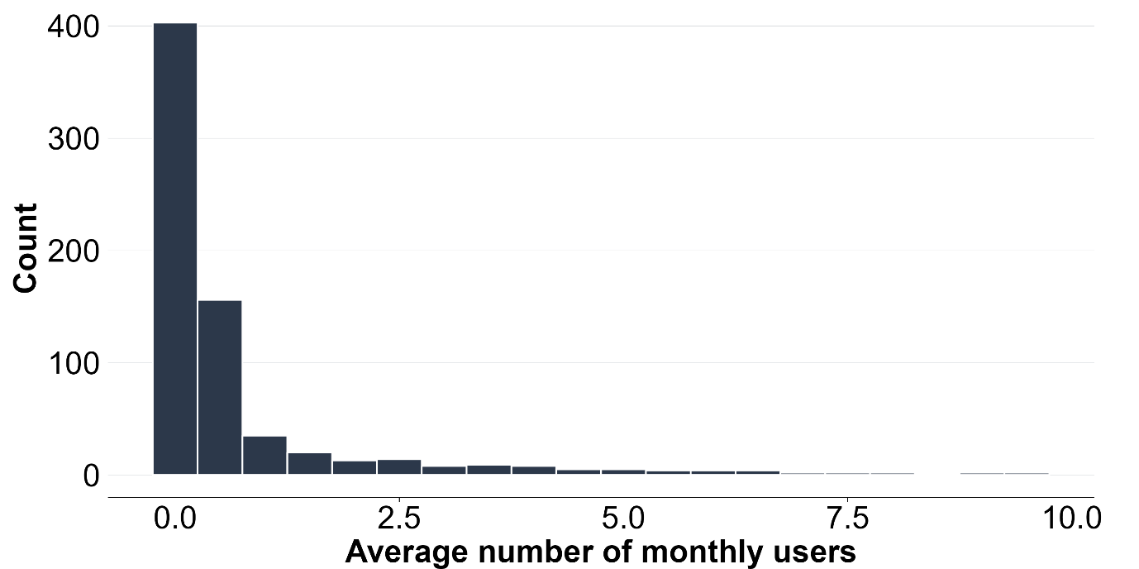

Figure 13: Average number of Dashboard webpage users per month, 2022–2024[5]

Source: Analysis undertaken by the Review

If the Dashboard is not updated to include new Commonwealth-State funding agreements as they commence it will become even less meaningful over time.

One option considered by the Review was to discontinue the Dashboard as a reporting product. In this scenario, performance monitoring for different agreements would continue to be the work of other bodies, such as Ministerial Councils and the AIHW. For example, the *Better and Fairer Schools Agreement* establishes its own arrangements, requiring ‘public reporting on progress against this Agreement through an education reporting dashboard’ (Commonwealth of Australia and Australian States and Territories 2024a). Discontinuing the Dashboard would therefore represent a saving to the Commonwealth.

However, discontinuing the Dashboard could be perceived as a reduction in transparency and accountability on government performance, particularly if the format and availability of public reporting varies between different agreements. For example, in housing there is no single location where all relevant performance information can be found.

Transparency has indirect and long-term benefits, such as increased public trust and improved government decision-making, which are difficult to quantify. This makes accurate cost-benefit analysis challenging. Nevertheless, the Review sees value in continuing a ‘one stop shop’ approach for publicly reporting progress against commitments in major Commonwealth-State funding agreements. Centralised reporting enables users to easily access and understand government performance across agreements. It also helps decision-makers identify how actions and outcomes connect across service sectors.

The Review recommends updating the Dashboard so that it covers current key government priorities. At the time of writing, these priorities, and their performance measurement frameworks, are outlined in:

* 5 National Agreements
  + *National School Reform Agreement*[6]
  + *National Health Reform Agreement*
  + *National Mental Health and Suicide Prevention Agreement*
  + *National Skills Agreement*
  + *National Agreement on Social Housing and Homelessness*
* *Land Transport Infrastructure Projects Agreement*
* *National Legal Assistance Partnership*.[7]

An updated Dashboard could help improve the effectiveness, efficiency and equity of government services and the wellbeing of the community.

Governments have also prioritised progress against the targets and indicators agreed as part of the *National Agreement on Closing the Gap*, which are published in the *Closing the Gap Information Repository*. The Review is not seeking to change or duplicate this dedicated reporting product.

A nationally coordinated approach across agreements could assist Ministerial Councils in satisfying their own reporting and monitoring requirements, where appropriate and noting that the update process will take time to implement. The Review also acknowledges that some agreements have specific arrangements that should continue independently. For example, the reporting tool being developed under the *Better and Fairer Schools Agreement.* Performance measures for these agreements should still be captured in the Dashboard and relevant agencies should collaborate with the Steering Committee to reduce compliance burden for data providers.

The updated Dashboard should have a clear purpose set out in a terms of reference, as well as formal governance arrangements to ensure its coverage remains relevant. This approach will prevent the Dashboard becoming out of date over time, as was the case with the 2017 approach. The Review considers that the Steering Committee is well placed to oversee the Dashboard, because of its wealth of experience in performance measurement, and the strong links between the RoGS and the Dashboard. New governance arrangements would authorise the Steering Committee to include new major Commonwealth-funding agreements into the Dashboard as they are developed, and remove reporting on older versions.

A renewed commitment to the Dashboard by governments will publicly demonstrate the value they place on transparency, accountability and action in major service delivery areas.

### Promoting performance reporting for reform

Currently, the RoGS and the Dashboard are not formally connected to any key decision‑making bodies. This is not necessary for transparency and accountability processes to be effective, but the Review considers it could link national performance reporting to conversations on cross-jurisdictional policy and best practice.

Following the 2009 review, the Steering Committee provided 3 written reports to COAG in 2012, 2015 and 2018 (PC 2024b). In the Review’s opinion this advice was mostly procedural and became repetitive by its second edition.

Between 2010 and 2014, the CRC reported to COAG on the performance of governments under National Agreements, which included comparative analysis between jurisdictions (*Chapter 2: Overview of the reporting products*)*.* However, since the dissolution of the CRC in 2014 there has been no dedicated body undertaking performance monitoring, assessment and reporting across these agreements. *Schedule C* still reflects the former arrangements, despite governments recommitting to the IGA FFR in 2022.

Without direct links to national bodies, there appear to be fewer reform conversations in the context of cross-sectoral performance, despite the existence of the RoGS and the Dashboard. The Dashboard was intended to bridge the gap left by the CRC, but it is unclear whether COAG ever directly used the product in its discussions. The Review found no evidence of this in any post-meeting communiqués. Post-COAG, the RoGS and the Dashboard have not been referenced by National Cabinet in any   
post-meeting communication.

Low productivity and tight fiscal environments make it critical for government services to be effective, efficient and equitable. While the previous reporting relationship for the RoGS and National Agreement performance was centred on COAG, in the refreshed Commonwealth-State relations architecture, the Review considers such reporting would better sit within the responsibilities of CFFR. CFFR includes all Australian Treasurers and has a broad scope, including to:

* improve national economic and fiscal outcomes, and the wellbeing of all Australians
* progress fiscal and economic reforms in areas of national significance, including productivity
* oversee Commonwealth-State funding agreements
* advocate for cross-cutting reforms (CFFR 2023).

Given CFFR’s wide range of responsibilities, the Review recommends that the Chair of the Steering Committee report annually to Heads of Treasuries (HoTs) instead of reporting directly to Australian Treasurers. HoTs is a supporting forum for CFFR that is chaired by the Secretary of the Commonwealth Treasury and includes the head of each State and Territory’s Treasury department. The primary purpose of HoTs meetings is to review and assesses draft papers on their readiness and suitability to progress to CFFR. HoTs can also consider bespoke agenda items and delegate work to other forums, including Deputy Heads of Treasuries (DHoTs) and CFFR working groups.

A formal relationship between the Chair of the Steering Committee and HoTs would deepen members’ understanding of government progress across sectors. It would also assist in identifying national reform opportunities. HoTs would be able to promote issues to Treasurers for discussion or action, consistent with CFFR’s terms of reference.

The report to HoTs should be engaging and strategic to prevent it becoming a compliance exercise. One option could be to focus on a priority service area or topic. The scope, parameters, format and timing of the report should be developed by the Steering Committee in collaboration with DHoTs and HoTs. Other bodies responsible for performance monitoring and reporting should also be consulted, including Ministerial Councils and the AIHW. Reporting could be verbal or written, but should take place at least once a year. Interim reporting could be added, where useful, such as before a State, Territory or Federal election. The report could also capture progress in implementing the review recommendations and any key learnings to date.

In designing the new report, the Steering Committee should examine the 3 previous reports provided to COAG as well as other reporting approaches to identify effective elements for engaging with HoTs (*Information* Box 6: Effective national reporting for decision-makers).

|  |
| --- |
| Information Box 6: Effective national reporting for decision-makers  An engaging and strategic report to a decision-making body should be clear and concise. It should also be effectively linked to policymaking and make the most of relevant national discussions.  The Commonwealth Grants Commission’s (CGC) state snapshots are not specifically designed for decision makers, but simply communicate outcomes from a complex process. The headline statement is complemented by clear graphics linked to the key message.  The AIHW’s Australia’s health 2024: data insights report covers 11 health topics, and includes analysis that can be used to shape future reform. It highlights key issues from a broad range of health data and presents them with a focus on actionable reforms. This is most clear in the Future focus/where to from heresections.  The Australia’s health 2024: data insights report also presents information relevant to current national conversations. The 2024 report examines concussions in Australia over the last decade which was the subject of a Senate Committee in 2023. It also examines electronic cigarette use (vaping) in Australia in 2022–2023 for which regulation was reformed in 2024. This highlights some recent examples of where important information has been prepared for policymakers to help them have discussions on significant issues.  Sources: (CGC 2024a; AIHW 2024b; Senate Community Affairs References Committee 2023; Butler 2023) |

The Chair of the Steering Committee is also the Chair of the PC. Therefore, this new reporting requirement would also help the PC play a ‘bigger role in monitoring and evaluating National Reform Agreements and specific government services’, as proposed in the Commonwealth Government’s Statement of Expectations (Commonwealth of Australia 2023b).

## Findings, recommendations and implementation suggestions

|  |  |
| --- | --- |
| Findings | |
| 1. The RoGS is a trusted source of information for governments and the public that relies on active engagement from all jurisdictions. 2. The Steering Committee has made significant progress in improving the RoGS over time, but more can be done to ensure it remains fit for purpose into the future. 3. The Dashboard is a clear and concise way of presenting progress on selected government commitments in major Commonwealth-State funding agreements at a point in time, but it doesn’t reflect current priorities and lacks a clear objective and effective governance structures. 4. The Steering Committee provides a valuable forum for interjurisdictional engagement but without a connection to an external decision-making body, opportunities for performance reporting to contribute to national policy and reform may be missed. | |
| Recommendations | Implementation suggestions |
| 1. **Reinvigorate the approach to performance reporting** | The Steering Committee would need to update governance documentation, including the RoGS terms of reference and its own terms of reference. It would also need to update its charter of operations to reflect changes arising from these (and any subsequent) recommendations. |
| * 1. CFFR to publicly endorse the RoGS, including its contribution to transparency and accountability and reaffirm all jurisdictions’ commitment to engaging in the process. | Public endorsement could take the form of a media release or communique from CFFR, or a published letter from the Chair of CFFR to the Chair of the Steering Committee. |
| * 1. The Steering Committee to prioritise action on continuous improvement in the RoGS, particularly in relation to indicator completeness and comparability. | The Steering Committee should prioritise its work to enhance comparability and completeness of indicators over time.  The continuous improvement program should be developed in consultation with users. To improve public visibility, the Steering Committee could publish its forward work plan at regular intervals, like the approach adopted by the ABS.[8] This could also cover progress in implementing the recommendations of this Review.  The triennial reports that followed the 2009 review also provided useful insights into the continuous improvement process and the publication of similar information would increase public visibility of work on data quality, timeliness and accessibility. |
| * 1. The Steering Committee to assume responsibility for the Dashboard and update it to cover major Commonwealth-State funding agreements by 2027–28. | The Steering Committee should take immediate responsibility for the Dashboard and commence updating it for major funding agreements. |
| 1. CFFR to assume oversight of the RoGS and the Dashboard and the Chair of the Steering Committee to report annually from 2026 to Heads of Treasuries on performance in government service delivery and major Commonwealth-State funding agreements. | The format of the report should be developed in close consultation with DHoTs, HoTs, and other bodies with responsibility for performance monitoring and reporting, including Ministerial Councils and the AIHW.  Commonwealth Treasury, in consultation with States and Territories, should also consider updates to Schedule C of the IGA FFR to reflect changed public accountability and performance reporting arrangements. |

# Chapter 4: The usefulness and accessibility of the information

## The need for additional analysis

Government and non-government stakeholders see the RoGS as a trusted source of information and an important transparency mechanism. However, they also reported that it does not provide an adequate narrative, draw out key messages or focus on trends over time and across jurisdictions. For example, the reporting does not include enough contextual information to help governments and the public understand what is causing changes in performance. There is also no identification of innovative programs, policies or approaches across and within jurisdictions. Highlighting comparative performance and areas of improvement and innovation in the RoGS would help jurisdictions learn from each other and encourage improvements in delivery and effectiveness.

### Quantitative and qualitive analysis

The RoGS contains limited quantitative analysis on the relative performance of jurisdictions over time. The sector Overview sections include information on national performance, but not information or analysis of the performance of jurisdictions, individually or comparatively, over successive reporting periods. The service area chapters include charts and tables on how States and Territories are performing, but no analysis to explain historical trends in performance and differences across jurisdictions. As a result, it’s difficult for users to accurately identify which jurisdictions are performing well or poorly or where further action may be required.

Quantitative analysis could be used to explain differences in performance indicator results. For example, accounting for factors that explain the differences between performance indicators, such as population densities, age structures and other variables.

It can be difficult to do comparisons or assessments of the performance of individual jurisdictions, especially if data is not complete and comparable. It can also be hard to identify improvements in outcomes consistently for all jurisdictions.

The RoGS also contains limited qualitative material. Qualitative data is interpretation-based and descriptive and can help users understand the ‘why’ and ‘how’ behind certain outcomes or behaviours (*Information* Box 7: Qualitative information). Quantitative and qualitative data provide different information, which when used together can provide a fuller picture of how government services are being delivered.

|  |
| --- |
| Information Box 7: Qualitative information  Qualitative data has a particular context, time and place and aim to understand outcomes, behaviours and their drivers. Qualitative data can be collected where quantitative data is unavailable or as a complement to deepen analysis. For example, knowing test scores in a school district have outperformed other school districts doesn’t tell you why.  Qualitative research is used by the National Centre for Vocational Education Research to enhance outcomes in the VET sector. For example, some VET students still achieve successful outcomes despite not completing their VET qualifications. Research found an additional 19.8 per cent of 2016–commencing students completed all enrolled subjects or modules, on top of the 49.5 per cent who successfully completed their program.  Qualitative narratives are used by the AIHW in its family, domestic and sexual violence reporting. One such example is the WEAVERs — a diverse group of women who play a role in ‘weaving’ lived experience into research and training at the University of Melbourne. The WEAVERs’ contributions are used alongside the AIHW’s data reporting to enrich the public understanding of how violence and its consequences is experienced by some people in a real-world context.  While useful, qualitative observations and research may not always apply generally. As the What Workspilot report notes, without an analysis of causal links between interventions and outcomes, sustainable improvements are only likely to come through trial and error.  Sources: (PC 2021a; Wilbrow and Hall 2024; Melbourne Social Equity Institute 2024; AIHW 2024c) |

Sharing experiences, including via case studies, could also help to facilitate the diffusion of good policy by reducing the need for a ‘trial and error’ approach. Case studies can measure the impact of community engagement programs, which are not captured well by quantitative data. Case studies can also help to tell the story of how data is used and why collecting data matters, and to facilitate change conversations. For example, the 2024 RoGS included a case study on flood mitigation, prevention and preparedness efforts in Queensland (*Information* Box 8: Flood mitigation, prevention and preparedness case study).

|  |
| --- |
| Information Box 8: Flood mitigation, prevention and preparedness case study  The 2024 RoGS included a case study on flood mitigation, prevention and preparedness efforts in Queensland. It looked at:   * the roles and responsibilities of local governments and State-level agencies * past studies of floods in Queensland * the role of community awareness in helping individuals and communities to prepare * household preparedness * flood warnings.   The case study was used to assess the flood risk and resilience of communities, and to inform planning and investment decisions. It highlighted examples of community awareness programs undertaken by government agencies in Queensland, flood mitigation, prevention and preparedness measures being implemented and recent attempts to improve Queensland’s existing flood warning systems.  The flood case study is an example of how analysis and other data sources could be used in the RoGS to provide insights on local and State programs in key policy areas.  Source: (Steering Committee 2024a) |

The Review considers including more quantitative and qualitative analysis will help facilitate improved service delivery, efficiency and performance over time. It is consistent with the approach being taken on Measuring What Matters to include insights (*Information* Box 9: Comprehensive Measuring What Matters ) and the OECD’s Government at a Glance publication. The OECD compares the satisfaction of citizens with public services across countries. Government at a Glance provides an overview of the results, including highlighting where results have improved or declined and where citizens are the most satisfied with services. The analysis also explains factors that may be causing comparatively low performance in some countries (OECD 2023b). This kind of material should be included in sector Overviewsections and the front of each service area chapter.

|  |
| --- |
| Information Box 9: Comprehensive Measuring What Matters Statement  The Measuring What Matters Statement and its dashboard have been designed to be high-level, concise, and accessible.  The Commonwealth is committed to refining the Framework over time, so that it properly takes account of changing public perspectives, and developments in how we collect, analyse and use data. A key focus will be on exploring greater disaggregation to better reflect the experience of different groups.  The Dashboard will be updated annually to take stock of progress and identify priorities for future action.  The Commonwealth will release a comprehensive *Measuring What Matters Statement* every 3 years. These statements will examine trends in wellbeing, how we are tracking over time, and where we are doing well or need to do better.  These insights will be used to inform budgets and government decision-making to deliver better outcomes for Australians.  Sources: (Commonwealth of Australia 2023c; Chalmers and Leigh 2024) |

### Cross-sectoral analysis

Stakeholders noted that the RoGS does not highlight the interdependence between service sectors, such as the influence of housing and education on health outcomes (*Information* Box 10: Social factors influencing health outcomes).

|  |
| --- |
| Information Box 10: Social factors influencing health outcomes  Social factors can influence health outcomes within and between countries. They are the conditions in which people are born, grow, work, live, and age. For example, health outcomes can be impacted by:   * income * education * early childhood development * employment status * housing * access to affordable and quality health care.   Numerous studies suggest that social determinants of health account for between 30 to 55 per cent of health outcomes. Therefore, it is important to consider their impact on health outcomes.  The AIHW publishes information on the social determinants of health. A recent article included data on the social characteristics of the Australian population and evidence from recent studies on how these characteristics can act to strengthen or undermine the health of individuals and communities. For example, the AIHW noted that poor-quality housing can worsen health outcomes, such as respiratory illness, cardiovascular disease and mental health.  Sources: (WHO 2023; AIHW 2024d) |

Presenting material, including evidence from research and analysis, across different sectors and domains, such as health, education, justice, and social services, would capture the interrelated and holistic nature of service delivery and outcomes. It may also provide more granular data and help identify specific areas for further action.

Cross-sectoral analysis, such as on the links between homelessness and mental health, could help users better understand how performance in one sector affects others. Qualitative analysis could highlight how policies are impacting on behaviour and outcomes.

These interdependencies could be captured as part of any quantitative and qualitative analysis of sectors.

### Improvements in services and innovation

Innovation is not easily identified by high-level performance indicators. Innovation may influence indicators over time, but direct links are hard to establish and even harder to attribute to government reforms. Innovation generally occurs at the business or program level.

There have been periodic attempts to make the RoGS more strategic and influential, but these have not been successful. For example, the RoGS has previously incorporated case studies and the Steering Committee oversaw 2 What Works reviews, a collection of global evidence on effective government services interventions (PC 2021a). In assessing the effectiveness of the What Worksreviews, the PC noted:

while systematic evidence reviews using the What Works method have the benefit of a rigorous process, they may not always yield practical and useful information for policymakers (PC 2021a).

The Review considers that including practical and relevant examples of innovative policies and practices would help the RoGS to be a more useful tool for governments and the public (*Information* Box 11: Examples of reporting on reform and innovation). There is much value in governments working to drive innovation and spread good practice, as shown in the PC's 2023 Productivity Inquiry (PC 2023c). The Steering Committee should therefore be closely involved in identifying suitable case studies.

Further, the RGSP Secretariat should engage with the Australian Centre for Evaluation and others to identify relevant examples of innovation and improvement at the program level. This would be consistent with the Commonwealth’s exploration of how the PC and the Australian Centre for Evaluation can work together more closely (Commonwealth of Australia 2023b). In developing this material, the Steering Committee can draw on research undertaken by the PC and others.

|  |
| --- |
| Information Box 11: Examples of reporting on reform and innovation  In 2017 and 2018, the Steering Committee published a series of case studies on significant recent reforms to the way government services are delivered in specific jurisdictions. These case studies, undertaken by the RGSP Secretariat, examined the issues and options addressed in the implementation of selected reforms in health, education, justice and community services.  The focus of the case studies was on how the reforms were implemented; why each option was chosen; and how these decisions affected the reform. The case studies were designed to increase understanding of how reform in government service provision is being carried out throughout Australia, and how governments are implementing changes in response to local challenges. The objective of the case studies was to help jurisdictions learn from each other by illustrating how similar issues across services are approached by different jurisdictions.  States and Territories could share their innovative approaches to delivering government services. For example, from 2025, all students from Prep to Grade 2 in Victoria will be taught using a systematic synthetic phonics approach as part of their reading programs. Teachers will spend a minimum of 25 minutes a day on explicit teaching of phonics and phonemic awareness. Systematic synthetic phonics is a structured approach that explicitly teaches the relationship between sounds and letters to read words. Focusing on teaching reading through phonics reflect evidence — from schools Australia-wide and internationally — that are achieving strong learning outcomes.  Detailed studies of successful reform at the organisational level can help governments understand how the effectiveness and efficiency of government services can be improved. The Susan McKinnon Foundation has published 2 case studies on reform in the delivery of prison and health pathology services in New South Wales. The case studies demonstrate that better outcomes and value for money can be achieved through taking a ‘business unit approach’, with reform at the organisational and managerial level.  The OECD often highlights the experience of different countries in implementing policies. For example, in 2024, the OECD used examples collected from a range of countries, including Australia, New Zealand, Portugal and Scotland, to illustrate how different curriculum approaches impact on the effectiveness of teaching and learning in schools, as well as the inclusivity of learning environments. Country examples:   * are short * include key contextual information, for example, teachers in South Korea can modify hours by up to 20 per cent for specific subjects * can highlight challenges, such as teacher retention and workloads.   Sources: (Steering Committee 2018; PC 2021b; Carroll 2024; Susan McKinnon Foundation 2023, 2024; OECD 2024) |

### Responsibility for additional analysis

The Review recommends the RoGS should include additional quantitative, cross-sectoral and qualitative analysis. This approach would make the reporting more relevant and help advance reform.

The Review understands that the Steering Committee has already been exploring options to make the Overviewsections more useful, including to improve consistency and add more intersectoral information and commentary for the benefit of non-technical users (PC 2024b). As a result, the 2025 RoGS will include 3 redesigned sector Overviewsections (PC 2024b).

However, as noted earlier in this report (*Chapter 3: The approach to performance reporting*), the consensus nature of the Steering Committee process can slow the development and implementation of improvements, as it requires all parties to agree. Further, the Review is concerned that a consensus model might limit the usefulness of additional analytical material due to sensitivity about perceived criticism.

Accordingly, to be most effective, the additional analysis needs to be undertaken separately from governments. This approach would enable the RoGS to identify and highlight areas of good and poor performance, at both a national and State level, ensuring that all governments are held accountable. With its broad and established expertise in economic and data analysis and public policy evaluation, independent status, and long history with the RoGS, the PC is well-placed to play this new role.

The Review acknowledges that this approach would be a significant change from the consensus model for producing the RoGS, and is not without risk. It could reduce willingness of jurisdictions to provide data and participate in the process, especially where they fear the information could be used to highlight areas of poor performance. This risk could be mitigated by a genuine recommitment by governments to the RoGS and the Dashboard (*Chapter 3: The approach to performance reporting*).

The new PC role would complement the role of the Steering Committee in producing the RoGS. The Steering Committee would remain responsible for determining the coverage of the report, developing and maintaining specific performance indicators, and implementing a program of review and continuous improvement.

The Review recommends that the additional analysis also include examples of innovation, and highlight areas where Commonwealth, State or Territory programs, policies and strategies are improving performance. For example, practices being implemented by some high performing schools to improve the performance of their students. This approach could be rolled out incrementally, with a focus on a different section each year. Examples should be selected based on evidence and proven effectiveness, such as through published evaluations. They should be innovative, have broader application across jurisdictions or in other contexts, and be in an area of whole‑of‑government policy priority.

The PC could work with Steering Committee members to identify suitable examples and content for this process and ensure any additional material is practical and useful, consistent with the findings of the What Workspilot. The case studies should be developed in consultation with the relevant jurisdiction.

### Phased approach

Some additional analysis can be done within existing resources of the RGSP Secretariat, if supported by CFFR. This could include more quantitative, cross-sectoral, longitudinal or qualitative analysis in the RoGS over time. Examples of innovative or high‑impact policies could also be included if States and Territories provide material.

Additional analysis should be phased in across sectors — for example, by including case studies on innovative programs and policies or in sector Overview sections as is already being considered — or by trialling with a specific equity group — for example, First Nations people. The effectiveness of this approach should be assessed and extended over time, including to other types of analysis, if successful. This approach should ensure that any additional analysis is practical and useful.

## Accessibility and presentation

The RoGS is a large and complex resource that can be difficult for users to navigate. The number of indicators and how they are presented were reported as overwhelming by some stakeholders.   
Non-government users reported that they did not generally have the analytical capacity, resources or time to easily find, understand, and analyse the information. However rather than reducing the number of service areas or indicators, they wanted simpler ways to find what they needed and more guidance and support on how to use and interpret the data.

The Steering Committee continues to work to improve the accessibility of the RoGS (*Chapter 3: The approach to performance reporting*). Some stakeholders appreciated now having access to the annual compiled report and CSV files, as this is their preferred data format for conducting State and Territory comparisons and other analysis. However, users also noted that it would be simpler to have the long‑term time series data in one place instead of having to download multiple spreadsheets across multiple editions of the RoGS.

Users also reported that it can be it difficult to understand the experience of different equity groups as relevant material is not presented in one place. For example, information on First Nations people is spread across service sectors rather than presented in a standalone section. These users wanted to see a greater focus on reporting holistically for equity groups and expressed interest in data by geographical and population subgroups. This included remoteness, socio-economic status, age, gender, and Aboriginal and Torres Strait Islander status.

The RoGS identifies 4 main groups of people that may have special needs or difficulties in accessing government services:

1. First Nations people
2. people living in rural or remote areas
3. people from a non-English speaking background
4. people with disability.

Currently data for these groups is spread across service areas (*Information* Box 12: Disaggregated data for First Nations people in the RoGS).

|  |
| --- |
| Information Box 12: Disaggregated data for First Nations people in the RoGS  In 2024, performance indicator data for First Nations people is available for 136 measures across 14 of the 17 covered service areas:   * early childhood education and care * school education * vocational education and training * police services * corrective services * primary and community health * public hospitals * services for mental health * aged care services * services for people with disability * child protection services * youth justice services * housing * homelessness services.   Currently, First Nations-specific data is reported separately in each of the relevant service sectors. While both the PDF and online versions of the RoGS indicate which data tables contain data relating to First Nations people, the actual information is embedded into the body of the report. Similarly, Excel data tables and CSV datasets are available for download from a single location on the RoGS website, but these are not broken down by equity group.  The ability to easily see disaggregated equity group data in a single location — such as through a filtering feature — would make it easier for users to see a more complete picture of service delivery for that group of people, including across different sectors.  Source: (Steering Committee 2024a; Analysis undertaken by the Review) |

The Review considers that users should be able to filter, select and present the data they want, within and across sectors. For example, a user should be able to extract data relevant to a particular equity group, such as First Nations people, for indicators in National Agreements, or for equity, effectiveness or efficiency indicators. This will make it easier for users to access, find and use the RoGS data.

The ABS and AIHW provide tools for users to interact with and customise their data. The ABS provides a free online product, Data Explorer, which enables users to create their own tables and visualisations (ABS 2024a). It is an interactive web browser interface where you can view, query and download data. AIHW releases data for different geographic areas and population subgroups, such as First Nations people, sex and age groups, and for indicators and measures of health and welfare. For example, you can view waiting times for emergency department care across all public hospitals, nationally and for individual States and Territories, or for a particular hospital for different periods by table or chart. Metadata specifications are also provided.

Users should also be able to interact with the data in a more in-depth way and easily pull RoGS data together across relevant service areas. Different formats, such as plain English, infographics, and interactive visualisations, would make the RoGS more accessible and engaging for diverse audiences. The AIHW provides this kind of functionality. For example, the AIHW includes socio‑economic factors, such as the proportion of people with low income and higher educational attainment, as part of its health performance framework.

Alternative ways of presenting the information, such as interactive maps, could also make the data more accessible for some user groups. Some stakeholders suggested that there should be a simplified interface (most referred to as a ‘dashboard’ — not to be confused with the specific Performance Reporting Dashboard), which highlights key messages for each of the service areas. There is a lot of flexibility in how dashboards are structured — there is no Australian design standard outlining what accessibility and user experience requirements must be met, though these do exist internationally (*Information* Box 13: Design standards for data dashboards).

|  |
| --- |
| Information Box 13: Design standards for data dashboards  Commonwealth agencies that publish web content must comply with the Digital Experience Policy, which includes standards for access and inclusion. This policy also outlines that online content should be simple to use, designed to meet user needs and be consistent with other government digital products.  Internationally, governments are beginning to design best practice standards for data dashboards. An example is the Data visualization: dashboard guidance document prepared by the UK Government Office for National Statistics. This guidance material addresses elements of the Digital Experience Policy and outlines that dashboards should:   * use simple and well labelled visuals that clearly tell a statistical story * provide access to data downloads for all visuals * have a look, feel and navigation that is consistent with other government dashboards * group related information and highlight important information at the top * reduce visual clutter — keep it simple * minimise the need for scrolling * work with different screen sizes, internet browsers and devices.   Sources: (Digital Transformation Agency 2024; Office for National Statistics 2024) |

Stakeholders identified examples of dashboards and data interfaces that they considered to be good practice (*Information* Box 14: Examples of accessible data). Generally, these dashboards and data interfaces have the following common characteristics:

* a visualisation of the top indicators.
* ability to filter visualisations by relevant variables such as location, date, expenditure.
* source data either linked or the underlying data available.
* a legend or definitions or provides contextual clarifications where the visualisation is heavy in jargon or technical information.
* ability to export as raw data, visualisations, or code to embed the interactive display elsewhere.
* an explanation of what has been done to get from source data to visualisation.

|  |
| --- |
| Information Box 14: Examples of accessible data interfaces  The dashboard view of the Closing the Gap Information Repositorydashboard in the Closing the Gap Information Repository provides the most up-to-date information available on the targets and indicators in the National Agreement on Closing the Gap. It identifies where progress is improving, worsening or unchanged and whether governments are on track to meet agreed targets. The Closing the Gap dashboard is accessible, uses simple visuals, with users able to access more detailed information on each target and indicator. New material is also highlighted.  The NSW government’s AgTrack — Agricultural and Land Use Dashboard — compiles recent agricultural data on production, value and employment at a state, regional and local government area scale, and presents it in an interactive format. The way it is presented tells a story.  The QLD government’s Corruption Allegations Data Dashboard allows users to interrogate the QLD Crime and Corruption Commission’s data. Data is provided over time and can be filtered by year, sector and crime. A glossary of terms and frequently asked questions are also provided.  Statistics Canada’s Aviation Data Visualization Hub provides civil aviation indicators and information on aircraft movements and airport activity. Additional explanatory information, including relevant definitions, is provided as well as links where further information can be founded. A ‘how to use’ guide is provided.  World Bank Group’s DataBank is an analysis and visualisation tool that contains collections of time series data on a variety of topics, including world development indicators and health and education statistics. Users can create their own report based on available datasets. Information can be viewed as a table, chart or map.  Sources: (PC 2024c; NSW Government 2024; Queensland Crime and Corruption Commission 2024; Statistics Canada 2024; World Bank 2024) |

Roundtable participants also supported changes in the presentation of data to reflect the interrelated nature of service delivery and outcomes. For example, the interface between the health, aged care and disability services sectors. This can be addressed by enabling users to select data across policy areas.

Some non-government stakeholders indicated the visibility of the RoGS was low. The Review believes making the design of the product more user-centred will boost its visibility among the public, particularly for NGOs. To further assist in raising the profile of the RoGS, the RGSP Secretariat could also provide more information for the media and non-government stakeholders following the release, to help them understand the material. For example, the RGSP Secretariat could provide more guidance and support on how to use and interpret the data, especially for non-technical users, or provide a briefing for the media, in line with guidelines developed and agreed by the Steering Committee. A greater role for the community will also likely be beneficial for promotion —an idea explored further below.

The Review recommends the Steering Committee revamp the presentation of the RoGS by 2027. Users should be able to interact with, analyse, compare and visualise all data in one place. This would allow them to easily generate data insights relevant to their individual or organisational needs. The new interface should be developed in consultation with government and non-government users, drawing on the experience and expertise of other data publication agencies in Australia and internationally. This revamp should be part of continuous improvement for the RoGS and as part of the redesign of the Productivity Commission’s website.

Attention should also be paid to how non‑comparable data is presented, that is it needs to be very clear where data is not comparable.

## Governance and production process

As previously outlined (*Chapter 3: The approach to performance reporting)*, stakeholders noted that the Steering Committee provides a valuable forum for interjurisdictional engagement and consensus building on measuring government performance. However, the governance and production processes do not adequately include and benefit from the perspectives of non-government representatives, including the voices of First Nations people and representative organisations, in both technical and strategic conversations.

Several stakeholders, particularly those outside of government, were concerned that the RoGS failed to capture what they consider to be key metrics of service effectiveness and expressed a desire to be more involved in the development and reporting of indicators.

The community is already represented on many data collection and governance bodies across a range of sectors, including justice, disability, and housing (*Information* Box 15: Community involvement in technical decision-making and governance).

|  |
| --- |
| Information Box 15: Community involvement in technical decision-making and governance  Members of the community play an important role in helping governments make decisions. Across all levels of government, community and consumer representatives sit on committees and advisory groups to give a voice to the community they represent.  At the national level, community representation on government committees and advisory groups is common in the health sector. Most people are eligible to sit on these committees as a community representative, however, these positions are usually filled by a person representing a distinct advocacy group. Even though leaders of advocacy groups might have more subject matter expertise than ordinary community members, they bring new perspectives and often lived experience and to the work of committees.  For example, the Perinatal Mental Health pilot Governance Committee has 2 positions for community members. These community members, who contribute advice on data collection for perinatal mental health screening, are representatives of Perinatal Anxiety and Depression Australia (PANDA). PANDA provides support to approximately 10,000 people per year and is a prominent representative of the perinatal mental health and wellbeing community.  Community perspectives are also gathered by governments in other ways, including to develop major technical reports and oversee agreements. For example, the Census gains community input from surveys, the AIHW’s Australia’s Health draws expertise from advisory groups with community representation, and the Closing the Gapagreement is supported by a Joint Council comprising representatives from governments and the Coalition of Aboriginal and Torres Strait Islander Peak Organisations.  Sources: (AIHW 2018, 2024b, 2024e, 2024f, 2024g; ABS 2024b; PANDA 2022; Commonwealth of Australia 2024a) |

There are a range of ways, non-government stakeholders could be involved in the RoGS process. For example, in targeted consultation on indicators under development or areas for improvement, in open conversations with academics and researchers, collaborating with existing community linked advisory groups, such as the Primary Health Care Advisory Committee, or via establishing a new advisory group. Depending on their design, options that increase the number of parties involved in producing the RoGS might affect how quickly consensus can be reached and impose additional costs on community groups and the RGSP Secretariat. These issues should be considered in determining the best approach.

The Review understands that the RGSP Secretariat has recently started to engage more with   
non-government groups throughout the RoGS process. Non-government organisations have been consulted to understand where they see data gaps and on what information would be helpful for them in advocating for improvements in government performance. Researchers have been engaged about data pilots that could generate new insights for performance reporting, including linked datasets. Service consumers and people with lived experience have been consulted to help inform the development of new indicators and measures, for example, in recent work to design new measures on adverse events in mental health settings.

The RGSP Secretariat is also accessible via the PC website, and over the years has adjusted the report in response to suggestions from members of the public. It is expected that this form of engagement will continue.

Non-government stakeholders suggested that the RoGS consider having a First Nations advisory group or an alternative way to engage with First Nations organisations, especially on the issues of data sovereignty and governance, and to ensure that the data reflects the perspectives and priorities of First Nations communities.

In 2024, the RGSP Secretariat started engaging with Aboriginal and Torres Strait Islander representative organisations on how First Nations data is presented in the RoGS and on issues relating to disaggregated data and not reporting data where it involves small numbers. The RGSP Secretariat referred to the Framework for Governance of Indigenous Dat*a* to guide this work (Coalition of Aboriginal and Torres Strait Islander Peak Organisations, Commonwealth of Australia, and Australian States and Territories 2020). This framework aims to provide First Nations people greater agency over how their data is governed to ensure its use within government better reflects their priorities (Commonwealth of Australia 2024b). Eight Indigenous organisations were consulted through this process. An initial ‘What We Heard’ document and proposed next steps will be considered by the Steering Committee in December 2024.

The Review recommends that the Steering Committee embed the needs and perspectives of the community into the production and governance of the RoGS, and where appropriate, the Dashboard. This should help ensure the RoGS meets the needs of the community.

The initial focus should be on improving engagement with First Nations people and organisations. This is consistent with the Commonwealth, State and Territory governments’ commitment to a new approach where policymaking that impacts on the lives of First Nations people will be done in partnership and with shared decision-making, and consistent with the Framework for the Governance of Indigenous Data.

Greater First Nations engagement and representation will help to ensure that their voices are central in conversations about their data, including on collection, use, presentation and dissemination.

## Findings, recommendations and implementation suggestions

|  |  |
| --- | --- |
| Findings | |
| 1. The RoGS performance reporting methodology is robust but does not extend to qualitative or quantitative analysis, which appears to limit the RoGS’ practical contribution to service delivery improvement. 2. Users outside of governments appreciate the RoGS as a transparency mechanism and an official source of data but it doesn’t fully meet their needs due to difficulty accessing and understanding the information. 3. The governance and production of the RoGS do not directly include and benefit from the perspectives of the community, including First Nations people. Performance indicators at times do not reflect what these groups consider to be key measures of government service delivery. | |
| Recommendations | Implementation suggestions |
| 2. Increase the usefulness and accessibility of the information |  |
| 1. The Productivity Commission to include additional quantitative, cross-sectoral and qualitative analysis in the RoGS, with an initial focus on case studies of innovative or high‑impact policies and programs, to encourage improvements in delivery and effectiveness from 2026. | This will require a change to the RoGS terms of reference to outline the PC’s analysis role.  The PC should identify a list of potential innovative and high‑impact programs and policies that could be highlighted in the RoGS. The case studies should be developed in consultation with the relevant jurisdiction.  The RoGS could include these case studies gradually over time. The PC should assess the effectiveness of this approach and extend it over time, if successful. |
| 1. The Steering Committee to revamp the presentation of the RoGS indicator data by 2027 and enhance engagement with the community, drawing on relevant Australian and international examples. | The Steering Committee should ensure users can interact with, analyse, compare and visualise all the data in one place. This work links with the redesign of the PC’s website, which is expected to be completed in mid-2025. Users should be involved in the redesign process. This revamp should be part of the RoGS program of continuous improvement.  Appropriate safeguards to protect the integrity of the data also must accompany any changes. |
| 1. The Steering Committee to embed the needs and perspectives of the Australian community into the governance and production of the RoGS and, where appropriate, the Dashboard by 2026. Engagement with First Nations people and organisations should be prioritised. | The Steering Committee should continue to engage with First Nations peoples and organisations on data use and presentation.  A separate advisory group for First Nations people could be established. |

# Chapter 5: The broader data and reporting ecosystem

## The RoGS and the Dashboard in a crowded landscape

Australia’s performance reporting landscape is crowded. Governments regularly report on what they have done, and the results achieved. Separate bodies report on government performance across different policy areas (*Information* Box 16: Other national performance reporting frameworks).

|  |
| --- |
| Information Box 16: Other national performance reporting frameworks  Commonwealth entities and companies are required to report annually on actual results achieved against performance measures published in their corporate plans and portfolio budget statements, where applicable under the Commonwealth Performance Framework.  Similar reporting requirements exist for State and Territory governments and for local councils. For example, the Queensland Government’s Performance Management Framework Policy is designed to help agencies meet legislated performance requirements. Indeed, some entities, such as Resources Victoria, report on their performance more frequently.  Additional reporting occurs in priority areas and for the distribution of goods and services tax (GST) revenue between States and Territories based on the recommendation of the CGC. This provides a rich source of information at the national, State, Territory and local level.  The CGC estimates and reports on how much each State and Territory needs to spend to deliver a comparable level of service, and how much each jurisdiction can raise from taxes and Commonwealth payments. The CGC then makes recommendations to the Commonwealth on how the GST revenue should be distributed.  Governments seek to deliver objectives and outcomes for their expenditure in key policy areas, which are specified in National Agreements. These agreements also include national targets and measures to track and report publicly on progress. In addition, the *Closing the Gap Information Repository* provides information on the targets and indicators in the *National Agreement on Closing the Gap*.  Other independent bodies, such as the AIHW, also report on government performance in certain sectors. This reporting can be regular or ad hoc.  In addition, governments also seek to evaluate the impact of policies and programs to assess their effectiveness and determine if changes need to be made. For example, in 2023, the Commonwealth established the Australian Centre for Evaluation to integrate evaluation evidence into policy design and embed good evaluation principles and practices across government. States and Territories have also implemented their own frameworks and undertake their own program evaluations. For example, New South Wales has mandatory requirements, recommendations and guidance for NSW Government agencies and entities planning and conducting evaluations.  Sources: (Department of Finance 2024; Queensland Government 2022; Coalition of Aboriginal and Torres Strait Islander Peak Organisations Commonwealth of Australia, and Australian States and Territories 2020; CGC 2024b; The Treasury 2024; NSW Government 2023) |

Given the wide array of information available to assess the effectiveness of government performance, it is not surprising that stakeholders — within and outside governments — expressed confusion about the role of the RoGS and the Dashboard in this environment. Several roundtable participants told the Review that there appeared to be significant duplication, noting that many indicators in the RoGS and the Dashboard were also captured by other government products. For example, the AIHW separately publishes data on different health indicators, cancer screening rates, presentations to emergency departments in public hospitals and people who accessed mental health services, which are also reported in the RoGS (AIHW 2024h).

Where bodies publish similar but not identical information, some stakeholders found it difficult to determine the right ‘source of truth’. For example, the RoGS measures participation by First Nations children in early childhood education and care, while the *Closing the Gap Information Repository* reports on whether First Nations children are engaged in high quality, culturally appropriate early childhood education in their early years (PC 2024c).

The Review considers that some of this apparent duplication reflects the development of different kinds of reporting tools for different purposes. In some instances, duplication is the result of independent development processes, such as those for National Agreement performance reporting. At other times, duplication is by design, such as where data contributes to a broader measurement mechanism, like a wellbeing framework. Measuring citizen wellbeing as a complement to economic indicators like GDP has gained prominence over the past decade, and in 2023 the Commonwealth introduced a national framework, Measuring What Matters (*Information* Box 17: Measuring What Matters and the RoGS).

|  |
| --- |
| Information Box 17: Measuring What Matters and the RoGS  *Measuring What Matters* tracks progress against 50 indicators across 5 wellbeing themes: healthy, secure, sustainable, cohesive and prosperous. Inclusion, equity and fairness are cross-cutting themes. It provides an overarching view of how Australia is faring against measures of individual and collective wellbeing.  *Measuring What Matters* draws on the RoGS for 2 indicators (‘Access to care and support services’ and ‘Feeling of safety’). The framework notes that it is intended as a complement to, rather than replacement for, existing frameworks, by providing a national view of societal wellbeing. It draws on, but does not replace, more detailed indicator frameworks, such as:   * tailored indicators developed for life outcomes of First Nations peoples * indicators on the equity, effectiveness and efficiency of government services * geographically-focused work.   Source: (Commonwealth of Australia 2023c) |

Like Measuring What Matters, the RoGS and the Dashboard are intended to complement other published government reporting, but the Review concedes their distinct purpose may not always be clear to intended users. Based on feedback from stakeholders, the Review did explore what more could be done to draw out the unique offering of the RoGS and the Dashboard. On the latter, an updated Dashboard that consolidates performance information for major Commonwealth-State funding agreements is notable, as there is no other product that brings together this information for key agreements in one place (*Chapter 3: The approach to performance reporting*).

The Review considered whether it might be appropriate to scale back the RoGS to only include data that is not otherwise publicly available. However, during consultation many stakeholders spoke highly of the RoGS as a ‘one stop shop’ for performance information across service areas nationally. These stakeholders also acknowledged that the RoGS had largely been immune to politically-driven measurement changes, and so could present a consistent time-series for many indicators, in some instances over 3 decades. This highlights the benefits of the RoGS’ long-standing cross-jurisdictional and consensus-based approach. This was seen as a core strength of the product that should be maintained. As such, relying on other bodies that may be subject to changing government perspectives on how to measure performance to continue to publish relevant data could risk the future feasibility of this kind of analysis. As a result, the Review does not support scaling back the RoGS.

Ultimately, there is no easy fix for the crowded reporting environment in which the RoGS and the Dashboard operate. Instances of duplication and overlap, while confusing for users, are sometimes unavoidable. That said, the Review considers opportunities exist to streamline back-end processes to reduce administrative burden through enhancing connections to data and digital experts, exploring the potential of integrated datasets, and more consistently employing the Steering Committee’s performance reporting expertise. In addition, greater engagement between the Steering Committee and the community will help improve the effectiveness and relevance of performance measures and improve understanding of the purpose and value of the RoGS and the Dashboard (*Chapter 4: The usefulness and accessibility of the information*)*.*

## Better connect to other data and digital experts

The Steering Committee already works closely with a range of other experts, including the AIHW and the ABS, to develop and improve data reporting. The AIHW and the ABS also participate on the Steering Committee as technical experts (*Chapter 2: Overview of the reporting products*). The RGSP Secretariat is a member of more than 15 ongoing and temporary data reference groups across the RoGS service areas (PC 2024b).

The Review acknowledges the broad scope of the Steering Committee’s interaction with parallel data reference groups via the RGSP Secretariat. That said, more can be done to strengthen linkages within RoGS service areas and build new ones with other relevant bodies. For example, connecting with committees related to National Agreement performance reporting and data development, such as the Strategic Committee for National Health Information and the Mental Health and Suicide Prevention Data Governance Forum. The RGSP Secretariat also does not participate on the police and corrective services data groups (PC 2024b).

The Steering Committee should focus efforts on gaining representation on these groups, and others with similar focuses, given the close connection to RoGS. Permanent representation, even in an observer capacity, would strengthen the RGSP Secretariat’s visibility of relevant data development work. This could help improve the quality and coverage of the RoGS. Through the RGSP Secretariat, the Steering Committee would also be able to contribute its expertise to the work of these data reference groups to collectively address performance reporting gaps.

Separately, stakeholders also suggested that it would be appropriate to explore greater engagement with the CGC. While the CGC has a different agenda — to advise the on the distribution of GST amongst the States and Territories — it faces some similar challenges to the RoGS. These include issues of data availability and comparability where sharing learnings could be beneficial. As a starting point, the RGSP Secretariat should meet with the CGC to explore how useful and practical an ongoing relationship might be.

An area where the Steering Committee has more limited connections is in the digital space. The Review explored how emerging technologies, in particular AI tools, might impact how performance data is collected, analysed and reported. Research indicated many governments are only at the early stages of integrating AI tools, meaning it is too early to say at this point what their impact might be (Commonwealth of Australia 2023d).

The Steering Committee should continue to watch these developments as they could change the way governments gather data and users interact with performance information. To facilitate this, the Steering Committee should establish a formal connection with the Data and Digital Ministers Meeting, and its supporting Data and Analytics Working Group, to ensure the RoGS and the Dashboard are well positioned to adopt developments in data and digital technologies.

Better connections would help to minimise unnecessary duplication between the RoGS, the Dashboard and other performance reports. It could also reduce the administrative burden on data providers by improving linkages between other existing data sources and enabling the sharing of best practice. It would also ensure other experts are aware that the RoGS and the Dashboard provide a rich central source of performance information.

## Explore linked data to enhance performance reporting

Stakeholders noted that there is a need to better understand both a person’s journey through the service system and how services in one sector might impact those in other sectors. Currently, reporting in the RoGS is broken down by service area and includes very limited cross-sectoral analysis. Linked or ‘integrated’ datasets can enable this kind of analysis by bringing together information from multiple data sources such as health, housing, education and social services to generate insights that wouldn’t be possible when only examining one source of data.

While data integration is not a new concept, governments have been focused on expanding integration efforts in recent years, both across services and jurisdictions. This work aims to improve the ‘front end’ experience for service users and to inform government policy, service delivery and research. Consistent with the *Intergovernmental agreement on data sharing between Commonwealth and State and Territory governments,* data and digital ministers are working collaboratively to enhance sharing and linking of public sector data (Commonwealth of Australia and Australian States and Territories 2021).

A range of linked datasets are currently maintained or are in development. For example, the Person Level Integrated Data Asset (PLIDA) — previously known as the Multi-Agency Data Integration Project — was established in 2015 (ABS 2024c). More recently, in 2023 all governments committed to a multilateral data sharing agreement to support the:

* Australian National Data Integration Infrastructure (ANDII) — a framework and ICT solution that enables streamlined data sharing for the creation of data assets
* National Disability Data Asset (NDDA) — a linked dataset being developed by the Department of Social Services in partnership with the ABS and AIHW (Commonwealth of Australia and Australian States and Territories 2023).

These linkage exercises have varying scopes and potential applications (*Information* Box 18: Linked datasets).

|  |
| --- |
| Information Box 18: Linked datasets  PLIDA provides insights about population groups’ characteristics, use of services and outcomes through combining administrative data from 7 Commonwealth agencies on health, education, government payments, income and taxation, employment, and population demographics. This dataset has been used to support the development of better government services to help vulnerable Australians survive heatwaves, measure the effect of education on the retirement outcomes of older Australians, and understand the characteristics of those at risk of homelessness.  The NDDA is currently under development and will eventually link de-identified data from Commonwealth, State and Territory government sources to better understand the life experiences of people with disability. The initial areas of focus are on health and employment outcomes for people with a disability. In the future the NDDA will expand to include information on early childhood development, school education, housing, justice, and transport. In the NDDA’s pilot phase, 5 test cases explored how best to share, link and access information through the NDDA and draw out new insights. These test cases covered early supports for children, encounters with the justice system, pathways into employment or further education, mental illness and psychological distress, and housing. The first results from the NDDA are expected to be released in late 2024, with it expected to be fully operational in 2026.  Sources: (ABS 2024d; NDDA 2021) |

The Review is not suggesting that linked data is a ‘silver bullet’ for government performance reporting. There are a number of caveats to these datasets that might limit their effectiveness or appropriateness for assessing service delivery performance, including source data quality and timeliness, restrictions on access, integration challenges, and privacy and ethical concerns (AIHW 2024b).

That said, the Review considers that linked datasets do represent an opportunity for the RoGS to potentially improve measurement and reduce reporting burden on data providers. However, collaboration and support at senior levels from all jurisdictions will be important to facilitate access and overcome any other issues that emerge.

The Review acknowledges that exploring linked datasets may not provide immediate returns. National data asset projects in development are facing challenges. The maturation of these assets will take some time.

The Steering Committee seeks to keep up to date on the development of key linked datasets. The Steering Committee should build on this work and actively consider whether these datasets could potentially be used in the RoGS, noting that it is difficult to know in advance how useful datasets might be until they have been explored. The RGSP Secretariat should also develop in-house capability to use integrated data, like PLIDA. In the short-term, this could help strengthen existing indicators and in the longer term this could enable the development of new indicators without increasing the burden on data providers.

This approach could significantly modernise and improve the RoGS, consistent with the Commonwealth’s expectation that the PC work to use more diverse data sources, including microdata, and identify priority data assets (Commonwealth of Australia 2023b).

## Use expertise in the major Commonwealth-State funding agreement process

Major Commonwealth-State agreements provide funding to deliver agreed policy objectives and outcomes (*Chapter 3: The approach to performance reporting*). These agreements outline the responsibilities of each level of government and specify targets and national measures that will be used to track and report on progress.

Given the substantial funding involved and policy areas covered, it is important that these policy objectives, outcomes, targets and national measures are specified appropriately (CFFR 2020). It also allows governments and the public to assess progress under these agreements. Several stakeholders raised concerns that some National Agreements don’t have performance frameworks that allow this kind of analysis to occur.

The Steering Committee and the RGSP Secretariat have considerable expertise in measuring performance in government service provision which has been built up over 30 years. This expertise encompasses what outputs, outcomes and indicators are appropriate and practical, complementing the subject-specific expertise of agencies responsible for leading agreement negotiations. It is a rich resource but accessed inconsistently. When drawn on, the Steering Committee’s involvement has been beneficial in the process of developing measurement frameworks for National Agreements, most recently the *National Agreement on Social Housing and Homelessness* (the NASHH) (Information Box 19: The RoGS and the NASHH).

|  |
| --- |
| Information Box 19: The RoGS and the NASHH  The NASHH commenced on 1 July 2024, replacing the previous *National Housing and Homelessness Agreement* (NHHA).  The objectives of the NASHH will be assessed against a suite of social housing and homelessness services indicators included in the NASHH’s *National Outcomes Framework*. The NASHH provides guidance on the national reporting and analysis arrangements with a requirement that, where appropriate, reporting and analysis will draw on existing data collections and reports, including the RoGS.  To enhance consistency and coherence while reducing duplication and reporting burden, data definitions across the RoGS and the NASSH were aligned. This approach also made it easier for States and Territories to support the NASHH reporting framework as there was a high-level of familiarity with the RoGS framework and data. Of the 18 indicators in the NASHH reporting framework, 8 will be drawn from the RoGS:   1. proportion of underutilised social housing households 2. percentage of greatest need allocations as a proportion of all new allocations 3. proportion of overcrowded households 4. proportion of households with at least 4 working facilities and not more than 2 major structural problems 5. proportion of tenants satisfied or very satisfied with overall services provided by the housing organisation 6. number of unassisted requests for services, split by accommodation and other services 7. number and proportion of clients with an identified need for services who were not provided or referred to those services, split by accommodation and other services 8. number and proportion of clients at risk of homelessness who receive assistance and avoid homelessness.   Source: (Commonwealth of Australia and Australian States and Territories 2024b) |

The Review considers consulting the Steering Committee, through the RGSP Secretariat, in the development of performance reporting frameworks for major Commonwealth-State agreements, is likely to provide substantial and mutual value. A more systematic approach to engagement would help ensure agreements consistently leverage the RoGS where appropriate and that other objectives, outcomes and indicators specified are meaningful, credible, balanced and collectible. Ultimately, this should improve the overall quality of performance measurement and reduce the data provision burden on governments under a ‘collect once, use many times’ approach.

Consultation may not be appropriate for all major Commonwealth-State funding agreements. It should happen where the parties have agreed and it is expected to be useful. Where undertaken, the Review is not seeking to prescribe the exact nature of the consultation process, conscious of not adding unnecessarily to the administrative process of developing Commonwealth-State funding agreements. This engagement should happen early in the process and could occur concurrently with the development of the agreement. Any advice provided would need to be timely.

Options could include direct consultation with the RGSP Secretariat, establishing a working group, or out-posting a RGSP Secretariat staff member to the lead agency. The appropriate mechanism should be determined between the lead agency and the Steering Committee. While the Review acknowledges that in many cases this would be an additional step in developing an agreement, the long-term benefits for transparency, accountability, and administrative burden reduction are potentially material.

This recommendation may not have much of an impact initially as many National Agreements have either recently been signed or are at an advanced stage in their development and negotiation.

## Findings, recommendations and implementation suggestions

|  |  |
| --- | --- |
| Findings | |
| 1. The RoGS and the Dashboard operate in a crowded environment for data and reporting and more could be done to join up different processes and products to reduce confusion for users. 2. Linked datasets could improve the measurement of government service performance and reduce the reporting burden on jurisdictions. 3. The Steering Committee has significant expertise in performance measurement that could be better used across governments. | |
| Recommendations | Implementation suggestions |
| 1. **Enhance connections to the broader data and reporting ecosystem** |  |
| * 1. The Steering Committee to expand its formal connections to other technical experts to help reduce duplication and better leverage other data sources and technological developments. | The RGSP Secretariat should seek to be represented on key data reference groups on sectors covered in the RoGS where it is not already a member. It should also meet separately with the CGC and Data and Analytics Working Group to explore how useful and practical ongoing relationships might be. |
| * 1. The Steering Committee to explore new opportunities for linked datasets to improve measurement and reduce data provision burden for the RoGS and the Dashboard. | The Steering Committee should continue to identify and explore new opportunities to use linked datasets in the RoGS. The RGSP Secretariat should therefore continue to develop in-house capability to use integrated data |
| * 1. The Steering Committee to be consulted in the development of performance reporting frameworks for new major Commonwealth-State funding agreements negotiated from 2025 where parties agree. | The guidelines for developing National Agreements should be updated.  Where parties agree, the lead policy agency would determine the exact nature of consultation with the RGSP Secretariat for each funding agreement. This requirement is not intended or expected to be onerous or delay the process. |

# Appendix 1: Review terms of reference

## Review scope

1. The Review will consider and make recommendations in relation to:
   1. the objective and purpose of the performance monitoring;
   2. the appropriate areas being covered by the reporting products, with this analysis being informed by recent developments in performance reporting in Australia and overseas;
   3. the effectiveness of existing performance measures, as well as investigating the potential for new performance measures and data sources, in supporting analysis of outcomes and efficiency in government services;
   4. the extent to which performance monitoring and reporting could be streamlined (including with other performance frameworks) to reduce administrative burden where appropriate, whilst also maximising accountability and transparency;
   5. the use, accessibility and timeliness of the reporting products and what actions could be taken to increase their utilisation;
   6. whether the existing governance arrangements, including the current Terms of Reference remain fit for purpose, given changes to the federation (including National Cabinet replacing COAG and the role of developing and agreeing Commonwealth-State funding agreements being delegated to CFFR); and
   7. the effectiveness of the current model of engagement with government and use of data in advancing reform.

## Process

1. These Terms of Reference for the Review have been agreed by CFFR.
   1. The Review will be undertaken by a Commonwealth Treasury-based team and include secondees from the PC and/or state and territory governments.
   2. The review team will consult relevant providers and users of reporting products including Commonwealth agencies, state and territory governments, non-government and community stakeholders and the Steering Committee for the Review of Government Service Provision and its secretariat.
   3. The review will commence in early 2024. the review team will report to CFFR, providing CFFR a mid-year update and a final report in December 2024, to enable CFFR to provide an agreed report to National Cabinet in the first quarter of 2025.
   4. The final report will include separate recommendations in relation to RoGS and dashboards in addition to any overarching findings and recommendations.

# Appendix 2: Data analysis methodology

## Media

### Streem monitoring

The Review used the media monitoring tool Streem to track media mentions on the keywords and phrases ‘Report on Government Services’ and ‘RoGS’ from 17 October 2023 to 17 October 2024. The analysis was limited to a year-long snapshot due to Streem’s license usage restrictions.

Streem extracts data from print, online, television, radio and parliamentary mentions. The Review analysed data by type, source, date, state, headline, author, summary and potential audience.

### Google Trends

A Google Trend search for the same keywords used with Streem was conducted from May 2019 to May 2024. Google Trends is a tool that shows the relative popularity of different search terms over time and across regions. Results can be filtered by time range, category, location, and type of search (e.g. web, image, news). Google Trends did not identify any significant spikes in searches over the   
5-year period. There was insufficient data to undertake a full trend analysis.

## Website access

The Review requested user and view data for the RoGS and Dashboard websites from the PC covering the period from 2018 to 2024.

The PC provided the Review with statistics on RoGS website usage for January 2018 to February 2024. This data was sourced from Google Analytics and included counts of unique views and total users for each year from 2018 to 2021. From 2022 to 2024, these counts were based on monthly usage statistics. The data was also broken down to website usage by section of the RoGS.

The PC provided more detailed data on Dashboard usage, which was also sourced from Google Analytics. This data included the following statistics for each webpage within the Dashboard:

* The total number of page views, including repeat views of a page
* The number of unique page views, which is the number of sessions during which the specified page was viewed at least once
* The number of first-time users accessing a page during the specified period (year, or monthly from 2022)
* The number views from users who have previously visited the page.

Excel versions of the data on RoGS website and Dashboard usage were imported into R Studio. Several time-series analyses were completed to understand when and how these websites were visited. Analysis focused on the most disaggregated data at the Section level, for example Part B: Section 3. It did not include visits at the Part level. This included a calculation of the average number page views for each month from January 2022 to February 2024 across the RoGS chapters (*Figure 7*). These analyses were used to support and interpret data from Streem monitoring.

Both the RoGS and Dashboard websites experienced seasonal viewing and user peaks. RoGS views peak around the data release dates in February and June, where usage is around 50 to 55 per cent higher than the annual monthly average. Dashboard views peak mid-year, but most of the site visits were from frequent users. On an average month, 95 per cent of all visits to the Dashboard were from 5 or fewer users.

Between 2018 and 2024, the RoGS website had an average of around 150,000 views annually. Annual views of the RoGS website declined slightly from 2018 to 2021, before increasing in 2022 and 2023 to just over 180,000, an increase of around 40 per cent. The increase in views in 2022 and 2023 was uniform across all sections.

Annual views of the Dashboard have been declining steadily since 2018. Over this time, the number of annual views decreased from 80,000 to 50,000, and the number of viewers decreased from about 20,000 per year to around 16,000 per year.

This analysis was limited to the amount of web traffic. It was unable to track ‘off-site’ use of data, such as the use and republication of data downloaded from the RoGS website.

## Indicator characteristics

The Review completed a detailed analysis of data related to the RoGS. The first dataset analysed was the data included in RoGS data tables from 2004 to 2024. The second dataset analysed was the indicator frameworks for each section.

The data analysis was completed in Microsoft Excel and Microsoft Power BI. These software packages met the needs of the Review, but lacked the tools needed to complete a deeper and more extensive analysis. The processes used for extracting, cleaning, and analysing the data are detailed below.

### Extracting data from RoGS tables

Since 2021, RoGS data has been released in range of formats, including CSV files. The data in the CSV files can be extracted, manipulated, and analysed easily. However, these CSV files lack important information about the comparability and completeness of indicators. The lack of comparability data and the limited time series meant that CSV files were not used in this analysis.

The Excel files (.xls and .xlsx) embedded in each year’s RoGS website were extracted and manipulated to create a useful dataset to support the broader work completed by the Review. This involved several steps:

1. The URLs for each Excel table were manually entered into an Excel spreadsheet.
2. A function was created in Power Query to:
   1. Open each spreadsheet associated with a URL.
   2. Extract each table within each spreadsheet.
   3. Append each table from every spreadsheet on top of each other with a reference to the year the table was published and the section.
3. A series of data transformation steps based on patterns and structures in the raw data were undertaken to identify important rows of information.
4. Further transformation steps cleaned the raw data into a table of approximately 20,000 rows that contained information on the sector, section, year, table caveats, data sources, comparability, and completeness for almost every unique table published in the RoGS since 2004.

Data was concatenated (linked together in series) into delimited strings when more than one value existed in a table. For example, tables with more than one source had an output of the 2 source values separated by a symbol (a | was used in this case).

There were 53 tables that had limited data extracted because of differences in the formatting of the published spreadsheets — 52 of these were in the Corrective services data tables for 2015.

### Collecting data on RoGS indicators

Since 1995 the indicator frameworks for each section have been published as a visual image. Originally these images were contained within hardcopy reports, and in more recent years these frameworks have been embedded as an image within the RoGS website.

The RoGS frameworks include important information on the comparability and completeness of measures, represented by a series of colours. The Review was unable to automatically upload data on these frameworks with the software available. Instead, data from each of the RoGS indicator framework visuals from 2010 was manually entered into an Excel spreadsheet.

Information collected for each framework included:

* name of indicator
* level of completeness and comparability shown in the image key
* whether the indicator was an output or outcome
* output type (equity, effectiveness and efficiency)
* indicator subtype (e.g. quality, effectiveness, access).

The third level of data in the framework did not contain useful information for the Review so it was not included.

### Coding indicators

The indicator framework data collection revealed that some indicators changed name or position within the framework over time. To keep track of these changes each indicator was given a code. This coding also supported faster data collection and quality control. More importantly, it created a way to connect the RoGS data table dataset and the indicator dataset.

Indicator codes were manually assigned to each table based on information contained in the information documents on the RoGS website. To improve efficiency and minimise manual repetition, indicator codes were copied across tables where there was no change in table name or indicator name. A series of quality control steps to verify the correct assignment of indicator codes was undertaken once the data was uploaded into Power BI.

RoGS documentation was used to determine if tables included data for indicator measures. In many instances the documentation specified that certain tables were for context. In the absence of this information, information on recent years’ measures and the location of the table within the section were used to determine if a table was an ‘indicator table’ — tables at the very end or very beginning are almost always contextual. Tables that were identified as ‘contextual’ were given a context code.

### Power BI data transformation and modelling

The Review imported Microsoft Excel spreadsheets containing the RoGS table data and indicator data into Microsoft Power BI and transformed it using the Power Query editor:

* Delimited strings were separated into columns. For example, a table with 5 data sources has the source column expanded into 5 separate columns, each representing one column.
* This process of concatenating and re-expanding data was undertaken primarily to conserve computer processing power in the absence of a dedicated database.
* Text transformations, such as removing text after delimiter, clean and trim, were used to clean and standardise text.
* Data sources were grouped to remove auxiliary information, such as catalogue number.
* Fuzzy search functions were used identify similarities in table names between years.
* Unique keys were created for data tables and indicators, based on name, section and year and used to create one-to-many relationships between tables.

The Power Query transformations resulted in a RoGS_master fact table, and dimension tables for indicator_framework and fuzzy_join (table resulting from fuzzy search). The RoGS_master and indicator_framework were joined by a unique key made up of the RoGS publication year and the assigned indicator code.

### Data transformations with DAX

Data Analysis Expressions (DAX), the language within Power BI, was used to undertake most of the data analysis. This included:

* Standardising section and sector names (where appropriate) so that time series analysis could be undertaken where there were variations in names across years. In some instances, sections needed to be split to conform with the current structure of the RoGS. For example, ‘Protection and Support Services’ (pre-2013) and ‘Child protection and youth support services’ (2013) included sub-frameworks on child protection and youth justice services. These 2 section parts were standardised in the current ‘Child protection services’ and ‘Youth justice services’, while conserving the original framework structure. Standardising did not change framework structures where sections moved between sectors, namely ‘Ambulance services’. Instead, conditional statements were used in calculations and measures to maintain accuracy and support time-series analysis.
* Normalising information on data sources, to provide a list of every data source in every data table since 2010. The count of data sources, as a percentage of the total number of tables, provided useful information on the agencies with the largest contribution of information to the RoGS.
* Calculating whether data sources were published or unpublished, based on text included (or absent) within the source information.
* Creating a table with a flattened structure of indicators by years. Having years in separate columns allowed indicator codes to be easily matched if it was observed that there were breaks in similar indicators across years. This format also supported simplified computation of measuresrelating to changes in indicators over time and was necessary for the creation of Sankey charts.
* Undertaking a series of calculations to determine how many consecutive years were between changes in an indicator’s completeness and comparability status. Similar calculations were used to determine when there was a change in completeness/comparability status.
* Grouping comparability and completeness statements extracted from RoGS table data. These statements vary significantly across tables, so grouping allowed tables to be categorised on whether completeness and comparability were complete, partially complete or not complete.

### Data analysis and visualisation

A series of simple data visualisations were created for initial analysis of the Review. These visuals, including bar chart, line charts and tables, were generated from existing and calculated tables to show trends in indicators and data tables over time (*Figure 14* and *Figure 15*).

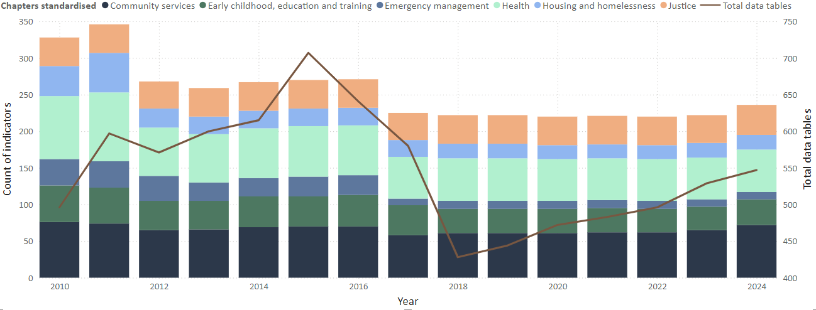Figure 14: Count of indicators by sector

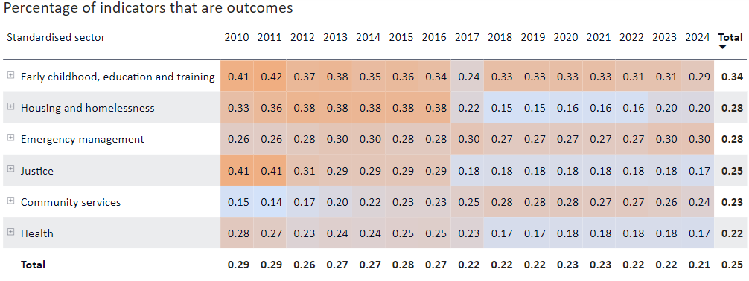Figure 15: Percentage of outcome indicators, 2010-2024

Following this initial review of high-level data, the Review explored data around the questions:

* How did indicators change following the review of RoGS indicators in 2016?
* What is the size of the role for State and Territory governments as data providers?
* How does the level of completeness and comparability for indicators change over time? These questions included:
  + Have there been any significant changes in indicator status in the last 5 years?
  + Are there any indicators that have had no data, or have had incomplete and non-comparable data for a long time?

#### Changes to the RoGS from 2016 to 2018

Flattened data on indicators and their comparability status was used to construct a Sankey chart. This chart, like the chart shown in *Figure 11*, initially showed gaps where similar indicators should be joined. As detailed in the quality control section below, analysis of this visualisation and supporting documentation was used to create new start and end points for indicators that were either split, merged, removed or added between 2016 and 2018.

The Review decided to analyse indicators over the 2 years from 2016 even though many of the indicators were due to be revised by the 2017 RoGS. This extended timeframe meant that indicators needing more time to be fully revised could be considered. This approach, however, may have captured indicators that were revised through separate processes.

*Figure 19* shows how indicators changed from 2016 to 2018. There were 2 major changes to indicator frameworks during this time — the removal of indicators on maternity services and the transfer of ambulance indicators from emergency management to health. *Figure 19* also shows that the there was a large amount of indicator consolidation during this time. Major areas of consolidation were indicators on accessibility, use and costs of early childhood education and primary health services.

This initial analysis on indicator changes from 2016 to 2018 showed that overall, there was a modest reduction in the number of indicators. Even though 89 indicators were removed directly, or through consolidation, the net reduction in indicator numbers was significantly affected by the addition of new indicators. Further analysis of year-specific changes was undertaken to understand these results. *Figure 20* shows that even though there was a significant reduction in the number of indicators in the year following the review, there were many new indicators in the 2018 RoGS. Of the 35 new indicators added to the 2018 RoGS, 6 were new outcome indicators.

The patterns seen between 2016 and 2018 may reflect 2 different processes. The first being the consolidation and removal of indicators following the 2016 review. The second as an independent process of adding new indicators, especially outcome indicators. It is also possible that the years of 2016 and 2018 outline the multiple stages needed to create a robust and relevant indicator framework.

#### Responsibilities of State and Territory governments

Early analysis showed that State and Territory governments were a source of data in 25 per cent of the tables in the 2024 RoGS (*Figure 9*). Analysis also showed that the relative contribution of data by States and Territories has remained steady over the last 20 years. Stakeholders from State and Territory governments have reported to the review that the burden of contributing data is increasing.

Data from the normalised data sources table described in *Data transformations with DAX* were conditionally grouped against the raw data to calculate whether a data table had State and Territory governments as a source, and whether there were other sources referenced. *Figure 16* shows that State and Territory governments are key contributors in the Emergency management and Justice sectors. It also shows that in these sectors, the sole use of data from these governments is decreasing. This analysis was limited to the sources listed in the data tables of the RoGS. It does not account for the contributions that State and Territories make to other reports and data collections, many of which are primary references across the RoGS.

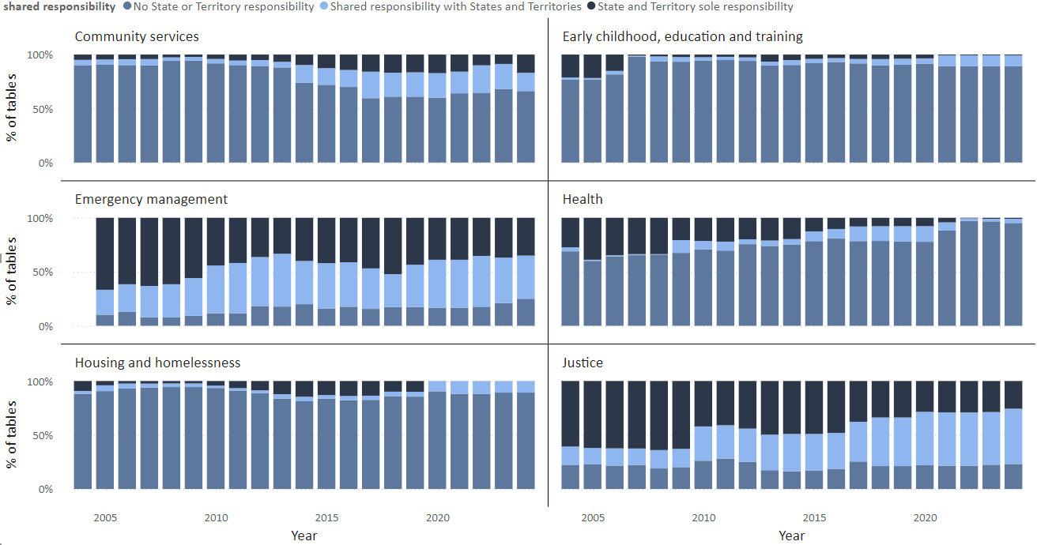

Figure 16: The proportion of tables where State and Territory governments are a sole contributor, or shared contributor to data

The relationship between the indicator codes and RoGS tables was used to calculate and visualise data contributions by table type. *Figure 17* shows that since 2014 there has been a significant reduction in the overall number of data tables to which State and Territory government contribute. Even though there has been a recent minor increase in these tables, there continues to be a steady reduction in the number of contextual data tables to which governments contribute.

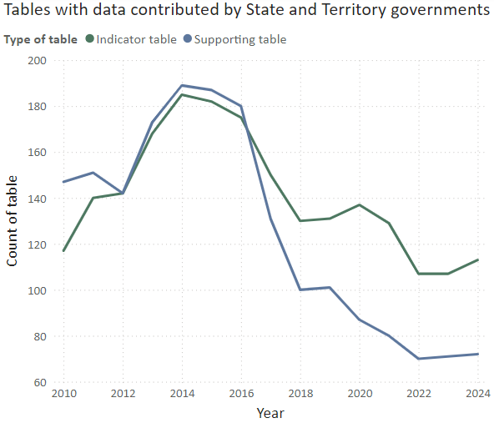

Figure 17: Tables with data from State and Territory governments (as sole and shared data contributors) by the type of data table

*Figure 18* shows that there have also been significant reductions in the amount of data from other sources going to contextual data tables. Over time, data is being used more efficiently, and the RoGS is becoming more concise. This highlights the work that continues to be done to improve the relevance and usability of RoGS products.

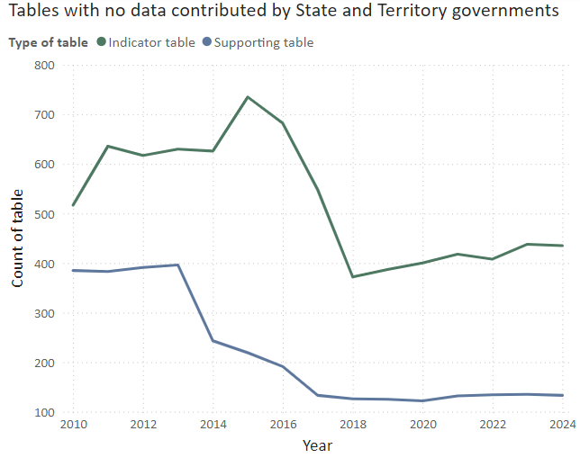

Figure 18: Tables with data from source other than State and Territory governments by the type of data table

#### Changes in indicator comparability and completeness

DAX computations on consecutive years of completeness and comparability were built into a range of conditional DAX measures. These measures were used to identify all indicators that had no change in completeness/comparability status for more than 5 and 10 years. These results were then refined to only include indicators included in the 2024 RoGS with many consecutive years of no data or minimal data. *Table 1* shows the number of indicators that meet these criteria.

These figures on consecutive non-completeness do not count measures that change levels of completeness, including those that change between no data and limited completeness/comparability. Further analysis was completed to understand which indicators experience these fluctuations in completeness, especially those that have a reduction over time. The Review set additional criteria to extract indicators that experienced a decrease from the highest level of comparability in the last 5 years. The results were visualised in a matrix table to illustrate the various stages of completeness (*Figure 12*).

#### Quality control

Quality control steps were undertaken throughout the data extraction, modelling, and analysis stages to ensure that data insights were as accurate as possible. During the data intake and transformation stages, quality control involved the use of error handling to identify issues in the bulk extracted data set. It also involved continual assessment of column profiles to ensure that data was extracted to the correct location and determine if any differences in table structure across years could impact query processes.

RoGS data tables include more than 20,000 rows, so targeted methods were used to test how accurately indicator codes were assigned to data tables. This included the use of measures to group table names by leading string and chapter name, and detect abnormalities in groups, particularly outside of change intervals (known removal, merging and additions of indicators). These measures were used to categorise the likelihood of a true error. Highly likely instances of errors (approximately 70) were manually rechecked against the indicator framework and RoGS supporting information.

The flattened tables and visualisations, such as tables and Sankey charts, were used to highlight possible connections between indicators. Supporting information in the RoGS was used to validate identified differences in coded indicators, such as the merging and splitting of indicators between years. This supporting information included explicit explanations of indicator transformations in past RoGS reviews, explanations within RoGS documentation, and similarities in tables and measures included across indicators. Joining tables were used to create these relationships and calculate year transformations to RoGS indicator frameworks.

A range of complex equations and DAX code was used as part of the detailed analysis. Randomised manual computation of the raw dataset was undertaken for all calculations to validate their accuracy. Where possible, results were cross-checked against values provided in RoGS documentation.

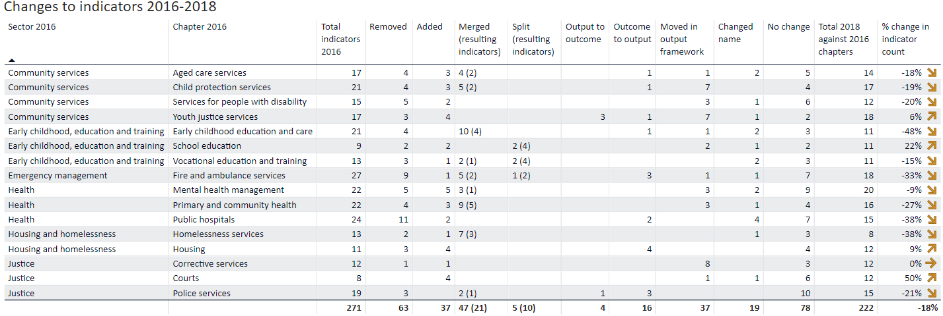Figure 19: Changes to indicators from 2016 to 2017, grouped by 2016 chapters – table

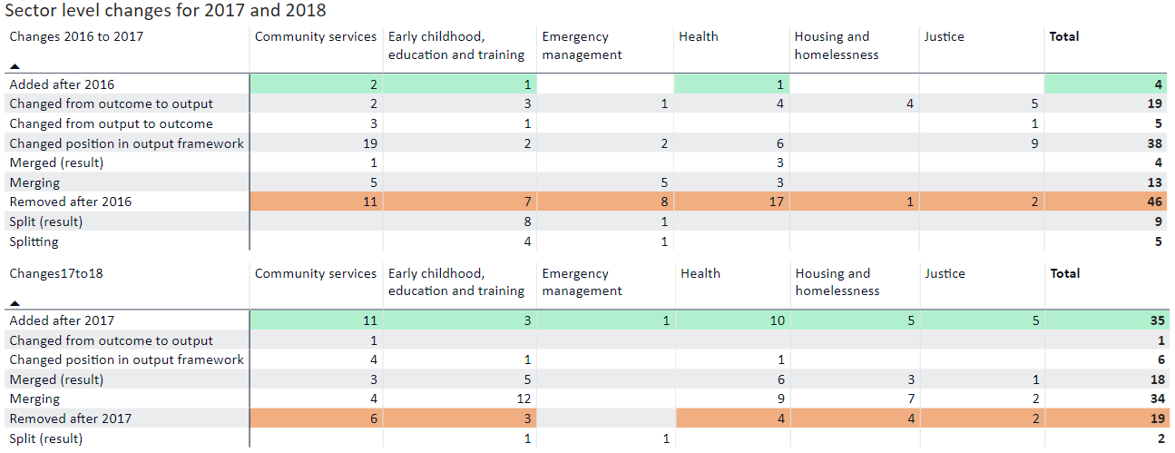Figure 20: Key changes to indicators for each year from 2016 to 2018 – table

# Appendix 3: Consultation process

The Review wishes to express its appreciation to all stakeholders for taking the time to share insights and views on the RoGS and the Dashboard. The feedback helped the Review to identify strengths of the reporting products and opportunities for improvement.

## Online survey

The Review conducted an online survey between 4 March 2024 and 5 April 2024 to publicly test   
high-level views on the RoGS and the Dashboard.

The survey was not intended to produce statistically significant results, but rather was developed as a quick way to gather some initial views and lines of inquiry for the Review. A link to the online survey was sent to all jurisdictions’ central and relevant line agencies, NGOs, higher education and research organisations, and peak bodies. The survey was also available to the public on the Review’s website and was promoted through social media channels.

The survey had 89 valid responses across State and Territory government agencies, Commonwealth agencies, NGOs and research organisations. No responses were received from media organisations or members of the public.

## Roundtables

### Governments

The Review convened 7 virtual roundtable meetings with State and Territory government line agencies between 10 April 2024 and 1 May 2024. Each roundtable was dedicated to one or several service areas covered by the RoGS and the Dashboard.

Roundtables explored views on the use, accessibility and timeliness of the products and their contribution to government decision making related to national reform and service delivery improvements. The Review engaged with data providers and users within governments.

More than 200 government agency representatives attended across all jurisdictions.

### Non-government organisations

The Review convened 7 virtual roundtable meetings with NGOs between 22 May 2024 and 5 June 2024. These brought together a range of participants from peak bodies, advocacy groups and academia related to the services areas covered by the RoGS and the Dashboard.

The Review drew on the RoGS embargo draft distribution list, supplemented by desktop research and consultation with government agencies, to develop a list of NGOs to approach.

Each roundtable was dedicated to one or several service areas covered by the RoGS and the Dashboard and sought to understand how NGOs use these products and other information on the delivery of government services to support their work.

More than 30 organisations attended the roundtables across the different service areas (Table 2).

| Table 2: Non-government organisation roundtable participants | | |
| --- | --- | --- |
| ACT Shelter | Community Housing Industry Association | Queensland Indigenous Family Violence Legal Service |
| AFAC National Council for Fire and Emergency Services | Monash University Department of Social Work | Royal Australian College of General Practitioners |
| Aged and Community Care Providers Association | Grattan Institute | Secretariat of National Aboriginal and Islander Child Care |
| Anglicare Victoria | Justice Reinvest | Shelter Tasmania |
| Aurora Education Foundation | Mental Health Australia | South Australian Aboriginal Community Controlled Organisation Network |
| Australian Association for Research in Education | Mission Australia | Surf Life Saving Australia |
| Australian Healthcare and Hospitals Association | National Aboriginal and Torres Strait Island Legal Services | Torrens Resilience Initiative |
| Australian Housing and Urban Research Institute | National Rural Health Alliance | Uniting Care Australia |
| Australian Primary Health Care Nurses Association | National Shelter | UNSW City Futures Research Centre |
| Catholic Health Australia | NSW Aboriginal Legal Service | Victorian Aboriginal Child Care Agency |
| Child Australia | Queensland Aboriginal and Torres Strait Islander Child Protection Peak | Warnumamalya Heath Services Aboriginal Corporation |

## Other engagement

More than 60 bilateral meetings were conducted over the course of the Review. These meetings were held with representatives of:

* State and Territory Treasuries and Premier’s/Chief Minister’s departments and other agencies, including the Steering Committee
* Commonwealth agencies, including the AIHW and the RGSP Secretariat
* NGOs.

At the request of the Review, the RGSP Secretariat provided a written submission in June 2024.

# Appendix 4: Stakeholder suggestions to strengthen performance indicators

A number of suggestions to improve performance reporting in the RoGS were raised during consultation. These suggestions reflect the perspectives of stakeholders and are not recommendations of the Review.

Suggested improvements include:

**Childcare, education and training** could include new indicators on student wellbeing and develop data to report on outcomes for students with disability and workforce sustainability.

**Justice** could further explore opportunities to link data.

**Emergency management** could better cover preparedness, prevention and mitigation services. It was acknowledged that measuring these elements in a repeatable, quantitative way is difficult, so a case study approach may be more appropriate.

**Health** could better cover the interrelated nature of service delivery and outcomes, for example, the interface between the health, aged care and disability services sectors. Introducing more   
patient-reported outcome and experience measures was also suggested.

**Aged care services** could report on the interface between the aged care and health systems and develop indicators of workforce sustainability. Including data and analysis on waiting lists, access to general practitioners and allied health services, integrated care models and outcomes for older people was also suggested.

**Services for people with disability** could include more data and analysis on the disability services sector and its interface with health and aged care.

**Child protection and youth justice services** could report indicators on young people exiting out of home care aged 18 to 21 years (potentially 22–25 years) and the health and well-being of children in care and protection. Including data on costs and outcomes of temporary care arrangements, children and youth reuniting with their families, how family violence connects with and affects services, and the overlap between child protection and youth justice was also suggested.

**Housing and homelessness services** could develop a consistent definition of community housing, report percentiles of income going to rent, and include data on the construction and acquisition of public and community housing.

# Appendix 5: References

ABS (Australian Bureau of Statistics) (2024a) [*Data Explorer*](https://explore.data.abs.gov.au), ABS website, accessed 31 October 2024.

ABS (2024b) [*Overview of the 2026 Census topic review*](https://www.abs.gov.au/census/2026-census-topic-review/overview-2026-census-topic-review), ABS website, accessed 22 October 2024.

ABS (2024c) [*Person Level Integrated Data Asset (PLIDA)*](https://www.abs.gov.au/about/data-services/data-integration/integrated-data/person-level-integrated-data-asset-plida), ABS website, accessed 23 September 2024.

ABS (2024d) [*PLIDA/MADIP Case Studies*](https://www.abs.gov.au/about/data-services/data-integration/use-and-benefits/plidamadip-case-studies#case-study-1-helping-vulnerable-australians-survive-heatwaves), ABS website, accessed 22 October 2024.

AIHW (2018) ‘[Australia’s health 2018](https://www.aihw.gov.au/getmedia/7c42913d-295f-4bc9-9c24-4e44eff4a04a/aihw-aus-221.pdf)’, *Australia’s health series no.* 16, catalogue number AUS221, AIHW, Australian Government, accessed 22 October 2024.

AIHW (Australian Institute of Health and Welfare) (2024a) [*Youth Justice*](https://www.aihw.gov.au/about-our-data/our-data-collections/youth-justice), AIHW website, accessed 1 November 2024.

AIHW (2024b) [*Our data collections*](https://www.aihw.gov.au/about-our-data/our-data-collections), AIHW website, accessed 22 October 2024.

AIHW (2024c) [*How are national data used to answer questions about FDSV?*](https://www.aihw.gov.au/family-domestic-and-sexual-violence/understanding-fdsv/what-is-fdsv/how-are-national-data-used-to-answer-questions-about-fdsv), AIHW website, accessed 22 October 2024.

AIHW (2024d) [*Social determinants of health*](https://www.aihw.gov.au/reports/australias-health/social-determinants-of-health), AIHW website, accessed 22 October 2024.

AIHW (2024e) [*Our committees*,](https://www.aihw.gov.au/about-us/committees) AIHW website, accessed 22 October 2024.

AIHW (2024f) [*Perinatal Mental Health pilot Governance Committee*](https://www.aihw.gov.au/about-us/committees/maternal-and-perinatal-health/pmhp-gc)*,* AIHW website, accessed 22 October 2024.

AIHW (2024g) [*Primary Health Care Advisory Committee*](https://www.aihw.gov.au/about-us/committees/primary-health-care-advisory-committee), AIHW website, accessed 22 October 2024.

AIHW (2024h) [*Australia’s health 2024: data insights*](https://www.aihw.gov.au/reports/australias-health/australias-health-2024-data-insights/contents/about), catalogue number AUS 250, AIHW, Australian Government, accessed 22 October 2024.

Australian National Audit Office (2023) [*Reporting Meaningful Performance Information*](https://www.anao.gov.au/work/insights/reporting-meaningful-performance-information), Australian National Audit Office website, accessed 29 June 2024.

Butler M (Minister for Health and Aged Care)(2 May 2023) [*Taking action on smoking and vaping*](https://www.health.gov.au/ministers/the-hon-mark-butler-mp/media/taking-action-on-smoking-and-vaping) [media release], Department of Health, accessed 22 October 2024.

Carroll B (Victorian Minister for Education) (13 June 2024) [*Making Best Practice Common Practice In The Education State*](https://www.premier.vic.gov.au/making-best-practice-common-practice-education-state) [media release], Victorian Government, accessed 22 October 2024.

CFFR (Council on Federal Financial Relations) (2020) [*The Federation Funding Agreements Framework*](https://federalfinancialrelations.gov.au/federation-funding-agreements-framework), Federal Financial Relations website, accessed 22 October 2024.

CFFR (2023) [*Terms of Reference: Council on Federal Financial Relations*](https://federalfinancialrelations.gov.au/sites/federalfinancialrelations.gov.au/files/2023-02/cffr-termsoferference-2023.pdf), CFFR, accessed 4 October 2024.

CGC (Commonwealth Grants Commission) (2024a) [*2024 State Snapshots*](https://www.cgc.gov.au/publications/state-snapshots/2024-state-snapshots), CGC website, accessed 22 October 2024.

CGC (2024b) [*About GST distribution*](https://www.cgc.gov.au/about-gst-distribution), CGC website, accessed 22 October 2024.

Chalmers J (Treasurer) and Leigh A (Assistant Minister for Employment) (26 June 2024) [*Media release: Measuring what matters to deliver better outcomes*](https://ministers.treasury.gov.au/ministers/jim-chalmers-2022/media-releases/measuring-what-matters-deliver-better-outcomes) [media release], Australian Government, accessed 22 October 2024.

COAG (Council of Australian Governments) (2009) [*COAG Meeting: Brisbane: 7 December 2009: Communique*](https://web.archive.org.au/awa/20210121023257mp_/https:/www.coag.gov.au/sites/default/files/communique/communique-dec-2009.pdf), Trove Web Archive, accessed 4 October 2024.

COAG (2016) [*COAG: Report on Performance 2016*](https://webarchive.nla.gov.au/awa/20210121023449/https:/www.coag.gov.au/performance-reporting), Trove Web Archive, accessed 22 October 2024.

COAG Reform Council (1 August 2014) [*COAG Reform Council*](https://webarchive.nla.gov.au/awa/20140801015905/http:/www.coagreformcouncil.gov.au/about)*: About us*, Trove Web archive, accessed 22 October 2024.

Coalition of Aboriginal and Torres Strait Islander Peak Organisations, Commonwealth of Australia, and Australian States and Territories (2020) [*National Agreement on Closing the Gap*](https://www.closingthegap.gov.au/sites/default/files/2022-09/ctg-national-agreement_apr-21-comm-infra-targets-updated-24-august-2022_0.pdf), Closing the Gap Partnership, accessed 22 October 2024.

Commonwealth of Australia and Australian States and Territories (2021) [*Intergovernmental Agreement on data sharing between Commonwealth and State and Territory governments*](https://federation.gov.au/sites/default/files/about/agreements/iga-data-sharing-signed.pdf), Australian Government, accessed 22 October 2024.

Commonwealth of Australia and Australian States and Territories (2022) [*Intergovernmental Agreement on Federal Financial Relations*](https://federalfinancialrelations.gov.au/sites/federalfinancialrelations.gov.au/files/2022-11/intergovernmental-agreement-on-federal-financial-relations.pdf), Australian Government, accessed 4 October 2024.

Commonwealth of Australia and Australian States and Territories (2023) [*Multilateral Data Sharing Agreement - Between the Commonwealth, States and Territories for the Australian National Data Integration Infrastructure (ANDII), National Disability Data Asset (NDDA) and future domain assets*](https://www.finance.gov.au/sites/default/files/2024-05/signed-mdsa_all.pdf), Australian Government, accessed 22 October 2024.

Commonwealth of Australia and Australian States and Territories (2024a) [*Heads of Agreement (Better and Fairer Schools Agreement 2025-2034)*](https://www.education.gov.au/recurrent-funding-schools/resources/heads-agreement), Department of Education, Australian Government, accessed 22 October 2024.

Commonwealth of Australia and Australian States and Territories (2024b) [*National Agreement on Social Housing and Homelessness*](https://federalfinancialrelations.gov.au/sites/federalfinancialrelations.gov.au/files/2024-06/nashh-final.pdf), Australian Government, accessed 22 October 2024.

Commonwealth of Australia (2019) [*Closing the Gap: Partnership*](https://www.closingthegap.gov.au/partnership), Closing the Gap website, accessed 22 October 2024.

Commonwealth of Australia (2023a) [*Data and Digital Government Strategy: The data and digital vision for a world-class APS to 2023*](https://www.dataanddigital.gov.au/sites/default/files/2023-12/Data%20and%20Digital%20Government%20Strategy%20v1.0.pdf), Australian Government, accessed 22 October 2024.

Commonwealth of Australia (2023b) [*Statement of Expectations - Productivity Commission*](https://treasury.gov.au/sites/default/files/2023-11/pc_statement_of_expectations.pdf), The Treasury, Australian Government, accessed 4 October 2024.

Commonwealth of Australia (2023c) [*Measuring What Matters: Australia's First Wellbeing Framework*](https://treasury.gov.au/sites/default/files/2023-07/measuring-what-matters-statement020230721_0.pdf), Australian Government, accessed 22 October 2024.

Commonwealth of Australia (2023d) [*The Data and Digital Government Strategy*](https://www.dataanddigital.gov.au/strategy), Australian Government website, accessed 22 October 2024.

Commonwealth of Australia (2024a) [*Joint Council on Closing the Gap*](https://www.closingthegap.gov.au/joint-council-closing-gap), Closing the Gap website, accessed 31 October 2024.

Commonwealth of Australia (2024b) [*Framework for Governance of Indigenous Data: Practical guidance for the Australian Public Service*](https://www.niaa.gov.au/sites/default/files/documents/2024-05/framework-governance-indigenous-data.pdf), Australian Government, accessed 22 October 2024.

Controller and Auditor-General of New Zealand (2016) [*Improving financial reporting in the public sector*](https://oag.parliament.nz/2016/financial-reporting/docs/financial-reporting.pdf), New Zealand Government, accessed 22 October 2024.

Controller and Auditor-General of New Zealand (2021) [*The problems, progress, and potential of performance reporting*](https://oag.parliament.nz/2021/performance-reporting/docs/performance-reporting.pdf), New Zealand Government, accessed 22 October 2024.

Department of Finance (2024) [*Commonwealth Performance Framework*](https://www.finance.gov.au/government/managing-commonwealth-resources/planning-and-reporting/commonwealth-performance-framework), Australian Department of Finance Website, accessed 22 October 2024.

Department of the Prime Minister and Cabinet (2016) *COAG: Report on Performance 2016*, Department of the Prime Minister and Cabinet, Australian Government.

Digital Transformation Agency (2024) [*Digital Experience Policy: Supporting better digital experiences for all people and business*](https://www.digital.gov.au/policy/digital-experience), digital.gov.au, accessed 22 October 2024.

Fentiman S (Queensland Minister for Health) (1 February 2024) [*Independent report finds Queensland is one of the nation’s best health performers*](https://statements.qld.gov.au/statements/99622) [media release], Queensland Government, accessed 4 October 2024.

Government of the United Kingdom (2021) [*Measuring success: Data you must publish*](https://www.gov.uk/service-manual/measuring-success/data-you-must-publish#:~:text=The%20Performance%20Platform%20was%20a,Platform%20on%2015%20March%202021), Gov.UK, accessed 22 October 2024.

Hoddinott S, Davies N, Fright M, Nye P and Richards G (2023) [*Performance Tracker 2023: Public services as the UK approaches a general election*](https://www.instituteforgovernment.org.uk/sites/default/files/2024-01/performance-tracker-2023.pdf), The Chartered Institute of Public Finance & Accountancy, Government of the United Kingdom, accessed 22 October 2024.

Independent Reference Group (2010) [*Review of the Report on Government on Government Services' performance indicator framework*](https://www.pc.gov.au/ongoing/report-on-government-services/review-rogs-pif/independent-reference-group-report.pdf), Steering Committee for the Review of Government Service Provision, accessed 22 October 2024.

Melbourne Social Equity Institute (2024) [*The WEAVERs Project*](https://socialequity.unimelb.edu.au/research/the-weavers-project#:~:text=The%20WEAVERs%20are%20a%20panel%20of%20survivors%20of%20violence%20against%20women.&text=The%20WEAVERs%20are%20a%20group,at%20the%20University%20of%20Melbourne), University of Melbourne website, accessed 22 October 2024.

NDDA (National Disability Data Asset) (2021) [*Pilot Findings*](https://www.ndda.gov.au/about/pilot-phase/pilot-findings/), NDDA website, accessed 22 October 2024.

NSW Government (2023) [*Evaluation Policy and Guidelines*](https://www.treasury.nsw.gov.au/finance-resource/evaluation-policy-and-guidelines), NSW Government, accessed 22 October 2024.

NSW Government (2024) [*AgTrack - Agricultural and Land Use Dashboard*](https://www.dpi.nsw.gov.au/agriculture/lup/agriculture-data-for-planning/dashboard), NSW Treasury website, accessed 22 October 2024.

OECD (2022) [*Open Government Data*](https://www.oecd.org/gov/digital-government/open-government-data.htm), OECD web archive, accessed 22 October 2024.

OECD (Organisation for Economic Cooperation and Development) (2023a) [*Service citizens scorecards*](https://www.oecd-ilibrary.org/sites/3d5c5d31-en/1/3/3/1/index.html?itemId=/content/publication/3d5c5d31-en&_csp_=6a6aa038f2496de10696e78b24488941&itemIGO=oecd&itemContentType=book), OECD iLibrary, accessed 22 October 2024.

OECD (2023b) [*Government at a Glance 2023*](https://doi.org/10.1787/3d5c5d31-en), OECD iLibrary, accessed 31 October 2024.

OECD (2024) [*Curriculum Flexibility and Autonomy: Promoting a thriving learning environment*](https://www.oecd-ilibrary.org/deliver/eccbbac2-en.pdf?itemId=%2Fcontent%2Fpublication%2Feccbbac2-en&mimeType=pdf), OECD Publishing, Paris, accessed 22 October 2024.

Office for National Statistics (2024) [*Data visualisation*](https://service-manual.ons.gov.uk/data-visualisation), Office for National Statistics website, Government of the United Kingdom, accessed 22 October 2024.

PANDA (Perinatal Anxiety & Depression Australia) (2022) [*2021-2022: PANDA Annual Impact Report*](https://panda.org.au/panda-2021-annual-impact-report), PANDA website, accessed 22 October 2024.

PC (Productivity Commission) (2021a) [*What Works pilot outcomes*](https://www.pc.gov.au/ongoing/report-on-government-services/what-works), RoGS website, accessed 22 October 2024.

PC (2021b) [*Enabling the public health approach to protecting children*](https://www.pc.gov.au/ongoing/report-on-government-services/what-works/child-protection/what-works-protecting-children.pdf), PC, accessed 22 October 2024.

PC (2023a) [*Performance Reporting Dashboard*](https://performancedashboard.d61.io/), Performance Reporting Dashboard, accessed 29 July 2024.

PC (2023b) [*Performance Reporting Dashboard: About*](https://performancedashboard.d61.io/about), Performance Reporting Dashboard, accessed 29 July 2024.

PC (2023b) [*Performance Reporting Dashboard: About*](https://performancedashboard.d61.io/about), Performance Reporting Dashboard, accessed 29 July 2024.

PC (2023c) [*Advancing Prosperity: 5-year Productivity Inquiry report*](https://www.pc.gov.au/inquiries/completed/productivity/report), PC website, accessed 22 October 2024.

PC (2024a) [*Quarterly productivity bulletin - June 2024*](https://www.pc.gov.au/ongoing/productivity-insights/bulletins/quarterly-bulletin-june-2024/bulletin-june-2024.pdf), PC, accessed 3 December 2024.

PC (2024b) *Response from the Secretariat for the Review of Government Service Provision to Review information requests* [unpublished] PC, Canberra.

PC (2024c) [*Closing the Gap: Information Repository*](https://www.pc.gov.au/closing-the-gap-data/dashboard), Closing the Gap Dashboard, accessed 22 October 2024.

PC and Forum of Federations (2012) ‘[Benchmarking in Federal Systems](https://www.pc.gov.au/research/supporting/benchmarking-federal-systems/benchmarking-federal-systems.pdf)’, *Roundtable Proceedings 19-20 December 2010,* Melbourne (Fenna A and Knüpling F eds)*,* PC, Canberra.

Phillips L (2018) ‘[Improving the Performance of Sub-national Governments through Benchmarking and Performance Reporting](https://www.oecd.org/content/dam/oecd/en/publications/reports/2018/02/improving-the-performance-of-sub-national-governments-through-benchmarking-and-performance-reporting_9a91dc8f/ffff92c6-en.pdf)’, *OECD Working Papers on Fiscal Federalism,* catalogue number No. 22, OECD Publishing, Paris, accessed 3 December 2024.

Queensland Crime and Corruption Commission (2024) [*Corruption allegations data dashboard*](https://www.ccc.qld.gov.au/about/corruption/corruption-allegations-data-dashboard), CCC website, accessed 22 October 2024.

Queensland Government (2022) [*Queensland Government Performance Management Framework Policy*](https://www.forgov.qld.gov.au/__data/assets/pdf_file/0017/183212/performance-management-framework-policy.pdf), Department of Premier and Cabinet, Queensland Government, accessed 22 October 2024.

Senate Community Affairs References Committee (2023) [*Concussions and repeated head trauma in contact sports*](https://parlinfo.aph.gov.au/parlInfo/download/committees/reportsen/RB000082/toc_pdf/Concussionsandrepeatedheadtraumaincontactsports.pdf), Australian Government, accessed 22 October 2024.

Senior Officials/Heads of Treasuries Working Group (2009) *Review of the Report on Government Services: Report to the Council of Australian Governments* [unpublished], COAG, Canberra.

Statistics Canada (2024) [*Aviation Data Visualization Hub*](https://www150.statcan.gc.ca/n1/pub/71-607-x/aviation-eng.htm), Statistics Canada website, accessed 22 October 2024.

Steering Committee for Review of Commonwealth/State Service Provision (1995) [*Report on Government Service Provision: 1995*](https://www.pc.gov.au/ongoing/report-on-government-services/1995/1995/1995.pdf), PC, Canberra, accessed 4 October 2024.

Steering Committee for Review of Commonwealth/State Service Provision (1997) [*Report on Government Services: 1997*](https://www.pc.gov.au/ongoing/report-on-government-services/1997/1997/1997v1.pdf), PC, Canberra, accessed 31 October 2024.

Steering Committee (Steering Committee for the Review of Government Service Provision) (2018) [*Interventions to support carers of people with dementia*](https://www.pc.gov.au/ongoing/report-on-government-services/what-works/dementia-support/dementia-support.pdf), Productivity Commission, accessed 22 October 2024.

Steering Committee (2024a) [*Report on Government Services: 2024*](https://www.pc.gov.au/ongoing/report-on-government-services), RoGS website, accessed 4 October 2024.

Steering Committee (2024b) [*Report on Government Services: Terms of Reference*](https://www.pc.gov.au/ongoing/report-on-government-services/terms-of-reference), PC website, accessed 4 October 2024.

Susan McKinnon Foundation (2023) [*Productivity gains in the non-market sector: Lessons from a NSW Success Story at the John Morony Correctional Centre*](https://www.susanmckinnon.org.au/wp-content/uploads/2024/04/SMF-John-Morony-Briefing-Deck-Aug23.pdf), Susan McKinnon Foundation, accessed 31 October 2024.

Susan McKinnon Foundation (2024) [*Lessons from NSW Health Pathology: Productivity, Control and Performance - Productivity gains in the non-market sector*](https://www.susanmckinnon.org.au/wp-content/uploads/2024/04/SMF-NSWHP-Briefing-Deck.pdf), Susan McKinnon Foundation, accessed 22 October 2024.

The Treasury (2024) [*About the Australian Centre for Evaluation*](https://evaluation.treasury.gov.au/about/about-australian-centre-evaluation), Australian Government, accessed 22 October 2024.

WHO (World Health Organization) (2023) [*Social determinants of health*](https://www.who.int/health-topics/social-determinants-of-health#tab=tab_1), WHO website, accessed 22 October 2024.

Wibrow B, Hall B and Griffin T (2024) [*The student journey: the many faces of completion and non-completion in VET*](https://www.ncver.edu.au/__data/assets/pdf_file/0046/9687295/The-student-journey-the-many-faces-of-completion-and-non-completion-in-VET.pdf), National Centre for Vocational Education and Research, accessed 22 October 2024.

World Bank (2024) [*DataBank*](https://databank.worldbank.org/home.aspx?_gl=1*bamekk*_gcl_au*MTcyNjk1NjQ4OS4xNzI0Mjk5NzI2), World Bank Group website, accessed 22 October 2024.

1. Steering Committee members represent State and Territory Treasuries, Premiers’ and Chief Ministers’ departments, the Australian Government Treasury, and the Department of the Prime Minister and Cabinet.
2. 2023–24 figures are used as updates to the Dashboard have been paused for 2024–25 while this Review is ongoing.
3. Data for 2024 is for January and February only.
4. This figure excludes indicators reported in the *National Indigenous Reform Agreement*, which was superseded by the *National Agreement on Closing the Gap* with bespoke performance reporting arrangements through the *Closing the Gap Information Repository*. This figure also does not account for indicators that may be relevant for the *National Skills Agreemen*t for which, as at 4 October 2024, the performance monitoring framework has not yet been released.
5. This figure displays the average number of monthly users for webpages below 10. Webpages with higher average views are excluded from the figure but not the analysis. Averages were calculated over 699 individual webpages.
6. The *National School Reform Agreement* expires on 31 December 2024 and will be replaced by the *Better and Fairer Schools Agreement* from 1 January 2025.
7. The *National School Reform Agreement* was extended until 31 December 2024 to allow the *Review to Inform a Better and Fairer Education System* to advise on the reform priorities which should be included in the next agreement. The *Better and Fairer Schools Agreement* will commence on 1 January 2025. The *National Legal Assistance Partnership* will expire on 30 June 2025 and will be replaced by the *National Access to Justice Partnership* which will commence on 1 July 2025.
8. See the *ABS Forward Work Program* found at <https://www.abs.gov.au/about/our-organisation/corporate-reporting/abs-corporate-plan/2024-25/forward-work-program>