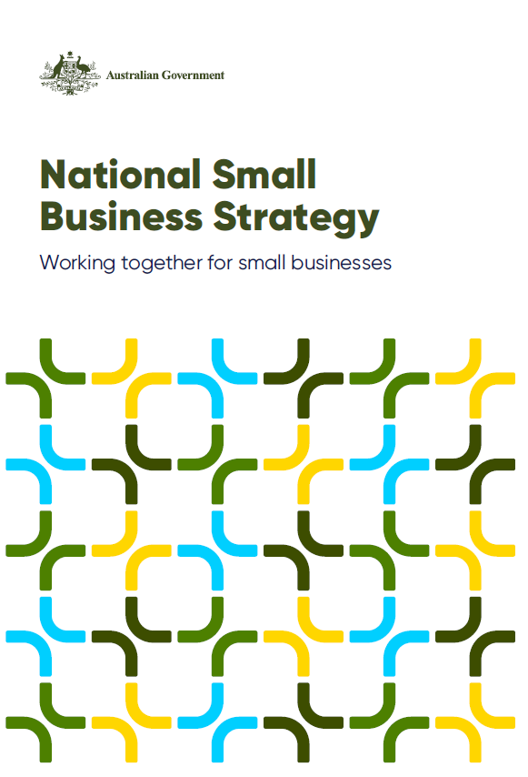

A joint initiative of the Australian, state and territory governments
© Commonwealth of Australia 2025
ISBN: 978-1-923278-09-7
This publication is available for your use under a Creative Commons Attribution 4.0 International licence, with the exception of the Commonwealth Coat of Arms, the Australian Government logo, photographs, images, third party materials, materials protected by a trademark, signatures and where otherwise stated. The full licence terms are available from creativecommons.org/licenses/by/4.0/legalcode.
Use of Commonwealth of Australia material under a Creative Commons Attribution 4.0 International licence requires you to attribute the work (but not in any way that suggests that the Treasury endorses you or your use of the work).
Commonwealth of Australia material used ‘as supplied’
Provided you have not modified or transformed Commonwealth of Australia material in any way including, for example, by changing the Commonwealth of Australia text; calculating percentage changes; graphing or charting data; or deriving new statistics from published statistics – then the Commonwealth of Australia prefers the following attribution:
Source: The Commonwealth of Australia.
Derivative material
If you have modified or transformed Commonwealth of Australia material, or derived new material from those of the Commonwealth of Australia in any way, then the Commonwealth of Australia prefers the following attribution:
Based on Commonwealth of Australia data.
Use of the Coat of Arms
The terms under which the Coat of Arms can be used are set out on the Department of the Prime Minister and Cabinet website (see www.pmc.gov.au/government/commonwealth-coat-arms).
Other uses
Enquiries regarding this licence and any other use of this document are welcome at:
Manager Media Unit The Treasury Langton Crescent Parkes ACT 2600 Email: media@treasury.gov.au
The Australian Government acknowledges the Traditional Custodians of country throughout Australia and their connections to land, sea and community. We pay our respect to their Elders past and present and extend that respect to all Aboriginal and Torres Strait Islander peoples today.

Contents

Why Australia needs a National Small Business Strategy 4
Small businesses matter 6
A national perspective 8
Across the states and territories 11
A shared responsibility 20
The small business ecosystem 20
Who does what? 22
Principles for working together to benefit small businesses 25
Collaborative 25
Targeted 25
Fair 26
Innovative 26
Timely 26
Focus areas 28
Easing the pressure on small businesses 28
Supporting small businesses to grow 32
Levelling the playing field 34
Looking forward 37
Endnotes 38

Why Australia needs a National Small Business Strategy
Small businesses are vital to Australia’s economic prosperity and our communities. They provide jobs, deliver services, drive innovation and productivity, contribute revenue and help define community identities.
Small businesses come in many shapes and sizes, operate across every sector of the economy and compete in many different markets. They are sole operators, side hustles, businesses grown from hobbies, family-operated businesses, and can be partnerships, trusts, incorporated and unincorporated entities.
The ecosystem in which small businesses operate is vast and complex. Small businesses interact with all tiers of government, other intermediaries, providers, and delivery organisations. All levels of government are involved in the development and implementation of policies, laws and programs affecting small businesses. This makes coordination and cohesion within and between governments challenging.
The Australian Government and state and territory governments (jurisdictions) share the objective of improving the operating environment for small businesses, no matter what stage of the operating life cycle they are in; from concept to start-up, growing to competing, innovating to maturity.
The National Small Business Strategy is the first of its kind and outlines how jurisdictions will work together to better support small businesses across our nation. It is a principles–based document that provides a framework for more effective coordination and collaboration across jurisdictions to:
- elevate small businesses in government decision making
- complement existing work within jurisdictions, and
- inform future policy directions to deliver better outcomes for small businesses.
It acknowledges that each level of government and other stakeholders play a role in the complex small business ecosystem.
Jurisdictions have worked together to create the National Small Business Strategy. It incorporates feedback from small business stakeholders and work already undertaken within jurisdictions. It does not replace or duplicate the strategic priorities, small business strategies or charters of individual jurisdictions.
Small Business Ministers are the stewards of the National Small Business Strategy.

Our vision for Australia’s small businesses
Our collective vision is to make it easier for small businesses to do business, innovate, thrive and continue contributing to the Australian economy and communities. We are committed to supporting small businesses through our policies, laws and programs.
Together, we will collaborate on matters that seek to:
- ease the pressure on small businesses
- support small businesses to grow, and
- level the playing field for small businesses.
With a collective vision and a shared commitment to drive a coordinated, collaborative and cohesive national approach to small business policies and supports, we can help create an operating environment for small businesses to prosper now and into the future.

Key objectives
The key objectives of this National Small Business Strategy are to:
- recognise the value of small businesses to economies and communities
- acknowledge the roles and responsibilities across different levels of government as well as other providers, delivery organisations and advocates that support small businesses
- outline a framework to facilitate a coordinated and cohesive approach to supporting small businesses that puts them at the centre of our decision making, and
- create efficiencies and reduce duplication of effort by embedding a collaborative approach to focus our efforts on supporting small businesses and sharing lessons learned.

Small businesses matter
There are almost 2.6 million small businesses in Australia, comprising around 97 per cent of all businesses (on 30 June 2024)¹. They contribute approximately $590 billion to the economy annually, accounting for almost one-third of Australia’s GDP². They employ around 5.4 million people, or around 42 per cent of the private sector’s workforce.³
However, the value of small businesses goes beyond their economic contribution. They are critical building blocks of the communities in which they operate, strengthening social capital, fostering social and community cohesion, acting as stewards of local identity and as hubs of cultural exchange.
Small businesses are often active participants in, and supporters of, their local community and strengthen its social capital. These contributions often include sponsoring sports teams, supporting local schools and students, donating to charities or volunteering at community events.
Small businesses are particularly vital to regional communities which often rely on a specific mix of businesses to make up their commercial and social ecosystems. They provide goods and services to rural and remote areas where large businesses may be unlikely to operate due to low-density populations. These networks of small businesses can create a sustainable local investment cycle in regional areas. The loss of a critical mass of small businesses in a town centre can lead to the decline of a community’s commercial hub with flow-on effects including a loss of ancillary services, less choice for local consumers and fewer local job opportunities.
Small businesses are also essential to the success of large businesses. Large businesses and companies rely on small businesses for local knowledge, supply chains and services, particularly in sectors such as manufacturing, tourism, and agriculture. The partnerships between small businesses and their larger counterparts contribute to a cycle of mutual benefit and growth, in regional communities and the broader Australian economy.
The design and delivery of government services directly affects small businesses and the people behind them. Governments that understand and acknowledge the unique experiences of small businesses and the pressures they face can better design and implement policies, laws and programs to support them.

The small business experience
Small business owners have varying motivations for starting a business. These can include seeking flexibility, an employment alternative, more income, the desire to pursue a dream and take advantage of talents or a market opportunity and wanting to contribute to the community.
Start-up journeys are varied. Many small businesses start with personal savings and may initially operate from the owner’s home. Some are family businesses. Others seek investors and partners to support a business idea or develop a product or service. Some invest in or purchase established businesses or franchises. Some small businesses experience rapid growth, others less so. They are particularly vulnerable in the earlier stages of the business.
The day–to–day operating experience is unique to every small business owner. There are myriad challenges and limited hours in the day to navigate government systems to comply with regulations, take advantage of government incentives or resolve issues.

- Wearing many hats – Most small business owners are sole traders and operate with fewer resources than larger businesses. They need to learn fast about legal and regulatory requirements, customer service, financial management, human resources, IT and digital technology, contracting and procurement, marketing, supply chains and various other responsibilities for which larger businesses have designated staff or departments.
- Navigating multiple challenges – Small business owners need to navigate a complex landscape of information, advice and supports to try and address multiple challenges at the same time as running their business. This can put immense pressure on business viability and the owner’s wellbeing.
- Balancing work and life – Running a business does not always allow for work–life balance. Small business owners’ personal lives are often tied closely to their business, with personal and business finances interconnected and their house doubling as a home and place of business. It can be difficult to draw the line between the personal and the passion for their product or service that led them into business. Such personal challenges can add to the pressures of running the business and vice versa.

A national perspective
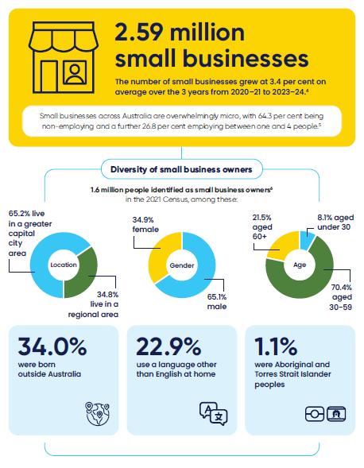

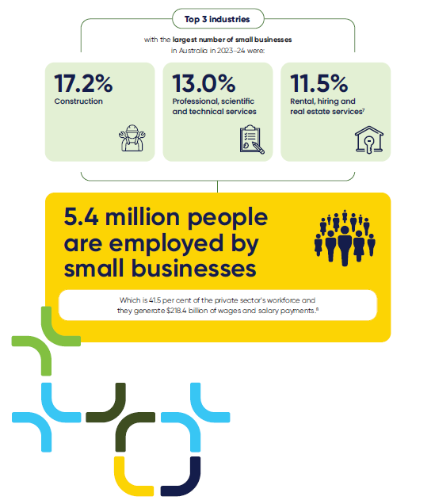

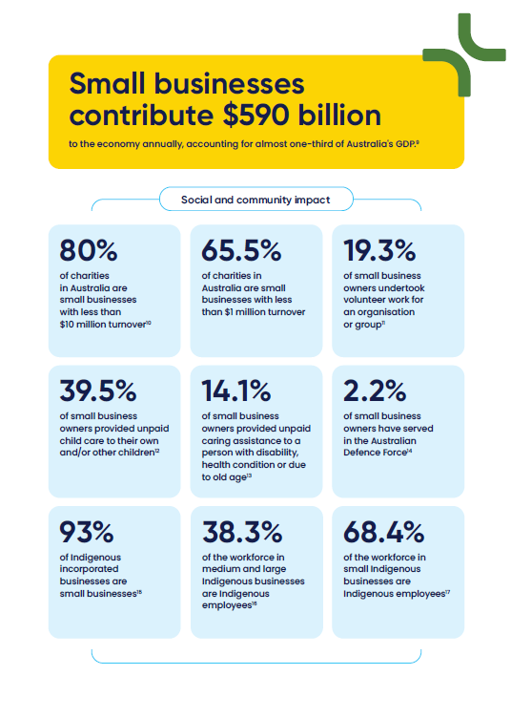

Across the states and territories
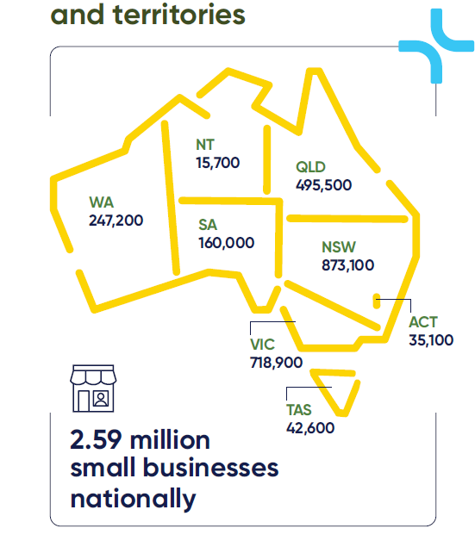

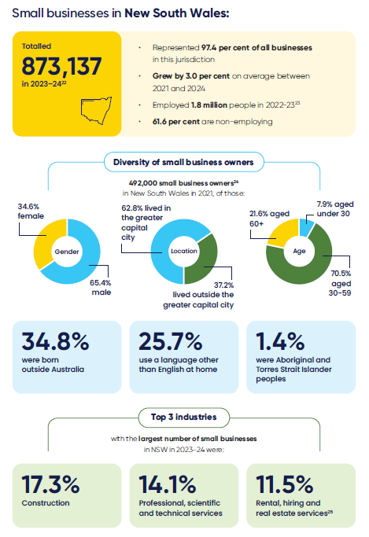

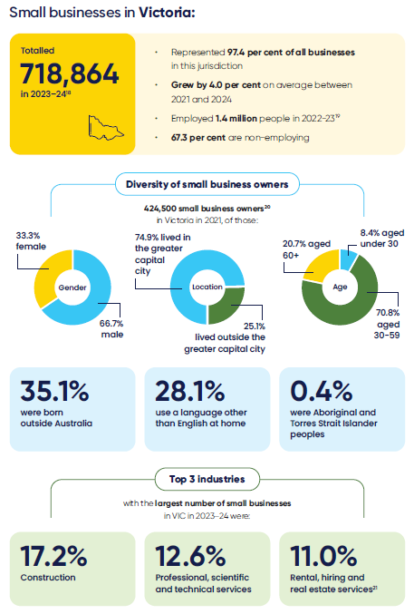

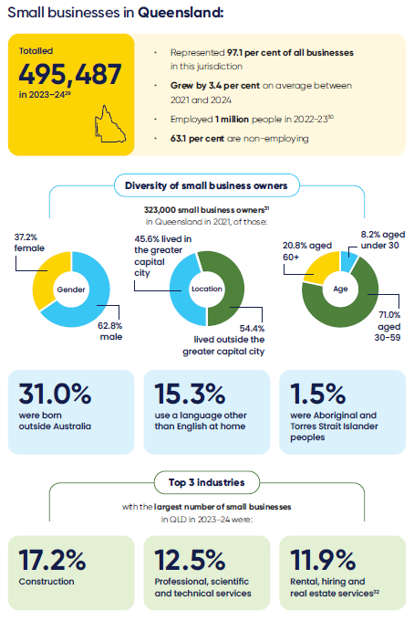

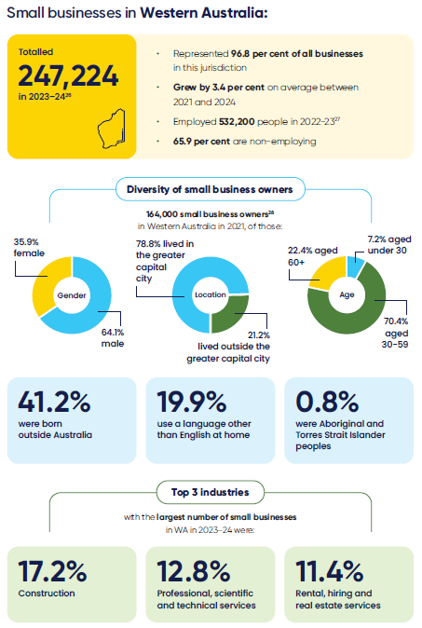

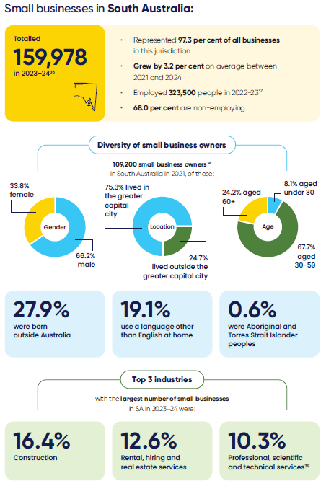

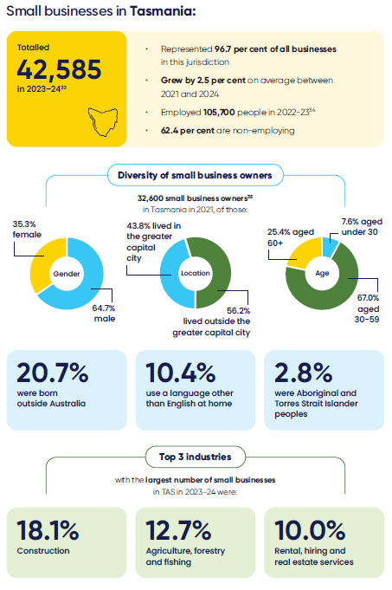

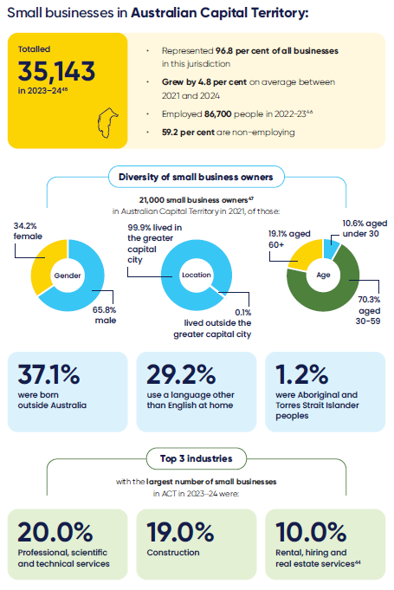

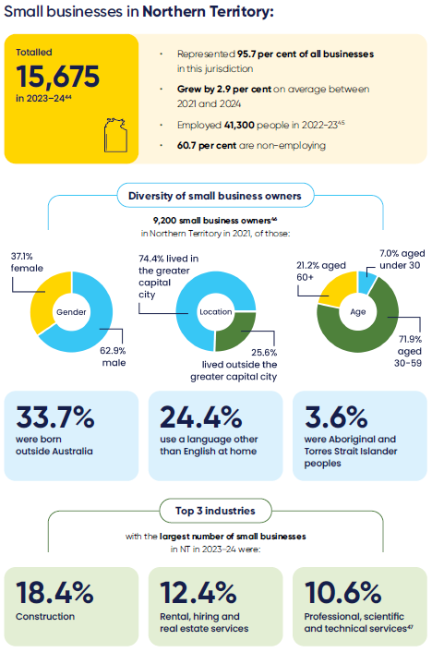

A shared responsibility

The small business ecosystem
Supporting small businesses is a shared responsibility. The ecosystem in which small businesses operate is vast, varied and complex and it evolves and shifts for each small business as their needs change.
Activities that support and affect small businesses cut across all levels of government, as well as other intermediaries, providers and delivery organisations. Together, we have the shared objective of creating the right conditions for all Australian small businesses to thrive at every stage of their life cycle.
Within this ecosystem, it is important to acknowledge the dispersed responsibility for policies, laws and programs that affect small businesses, which present a challenge for effective coordination and cohesion within and between governments. This has created additional complexity for small businesses to navigate.
This National Small Business Strategy sets out how jurisdictions will work together to create efficiencies and reduce duplication and complexity within the government system.

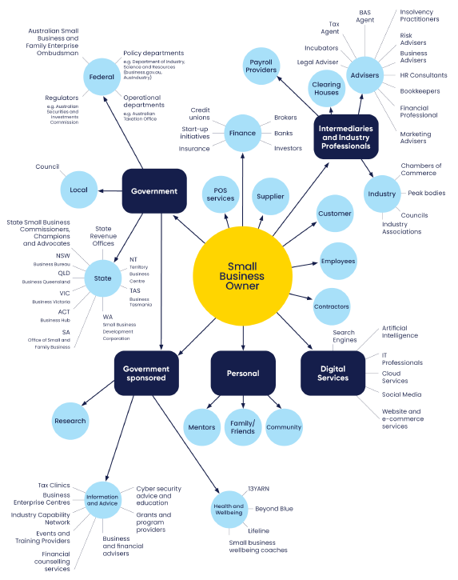

Who does what?
Australia has 3 levels of government that work together to provide communities with the services they need. Each level of government has its own responsibilities, although in some cases we share responsibilities.

Australian Government
The Australian Government is well positioned to reach small businesses at a macro level and deliver or fund national initiatives, including information resources.
The Government influences and impacts the operating environment of small businesses through:
- Taxes and transfers
- Rebates and incentives
- Legislation
- Regulation
- Policy development and implementation
- Macroeconomic and microeconomic reform
- Education and training
- Funding for initiatives (for example, grants)
- Advisory and support services
- Codes
- National research and data collection
State and territory governments
State and territory governments deliver funding and state–based small business initiatives, participate in national initiatives, and bring place–based knowledge which can inform and influence Australian Government initiatives.
State and territory governments influence and impact the operating environment of small businesses through:
- Taxes and transfers
- Rebates and incentives
- Legislation
- Regulation
- Policy development and implementation
- Microeconomic reform
- Education and training
- Funding for initiatives (for example, grants
- Advisory and support services
- Planning and zoning
- State-based data collection
- Promotion and attraction activities.

Local governments
Local governments actively support their local small business community and undertake direct, targeted and, in some areas, a ‘shop-front’ style engagement with small businesses to enable their day–to–day operations.⁴⁸
Local governments influence and impact the operating environment of small businesses through:
- Rates
- Policy development and implementation
- Licensing and permits
- By-laws
- Planning and zoning
- Funding for initiatives (for example, grants)
- Local data collection
- Promotion and attraction activities.
Intermediaries, providers and delivery organisations
Intermediaries such as Small Business Commissioners, the Australian Small Business and Family Enterprise Ombudsman, accountants and advisors, not-for-profits, industry associations and business councils, as well as other delivery organisations, undertake in-depth engagement with small businesses. They can deliver initiatives directly or partner and co-design supports with other organisations, including those funded by the Australian and/or state and territory governments.
Advocacy groups, providers and delivery organisations influence and affect the operating environment of small businesses through:
- Advocacy and promotion
- Program delivery
- Dispute resolution
- Policy development and submissions
- Advisory services
- Networks
- Research and data collection
Case Study
Queensland Government
Queensland small and family businesses are pivotal to the economic future, social inclusion and identity of the state. Through its Small Business First approach, the Queensland Government is focused on establishing the right operating environment for the state’s more than 495,000 small and family businesses. This includes prioritising the reduction of red tape, making government services more efficient and accessible and enabling innovation.
Key commitments include implementation of a new dedicated small business concierge service to streamline and improve access to government services, delivery of improved procurement processes and five business day payment terms through the ‘On Time, Every Time Payment Guarantee’. There is also support to deter crime on small businesses through a new $40 million Secure Communities Partnership Program and support for regional business hubs through a new Regional Business Gateways program.
As a critical first step in unleashing the potential of small and family businesses in the State, the Queensland Small Business Commissioner (QSBC) has been tasked with a renewed focus on reducing red tape for small and family businesses. Action to reduce red tape will allow small and family businesses is critical at a time when many are doing it tough and will result in small and family business owners being able to spend more time on servicing their customers and supporting local jobs and growth.
Queensland is focused on being a customer-centric Government, with a key component being improving customer service for small and family businesses across the State.

Principles for working together to benefit small businesses
The framework for collaboration includes a set of key principles that will guide how jurisdictions will work together and across governments on focus areas and towards the vision for small businesses set out in this National Small Business Strategy.

Collaborative
We will work collaboratively and consult across jurisdictions to share and leverage our knowledge and experience to develop best practice models that benefit small businesses across the country.
By working collaboratively, we will be able to make linkages between small business supports, policies and programs across jurisdictions in useful and new ways to complement and amplify the work already underway, with the aim of avoiding duplication of effort and confusion for small business owners. We will also be able to identify opportunities to develop new initiatives.

Targeted
We will target our collaborative approaches to ensure we maximise our efforts and available resources for the benefit of small businesses.
Together, we aim to provide information, resources and supports to the right small business owners at the right time, through the right channels, so they are easy and practical for small businesses and other relevant stakeholders to access and use.
Case Study
New South Wales Government – Service NSW Business Bureau
The New South Wales (NSW) Government launched the Service NSW Business Bureau on 25 October 2023. The Bureau provides one front door for businesses to access NSW Government information, services and support.
The Bureau delivers navigation support, personalised advice and access to services for NSW businesses, helping them export their products, boost their procurement with government and cut unproductive red tape. This includes through free, tailored specialist support from independent business advisors.
The Bureau’s Business Concierges make it easier for small businesses to access government support, understand government requirements, apply for licences and permits, and receive disaster and emergency assistance and referrals to mental health support.
The Bureau’s rapid response team has provided on-the-ground support for businesses facing crises. They have assisted businesses impacted by floods in Western Sydney and the Blue Mountains, construction sinkholes in Sydney, and power outages in Far West NSW.
Since its launch, the Bureau has responded to more than 265,000 requests for assistance and delivered around 45,000 hours of business advice on topics such as planning, marketing and cash flow to business owners across NSW. The Business Bureau’s webpages have attracted more than 2.2 million visits, with NSW businesses benefiting from access to personalised guidance, tailored advice and free digital tools.

Fair
We will listen to small businesses and elevate them in our discussions and decision making, including by continuing to hold biannual Small Business Ministers’ Meetings.
We will promote right-sized regulation, through consideration of the costs and benefits when developing policy. We will work to make compliance and administrative burdens proportionate to the risks and benefits to the community and to small businesses.
We will consider the impacts on small businesses early in, and at all stages of, the development of cross–jurisdictional policies, and in doing so, put small businesses at the centre of government decision making.
We will seek to make the operating environment more equitable for small businesses. This includes looking for opportunities to harmonise policies and regulation, where possible, and addressing where there are power imbalances between larger and smaller businesses, so that small businesses around the country get a fair go.

Innovative
Innovative approaches to supporting small businesses can help foster new opportunities to better deliver supports or identify new or underutilised channels for assisting small businesses.
We will be innovative in our delivery of supports, by understanding the issues affecting small businesses and how small business owners prefer to engage with services, and by sharing lessons learned of what has and has not worked across jurisdictions.

Timely
We will support timely decision making by governments to create a stable and supportive environment that fosters the growth and sustainability of small businesses, particularly during times of crisis, such as responding to natural disasters and other sudden and unexpected shocks.
We will work together to share information, trends and insights to enable timely responses to emerging issues.

Case Study
Western Australian Government – Small Business Friendly Approvals Program
The Small Business Development Corporation (SBDC) undertook the Small Business Friendly Approvals Program between 2021 and 2023. With $2.2 million in funding from Streamline WA, this whole-of-government initiative was developed to make it easier to do business in Western Australia through improved regulation and regulatory practice.
Twenty Local Government Authorities (LGAs) partnered with the SBDC to design reforms that would improve their small business customers’ experience in the application and approvals process, when starting, growing, or relocating their business in the local government areas.
With delivery completed in early 2023, 9 of the participating LGAs received invitations to contribute to an independent economic evaluation of the program. Findings of the review included:
  - the roll-out of individual Action Plans for participating LGAs will collectively deliver a net benefit to Western Australia of $73.8 million over the next 10 years
  - nearly 9 dollars ($8.94) of benefits were projected to be delivered from every dollar invested, and
  - the program delivered qualitative benefits, such as creating culture change among LGA teams, improving the reputation of participating areas as good places to establish a business, and increasing efficiencies for both the LGAs and business applicants.
In November 2023, the program received a silver achievement award from the Institute of Public Administration Australia (IPAA) WA in the category of Best Practice in Collaboration Across Government Agencies.

Focus areas
Governments at all levels provide a range of supports and strive to improve the operating environment for small businesses. This National Small Business Strategy will help promote alignment of our efforts to maximise the benefits for small businesses.
Jurisdictions have common challenges, opportunities and priority areas of focus in relation to small businesses across Australia. At a high level, jurisdictions will continue to focus on 3 key priorities:
- easing the pressure on small businesses
- supporting small businesses to grow, and
- levelling the playing field for small businesses.
We also each have unique challenges and opportunities in relation to small businesses in our jurisdictions, and these may change over time. The focus areas broadly reflect the agreed priorities to achieve our collective vision, although individual jurisdictions may have more, or less, activity in a particular area due to their current priorities and circumstances.
By embedding this National Small Business Strategy into the way we work every day, at every level, we will be ready to tackle new and emerging challenges and opportunities, together.

Easing the pressure on small businesses
Governments can help ease pressure on small businesses by streamlining processes to minimise administrative burden and help small businesses bounce back from challenges. Supports are vital to help small business owners be prepared and able to manage the day–to–day stressors of running a small business, as well as bounce back from sudden and unexpected events, such as natural disasters or a cyber incident.

Building business–specific skills and capability
To build their capabilities small business owners need targeted information, resources and supports at the right time, which are easy to understand and easy to access through the right channels.
Specialised assistance is available for small businesses throughout the business life cycle including in areas such as digitalisation, cyber prevention and recovery, marketing, managing cash flow and debts, accessing capital, and strategic and succession planning. We are committed to building and enhancing the services and supports available to small businesses.

Case Study
Tasmanian Government – Palawa Business Hub
The Tasmanian Government provides a range of services to assist people to run a small business in Lutruwita/Tasmania, however these services are underutilised by the Tasmanian Aboriginal community. To address this, Tasmania’s Small Business Growth Strategy 2026 included an engagement activity as a deliverable in its implementation plan.
The priority was taking a considered approach to develop connections and relationships with the Aboriginal community. The Tasmanian Government developed a collaborative relationship with Marrawah Law Pty Ltd, an Aboriginal law firm that is 100 per cent Aboriginal owned with more than 70 per cent Aboriginal staff, which led the development of the Palawa Business Hub.
The Hub is the first Tasmanian fit-for-purpose, Aboriginal-led, one-stop shop for current and future Aboriginal business owners, entrepreneurs, and community leaders to connect and collaborate. The Hub intends to build the capacity of Tasmanian Aboriginal businesses and link them to industry and government in a culturally sound way.
The Tasmanian Government has supported the development of the Hub through funding for its website, and through partnering to deliver a program of events across the state. There is also a dedicated person within Business Tasmania to whom the Hub refers clients. Since the establishment of this relationship many more Aboriginal businesses are aware of the range of supports available and are accessing these services.
This collaboration has provided a platform where Aboriginal people and businesses have wrap around support for their business needs in a culturally appropriate manner.

Building digital and cyber safety skills
Adopting digital technology – including accounting tools, online marking, robotics, automation, and generative Artificial Intelligence (AI) – is key to a stronger, more productive, and resilient economy. Digital technology can help small businesses deliver products and services faster, respond to changing consumer demands, and welcome customers who want to buy online. Australian small businesses have made significant strides towards digitalisation in recent years. Maintaining this momentum will be important for small businesses to remain competitive and increase productivity.
At the same time, it is important for small businesses to prevent and protect against cyber threats while operating online. Cyber incidents can have severe impacts on small businesses, including financial loss and reputational damage. In 2022–23, there were nearly 94,000 cybercrimes reported to the Australian Cyber Security Centre, with incidents costing small businesses an average of $46,000.
Digital literacy among small business owners tends to be lower and impacts their preparedness for, and recovery from, cyber incidents.
We are committed to ensuring that digital and cyber policies and programs support small businesses to adopt and harness digital opportunities while being cyber secure.

Improving interactions with government
Modernising and streamlining government processes, including through digital technology solutions, will make it easier for small businesses to interact with governments.
We will continue to improve Australian, state and territory government resource hubs for small businesses, ensuring information is appropriate and up to date. Resources should be easy to find and navigate, and designed with the needs of busy small business owners and stakeholders in mind.
Case Study
Australian Government – Digital Solutions program
The Australian Government’s Digital Solutions program helps support small businesses to harness opportunities and grow in the digital economy.
Under Digital Solutions, small businesses can access up to 4 hours of one-on-one digital advice from a qualified and experienced business advisor for a small fee. They can also access free workshops, webinar presentations and self-directed tutorials.
Services cover a range of topics including digital marketing, social media, websites, selling online and cybersecurity.
Daniel McCullough is one of the more than 6,800 small businesses that use the program across Australia. Daniel owns Pharus Wellbeing, which provides mental health education, awareness and training for communities, organisations, sporting clubs across Australia.
He recently transitioned his online business from part-time to full-time and he reached out to the Digital Solutions program for guidance on how to grow his business.
After connecting with the program, Daniel learned how to streamline his online booking system, made use of AI and started an eNewsletter to stay connected with clients, and improved search engine optimisation for his website to increase online visibility.

Promoting proportionate regulation and simplification of red tape
We know that regulatory complexity and volume is a burden for small businesses.
We will continue to strive to streamline and simplify the compliance burden for small businesses by sharing best practice between jurisdictions and ensuring we communicate clearly to small businesses the impacts of any changes or new regulation.

Support through climate-related resilience
Climate–related changes can be challenging for many small businesses to anticipate or respond to and can affect the ongoing viability of some small businesses.
We remain committed to supporting small businesses to better understand, anticipate and respond to climate-related risks, including more frequent and intense natural disasters, and to build resilience and undertake business continuity planning.
As Australia and the world transition to net zero emissions, opportunities are emerging for small businesses to adopt new technologies and sustainable energy sources. These opportunities exist alongside challenges associated with emerging industries, changes to national and international supply chains and greater expectations that businesses of all sizes are more transparent about their impacts on the environment and society.
The Australian Government’s Net Zero Plan and associated sectoral emissions reduction plans will outline the economy’s transition to net zero by 2050.
We will stay informed and connected across jurisdictions to make sure we are aware, in a timely manner, of additional supports small businesses may require as climate-related challenges increase.
Case Study
Northern Territory Government – Ikuntji Artists
Ikuntji Artists Aboriginal Corporation is a member–based, not–for–profit, Aboriginal art centre. It is situated in the community of Haasts Bluff (Ikuntji) in the Northern Territory, and has a board of five Indigenous directors, all of whom live and work locally. Haasts Bluff has a population of around 150 people.
Ikuntji Artists have been supported over the past 5 years through the Northern Territory Government’s Smarter Business Solutions, Business Growth Digital Solutions, Business Growth Mentor Support and an Aboriginal Workforce Grant. Through this support they diversified and adapted their business to online sales during COVID, introduced new products and garnered international interest, significantly increasing their turnover.
The Northern Territory Government’s Aboriginal Workforce Grant received by Ikuntji Artists supported the business to train five local Indigenous designers and employ 8 new staff, through textile design and screen-printing workshops.
With the fabric produced through these workshops, the Ikuntji Artists have participated in Australia, Paris, Dublin, Auckland and New York Fashion Weeks; and garments made from their fabrics have featured on the cover of Australian Vogue and on Red Carpet Runways throughout Australia.
In June 2023 Ikuntji Artists were the first ever ALL-Indigenous fashion show at Australian Fashion Week – models, designers, fabrics. They went on to feature in the July 2023 issue of Australian Vogue.
Ikuntji Artists have been recognised for their success in business with multiple business and fashion awards.

Supporting small businesses to grow
While many small businesses prefer stability over growth, growth is also necessary to achieve stability.⁵⁰ Governments can support small businesses that want to grow by encouraging business entry, dynamism and innovation. This includes practical measures that put small businesses at the centre of future growth of our economy.

Promoting innovation
Innovation can help small businesses save time and money and respond to changing economic, environmental, and technological conditions.
Innovative small businesses and start-ups play a crucial role in the economy and Australia’s global competitiveness. It is important to remove barriers for small businesses wanting to take advantage of opportunities, access new markets and implement new ways of doing business.
We can do this by reducing, and/or streamlining regulatory burden and increasing investment in business growth and development.
Case Study
ACT Government – Canberra Innovation Network
With the help of the Innovation Connect (ICON) grant program, we’re seeing Canberra businesses like Future Swirl grow and shake up different industries. In Future Swirl’s case, they are operating in the plant-based food industry, a global multi-million-dollar market.
Founder Maddalena Easterbrook has created Australia’s first handcrafted dairy, soy and nut free oat milk soft serve. Maddalena received a $30,000 ICON grant from the ACT Government’s Canberra Innovation Network (CBRIN) to help scale up operations and establish a manufacturing facility to create take home tubs for customers.
Plant-based food alternatives are a growing and global industry valued at nearly $5 billion and expected to reach nearly $100 billion by 2030. CBRIN saw that the Future Swirl product had the capacity to scale and succeed.
The ICON grant program is an ACT Government grant facilitated by the CBRIN. It offers matched funding between $10,000 and $30,000 for innovative entrepreneurs to support the thriving start-up culture in Canberra.

Supporting diversity and specific cohorts
Small businesses are as diverse as Australia’s population and specific groups may require additional support to unlock business potential.
We will consider how to tailor supports for, and targeted to, diverse small businesses including those owned and/or led by First Nations people, women, culturally and linguistically diverse (CALD) people, and people with disability.
We will continue to focus on First Nations economic empowerment through the National Agreement on Closing the Gap. The First Nations Economic Partnership with the Coalition of Peaks and other organisations also seeks to improve economic outcomes for Indigenous Australians including those operating small businesses.
Case Study
South Australian Government – Women in Business Program
Kennedy Parker, an e-commerce business with a flagship store in Adelaide, has rapidly established itself as a leader in high-quality leather shoes, specialising in goodyear welted footwear. Founded by Jayne-Anne, the brand fills a market gap for durable and stylish shoes, appealing to the modern man seeking sophistication.
Facing the challenges of being a sole trader, Jayne-Anne recognised the importance of mentorship and support. Joining the Government of South Australia’s Women in Business Program, delivered by Adelaide Business Hub, proved transformative for her business. ‘The toughest part was doing everything alone,’ she recalls. The program provided invaluable mentorship, allowing Jayne-Anne to gain insights that significantly enhanced her decision making.
Through workshops and guidance from experts, she learned the importance of community in business. This collaborative approach led to more informed choices, enabling the business to remain strong and successfully navigate early challenges. The program boosted Jayne-Anne’s confidence and equipped her with strategies to ensure sustainable growth, even during difficult periods.
Two years into operation, Kennedy Parker is thriving, thanks to the blend of high-quality craftsmanship and the strategic guidance received from the program. Jayne-Anne advocates for the Women in Business Program, stating, ‘It’s excellent value, no matter what stage your business is at.’
With the support of expert mentorship, Kennedy Parker is poised for continued success, offering customers beautifully crafted shoes that make a statement.

Small business workforce challenges
Small businesses face several workforce challenges such as recruiting and retaining appropriately skilled staff and meeting changing regulatory requirements.
These challenges require solutions across a range of government policies from macroeconomic management to domestic skills and training and targeted migration to tailored support.
We will continue to help small businesses respond to workforce issues, challenges and opportunities so they can access and develop the skilled workforce they need to operate and grow their businesses and remain competitive.

Levelling the playing field
Governments can help level the playing field for small businesses by ensuring they get a fair go and enabling healthy competition.

Access to procurement
Supporting small businesses to engage in government procurement processes is central to governments backing small businesses.
We will continue to look for ways to make it easier for small businesses to participate in government procurement. All jurisdictions agree that improvements to the policies and procedures connected to government procurement are necessary to maximise the opportunities for small businesses to compete.

Addressing the power imbalance between small and large businesses
Due to the inherent power imbalance between small and large businesses, governments have a role in facilitating fairness in the business operating environment.
We are committed to ensuring there are adequate policies in place to improve payment times for small businesses, help protect them from unfair contract terms and ensure they can access justice in timely and cost‑effective ways.

Promoting healthy competition
Enhancing competition can help improve the operating environment for small businesses. Healthy competition can level the playing field, giving entrepreneurs better opportunities to start a business and enabling all businesses to get a fair go and to have an opportunity to succeed.
We will continue to explore ways to boost competition to ensure small businesses benefit from a more level playing field.

Case Study
Victorian Government – Supporting multicultural traders and precincts
Multicultural businesses are vital to Victoria's economy, enhancing global connections, creating local jobs, and enriching the state's cultural diversity and innovation capability.
One-third of all small business owners are migrants and a study from 2017 found that 83 per cent of migrant business owners did not own a business before coming to Australia.⁵²
Multicultural precincts are vibrant business and cultural hubs in activity centres, with significance to local cultural communities and the broader state.
Business trader groups are an important channel for connecting and building the capability of Victoria’s multicultural businesses and for providing services important for small business success.
The Victorian Government is dedicated to fostering a diverse and vibrant business community and is delivering a range of initiatives to support multicultural traders and precincts including:
  - support for peak multicultural trader associations to ensure their members have access to services they need
  - enabling smaller trader groups to fund locally led projects that bolster the success of multicultural traders through grants of up to $20,000 under the Multicultural Business Chambers and Trader Groups program
    - eligible projects include in-language networking events, skill-building workshops, digital channel upgrades, marketing campaigns and business expos. By facilitating collaboration and knowledge-sharing, this program empowers multicultural businesses and stimulates local economies
  - upgrading and revitalising business and cultural hubs in Victoria’s multicultural precincts – including Box Hill, Chinatown in the CBD, Dandenong, Oakleigh, Elsternwick, Footscray, Richmond, and more
  - helping train 500 staff to fill jobs and support small business owners in multicultural precincts, and
  - enhancing collaboration in the planning, placemaking and activation of multicultural business precincts, to achieve better outcomes for traders, local communities and the State
    - this includes development of Victoria’s first ever good practice guide to enable meaningful engagement with traders and leveraging cultural diversity to promote, activate and enhance business outcomes.

Case Study
Australian, state and territory governments – Revitalising National Competition Policy
Australia’s treasurers have agreed to revitalise National Competition Policy, committing to updated National Competition Principles and an ambitious 10-year pro-competitive reform agenda through the Council on Federal Financial Relations.
The first tranche of reforms focuses on easing cost of living pressures and regulatory burdens, to benefit Australian consumers, workers and businesses. This includes:
  - levelling the regulatory playing field for modern methods of construction to reduce the build-time and costs of new housing
  - fast‑tracking the adoption of international product safety standards, giving consumers and businesses better access to a wider range of safe, high‑quality and affordable products
  - working on the development of ‘rights to repair’ for a broader range of consumer products to drive down repair costs, increase business opportunities and reduce wastage by removing barriers to competition for repairs, especially in agriculture and farming, and
  - developing a framework for national worker screening in the care economy to make it easier for cleared workers and volunteers to go to where they are most needed.
There will be other reforms added in late 2025, mid-2027 and mid-2030. Development of reforms will occur under 5 themes:
  - promoting a more dynamic business environment
  - harnessing the benefits of competition in the net zero transformation
  - lowering barriers to labour mobility
  - better harnessing choice, competition and contestability in human services, and
  - leveraging the economic opportunities of data and digital technology.
Outcomes from these reforms could include:
  - creating a seamless national economy by aligning state regulations and requirements to facilitate nationwide business operations
  - ensuring quality goods and services are accessible across Australia, including in regional and rural areas
  - addressing recognised competition issues in emerging sectors that could prevent businesses from innovating and adopting new technologies and data
  - creating a level playing field for small and bigger businesses, making sure regulation does not inadvertently create obstacles for businesses trying to enter into, or expand in, markets where big players may dominate, and
  - ensuring businesses do not face unnecessary compliance costs, especially for small businesses that have fewer resources to deal with complex regulation.
National Competition Policy will deliver significant benefits. The Productivity Commission has estimated that the benefits could include increasing GDP by up to $45 billion, some $5,000 per household per year, and reducing consumer prices.
Revitalised National Competition Policy builds on the success of the original National Competition Policy in 1995, which led to a decade of reform that boosted and strengthened Australia’s economy and benefited businesses and consumers. Previous reforms increased GDP permanently by around 2.5 per cent, around $5,000 per household in today’s dollars each year.

Looking forward
This National Small Business Strategy sets out a coordinated, collaborative, and cohesive national approach to supporting Australia’s small businesses. We agree to adopt this framework to keep working towards our collective vision for small businesses by:
- continuing the biannual Small Business Ministers’ Meetings and supporting officials’ forums as a national community of practice, to drive shared priorities and to share best practice
- adopting and embedding the key principles to guide how we work together on our focus areas for small businesses and achieve the objectives set out in this National Small Business Strategy
- working together to better understand the network of support in the small business ecosystem, our linkages, gaps and any unnecessary duplication, and
- regularly examining our focus areas to ensure they are contemporary and find opportunities for alignment and collaboration on new initiatives.

Endnotes
1 Australian Bureau of Statistics (ABS) (Jul2020-Jun2024), Counts of Australian Businesses, including Entries and Exits, ABS website, accessed 18 December 2024.
2 Australian Bureau of Statistics (ABS) (2022-23), Australian Industry, ABS website, accessed 18 December 2024.
3 Australian Bureau of Statistics (ABS) (2022-23), Australian Industry, ABS website, accessed 18 December 2024.
4 Australian Bureau of Statistics (ABS) (Jul2020-Jun2024), Counts of Australian Businesses, including Entries and Exits, ABS website, accessed 18 December 2024.
5 Australian Bureau of Statistics (ABS) (Jul2020-Jun2024), Counts of Australian Businesses, including Entries and Exits, ABS website, accessed 18 December 2024.
6 Australian Bureau of Statistics (ABS) (2021), Microdata and TableBuilder: 2021 Census of Population and Housing, ABS website, accessed 8 November 2024. The numbers of small business owners and small businesses differ for several reasons: a business owner can own multiple businesses; the number of small businesses is as at 30 June 2024 whilst the number of small businesses owners is sourced from the 2021 Census; ABS Counts of Australian Businesses, including Entries and Exits counts all businesses that are active in the last 3 years whereas a person is only counted as a business owner in the Census if they run their own businesses in the week before the Census; a person who runs a business may choose to report themselves as an employee or not to state their employment status in the Census if they are also employed by others and running a business is not their main occupation.
7 Australian Bureau of Statistics (ABS) (Jul2020-Jun2024), Counts of Australian Businesses, including Entries and Exits, ABS website, accessed 18 December 2024.
8 Australian Bureau of Statistics (ABS) (2022-23), Australian Industry, ABS website, accessed 18 December 2024
9 Australian Bureau of Statistics (ABS) (2022-23), Australian Industry, ABS website, accessed 18 December 2024
10 Australian Charities and Not-for-profits Commission (ACNC) (2024), Australian Charities Report 10th edition, ACNC website, accessed 1 November 2024.
11 Australian Bureau of Statistics (ABS) (2021), Microdata and TableBuilder: 2021 Census of Population and Housing, ABS website, accessed 8 November 2024.
12 Australian Bureau of Statistics (ABS) (2021), Microdata and TableBuilder: 2021 Census of Population and Housing, ABS website, accessed 8 November 2024.
13 Australian Bureau of Statistics (ABS) (2021), Microdata and TableBuilder: 2021 Census of Population and Housing, ABS website, accessed 8 November 2024.
14 Australian Bureau of Statistics (ABS) (2021), Microdata and TableBuilder: 2021 Census of Population and Housing, ABS website, accessed 8 November 2024.
15 Office of the Registrar of Indigenous Corporations Database (ORIC) (August 2024), Aboriginal and Torres Strait Islander corporations, Data.gov.au website, accessed 1 November 2024. The number includes small and medium corporations by ORIC definition i.e. corporations with less than $5 million of gross operating income and less than 24 employees.
16 Supply Nation (2022), Supply Nation Research and Policy Brief No.3, Supply Nation website, accessed 1 November 2024.
17 Supply Nation (2022), Supply Nation Research and Policy Brief No.3, Supply Nation website, accessed 1 November 2024.
22 Australian Bureau of Statistics (ABS) (Jul2020-Jun2024), Counts of Australian Businesses, including Entries and Exits, ABS website, accessed 18 December 2024.
23 Australian Bureau of Statistics (ABS) (2022-23), Australian Industry, ABS website, accessed 18 December 2024.
24 Australian Bureau of Statistics (ABS) (2021), Microdata and TableBuilder: 2021 Census of Population and Housing, ABS website, accessed 8 November 2024.
25 Australian Bureau of Statistics (ABS) (Jul2020-Jun2024), Counts of Australian Businesses, including Entries and Exits, ABS website, accessed 18 December 2024.
19 Australian Bureau of Statistics (ABS) (2022-23), Australian Industry, ABS website, accessed 18 December 2024.
18 Australian Bureau of Statistics (ABS) (Jul2020-Jun2024), Counts of Australian Businesses, including Entries and Exits, ABS website, accessed 18 December 2024.
21 Australian Bureau of Statistics (ABS) (Jul2020-Jun2024), Counts of Australian Businesses, including Entries and Exits, ABS website, accessed 18 December 2024.
20 Australian Bureau of Statistics (ABS) (2021), Microdata and TableBuilder: 2021 Census of Population and Housing, ABS website, accessed 8 November 2024.
29 Australian Bureau of Statistics (ABS) (Jul2020-Jun2024), Counts of Australian Businesses, including Entries and Exits, ABS website, accessed 18 December 2024.
30 Australian Bureau of Statistics (ABS) (2022-23), Australian Industry, ABS website, accessed 18 December 2024.
31 Australian Bureau of Statistics (ABS) (2021), Microdata and TableBuilder: 2021 Census of Population and Housing, ABS website, accessed 8 November 2024.
32 Australian Bureau of Statistics (ABS) (Jul2020-Jun2024), Counts of Australian Businesses, including Entries and Exits, ABS website, accessed 18 December 2024.
26 Australian Bureau of Statistics (ABS) (Jul2020-Jun2024), Counts of Australian Businesses, including Entries and Exits, ABS website, accessed 18 December 2024.
27 Australian Bureau of Statistics (ABS) (2022-23), Australian Industry, ABS website, accessed 18 December 2024.
28 Australian Bureau of Statistics (ABS) (2021), Microdata and TableBuilder: 2021 Census of Population and Housing, ABS website, accessed 8 November 2024.
36 Australian Bureau of Statistics (ABS) (Jul2020-Jun2024), Counts of Australian Businesses, including Entries and Exits, ABS website, accessed 18 December 2024.
37 Australian Bureau of Statistics (ABS) (2022-23), Australian Industry, ABS website, accessed 18 December 2024.
38 Australian Bureau of Statistics (ABS) (2021), Microdata and TableBuilder: 2021 Census of Population and Housing, ABS website, accessed 8 November 2024.
39 Australian Bureau of Statistics (ABS) (Jul2020-Jun2024), Counts of Australian Businesses, including Entries and Exits, ABS website, accessed 18 December 2024.
33 Australian Bureau of Statistics (ABS) (Jul2020-Jun2024), Counts of Australian Businesses, including Entries and Exits, ABS website, accessed 18 December 2024.
34 Australian Bureau of Statistics (ABS) (2022-23), Australian Industry, ABS website, accessed 18 December 2024.
35 Australian Bureau of Statistics (ABS) (2021), Microdata and TableBuilder: 2021 Census of Population and Housing, ABS website, accessed 8 November 2024.
45 Australian Bureau of Statistics (ABS) (Jul2020-Jun2024), Counts of Australian Businesses, including Entries and Exits, ABS website, accessed 18 December 2024.
46 Australian Bureau of Statistics (ABS) (2022-23), Australian Industry, ABS website, accessed 18 December 2024.
47 Australian Bureau of Statistics (ABS) (2021), Microdata and TableBuilder: 2021 Census of Population and Housing, ABS website, accessed 8 November 2024.
44 Australian Bureau of Statistics (ABS) (Jul2020-Jun2024), Counts of Australian Businesses, including Entries and Exits, ABS website, accessed 18 December 2024.
40 Australian Bureau of Statistics (ABS) (Jul2020-Jun2024), Counts of Australian Businesses, including Entries and Exits, ABS website, accessed 18 December 2024.
41 Australian Bureau of Statistics (ABS) (2022-23), Australian Industry, ABS website, accessed 18 December 2024.
42 Australian Bureau of Statistics (ABS) (2021), Microdata and TableBuilder: 2021 Census of Population and Housing, ABS website, accessed 8 November 2024.
43 Australian Bureau of Statistics (ABS) (Jul2020-Jun2024), Counts of Australian Businesses, including Entries and Exits, ABS website, accessed 18 December 2024.
48 The Australian Capital Territory (ACT) does not have a separate system of local government. The ACT Legislative Assembly is responsible for both state and local government responsibilities. The responsibilities of the three levels of government, Parliamentary Education Office website, accessed 3 January 2025.
49 Except in the Northern Territory.
50 Understanding the life cycle and mindset of Queensland small businesses, Queensland Small Business Commissioner, May 2024, Queensland Small Business Commissioner website, accessed 18 September 2024.
51 Australian Bureau of Statistics (ABS) (2021), Microdata and TableBuilder: 2021 Census of Population and Housing, ABS website, accessed 8 November 2024.
52 CGU Migrant Small Business Report 2017, Analysis & Policy Observatory website, accessed 3 January 2024

