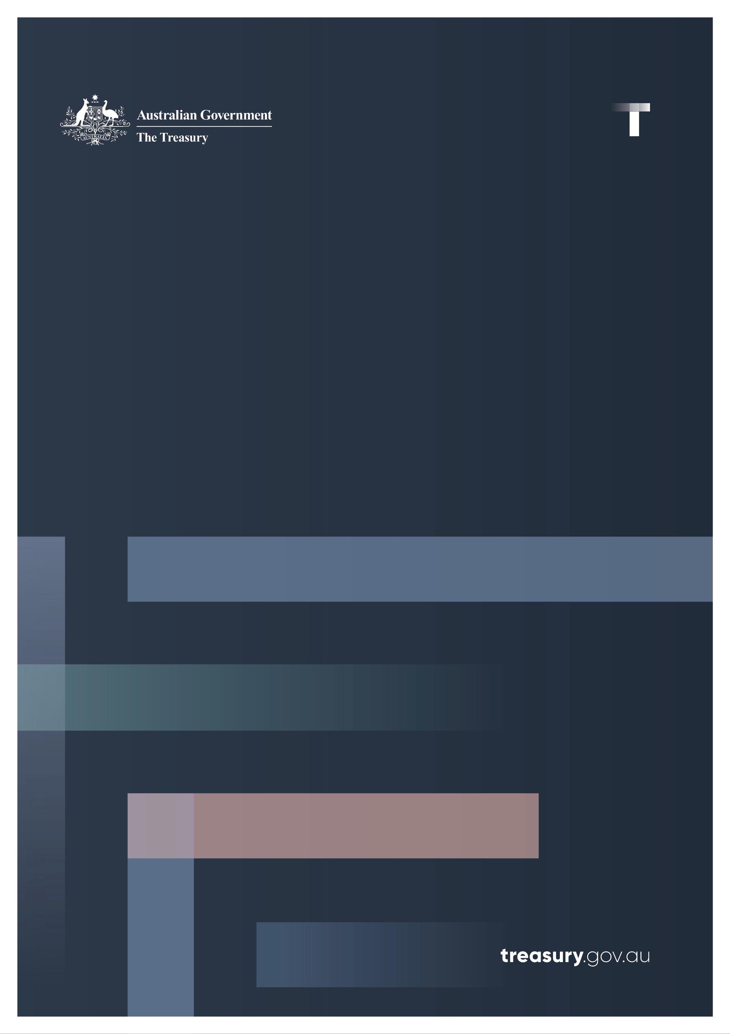

National Interest Statement

2024 Loan Agreement between the Commonwealth of Australia and the Independent State of Papua New Guinea

February 2025

# Contents

Summary 1

Legislative Requirements 2

National Interest Assessment 3

Nature and Terms of the Loan Agreement 4

# Summary

This National Interest Statement (Statement) relates to the loan agreement between Australia and the Independent State of Papua New Guinea (PNG) for A$570 million. This Statement is being tabled pursuant to the requirements of sections 8D-8E of the *International Monetary Agreements Act 1947* (IMA Act).  
  
The loan is in response to a request by letter from PNG Treasurer, Mr Ian Ling-Stuckey on 25 August 2024 requesting financial assistance. In his letter, Treasurer Ling-Stuckey thanked Australia for vital budget support and noted the important progress the PNG government has taken to repair PNG’s budget. The letter formally requested further support to enable the PNG Government to meet its 2024 budget financing needs.  
  
The provision of further bilateral support reinforces the positive relationship between Australia and PNG and the importance both governments attach to regional prosperity and stability. The loan builds on the previous budget support loans Australia provided in 2020, 2021, 2022 and 2023 and represents Australia’s continued support under the Comprehensive Strategic and Economic Partnership with PNG.  
  
On 12 December 2024, Australia formally entered into a loan agreement with PNG to support its estimated 2024 budget financing shortfall and support the delivery of reform actions under PNG’s International Monetary Fund Extended Credit Facility and Extended Fund Facility Program (IMF Program). The IMF Program continues to support PNG’s reform agenda, helping protect the vulnerable and foster inclusive growth, with a focus maintained on strengthening debt sustainability, alleviating foreign exchange shortages, and enhancing governance and operationalising the anti-corruption framework. The IMF Program provides PNG with US$928 million and demonstrates PNG’s commitment to secure other concessional financing with which to address its fiscal shortfall.

The PNG Government remains committed to budget repair and improving the country’s fiscal position. In comparison to PNG’s 2023 Budget deficit of K$4.8 billion (A$1.83 billion) or 4.3 per cent of GDP, PNG’s 2024 MYEFO identified the current budget deficit of K$3.98 billion (A$1.52 billion) or 3.2 per cent of GDP.  
  
The loan is provided at the Australian Government’s cost of borrowing and involves no cost to the Australian taxpayer.

# Legislative Requirements

The IMA Act (section 8c (1)) provides that Australia may enter into an agreement for a loan to another country where the loan provides financial assistance in support of an IMF program to another country and if the Treasurer is satisfied that at least one other government or organisation has, or will be, providing similar assistance.

Australia’s loan of A$570 million will be provided in support of the IMF-funded Extended Credit Facility and Extended Fund Facility Program. The Program supports PNG’s reform agenda, which seeks to help protect the vulnerable and foster inclusive growth. The reforms under the Program focus on strengthening debt sustainability, alleviating foreign exchange shortages, and enhancing governance and operationalizing the anti-corruption framework.

New Zealand provided funding of US$850,000 to PNG’s Treasury in support of PNG’s ongoing economic reform agenda, including under the IMF Extended Credit Facility and Extended Fund Facility Program.

This Statement is tabled pursuant to the requirements of sections 8D-8E of the IMA Act. The IMA Act requires the Treasurer to table a statement as soon as practicable after entering into such an agreement. The Statement should include a description, in as much detail as practicable, of the nature and terms of the agreement; and the reasons why the agreement is in Australia’s national interest, having regard to foreign policy, trade and economic interests.

# National Interest Assessment

It is in Australia’s national interests to promote economic and political stability in PNG given its geographic proximity and the unique and enduring connections that span decades. PNG’s security and stability is a fundamental Australian strategic interest.

Helping the PNG Government meet its estimated 2024 budget financing shortfall will support the continued funding of essential government services such as healthcare and education, support PNG’s economic reform, and ongoing budget repair efforts. It will also support PNG to deliver reform under the International Monetary Fund Extended Credit Facility and Extended Fund Facility Program (IMF Program).

PNG’s economic outlook for 2024 shows stabilisation from the pandemic. In 2024, the PNG economy is projected to grow at 4.6 per cent. Many challenges remain from inflationary pressures, a slowing global economy, and a weak fiscal position. This loan builds upon the support Australia provided to PNG in 2020, 2021, 2022 and 2023 to help with budget repair efforts and support the delivery of reform actions.

PNG’s self-identified long-term budget repair goals warrant Australian support and this loan will continue to strengthen our bilateral relationship underpinned by the Comprehensive Strategic and Economic Partnership (CSEP) of 2020. The CSEP provides an enduring and overarching framework for deepening bilateral cooperation across security, trade and investment, governance, development cooperation, health, education, gender equality, climate change, people-to-people and institutional links, underpinned by a commitment to achieving concrete outcomes by 2030.

As PNG focuses on economic repair, the clear goals of the PNG Government remain providing a better standard of living and more opportunities for its citizens. These considerations are core to Australia’s decision to approve the loan.

# Nature and Terms of the Loan Agreement

On 12 December 2024, Australia and PNG entered into a 20-year loan following a request from the PNG Treasurer, Mr Ian Ling-Stuckey, to support PNG to meet its estimated 2024 budget financing shortfall. The loan will also assist PNG in delivering economic reforms under the International Monetary Fund Extended Credit Facility and Extended Fund Facility Program. This loan represents Australia’s continued commitment to helping PNG towards more sustainable macroeconomic policy settings and reducing longer-term vulnerability.

The total principal of the loan is A$570 million with the base interest rate set at the 10-year Australian Government bond rate as at the date 10 business days before a date nominated by PNG to draw down the loan (23 December), being 4.216 per cent (as published on 6 December). This rate, along with the rates of other Australian Government Securities, are published on the Reserve Bank of Australia website (and are subject to revisions). Repayments of the loan principal and interest are six monthly.

The loan is provided on a full cost recovery basis to ensure that it can be provided to PNG at no cost to Australian taxpayers. Australia has an option to review the loan’s interest rate 10 years after drawdown, or at any earlier date, at which time the rate can be amended if it no longer aligns with the Australian Government’s cost of borrowing.