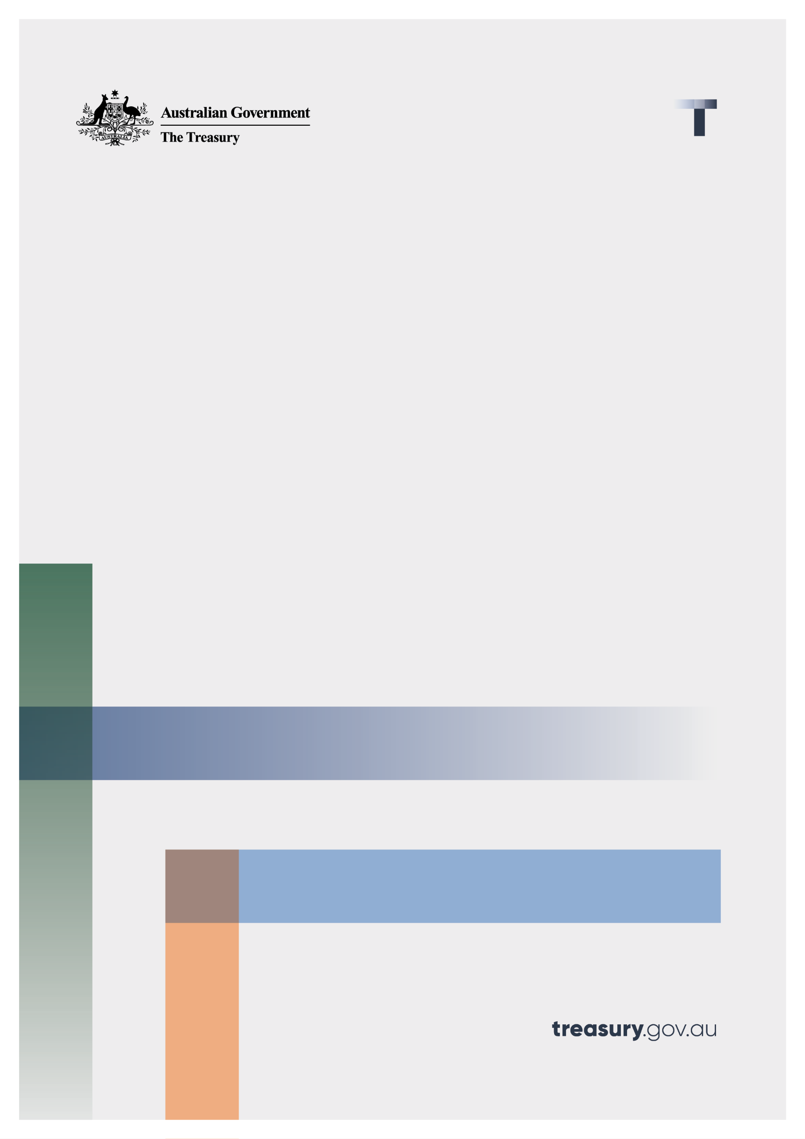

**Post-Implementation review: Compensation Scheme of Last Resort**

Terms of Reference

January 2025

© Commonwealth of Australia 2025

This publication is available for your use under a [Creative Commons Attribution 4.0 International](https://creativecommons.org/licenses/by/4.0/) licence, with the exception of the Commonwealth Coat of Arms, the Treasury logo, photographs, images, third party materials, materials protected by a trademark, signatures and where otherwise stated. The full licence terms are available from [creativecommons.org/licenses/by/4.0/legalcode](http://creativecommons.org/licenses/by/4.0/legalcode).

Creative Commons attribution licence 3.0 icon. 

Use of Treasury material under a [Creative Commons Attribution 4.0 International](https://creativecommons.org/licenses/by/4.0/) licence requires you to attribute the work (but not in any way that suggests that the Treasury endorses you or your use of the work).

**Treasury material used ‘as supplied’.**

Provided you have not modified or transformed Treasury material in any way including, for example, by changing the Treasury text; calculating percentage changes; graphing or charting data; or deriving new statistics from published Treasury statistics – then Treasury prefers the following attribution:

Source:The Commonwealth of Australia.

**Derivative material**

If you have modified or transformed Treasury material, or derived new material from those of the Treasury in any way, then Treasury prefers the following attribution:

Based on Commonwealth of Australia data.

**Use of the Coat of Arms**

The terms under which the Coat of Arms can be used are set out on the Department of the Prime Minister and Cabinet website (see [www.pmc.gov.au/government/commonwealth-coat-arms](http://www.pmc.gov.au/government/commonwealth-coat-arms)).

**Other uses**

Enquiries regarding this licence and any other use of this document are welcome at:

Manager  
Media and Speeches Unit  
The Treasury  
Langton Crescent   
Parkes ACT 2600  
Email: [media@treasury.gov.au](mailto:media@treasury.gov.au)

In the spirit of reconciliation, the Treasury acknowledges the Traditional Custodians of country throughout Australia and their connections to land, sea and community. We pay our respect to their Elders past and present and extend that respect to all Aboriginal and Torres Strait Islander peoples.

# Contents

Contents ii

Consultation Process 1

Request for feedback and comments 1

Terms of reference 2

Background 2

Scope of the review 2

# Consultation Process

## Request for feedback and comments

|  |  |
| --- | --- |
| Email | CSLRreview@treasury.gov.au |
| Mail | Director  Programs and Redress Unit  Financial System Division  The Treasury  Langton Crescent  PARKES ACT 2600 |
| Enquiries | Enquiries can be initially directed to CSLRreview@treasury.gov.au. |

# Terms of reference

## Background

The Compensation Scheme of Last Resort (CSLR) was introduced to provide victims of financial services misconduct with access to redress and compensation within the scope of the scheme, after all other avenues have been exhausted. The CSLR includes objectives to:

* Support confidence in the financial system’s external dispute resolution framework;
* Provide some compensation for victims of financial services misconduct as a last resort where a determination issued by the Australian Financial Complaints Authority remains unpaid and the determination relates to a financial product or service within the scope of the scheme; and
* Be sustainable over time and funded by an industry levy.

The Government is directing the Treasury to undertake a post-implementation review (review) of the scheme to ensure the scheme is delivering its intended objectives. This will give stakeholders confidence in the scheme and support the outcomes of consumers.

## Scope of the review

The review will improve understanding of the scheme’s operation and the outcomes it is delivering.

The review will consider:

* How the CSLR is delivering on its intended objectives;
* How the CSLR funding model is formulated, including its potential impacts on businesses who fund the industry levy;
* How the powers of the CSLR Operator interact with delivery of the scheme; and
* The current scope of the CSLR and any related matters.

The review should have regard of other current and recent reviews and inquiries as relevant.