

Positioning Australia’s financial reporting system for the future

**Designing a single, flexible standard setting body**

Consultation paper

January 2025

© Commonwealth of Australia 2025

This publication is available for your use under a [Creative Commons Attribution 4.0 International](https://creativecommons.org/licenses/by/4.0/) licence, with the exception of the Commonwealth Coat of Arms, the Treasury logo, photographs, images, third party materials, materials protected by a trademark, signatures and where otherwise stated. The full licence terms are available from <http://creativecommons.org/licenses/by/4.0/legalcode>.

Creative Commons attribution licence 3.0 icon. 

Use of Treasury material under a [Creative Commons Attribution 4.0 International](https://creativecommons.org/licenses/by/4.0/) licence requires you to attribute the work (but not in any way that suggests that Treasury endorses you or your use of the work).

**Treasury material used ‘as supplied’**

Provided you have not modified or transformed Treasury material in any way including, for example, by changing the Treasury text; calculating percentage changes; graphing or charting data; or deriving new statistics from published Treasury statistics — then Treasury prefers the following attribution:

*Source:* The Commonwealth of Australia.

**Derivative** **material**

If you have modified or transformed Treasury material, or derived new material from those of the Treasury in any way, then Treasury prefers the following attribution:

*Based on* Commonwealth of Australia data.

**Use of the Coat of Arms**

The terms under which the Coat of Arms can be used are set out on the Department of the Prime Minister and Cabinet website (see [www.pmc.gov.au/government/commonwealth-coat-arms](http://www.pmc.gov.au/government/commonwealth-coat-arms)).

**Other uses**

Enquiries regarding this licence and any other use of this document are welcome at:

Manager  
Media and Speeches Unit  
The Treasury  
Langton Crescent   
Parkes ACT 2600  
Email: [media@treasury.gov.au](mailto:media@treasury.gov.au)

In the spirit of reconciliation, the Treasury acknowledges the Traditional Custodians of country throughout Australia and their connections to land, sea and community. We pay our respect to their Elders past and present and extend that respect to all Aboriginal and Torres Strait Islander peoples.

# Contents

Contents ii

Consultation process 1

Request for feedback and comments 1

Closing date for submissions: 21 February 2025 1

Confidentiality 1

Glossary 2

Introduction 3

The current institutional arrangements 4

Rationale for change 4

The proposed new institutional arrangements 5

Benefits and objectives 5

Design principles 6

Overview of the proposed new statutory body 7

Key considerations 10

Functions and powers of the new body 10

Roles of the governing Board and the standard setting committees 12

Appointments, qualifications and staff 14

Strengthening institutional governance 15

Next steps 16

Attachment A: International comparison 17

Attachment B: Comparison of key features 18

Table 1: Summary comparison of key features 18

Attachment C: List of consultation questions 20

# Consultation process

## Request for feedback and comments

This consultation paper seeks feedback on the proposed design of new institutional arrangements for the setting of accounting, sustainability and auditing and assurance standards in Australia. The proposed design combines the Australian Accounting Standards Board (AASB), the Auditing and Assurance Standards Board (AUASB) and the Financial Reporting Council (FRC) into a single body.

### Closing date for submissions: 21 February 2025

|  |  |
| --- | --- |
| Email | FRSReform@treasury.gov.au |
| Mail | Director  Financial Reporting System Reform Unit  Market Conduct Division  The Treasury  Langton Crescent  PARKES ACT 2600 |
| Enquiries | Enquiries can be initially directed to FRSReform@treasury.gov.au |

The principles and detailed proposals outlined in this paper have not received Government approval and are not yet law. As a consequence, this paper is merely a guide as to how the principles might operate and the proposals that might be adopted.

## Confidentiality

Submissions received in response to this consultation may be shared with other Commonwealth agencies for the purposes of developing and progressing the proposed reforms. All information (including name and address details) contained in submissions may be made available to the public on the Treasury website unless you indicate that you would like all or part of your submission to remain confidential. Automatically generated confidentiality statements in emails are not sufficient for this purpose.

If you would like only part of your submission to remain confidential, please provide this information clearly marked as such in a separate attachment.

Please note that legal requirements, such as those imposed by the *Freedom of Information Act 1982*, may affect the confidentiality of your submission. For further information, please refer to Treasury’s [Submission Guidelines](https://treasury.gov.au/submission-guidelines).

# Glossary

| Term | Definition / meaning |
| --- | --- |
| AASB | Australian Accounting Standards Board |
| ASIC | Australian Securities and Investments Commission |
| AUASB | Auditing and Assurance Standards Board |
| CLERP | Corporate Law Economic Reform Program |
| External reporting | Periodic communications of financial and other information concerning an entity for the purposes of informing stakeholders external to the entity (for example, a company’s annual report). The term contrasts with reporting prepared for internal business purposes (such as management accounts) |
| Financial reporting system | The institutional arrangements for accounting, sustainability and auditing and assurance standard setting and oversight established under Part 12 of the ASIC Act |
| FRC | Financial Reporting Council |
| PAB | An Australian professional accounting body (one of Chartered Accountants Australia and New Zealand, CPA Australia and the Institute of Public Accountants) |
| PJC Report | Report of the Parliamentary Joint Committee on Corporations and Financial Services inquiry, *Ethics and Professional Accountability: Structural Challenges in the Audit, Assurance and Consultancy Industry*, which commenced in June 2023 with the report released on 7 November 2024 |
| Statutory body | An Australian Government body established through legislation for a public purpose |
| UK FRC | Financial Reporting Council (UK) |
| XRB | External Reporting Board (New Zealand) |
| ***Legislation*** |  |
| ASIC Act | *Australian Securities and Investments Commission Act 2001* |
| Corporations Act | *Corporations Act 2001* |
| Public Service Act | *Public Service Act 1999* |

# Introduction

Australia’s financial reporting system aims to support the Australian economy by maintaining investor confidence, reducing the cost of capital, and enabling Australian entities to compete overseas effectively.

Recent efforts to develop sustainability and climate-related financial disclosure standards in Australia and internationally have highlighted the need to ensure the institutional arrangements for standard setting are sufficiently flexible to respond to developments in the reporting landscape now and in the future.

To this end, in November 2023 the Government announced its intention to streamline the financial reporting architecture by combining the Financial Reporting Council (FRC), the Australian Accounting Standards Board (AASB) and the Auditing and Assurance Standards Board (AUASB) into a single body.[1]

As foreshadowed in Treasury’s December 2022 consultation paper,[2] this consultation seeks feedback from stakeholders to assist in refining and settling the proposed design of the new single, flexible standard setting body ahead of draft legislation being finalised. For the avoidance of doubt, we are not seeking views on the merits of combining the AASB, AUASB and FRC into a single body.

In May 2024 Treasury released a consultation paper[3] seeking stakeholder feedback on the regulation of accounting, auditing and consulting firms in Australia and raising questions on the following matters (amongst others):

* the adequacy of prescribed governance requirements for large partnerships
* the adequacy of current professional standards, regulations and laws (including those relating to independence and the management of conflicts of interest)
* whether the transparency requirements for accounting, auditing and consulting firms are sufficient to:
  + give capital markets confidence that independent audit services are delivered in accordance with prescribed laws and standards
  + enable stakeholders to obtain the information they need to inform their engagement with the firm(s)[4]
* the adequacy of regulatory enforcement capabilities and standard setting
* the protection of whistleblowers
* competition and resilience in the audit sector.

Informed by this consultation process, a key focus of the merger of the financial reporting bodies is to embed additional flexibility within Australia’s financial reporting system.

## The current institutional arrangements

The institutional arrangements for accounting, sustainability and auditing and assurance standard setting in Australia constitute the Australian financial reporting system as set out in Part 12 of the *Australian Securities and Investments Commission Act 2001* (ASIC Act). In addition to establishing the AASB, the AUASB, their respective Offices and the FRC, the ASIC Act recognises the roles of a range of other government and non-government organisations in the financial reporting landscape, including the Australian Securities and Investments Commission (ASIC), the Companies Auditors Disciplinary Board, the professional accounting bodies (PABs) and the international standard setting bodies. Other organisations such as the Accounting Professional & Ethical Standards Board also play a role.

The AASB and the AUASB have the power to make standards under the *Corporations Act 2001* (Corporations Act).[5] While the AASB and AUASB operate independently in developing and implementing standards, they are subject to the broad strategic direction, oversight and advice of the FRC. The FRC’s functions also include broad oversight of standard setting processes and audit quality.

In practice, the FRC has partly relied on the resources of the AASB and AUASB for various initiatives, including implementing its Audit Quality Action Plan and leading international and domestic stakeholder engagement on current and emerging issues.

In November 2023, the financial reporting system was amended to facilitate the development and implementation of sustainability standards, by:

* expanding the role of the AASB to include formulating sustainability standards
* expressly confirming that the AUASB’s functions include developing and maintaining relevant auditing and assurance standards for sustainability purposes
* empowering the FRC to provide strategic oversight and governance in relation to the AASB’s and AUASB’s new sustainability standard setting functions.

Parliament has also recently passed further legislation setting out new climate-related financial disclosure requirements that leverage the existing financial reporting requirements in the Corporations Act. Under the *Treasury Laws Amendment (Financial Market Infrastructure and Other Measures) Act 2024*, which received Royal Assent on 17 September 2024, certain entities will be required to prepare a new ‘sustainability report’ alongside their annual financial report for financial years commencing on or after 1 January 2025. The sustainability report will include a ‘climate statement’ to be prepared in line with sustainability standards made by the AASB.[6]

## Rationale for change

International best practice financial reporting is undergoing a significant shift. Financial markets are recognising that a wider range of factors, including environmental, social and governance concerns, are important sources of material financial risks and opportunities for businesses and financial institutions. This in turn is driving demand from investors, regulators and other interested parties for greater transparency in the form of high-quality, standardised disclosures. The creation of the International Sustainability Standards Board in 2021 by the International Financial Reporting Standards Foundation to develop globally consistent and financially integrated sustainability-related disclosure standards responds to this demand.

It is critical that Australia’s financial reporting system keeps pace with these and other developments to support Australia’s reputation as an attractive destination for international capital. However, there are structural barriers within the current institutional arrangements for standard setting that constrain the Government’s ability to respond to future developments and needs.

With the potential for further changes in the reporting landscape in the future, consolidating standard setting within a single body with greater structural flexibility, while leveraging the existing bodies’ standard setting expertise and credibility, will better position Australia’s financial reporting system for the future.

# The proposed new institutional arrangements

## Benefits and objectives

To implement the Government’s announced change, legislation will be developed to combine the functions and powers of the FRC, AASB and AUASB within a single statutory body responsible for standard setting and advice to government in relation to external reporting.[7]

Reforming the existing institutions into a single, flexible body will seek to realise several benefits:

* **Facilitating sustainability reporting standard setting by a dedicated technical committee.** New institutional arrangements will enable the transition of sustainability reporting standard setting to a standalone technical committee with a focussed remit while retaining access to support and relevant expertise from within the body more broadly.
* **Greater flexibility to meet future external reporting needs.** Removing some of the structural barriers inherent in having separately constituted statutory bodies responsible for different aspects of the financial reporting system will improve the capacity to respond to future developments in the external reporting landscape – including, for example, taking on new standard setting functions. Within a single body:
  + the established internal governance and accountability arrangements can be leveraged whenever new functions are acquired, avoiding duplication and further fragmentation within the system
  + administrative arrangements to ensure appropriate technical expertise and insight are brought to bear in standard setting (such as the establishment by a governing board of technical standard setting committees to make, formulate or advise on standards) can be more easily adopted and adapted as responsibilities and priorities evolve
  + it will be easier to allocate and redeploy resources in a way that both addresses urgent and emerging issues and reflects a holistic view of standard setting and other priorities across the system
  + there will be greater scope to implement continuous improvements in the structure without the need for legislative changes.
* **Further streamlining of administrative operations.** Removing the need for separate secretariat functions to be provided by Treasury for the FRC will enable full internalisation and integration of administrative and specialist staff and support services.

## Design principles

Having regard to the benefits and objectives of consolidating the existing bodies, the following key design principles have informed the new institutional arrangements for standard setting now proposed. Feedback on the proposals in this paper will be considered having regard to these principles.

#### 1. Flexibility – ensuring the institutional arrangements are positioned for the future

Designing the new body with a view to maximising flexibility will better facilitate the evolution of standard setting and other functions over time and increase the responsiveness and adaptability of the body to address new developments and emerging challenges.

Increased flexibility will require comparatively less prescription in legislation on matters such as the operations and internal governance and organisation of the body. The new institutional arrangements will need to strike the right balance between flexibility and prescription so that the new body has a clear remit while being able to adapt to future needs in external reporting, including any new responsibilities. Too little specificity in the legislation may compromise user and market confidence, while too much would reduce the benefits of merging the existing bodies and be inconsistent with the objectives of the reform. An appropriate balance ensures flexibility while supporting both autonomy and accountability.

#### 2. Preserving, as far as practicable, key features of the current institutional arrangements that work well

A key goal in the transition to the new body is to minimise any disruption to ongoing standard setting processes, including the development of new standards in relation to sustainability, and to reduce the impacts on stakeholders and markets of the uncertainty that is inherent to any change process. Many of the key features of the current arrangements are proposed to be retained, including the high level and variety of skills, experience and expertise of the individuals involved in the standard setting functions.

Some features of the current approach will need to evolve, however, to accommodate the merger of the bodies, given, for example, that the standard setting functions and broad oversight function will be performed within the same body.

#### 3. Ensuring institutional accountability

It is important that the new single body has appropriate accountability arrangements. At the same time these arrangements must not themselves create a barrier to future expansion or evolution of the body’s functions.

The consolidation of the existing bodies also provides an opportunity to review and strengthen the new body’s accountability and governance arrangements, for example, through the incorporation of mechanisms to identify and address conflicts of interests and ensuring the responsible Minister has the capacity to terminate Board appointments in appropriate circumstances. The standards will also continue to be disallowable instruments and subject to the normal tabling and scrutiny process as required by the *Legislation Act 2003.*

## Overview of the proposed new statutory body

It is proposed a new statutory body will be responsible for the functions currently performed by the FRC, AASB and AUASB – including formulating, issuing, and providing advice and reports to government relating to, accounting standards, auditing and assurance standards and sustainability standards.

The new body will be governed by a government-appointed Board, constituted by members with experience and expertise appropriate to its functions as well as its strategic direction setting, general oversight and governance roles. It is proposed the Board will be the accountable authority of the new body and collectively responsible for the relevant duties and powers outlined in the *Public Governance, Performance and Accountability Act 2013*.

While the new body will be vested with functions and powers currently performed and exercised by the FRC, AASB and AUASB, it is anticipated the Board will initially establish three dedicated technical committees to perform its standard setting functions: an accounting standards committee, a sustainability reporting standards committee, and an auditing and assurance standards committee.

The technical committees, which will be constituted by professionals with relevant technical knowledge and expertise appointed by the Board, will have delegated power to make and formulate standards directly. Additionally, the Board will be able to set up other committees (such as advisory committees) and will have the power to delegate powers for administrative purposes comparable to other Commonwealth entities. Existing procedural arrangements are expected to be largely retained.

The Board, Chair and committees will be supported by a Chief Executive Officer[8] leading a team of permanent staff supplemented by external expertise where appropriate. Unlike the current arrangements whereby the FRC is supported by a secretariat within Treasury, the new body will be fully resourced in‑house.

There are some parallels between the proposed board and committee structure within the new body and the current split of functions between the three existing bodies. While the the new body’s Board will necessarily assume some of the governance and administrative functions currently undertaken by the Offices of the AASB and AUASB, the role of the technical committees in relation to accounting and audit and assurance will have recognisable parallels to the current system, preserving a number of key benefits of the existing structure. This will assist with minimising disruption to the bodies during the transition and will facilitate the continuation of existing arrangements for international engagement and trans-Tasman cooperation.

Although there is no single, typical model for financial reporting standard setting institutions internationally, delegating the standard setting function to committees or sub-boards is consistent with approaches that have been taken in comparable jurisdictions which have a single body responsible for standard setting functions (see Attachment A).

The diagrams below illustrate the proposed structure of the new body, and Attachment B elaborates on key details – including a comparison between the current institutional arrangements and the proposed structure of the new body.

Particular matters for consideration are discussed in the following section of this paper.

#### Diagram 1: Current institutional arrangements compared to indicative future structure

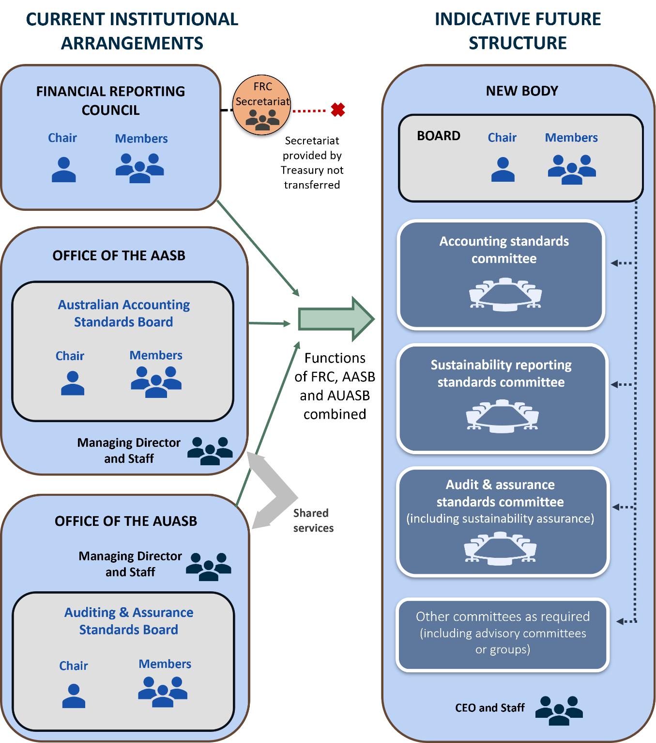

#### Diagram 2: Indicative organisation of the new body

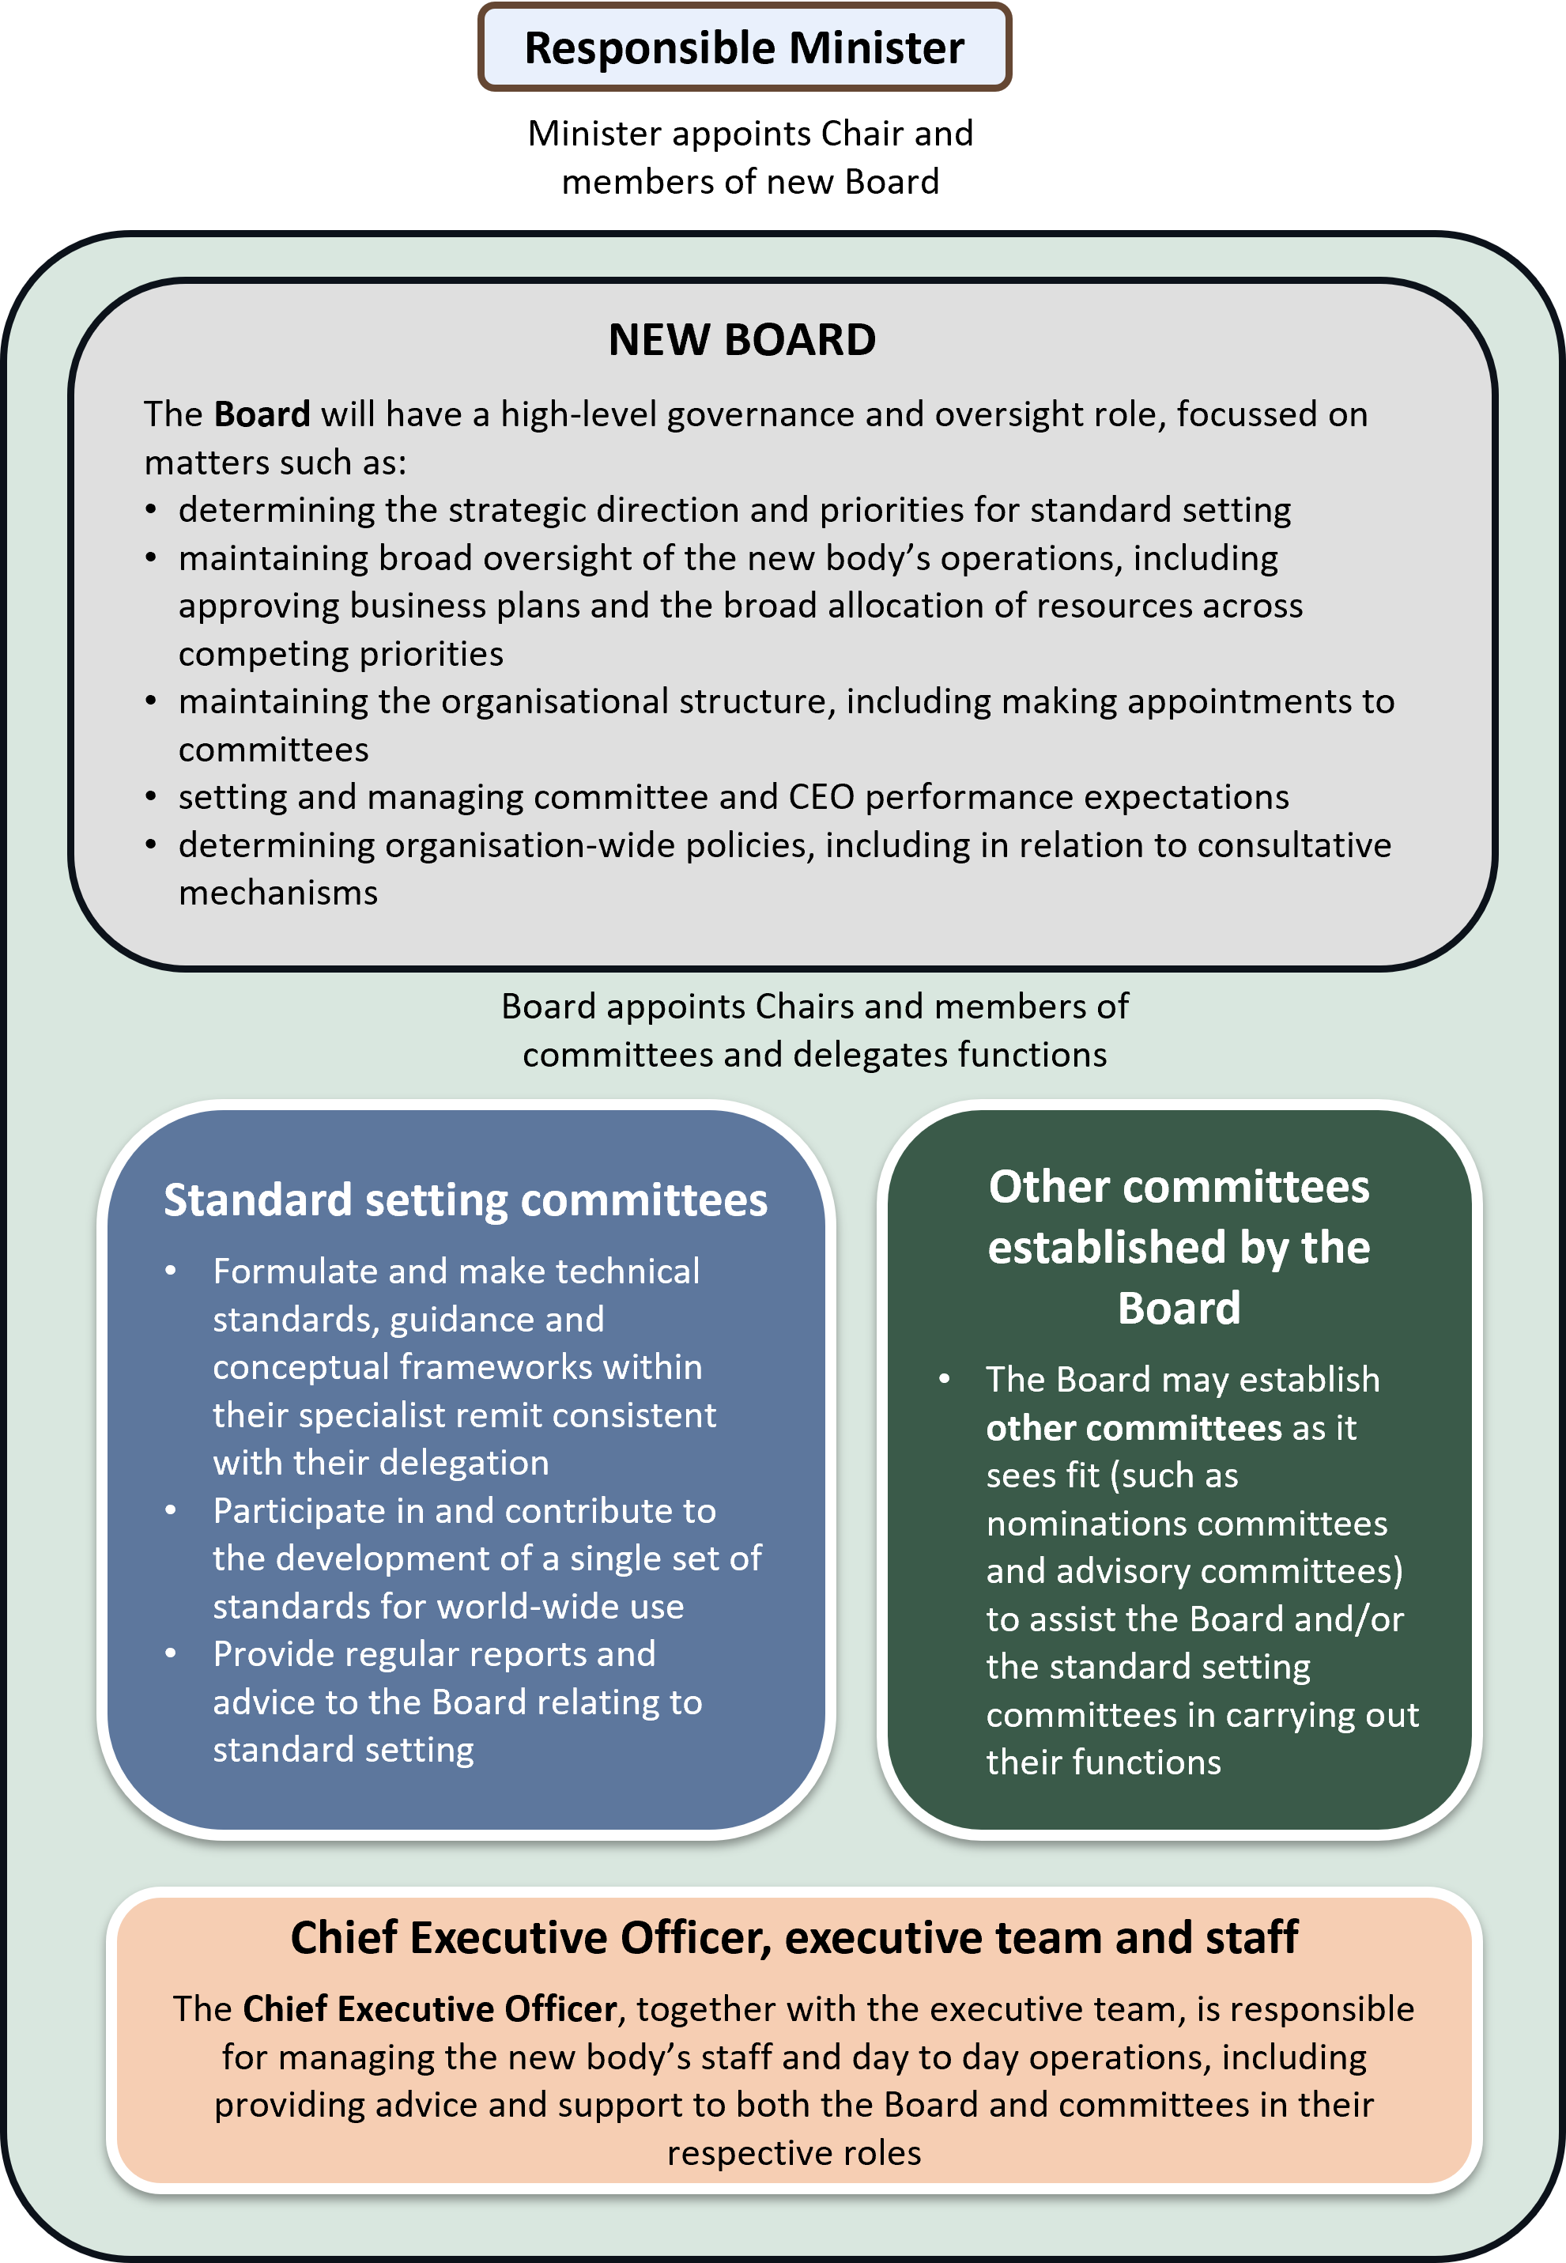

## Key considerations

### Functions and powers of the new body

It is proposed that the new body will be responsible for the key standard setting and advice functions currently performed by the FRC, AASB and AUASB, including:

* *Standard setting* – making and formulating accounting standards, auditing and assurance standards and sustainability standards.
* *Evaluation and consultation* – developing conceptual frameworks for the purpose of evaluating proposed domestic and international accounting, auditing and sustainability standards and establishing appropriate consultative mechanisms.
* *International monitoring and engagement* – monitoring the development of international standards and the development of standards that apply in major international financial centres and participating in, and contributing to, the development of a single set of relevant standards for world-wide use
* *Strategic advice and reporting* – giving the responsible Minister reports about the processes for setting relevant standards in Australia and giving strategic policy advice and reports in relation to the quality of audits
* *Advancing and promoting the objectives of the financial reporting system* – including educative activities to support implementation and adoption of standards in Australia.

Functions and powers in the current law which relate to the FRC’s oversight of the AASB and AUASB would naturally form part of the new body’s internal management. Further discussion of this is set out in the following section of this consultation paper.

The responsible Minister will have the ability to confer new functions on the new body in writing, as is currently the case in relation to the FRC. The new body will also have the power to establish standard setting and other committees, advisory groups and consultative groups as is necessary or convenient to carry out its functions. Together these powers support the objective of increasing flexibility in the financial reporting system as:

* should future circumstances warrant, the new body may be empowered to formulate new kinds of standards and in turn would be able to set up a new committee with appropriate expertise and delegated authority to deliver that function
* the new body will also be able to optimise its internal structure to meet evolving priorities within its existing functions (for example, if it were considered efficient and appropriate for future tranches of sustainability standards to be set by technical committees separately constituted with expertise relevant to each particular kind of sustainability standard).

Legislative changes may still be required from time to time, for example, to introduce new reporting requirements, make compliance with new kinds of standards mandatory, or to confer different functions on the body. However, the new institutional arrangements may provide greater scope and flexibility for the new body to formulate proposed or voluntary standards without the need for legislation.

#### The Financial Reporting Council’s audit quality function

In addition to its role providing oversight of, and advice in relation to, standard setting, the FRC also has responsibility for strategic policy advice and reports in relation to the quality of audits conducted by Australian auditors.[9] This extends to matters such as:

* the adequacy of the Australian requirements (relevant legislative provisions, auditing standards and applicable codes of professional conduct) in light of international developments regarding audit quality
* the oversight of quality assurance reviews by PABs
* the investigation and disciplinary procedures of PABs
* the teaching of professional and business ethics by, or on behalf of, PABs insofar as it relates to audit quality.

The FRC does not have the power to take enforcement action in relation to any deficiencies that it becomes aware of, or compel action as a result of, its investigations.

Broader scrutiny has been given to the frameworks for ethical standard setting, audit quality assurance and enforcement through processes such as the Parliamentary Joint Committee on Corporations and Financial Services 2023 inquiry into the audit, assurance and consultancy industry (PJC Report), and Treasury’s ongoing consideration of the regulation of accounting, auditing and consulting firms in Australia – including via the consultation paper released in May 2024.[10]

These papers acknowledge a number of potential issues relating to enforcement and standard setting, including that:

* a large number of bodies are tasked with setting, overseeing and enforcing audit-related standards which may be resulting in overlaps and gaps
* ASIC has a broad range of regulatory priorities, limiting the total regulatory effort that can be dedicated to audit quality oversight.

|  |
| --- |
| Consultation questions  1. Structure of the new body – Do you agree with the proposed structure for the new body? Are there any changes to the proposed structure that will better meet the design principles? |

While in principle the FRC’s existing function of giving strategic policy advice and reports relating to audit quality will be assumed by the new body, further consideration will be given to matters such as the best fit and appropriate scope of this function in the context of Treasury’s ongoing review.

### Roles of the governing Board and the standard setting committees

A key design issue is the relationship between the governing Board of the new body and its technical standard setting committees – in particular, the functional and authoritative separation between the two.

#### Background

The current institutional arrangements for standard setting in Australia have their origins in the CLERP 1 reforms of 2000.[11] Under those reforms the FRC was established as an advisory body to represent key interest groups and provide broad oversight of the accounting standard setting process. The FRC was given responsibility for approving and monitoring the priorities and business plan, budget and staffing arrangements of a reconstituted AASB with a view to engendering greater stakeholder involvement in accounting standard setting and more fit for purpose financial reporting. The FRC also had a power to determine the AASB’s broad strategic direction and give the AASB directions on matters of general policy which the AASB was required to follow.

A key element of the CLERP 1 reforms was the delineation of the policy setting roles of the advisory and oversight body and the standard setting body, with the FRC setting the general and strategic policy direction and priorities, and the standard setting body independently free to determine the technical content of particular standards within the confines of that framework.

These arrangements were replicated in 2004 when the AUASB was reconstituted as a statutory body and auditing standards were given a statutory footing as part of the CLERP 9 reforms.[12]

Given the FRC was purposely designed to have broad stakeholder representation in order to bring a variety of distinct perspectives to the standard setting system, there was a concern that if it were to make and formulate detailed standards itself a ‘lowest common denominator’ approach may emerge whereby the standards would need to accommodate the preferences of every interest group represented, ultimately undermining the credibility of the standards.

As such, the FRC was expressly prevented from directing, or exercising a power of veto over, the AASB and AUASB in relation to the development, making or recommendation of a particular standard.[13]

#### Adapting to a single body

With the merger of the existing bodies and the transition to a board and committee structure, it is not proposed to retain an express legislative provision delineating the role and powers of the new Board and its standard setting committees. There are several reasons for this.

* With the new institutional arrangements, the Board will be accountable for the decisions and performance of the new body as a whole. While the delegation of its standard setting function would mean it would be rare for the Board to involve itself in day-to-day technical standard setting, it is nonetheless appropriate for the Board to reserve its power to act. This avoids unnecessary fragmentation of the new body’s accountability arrangements where the Board is responsible for, but ultimately has no ability to address, exceptional but significant issues that may arise.
* Consistent with the objective of enhancing flexibility, it is generally preferable to minimise the legislative prescription around matters such as the internal management of the new body.
* Removal of the express legislative provision will not preclude key benefits of the current institutional arrangements being retained:
  + appropriate technical expertise will still be brought to bear in standard setting with the technical committees, constituted by members selected for their relevant expertise, being responsible for making and formulating standards directly
  + the standard setting committees will retain their own distinctiveness as part of the new body and will be free to continue to engage directly, and on their own behalf, with international counterparts.
* Not expressly delineating the role and powers of the Board and its standard setting committees in legislation is consistent with the institutional arrangements in comparable jurisdictions where standard setting is performed by a single statutory body, such as the UK’s Financial Reporting Council (UK FRC) and New Zealand’s External Reporting Board (XRB).
* With respect to the concerns originally raised in the CLERP 1 reforms which led to the express division of responsibility in the legislation:
  + the new Board’s role with respect to the committees will differ somewhat from the FRC’s role (as a representative advisory body) in relation to the AASB and AUASB, particularly as the Board will have governance responsibilities necessitating a broader focus and additional considerations in terms of its membership
  + on the rare occasion the Board may find it necessary to intervene in relation to the process of setting a particular technical standard, it would do so acting collectively rather than as individual members representing any particular interested group or perspective.

The new body will continue to act independently in carrying out its functions and exercising its powers.

#### Delegations

It is not proposed that the legislation prescribe that particular committees must be established or details of what should be delegated to them. Consistent with the objective of enhancing flexibility, the proposed design will seek to ensure the internal governance structures of the new body can adapt and remain appropriate over time. Accordingly, it is not anticipated that the legislation would be overly prescriptive in describing how the Board must fulfil its functions. As responsibility vests in the Board, the Board will have appropriate autonomy to determine how best to perform its functions. This includes flexibility to establish and amend committees as it sees fit.

#### Additional mechanisms

The proposed structure of the new body seeks to preserve key elements of the existing institutional arrangements while making necessary changes to ensure appropriate accountability and flexibility within a single body. Even without expressly prescribing respective roles in legislation, there is an expectation that the Board would be focussed on providing broad strategic direction at an appropriate level while its standard setting committees determine the need for, and content of, particular standards and any associated guidance.

Mechanisms are also available to reinforce this expectation, for example:

* A Statement of Expectations issued by the responsible Minister to the new body could provide additional detail regarding government policies and objectives relevant to the body, including expectations as to organisational and governance matters. Statements of Expectations, along with entities’ Statements of Intent in response, are generally publicly available.
* Provisions concerning the Board’s transparency around its deliberations and decision‑making would contribute to ensuring that there is public accountability and scrutiny of its approach:
  + The terms of reference of the technical committees and/or relevant delegations of power will be publicly available.
  + To the extent Board and committee meetings concern standards, they will be required to be open to observation by the public (such as is required by sections 236A and 236E of the ASIC Act in respect of the AASB and AUASB meetings currently) ensuring there is transparency in any instance where the Board were to consider it necessary to involve itself in a matter relating to technical standard setting.

|  |
| --- |
| Consultation questions  2. Issuing standards – Do you agree with the proposed model for issuing technical standards? Are there any alternative mechanisms that could be adopted that better meet the design principles?  3. Transparency measures – Are the proposed transparency measures relating to the respective roles of the Board and committees adequate? If not, what additional measure would you suggest? |

### Appointments, qualifications and staff

#### Appointments process

Currently, the responsible Minister appoints the Chair and members of the FRC and the Chairs of the AASB and AUASB. The FRC appoints the other members of the AASB and AUASB. With the establishment of the new body, the responsible Minister will only appoint the Chair and members of the governing Board. The Chairs and members of the technical standard setting committees and any other committees established by the Board will be appointed by the Board.

The legislation will not prescribe that the Chairs of the standard setting committees or any other member of the standard setting committees must be members of the governing Board.

#### Qualifications and remuneration

In relation to the Board, it is expected appointments will necessarily reflect:

* the mandate of the new body (as it may evolve over time)
* the governance functions of the Board generally
* the role of the Board as the accountable authority of the new body.

As such, the requisite qualifications, skills and experience requirements for the Board Chair and members will be appropriately broad and may include knowledge or experience in business, accounting, auditing, law, government, science, sustainability or climate change, corporate governance and/or markets, as well as any other field relevant to additional functions conferred by the Minister in future.

It is proposed that the skills and experience requirements currently in place for membership of the AASB and AUASB will be replicated for appointments to the new body’s standard setting committees. This is appropriate having regard to their continuing focus on technical standard setting.

The PJC Report highlighted the tension between standard setters (and regulators) having access to relevant skills and experience to perform their functions and ensuring such bodies are able to act independently of the industry they oversee. Consideration will need to be given to whether there is the potential for conflicts of interest to arise where candidates for membership of the Board or committees have close, contemporaneous ties to the accounting and auditing industry, and how best these could be addressed or managed.

The remuneration and terms and conditions for both the Board and technical standard setting committee Chairs and members will be determined by the Remuneration Tribunal. Remuneration and terms and conditions for Chairs and members of other committees established by the Board, such as a nominations committee or other advisory groups or committees, would be determined by the Board.

#### Staff

The new body will be able to engage staff or consultants under written agreements. It will also be able to engage staff under the *Public Service Act 1999* (Public Service Act).

It is envisaged an appropriately qualified person would be engaged as Chief Executive Officer responsible for the day-to-day operations of the new body. Staff will report to the Chief Executive Officer, who will in turn be accountable to the Board (through the Chair).

|  |
| --- |
| Consultation questions  4. Board and committee appointment eligibility – Should requirements be imposed that candidates for membership of the new Board and/or its technical standard setting committees must demonstrate appropriate independence from industry (for example, not having worked in an accounting or auditing firm for a specified period or not having financial ties to a firm)? What should those particular requirements entail and how can those be balanced against the need for specialist expertise? |

### Strengthening institutional governance

The creation of the new body presents an opportunity to strengthen the institutional governance arrangements and address any current gaps. Areas already identified where there are opportunities to strengthen the current arrangements include the addition of mechanisms to prohibit conflicts of interest involving members[14] and the capacity for the responsible Minister to formally terminate the appointment of Board members in certain circumstances.

A more robust corporate governance framework will result from:

* requiring Board members to disclose potential or actual conflicts of interests, including business relationships and financial interests, to the responsible Minister
* requiring committee members to disclose potential or actual conflicts of interests, including business relationships and financial interests, to the Chair of the Board

|  |
| --- |
| Consultation questions  5. Strengthening institutional governance – Do you agree with the proposed changes to strengthen the governance and oversight? Are there any other gaps or opportunities to strengthen the governance arrangements of the new body? |

* replicating the existing AASB and AUASB termination provisions for members of the new Board.

# Next steps

Stakeholders are invited to respond to the questions in this paper and provide other views on the design of the new body to assist Treasury in settling the arrangements to implement the Government’s decision to combine the existing bodies.

Public consultation will be undertaken on exposure draft legislation, including appropriate transitional arrangements, in due course.

# Attachment A: International comparison

Review of the financial reporting governance arrangements internationally reveals a range of approaches, with no single, typical model.

A summary of the approaches taken in two comparable jurisdictions where technical standard setting and oversight is combined in a single body is set out below.

|  |
| --- |
| International comparison – oversight and standard setting  There are precedents in other jurisdictions for oversight and standard setting being performed by a single integrated organisation:   * *New Zealand* – All functions and responsibilities of the XRB ultimately rest with the XRB Board. Although the XRB is the standard setter, the Board delegates its standard setting function to committees: the New Zealand Accounting Standards Board, the New Zealand Sustainability Reporting Board and the New Zealand Auditing and Assurance Standards Board. This arrangement allows the XRB Board to focus on the standards framework at the strategic level, while the standard setting Boards focus on the standards’ technical detail. * *United Kingdom* – The UK FRC Board is collectively responsible for the long-term success of the UK FRC. The Board approves codes, standards, guidance, policy and major projects. The Board approves the issuing of codes and standards relating to the UK FRC’s remit – i.e. corporate governance, stewardship, corporate reporting, accounting, auditing, assurance services and actuarial work – that are developed within the UK FRC. |

# Attachment B: Comparison of key features

The following table elaborates on the diagrams and provides a summary comparison of the key features of the current institutional arrangements and the indicative future structure.[15]

Table 1: Summary comparison of key features

| Feature | Current state | Indicative future state |
| --- | --- | --- |
| Broad institutional arrangements | FRC, AASB and AUASB are separately constituted with their own functions and responsibilities  FRC is a representative advisory body with advice, general oversight and strategic direction setting functions but no power itself to set standards. It has no staff of its own with secretariat functions provided by Treasury  AASB and AUASB operate as standalone technical standard setters. Financial and administrative arrangements are handled by the Chairs of the boards through separately constituted Offices but under a shared services model. There is one corporate services team for both Offices | The new body will be constituted as a single non‑corporate Commonwealth entity to perform functions currently performed by the three existing bodies  Standard setting will be performed by technical committees through delegations from a governing Board  Financial and administrative matters will ultimately be the responsibility of the governing Board rather than the Chairs of the technical committees  Both the Board and committees will be supported by, and work closely with, administrative and technical staff led by a Chief Executive Officer delegated responsibility for the day-to-day operations of the new body  Treasury will no longer provide secretariat services (as it currently does for the FRC) |
| Functions and powers | Together the bodies are responsible for setting of standards for accounting, sustainability, and auditing and assurance, advice in relation to standard setting and audit quality  The responsible Minister can confer additional functions on the FRC, but not the AASB and AUASB  The FRC has the power to establish committees and advisory groups. The AASB and AUASB can also create advisory panels and consultative groups | The new body will have similar legislative functions to the three existing bodies. Certain functions of the FRC will become matters of internal management within a merged body  Flexibility is built in to enable new standard setting functions to be assumed by the new body as and when required  The new Board will have the power to create, and delegate to:   * standard setting committees (delegated the power to make and formulate standards) * other committees, advisory groups or consultative groups (e.g. nominations committee, advisory groups to assist the Board and/or standard setting committees) |
| Procedural provisions and transparency | Meetings (or parts of meetings) of the AASB and AUASB that concern the contents of accounting, auditing and assurance or sustainability standards (or international equivalents) must be held in public | Similar requirements will apply to Board meetings and standard setting committee meetings |
| Accountabilities under the *Public Governance, Performance and Accountability Act 2013* | The AASB Chair and AUASB Chair are the accountable authorities of the Office of the AASB and Office of the AUASB, respectively | The Board will be the accountable authority of the new body |
| Appointments and qualifications | The responsible Minister appoints the FRC’s Chair and members as well as the Chairs of the AASB and AUASB  Other AASB and AUASB members are appointed by the FRC  The FRC, AASB and AUASB have no legislated minimum size. The FRC has no maximum for membership while the Board Charter of the AASB and AUASB stipulate maximums of 14 members  Persons may only be appointed to the AASB or AUASB if their knowledge of, or experience in, business, accounting, law, government, science, sustainability, climate change (or in the case of the AUASB - auditing) qualifies them for the appointment | The Chair and Board of the new body will be appointed by the responsible Minister. The legislation will not prescribe the size of the Board  Qualification requirements in relation to Board appointments will be similar to those applying currently to the AASB and AUASB but also reflect the governance role of the Board  The Board will have the power to establish committees and appoint their members. The Board will determine the appropriate size of committees  Similar qualification requirements will apply to appointments to committees delegated the power to make or formulate accounting, auditing and assurance or sustainability standards |
| Remuneration arrangements | All FRC, AASB and AUASB positions are statutory appointments remunerated in accordance with a Remuneration Tribunal determination | Individuals appointed to the Board and to committees delegated the power to make or formulate standards will be remunerated in accordance with a Remuneration Tribunal determination |
| Staffing | The AASB and AUASB (through their respective Offices) are able to engage staff or consultants under written agreements on terms and conditions determined by the Chair. Staff are also able to be engaged under the Public Service Act  AASB and AUASB participate in a shared services model whereby administrative staff and back of house functions are shared | The new body will be able to engage staff or consultants under written agreements. Staff will also be able to be engaged under the Public Service Act  Staff will be staff of the new body |
| Funding and resourcing | FRC does not receive an annual appropriation and is supported by a secretariat within Treasury  AASB and AUASB receive annual appropriations and are subject to usual public sector scrutiny and accountability mechanisms consistent with their status as Commonwealth entities | The new body will be independently resourced through annual appropriations and will be subject to usual public sector scrutiny and accountability mechanisms consistent with its status as a Commonwealth entity  The new body will have flexibility to allocate its resources across its functions as appropriate  Secretariat support will no longer be provided by Treasury |

# Attachment C: List of consultation questions

|  |
| --- |
| Consultation questions The proposed new institutional arrangements 1. Structure of the new body – Do you agree with the proposed structure for the new body? Are there any changes to the proposed structure that will better meet the design principles?  2. Issuing standards – Do you agree with the proposed model for issuing standards? Are there any alternative mechanisms that could be adopted that better meet the design principles?  3. Transparency measures – Are the proposed transparency measures relating to the respective roles of the Board and committees adequate? If not, what additional measure would you suggest?  4. Board and committee appointment eligibility – Should requirements be imposed that candidates for membership of the new Board and/or its technical standard setting committees must demonstrate appropriate independence from industry (for example, not having worked in an accounting or auditing firm for a specified period or not having financial ties to a firm)? What should those particular requirements entail and how can those be balanced against the need for specialist expertise?  5. Strengthening institutional governance – Do you agree with the proposed changes to strengthen the governance and oversight? Are there any other gaps or opportunities to strengthen the governance arrangements of the new body? |

1. J Chalmers and S Jones, [*Streamlining financial reporting architecture*](https://ministers.treasury.gov.au/ministers/jim-chalmers-2022/media-releases/streamlining-financial-reporting-architecture) [Media release], Australian Government, 21 November 2023.
2. Department of the Treasury, [*Climate-related financial disclosure*](https://treasury.gov.au/consultation/c2022-314397) [Public consultation paper], Department of the Treasury, Australian Government, 2022.
3. Department of the Treasury, [*Response to PwC – Regulation of accounting, auditing and consulting firms in Australia*](https://treasury.gov.au/consultation/c2024-509472) [Public consultation paper], Department of the Treasury, Australian Government, 2024.
4. Reflecting the broad range of services provided by accounting, auditing and consulting firms, these firms have many stakeholders, including clients, employees, suppliers/creditors, regulators and industry bodies.
5. The bodies’ functions are set out in subsections 227(1) (in respect of the AASB) and 227B(1) (in respect of the AUASB) of the ASIC Act.
6. The Act also enables the Minister to make a legislative instrument requiring additional statements relating to financial matters concerning environmental sustainability to be included as part of the annual sustainability report.
7. ‘External reporting’ in this context refers to the periodic communication of financial and other information concerning an entity for the purposes of informing stakeholders external to the entity (for example, the preparation of annual reports). The term contrasts with reporting prepared for internal business purposes (such as management accounts).
8. The title ‘Chief Executive Officer’ is used as an indication of the type of role but the title and scope of the position would be determined by the new body’s Board.
9. The *Corporations Legislation Amendment (Audit Enhancement) Act 2012* repealed a requirement for the FRC to monitor auditor independence, and replaced it with the responsibility to give strategic policy advice and reports, to the Minister and professional accounting bodies, in relation to the quality of audits conducted by Australian auditors (see subsections 225(2B) and (2C) of the ASIC Act).
10. Department of the Treasury, [*Response to PwC – Regulation of accounting, auditing and consulting firms in Australia*](https://treasury.gov.au/consultation/c2024-509472) [Public consultation paper], Department of the Treasury, Australian Government, 2024.
11. The CLERP 1 reforms were enacted by the *Corporate Law Economic Reform Program Act 1999* and were informed by consultation undertaken by Treasury in 1997: see <https://treasury.gov.au/publication/clerp-paper-no-1-proposals-for-reform-accounting-standards>.
12. The CLERP 9 reforms were enacted by the *Corporate Law Economic Reform Program (Audit Reform and Corporate Disclosure) Act 2004* and were informed by consultation undertaken by Treasury in 2002: see <https://treasury.gov.au/publication/clerp-paper-no-9-proposals-for-reform-corporate-disclosure>.
13. Subsections 225(5) to (8) of the ASIC Act.
14. For example, as the PJC Report noted, there are inconsistencies and gaps in the disclosure of interests requirements for the FRC, AASB and AUASB.
15. Note that consideration is separately being given to whether a new entity should be established in legislation to replace the existing bodies or whether two of the existing bodies should be rolled into the legislative framework of the third. This question is largely mechanical in nature and will not impact the ongoing operations or functions of the new body.