* 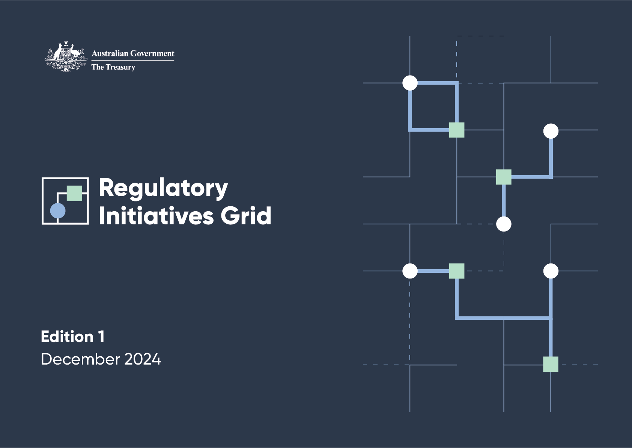

© Commonwealth of Australia 2024

ISBN: 978‑1‑923278‑04‑2

This publication is available for your use under a Creative Commons Attribution 4.0 International licence, with the exception of the Commonwealth Coat of Arms, the Treasury logo, photographs, images, third party materials, materials protected by a trademark, signatures and where otherwise stated. The full licence terms are available from creativecommons.org/licenses/by/4.0/legalcode.

Creative Commons badge: CC-BY

Use of Treasury material under a Creative Commons Attribution 4.0 International licence requires you to attribute the work (but not in any way that suggests that the Treasury endorses you or your use of the work).

**Treasury material used ‘as supplied’**

Provided you have not modified or transformed Treasury material in any way including, for example, by changing the Treasury text; calculating percentage changes; graphing or charting data; or deriving new statistics from published Treasury statistics – then Treasury prefers the following attribution:

*Source: The Australian Government the Treasury, Australian Taxation Office (ATO) Australian Securities and Investments Commission (ASIC), Attorney‑General’s Department (AGD), Australian Prudential Regulation Authority (APRA), Australian Transaction Reports and Analysis Centre (AUSTRAC), Reserve Bank of Australia (RBA), Australian Financial Security Authority (AFSA) and the Australian Competition and Consumer Commission (ACCC).*

**Derivative material**

If you have modified or transformed Treasury material, or derived new material from those of the Treasury in any way, then Treasury prefers the following attribution:

*Based on Commonwealth of Australia data.*

**Use of the Coat of Arms**

The terms under which the Coat of Arms can be used are set out on the Department of the Prime Minister and Cabinet website (see www.pmc.gov.au/government/commonwealth‑coat‑arms).

**Other uses**

Enquiries regarding this licence and any other use of this document are welcome at:

Manager, Media Unit  
The Treasury

Langton Crescent, Parkes, ACT 2600

Email: media@treasury.gov.au

In the spirit of reconciliation, the Treasury acknowledges the Traditional Custodians of country throughout Australia and their connections to land, sea and community. We pay our respect to their Elders past and present and extend that respect to all Aboriginal and Torres Strait Islander peoples.

# **Contents**

Foreword 1

Snapshot of regulatory initiatives 2

Introduction 4

Sectors 5

Categories 5

Contributing agencies 6

Scope 7

How to read the RIG 8

RIG formats 9

Feedback 9

Future updates 9

1. Policy development 10

2. Development of legislation, regulations and instruments 12

3. Ongoing program implementation 21

4. Review and evaluation 29

# Foreword

Our Government’s reform agenda is all about modernising our economy and maximising our advantages. A big part of this agenda is focused on getting capital flowing more efficiently and effectively in our economy by making it simpler and easier to do business in Australia.

That’s why we’re proud to be publishing the inaugural edition of the financial sector Regulatory Initiatives Grid (RIG), which we’ve been working on since March this year. The RIG will enhance our work to support the standard business of regulation to be carried out in a more coordinated way across the financial sector.

The RIG will help financial services businesses engage with the Government and regulators more effectively and support regulators to avoid duplication, build shared strategic priorities, and focus on how to best implement reforms.

It will give financial services providers clear visibility of regulation that might impact their businesses and will support engagement with proposed reforms and their implementation. It houses a forward program of initiatives from agencies including the Treasury, Attorney-General’s Department, Australian Securities and Investments Commission (ASIC), the Australian Prudential Regulation Authority (APRA), the Australian Competition and Consumer Commission (ACCC), the Reserve Bank of Australia (RBA), the Australian Taxation Office (ATO), the Australian Financial Security Authority (AFSA) and the Australian Transaction Reports and Analysis Centre (AUSTRAC).

The RIG complements existing transparency tools like agency corporate plans.

We thank the financial sector and all stakeholders for their considered engagement in developing the RIG. Its release marks an important step forward in our ongoing partnership to build a financial system that is stronger and more resilient, dynamic, competitive, and fit for the future.

We look forward to continuing to engage with the sector as the RIG progresses.



**The Hon Dr Jim Chalmers MP**

Treasurer

# Snapshot of regulatory initiatives

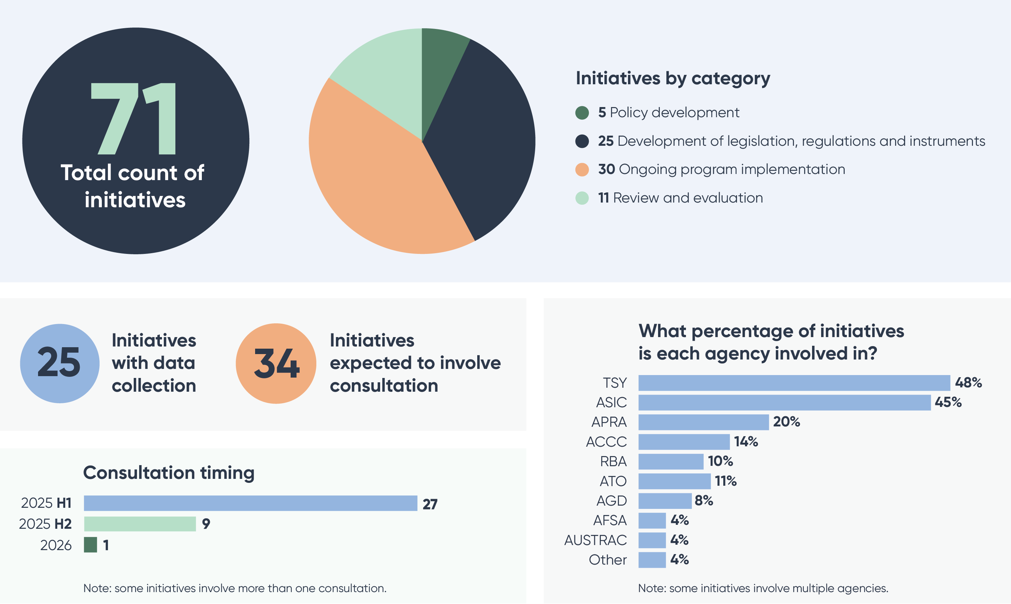

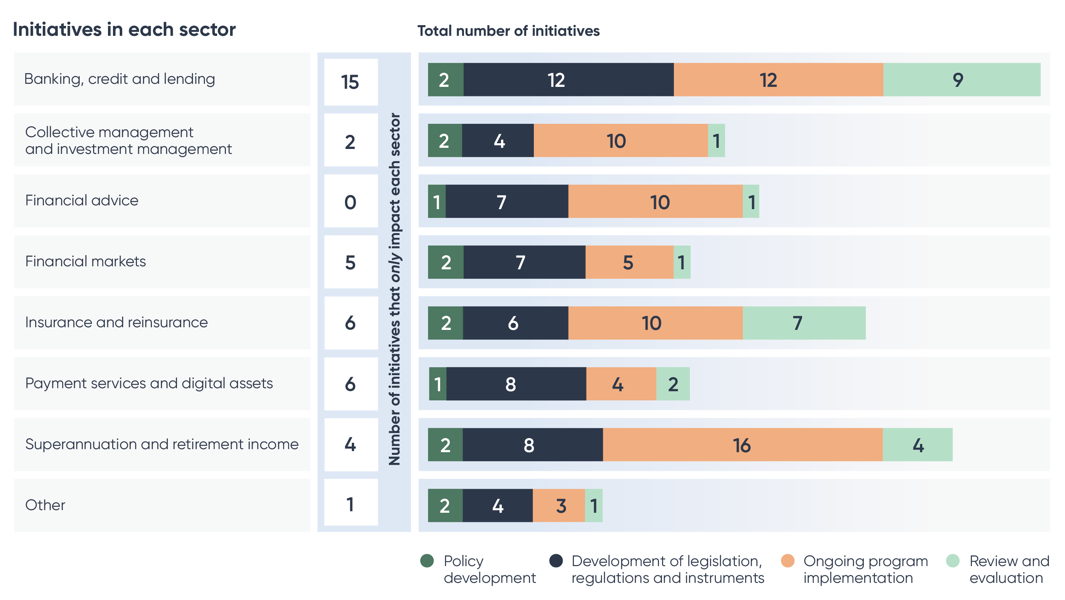

# Introduction

The Australian Government announced the introduction of a financial sector Regulatory Initiatives Grid (RIG) in March 2024. The RIG forms part of the Government’s productivity and competition agenda, to boost economic dynamism and resilience of Australia’s financial sector.

The RIG will provide the financial sector with greater transparency of the regulatory landscape by listing reform priorities and initiatives that will materially affect the financial sector over the next 2 years. Publishing these measures in a single source and in a consistent format provides many benefits. It better informs stakeholders about the strategic direction of regulatory reform. It supports more effective engagement between the sector, government and regulators. It makes it easier to identify common challenges and risks, and collaborate on priorities. It also supports change management in the financial sector, helping businesses to plan and reduce costs of engaging with proposed reforms and regulatory efforts.

Stakeholders will have an opportunity to have a say on the long‑term design of the RIG. It will be refined in response to stakeholder feedback to ensure it remains fit for purpose.

## Sectors

The RIG divides the financial system into 8 sectors:

* Banking, credit and lending
* Collective management and investment management
* Financial advice
* Financial markets
* Insurance and reinsurance
* Payment services and digital assets
* Superannuation and retirement income
* Other.

## Categories

The RIG divides initiatives into 4 categories that reflect policy lifecycle phases:

1. Policy development
2. Development of legislation, regulations and instruments
3. Ongoing program implementation
4. Review and evaluation.

## Contributing agencies

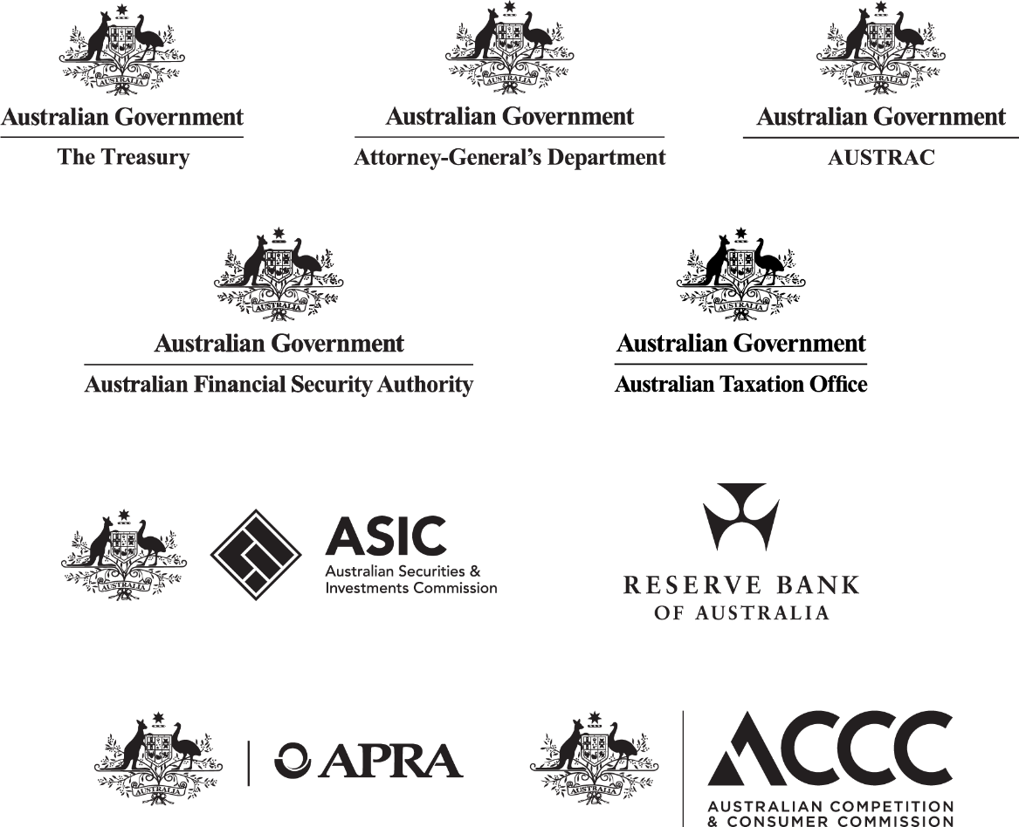

Attorney‑General’s Department initiatives are limited to matters relating to the regulatory frameworks administered by AUSTRAC and the Australian Financial Security Authority.

Australian Taxation Office initiatives are limited to matters relating to the superannuation guarantee and self‑managed superannuation funds.

Australian Competition and Consumer Commission initiatives are limited to matters relating to the financial sector.

## Scope

The scope of the RIG is limited to publicly communicated initiatives and activities that will materially affect the financial sector in the 2 years from the RIG’s publication date.

The RIG has a strategic focus and only includes initiatives that will materially affect the financial sector. The RIG is not intended to be exhaustive. It does not include day‑to‑day work undertaken by regulators. The RIG does not include:

* regulatory investigations relating to significant compliance or enforcement activities
* non‑regulatory initiatives and activities (such as undertaking research, strengthening financial literacy, and engaging with the financial sector to explore opportunities to enhance existing systems)
* multi‑agency simulation activities to test preparedness and crisis response
* standard or long‑standing processes or activities that are well understood by industry stakeholders
* initiatives led by international bodies or international organisations, unless a contributing agency is responsible for implementing measures that satisfy the inclusion criterion.

This information is also in the RIG Terms of Reference at **www.**[treasury.gov.au/RIG](http://www.treasury.gov.au/RIG).

## How to read the RIG

**The RIG Edition 1 includes initiatives publicised prior to 30 November 2024. Initiatives publicised after 30 November 2024 are not included in Edition 1.**

Each initiative includes the following information.

|  |  |  |
| --- | --- | --- |
|  | **Agency** | The agency/ies responsible for progressing the initiative.  The lead agency is listed first in **Bold**, followed by other agencies involved in the initiative listed in Italic.  ‘Other’ refers to government agencies involved in the initiative that are not ‘Contributing agencies’. |
|  | **Sector** | The sector/s that will be materially affected by the initiative.  Initiatives are grouped by sectors in alphabetical order. |
|  | **Initiative** | The initiative’s name and high‑level description. Where available, a hyperlink will be provided to enable users to easily visit the initiative’s webpage containing more information. |
|  | **Forward calendar**  **First year (Q1–Q4) and second year (H1–H2)** | A breakdown of planned activities in the next 2 years. The forward calendar is presented in quarter year periods for year 1 (Q1 – Q4), and half year periods for year 2 (H1 – H2). All activities and dates are indicative only and are subject to change by the agency or regulator.  **If an initiative has no activities in its forward calendar, it means that specific timeframes have not been publicly communicated at the time of the RIG’s publication.** |

Information contained in the RIG is subject to change. For example, from shifts in government priorities or financial market conditions.

## RIG formats

|  |
| --- |
| The RIG is available on the Treasury website at [**treasury.gov.au/RIG**](http://www.treasury.gov.au/RIG)**.** The RIG is available in 3 formats: a static report, an interactive dashboard and a Microsoft Excel Workbook. |

## Feedback

Stakeholder feedback on the RIG’s design is welcome. Please send your feedback to **RIG@Treasury.gov.au.**

Please indicate in your response whether you agree/do not agree to share the personal data contained in your response (for example, your name and email address) with contributing agencies.

Treasury intends to use stakeholder feedback to inform the RIG’s ongoing design and administration.

## Future updates

Treasury intends to continuously refine the RIG in response to stakeholder feedback. This will help ensure it remains fit for purpose.

Treasury plans to publish the first RIG update in September 2025. After this, the RIG will be published twice a year (March and September).

1. Policy development

This category includes **5** policy development initiatives. Examples of policy development activity include: seeking stakeholder feedback on a proposed policy and formulating policy statements. Initiatives that include both policy development and developing legislation, regulations or instruments are included in the ‘Developing legislation, regulations and instruments’ category.

**Forward calendar**

| Agency | Sector | Initiative | Q1 2025 activity | Q2 2025 activity | Q3 2025 activity | Q4 2025 activity | H1 2026 activity | H2 2026 activity |
| --- | --- | --- | --- | --- | --- | --- | --- | --- |
| TSY | All | [Reforms to streamline and strengthen Australia’s foreign investment framework](https://ministers.treasury.gov.au/ministers/jim-chalmers-2022/media-releases/reforms-strengthen-australias-foreign-investment)  On 1 May 2024, the Government announced reforms to streamline and strengthen Australia’s foreign investment framework. The reforms apply greater scrutiny to high‑risk investments to protect the national interest while streamlining assessment of low‑risk investments.  The Government has commenced implementation, which will continue in 2025. |  |  |  |  |  |  |
| **AGD**  AFSA | Banking, credit and lending | [Minimal asset procedure consultation](https://ministers.ag.gov.au/media-centre/bankruptcy-law-reforms-08-07-2024)  AGD consulted in 2024 on a potential new personal insolvency option proposed for individuals with less than $50,000 in debts and minimal realisable assets to pay those debts. This is intended to allow a person access to a fresh start sooner than a bankruptcy, where that person has no other way to pay, and without leaving creditors worse off.  Timing of any further work will be announced in due course. |  |  |  |  |  |  |
| RBA  ASIC  TSY | Financial markets  Other | **Bonds and repo clearing consultation**  The Council of Financial Regulators (CFR) is consulting on the costs and benefits from the introduction of a central counterparty (CCP) in the Australian bond and repurchase agreement (repo) markets. The consultation will consider circumstances under which a bond and repo CCP could be operated safely and efficiently by an overseas operator. |  | Response to consultation to be published |  |  |  |  |
| TSY | Insurance and reinsurance | [Insurance standard cover and standard term reforms](https://treasury.gov.au/consultation/c2024-501098)  Treasury consulted on changes to the standard cover regime and/or implementing standard definitions for several claim‑related terms in insurance contracts to improve understanding and limit unintentional underinsurance. Consultation on options was completed in April 2024 and options are being considered.  Timing of any further work will be announced in due course. |  |  |  |  |  |  |
| TSY  ASIC | Superannuation and retirement income  Collective management and investment management | [**Sustainable investment product labels**](https://treasury.gov.au/publication/p2024-536290)  The Government will establish consistent labels and disclosure requirements for investment products marketed as ‘sustainable’ or similar, including for managed funds and within the superannuation system. The Government is targeting 2027 for regime commencement, subject to final policy decisions. | Consultation |  |  |  |  |  |

1. Development of legislation, regulations and instruments

This category includes **25** initiatives. The initiatives in this section cover the development of primary and subordinate legislation, amendments to existing laws and regulations, the development of industry codes and the notification of tax determinations. Initiatives that involve policy development related to developing legislation, regulations and instruments are also included in this section.

**The timing of activities that would support the initial implementation of legislative measures, such as the development of relevant regulations, legislative instruments and/or regulatory guidance, are subject to the passage of the relevant legislation and ongoing Government and regulator consideration. Where there is sufficient certainty that certain activities will be undertaken to support implementation, activities have been identified.**

**Forward calendar**

| **Agency** | **Sector** | **Initiative** | **Q1 2025 activity** | **Q2 2025 activity** | **Q3 2025 activity** | **Q4 2025 activity** | **H1 2026 activity** | **H2 2026 activity** |
| --- | --- | --- | --- | --- | --- | --- | --- | --- |
| **TSY**  ACCC | All | [**Merger reform**](https://treasury.gov.au/review/competition-review-2023/mergers)  In April 2024, the Government announced reforms to Australia’s merger rules to promote competition, protect consumers and provide greater certainty by streamlining merger and acquisition approval processes.  The Treasury Laws Amendment (Mergers and Acquisitions Reform) Bill 2024 passed on 28 November 2024 to give effect to these reforms through amendments to the *Competition and Consumer Act 2010* (and associated subordinate legislation).  The new merger control system will commence from 1 January 2026, and will apply on a voluntary basis from 1 July 2025. | Consultation on subordinate legislation |  | Commences on a voluntary basis from 1 July 2025 |  | Commences 1 January 2026 for mandatory notification |  |
| **AGD**  AUSTRAC | All | [**Reforms to the *Anti‑Money Laundering and Counter‑Terrorism Financing Act 2006***](https://www.ag.gov.au/crime/anti-money-laundering-and-counter-terrorism-financing/anti-money-laundering-and-counter-terrorism-financing-amendment-bill)  The Anti‑Money Laundering and Counter‑Terrorism Financing Amendment Bill 2024 passed the Parliament on 29 November 2024. The Bill reforms Australia’s anti-money laundering and counter-terrorism financing (AML/CTF) regime. It amends some obligations that currently apply to the financial sector, such as the travel rule and International Funds Transfer Instruction (IFTI) reporting. The Bill also simplifies and clarifies core AML/CTF obligations including the requirement to have an AML/CTF program and undertake customer due diligence. | Changes to AUSTRAC powers and penalties commence 28 days after Royal Assent.  New tipping off offence commences 31 March 2025 |  |  |  | AML/CTF programs, customer due diligence, travel rule and value transfer provisions, and amended exemptions commence 31 March 2026 | New obligations for tranche two entities commence 1 July 2026.  Changes to bearer negotiable instruments commence 1 July 2026 |
| **AUSTRAC**  AGD | All | [**Anti‑Money Laundering and Counter‑Terrorism Financing Rules**](https://www.austrac.gov.au/second-stage-consultation-reforming-australias-amlctf-regime-now-open)  As part of the reforms to the *Anti-Money Laundering and Counter‑Terrorism Financing Act 2006*, development of Anti‑Money Laundering and Counter‑Terrorism Financing (AML/CTF) Rules will improve the effectiveness of the AML/CTF regime by simplifying and clarifying the existing regime to make it easier for businesses to meet their obligations, and will modernise the regime to reflect changing business structures and technologies across the economy. | Consultation on draft Rules | Rules made |  |  |  |  |
| **TSY**  ASIC | Banking, credit and lending | [**Buy Now, Pay Later reforms**](https://www.aph.gov.au/Parliamentary_Business/Bills_Legislation/Bills_Search_Results/Result?bId=r7199)  The Treasury Laws Amendment (Responsible Buy Now Pay Later and Other Measures) Bill 2024 passed on 28 November 2024. It amended the *National Consumer Credit Protection Act 2009* to regulate Buy Now, Pay Later (BNPL) products as a form of consumer credit. In the first half of 2025 Treasury will finalise the related BNPL Regulations.  ASIC intends to issue regulatory guidance to assist the implementation of the legislation. | Consultation by ASIC on guidance | Regime will commence |  |  |  |  |
| **TSY**  ACCC | Banking, credit and lending | [**Consumer Data Right (CDR) Rules v8 (Non‑bank lending Rules and operational enhancements)**](https://treasury.gov.au/consultation/c2024-598346)  Changes to the CDR Rules and standards (through the Data Standards Body) will implement mandatory non‑bank lending sector participation, address industry costs and support key use cases. The Government has announced that amendments to the CDR Rules will be made in early 2025 and CDR obligations for non‑bank lenders will commence from mid‑2026. | Amendments to CDR Rules commence |  |  |  |  | Phased obligations for non‑bank lenders commence (subject to CDR Rules being amended) |
| **TSY** | Banking, credit and lending | [**Government’s response to the Retail Deposit and Home Loan Price inquiries**](https://ministers.treasury.gov.au/ministers/jim-chalmers-2022/media-releases/helping-australians-get-better-deal-banking-products)  The Government announced in June 2024 that it will help Australians find and switch to better mortgage deals and get better interest rates on their savings accounts through a range of measures. Measures include: improving banks’ communications around interest rates on transaction or savings accounts, strengthening financial product comparison website disclosures, streamlining access to mortgage discharge forms, and investigating the prompting of consumers.  Timing of further legislative work will be announced in due course. |  |  |  |  |  |  |
| **AGD**  AFSA | Banking, credit and lending | [**Personal insolvency reforms**](https://ministers.ag.gov.au/media-centre/bankruptcy-law-reforms-08-07-2024)  Reforms to improve the personal insolvency system will ensure a fairer outcome for debtors in the personal insolvency system and reduce the stigma currently associated with entering into bankruptcy.  Timing of any further work will be announced in due course. |  |  |  |  |  |  |
| **TSY**  ACCC  ASIC | Banking, credit and lending | [**Scams Prevention Framework**](https://budget.gov.au/content/bp2/download/bp2_2024-25.pdf)  The Scams Prevention Framework Bill 2024 was introduced into the Parliament on 7 November 2024 and is currently before the House of Representatives. The Bill provides a framework for preventing and responding to scams and, subject to passage, would among other things establish principles‑based obligations in relation to preventing, detecting, reporting, disrupting, and responding to scam activity. |  |  | Commences  (subject to passage) |  |  |  |
| **TSY**  ACCC  ASIC | Banking, credit and lending | [**Scams Prevention Framework – Sector‑specific designation and code for banks**](https://ministers.treasury.gov.au/ministers/stephen-jones-2022/transcripts/interview-patricia-karvelas-rn-breakfast-abc)  Subject to the passage of the Scams Prevention Framework Bill 2024, the banking sector is intended to be designated by legislative instrument and a mandatory industry code will be developed for banks to prevent, detect, report, disrupt and respond to scams. ASIC will be the responsible regulator for enforcing the bank‑specific code, working with the ACCC as the regulator for the overarching principles of the Scams Prevention Framework in the primary legislation.  Public consultation will be undertaken to inform the development of the designation instrument, as well as the bank code, and supporting Scams Prevention Framework (SPF) rules, with the timing of any consultation subject to the passage of the Bill. | Drafting subordinate legislation | Consultation on designation instrument (subject to passage of Scams Prevention Framework Bill) | Consultation on code and SPF rules; and designation instrument commences  (subject to passage of Scams Prevention Framework Bill) |  | Sector-specific code and rules commence  (subject to passage of Scams Prevention Framework Bill and any transitional arrangements) |  |
| **TSY** | Banking, credit and lending | [**Cash acceptance mandate**](https://ministers.treasury.gov.au/ministers/jim-chalmers-2022/media-releases/ensuring-future-cash-and-next-steps-phasing-out-cheques)  In November 2024, the Government announced it will mandate that businesses must accept cash when selling essential items, with appropriate exemptions for small businesses.  Policy consultation will commence prior to the end of 2024. Final details of the mandate will be announced in 2025. Subject to the passage of legislation, the mandate is to apply from 1 January 2026. |  |  | Exposure Draft consultation |  | Subject to the outcomes of consultation, the mandate would commence from 1 January 2026 |  |
| **AGD**  AFSA | Banking, credit and lending  Financial advice  Financial markets  Insurance and reinsurance | [**Personal Property Securities Amendment (Framework Reform) Bill**](https://consultations.ag.gov.au/legal-system/government-response-to-pps-review/)  Amendments to the *Personal Property Securities Act 2009* in response to the 2015 Statutory Review of this Act (the Whittaker Review) are designed to reduce complexity for users of the Personal Property Securities framework.  Timing of any further work will be announced in due course. |  |  |  |  |  |  |
| **TSY**  ASIC  APRA | Financial advice  Insurance and reinsurance  Superannuation and retirement income | [**Delivering Better Financial Outcomes**](https://treasury.gov.au/publication/p2023-471470) – tranche two  In December 2023, the Government announced its final response to the Quality of Advice review – the Delivering Better Financial Outcomes package. The reforms aim to increase the affordability and accessibility of financial advice by reducing red tape and modernising the regulatory framework.  Legislation delivering the first tranche of reforms passed in July 2024. Legislation implementing the second tranche of reforms will be introduced following public consultation. Subordinate legislation will be developed and consulted on subject to passage of primary legislation.  ASIC intends to issue regulatory guidance to assist implementation of the legislation. | Consultation on exposure draft legislation (second tranche of reforms) |  |  |  |  |  |
| **ASIC** | Financial markets | **Competition in clearing and settlement (CICS) reforms – new rules**  ASIC is finalising proposals to make rules to facilitate competitive outcomes in the monopoly provision of clearing and settlement services (following the passage of the CICS reforms). | Rules made by ASIC |  |  |  |  |  |
| **ASIC** | Financial markets | **Market integrity rules – consultation and amendment**  Following consultation, amend provisions of the ASIC Market Integrity Rules (Securities Markets) 2017 and ASIC Market Integrity Rules (Futures Markets) 2017 relating to trading infrastructure, automated order processing and false or misleading appearances. | Consultation on amendments to rules | Rules made by ASIC |  |  |  |  |
| **TSY** | Financial markets  Banking, credit and lending  Collective investment and investment management  Financial advice | [**Exempting interfunding from mandatory foreign investment notification**](https://treasury.gov.au/consultation/c2024-509548)  In May 2024, the Government consulted on regulation changes to exempt passive or low‑risk interfunding transactions from mandatory notification requirements and fees under the *Foreign Acquisitions and Takeovers Act 1975*. These changes will make it easier for institutional investors to manage their portfolios and will decrease the regulatory burden and financial costs for investors who undertake interfunding activities.  Timing of next steps will be announced in due course. |  |  |  |  |  |  |
| **TSY** | Insurance and reinsurance | [**Ban on adverse genetic test results in life insurance**](https://ministers.treasury.gov.au/ministers/stephen-jones-2022/media-releases/total-ban-use-adverse-genetic-testing-results-life)  The Government has announced it will develop legislation to ban the use of adverse predictive genetic test results in underwriting life insurance. | Expected consultation on design of the measure |  |  |  |  |  |
| **TSY**  ASIC | Other | [**Licensing exemptions for Foreign Financial Service Providers (FFSPs)**](https://www.aph.gov.au/Parliamentary_Business/Bills_Legislation/Bills_Search_Results/Result?bId=r7133)  Proposed amendments to the FFSP regime would establish new exemptions to requirements to hold an Australian financial services license (AFSL) for FFSPs. The amendments would also provide for greater regulatory oversight of FFSPs.  The amendments were introduced to the House of Representatives on 30 November 2023 under the Treasury Laws Amendment (Better Targeted Superannuation Concessions and Other Measures) Bill 2023, which has been split, and the amendments are currently before the Senate under the Treasury Laws Amendment (Miscellaneous Measures) Bill 2024.  The amendments would take effect on 1 April 2025, subject to passage of the legislation.  ASIC intends to issue regulatory guidance to assist implementation of the legislation. |  | Commences 1 April 2025  (subject to passage) |  |  |  |  |
| **TSY**  ASIC | Payment services and digital assets | [**Digital Asset Platform reforms**](https://treasury.gov.au/consultation/c2023-427004)  The Government consulted from October to December 2023 on a licensing framework for entities holding digital assets for Australians and Australian businesses, and has been considering the feedback received. The proposed regulatory framework would apply to digital asset facilities that present similar risks to entities that operate in the traditional financial system. It proposes to leverage the Australian financial services framework to regulate digital asset facilities to ensure consistent oversight and safeguards for consumers.  ASIC intends to issue regulatory guidance to assist implementation of the legislation. |  | Consultation on exposure draft legislation |  |  |  |  |
| **TSY**  ASIC  APRA | Payment services and digital assets | [Payments system modernisation (Regulation of payment service providers)](https://treasury.gov.au/consultation/c2023-469663)  The Government has undertaken 2 rounds of consultation on a licensing framework for payment service providers (PSPs) and has been considering the feedback received. The proposed reforms will ensure the regulation of payment services is fit for purpose and provides consistent regulation based on the activity a payment service provider performs. The reforms will be implemented in 2 tranches. Legislation for the core licensing framework, which will establish the regulatory perimeter of the regime and the obligations imposed on licensed PSPs, will be undertaken in the first tranche of the reforms.  ASIC intends to issue regulatory guidance to assist implementation of the legislation. |  | Consultation on exposure draft legislation for the first tranche of reforms |  |  |  |  |
| **TSY**  RBA  ASIC  APRA  ACCC  AUSTRAC | Payment services and digital assets | [**Reforms to the *Payment Systems (Regulation) Act 1998***](https://www.aph.gov.au/Parliamentary_Business/Bills_Legislation/Bills_Search_Results/Result?bId=r7133)  The Government is updating the *Payment Systems (Regulation) Act 1998* (PSRA) to ensure regulators and the Government can address new entrants and new risks related to payments systems and participants.  The amendments were introduced to the House of Representatives on 30 November 2023 under the Treasury Laws Amendment (Better Targeted Superannuation Concessions and Other Measures) Bill 2023, which has been split, and the amendments are currently before the Senate under the Treasury Laws Amendment (Miscellaneous Measures) Bill 2024. Amendments will take effect 6 months after the Bill is enacted. Any changes in regulatory requirements will be informed by the RBA’s series of reviews on retail payments. | Consultation on exposure draft of the regulations |  |  |  |  |  |
| **TSY**  RBA | Payment services and digital assets | [**Reducing card surcharges for Australians and small businesses**](https://www.pm.gov.au/media/reducing-card-surcharges-australians-and-small-businesses)  The Government announced in October 2024 that it is prepared to ban debit card surcharges from 1 January 2026, subject to phase 1 of the RBA review of retail payments regulation – merchant card payment costs and surcharging.  The timing of future activities under this initiative will be informed by the RBA review. The ban could require new legislation if not effected by the RBA in the existing framework. |  |  |  |  | If legislated, the ban on debit card surcharging would apply from 1 January 2026 |  |
| **TSY**  ATO  AGD | Superannuation and retirement income | [**Access to offenders’ superannuation**](https://archive.budget.gov.au/2023-24/myefo/download/myefo2023-24.pdf)  The Government will develop legislation to prevent child sexual abuse offenders from shielding their assets in superannuation to avoid court‑ordered compensation for victims and survivors. Victims and survivors of child sexual abuse would be able to seek access, via a court order, to additional personal or salary sacrifice superannuation contributions made by the offender after the first offence occurred where a related court order for compensation remains unpaid after 12 months. Applications to identify any potential eligible superannuation would be facilitated by the ATO.  Legislation is to be developed in due course. |  |  |  |  |  |  |
| **DSS**  ATO  TSY | Superannuation and retirement income | [**Superannuation on Paid Parental Leave**](https://www.pm.gov.au/media/paying-superannuation-paid-parental-leave)  The Government will make Superannuation Guarantee equivalent payments to recipients of Commonwealth Government funded Paid Parental Leave, for parents of babies born or adopted on or after 1 July 2025. Payments will be made by the ATO directly to recipients’ superannuation accounts annually, from 1 July 2026. Paying superannuation on Paid Parental Leave recognises the important contribution parents make to society and is a key step towards reducing the retirement savings gap and improving the fairness of Australia’s retirement income system.  The *Paid Parental Leave Amendment (Adding Superannuation for a More Secure Retirement) Act 2024* received Royal Assent on 1 October 2024. |  |  | Eligibility commences for babies born or adopted on or after 1 July 2025 |  |  | Commencement of payments to eligible parents |
| **TSY**  ATO | Superannuation and retirement income  Financial advice | [**Better targeted superannuation concessions**](https://www.aph.gov.au/Parliamentary_Business/Bills_Legislation/Bills_Search_Results/Result?bId=r7133)  The Government is ensuring the sustainability of superannuation tax concessions by applying an additional 15 per cent tax on earnings attributable to superannuation balances exceeding $3 million.  The amendments were introduced to the House of Representatives on 30 November 2023 under the Treasury Laws Amendment (Better Targeted Superannuation Concessions and Other Measures) Bill 2023, and are currently before the Senate under the Treasury Laws Amendment (Better Targeted Superannuation Concessions) Bill 2023. Intended commencement on 1 July 2025 is subject to passage of the Bill through Parliament. Supporting Regulations will be made following passage of the primary law.  The ATO intends to issue guidance to assist the implementation of the legislation. |  |  | Commences 1 July 2025 (subject to passage) |  |  |  |
| **TSY**  ATO | Superannuation and retirement income  Payment services and digital assets | [**Payday superannuation**](https://ministers.treasury.gov.au/ministers/stephen-jones-2022/media-releases/payday-superannuation-design-details-ensure-super-paid)  The Government will require employers to align the frequency of the payment of their employees’ superannuation with their salary and wages. Specifically, employers will become liable for the updated superannuation guarantee charge if superannuation contributions are not received by their employees’ superannuation fund within 7 days of ‘payday’. Several changes are also being made to support the transition to Payday Super and protect employees in the onboarding process, including revising choice of fund rules and limiting the advertising of superannuation products during onboarding.  Draft legislation will be released for consultation. Employer obligations are planned to commence on 1 July 2026, subject to the passage of legislation.  The ATO intends to issue guidance to assist the implementation of the legislation. | Consultation on exposure draft legislation |  |  |  |  | Employer obligations commence from 1 July 2026 (subject to passage) |

1. Ongoing program implementation

This category includes **30** initiatives. The initiatives in this section cover the broad spectrum of activities being administered under existing policy and/or legislative frameworks, including the development of regulatory guidance material, program reconciliation and acquittal activity, the roll out of new portals and software and technology, and thematic surveillances that review compliance by entities with their existing obligations.

**Forward calendar**

| Agency | Sector | Initiative | Q1 2025 activity | Q2 2025 activity | Q3 2025 activity | Q4 2025 activity | H1 2026 activity | H2 2026 activity |
| --- | --- | --- | --- | --- | --- | --- | --- | --- |
| ATO | All | [Capital raised for the purpose of funding franked distributions – ATO compliance approach – Practical Compliance Guideline (ATO guidance reference number 4194)](https://www.ato.gov.au/about-ato/ato-advice-and-guidance/advice-under-development-program/advice-under-development-income-tax-issues#ato-4194Capitalraisedforthepurposeoffundingfrankeddistributionsnew)  This draft Practical Compliance Guideline outlines the framework used to assess the level of risk of the integrity measure in section 207‑159 of the *Income Tax Assessment Act 1997* applying to deny franking credits attached to a distribution. The Guideline outlines what features and types of documentation are relevant when considering whether an arrangement is low or high risk. Taxpayers can use this Guideline to understand the types of arrangements to which the ATO would apply compliance resources.  Final guidance is expected to be issued in 2025, following consultation on draft guidance. | Consultation on draft guidance |  |  |  |  |  |
| TSY  ASIC  Other | All | [**Climate‑related financial disclosures**](https://www.aph.gov.au/Parliamentary_Business/Bills_Legislation/Bills_Search_Results/Result?bId=r7176)  The Government is implementing mandatory climate‑related financial disclosure requirements for large businesses and financial institutions. Legislation received Royal Assent on 17 September 2024 and requirements will phase in for different‑sized entities, commencing 1 January 2025.  ASIC proposes to publish a regulatory guide to help reporting entities comply with the new sustainability reporting obligations and to explain ASIC’s approach to administration of the regime. | Applies to financial years commencing 1 January 2025.  Updated guidance published |  |  |  |  |  |
| TSY  ACCC | Banking, credit and lending | [**Consumer Data Right (CDR) authentication uplift**](https://github.com/ConsumerDataStandardsAustralia/future-plan/issues/124)  Changes to the authentication standards (through the Data Standards Body) will be made to meet best practice security requirements, align to international security standards, and address identified security and consumer experience concerns raised due to the current use of one‑time‑passwords. | Consultation on uplift part 2 | Consultation on uplift part 3 |  |  |  | Part 1 obligations on banks commence |
| TSY  *ACCC* | Banking, credit and lending | [Consumer Data Right (CDR) Rules (Consent amendments and operational enhancements)](https://www.legislation.gov.au/F2024L01409/latest/text)  Changes to the CDR Rules and standards (through the Data Standards Body) aim to simplify the consumer consent process and support key use cases. The Rules were registered on 11 November 2024. |  |  | Obligations commence for data recipients regarding CDR receipts and 90‑day notifications | Obligations commence for recipients regarding information about supporting parties; and CDR representatives regarding consumer experience standards. |  |  |
| TSY  ACCC | Banking, credit and lending | [**Consumer Data Right (CDR) standards maintenance iterations**](https://cdr-support.zendesk.com/hc/en-us/articles/900005585003-Standards-Maintenance)  Ongoing maintenance and enhancement of the CDR standards (through the Data Standards Body) will continue to address technical issues and support the functioning of the CDR. | Maintenance iteration | Maintenance iteration | Maintenance iteration | Maintenance iteration | Maintenance iterations x 2 | Maintenance iterations x 2 |
| TSY | Banking, credit and lending | [**Coronavirus SME Guarantee Scheme Phase 1 (SMEG1)**](https://treasury.gov.au/coronavirus/sme-recovery-loan-scheme/smes-phase-1)  This scheme facilitates the lending of debt finance to small and medium businesses via a Government guarantee of loans to participating lenders. The final data for lenders to submit a claim under SMEG 1 was 30 September 2024. After this date, a reconciliation process will commence, whereby, all lenders who have been paid a claim by the Commonwealth are to submit a Final Claim and Remittance Account to Treasury. This Account will be assessed to verify that the Commonwealth did not under or overpay a lender throughout the life of SMEG 1. Lenders have until 30 March 2025 to submit their Account. |  | Program closure is due to end in April 2025 |  |  |  |  |
| APRA | Banking, credit and lending  Superannuation and retirement income | **System stress test**  APRA will undertake a system stress test to understand resilience and risk across the financial system. |  | System stress test commences |  |  |  |  |
| TSY  APRA  ASIC | Banking, credit and lending  Insurance and reinsurance  Superannuation and retirement income | [**Financial Accountability Regime (FAR)**](https://www.aph.gov.au/Parliamentary_Business/Bills_Legislation/Bills_Search_Results/Result?bId=r6988)  The FAR extends the former Banking Executive Accountability Regime to insurers and superannuation entities. The FAR will apply to insurers and superannuation entities from 15 March 2025. | Applies to all entities from 15 March 2025 |  |  |  |  |  |
| APRA | Banking, credit and lending  Insurance and reinsurance  Superannuation and retirement income | **Transition of data collections from Direct to APRA (D2A) to APRA Connect**  Transitioning the remaining D2A data collections not related to policy priorities to APRA Connect will enable decommissioning of legacy systems. | Finalise strategy |  |  |  |  |  |
| ASIC | Banking, credit and lending  Collective investment and investment management  Financial advice  Insurance and reinsurance  Superannuation and retirement income | **Update of Regulatory Guide 53 *The use of past performance in promotional material* and Regulatory Guide 234 *Advertising financial products and services (including credit****)*  ASIC will update 2 disclosure‑related guidance documents:   * Regulatory Guide 53 *The use of past performance in promotional material* * Regulatory Guide 234 *Advertising financial products and services (including credit): Good practice guidance.* |  |  |  | Consultation commences | Updated guidance published |  |
| ASIC | Banking, credit and lending  Collective investment and investment management  Financial advice  Insurance and reinsurance  Superannuation and retirement income | **Update of Regulatory Guide 183 *Approval of financial services sector codes of conduct***  ASIC will update Regulatory Guide 183 *Approval of financial services sector codes of conduct*, to consider changes such as reforms following the Financial Services Royal Commission to make certain parts of industry codes ‘enforceable code provisions’ and for ASIC to designate those provisions. |  |  | Consultation commences |  | Updated guidance published |  |
| TSY  ATO | Collective investment and investment management | **Foreign investment portal for investors and agents**  The Government is modernising how foreign investment is managed in Australia through the delivery of a new Foreign Investment Portal. Once launched, this portal will replace the current Foreign Investment Review Board (FIRB) Application Portal. The portal will provide a more efficient, functional, transparent, and secure experience for investors and their agents. |  | Build of new portal |  |  |  |  |
| ASIC | Collective investment and investment management | **Review of corporate adviser and private finance fund internal arrangements**  ASIC will conduct a review of governance and practices of selected corporate advisers and private finance fund internal arrangements, including:   * For corporate advisers, governance arrangements, management of conflicts of interest, staff and insider trading and protection of confidential information * For wholesale private finance funds, governance, valuation practices, management of conflicts of interest, staff and insider trading, protection of confidential information and fair treatment of investors * For private credit funds that are retail (registered) managed investment schemes (including governance and practices in relation to disclosure, distribution, valuation and credit risk management). | Data collection |  |  |  |  |  |
| TSY  ASIC | Financial advice  Banking, credit and lending  Collective investment and investment management | [**Compensation Scheme of Last Resort (CSLR)**](https://cslr.org.au/)  Ongoing work is progressing to facilitate the payment of compensation to eligible consumers who have an unpaid determination from the Australian Financial Complaints Authority (AFCA), primarily due to the insolvency of the relevant financial service provider.  The CSLR commenced operation on 2 April 2024. The CSLR Operator is working to finalise cost estimates for the 2025–26 annual levy which is payable by entities in the personal financial advice, credit intermediation, securities dealing and credit provision sub‑sectors who are required to be AFCA members. | Estimated costs for 2025–26 annual levy published by CSLR Operator | Issuance of 2025–26 annual levy |  |  | Estimated costs for 2026–27 annual levy published by CSLR Operator  Issuance of 2026–27 annual levy |  |
| ASIC | Financial advice  Collective investment and investment management  Insurance and reinsurance  Superannuation and retirement income | **Update of Regulatory Guide 168 *Product Disclosure Statements (and other disclosure documents)***  ASIC will undertake a comprehensive update of Regulatory Guide 168 *Disclosure: Product Disclosure Statements (and other disclosure obligations)*, including consideration of changes resulting from the Delivering Better Financial Outcomes reforms. |  | Consultation commences |  | Updated guidance published |  |  |
| ASIC | Financial advice  Collective investment and investment management  Insurance and reinsurance  Superannuation and retirement income | **Update of Regulatory Guide 181 *Licensing: Managing conflicts of interest***  ASIC will update Regulatory Guide 181 *Licensing: Managing conflicts of interest*, including consideration of case law and law reform (including penalties for breaching the conflicts management obligations). |  |  | Consultation commences |  | Updated guidance published |  |
| RBA  ASIC  TSY | Financial markets | [**Clearing and settlement facility resolution guidance**](https://www.rba.gov.au/publications/submissions/payments-system/financial-market-infrastructure-regulatory-reforms-february-2024/index.html)  The RBA will provide guidance for clearing and settlement facilities and market participants describing how and when the RBA expects to use the resolution powers provided by the recent financial market infrastructure (FMI) regulatory reforms. |  | Consultation on draft guidance |  |  |  |  |
| ASIC | Financial markets | **Financial market infrastructure guidance**  ASIC is working on updates to regulatory guidance to assist industry to comply with the enhanced regulatory framework for financial market infrastructures (FMIs). This follows passage of legislation giving ASIC and the RBA enhanced powers to monitor, manage and respond to risks related to FMIs. |  |  | Consultation on guidance | Updated guidance published |  |  |
| ASIC | Financial markets | **Market integrity rules – regulatory guidance**  Contingent on amendments to ASIC’s Market Integrity Rules related to trading, consult on updates to ASIC’s Regulatory Guides, including updating:   * Regulatory Guide (RG) *172 Financial markets: Domestic and overseas operators* * RG 241 *Electronic trading* * RG 265 *ASIC market integrity rules for participants of securities markets* * RG 266 *ASIC market integrity rules for participants of futures markets* |  |  | Consultation on changes to RGs | Updated RG published |  |  |
| ASIC | Insurance and reinsurance | **Direct sales of life insurance**  ASIC will review compliance by selected life insurers with the laws relevant to the direct sales of life insurance and seek to identify areas for improvement and better practice. |  |  | Report published |  |  |  |
| ASIC | Insurance and reinsurance | **Insurance claims handling and floods**  ASIC will undertake reviews of selected insurers’ compliance with their obligations in relation to claims handling (detailed in Information Sheet 253). Specifically, this will include:   * a review of general insurers’ implementation of recommendations in [Report 768 Navigating the storm: ASIC’s review of home insurance claims](https://download.asic.gov.au/media/tgrozota/rep768-published-16-august-2023.pdf) (including communication, project management and the treatment of vulnerable customers) * follow up work arising from the Parliamentary Floods Inquiry. | Compliance monitoring | Compliance monitoring |  |  |  |  |
| **RBA**  Other | Payment services and digital assets | **Receipt of *Security of Critical Infrastructure (SOCI) Act* *2018* annual attestations**  Under the SOCI Act, the RBA will receive annual attestations of compliance with the SOCI Act Risk Management Program rules. The RBA is establishing a portal on the RBA website to streamline the submission process. This item is limited to a focus on critical infrastructure payment systems only. This commenced in September 2024. |  |  | Annual attestations due |  |  | Annual attestations due |
| ASIC | Payment services and digital assets | Update crypto assets guidance  ASIC will finalise a consultation on possible updates to Information Sheet 225 to clarify ASIC’s views about the regulatory perimeter as it applies to crypto assets. |  | Publication of any changes to the Information Sheet |  |  |  |  |
| ASIC | Superannuation and retirement income | **Member services review**  This is a multi‑year project reviewing industry compliance with laws relevant to the delivery of member services. The first phase of the review examines selected superannuation trustees’ death benefit claims handling practices. ASIC will be publishing a report on claims handling practices and then assessing industry progress in implementing improvements identified in the report. | Report published |  | Data collection |  |  |  |
| ASIC | Superannuation and retirement income | [**Update of ASIC Regulatory Guidance – Financial reporting obligations**](https://asic.gov.au/regulatory-resources/find-a-document/regulatory-document-updates/regulatory-developments-timetable/)  ASIC will update its Regulatory Guides on financial reporting obligations to include registrable superannuation entities, including Regulatory Guide 34 *Auditor’s obligations: Reporting to ASIC* and Regulatory Guide 43 *Financial reports and audit relief*. | Finalisation of guidance material |  |  |  |  |  |
| ATO | Superannuation and retirement income  Collective investment and investment management | [[Expenditure incurred under a non‑arm’s length arrangement and superannuation contributions – Updated Guidance (ATO guidance reference number 4182)](https://www.ato.gov.au/about-ato/ato-advice-and-guidance/advice-under-development-program/advice-under-development-superannuation-issues#ato-4182Expenditureincurredunderanonarmslengtharrangementandsuperannuationcontributions)](https://www.ato.gov.au/about-ato/ato-advice-and-guidance/advice-under-development-program/advice-under-development-superannuation-issues#ato-4182Expenditureincurredunderanonarmslengtharrangementandsuperannuationcontributions)  The Commissioner of Taxation will provide updated guidance, including on the application of amendments made by the *Treasury Laws Amendment (Support for Small Business and Charities and Other Measures) Act 2024* relating to the non‑arm’s length expenditure and non‑arm’s length component provisions.  Final guidance is expected to be issued in the upcoming 24 months, following consultation on draft guidance. |  |  |  |  |  |  |
| ATO | Superannuation and retirement income  Financial advice | [**Advice fees paid by superannuation funds – Practical Compliance Guideline (ATO guidance reference number 4166)**](https://www.ato.gov.au/about-ato/ato-advice-and-guidance/advice-under-development-program/advice-under-development-superannuation-issues#ato-4166Advicefeespaidbysuperannuationfundsnew)  This draft Practical Compliance Guideline will provide superannuation funds with guidance on deductions for the payment of advice fees requested by members.  Final guidance is expected to be issued in the upcoming 24 months, following consultation on draft guidance. | Consultation on draft guidance |  |  |  |  |  |
| ASIC | Superannuation and retirement income  Financial advice | **Retirement income: member communications review**  ASIC will review a sample of superannuation trustees’ retirement focused communications with their members, including decision‑making processes and guidance tools. | Data collection | Consultation with stakeholders | Report published |  |  |  |
| ASIC | Superannuation and retirement income  Financial advice | **Review of self‑managed superannuation funds establishment advice**  ASIC will finalise a surveillance of personal advice provided to retail clients about the establishment of self‑managed superannuation funds (SMSFs) that assesses the quality of advice by selected financial advisers and considers the role of Australian Financial Services licensees. |  |  | Report published |  |  |  |
| ASIC | Superannuation and retirement income  Other | **Financial reporting and audit surveillance**  ASIC will conduct a surveillance of:   * financial reports of listed entities and superannuation funds and other public interest entities including previously grandfathered large proprietary companies on a risk basis * audit surveillances across audit firms, selected on a risk basis from the financial reports noted above.   ASIC’s findings will be published in a public report. | Compliance monitoring | Compliance monitoring | Compliance monitoring | Report published |  |  |

1. Review and evaluation

This category includes **11** initiatives. The initiatives in this section cover those that relate to the final stage of the policy development cycle, including legislative reviews, policy reviews, reviews of existing prudential standards, government‑directed inquiries, audits and reports.

**Forward calendar**

| Agency | Sector | Initiative | Q1 2025 activity | Q2 2025 activity | Q3 2025 activity | Q4 2025 activity | H1 2026 activity | H2 2026 activity |
| --- | --- | --- | --- | --- | --- | --- | --- | --- |
| TSY | All | **Review of the 2020 Foreign Investment reforms**  Treasury will undertake a post**‑**implementation review to evaluate the effectiveness of the 2020 Foreign Investment reforms. |  |  |  | Post‑implementation review complete |  |  |
| TSY  ACCC  ASIC  APRA  RBA | Banking, credit and lending | [**Council of Financial Regulators Review into small and medium sized banks**](https://ministers.treasury.gov.au/ministers/jim-chalmers-2022/media-releases/helping-australians-get-better-deal-banking-products)  The Council of Financial Regulators in conjunction with the ACCC is conducting a review into how competition and dynamism can be better supported in the small and medium sized banking sectors, as well as steps that may be taken to ensure increased proportionality and balance (between competition, innovation and stability objectives) in regulation.  The review was announced on 15 June 2024 and is due to report by 1 July 2025. | Consultation |  | Final report due |  |  |  |
| APRA | Banking, credit and lending | **Develop formal licensing criteria**  APRA will review its licensing framework for banks, to support greater clarity and efficiency in banks’ licensing processes. |  | Consultation |  |  |  |  |
| APRA | Banking, credit and lending | **Liquidity**  APRA will conduct a review of prudential standard APS 210 Liquidity (APS 210) to reflect lessons learned from the global banking instability in 2023 to ensure the prudential framework remains fit-for-purpose. |  |  | Consultation – discussion paper (released  Q3 2025 at the earliest) |  | Consultation – draft standards | Prudential standard updated |
| APRA | Banking, credit and lending  Insurance and reinsurance | **Additional Tier 1 (AT1) capital**  APRA will review and adjust the capital prudential standards to reflect lessons learned from the global banking instability in 2023 to ensure the prudential framework remains fit‑for‑purpose. |  | Consultation – draft standards |  | Prudential standards updated |  |  |
| APRA | Banking, credit and lending  Insurance and reinsurance  Superannuation and retirement income | **Climate risk**  APRA will consult on amendments to Prudential Standard CPS 220 Risk Management (CPS 220) to embed climate‑related financial risk considerations more clearly. |  | Consultation - TBC |  | Prudential standard updated |  | Amendments to take effect |
| APRA | Banking, credit and lending  Insurance and reinsurance  Superannuation and retirement income | **Governance**  APRA will conduct a broad review of governance requirements to ensure that the prudential framework remains fit‑for‑purpose. The review will include those requirements set out in:   * Prudential Standard CPS 510 Governance (CPS 510) * Prudential Standard SPS 510 Governance (SPS 510) * Prudential Standard CPS 520 Fit and Proper (CPS 520) * Prudential Standard SPS 520 Fit and Proper (SPS 520) * Prudential Standard SPS 521 Conflicts of Interest (SPS 521). | Consultation – discussion paper |  |  | Consultation – draft standards | Prudential standards updated |  |
| APRA | Banking, credit and lending  Insurance and reinsurance  Superannuation and retirement income | **Significant Financial Institution (SFI) thresholds**  APRA will review the asset thresholds for SFIs to ensure that they remain appropriate. | Consultation |  |  | Prudential standards updated | Commences |  |
| APRA | Insurance and reinsurance | **General insurance reinsurance: Review reinsurance prudential requirements**  APRA will consult on reinsurance settings for general insurance to consider the scope to promote access to alternative reinsurance. |  | Consultation |  | Prudential requirements updated | Commences in June 2026 |  |
| ACCC | Insurance and reinsurance | [**Insurance monitoring**](https://www.accc.gov.au/by-industry/insurance/insurance-monitoring)  The ACCC is monitoring the prices, costs and profits of home, contents, strata, and certain commercial insurance policies, before and after the introduction of the cyclone reinsurance pool.  The ACCC is required to report at least once each calendar year until 30 June 2026. |  |  |  | Reporting requirement for 2025 due by end of calendar year | Final report due by 30 June 2026 |  |
| RBA | Payment services and digital assets  Banking, credit and lending | [**Review of retail payments regulation – merchant card payment costs and surcharging**](https://www.rba.gov.au/media-releases/2024/mr-24-16.html)  The RBA will review merchant card payment costs and surcharging, to see whether new regulations or amendments to existing regulations are warranted to promote competition, efficiency and safety in the payments system.  First phase milestones are outlined. The second‑phase activities will depend on the passage of reforms to the *Payment Systems (Regulation) Act 1998*. |  | Consultation paper published (first phase) |  | Conclusions paper published (first phase) |  |  |