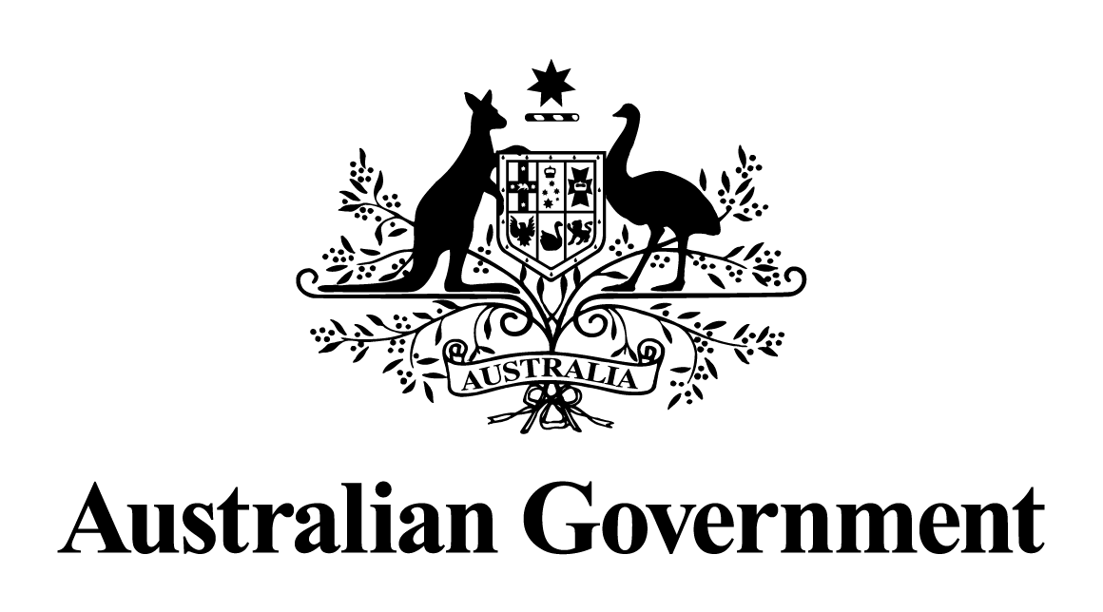

Australian Government response to the   
Senate Committee Economics report:

Treasury Laws Amendment (Delivering Better Financial Outcomes and Other Measures) Bill 2024

September 2024

# Introduction

*Treasury Laws Amendment (Delivering Better Financial Outcomes and Other Measures) Bill 2024* (the Bill) contains six schedules:

* Schedule 1 delivers the first tranche of the Delivering Better Financial Outcomes package, the Government's response to the Quality of Advice Review.
* Schedule 2 updates the petroleum resource rent tax general anti-avoidance rules so that they align with the more robust approach of the general anti-avoidance provisions contained in part IVA of the *Income Tax Assessment Act 1936*.
* Schedule 3 amends the *Petroleum Resource Rent Tax Assessment Act 1987* to clarify the meaning of the phrase 'exploration for petroleum'. It also clarifies that mining, quarrying or prospecting rights cannot be depreciated for income tax purposes until they are used, not merely held, and the circumstances in which the issue of new rights over areas covered by existing rights lead to income tax adjustments.
* Schedule 4 amends domestic legislation governing Australia's agreements with international financial institutions to automatically incorporate amendments made to the treaties between Australia and these institutions. This reflects modern drafting practices and will avoid administratively burdensome processes, helping Australia honour its commitments to the international financial institutions that we are a member of.
* Schedule 5 amends various laws in the Treasury portfolio to ensure that those laws operate in accordance with policy intent, makes minor changes to improve administrative outcomes and remedies unintended consequences, as well as corrects technical and drafting defects.
* Schedule 6 amends film tax offsets in the *Income Tax Assessment Act 1997* to attract international investment in the Australian screen industry and increases training opportunities on large budget film productions. It raises the film location tax offset from 16.5 per cent to 30 per cent and introduces a new producer tax offset for drama series spending $35 million per season.

The Bill passed both Houses on 4 July 2024 and received Royal Assent on 9 July 2024 as the *Treasury Laws Amendment (Delivering Better Financial Outcomes and Other Measures) Act 2024.*

The Government thanks the Senate Economics Legislation Committee for its inquiry into the Bill, and thanks the organisations and individuals who made submissions to the inquiry and participated in the public hearing.

The Government’s responses to the recommendations made in the Committee’s final report are provided below. In line with the guidelines on Government responses, recommendations that a bill or bills be passed, rejected, or amended have not been responded to. This includes the Committee’s recommendation in the Main Report that the Senate pass the Bill and recommendation 2 in the Greens Senators' additional comments.

# Response to the recommendations

## Coalition Senators' Dissenting Report

|  |
| --- |
| Recommendation 1  That Part 1 Schedule 1 of the Bill be removed and the provisions re-consulted on by the Treasury in anticipation of Tranche 2 of the Government’s legislation implementing the Quality of Advice review recommendations.  Australian Government response  the Government **notes** this recommendation.  The Government tabled Parliamentary Amendments to Part 1 of Schedule 1 in the Senate following constructive engagement from stakeholders and in response to feedback received on the Bill. The amendments to the Bill were publicly supported by stakeholders and will support improved access to financial advice for Australians while maintaining consumer protections. These amendments were agreed.  Part 1 of Schedule 1 clarifies that Australians can use their superannuation accounts to pay for personal financial advice from a financial adviser. Superannuation funds will continue to satisfy their current obligations that govern the usage of member funds. |

## Greens Senators' additional comments

|  |
| --- |
| Recommendation 1  The Australian Government prioritise the introduction of its legislative reforms for local requirements for streaming services to the Australian Parliament.  Australian Government response  the Government **supports** this recommendation.  In the National Cultural Policy Revive, the Albanese Labor Government reiterated its election commitment to introduce Australian screen content requirements on streaming platforms to ensure continued access to local stories and content.  The Government is undertaking a genuine consultation process and is taking the time to consider views to support ongoing investment in, and production of, Australian stories. The Government wants to get the new obligation right and is working through the final details of the Australian screen content obligation. The Government is aiming to introduce legislation as soon as practicable. The obligation will be introduced as part of the Australian Government’s broader reforms to media legislation and is the joint responsibility of the Minister for Communications and the Minister for the Arts. |