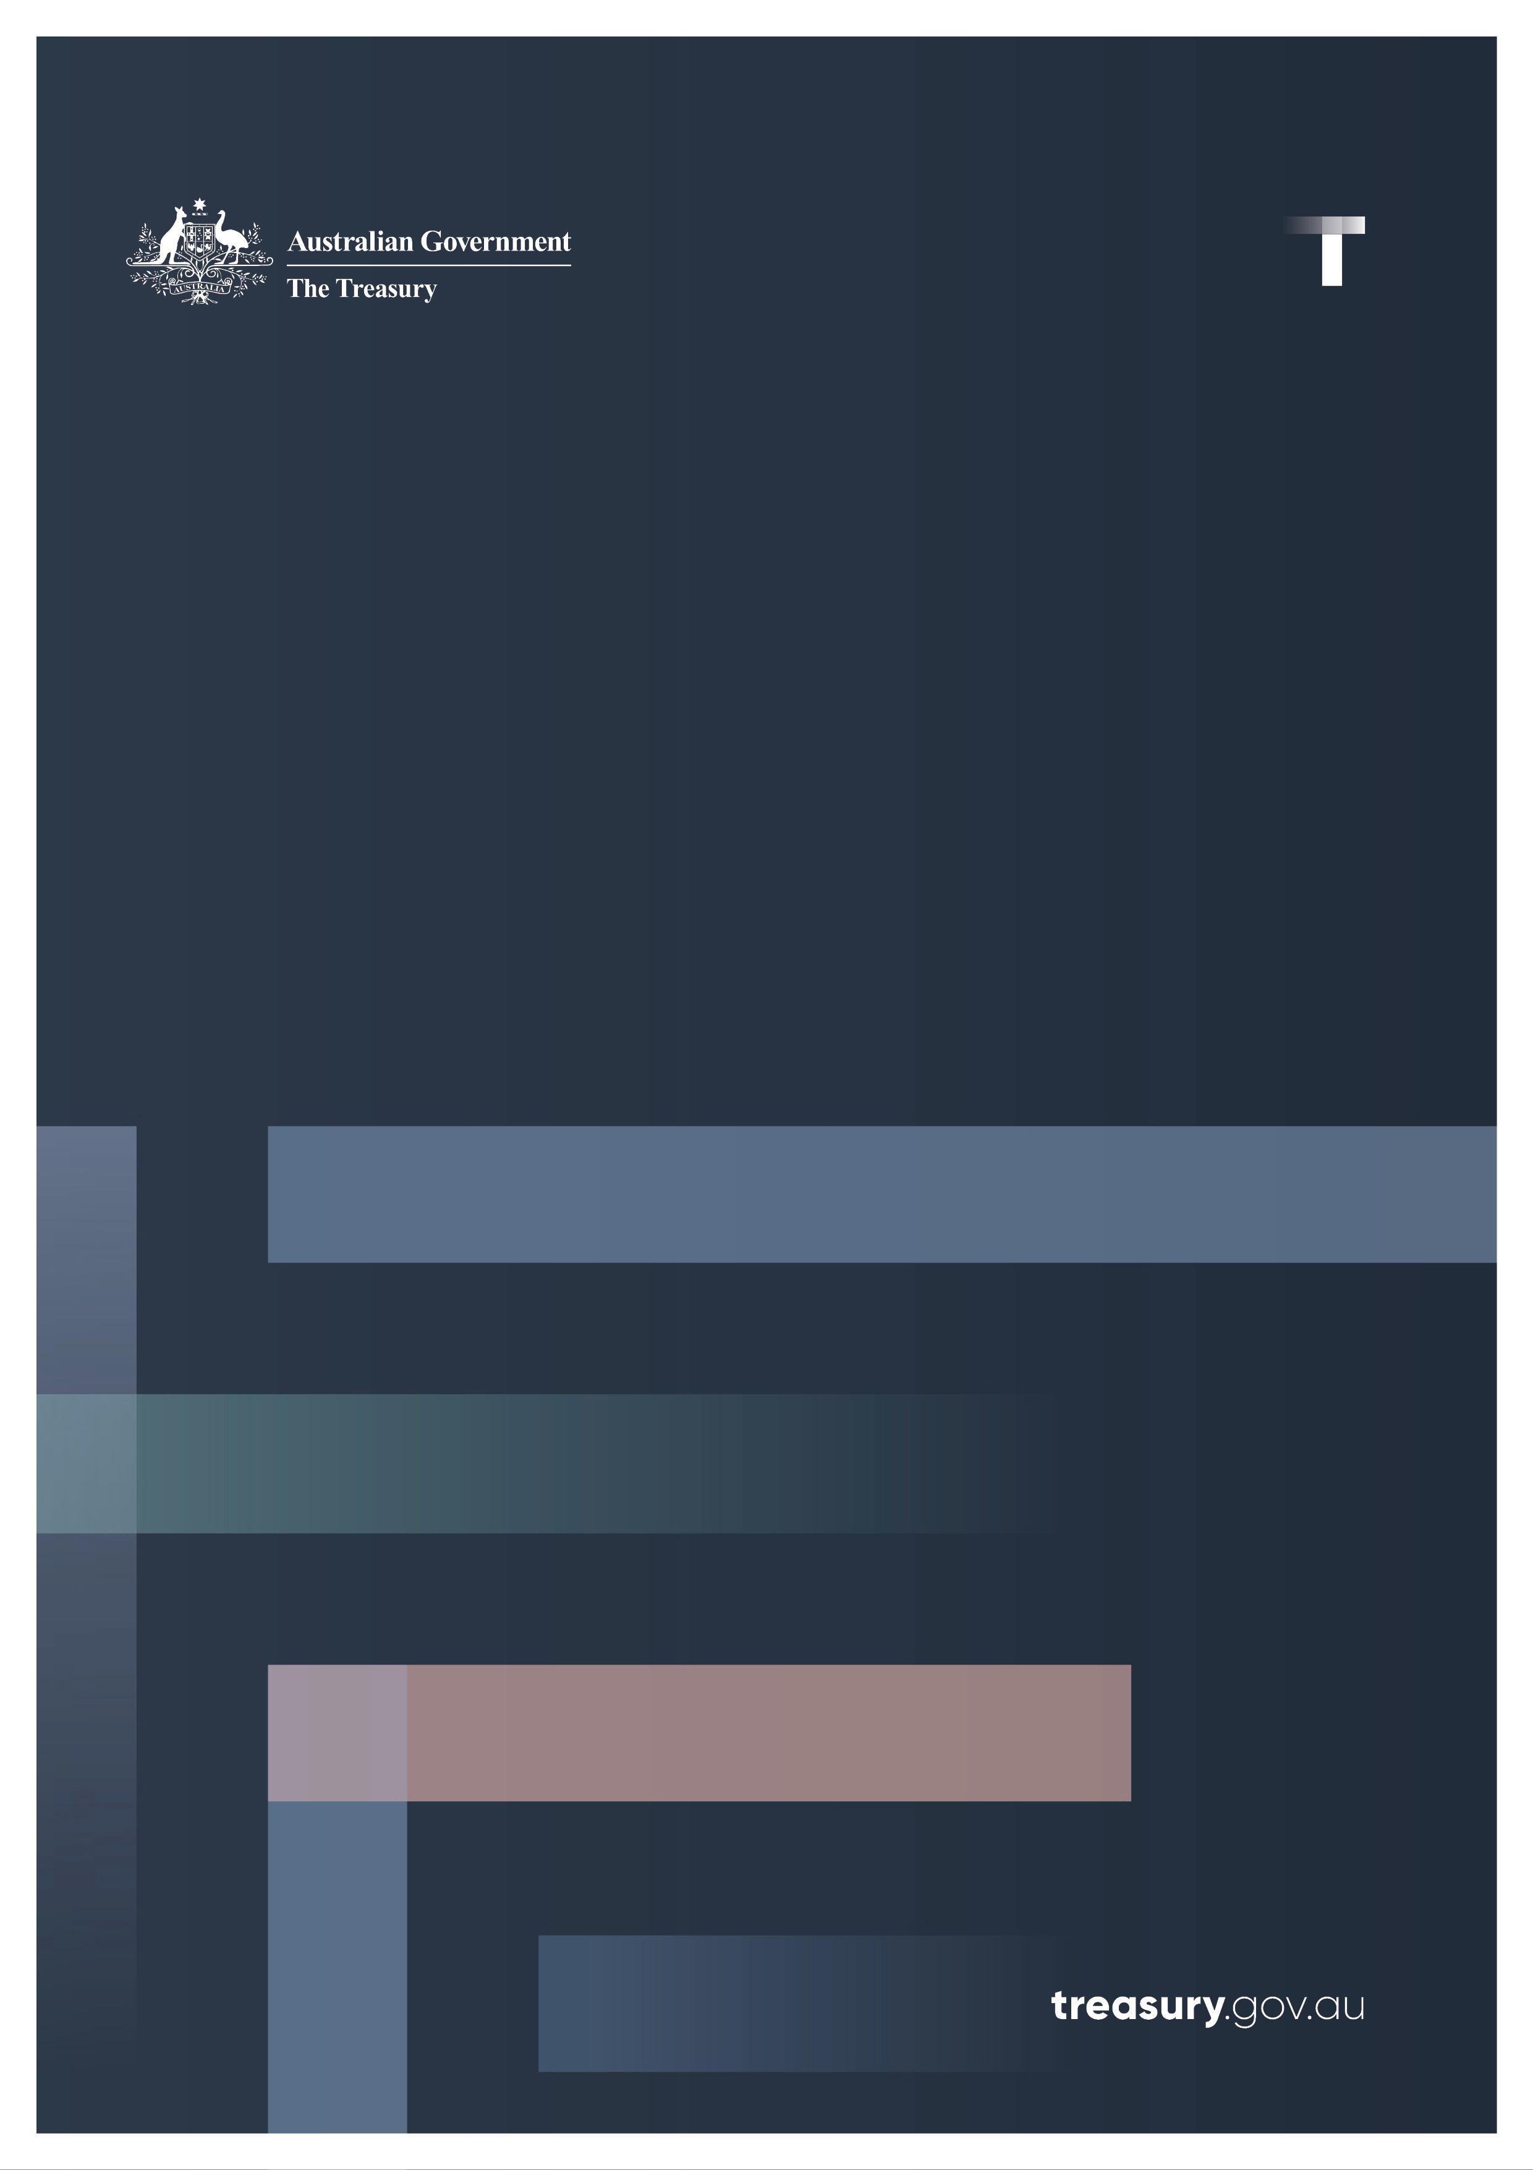

Cheques Transition Plan

Winding down Australia’s cheques system

November 2024

© Commonwealth of Australia 2024

ISBN: 978-1-923278-02-8

This publication is available for your use under a [Creative Commons Attribution 3.0 Australia](http://creativecommons.org/licenses/by/3.0/au/deed.en) licence, with the exception of the Commonwealth Coat of Arms, the Treasury logo, photographs, images, signatures and where otherwise stated. The full licence terms are available from <http://creativecommons.org/licenses/by/3.0/au/legalcode>.

Creative Commons attribution licence 3.0 icon. 

Use of Treasury material under a [Creative Commons Attribution 3.0 Australia](http://creativecommons.org/licenses/by/3.0/au/deed.en) licence requires you to attribute the work (but not in any way that suggests that the Treasury endorses you or your use of the work).

**Treasury material used ‘as supplied’**

Provided you have not modified or transformed Treasury material in any way including, for example, by changing the Treasury text; calculating percentage changes; graphing or charting data; or deriving new statistics from published Treasury statistics – then Treasury prefers the following attribution:

*Source: The Australian Government the Treasury.*

**Derivative** **material**

If you have modified or transformed Treasury material, or derived new material from those of the Treasury in any way, then Treasury prefers the following attribution:

*Based on The Australian Government the Treasury data*.

**Use of the Coat of Arms**

The terms under which the Coat of Arms can be used are set out on the Department of the Prime Minister and Cabinet website (see [https://www.pmc.gov.au/honours‑and‑symbols/commonwealth‑coat‑arms](https://www.pmc.gov.au/honours-and-symbols/commonwealth-coat-arms)).

**Other uses**

Enquiries regarding this licence and any other use of this document are welcome at:

Manager  
Media Unit  
The Treasury  
Langton Crescent   
Parkes ACT 2600  
Email: [media@treasury.gov.au](mailto:media@treasury.gov.au)

*In the spirit of reconciliation, the Treasury acknowledges the Traditional Custodians of country throughout Australia and their connections to land, sea and community. We pay our respect to their Elders past and present and extend that respect to all Aboriginal and Torres Strait Islander peoples.*

# Contents

Foreword 1

Introduction 2

Transition timeline 3

Industry coordination 4

Next steps 5

# Foreword

The Albanese Government is modernising the way Australians make and receive payments, to make our payments system more resilient and up to date with the modern world.

New digital products are changing the way we make payments, and the way businesses provide payment services.

Our vision is for Australia to have a modern, world class and efficient payments system that is safe, trusted and accessible, and enables greater competition, innovation and productivity across the economy.

This vision was set out in our Strategic Plan for Australia’s Payments System, which we released in June 2023. A key component of the plan is modernising payments infrastructure by winding down the cheques system before 2030.

Since we released the Plan, we’ve been consulting widely with cheque users, financial institutions, community groups, industry groups and governments to hear a range of perspectives on the challenges and opportunities in moving away from cheques.

Although they were once a cornerstone of Australia’s payment system, cheques now account for less than 0.1% of total volume of retail payments in Australia. Winding them down in a staged, responsible manner will help reduce transaction costs across the economy, drive down the costs of the associated goods and services and improve productivity.

We are releasing a Cheques Transition Plan, to make sure the transition away from cheques is smooth and Australians who use cheques are well supported through the transition.

The Plan will take place in two phases. First, phasing out the ability of consumers and businesses to write cheques as a form of payment, and then stopping financial institutions from accepting them as a form of payment.

We will work closely with the financial sector, regulators and bank customers to implement this plan in a responsible, methodical way. We understand parts of the community still rely on cheques to make and receive payments and we expect the major banks to play a big role in educating these customers about the changes and supporting them through the transition, alongside government.

We are pleased to announce the Australian Payments Network working with the major banks and key players in the cheques system, will ask the Australian Competition & Consumer Commission (ACCC) for authority to coordinate the transition away from cheques. Government will stay closely involved in this coordination to ensure the transition is orderly, but it will be spearheaded by the private sector.

|  |  |
| --- | --- |
| ****The Hon Jim Chalmers MP Treasurer**** | ****The Hon Stephen Jones MP Assistant Treasurer Minister for Financial Services**** |

# Introduction

The Australian Government is committed to supporting a smooth and orderly closure of Australia’s cheques system. All impacted cheques users will be supported to transition to alternative payment methods. The Government also remains committed to maintaining and ensuring continued access to cash throughout Australia.

The Government is taking a leading role, setting a plan for governments and the financial services industry to work together to support Australia’s transitioning away from cheques. In close collaboration with the financial services industry, the Government is helping Australians to adopt digital payment methods by investing in education, infrastructure and outreach programs. These Government programs, including the Be Connected program and the Better Connectivity Plan, are improving digital inclusion, uplifting digital capabilities and increasing digitally connectivity and access across Australia. Banks will support their customers to transition to alternative payment methods and ensure suitable alternative payment solutions are available which meet their needs.

This Cheques Transition Plan has been informed by feedback to the winding down Australia’s cheques system consultation paper and ongoing engagement with financial institutions, consumers and industry groups.

Australians are continuing to shift from using physical to digital forms of payment, a trend that has accelerated since the COVID 19 pandemic. These efficient, cheaper and convenient means of payment have led to a decline in cheque use from what was once a cornerstone of Australia’s payment system to comprising less than 0.1% of total volume of retail payments in Australia today.

Monthly cheque volume decline over 20 years (‘000)

Source: Reserve Bank of Australia Statistical Tables

This declining trend in cheque volume, and the long processing times and manual effort required, have impacted the economics of cheques. Cheques are becoming increasingly costly to process on a per transaction basis, with costs continuing to increase as use declines further. The average cost of processing a cheque now exceeds $5, and clearing a cheque generally takes between 3 and 7 business days.

Winding down Australia cheques system will allow the benefits of cheaper, faster, more efficient and secure digital payments to be fully realised. This productivity increasing reform will directly reduce transaction costs across the economy and ultimately help drive down the costs of the associated goods and services. Australians who currently use cheques can benefit from reduced transaction fees, quicker processing times and additional identity verification measures. Faster transactions, made in near‑real time, will help Australians and small businesses to take advantage of the digital economy to improve the way payments are made and improve cash flow.

A key priority for the Government is to ensure the payments system fosters the development of modern, efficient payment infrastructure that promotes greater financial inclusion. However, like many productivity boosting reforms, some cohorts of cheques end users may face additional challenges when transitioning to different payment methods. This includes for example older Australians, vulnerable cohorts of cheques users and cheques users in remote areas. Similarly, the impacts will be felt disproportionately by different industries and sectors of the economy where the use of cheques is more prevalent, including by charities, the gaming industry and small businesses.

# Transition timeline

The Government has considered feedback and has developed a simplified cheques transition timeline. The transition timeline provides more time for cheques end users to transition away from certain chequing products, and for the financial services industry to develop suitable alternative payment solutions for all cheques use cases. It balances the needs of cheques end users with the productivity and efficiency gains through closing the cheques system sooner.

The transition timeline has been simplified to two milestone dates for phasing out cheques. The first milestone date is ceasing issuance of all cheques by 30 June 2028 and the second milestone date is ceasing acceptance of all cheques on 30 September 2029.

The milestone dates have been set to ensure all personal, commercial and government cheques go stale by the final date they can be accepted for payment. As personal, commercial and government cheques become stale 15 months after being drawn, these cheques drawn on or before 30 June 2028 will become stale on or before 30 September 2029. Outside of contractual arrangements, financial institutions are generally not obligated to pay a stale cheque; allowing most cheques to be accepted before going stale ensures that cheque users can continue to cash valid cheques.

Staged transition plan

|  |  |
| --- | --- |
| By 30 June 2028  Cease issuance of personal, commercial, government and bank cheques. Cheques written after this date will not be accepted, and no payment will be made. | On 30 September 2029  Cease acceptance of personal, commercial, government and bank cheques. Cheques will no longer be accepted for payment by financial institutions. Close the cheques system. |

The dates for ceasing issuance of commercial, government and bank cheques proposed in the consultation paper have been pushed back to align with the date for ceasing issuance of personal cheques to 2028. This provides more time to overcome barriers to ceasing cheque issuance, including identifying and developing suitable alternative payment methods and systems for all cheques use cases, and gives additional time to support adversely impacted cheques users to transition and for governments to make necessary legislative amendments. The single date for ceasing cheque issuance provides greater simplicity to all Australians on when cheques can no longer by written for payment.

Phase two is ceasing acceptance of all cheques, removing the cheques infrastructure and repealing the *Cheques Act 1986* to end on 30 September 2029. As bank cheques traditionally do not go stale, the financial services industry are exploring options to continue to honour any unpresented bank cheques, should it be needed. The updated end date for ceasing acceptance of cheques is consistent with the ‘no later than 2030’ date announced in the Strategic Plan for Australia’s Payments System.

Some Australian individuals, businesses and government entities are still receiving cheques from foreign jurisdictions. Foreign cheques are processed in a different manner to domestic cheques and are subject to separate rules than those in the Australian Paper Clearing System (APCS) framework. A number of small financial institutions provide foreign cheque acceptance and processing services which will not be impacted by the 30 September 2029 end date. There continues to be options for processing foreign cheques and the Government will support international efforts to enhance cross-border payments.

The Government is committed to a smooth, phased transition of Australia’s cheques system through a coordinated, whole of economy approach. Adequate communication, education and support for all impacted cheques users will underpin these outcomes. An uncoordinated or sudden withdrawal of cheques by financial institutions could create frustration and confusion for cheque users.

# Industry coordination

The Government expects the financial services industry to play a lead role in ensuring Australians are adequately supported to transition away from cheques and that the closure is appropriately coordinated. The financial services industry needs to ensure that there are suitable alternatives for all cheques use cases and that they are engaging with and supporting their customers to transition and providing targeted, timely and consistent education alongside industry associations and consumer groups.

There are currently 5 commercial banks in Australia with Tier 1 status under the APCS, allowing them to clear directly with one another and settle their resulting obligations across their Exchange Settlement accounts with the Reserve Bank of Australia (RBA). The premature withdrawal of one of these commercial banks from cheque processing sponsorship is a risk to achieving a smooth transition, as it risks creating a domino effect as the major banks all exit to avoid being the last bank left bearing the full cost of the system. While some smaller financial institutions have already withdrawn from the cheques system, others may wish to remain in the system until closure. The withdrawal of sponsorship arrangements could force dependent financial institutions to withdraw chequing services. If not properly coordinated, it could result in some undesirable outcomes, such as end users having to open additional accounts or move to banks that enable the continued use of cheques services until the system’s closure. There have been concerns expressed by some end users and financial sector participants that banks will transition well before the Government’s announced end date.

Coordination between banks, critical suppliers and vendors will be fundamental to mitigating undesirable outcomes and achieving a smooth transition. AusPayNet, the self‑regulatory body for the Australian payments industry and administrator of the APCS, have developed an industry program of work to coordinate the transition away from cheques. They will seek ACCC authorisation to enable collaboration among industry on the coordination program. Government expects the major banks to sign up to and adhere to this program of work. The Government does not expect smaller financial institutions which have already exited the chequing system to recommence chequing services. The industry coordination will include workstreams on overall migration management, migration of use cases and clear and consistent industry communications.

As part of the migration management, the industry coordination program will settle exit conditions that must be met for a bank to cease chequing services. It is expected that these conditions will support a smooth transition, particularly in light of a growing number of small and medium sized banks ending their chequing services. Government expects that these conditions will consider:

1. All customers that use cheques will be supported to transition to readily accessible alternative payment methods.
2. Tier 1 banks must continue to provide cheque clearing services to dependent partner banks until they are ready to transition, including those which wish to continue providing cheque services over the transition periods.
3. Banks which stop cheque issuing services early must remain members and contribute to funding the APCS, and banks must ensure the cheques supply chain is adequately supported until the milestone end dates.
4. Banks which stop cheque issuing services early must provide a minimum notice period of 6 months for ceasing cheque issuing services, allowing consumers and businesses to make necessary adjustments to transition to alternative payment methods.
5. Banks which are existing members of Bank@Post, must allow their customers to continue to cash a cheque via participating Bank@Post outlets until the milestone end dates.
6. Banks still in the chequing system must provide minimum service levels to customers, including allowing existing customers to continue writing cheques and the provision of new cheque books on request up to their end date for cheque issuing, and the ability to deposit any cheques received up to the end date for cheque acceptance.

# Next steps

In collaboration with the financial services industry, Government will monitor progress towards the two milestone dates for ceasing chequing services. This includes reductions in cheque volume and numbers of cheque users, the development of suitable payment solutions for all cheque use cases and any emerging challenges that arise during the transition phases. Government will ensure financial institutions continue to work with their customers to smoothly transition away from cheque use.

The Commonwealth will work with state governments to reduce government cheque use ahead of the target end dates and will work towards removing legislative and regulatory barriers entrenching the use of cheques. The Commonwealth will develop legislative amendments to meet the cheques transition timing and in line with established practice, including public consultation. The Commonwealth will seek to upgrade payments systems and internal processes to reduce cheque usage. Through reducing cheque volumes sooner, governments, financial institutions, industry associations and consumers groups will be able to identify and focus support on the remaining cheques users and use cases.

Government will continue to work with banks and consider what support may be required for existing cheque users to support their continued financial inclusion. This includes ensuring vulnerable cohorts are supported to build digital skills and capabilities to be able to use digital alternative payment methods.