# Fact Sheet

## Treasury Laws Amendment (Mergers and Acquisitions Reform) Bill 2024

In April 2024, the Australian Government announced reforms to Australia’s merger rules to promote competition, protect consumers and provide greater certainty by streamlining the approvals process.[1]

The reforms will deliver a merger control system that will be faster, simpler and more transparent. The Australian Competition and Consumer Commission (ACCC) will have stronger powers to better target, identify and scrutinise transactions that are likely to increase the cost of living for consumers and harm other businesses, making the economy less productive.

On 24 July 2024, Treasury released the exposure draft of what is now the *Treasury Laws Amendment (Mergers and Acquisitions Reform) Bill 2024*. On 30 August 2024, Treasury released a consultation paper on notification thresholds.

This fact sheet explains the Australian Government’s merger reform policy and legislation following extensive consultation with stakeholders and is designed to be read alongside the Government’s response to consultation released on 10 October 2024.[2]

These reforms will be implemented principally through amendments to the Competition and Consumer Act 2010(CCA) and associated subordinate legislation.

Treasury will consult on the subordinate legislation, which will cover notification thresholds, fees, and the ACCC’s public register and associated transparency safeguards in 2024-25.

## Treasury Laws Amendment (Mergers and Acquisitions Reform) Bill 2024: Legislation framework

| Purpose | References | Outcome |
| --- | --- | --- |
| Targeted mandatory notification thresholds | Section 45AW;  Section 51ABB;  Section 51ABO;  Section 51ABP;  Section 51ABQ;  Section 51ABR;  Section 51ABS;  Section 51ABT;  Part IVA, Division 1, Subdivision C | * Targeting acquisitions, particularly of shares or assets, that may affect the competitive structure of a market, with flexibility to adjust the scope based on emerging issues or developments. * Allows notification thresholds to be set in subordinate legislation using metrics such as turnover and transaction value. * Excludes acquisitions of shares that do not give rise to control (within the meaning of section 50AA of the Corporations Act 2001). * Minimises impact on takeovers and capital markets by excluding from the requirement to notify acquisitions that result in up to 20% voting power of publicly listed entities or an unlisted widely held company (entities to which Chapter 6 of the Corporations Act applies). * Allows a Treasury Minister to determine whether certain categories of transactions should be notifiable or exempt from notification. * Merger parties may seek a ‘notification waiver’ from the ACCC that, if granted, means an acquisition does not need to be notified. * A Treasury Minister may set targeted notification obligations in response to evidence-based concerns regarding certain high-risk acquisitions. Reports that the ACCC may give to the Minister will be published. |
| Suspensory timelines supporting prompt review | Section 45AY; Section 51ABE;  Part IVA, Division 3, Subdivision B;  Section 51ABZI;  Section 51ABZZG | * Clear review timelines are an important procedural safeguard and will assist merger parties in transaction planning and interested stakeholders to engage with the ACCC’s review. * Extensions are only available under certain circumstances, such as when the notifying parties consent or if they have not responded to a compulsory information gathering notice within 10 business days. * Initial ‘Phase 1’ review period of up to 30 business days or ‘fast-track’ determination if no concerns are identified after 15 business days. * In-depth ‘Phase 2’ review period of up to 90 business days. * Merger parties may seek review of intermediate decisions (incomplete or misleading notifications, material changes of fact etc,) with timeframes of 7 days for the ACCC and 14 days for the Tribunal to ensure timely resolution. |
| Stronger, expert administrative decision-maker | Section 51ABZH; Section 51ABZF;  Section 45AZA; Section 76; Section 77D; Section 81B; Section 86E | * The ACCC will determine whether an acquisition may or may not be put into effect, with or without conditions. Certain administrative decision-making thresholds must be satisfied before the ACCC may include conditions or determine that an acquisition must not be put into effect. * Penalties apply for failure to comply with requirement to notify, breach of the requirement to suspend completion of an acquisition, and/or for providing false or misleading information. |
| Empowering the ACCC to protect competition and consumers | Section 51ABZH  Explanatory Memorandum, Chapter 4 | * Clarifies that a substantial lessening of competition can result from creating, strengthening or entrenching a substantial degree of power in the market for the purposes of merger assessments. * Guiding factors in the Explanatory Memorandum will assist the ACCC in its role as an administrative decision-maker and ensure emphasis is placed on evidence-based economic analysis of competitive effects. |
| Effective review of serial acquisitions | Section 51ABP;  Section 51ABZH | * The combined effect of acquisitions within the previous three years by the acquisition parties may be considered as part of the review of the notifiable acquisition and aggregated for determining if the notification thresholds are met. * The ACCC may take into account the combined effect of acquisitions involving the same or substitutable goods or services, and across different geographic areas. |
| Facilitates acquisitions in the national interest | Part IVA, Division 5; Section 51ABZW; Section 51ABZY | * Permits an acquisition, following the ACCC’s competition assessment, that is of net public benefit to the community. * Where parties provide sufficient information to enable the ACCC to expedite its competition assessment within the time limits and determine an acquisition is likely to substantially lessen competition, the ACCC can quickly proceed to the public benefit process. |
| Transparency and predictability | Section 51ABZZH; Section 51ABZZI; Section 51ABZE;  Section 51ABZJ;  Section 51ABZK;  Section 51ABZW; | * Greater transparency around decision-making with the publication of information and documents on a public register. * The ACCC will give notifying parties a written notice where it decides that a notification is subject to Phase 2. The notice will identify the parties, describe the economic activities in which they engage, the nature of the theory of harm, as well as the matters to be investigated further at Phase 2. * To promote good-decision making and ensure procedural fairness, notifying parties will be able to respond to a notice of competition concerns from the ACCC during Phase 2, setting out the ACCC’s preliminary assessment of whether the acquisition would be likely to substantially lessen competition and grounds for the assessment, referring to the evidence or other material on which those grounds are based. * The ACCC will publish reasons for its determination and provide them to the notifying parties for notifications and public benefit applications. |
| Review of administrative decisions and procedural safeguards | Part IX, Division 1A and 1B;  Section 100C;  Section 100S;  Section 100Q | * ACCC determinations subject to merits review by the Australian Competition Tribunal, a specialist body with independent economic, business and legal expertise, based on material before the ACCC. * Ensures independent and efficient reviews of ACCC determinations. * Safeguards to ensure that reviews sought by third parties must have sufficient merit to proceed. The Tribunal can dismiss applications if, for example, it is frivolous, vexatious or is otherwise an abuse of process. The Tribunal can also award costs if satisfied that it is appropriate to do so. * Empowers consumer associations and consumer interest groups to participate in Tribunal reviews. * The Tribunal may permit notifying parties to provide information relevant to the ACCC’s determination and reasons if they were not given reasonable opportunity to respond before the ACCC made the determination. * The Tribunal will be able to seek information or ask questions of technical experts. The Tribunal may also allow participants in the proceedings or the ACCC to ask questions of the technical expert. |
| Transitional Arrangements | Section 188;  Section 189;  Schedule 1 Part 3 | * Businesses must notify the ACCC of notifiable acquisitions from 1 January 2026 and will be able to voluntarily notify under the new system from 1 July 2025. * Businesses that have received informal ‘clearance’ or been granted merger authorisation under the current system between 1 July 2025 and 31 December 2025 will be exempt from notification, provided the acquisition is put into effect within one year of the decision. * To support smooth transition in the initial years, section 50 of the CCA will be retained for non-notifiable/non-notified acquisitions, with amendments for consistency with the new system. |

## Treasury Laws Amendment (Mergers and Acquisitions Reform) Bill 2024: Review Timelines (Phase 1, Phase 2 and Public Benefit)

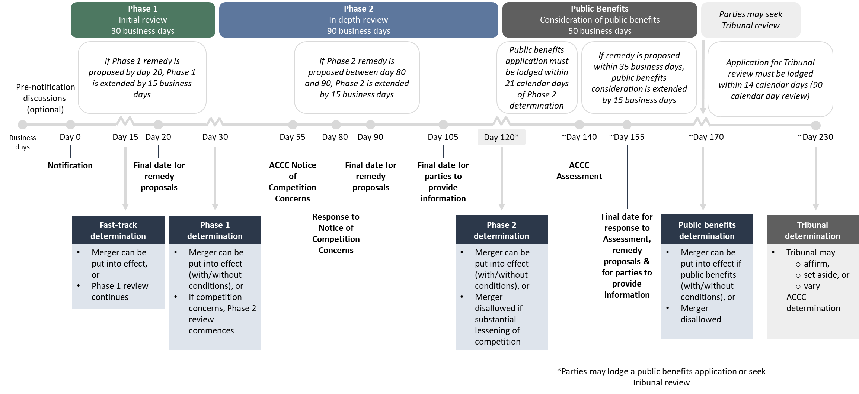

1. [Merger Reform: A Faster, Stronger and Simpler System for a More Competitive Economy (treasury.gov.au)](https://treasury.gov.au/publication/p2024-517964).
2. [Merger reform for a more competitive economy: Government response to consultation](https://treasury.gov.au/publication/p2024-589891).