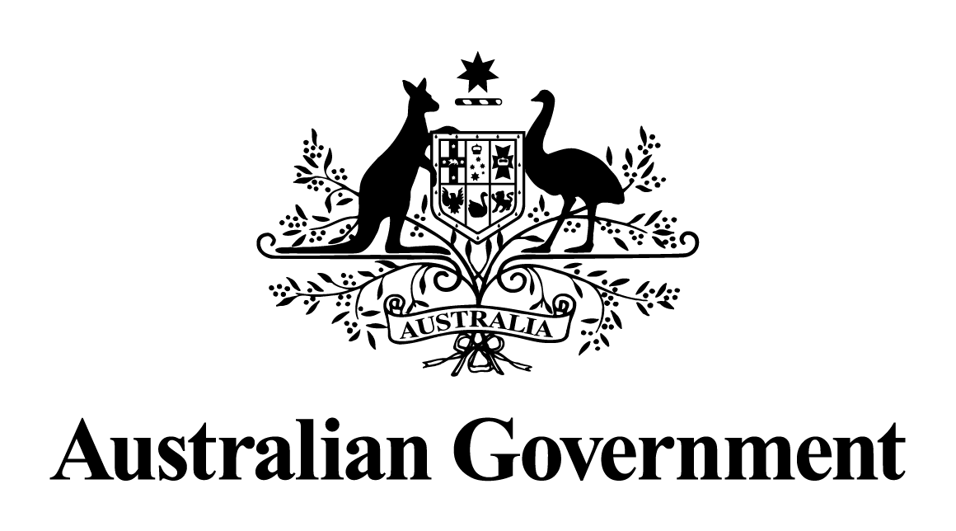

Australian Government response to the   
Senate Committee on Economics report:

Corporations Amendment (Improving Outcomes for Litigation Funding Participants) Bill 2021

May 2024

# Response to the recommendations

|  |
| --- |
| Recommendation 1  The committee recommends the Australian Government (through the Attorney-General) refer to the Australian Law Reform Commission a review on the impacts of the bill (and any other related matters) to be conducted after the provisions of the bill have been in effect for three years. The review should be tabled in Parliament as soon as reasonably practicable.  Australian Government response  The Government **notes** this recommendation. However, given the passage of time since this report was tabled, a substantive Government response is no longer appropriate. |