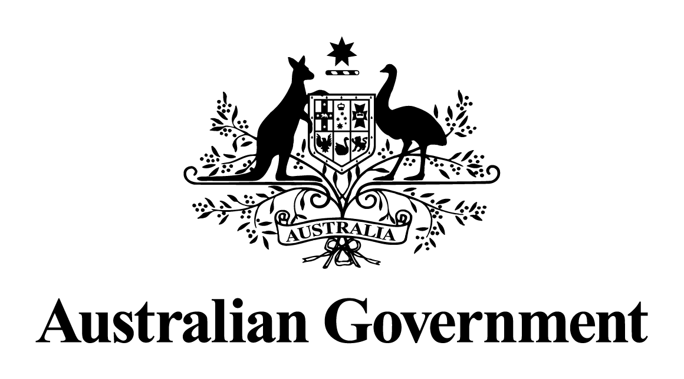

Australian Government response to the   
Senate Committee on Economics report:

Offshore Petroleum (Laminaria and Corallina Decommissioning Cost Recovery Levy) Bill 2021 [Provisions] and Treasury Laws Amendment (Laminaria and Corallina Decommissioning Cost Recovery Levy) Bill 2021 [Provisions]

May 2024

# Response to the recommendations

|  |
| --- |
| Additional comments—Australian Greens – Recommendation 1  That the government undertake public reporting on the amount of the levy that is collected each year.  Australian Government response  The Government **notes** this recommendation. However, given the passage of time since this report was tabled, a substantive Government response is no longer appropriate. |
| Additional comments—Australian Greens – Recommendation 2  That the government require gas and oil companies to publicly report on their decommissioning liabilities each year.  Australian Government response  The Government **notes** this recommendation. However, given the passage of time since this report was tabled, a substantive Government response is no longer appropriate. |
| Additional comments—Australian Greens – Recommendation 3  That the government makes the levy permanent to ensure industry are responsible for the full costs of decommissioning now and into the future.  Australian Government response  The Government **notes** this recommendation. However, given the passage of time since this report was tabled, a substantive Government response is no longer appropriate. |
| Additional comments—Australian Greens – Recommendation 4  That the government implements a long-term solution to ensure industry covers the full cost of offshore decommissioning, informed by overseas models that are underpinned by transparency and accountability.  Australian Government response  The Government **notes** this recommendation. However, given the passage of time since this report was tabled, a substantive Government response is no longer appropriate. |