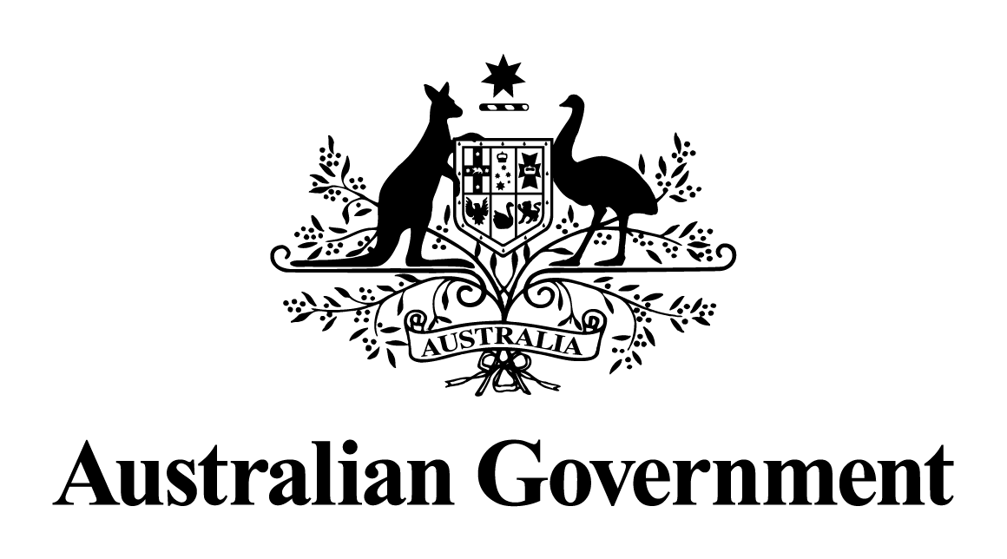

Australian Government response to the   
Senate Economics Committee report:

Financial Accountability Regime Bill 2021 [Provisions], Financial Sector Reform (Hayne Royal Commission Response No.3) Bill 2021 [Provisions], Financial Services Compensation Scheme of Last Resort Levy Bill 2021 [Provisions], and Financial Services Compensation Scheme of Last Resort Levy (Collection) Bill 2021 [Provisions]

May 2024

# Response to the recommendations

|  |
| --- |
| Additional comments from Labor Senators - Recommendation 1  Labor Senators recommend that the Australian Government expand the scope of the Compensation Scheme of Last Resort to include managed investment schemes.  Australian Government response  The Government **notes** this recommendation. However, given the passage of time since this report was tabled, a substantive Government response is no longer appropriate. |