How competition impacts prices: The Australian aviation sector
  - Omer Majeed, Robert Breunig
and Adrian Domazet

© Commonwealth of Australia 2024
ISBN: 978-1-925832-99-0
This publication is available for your use under a Creative Commons Attribution 3.0 Australia licence, with the exception of the Commonwealth Coat of Arms, the Treasury logo, photographs, images, signatures and where otherwise stated. The full licence terms are available from http://creativecommons.org/licenses/by/3.0/au/legalcode.
Use of Treasury material under a Creative Commons Attribution 3.0 Australia licence requires you to attribute the work (but not in any way that suggests that the Treasury endorses you or your use of the work).
Treasury material used ‘as supplied’
Provided you have not modified or transformed Treasury material in any way including, for example, by changing the Treasury text; calculating percentage changes; graphing or charting data; or deriving new statistics from published Treasury statistics – then Treasury prefers the following attribution:
Source: The Australian Government the Treasury.
Derivative material
If you have modified or transformed Treasury material, or derived new material from those of the Treasury in any way, then Treasury prefers the following attribution:
Based on The Australian Government the Treasury data.
Use of the Coat of Arms
The terms under which the Coat of Arms can be used are set out on the Department of the Prime Minister and Cabinet website (see https://www.pmc.gov.au/honours-and-symbols/commonwealth-coat-arms).
Other uses
Enquiries regarding this licence and any other use of this document are welcome at:
Manager
Media Unit
The Treasury
Langton Crescent
Parkes ACT 2600
Email: media@treasury.gov.au

Acknowledgement and Disclaimer
We are grateful to Prof. John Kwoka from Northeastern University, Marcia Keegan, colleagues at Treasury, Department of Infrastructure, Productivity Commission, Australian National University, University Technology Sydney and Macquarie University for their comments and suggestions. We are also grateful for the leadership of Jason McDonald and Owen Freestone, and the early work of Ariun Bayarjargal, Toby Markham, Derek Wu and David Hansell on the paper. We are grateful for the support of OAG in terms of providing support and access to the data. We are also grateful for the support of Jennifer Fletcher, Jamal Ara, Husn Ara Majeed and Bridget Lee.
We also stress that the views expressed in this paper are those of the authors and not necessarily those of the Commonwealth Treasury or the Australian government. All errors and omissions remain our own.

Contents
Abstract 1
1. Introduction 4
2. Literature Review 5
History of Airline Carriers in Australia 6
The International Experience 6
Evidence of Strategic Pricing and Merger Behaviour 7
3. Data 8
Trends and impacts of competition in Australia 11
4. Methodology 15
Empirical model 15
Estimation 15
5. Results 16
All time periods 17
Pre- and post-COVID 19
6. Qantas and Jetstar Interactions 22
7. Robustness 26
Bigger impact for competition when the competition base is low 27
Regional routes 27
Competition also helps lower the rate of growth in prices 29
8. Conclusion 31
Bibliography 33
Appendix 36

Abstract
As a small open economy with dispersed populations across a vast landmass, aviation is particularly important for Australia. Aviation is essential for transporting both goods and people, as well as transmitting ideas. While it is well documented that competition has transformed the US and European airline industries, evidence for Australia is lacking. Using comprehensive microdata, this paper is the first to examine the evolution of aviation competition in Australia and its impact on domestic airfares. We examine how the impact of competition differs depending upon the baseline level of competition and we assess the impact of competition on price growth. We find a strong link between the degree of competition and airfares across the aviation network, with increases in the number of airlines on a route resulting in significant reductions in airfares. This effect is strongest when competition is starting from a low base. Our results also show that increasing competition lowers price growth, and that the mere threat of competition can lower airfares. Overall, we show that competition has strong positive implications for passenger welfare through reducing prices.

Key points
- The aviation sector is an important part of the Australian economy, supporting the movement of people and freight across the country, producing spillovers of innovation and ideas across the economy, and helping to promote the economic and social interests of regional and remote areas. A well-functioning and competitive aviation sector is crucial to the well-being of Australian consumers and businesses.
- Using novel data, this paper reports results from the first detailed study examining airline competition in Australia, its evolution and its effects on airfares.
- Increased competition has positive implications for passenger welfare and cost of living pressures. Descriptive and econometric results show that competition has a significant downward impact on airfares. When a route is serviced by a monopoly, airfare per kilometre is around 40 cents (in real terms); for a duopoly, this falls to less than 30 cents and continues to decline as more airlines are added.
- Using a large dataset, and controlling for other factors such as income, our results suggest that the presence of an additional airline on a route leads to airfares that are 5 to 10 per cent lower, falling further with additional airlines. We also find that the threat of competition is associated with lower airfares.
- Our results show that where the level of competition is low, increased competition places more downward pressure on airfares (e.g. post COVID- and on regional routes).
- Our results additionally suggest that competition can reduce price growth, where having more airlines on a route led to lower airfare growth.
- While focused on the aviation sector, this study underscores the broader point: greater competition can deliver significant cost of living benefits to Australian consumers through price reductions.
- Competition in the aviation sector is estimated to have saved consumers $27.2 billion to $35.2 billion (in 2023 dollars) over the 14-year period to 2023.
- The economic behaviour of Qantas, the dominant player, strongly determines the overall results. Qantas responds differently to entry of affiliated (Jetstar) and non-affiliated competitors.
- Qantas reduces prices when a non-affiliated competitor enters a route.
- Qantas raises prices when Jetstar, an affiliated airline, enters the market, suggesting the presence of Jetstar allows Qantas to exercise a greater degree of price discrimination.
- Overall, the entry of Jetstar lowers average airfares and provides consumers with more options.

Key points (continued)
- While the aviation sector remains concentrated in Australia, competition has generally improved over the past 14 years:
- Between 2010 and 2023, low-cost carriers (LCCs) gradually increased their share of passenger seats from 27 to 37 per cent across all routes.
- The average number of airlines on the top 200 routes increased from 2.4 to 2.8 over the same period.
- The share of top 200 routes with only 1 airline declined from 39 to 19 per cent, while those with 2 and 3 airlines increased by 6 and 9 percentage points, respectively, between 2010 and 2023.
- Regional airlines, which typically have higher average fares, can sometimes offer very competitive fares on busier routes and undergo rapid phases of expansion. While this is beneficial to consumers, the sustainability of these services depends on the long-run cost structures of the airlines (including economies of scale), the behaviours of other airlines, and developments on the demand-side of the market, among other factors.
- The aviation sector, both domestic and international, is always undergoing change including through entries and exits of services and carriers in response to changing demand, management practices, behaviour of incumbents or exogenous factors.
- COVID-19 pandemic was a case-in-point, resulting in large-scale disruptions to the market and having the effect of significantly reducing the proportion of the market held by LCCs. The previous trend of increasing competition may eventually recover, but this may be a slow process.
- While we document an increase in competition increasing across several metrics over the large periods of the study, recent disruptions including to Bonza and Rex services will need to be monitored closely in terms of their short and longer run effects on competition.
- Measuring competition is complex and typically one measure is not enough to examine the trends and patterns of competition.

- Introduction
A well-functioning and competitive aviation sector delivers affordable services to consumers and promotes the competitiveness of other businesses. The aviation sector facilitates the diffusion of ideas, supports labour and capital mobility, and enhances economic growth and business dynamism. Aviation is also a crucial input to other industries, ranging from tourism to high value added manufacturing and agricultural products (Athukorala, Talgaswatta, and Majeed, 2017; Australian Trade and Investment Commission, 2024). For a country as vast as Australia, economic and social inclusion in remote areas and families’ connections across the country depend in large part on a well-functioning and affordable aviation sector.
Evidence shows that competition transformed European and North American aviation markets. Research from these regions documented how competition, especially from low-cost carriers (LCCs), led to reductions in airfares, increased passenger demand and improved consumer welfare (Dresner, Lin and Windle, 1996; Alderighi, Cento, Nijkamp, and Rietveld, 2007 and 2012; Hofer, Windle, and Dresner, 2008; Scotti and Dresner 2022).
However, the aviation sector remains under-studied in Australia. This is the first paper to examine how competition has evolved and impacted airfares in Australia. Using extensive microdata, our research shows that competition in the aviation sector increased significantly over the last decade. LCCs have gradually increased their share of passenger seats at the expense of two legacy carriers (LGCs), Qantas and Virgin. In 2010, LCCs accounted for about 30 per cent of domestic passenger flows, and their share had grown to 40 per cent in 2020. During this same period, competition within routes – as measured by the number of carriers – also increased, with the share of top 200 routes serviced by a single carrier falling from 39 per cent to 27 per cent.
The COVID-19 pandemic disrupted this trend, and seats offered by LCCs reduced significantly. While LCCs have gradually re-established their share, they have yet to attain pre-COVID levels. The impact of COVID-19 on airlines is consistent with the broader literature that larger firms are less likely than smaller or medium firms to be constrained by credit or cash as a result of major shocks– for example, Mancusi and Vezzulli (2010) and Bakhtiari, Breunig, Magnani and Zhang (2020).
This study, while focused on the aviation sector, captures a broader point: that competition can deliver significant cost of living relief to Australian consumers through price reductions. Our results show that increased competition matters for airfares and consumer welfare. Using econometrics and a large, detailed dataset, our results suggest the presence of an additional airline on a route reduces airfares by 5 to 10 per cent, falling further with additional airlines. Just as important, competition also has a strong impact on the growth rate of fares, especially in response to demand shocks. Routes with more airlines see a slower growth rate. In particular, routes with three to five airlines see lower price growth than routes with one or two airlines. We also find that the threat of competition results in reduced airfares.
Australia is a large country, while population centres concentrated mostly on the East Coast, towns and jobs spread across the continent. Australia has around 1,200 unidirectional routes that carried around 100 million domestic passengers per year prior to COVID-19. We examine detailed microdata on their traffic flows, route behaviours of airlines and the impact of competition on consumers in the domestic market. The dataset spans 2010 to 2023 with around 140,000 observations at the airline-route-month level, and key supply variables including passenger movements and average airfares across a range of travel classes.
The remainder of the paper is organised as follows. Section 2 provides a brief review of the literature on the impact of competition on airfares and the recent history of airlines in Australia. Section 3 discusses the data. Section 4 explains our methodology. Section 5 presents our results. Section 6 examines the differential impact of Jetstar on all airlines, Qantas and Virgin airfares. Section 7 discusses robustness and sensitivity checks, and we conclude in Section 8.
- Literature Review
Overseas studies show competition having a strong impact on airfares (Dresner et al. 1996, Morrison 2001, Goolsbee and Syverson 2008, Alderighi et al. 2012, Brueckner, Lee and Singer 2013, Kwoka, Hearle, and Alepin 2016). Yet systematic and quantitative analysis of airline competition on airfares is missing in Australia.
The Bureau of Transport and Communications Economics (now the Bureau of Infrastructure and Transport Research Economics (BITRE)) published the most recent domestic study in 1991. They found that, after industry deregulation in October 1990, increasing the number of airlines on routes lowered airfares (BITRE, 1991), but they did not undertake extensive econometric analysis. De Roos, Mills and Whelan (2010) examined the interaction between competition and pricing dynamics in Australia between 2003 and 2006, but focused primarily on price dispersion and considered only three airlines.

History of Airline Carriers in Australia
Box 1: History of entrance of airline carriers in Australia
Deregulation of the industry in October 1990 enabled LCCs to enter the market. Prior to deregulation, airlines faced less competition, which provided them with advantages including the early establishment of routes and access to both airport terminals and take-off and landing slots. The industry was characterised by low labour productivity and high and stable profits (BITRE, 1991; Forsyth, 2003).
Throughout the 2000s, apart from an unsuccessful entry attempt by foreign-owned LCC Tiger Airways (later acquired by Virgin Australia), the airline industry was effectively a duopoly operated by two large groups: Qantas, and Virgin. In 2004, Qantas launched its wholly owned LCC subsidiary, Jetstar, as part of its two-brand strategy to operate low-cost markets.

Figure 1: Timeline of entrance and exit of low-cost carriers and regional airlines
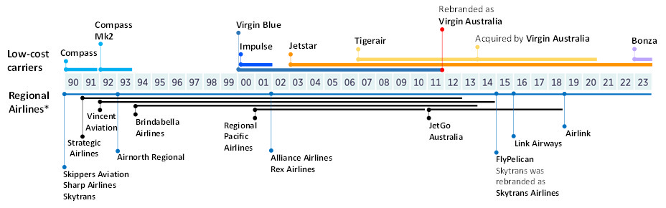
Airlines that commenced operations since 1990. Other regional airlines included in OAG data but not appearing here include Airlines Tasmania (1977-), Aviair (1984-) and Aeropelican Air Services (1968-2013). Source: Adapted from Australian Competition and Consumer Commission (2023a, p. 24).

The Australian airline industry is dominated by these two LGC airlines (Burton, 2023). Their price setting behaviour in the Australian domestic market is examined by Ma, Wang, Yang, and Zhang (2019), who find the likelihood of Qantas entering a price war increases when their market share drops below 50 per cent. Wang, Tsui, Li, Lei and Fu (2020) explore strategic economic behaviour of Qantas and their affiliated LCC, Jetstar, in their decisions to enter the Trans-Tasman market. We explore the joint behaviour of Qantas and Jetstar with respect to airfares in Section 6.

The International Experience
Globally, LCCs have transformed competition in airline markets over the last three decades. LCC competition is characterised by cost advantages often achieved by operating simple point-to-point schedules (short hauls), fast turnaround at gates, high aircraft utilisation, reduced focus on the in-flight experience, and the use of cost-saving, secondary airports. The cost difference between LCCs and LGCs is estimated at 20-30 per cent on short- to medium-haul services (Kwoka et al. 2016;
Tan, 2016).
The impact of competition in the aviation industry is most studied for North America and European countries. For the US, studies find competition substantially reduces airfares (Windle and Dresner, 1995; Lin, Dresner and Windle 2001; Morrison, 2001; Goolsbee and Syverson, 2008; Alderighi et al., 2012) but the effect varies by type and size of markets, ranging from a 5 per cent to 48 per cent fall in average airfares. Reductions in airfares follow competition on routes from improved operations at departure, arrival and adjacent airports and from the threat of competition (Morrison, 2001; Brueckner et al. 2013; Kwoka et al. 2016).
European and US studies find LCCs cause the biggest reduction in airfares (Wilken, Berster and Gelhausen, 2016; Brueckner et al. 2013). However, when LCCs compete on international long-haul routes, they struggle against network carriers (Whyte and Lohmann, 2015a). On long-haul routes, network carriers generate high-yield from business-class seats, giving them power to set economy fares at close to marginal costs.
Several European studies document how increased competition and LCCs put downward pressure on incumbents’ prices (Dobruszkes, 2006; European Parliament Committee on Transport and Tourism, 2007). The largest impacts emerge following route-specific competition from LCCs (Asahi and Murakami, 2017; Ren, 2020). Dresner, Gualini, Martini and Valli (2021) found the presence on routes of Norwegian, a large Norwegian LCC, reduced airfare costs by 12 per cent on average across routes. Similarly, Gualini, Martini and Porta (2024) found a 17 per cent reduction in fares on European routes with LCCs. Evidence suggests LCCs impact average airfares in both business and leisure markets (Alderighi et al. 2012).
Over the past 15-20 years, LCCs have increasingly entered the long-haul services market and/or transformed into Full Service Airlines (FSAs) (Morrell, 2008; Budd, Francis, Humphreys and Ison, 2014). The signing of the 2007 Open Skies Agreement (OSA) between the US and the European Union (EU) facilitated LCCs market access to long-haul services in the North Atlantic region. Virgin Australia (formerly Virgin Blue) and Southwest Airlines increased presence on specific routes through air terminal port dominance before becoming FSAs (Australian Competition and Consumer Commission, 2023a; Asahi and Murakami, 2017).

Evidence of Strategic Pricing and Merger Behaviour
Researchers have examined the dynamic pricing behaviour of incumbents in response to the entrance of new carriers into the market. Competition from LCCs tends to intensify airfare volatility (the range of low to high fares for a specific route) for incumbent airlines. Results from these studies imply that in the presence of LCCs, FSAs adopt a more aggressive “high-low” pricing strategy, where airfare costs for a departure date are initially high, but as the date nears and tickets become less desirable, FSAs heavily discounts prices. (Mantin and Koo, 2009; Alderighi, Gaggero and Piga, 2015; Tan, 2016; Varella, Frazão and Oliveira, 2017).
To respond to LCC’s point-to-point air service strategy, FSAs eliminate hub by-pass routes and reduce secondary hubs to build fewer but stronger ‘fortress hubs’ (Scotti and Dresner 2022). Other strategies they employ to maintain their incumbent advantage include high-quality boarding and in-flight experiences and strengthening airline alliances to increase brand loyalty (Lim and Lee, 2020).
Finally, evidence suggests airline mergers lower airfares. Mergers can facilitate streamlined layover coordination between two airline routes, but can also diminish competitive pressure for future quality improvements (Rupp, Owens and Plumly, 2006). Chen and Gayle (2019) and Gualini, Martini and Porta (2022) find increasing product quality in markets where the merging firms did not compete prior to merging but decreasing quality where they competed previously.
Overall, international literature demonstrates a strong relationship between increasing airline competition and reduced airfares. Despite dynamic development in the Australian aviation industry, no study to date explores entry, exit, and mergers in the aviation market. Access to newly available micro data in Australia allows us to examine and distinguish the impact of both LCC competition and competition between LGC airlines.
- Data
We extract both passenger movement and price data from the OAG Traffic Analyser. The data include monthly observations from February 2010 to November 2023 at an airline-route level. We examine a range of price variables: Average total fare is the total fare paid across all fare classes, online fare is the fare collected from an airline’s website, business fare is the fare collected for business class and minimum fare is the lowest fare paid across all fare classes, including business, premium economy, and discount economy.
For the purposes of this analysis, we define routes as directional pairs of airports. Only direct routes between two Australian airports are considered. The airline passenger data are supplemented by monthly Statistical Area 4 (SA4)-level economic indicators, including population, median income, population density and number of yearly tourist visitors.
The use of these control variables is similar to approaches used in the literature (Dresner et al. 2021; Kwoka et al. 2016; Borenstein 2011). Population density is constructed using SA4 size and population count. Median income is the annual median income of employees for each SA4 region, taken from the Australian Bureau of Statistics (ABS) Personal Income in Australia. It covers all employed people who interact with the Australian taxation system for whom personal income is identified (ABS, 2023). The number of yearly tourist visitors is survey data from Tourism Research Australia’s National Visitor Survey (NVS), which collects information on recent travel experiences. The data are an annual total of day and overnight travellers by region, where the survey respondent identified ‘holiday’ as their purpose for travel. Regional estimates are constructed by mapping NVS tourism regions to SA4 regions using an ABS correspondence file.

Table 1: Summary statistics
VARIABLES | N | mean | sd | min | max
Average total fare | 41,945 | 202.4 | 93.87 | 10.07 | 1,838
Online fare | 29,859 | 179.1 | 82.72 | 40.83 | 713.2
Minimum fare | 51,638 | 155.3 | 75.99 | 10.07 | 1,838
Business fare | 22,009 | 727.9 | 368.5 | 14.10 | 4,522
LGC 0 | 68,925 | 0.065 | 0.247 | 0 | 1
LGC 1 | 68,925 | 0.298 | 0.457 | 0 | 1
LGC 2 | 68,925 | 0.637 | 0.481 | 0 | 1
LCC 0 | 68,925 | 0.236 | 0.425 | 0 | 1
LCC 1 | 68,925 | 0.518 | 0.5 | 0 | 1
LCC 2 | 68,925 | 0.229 | 0.42 | 0 | 1
LCC 3 | 68,925 | 0.017 | 0.128 | 0 | 1
Number of airlines (departing airport) | 68,925 | 5.412 | 1.927 | 1 | 10
Number of airlines (arriving airport) | 68,925 | 5.406 | 1.912 | 1 | 10
Tourism visitors (arriving city, 000’s) | 68,725 | 438.8 | 334.4 | 5.665 | 1,211
Tourism visitors (departing city, 000’s) | 68,725 | 438.2 | 334.8 | 5.665 | 1,211
Herfindahl index (route) | 63,504 | 0.283 | 0.0147 | 0.196 | 0.311
Population | 68,925 | 3.993e+06 | 2.111e+06 | 229,778 | 1.068e+07
Median income | 68,925 | 46,111 | 2,546 | 35,531 | 52,355
Note: Top 200 routes. Statistics are based on airline-route-month observations. Population is the sum of both departing and arriving city. Median income is a weighted sum of departing and arriving city.

We follow the literature (such as Kwoka et al. 2016) and categorise airlines into two distinct groups: LGCs (Qantas and Virgin) and LCCs (all remaining airlines). LGCs typically have larger aircraft fleets and operate in a well-connected network of airport hubs. On the other hand, LCCs typically benefit from cost advantages by offering lower quality services, characterised by the absence of customer lounges, lack of seating options, fewer fare offerings, flights scheduled during off-peak times, and without the expense of hub network upkeep (Wong, Zhang, Cheung and Chu 2019; Kwoka et al. 2016; Dresner et al 2021). LGC and LCC variables are indicator variables which capture the number of LGCs and LCCs operating on a route. For example, LCC 1 are routes where there is one low-cost carrier present. Summary statistics of variables appear in Table 1.
The Australian domestic market is characterised by its geographic spread and highly localised East Coast population centres. Figure 2 shows that despite most population located along the East Coast, many airports connect sparsely populated areas to major cities. As a result, over 1,200 distinct routes appear in the data, though many with low passenger movements and infrequent flights. Peaking pre-COVID, around 100 million domestic passenger movements occurred each year (Figure 3). Movements in 2024 remain well below those of the pre-COVID peak but the market continues to recover.

Figure 2: Map of Australian airports and median income
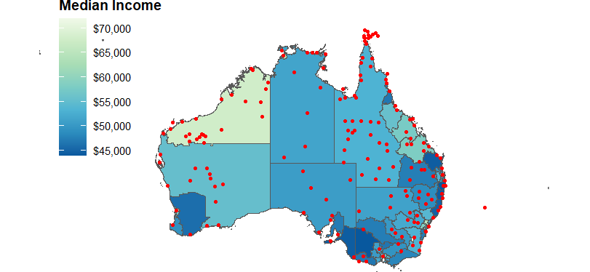
Source: Authors calculations using OAG and ABS data

Figure 3: Number of passenger movements by year
Australia, 2010 to 2023, all routes
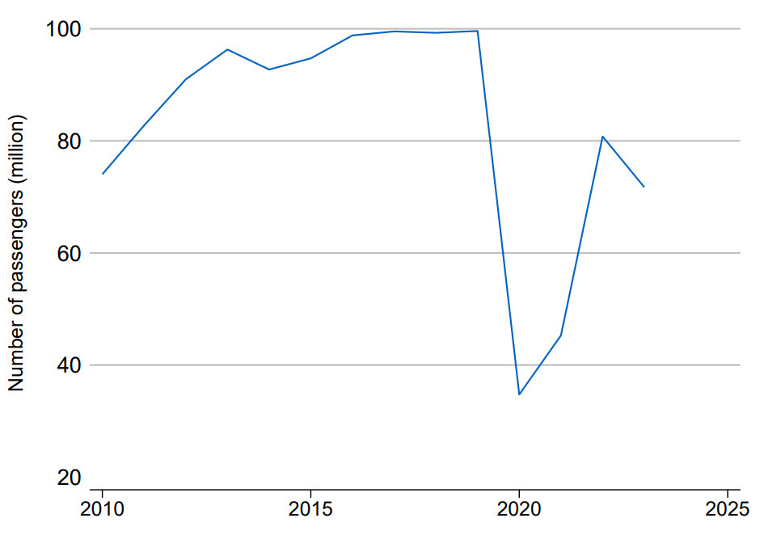
Source: Authors calculations using OAG data

Trends and impacts of competition in Australia

Trends
This section explores the key trends in the domestic aviation market. By any conventional measure, the market is highly concentrated and historically has been serviced by two dominant LGCs, most recently Qantas and Virgin. Figure 4 (Panel A) shows that in 2010 these two airlines carried around 70 per cent of domestic passengers. However, since 2010 we observe a marked increase in competition, as the share of passengers serviced by LCCs steadily increases to 40 per cent in 2020. As LCCs entered the market, many competed directly with LGCs, with the mean number of airlines on the top 200 routes gradually increasing (line of Figure 4, Panel B), and the median number of airlines climbing from 2 to 3 per route (dots of Figure 4, Panel B). COVID-19 was a major disruption to the airline industry, triggering a decline in activity by LCCs and allowing LGCs to regain a greater hold of the market share. The share of passenger traffic accounted for by LCCs reduced to a level similar to 10 years earlier. As pandemic restrictions were removed and air travel resumed, LCCs began to recover their share of passengers. However, the rate of passenger growth for LCCs is lower than LGCs. This reflects the ability of LGCs to add seats faster than LCCs. The impact of COVID-19 on airlines is consistent with the broader literature that larger firms are less likely to be credit or cash constrained as a result of major shocks than smaller or medium-sized firms – for example, Mancusi and Vezzulli (2010) and Bakhtiari et al. (2020).

Figure 4: Trends in competition (Panels A and B)
(A) Share of passengers by low-cost carriers | (B) Mean and median number of airlines on a route
Australia, 2010 to 2023, all routes | Australia, 2010 to 2023, top 200 routes
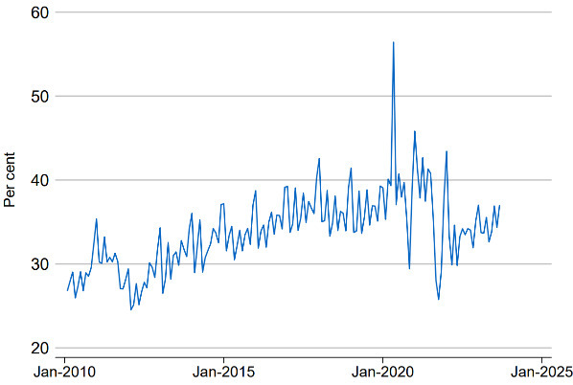 | 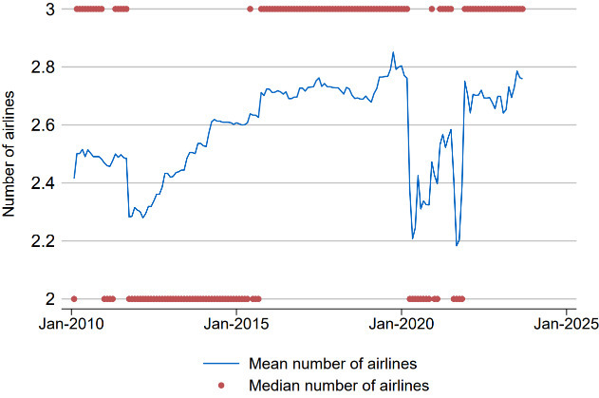
Source: Authors calculations using OAG data
Note: 2020 dip caused by the pandemic. Direction matters for route.

The increasing presence of LCCs in the market has shifted the degree of competition across routes. A greater share of routes now have multiple airlines operating. Figure 5 shows that the share of top 200 routes serviced by a single carrier decreased from nearly 40 per cent in 2010 to about 27 per cent in 2020. In the same period, the share of routes operated by two carriers increased from around 32 per cent to nearly 40 per cent. Post-COVID saw further changes to route level competition, with the share of routes serviced by three carriers larger than ever before at 32 per cent. In the later years, we observe the first emergence of routes with five competitors: between Melbourne, Sydney, Brisbane and Cairns.

Figure 5: Competition across routes has increased over time
Australia, 2010 to 2023, top 200 routes
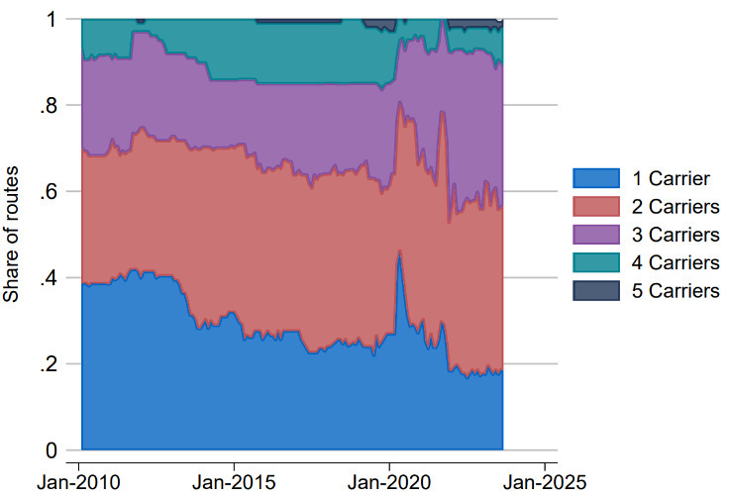
Source: Authors calculations using OAG data

As the industry emerged from travel restrictions and air travel picked up, airlines had an opportunity to reconsider the choice of routes on which they operate. Figure 6 (Panel A) shows that prior to COVID-19, most major airlines flew a consistent number of routes. Post-COVID can be characterised as a period of expansion for some airlines and consolidation for others.
The diversity of routes flown by airlines – measured by the average number of routes offered relative to the most routes offered by any airline – has not recovered from pandemic lows (Panel B of Figure 6). The decrease in route diversity could reflect three factors. First, the expansion of routes offered by Qantas in combination with a consolidation of existing routes by all other airlines (as seen in Panel A). Second, consolidation of routes by non-dominant airlines. Third, recent increases in industry entrants (Panel C) operating relatively fewer routes. Together, these lower average measures of route diversity. Figures 4, 5 and 6 also highlight the complexity of using just one indicator to monitor competition on routes, suggesting a combination of indicators is better.

Figure 6: Trends in routes flown by airlines (Panels A, B and C)
(A) Routes offered by airlines have changed since COVID-19 | (B) Routes serviced by airlines are becoming less diverse
Australia, 2010 to 2023, all routes | Australia, 2010 to 2023, all routes
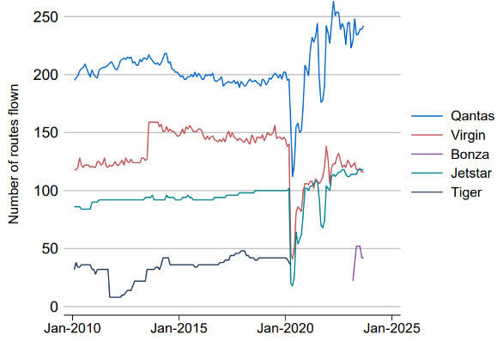 | 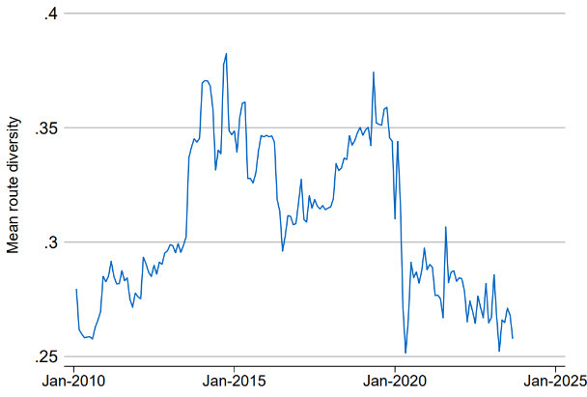
(C) Number of airlines in operation
Australia, 2010 to 2023, all routes
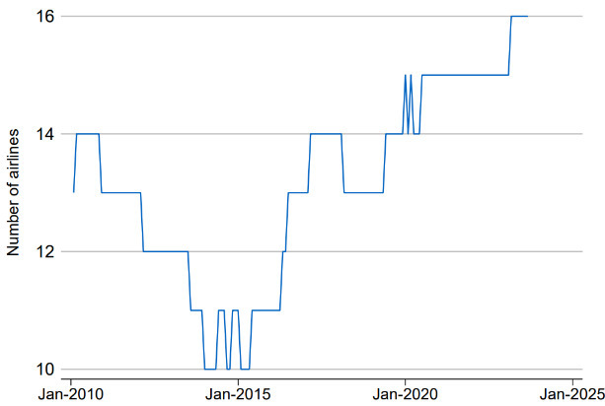
Source: Authors calculations using OAG data
Note: Diversity measured as a proportion of routes offered by an airline relative to other airlines

The aviation sector, both domestic and international, is often undergoing change with entries and exits (as shown in Figure 6 Panel C). This could reflect changing demand, management practices, behaviour of incumbents or exogenous factors. While we see competition increasing across several metrics, recent disruptions including to Bonza and Rex services will need to be monitored closely in terms of their short and medium effects on competition.

Impact on airfares
We present descriptive evidence linking more airlines on a route to lower airfares before presenting econometric analysis in the following section. Figure 7 shows that routes serviced by a monopoly have, on average, higher fares per km than routes with more competition. For instance, when a route is serviced by a monopoly carrier, consumers pay about 40 cents per km, falling to 28 cents when two airlines are present, and 19 cents for three airlines. We see a continued decline in airfares per km as more airlines are added, although at a decreasing rate.

Figure 7: More airlines operating a route is associated with lower fares
Average fare per km decreases as more carriers service a route
Australia, 2010 to 2023, all routes
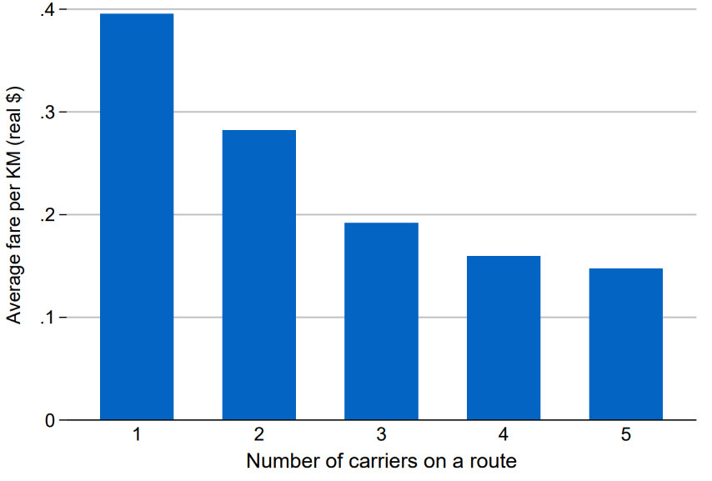
Source: Authors calculations using OAG data
Note: Routes that experienced a change in competitors operating them

In addition to the number of airlines on a route, much price variation is due to route-specific factors (Kwoka et al. 2016). Figure 8 (Panel A) shows average fares for selected airlines. It shows that across all routes, Regional Express has a higher average total fare per km compared to Qantas, Virgin and Jetstar. This partly reflects Regional Express mostly focusing on remote and regional routes with typically lower passenger volumes, fewer airlines and higher input costs for labour and enabling services. In Panel B, we find that on a busier route, such as Sydney to Melbourne, Regional Express can lower fares and compete with other airlines, behaving like an LCC. This pattern is consistent across different routes and highlights the effect of route specific characteristics on airfares. Airlines that fly regional routes typically have higher costs and can sometimes compete with lower airfares on busier routes with lower fares. While this is beneficial to consumers, the sustainability of these routes depends on the long-run cost structures of the airlines (including economies of scale), the behaviours of other airlines and developments on the demand-side of the market among other factors.

Figure 8: Routes matter for competition to affect prices (Panels A and B)
(A) Average total fare per KM (all routes) | (B) Average total fare per KM (Syd – Mel)
2010 to 2023 | 2010 to 2023
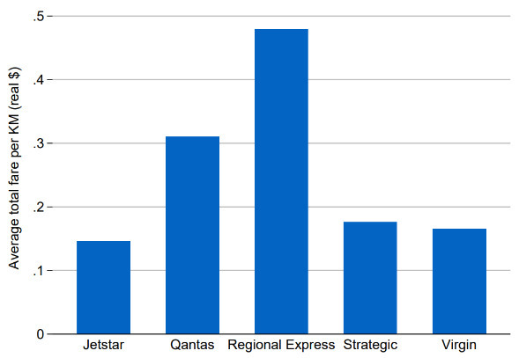 | 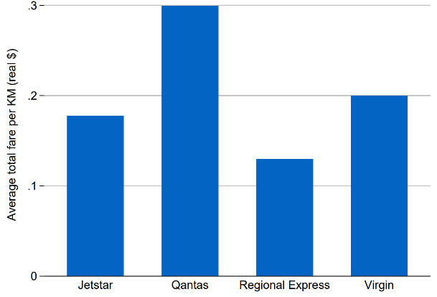
Source: Authors calculations using OAG and ABS data
Note: Direction matters for route
- Methodology

Empirical model
For econometric analysis, we follow the international literature (Kwoka et al., 2016, Evans and Kessides 1994, Brueckner et al. 2013) and use the model described in equation 1, where $i$ indicates airline, $j$ route and $t$ time. $P$, the dependent variable, denotes price (average price, minimum fare, online fare or business fare depending upon the model). We exclude routes that have no legacy carriers. We include dummy variables for the presence of an additional legacy carrier, $LGC_{jt}$, and dummy variables which capture whether there is one, two or three or more low-cost carriers: ${LCC_1}_{jt}$, ${LCC_2}_{jt}$, and ${LCC_3}_{jt}$, respectively. $X_{jt}$ is a vector of control variables likely to affect supply and demand, in particular population, median income and tourist flows at departure and arrival; ${Arr_comp}_{jt}$ and ${Dep_comp}_{jt}$ are the number of airlines operating from arrival and departure airports (which we use as proxies for the threat of competition); $Covid$ is a dummy for the COVID-19 period; $λ$ and $v$ are time and route fixed effects.
$$\begin{aligned}\ln\left(P_{ijt}\right)=B_{1}LGC_{jt}+B_{2}{LCC_1}_{jt}+ B_{3}{LCC_2}_{jt}+ B_{4}{LCC_3}_{jt}+ B_{5}{Arr_comp}_{jt}+ B_{6}{Dep_comp}_{jt} \\ +BX_{jt}+B_{7}Covid_{t}+λ_{t}+v_{j}+ϵ_{ijt}\#\left(1\right)\end{aligned}$$
COVID-19 significantly disrupted air travel in Australia. We employ two strategies to explore this impact. First, we include a dummy variable in our model for the pandemic period, defined as January 2020 through February 2022, inclusive. However, as we expect COVID-19 to impact both the level of prices and the relationships between variables, our preferred estimates split the data into pre- and post-COVID periods (January 2020 and after) and we separately estimate regressions for each period.
We test whether competition has a greater impact when the competition base is low. We test this hypothesis in two ways. First, by using the post-COVID data which, as seen in Figures 4-5, starts from a lower base of competition than the pre-COVID data. Second, limiting our results to regional routes with typically fewer airlines competing on the same route. In both cases, we show the impact of increased competition is higher – suggesting that the level of competition matters and markets with less competition gain more from increasing competition. In the same vein, we test whether increased competition also leads to slower price growth.

Estimation
Despite access to extensive microdata, challenges remain to accurately measuring all relevant factors which might influence prices on a route. In response, we follow Kwoka et al. (2016) and Evans and Kessides (1994) in adopting a route fixed effects model, which controls for time-invariant, route specific factors. The literature argues these fixed effects capture most variation in airfares across routes (see Kwoka et al. (2016) and Evans and Kessides (1994)). The same can be observed in our case.
Given the data and specification of equation (1), our model is likely to suffer from endogeneity. That is, the estimates cannot be treated as causal. The primary cause is the bi-directional effect between prices and competition. More competition, according to our hypothesis, should lead to lower prices. But a market where prices are rising for other reasons may draw in more competitors. Several papers use city population and income as instrumental variables for measures of competition. However, these variables are not suitable as instruments as they impact prices directly and thus belong in the main regression. This precludes them being used as instruments. Papers that do use instruments do not find estimates to be significantly different from fixed effect estimates (Kwoka et al. 2016), which will control for endogeneity arising from time-invariant, route specific factors.
Our approach will be to use fixed effects estimation and not attempt to estimate any models using instrumental variables. We note that any remaining endogeneity through market structure would likely bias our results towards zero, since routes with characteristics that are correlated with high fares would attract entry (Kwoka et al. 2016). For these reasons, our results are most likely to underestimate the impact of competition on airfares. As such, our estimates should be viewed as lower bounds on the effect of competition on prices.
Carriers with common owners, like LGC Qantas and LCC Jetstar, may allow for coordinated price setting. In robustness tests, we use airline fixed effects, which only exploit within-airline variation in prices, and find that results remain largely the same. We utilise cluster-robust standard errors.
We calculate the estimated benefit to consumers based on a counterfactual scenario, in which fares are adjusted using results from the regressions below. The difference between this counterfactual scenario and the actual data can then be used to determine the estimated benefit to consumers. Note that this approach applies average changes on total average fare to all routes with more than one airline and does not consider the responsiveness of consumer demand.
- Results
In Tables 2, 3 and 4, we demonstrate how adding an additional LGC or an LCC can impact average airfares, minimum airfares, online airfares and business airfares. We consider all, top 100, top 200 and top 300 routes by passenger numbers, separating results by LGCs and LCCs. We estimate regressions for the full period (2010–2023) (Table 2) and for the data split pre-Jan 2020 (Table 3) and post-Jan 2020 (Table 4). As mentioned, we prefer estimates that separate these two time periods. Results in this report focus on the top 200 routes, which accounted for about 95 per cent of passenger movements in 2023. Qualitatively, results are similar when we consider all routes, top 100, top 200 or top 300 routes.
We consistently find that increased competition leads to reduced airfares. Our results suggest the presence of an additional airline on a route means airfares are around 5 to 10 per cent lower, falling further with additional airlines – sometimes more than 15 per cent. Additionally, we find the threat of competition can lower airfares.
We estimate that competition in the aviation sector saved consumers $27.2 billion to $35.2 billion (in 2023 dollars) over the 14-year period to 2023. This is equivalent to a saving of about $60 for every return trip, or about $240 for a family of four, and is around 10 per cent of the domestic passenger market size.

All time periods
Table 2 shows results for the full period, 2010–2023. Column 1 shows results for average fares, column 2 for minimum fares, column 3 for online fares and column 4 for business fares. For all four fare types, we see that increased competition results in lower prices. Results show that adding an additional LGC carrier reduces total average airfares by around 9 per cent. While adding one, two or three LCCs reduces average airfares by around 2 per cent, 4 per cent and 17 per cent, respectively. For minimum airfares, an additional LGC reduces airfares by around 7 per cent, while adding one, two or three LCCs reduces airfares by around 6 per cent, 7 per cent and 21 per cent, respectively. Similarly, for online fares an additional LGC reduces airfares by around 3 per cent and adding one, two or three LCCs reduce airfares by around 4 per cent, 6 per cent and 7 per cent, respectively. For business fares, an additional LGC reduces airfares by nearly 5 per cent. Adding one LCC increases airfares by 2 per cent though this is not statistically significant; a second LCC has no impact and a third LCC reduces airfares by about 8 per cent and this last estimate is statistically significant.
In contrast to our results, LCCs generally have a larger impact than LGCs in the European and North American studies (Brueckner et al. 2013; Kwoka et al. 2016; and Alderighi et al. 2012). This may reflect that LCCs in Australia typically have smaller fleets than their European or North American counterparts and thus less ability to challenge incumbents.
We also see additional airlines operating from departure and arrival airports (a proxy for the threat of competition) putting downward pressure on airfares. These results are stronger when the levels of competition are low, as we observe in the results for the post-COVID period.
In addition to the competition variables, Table 2 highlights other demand and supply side variables that impact airfares. We see that median income consistently has a statistically significant, positive impact on average, minimum and business fares. Population has a statistically significant and positive impact on average and online airfares.

Table 2: Effect of increasing airlines on a route
Top 200 routes: 2010–2023
VARIABLES | (1) Average total fare | (2) Minimum fare | (3) Online fare | (4) Business fare
Additional LGC | -0.09*** | -0.07*** | -0.03* | -0.05*
 | (0.02) | (0.02) | (0.02) | (0.03)
First LCC | -0.02 | -0.06*** | -0.04* | 0.02
 | (0.02) | (0.02) | (0.02) | (0.02)
Second LCC | -0.04* | -0.07** | -0.06** | -0.00
 | (0.02) | (0.03) | (0.03) | (0.04)
Third LCC | -0.19*** | -0.23*** | -0.07** | -0.08**
 | (0.03) | (0.03) | (0.03) | (0.04)
Number of airlines (departing airport) | -0.03 | 0.03 | -0.07*** | -0.03
 | (0.03) | (0.03) | (0.02) | (0.04)
Number of airlines (arriving airport) | -0.03 | 0.03 | -0.06*** | -0.02
 | (0.02) | (0.03) | (0.02) | (0.04)
Population | 0.73** | 0.24 | 1.23** | 0.58
 | (0.36) | (0.50) | (0.54) | (0.70)
Income | 2.91*** | 3.30*** | 2.32 | 3.44***
 | (0.75) | (0.71) | (1.50) | (0.88)
Constant | -36.61*** | -33.79*** | -38.20* | -39.11***
 | (9.58) | (10.90) | (21.46) | (12.99)
Observations | 40,527 | 48,852 | 28,478 | 22,009
R-squared | 0.09 | 0.07 | 0.18 | 0.12
Economic Variables | Yes | Yes | Yes | Yes
Route Fixed Effects | Yes | Yes | Yes | Yes
Time Fixed Effects | Yes | Yes | Yes | Yes
Robust standard errors in parentheses
*** p<0.01, ** p<0.05, * p<0.1
Source: Authors calculations using OAG and ABS data
Note: Standard errors clustered at the route level. Population is the sum of both departing and arriving city. Median income is a weighted sum of departing and arriving city. LGC and LCC coefficients must be log transformed to quantify exact impacts.

Pre- and post-COVID
Tables 3 shows results limited to pre-COVID years (February 2010 to January 2020) to be consistent with the results for all years in Table 2. Again, we find the presence of additional carriers on a route puts downward pressure on airfares.
For the average total fare, adding an additional LGC carrier has the greatest statistically significant impact, reducing fares by about 13 per cent. Adding additional LCCs reduces airfares by a further 3 to 5 per cent, though is not statistically significant. For the minimum fare, an additional LGC carrier reduces airfares by 11.3 per cent while adding additional one, two or three LCCs can reduce fares by 7.7, 8.6 and 18.1 per cent, respectively. Online fares in the pre-COVID period were more sensitive to changes in competition than for the full time period, particularly competition from additional LCCs. An additional LGC reduces online airfares by about 4 percent, while adding one, two or three low-cost carriers reduced fares by 4.9, 13.9 and 11.3 per cent, respectively. For business fares, additional carriers, regardless of LGC or LCC, has no significant impact on airfares.
The threat of entry by other carriers puts downward pressure on fares, but the coefficient is only statistically significant in the online fare model. Economic variables largely behave in the direction we expect. Increases in median income, reflecting higher demand, have a statistically significant and positive impact on all fare types. However, population is either insignificant or, in the case of minimum fare, has a negative effect on prices. The latter result is surprising but the overall model remains consistent with our expectations.

Table 3: Effect of increasing airlines on a route
Top 200 routes – pre-COVID
VARIABLES | (1) Average total fare | (2) Minimum fare | (3) Online fare | (4) Business fare
Additional LGC | -0.14*** | -0.12*** | -0.04* | 0.01
 | (0.03) | (0.04) | (0.02) | (0.05)
First LCC | -0.03 | -0.08** | -0.05 | 0.02
 | (0.02) | (0.03) | (0.03) | (0.03)
Second LCC | -0.03 | -0.09* | -0.15*** | 0.01
 | (0.03) | (0.05) | (0.05) | (0.07)
Third LCC | -0.05 | -0.20*** | -0.12** | 0.02
 | (0.04) | (0.06) | (0.05) | (0.08)
Number of airlines (departing airport) | -0.02 | 0.03 | -0.05* | -0.07
 | (0.03) | (0.04) | (0.03) | (0.05)
Number of airlines (arriving airport) | -0.03 | 0.02 | -0.04* | -0.04
 | (0.03) | (0.04) | (0.03) | (0.05)
Population | 0.05 | -1.67** | 0.63 | 1.54
 | (0.57) | (0.70) | (0.76) | (1.20)
Income | 4.06*** | 5.76*** | 3.22*** | 2.67**
 | (0.81) | (0.75) | (1.16) | (1.08)
Constant | -38.81*** | -31.82*** | -38.80** | -45.26***
 | (10.18) | (10.63) | (17.51) | (14.99)
Observations | 30,968 | 36,049 | 16,929 | 16,393
R-squared | 0.06 | 0.05 | 0.05 | 0.09
Economic Variables | Yes | Yes | Yes | Yes
Route Fixed Effects | Yes | Yes | Yes | Yes
Time Fixed Effects | Yes | Yes | Yes | Yes
Robust standard errors in parentheses
*** p<0.01, ** p<0.05, * p<0.1
Source: Authors calculations using OAG and ABS data
Note: Standard errors clustered at the route level. Population is the sum of both departing and arriving city. Median income is a weighted sum of departing and arriving city. LGC and LCC coefficients must be log transformed to quantify exact impacts.

Results for the post-COVID years (January 2020 to November 2023) in Table 4 show a larger impact from competition. This may reflect a larger impact of competition when the base level of competition is low or that airlines may have been pursuing different pricing strategies post-COVID. Table 4 shows increases in competition putting downward pressure on fares in the post-COVID environment, with the effect of the second and third low-cost carrier greater than in the pre-COVID period.

Table 4: Effect of increasing airlines on a route
Top 200 routes – post-COVID
VARIABLES | (1) Average total fare | (2) Minimum fare | (3) Online fare | (4) Business fare
Additional LGC | -0.04 | -0.02 | 0.02 | -0.08**
 | (0.02) | (0.02) | (0.02) | (0.04)
First LCC | -0.00 | -0.06*** | -0.05*** | 0.05**
 | (0.02) | (0.02) | (0.02) | (0.02)
Second LCC | -0.06** | -0.11*** | -0.07** | 0.03
 | (0.02) | (0.03) | (0.03) | (0.03)
Third LCC | -0.35*** | -0.27*** | -0.12*** | -0.17***
 | (0.04) | (0.04) | (0.05) | (0.06)
Number of airlines (departing airport) | -0.10*** | -0.06 | -0.05 | -0.01
 | (0.03) | (0.04) | (0.03) | (0.04)
Number of airlines (arriving airport) | -0.07** | -0.02 | -0.01 | -0.01
 | (0.03) | (0.04) | (0.03) | (0.04)
Population | 4.49*** | 6.33*** | 0.95 | 2.40**
 | (0.76) | (1.03) | (0.83) | (1.11)
Income | 62.03 | 32.15 | 16.50 | 65.03*
 | (39.71) | (49.84) | (40.19) | (35.15)
Constant | -721.79* | -432.27 | -184.50 | -722.40*
 | (421.16) | (527.68) | (427.14) | (372.46)
Observations | 9,559 | 12,803 | 11,549 | 5,616
R-squared | 0.23 | 0.15 | 0.29 | 0.16
Economic Variables | Yes | Yes | Yes | Yes
Route Fixed Effects | Yes | Yes | Yes | Yes
Time Fixed Effects | Yes | Yes | Yes | Yes
Robust standard errors in parentheses
*** p<0.01, ** p<0.05, * p<0.1
Source: Authors calculations using OAG and ABS data
Note: Standard errors clustered at the route level. Population is the sum of both departing and arriving city. Median income is a weighted sum of departing and arriving city. LGC and LCC coefficients must be log transformed to quantify exact impacts.

Specifically, we find that for the average total fare, adding an additional legacy carrier reduces airfares by 3.9 per cent, but is not statistically significant. While the presence of the first low-cost carrier has no significant reduction on airfares, the second reduces airfares by 5.8 per cent and the third by 29.5 per cent. Similarly, an additional legacy carrier operating on a route reduces minimum fares by about 2 per cent, although this estimate is not statistically significant. Low-cost carriers had the largest and most significant impact, with the first low-cost carrier reducing minimum fares by 5.8 per cent, the second by 10.4 per cent, and the third by 23.6 per cent, all highly statistically significant. For online fares, an additional legacy carrier increased fares by 2 per cent, not a statistically significant result, while low-cost carriers significantly reduced fares by 4.8 per cent for the first, 6.8 per cent for the second and 23.7 per cent for the third airline. For business fares, an additional LGC reduces airfares by nearly 8 per cent while the first LCC increases fares by about 5 per cent, the second LCC has no significant effect and the third LCC reduces fares by nearly 16 per cent. Our results show that business fares are more sensitive to competition changes in the post-COVID period.
Starting from a lower base level of competition increased the effect that threat of entry can have on fares. We find that having additional airlines operating from the departing and arriving airport can have a significant impact on average total fares. As previously seen, increases in median income and population put upward pressure on prices for all fare types, though estimated coefficients are sometimes not statistically significant.
- Qantas and Jetstar Interactions
This section explores how the largest legacy carrier, Qantas, interacts with its affiliated LCC, Jetstar, in relation to airfares within a market. Qantas launched Jetstar in May 2004 as a LCC in the domestic market. The two airlines have a codeshare arrangement and Jetstar is often seen as allowing Qantas the ability to exercise a broader pricing and seat composition strategy.
The two carriers offer different fares and composition of services, as is evident from Figures 9 and 10. Jetstar mostly offers seats on the lower end of the price distribution (i.e. Discount Economy), Qantas offers a higher proportion of seats for higher-priced tickets in the Fully Flexible, Premium Economy and Business fare categories. Figure 10 shows that the fares offered by Jetstar are lower than Qantas, both for the average fare and Discount Economy fare. The figures indicate that Jetstar’s operations might allow Qantas to segment the market and exercise a greater degree of price discrimination.

Figure 9: Composition of Monthly Seats (Average), by Airline and Seat Class
Source: Authors calculations using OAG data

Figure 10: Qantas and Jetstar target different markets
Australia, 2010 to 2023, all routes
Source: Authors calculations using OAG data

To properly understand how Jetstar and Qantas interact, we modify equation 1 by distinguishing between whether competing LCC carriers involve Jetstar or not:
$$\begin{aligned}\ln\left(P_{ijt}\right)=B_{1}LGC_{jt}+B_{2}{LCC_1NJST}_{jt}+ B_{2}{LCC_1IJST}_{jt}+ B_{2}{LCC_2NJST}_{jt}+ B_{2}{LCC_2IJST}_{jt}+ \\ B_{2}{LCC_3NJST}_{jt}+ B_{2}{LCC_3IJST}_{jt}+ B_{5} {Arr_{comp}}_{jt}+ B_{6}{Dep_{comp}}_{jt} \\ +BX_{jt}+B_{7}Covid_{t}+λ_{t}+v_{j}+ϵ_{ijt}\#\left(2\right)\end{aligned}$$
The new NJST variables indicate LCCs when the LCCs do not include Jetstar, IJST indicates when LCCs include Jetstar. For instance, $LCC_1NJST$ equals one when there is one, non-Jetstar LCC on the route, $LCC_1IJST$ equals one when there is one LCC, Jetstar, on the route. We estimate equation (2) for all carriers combined and separately for Qantas and Virgin. This section focuses on the pre-COVID period; results for all periods and the post-COVID period are shown in the Appendix B.
Splitting the LCCs into Jetstar and non-Jetstar increases the standard errors and produces many coefficients that are not statistically significant. However, looking at Table 5 which contains the results for all airlines, the general impact of LCCs putting downward pressure on prices remains. The addition of an LGC has a stronger impact than additional LCCs in reducing prices, consistent with the results above. Further, the effect of the third LCC entering a route is only statistically significant in the post-covid sample when the base level of competition is lower, as explored in Section 7.
Table 6 presents results for Qantas only. This provides evidence of potential strategic pricing behaviour between Qantas and Jetstar. The consistent pattern across most airfares is that the entry of Jetstar results in Qantas charging higher prices. This, combined with the results above, suggest that the Qantas group potentially uses Jetstar to segment the market—charging lower fares for Jetstar and higher fares for Qantas. However, this is welfare enhancing for consumers overall, because average airfares are lowered by LCC entry irrespective of whether the LCC is Jetstar or not. Wang et al. (2020) document how interactions by Qantas and Jetstar allows the two airlines to achieve synergy and competition benefits. This kind of behaviour is fairly normal in terms of legacy carriers interacting with their LCC subsidiary (for a study of the “carrier-within-a-carrier” strategy, see for example, Graham, 2015, and Whyte and Lohmann, 2015b). Such arrangement is used by several of the world’s leading airlines (Pearson and Merkert, 2014).
When we restrict focus to Virgin only (Table 7), we don’t find any strong patterns which differ by whether the LCC entry is Jetstar or not. Most coefficients are statistically insignificant given smaller sample sizes and the separating of the LCC variables into smaller groups.

Table 5: Effect of increasing airlines on a route
Top 200 routes – pre-COVID – Jetstar separated
VARIABLES | (1) Average total fare | (2) Minimum fare | (3) Online fare | (4) Discount economy | (5) Full economy | (6) Premium economy | (7) Business fare
First LCC (not Jetstar) | -0.04 | -0.10*** | -0.05 | -0.01 | -0.02 | -0.10*** | 0.06*
 | (0.03) | (0.03) | (0.03) | (0.03) | (0.02) | (0.03) | (0.03)
First LCC | -0.00 | -0.01 | 0.11*** | -0.04 | -0.05 | -0.02 | -0.09
 | (0.05) | (0.08) | (0.04) | (0.04) | (0.03) | (0.09) | (0.06)
Second LCC (not Jetstar) | -0.13** | -0.18*** | -0.05 | -0.12** | 0.03 | -0.10
 | (0.05) | (0.06) | (0.04) | (0.05) | (0.07) | (0.08)
Second LCC | 0.00 | -0.01 | -0.03*** | -0.07 | -0.13*** | 0.00 | -0.09
 | (0.05) | (0.09) | (0.01) | (0.05) | (0.05) | (0.10) | (0.08)
Third LCC | -0.02 | -0.12 |  | -0.09 | -0.04 | -0.03 | -0.08
 | (0.06) | (0.09) |  | (0.06) | (0.05) | (0.10) | (0.09)
Additional LGC | -0.14*** | -0.11*** | -0.04* | -0.11*** | 0.03 | -0.07 | -0.00
 | (0.03) | (0.04) | (0.02) | (0.03) | (0.02) | (0.04) | (0.04)
Number of airlines | -0.02 | 0.03 | -0.05* | -0.04 | 0.06* | 0.07 | -0.07
(departing airport) | (0.03) | (0.04) | (0.03) | (0.03) | (0.03) | (0.04) | (0.05)
Number of airlines | -0.03 | 0.02 | -0.04* | -0.05* | 0.05 | 0.05 | -0.05
(arriving airport) | (0.03) | (0.04) | (0.03) | (0.03) | (0.03) | (0.04) | (0.05)
Population | 0.01 | -1.69** | 0.71 | 0.33 | -0.66 | -2.70*** | 1.32
 | (0.57) | (0.70) | (0.77) | (0.48) | (0.51) | (0.88) | (1.20)
Income | 4.05*** | 5.68*** | 3.26*** | 3.41*** | 3.81*** | 5.36*** | 3.02***
 | (0.81) | (0.74) | (1.16) | (0.74) | (1.13) | (0.79) | (1.08)
Constant | -38.13*** | -30.71*** | -40.43** | -36.06*** | -25.19** | -12.34 | -45.51***
 | (10.19) | (10.60) | (17.59) | (8.84) | (11.67) | (12.39) | (14.78)
Observations | 30,968 | 36,049 | 16,929 | 30,817 | 26,042 | 26,261 | 16,393
R-squared | 0.06 | 0.06 | 0.05 | 0.08 | 0.06 | 0.10 | 0.09
Economic Variables | Yes | Yes | Yes | Yes | Yes | Yes | Yes
Route Fixed Effects | Yes | Yes | Yes | Yes | Yes | Yes | Yes
Time Fixed Effects | Yes | Yes | Yes | Yes | Yes | Yes | Yes
Robust standard errors in parentheses
*** p<0.01, ** p<0.05, * p<0.1
Source: Authors calculations using OAG and ABS data
Note: Standard errors clustered at the route level. Population is the sum of both departing and arriving city. Median income is a weighted sum of departing and arriving city. LGC and LCC coefficients must be log transformed to quantify exact impacts. Most instances of 3 LCCs include Jetstar, as such we are unable to distinguish between 3 LCCs when there is Jetstar and when there isn’t Jetstar on the route.

Table 6: Effect of increasing airlines on a route
Top 200 routes – pre-COVID – Qantas only
VARIABLES | (1) Average total fare | (2) Minimum fare | (3) Online fare | (4) Discount economy | (5) Full economy | (6) Premium Economy | (7) Business fare
First LCC (not Jetstar) | -0.06** | -0.12*** | 0.02 | -0.02 | -0.01 | -0.11** | 0.05***
 | (0.02) | (0.04) | (0.02) | (0.02) | (0.02) | (0.05) | (0.02)
First LCC | 0.07*** | 0.07*** | -0.09 | 0.05*** | 0.06** | 0.12*** | -0.05***
 | (0.02) | (0.02) | (0.09) | (0.02) | (0.03) | (0.02) | (0.02)
Second LCC (not Jetstar) | -0.17** | -0.26*** | 0.02 | -0.12* | -0.13 | -0.22**
 | (0.07) | (0.08) | (0.02) | (0.06) | (0.13) | (0.09)
Second LCC | 0.05** | 0.13*** | 0.00 | -0.01 | -0.02 | 0.19*** | -0.15***
 | (0.02) | (0.04) | (0.01) | (0.03) | (0.05) | (0.05) | (0.04)
Third LCC | 0.01 | -0.04 |  | -0.08*** | 0.13** | 0.15*** | -0.14***
 | (0.03) | (0.05) |  | (0.03) | (0.05) | (0.05) | (0.04)
Additional LGC | -0.08** | -0.05 | 0.01 | -0.06** | 0.02 | -0.03 | 0.04
 | (0.03) | (0.04) | (0.02) | (0.02) | (0.02) | (0.04) | (0.02)
Number of airlines | 0.05* | 0.11** | -0.04* | 0.02 | 0.04 | 0.08 | -0.03
(departing airport) | (0.03) | (0.04) | (0.02) | (0.02) | (0.03) | (0.05) | (0.03)
Number of airlines | 0.04 | 0.08* | -0.04* | 0.02 | -0.00 | 0.05 | -0.02
(arriving airport) | (0.03) | (0.04) | (0.02) | (0.02) | (0.03) | (0.04) | (0.03)
Population | -1.25** | -1.62* | 1.48*** | -0.56 | -0.64 | -1.48 | 0.09
 | (0.62) | (0.95) | (0.47) | (0.48) | (0.59) | (0.99) | (0.81)
Income | 4.37*** | 4.63*** | 2.46*** | 3.81*** | 2.36** | 2.69*** | 1.29
 | (0.66) | (0.69) | (0.81) | (0.64) | (0.97) | (0.70) | (0.78)
Constant | -23.07** | -20.77* | -43.18*** | -27.31*** | -9.90 | -2.07 | -8.44
 | (9.75) | (12.46) | (11.53) | (7.87) | (11.18) | (12.53) | (11.32)
Observations | 16,884 | 16,923 | 6,352 | 16,882 | 15,954 | 16,692 | 8,762
R-squared | 0.25 | 0.16 | 0.32 | 0.23 | 0.07 | 0.15 | 0.13
Economic Variables | Yes | Yes | Yes | Yes | Yes | Yes | Yes
Route Fixed Effects | Yes | Yes | Yes | Yes | Yes | Yes | Yes
Time Fixed Effects | Yes | Yes | Yes | Yes | Yes | Yes | Yes
Robust standard errors in parentheses
*** p<0.01, ** p<0.05, * p<0.1
Source: Authors calculations using OAG and ABS data
Note: Standard errors clustered at the route level. Population is the sum of both departing and arriving city. Median income is a weighted sum of departing and arriving city. LGC and LCC coefficients must be log transformed to quantify exact impacts. Most instances of 3 LCCs include Jetstar, as such we are unable to distinguish between 3 LCCs when there is Jetstar and when there isn’t Jetstar on the route.

Table 7: Effect of increasing airlines on a route
Top 200 routes – pre-COVID – Virgin only
VARIABLES | (1) Average total fare | (2) Minimum fare | (3) Online fare | (4) Discount economy | (5) Full economy | (6) Premium economy | (7) Business fare
First LCC (not Jetstar) | 0.05* | -0.01 | 0.02 | 0.04* | -0.08** | -0.02 | -0.01
 | (0.03) | (0.03) | (0.02) | (0.03) | (0.04) | (0.02) | (0.02)
First LCC | 0.07 | -0.00 | 0.06** | 0.05 | -0.11*** | -0.03 | 0.02
 | (0.06) | (0.05) | (0.03) | (0.07) | (0.04) | (0.05) | (0.03)
Second LCC | -0.05 | -0.11 | -0.02* | -0.09 | -0.08 | -0.06 | -0.03
 | (0.08) | (0.07) | (0.01) | (0.09) | (0.05) | (0.06) | (0.04)
Third LCC | -0.05 | -0.06 |  | -0.07 | -0.07 | -0.08 | -0.06
 | (0.09) | (0.07) |  | (0.10) | (0.06) | (0.06) | (0.04)
Additional LGC | -0.08 | -0.06 | 0.03 | -0.06 | -0.04 | -0.00 | -0.07**
 | (0.05) | (0.06) | (0.02) | (0.05) | (0.03) | (0.02) | (0.03)
Number of airlines | -0.05 | -0.08* | -0.11*** | -0.02 | 0.12** | -0.02 | -0.01
(departing airport) | (0.05) | (0.05) | (0.03) | (0.05) | (0.06) | (0.02) | (0.03)
Number of airlines | -0.07* | -0.05 | -0.12*** | -0.06 | 0.18*** | -0.01 | 0.00
(arriving airport) | (0.04) | (0.05) | (0.03) | (0.04) | (0.06) | (0.03) | (0.03)
Population | 1.60 | 3.08** | -1.16 | 0.88 | -0.21 | 1.56** | 2.17**
 | (1.61) | (1.23) | (0.71) | (1.58) | (1.23) | (0.63) | (0.85)
Income | 2.23 | 5.02*** | 2.23** | 2.07 | 7.56*** | 1.50** | -0.72
 | (1.55) | (1.18) | (1.03) | (1.50) | (1.75) | (0.67) | (1.00)
Constant | -43.25** | -95.23*** | -1.02 | -30.65* | -72.48*** | -34.65*** | -20.65*
 | (16.81) | (14.71) | (12.90) | (15.85) | (22.21) | (8.41) | (10.86)
Observations | 11,929 | 11,933 | 5,492 | 11,793 | 8,362 | 9,460 | 7,626
R-squared | 0.44 | 0.27 | 0.21 | 0.44 | 0.14 | 0.15 | 0.90
Economic Variables | Yes | Yes | Yes | Yes | Yes | Yes | Yes
Route Fixed Effects | Yes | Yes | Yes | Yes | Yes | Yes | Yes
Time Fixed Effects | Yes | Yes | Yes | Yes | Yes | Yes | Yes
Robust standard errors in parentheses
*** p<0.01, ** p<0.05, * p<0.1
Source: Authors calculations using OAG and ABS data
Note: Standard errors clustered at the route level. Population is the sum of both departing and arriving city. Median income is a weighted sum of departing and arriving city. LGC and LCC coefficients must be log transformed to quantify exact impacts. Most instances of 3 LCCs include Jetstar, as such we are unable to distinguish between 3 LCCs when there is Jetstar and when there isn’t Jetstar on the route.
- Robustness
We undertook several robustness checks. First, we re-estimated all models with a simpler specification to remove all economic city-level variables. The estimated the models using various subsets of the data: all routes and the top 100, 200 and 300 routes based on passenger numbers. We estimated models with airline-level fixed effects and we also estimated market-level, as opposed to airline-level, models. Lastly, various alternative definitions of population and income are used and we added tourism activity to the explanatory variables. Qualitatively, our results remain robust to these changes. We examined the behaviour of incumbents only and again found a strong, negative relationship between increased competition and prices.

Bigger impact for competition when the competition base is low
The previous section showed that competition can have a bigger impact when the competition base is lower, in particular in the post-COVID period. However, several factors could have affected these post-COVID results. For more evidence on the impact of competition from a low base, we restrict the data to regional routes with typically fewer airlines operating. If competition’s impact is higher when the base is low, then we are likely to see stronger reductions in airfares on regional routes as competition increases.

Regional routes
Preceding results are all based on the top 200 routes accounting for about 95 per cent of all passenger movements. While those routes are representative of aviation activity within Australia, they do not include the 1,000 routes connecting regional and remote Australia. These are routes typically characterised by low frequency, low passenger volumes, greater distances, typically higher average fixed costs per passenger and lower competition. Given the low base of competition on these routes, our hypothesis is that we would find increasing competition having a bigger impact on these routes. We define regional routes as flights departing or arriving in cities with a population below 200,000 at the SA-4 level.
Table 8 shows results limited to routes flying in or out of regional cities. For the average total fare, an additional LGC reduces fares by 11.3 per cent, and by a further 4–5 per cent for additional LCCs. The minimum fare is impacted most by changes in competition. An additional LGC reduces the minimum fare by about 14 per cent, while the first and second LCCs reduce minimum fares by 12.2 per cent and 13.9 per cent, respectively. An additional LGC reduces online fares by 9.5 per cent, the first LCC by 1 per cent and the second LCC by 12.2 per cent. Finally, an additional LGC reduces business fares by about 7 per cent, while additional LCCs have no impact. All results are statistically significant, with the exception of the first LCC’s impact on online fares and LCCs’ impact on business fares. Regional routes have fewer competitors servicing them; it is rare (only 12 cases) that there are more than two low-cost carriers so we do not include a variable for a third LCC. Here we confirm our hypothesis that competition has a much bigger impact when the competition base is low.
The large number of routes connecting regional Australia generally have fewer airlines servicing them and less competition than routes between major cities. Figure 11 (Panel A) shows that routes operating to or from regional airports typically have between one and two carriers servicing them at any given time. This is compared with city-to-city routes with typically between two and three airlines. Figure 11 (Panel B) graphs some results from table 5 and table 2 demonstrating the impact of an additional airline on the minimum fare offered is about twice as high for regional routes than for top 200 routes.

Table 8: Effect of increasing airlines on a route
Regional routes: 2010–2023
VARIABLES | (1) Average total fare | (2) Minimum fare | (3) Online fare | (4) Business fare
Additional LGC | -0.12*** | -0.15*** | -0.10*** | -0.07**
 | (0.02) | (0.03) | (0.02) | (0.03)
First LCC | -0.04** | -0.13*** | -0.01 | 0.03
 | (0.02) | (0.03) | (0.02) | (0.03)
Second LCC | -0.05* | -0.15* | -0.13*** | -0.03
 | (0.03) | (0.08) | (0.03) | (0.05)
Number of airlines (departing airport) | 0.03 | 0.12** | -0.07** | -0.05
 | (0.03) | (0.05) | (0.03) | (0.04)
Number of airlines (arriving airport) | 0.02 | 0.13*** | -0.06** | -0.05
 | (0.03) | (0.05) | (0.03) | (0.05)
Population | 0.10 | -2.12** | -0.15 | -1.13
 | (0.38) | (0.84) | (0.62) | (0.74)
Income | 1.67** | 3.16*** | 5.44*** | 2.63***
 | (0.74) | (1.05) | (1.75) | (0.98)
Constant | -14.06 | 1.64 | -50.85** | -4.79
 | (9.79) | (13.75) | (22.74) | (13.58)
Observations | 28,120 | 30,919 | 15,158 | 8,256
R-squared | 0.09 | 0.08 | 0.23 | 0.10
Economic Variables | Yes | Yes | Yes | Yes
Route Fixed Effects | Yes | Yes | Yes | Yes
Time Fixed Effects | Yes | Yes | Yes | Yes
Robust standard errors in parentheses
*** p<0.01, ** p<0.05, * p<0.1
Source: Authors calculations using OAG and ABS data
Note: Standard errors clustered at the route level. Population is the sum of both departing and arriving city. Median income is a weighted sum of departing and arriving city. LGC and LCC coefficients must be log transformed to quantify exact impacts. Regional defined as SA4 areas with population less than 200,000.

Figure 11: Airfares more sensitive with a lower competition base (Panels A and B)
(A) Regional routes have fewer airlines  Australia, 2010 to 2023, all routes  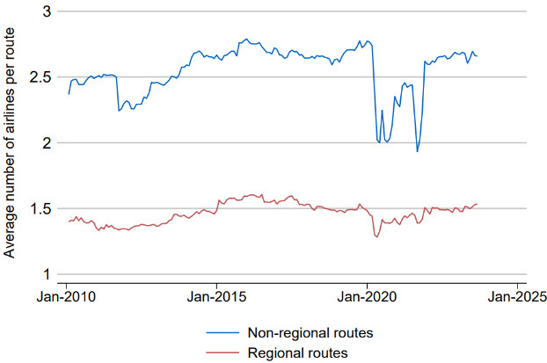 | (B) Effect of increasing airlines on a route for minimum fares  Australia, 2010 to 2023, all routes  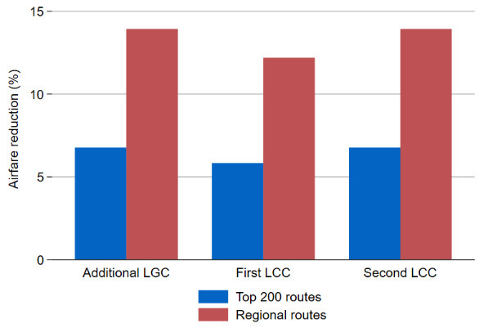
Source: Authors calculations using OAG and ABS data

Competition also helps lower the rate of growth in prices
In this section we ask another important question: does competition impact airfare price changes? We hypothesise that higher competition on routes will translate into lower airfare growth on those routes.
Figure 12 shows two clear breaks in the post-COVID price growth series. We therefore limit our analysis to the pre-COVID period. The pre-COVID period was largely characterised by increasing population and income, where we see moderate levels of increasing demand. We estimate a fixed effects regression of price growth on the number of airlines on a route for the full time period – in line with the model in equation $\left(1\right)$. Table 9 shows that additional carriers operating on a route have a statistically significant impact on limiting price growth. When we take non-linearity into account, we see routes with three to five airlines experience lower price growth than those with one to two airlines (see Figure 13).

Figure 12: Price growth has spiked in the past
Australia, 2010 to 2023, all routes
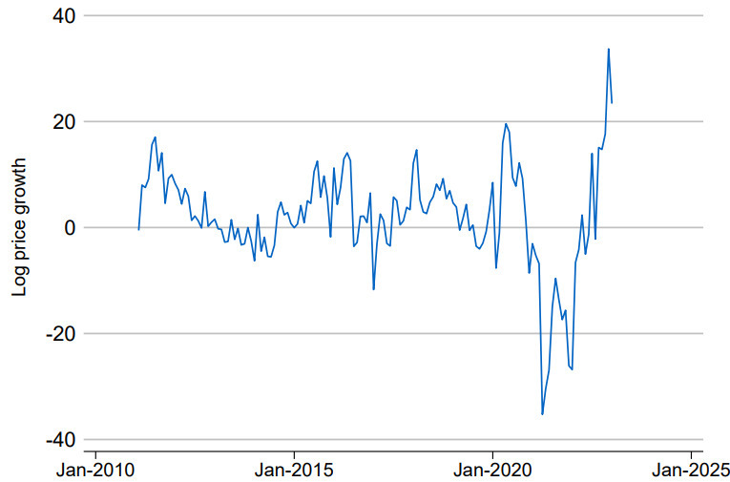
Source: Authors calculations using OAG and ABS data

Table 9: Effect on price growth of increasing airlines
All routes – pre-COVID
VARIABLES | (1) Average fare growth | (2) Average fare growth | (3) Average fare growth
Number of airlines (discrete) | -2.58*** | -2.36**
 | (0.96) | (0.97)
Number of airlines (indicator)
2 Airlines |  |  | -0.90
 |  |  | (1.39)
3 Airlines |  |  | -6.48**
 |  |  | (2.56)
4 Airlines |  |  | -6.54**
 |  |  | (2.74)
5 Airlines |  |  | -6.31*
 |  |  | (3.77)
Observations | 31,246 | 31,246 | 31,246
R-squared | 0.03 | 0.03 | 0.03
Economic Variables | No | Yes | Yes
Threat of competition | No | Yes | Yes
Route Fixed Effects | Yes | Yes | Yes
Time Fixed Effects | Yes | Yes | Yes
Robust standard errors in parentheses
*** p<0.01, ** p<0.05, * p<0.1
Note: Standard errors clustered at the route level
Source: Authors calculations using OAG and ABS data

Figure 13: Increasing the number of airlines suppresses airfare price growth
Australia, pre-COVID, all routes
Source: Authors calculations using OAG and ABS data
Note: Coefficients are detailed in Table 6
Bars represent coefficient estimates. Lines represent 95% confidence intervals
- Conclusion
Australia’s aviation sector is important for the diffusion of ideas, business dynamism, capital and labour mobility, economic growth, and for social inclusion of remote areas. This is the first detailed study to examine how competition affects airfares in Australia. We contribute to the evidence on competition and aviation, building on studies from other OECD economies. Our paper sheds new insights on how competition has impacted airfares post-COVID and how competition interacts with price growth.
The paper uses novel, detailed microdata to examine the effects on domestic airfares of additional carriers entering a route. Key trends from the data show that from 2010, the median number of airlines on the top 200 routes and the share of passengers flown by LCCs have both increased. Further, competition within the top 200 routes has increased and the share of routes serviced by a single carrier declined, meaning more routes are being serviced by two or three carriers. The share of routes serviced by three carriers is larger than ever before. However, the COVID-19 pandemic saw LCCs lose market share to LGCs, and they have recovered at a slower rate than LGCs. These results hold more generally when we consider all routes or the top 100 or the top 300 routes as measured by number of passengers flown.
Descriptive and econometric results demonstrate the significant impact increased competition has on reducing airfares in Australia and limiting price growth. We find clear evidence that the presence of an additional airline on a route means airfares will be 5 to 10 per cent lower, with additional airlines resulting in further reductions. In contrast to the European and North American results, we see that competition from LGCs can reduce airfares more than competition from LCCs. We find a strong and robust relationship suggesting that price growth is curtailed by increased competition. Routes with three to five airlines see lower price growth than routes with one to two airlines, especially at times of demand shocks. In some cases, the threat of competition can lower airfares.
The results show that the Australian aviation sector is subject to regular, periodic entry and exit by airlines, with LGCs retaining their overall market dominance. Despite this, the competitive threat from LCCs has significantly improved over time. However, this has not been the case uniformly across the network, and where the threat of entry has diminished, our results have shown that airfares tend to rise. Thus the key point remains that reducing and removing barriers to entry and expansion, especially on routes where there are only one or two airlines, can significantly improve prices for consumers.
Overall, these results have comprehensively documented a simple but important core point: competition can deliver significantly more affordable prices for Australian consumers by creating pressure on airline businesses to compete. These results should assist policymakers in their task of ensuring Australia’s aviation sector serves the best interests of the Australian community.

Bibliography
Alderighi, M., Cento, A., Nijkamp, P. and Rietveld, P., 2007. Assessment of new hub‐and‐spoke and point‐to‐point airline network configurations. Transport Reviews, 27(5), pp.529–549.
Alderighi, M., Cento, A., Nijkamp, P. and Rietveld, P., 2012. Competition in the European aviation market: the entry of low-cost airlines. Journal of Transport Geography, 24, pp.223–233.
Alderighi, M., Gaggero, A.A. and Piga, C.A., 2015. The effect of code-share agreements on the temporal profile of airline fares. Transportation Research Part A: Policy and Practice, 79, pp.42–54.
Asahi, R. and Murakami, H., 2017. Effects of Southwest Airlines’ entry and airport dominance. Journal of Air Transport Management, 64, pp.86–90.
Athukorala, P. C., Talgaswatta, T., and Majeed, O., 2017. Global production sharing: Exploring Australia’s competitive edge. The World Economy, 40(10), 2172–2192.
Australian Bureau of Statistics (June 2016) ‘Employee income’ [time series spreadsheet], Estimates of Personal Income for Small Areas, accessed 28 April 2024.
Australian Bureau of Statistics (December 2023) ‘Table 3. Employee income, earners and summary statistics by geography’ [time series spreadsheet], Personal Income in Australia, accessed 28 April 2024.
Australian Competition and Consumer Commission (2023a) Airline Competition in Australia. Available at: https://www.accc.gov.au/about-us/publications/serial-publications/domestic-airline-competition-monitoring-reports/airline-competition-in-australia-march-2023-report (Accessed: 06 December 2023).
Australian Competition and Consumer Commission (2023b) Airline Competition in Australia | final report. Available at: https://www.accc.gov.au/system/files/Airline%20competition%20in%20Australia%20-%20June%202023%20report.pdf (Accessed: 06 December 2023).
Australian Trade and Investment Commission, 2024, Australian Trade and Investment Commission website, accessed 28 May 2024, https://international.austrade.gov.au/en/do-business-with-australia/sectors/tourism-and-the-visitor-economy#ref0
Bureau of Transport and Communications Economics, 1991, Report 73: Deregulation of Domestic Aviation – The First Year, Australian Government Publishing Service Canberra.
Bakhtiari, S., Breunig, R., Magnani, L. and Zhang, J., 2020. Financial constraints and small and medium enterprises: A review. Economic Record, 96(315), pp.506–523.
Brueckner, J.K., Lee, D. and Singer, E.S., 2013. Airline competition and domestic US airfares: A comprehensive reappraisal. Economics of Transportation, 2(1), pp.1–17.
Budd, L., Francis, G., Humphreys, I. and Ison, S., 2014. Grounded: Characterising the market exit of European low cost airlines. Journal of Air Transport Management, 34, pp.78–85.
Burton, T. (2023) ‘Australians are being taken for a ride by the flying kangaroo’, Australian Financial Review, 7 September. Available at: https://www.afr.com/politics/federal/australians-are-being-taken-for-a-ride-by-the-flying-kangaroo-20230906-p5e2mb (Accessed: 06 December 2023).
Chen, Y. and Gayle, P.G., 2019. Mergers and product quality: Evidence from the airline industry. International Journal of Industrial Organization, 62, pp.96–135.
De Roos, N., Mills, G. and Whelan, S., 2010. Pricing dynamics in the Australian airline market. Economic Record, 86(275), pp.545–562.
Dobruszkes, F., 2006. An analysis of European low-cost airlines and their networks. Journal of Transport Geography, 14(4), pp.249–264.
Dresner, M., Lin, J.S.C. and Windle, R., 2017. The impact of low-cost carriers on airport and route competition. In Low Cost Carriers (pp. 241–260). Routledge.
Dresner, M., Gualini, A., Martini, G. and Valli, M., 2021. Airline competition and LCCs in the North Atlantic market. Journal of Transport Economics and Policy (JTEP), 55(4), pp.261–282.
European Parliament Committee on Transport and Tourism (2007) The Consequences of the Growing European Low-Cost Airline Sector. Available at: https://www.europarl.europa.eu/RegData/etudes/etudes/join/2007/397234/IPOL-TRAN_ET(2007)397234_EN.pdf (Accessed: 06 December 2023).
Evans, W.N. and Kessides, I.N., 1994. Living by the “golden rule”: Multimarket contact in the US airline industry. The Quarterly Journal of Economics, 109(2), pp.341–366.
Forsyth, P., 2003. Airport competition and the efficiency of price structures at major airports. In GARS Research Seminar, Leipzig.
Goolsbee, A. and Syverson, C., 2008. How do incumbents respond to the threat of entry? Evidence from the major airlines. The Quarterly journal of economics, 123(4), pp.1611–1633.
Graham, B. and Vowles, T.M., 2017. Carriers within carriers: A strategic response to low-cost airline competition. In Low Cost Carriers (pp. 353–374). Routledge.
Gualini, A., Martini, G. and Porta, F., 2022. The Effect of Low-Cost competition on Airfares in the European Skies. In Quaderni del Dipartimento di Scienze economiche (Vol. 15). Università degli studi di Bergamo.
Gualini, A., Martini, G. and Porta, F., 2024. Are low cost carriers airfares still lower? A comparison with full service carriers in Europe. Journal of the Air Transport Research Society, 2, p.100012.
Hofer, C., Windle, R.J. and Dresner, M.E., 2008. Price premiums and low cost carrier competition. Transportation Research Part E: Logistics and Transportation Review, 44(5), pp.864–882.
Kwoka, J., Hearle, K. and Alepin, P., 2016. From the fringe to the forefront: Low cost carriers and airline price determination. Review of Industrial Organization, 48, pp.247–268.
Lawrence, C., 1991. Deregulation of Domestic Aviation-The First Year. Available at SSRN 1317203.
Lin, J.S.C., Dresner, M. and Windle, R., 2001. Determinants of price reactions to entry in the US airline industry. Transportation Journal, pp.5–22.
Lim, J. and Lee, H.C., 2020. Comparisons of service quality perceptions between full service carriers and low cost carriers in airline travel. Current issues in Tourism, 23(10), pp.1261–1276.
Ma, W., Wang, Q., Yang, H. and Zhang, Y., 2019. An analysis of price competition and price wars in Australia’s domestic airline market. Transport Policy, 81, pp.163–172.
Mancusi, M.L. and Vezzulli, A., 2010, March. R&D, innovation and liquidity constraints. In CONCORD 2010 conference, Sevilla (pp. 3–4).
Mantin, B. and Koo, B., 2009. Dynamic price dispersion in airline markets. Transportation Research Part E: Logistics and Transportation Review, 45(6), pp.1020–1029.
Morrell, P., 2008. Can long-haul low-cost airlines be successful?. Research in Transportation Economics, 24(1), pp.61–67.
Morrison, S.A., 2001. Actual, adjacent, and potential competition estimating the full effect of Southwest Airlines. Journal of Transport Economics and Policy (JTEP), 35(2), pp.239–256.
Pearson, J. and Merkert, R., 2014. Airlines-within-airlines: A business model moving East. Journal of Air Transport Management, 38, pp.21–26.
Ren, J., 2020. Fare impacts of Southwest Airlines: A comparison of nonstop and connecting flights. Journal of Air Transport Management, 84, p.101771.
Rupp, N., Owens, D. and Plumly, L., 2006. Does competition influence airline on-time performance. Advances in airline economics, 1(1), pp.251–272.
Scotti, D. and Dresner, M., 2022. The impact of low-cost carriers’ growth on the air networks of european network carriers. Journal of Transport Economics and Policy (JTEP), 56(4), pp.429–444.
Tan, K.M., 2016. Incumbent response to entry by low‐cost carriers in the US airline industry. Southern Economic Journal, 82(3), pp.874–892.
Varella, R.R., Frazão, J. and Oliveira, A.V., 2017. Dynamic pricing and market segmentation responses to low-cost carrier entry. Transportation Research Part E: Logistics and Transportation Review, 98, pp.151–170.
Wang, K., Tsui, W.H.K., Li, L.B., Lei, Z. and Fu, X., 2020. Entry pattern of low-cost carriers in New Zealand-The impact of domestic and trans-Tasman market factors. Transport Policy, 93, pp.36–45.
Wilken, D., Berster, P. and Gelhausen, M.C., 2016. Analysis of demand structures on intercontinental routes to and from Europe with a view to identifying potential for new low-cost services. Journal of Air Transport Management, 56, pp.79–90.
Windle, R.J. and Dresner, M.E., 1995. The short and long run effects of entry on US domestic air routes. Transportation Journal, pp.14–25.
Whyte, R. and Lohmann, G., 2015a. Low-cost long-haul carriers: A hypothetical analysis of a ‘Kangaroo route’. Case Studies on Transport Policy, 3(2), pp.159–165.
Whyte, R. and Lohmann, G., 2015b. The carrier-within-a-carrier strategy: An analysis of Jetstar. Journal of Air Transport Management, 42, pp.141–148.
Wong, W.H., Zhang, A., Cheung, T.K.Y. and Chu, J., 2019. Examination of low-cost carriers’ development at secondary airports using a comprehensive world airport classification. Journal of Air Transport Management, 78, pp.96–105.

Appendix

Appendix A – Rex case study
Given the recent announcement of Rex entering voluntary administration and grounding its Domestic 737 services, this section examines their position on affected routes. The aviation sector, both domestic and international, is often undergoing change with entries and exits. This could reflect changing demand, management practices, behaviour of incumbents or exogenous factors. Figure 6 (Panel C) shows that in the domestic aviation market, Australia has witnessed several airlines entries and exits since 2010. Rex’s withdrawal from capital city routes is an interesting case study given their importance on various routes.
In July 2024, Rex announced that it would enter voluntary administration and ground its Domestic 737 services with flights between major airports being cancelled, totalling 26 uni-directional routes. The primary service offering of regional routes was unaffected by this announcement, and we see that the affected routes are a relatively small share of all routes Rex services, reaching a maximum of around 20 per cent in terms of number of flights flown (Figure A1).

Figure A1: Affected services make up a small portion of total flights
Rex, 2021 to 2024, all routes
Source: Authors calculations using OAG data
On these routes, Rex typically had a low passenger share, ranging from 0.3 to 13 per cent, as it competed with the two incumbent LGC’s and Jetstar for passengers with a significantly smaller fleet size and aircraft. Table A1 below shows Rex’s market share on affected routes in the 12 months to May 2024.

Table A1: Rex market share on affected routes
Affected routes, May 2023 – May 2024
Route | Rex market share (%)
ADL - BNE | <10%
ADL - MEL | <15%
ADL - PER | NA
ADL - SYD | <10%
BNE - ADL | <10%
BNE - CNS | <5%
BNE - MEL | <10%
BNE - SYD | <15%
CBR - MEL | <15%
CNS - BNE | <5%
HBA - MEL | <10%
MEL - ADL | <15%
MEL - BNE | <10%
MEL - CBR | <15%
MEL - HBA | <10%
MEL - OOL | <5%
MEL - PER | NA
MEL - SYD | <10%
OOL - MEL | <5%
OOL - SYD | <5%
PER - ADL | NA
PER - MEL | NA
SYD - ADL | <10%
SYD - BNE | <15%
SYD - MEL | <10%
SYD - OOL | <5%
Despite this, these routes have quickly become a large portion of Rex’s total passenger share. Figure A2 (Panel A) shows that the affected routes saw a significant increase in passengers flown by Rex, going from close to 50 per cent of its passengers to 70 per cent in late 2023. This is not surprising given the significant demand for travel along these routes compared to regional routes. Consistent with Figure 8, we also see that on these busier routes, Rex competes directly with incumbent carriers by offering amongst the lowest fares, as shown in Figure A2 (Panel B).

Figure A2: Trends in competition (Panels A and B)
(A) Share of Rex passengers on affected routes | (B) Average airfares on affected routes
Australia, 2021 to 2024, affected routes | Australia, 2020 to 2024, affected routes
Source: Authors calculations using OAG data

Appendix B

Table B1: Summary statistics
VARIABLES | N | mean | sd | min | max
Average total fare | 65,904 | 218.8 | 109.1 | 10.07 | 1,838
Online fare | 34,510 | 189.9 | 94.87 | 40.83 | 873.5
Minimum fare | 77,006 | 174.1 | 90.53 | 10.07 | 1,838
Business fare | 23,117 | 751.5 | 394.2 | 14.10 | 4,522
LGC 0 | 137,371 | 0.432 | 0.495 | 0 | 1
LGC 1 | 137,371 | 0.242 | 0.428 | 0 | 1
LGC 2 | 137,371 | 0.327 | 0.469 | 0 | 1
LCC 0 | 137,371 | 0.197 | 0.397 | 0 | 1
LCC 1 | 137,371 | 0.661 | 0.473 | 0 | 1
LCC 2 | 137,371 | 0.134 | 0.340 | 0 | 1
LCC 3 | 137,371 | 0.008 | 0.091 | 0 | 1
Number of airlines (departing airport) | 137,371 | 4.370 | 2.448 | 1 | 10
Number of airlines (arriving airport) | 137,371 | 4.349 | 2.433 | 1 | 10
Tourism visitors (arriving city, 000’s) | 136,606 | 332.8 | 319.0 | 4.855 | 1,211
Tourism visitors (departing city, 000’s) | 136,615 | 333.7 | 319.1 | 4.855 | 1,211
Herfindahl index (route level) | 111,368 | 0.283 | 0.0157 | 0.196 | 0.311
Population | 137,225 | 2.739e+06 | 2.347e+06 | 163,210 | 1.068e+07
Median income | 137,225 | 45,521 | 3,511 | 34,273 | 60,416
Note: All routes. Statistics are based on airline-route-month observations. Population is the sum of both departing and arriving city. Median income is a weighted sum of departing and arriving city.

The following tables show results when including a measure of tourism activity on each route. Note that a variety of tourism measures were tested, and each had similar qualitative results. This includes the count of visitors in each city, ratio of visitors to population for each city and joint tourism proportions.

Table B2: Effect of increasing airlines on a route
Top 200 routes: 2010–2023
VARIABLES | (1) Average total fare | (2) Minimum fare | (3) Online fare | (4) Business fare
Additional LGC | -0.08*** | -0.07*** | -0.02 | -0.04
 | (0.02) | (0.02) | (0.02) | (0.03)
First LCC | -0.02 | -0.06*** | -0.03* | 0.02
 | (0.02) | (0.02) | (0.02) | (0.02)
Second LCC | -0.03* | -0.07** | -0.06** | -0.00
 | (0.02) | (0.03) | (0.03) | (0.04)
Third LCC | -0.18*** | -0.22*** | -0.07** | -0.08**
 | (0.03) | (0.03) | (0.03) | (0.04)
Number of airlines (departing airport) | -0.03 | 0.01 | -0.07*** | -0.04
 | (0.02) | (0.03) | (0.02) | (0.04)
Number of airlines (arriving airport) | -0.03 | 0.01 | -0.06*** | -0.02
 | (0.02) | (0.03) | (0.02) | (0.04)
Number of tourism visitors (arriving city) | 0.10*** | 0.12*** | 0.09*** | -0.07
 | (0.03) | (0.03) | (0.03) | (0.05)
Number of tourism visitors (departing city) | 0.10*** | 0.14*** | 0.07*** | -0.08
 | (0.03) | (0.03) | (0.03) | (0.05)
Population | 0.67* | 0.17 | 0.76 | 0.98
 | (0.35) | (0.49) | (0.51) | (0.76)
Income | 3.72*** | 4.30*** | 2.42* | 2.79***
 | (0.73) | (0.70) | (1.35) | (0.83)
Constant | -45.45*** | -45.03*** | -33.13* | -37.31***
 | (9.40) | (10.51) | (19.13) | (11.86)
Observations | 40,290 | 48,582 | 28,227 | 21,839
R-squared | 0.09 | 0.07 | 0.18 | 0.12
Economic Variables | Yes | Yes | Yes | Yes
Route Fixed Effects | Yes | Yes | Yes | Yes
Time Fixed Effects | Yes | Yes | Yes | Yes
Robust standard errors in parentheses
*** p<0.01, ** p<0.05, * p<0.1
Source: Authors calculations using OAG and ABS data
Note: Standard errors clustered at the route level. Population is the sum of both departing and arriving city. Median income is a weighted sum of departing and arriving city. LGC and LCC coefficients must be log transformed to quantify exact impacts.

Table B3: Effect of increasing airlines on a route
Top 200 routes: 2010–2023 – Qantas only
VARIABLES | (1) Average total fare | (2) Minimum fare | (3) Online fare | (4) Business fare
Additional LGC | -0.03 | -0.03 | -0.05*** | 0.00
 | (0.02) | (0.03) | (0.01) | (0.02)
First LCC | -0.03* | -0.08*** | 0.00 | 0.04***
 | (0.02) | (0.03) | (0.01) | (0.01)
Second LCC | -0.05*** | -0.04 | 0.06** | -0.03
 | (0.02) | (0.04) | (0.02) | (0.02)
Third LCC | -0.12*** | -0.21*** | -0.01 | -0.01
 | (0.02) | (0.04) | (0.03) | (0.03)
Number of airlines (departing airport) | 0.02 | 0.08** | -0.01 | 0.01
 | (0.02) | (0.04) | (0.02) | (0.02)
Number of airlines (arriving airport) | 0.02 | 0.07* | 0.00 | 0.00
 | (0.02) | (0.03) | (0.02) | (0.03)
Population | -0.37 | -0.61 | 1.92*** | -0.37
 | (0.46) | (0.71) | (0.49) | (0.60)
Income | 3.06*** | 3.24*** | 0.82 | 1.66**
 | (0.72) | (0.73) | (1.18) | (0.77)
Constant | -21.90** | -20.62 | -32.04* | -5.54
 | (10.00) | (12.60) | (17.38) | (10.69)
Observations | 22,064 | 22,539 | 11,941 | 11,434
R-squared | 0.24 | 0.15 | 0.50 | 0.13
Economic Variables | Yes | Yes | Yes | Yes
Route Fixed Effects | Yes | Yes | Yes | Yes
Time Fixed Effects | Yes | Yes | Yes | Yes
Robust standard errors in parentheses
*** p<0.01, ** p<0.05, * p<0.1
Source: Authors calculations using OAG and ABS data
Note: Standard errors clustered at the route level. Population is the sum of both departing and arriving city. Median income is a weighted sum of departing and arriving city. LGC and LCC coefficients must be log transformed to quantify exact impacts.

Table B4: Effect of increasing airlines on a route
Top 200 routes – pre-COVID
VARIABLES | (1) Average total fare | (2) Minimum fare | (3) Online fare | (4) Business fare
Additional LGC | -0.14*** | -0.12*** | -0.04* | 0.00
 | (0.03) | (0.04) | (0.02) | (0.05)
First LCC | -0.03 | -0.08** | -0.04 | 0.01
 | (0.02) | (0.03) | (0.04) | (0.03)
Second LCC | -0.03 | -0.09* | -0.15*** | 0.00
 | (0.03) | (0.05) | (0.05) | (0.07)
Third LCC | -0.05 | -0.20*** | -0.13** | 0.01
 | (0.04) | (0.06) | (0.05) | (0.08)
Number of airlines (departing airport) | -0.03 | 0.02 | -0.04 | -0.06
 | (0.03) | (0.04) | (0.03) | (0.05)
Number of airlines (arriving airport) | -0.04 | 0.01 | -0.03 | -0.04
 | (0.03) | (0.04) | (0.03) | (0.05)
Number of tourism visitors (arriving city) | 0.03 | 0.02 | 0.15*** | -0.21**
 | (0.04) | (0.05) | (0.04) | (0.09)
Number of tourism visitors (departing city) | 0.05 | 0.07 | 0.11** | -0.22***
 | (0.04) | (0.04) | (0.04) | (0.08)
Population | 0.03 | -1.68** | -0.26 | 1.53
 | (0.56) | (0.70) | (0.84) | (1.21)
Income | 4.26*** | 5.96*** | 1.85 | 1.79*
 | (0.80) | (0.77) | (1.18) | (1.04)
Constant | -41.07*** | -34.19*** | -12.33 | -33.30**
 | (9.90) | (10.46) | (19.89) | (13.24)
Observations | 30,968 | 36,049 | 16,929 | 16,393
R-squared | 0.06 | 0.06 | 0.05 | 0.09
Economic Variables | Yes | Yes | Yes | Yes
Route Fixed Effects | Yes | Yes | Yes | Yes
Time Fixed Effects | Yes | Yes | Yes | Yes
Robust standard errors in parentheses
*** p<0.01, ** p<0.05, * p<0.1
Source: Authors calculations using OAG and ABS data
Note: Standard errors clustered at the route level. Population is the sum of both departing and arriving city. Median income is a weighted sum of departing and arriving city. LGC and LCC coefficients must be log transformed to quantify exact impacts.

Table B5: Effect of increasing airlines on a route
Top 200 routes – pre-COVID – Qantas only
VARIABLES | (1) Average total fare | (2) Minimum fare | (3) Online fare | (4) Business fare
Additional LGC | -0.07** | -0.04 | 0.01 | 0.03
 | (0.03) | (0.04) | (0.02) | (0.02)
First LCC | -0.05** | -0.10*** | 0.02 | 0.04**
 | (0.02) | (0.04) | (0.02) | (0.02)
Second LCC | -0.07** | -0.04 | 0.04 | -0.07
 | (0.03) | (0.06) | (0.03) | (0.04)
Third LCC | -0.11*** | -0.20*** | 0.04 | -0.05
 | (0.03) | (0.07) | (0.03) | (0.05)
Number of airlines | 0.05* | 0.10** | -0.04* | -0.03
(departing airport) | (0.03) | (0.04) | (0.02) | (0.03)
Number of airlines | 0.04 | 0.07* | -0.04* | -0.02
(arriving airport) | (0.03) | (0.04) | (0.02) | (0.03)
Population | -1.23** | -1.57* | 1.51*** | 0.11
 | (0.62) | (0.95) | (0.47) | (0.81)
Income | 4.43*** | 4.70*** | 2.47*** | 1.15
 | (0.67) | (0.71) | (0.81) | (0.78)
Constant | -23.98** | -22.32* | -43.62*** | -7.31
 | (9.70) | (12.39) | (11.60) | (11.50)
Observations | 16,884 | 16,923 | 6,352 | 8,762
R-squared | 0.25 | 0.16 | 0.32 | 0.13
Economic Variables | Yes | Yes | Yes | Yes
Route Fixed Effects | Yes | Yes | Yes | Yes
Time Fixed Effects | Yes | Yes | Yes | Yes
Robust standard errors in parentheses
*** p<0.01, ** p<0.05, * p<0.1
Source: Authors calculations using OAG and ABS data
Note: Standard errors clustered at the route level. Population is the sum of both departing and arriving city. Median income is a weighted sum of departing and arriving city. LGC and LCC coefficients must be log transformed to quantify exact impacts.

Table B6: Effect of increasing airlines on a route
Top 200 routes – post-COVID
VARIABLES | (1) Average total fare | (2) Minimum fare | (3) Online fare | (4) Business fare
Additional LGC | -0.04 | -0.02 | 0.02 | -0.07*
 | (0.02) | (0.02) | (0.02) | (0.04)
First LCC | 0.00 | -0.06*** | -0.05*** | 0.06***
 | (0.02) | (0.02) | (0.02) | (0.02)
Second LCC | -0.06** | -0.11*** | -0.07** | 0.03
 | (0.02) | (0.03) | (0.03) | (0.03)
Third LCC | -0.34*** | -0.27*** | -0.12*** | -0.16***
 | (0.04) | (0.04) | (0.04) | (0.05)
Number of airlines (departing airport) | -0.10*** | -0.05 | -0.04 | 0.02
 | (0.04) | (0.04) | (0.03) | (0.04)
Number of airlines (arriving airport) | -0.06* | -0.01 | -0.00 | 0.01
 | (0.03) | (0.04) | (0.03) | (0.04)
Number of tourism visitors (arriving city) | 0.05 | 0.07* | 0.09*** | 0.10**
 | (0.03) | (0.04) | (0.03) | (0.05)
Number of tourism visitors (departing city) | 0.04 | 0.07* | 0.08** | 0.11*
 | (0.04) | (0.04) | (0.03) | (0.05)
Population | 3.93*** | 5.47*** | -0.19 | 1.17
 | (0.77) | (0.89) | (0.81) | (1.13)
Income | 55.72 | 22.75 | 7.60 | 45.54
 | (38.80) | (47.73) | (37.22) | (32.89)
Constant | -646.98 | -320.27 | -73.56 | -497.58
 | (412.23) | (504.85) | (396.42) | (350.74)
Observations | 9,322 | 12,533 | 11,298 | 5,446
R-squared | 0.23 | 0.15 | 0.30 | 0.16
Economic Variables | Yes | Yes | Yes | Yes
Route Fixed Effects | Yes | Yes | Yes | Yes
Time Fixed Effects | Yes | Yes | Yes | Yes
Robust standard errors in parentheses
*** p<0.01, ** p<0.05, * p<0.1
Source: Authors calculations using OAG and ABS data
Note: Standard errors clustered at the route level. Population is the sum of both departing and arriving city. Median income is a weighted sum of departing and arriving city. LGC and LCC coefficients must be log transformed to quantify exact impacts.

Table B7: Effect of increasing airlines on a route
Top 200 routes – post-COVID – Qantas only
VARIABLES | (1) Average total fare | (2) Minimum fare | (3) Online fare | (4) Business fare
First LCC | 0.02* | -0.02** | -0.03** | 0.02
 | (0.01) | (0.01) | (0.01) | (0.01)
Second LCC | 0.00 | -0.07*** | -0.07*** | 0.00
 | (0.01) | (0.03) | (0.03) | (0.02)
Third LCC | -0.15*** | -0.17*** | -0.15*** | -0.04
 | (0.03) | (0.03) | (0.03) | (0.05)
Additional LGC | 0.00 | -0.02* | -0.04*** | -0.03*
 | (0.01) | (0.01) | (0.01) | (0.02)
Number of airlines | -0.07*** | -0.04* | -0.00 | -0.01
(departing airport) | (0.03) | (0.02) | (0.03) | (0.03)
Number of airlines | -0.04 | 0.01 | 0.04 | -0.02
(arriving airport) | (0.02) | (0.02) | (0.02) | (0.04)
Population | 1.07* | 2.39*** | 2.31*** | 0.29
 | (0.60) | (0.80) | (0.78) | (0.76)
Income | 97.54*** | 45.31 | 29.57 | 0.61
 | (30.80) | (34.42) | (39.25) | (25.01)
Constant | -1,048.22*** | -512.42 | -343.77 | -4.25
 | (328.77) | (366.23) | (418.30) | (264.53)
Observations | 5,180 | 5,616 | 5,589 | 2,672
R-squared | 0.39 | 0.24 | 0.56 | 0.10
Economic Variables | Yes | Yes | Yes | Yes
Route Fixed Effects | Yes | Yes | Yes | Yes
Time Fixed Effects | Yes | Yes | Yes | Yes
Robust standard errors in parentheses
*** p<0.01, ** p<0.05, * p<0.1
Source: Authors calculations using OAG and ABS data
Note: Standard errors clustered at the route level. Population is the sum of both departing and arriving city. Median income is a weighted sum of departing and arriving city. LGC and LCC coefficients must be log transformed to quantify exact impacts.

Table B8: Effect of increasing airlines on a route
Top 200 routes – all periods – Jetstar separated
VARIABLES | (1) Average total fare | (2) Minimum fare | (3) Online fare | (4) Discount economy | (6) Full economy | (7) Premium economy | (7) Business fare
First LCC (not Jetstar) | -0.03* | -0.07*** | -0.00 | -0.01 | -0.01 | -0.06** | 0.06**
 | (0.02) | (0.02) | (0.02) | (0.02) | (0.02) | (0.03) | (0.03)
First LCC | 0.01 | -0.04 | -0.12*** | 0.00 | 0.01 | -0.01 | -0.05
 | (0.03) | (0.04) | (0.02) | (0.02) | (0.02) | (0.05) | (0.03)
Second LCC (not Jetstar) | -0.05 | -0.07** | 0.04 | -0.02 | 0.11** | -0.01 | -0.25***
 | (0.03) | (0.04) | (0.03) | (0.03) | (0.05) | (0.05) | (0.03)
Second LCC | -0.00 | -0.06 | -0.13*** | -0.03 | -0.03 | -0.02 | -0.06*
 | (0.03) | (0.05) | (0.02) | (0.03) | (0.03) | (0.06) | (0.04)
Third LCC | -0.16*** | -0.21*** | -0.14*** | -0.16*** | -0.00 | -0.21*** | -0.14***
 | (0.04) | (0.05) | (0.03) | (0.04) | (0.03) | (0.06) | (0.04)
Additional LGC | -0.09*** | -0.07*** | -0.03* | -0.07*** | 0.03* | -0.02 | -0.05*
 | (0.02) | (0.02) | (0.02) | (0.02) | (0.02) | (0.03) | (0.03)
Number of airlines | -0.02 | 0.03 | -0.07*** | -0.04* | 0.04 | 0.06 | -0.04
(departing airport) | (0.02) | (0.03) | (0.02) | (0.02) | (0.03) | (0.04) | (0.04)
Number of airlines | -0.02 | 0.03 | -0.07*** | -0.04* | 0.03 | 0.05 | -0.02
(arriving airport) | (0.02) | (0.03) | (0.02) | (0.02) | (0.03) | (0.04) | (0.04)
Population | 0.70* | 0.22 | 1.37** | 0.79** | -0.09 | -0.48 | 0.61
 | (0.37) | (0.51) | (0.55) | (0.31) | (0.40) | (0.64) | (0.69)
Income | 2.88*** | 3.28*** | 2.46 | 2.36*** | 2.85** | 2.43*** | 3.64***
 | (0.75) | (0.70) | (1.54) | (0.66) | (1.12) | (0.76) | (0.88)
Constant | -35.90*** | -33.42*** | -41.69* | -31.62*** | -23.42* | -13.88 | -41.62***
 | (9.66) | (10.94) | (22.05) | (8.45) | (12.56) | (12.50) | (12.87)
Observations | 40,527 | 48,852 | 28,478 | 40,372 | 33,631 | 34,953 | 22,009
R-squared | 0.09 | 0.07 | 0.18 | 0.10 | 0.06 | 0.08 | 0.12
Economic Variables | Yes | Yes | Yes | Yes | Yes | Yes | Yes
Route Fixed Effects | Yes | Yes | Yes | Yes | Yes | Yes | Yes
Time Fixed Effects | Yes | Yes | Yes | Yes | Yes | Yes | Yes
Robust standard errors in parentheses
*** p<0.01, ** p<0.05, * p<0.1
Source: Authors calculations using OAG and ABS data
Note: Standard errors clustered at the route level. Population is the sum of both departing and arriving city. Median income is a weighted sum of departing and arriving city. LGC and LCC coefficients must be log transformed to quantify exact impacts. Most instances of 3 LCCs include Jetstar, as such we are unable to distinguish between 3 LCCs when there is Jetstar and when there isn’t Jetstar on the route.

Table B9: Effect of increasing airlines on a route
Top 200 routes – all periods – Qantas Only
VARIABLES | (1) Average total fare | (2) Minimum fare | (3) Online fare | (4) Discount economy | (5) Full economy | (6) Premium economy | (7) Business fare
First LCC (not Jetstar) | -0.05*** | -0.11*** | 0.02** | -0.02 | -0.02 | -0.11*** | 0.03***
 | (0.02) | (0.03) | (0.01) | (0.01) | (0.02) | (0.04) | (0.01)
First LCC | 0.06*** | 0.01 | -0.06** | 0.03* | 0.06*** | 0.04 | 0.05
 | (0.02) | (0.03) | (0.02) | (0.02) | (0.02) | (0.03) | (0.03)
Second LCC (not Jetstar) | -0.09*** | -0.17*** | 0.05** | -0.06** | 0.00 | -0.19*** | -0.36***
 | (0.03) | (0.05) | (0.02) | (0.03) | (0.08) | (0.06) | (0.04)
Second LCC | 0.03 | 0.05 | 0.01 | -0.01 | 0.00 | 0.05 | -0.02
 | (0.02) | (0.04) | (0.03) | (0.02) | (0.03) | (0.04) | (0.03)
Third LCC | -0.04 | -0.12*** | -0.05 | -0.10*** | 0.10** | 0.01 | 0.00
 | (0.02) | (0.04) | (0.03) | (0.02) | (0.04) | (0.04) | (0.03)
Additional LGC | -0.04* | -0.04 | -0.04*** | -0.03** | 0.06** | -0.01 | 0.00
 | (0.02) | (0.03) | (0.01) | (0.01) | (0.03) | (0.03) | (0.02)
Number of airlines | 0.03 | 0.08** | -0.02 | 0.01 | 0.03 | 0.05 | 0.01
(departing airport) | (0.02) | (0.04) | (0.02) | (0.02) | (0.03) | (0.04) | (0.02)
Number of airlines | 0.03 | 0.07** | -0.01 | 0.01 | -0.01 | 0.04 | 0.01
(arriving airport) | (0.02) | (0.03) | (0.02) | (0.02) | (0.03) | (0.04) | (0.03)
Population | -0.41 | -0.70 | 1.91*** | 0.16 | -0.47 | -0.68 | -0.37
 | (0.46) | (0.72) | (0.50) | (0.35) | (0.43) | (0.77) | (0.60)
Income | 3.00*** | 3.17*** | 0.83 | 2.44*** | 2.13** | 2.09*** | 1.63**
 | (0.72) | (0.71) | (1.21) | (0.61) | (1.03) | (0.68) | (0.77)
Constant | -20.70** | -18.79 | -32.00* | -23.17*** | -9.99 | -7.33 | -5.19
 | (10.09) | (12.62) | (17.99) | (8.04) | (11.80) | (12.76) | (10.73)
Observations | 22,064 | 22,539 | 11,941 | 22,062 | 20,238 | 21,778 | 11,434
R-squared | 0.25 | 0.15 | 0.50 | 0.25 | 0.08 | 0.16 | 0.13
Economic Variables | Yes | Yes | Yes | Yes | Yes | Yes | Yes
Route Fixed Effects | Yes | Yes | Yes | Yes | Yes | Yes | Yes
Time Fixed Effects | Yes | Yes | Yes | Yes | Yes | Yes | Yes
Robust standard errors in parentheses
*** p<0.01, ** p<0.05, * p<0.1
Source: Authors calculations using OAG and ABS data
Note: Standard errors clustered at the route level. Population is the sum of both departing and arriving city. Median income is a weighted sum of departing and arriving city. LGC and LCC coefficients must be log transformed to quantify exact impacts. Most instances of 3 LCCs include Jetstar, as such we are unable to distinguish between 3 LCCs when there is Jetstar and when there isn’t Jetstar on the route.

Table B10: Effect of increasing airlines on a route
Top 200 routes – all periods – Virgin Only
VARIABLES | (1) Average total fare | (2) Minimum fare | (3) Online fare | (4) Discount economy | (5) Full economy | (6) Premium economy | (7) Business
First LCC (not Jetstar) | 0.04** | 0.02 | 0.03 | 0.03* | -0.06** | -0.02 | 0.04*
 | (0.02) | (0.02) | (0.02) | (0.02) | (0.02) | (0.02) | (0.02)
First LCC | 0.07** | -0.02 | -0.01 | 0.07*** | -0.06* | -0.09** | 0.01
 | (0.03) | (0.03) | (0.02) | (0.03) | (0.03) | (0.03) | (0.02)
Second LCC (not Jetstar) | -0.03 | -0.06* | -0.14*** | -0.00 | 0.80*** | -0.10***
 | (0.03) | (0.04) | (0.03) | (0.03) | (0.05) | (0.03)
Second LCC | -0.01 | -0.04 | -0.01 | -0.01 | -0.06 | -0.09*** | -0.03
 | (0.03) | (0.03) | (0.03) | (0.03) | (0.04) | (0.03) | (0.02)
Third LCC | -0.10** | -0.12** | -0.06* | -0.05 | -0.09** | -0.22*** | -0.08**
 | (0.05) | (0.05) | (0.03) | (0.05) | (0.04) | (0.04) | (0.03)
Additional LGC | -0.02 | -0.06** | 0.04** | 0.00 | -0.06*** | -0.05** | -0.05***
 | (0.02) | (0.03) | (0.02) | (0.02) | (0.02) | (0.02) | (0.02)
Number of airlines | -0.04 | -0.04 | -0.09*** | -0.03 | 0.08* | 0.02 | 0.00
(departing airport) | (0.03) | (0.03) | (0.03) | (0.03) | (0.05) | (0.03) | (0.03)
Number of airlines | -0.06** | -0.02 | -0.10*** | -0.06** | 0.12*** | 0.04 | 0.03
(arriving airport) | (0.03) | (0.04) | (0.02) | (0.03) | (0.05) | (0.04) | (0.03)
Population | 2.37*** | 4.46*** | 3.50*** | 1.50** | 1.78** | 4.21*** | 1.62***
 | (0.80) | (0.84) | (0.61) | (0.75) | (0.77) | (0.71) | (0.51)
Income | 1.43 | 3.83*** | 0.73 | 1.51 | 6.25*** | -0.85 | 0.20
 | (1.04) | (0.92) | (1.30) | (0.99) | (1.53) | (0.59) | (0.69)
Constant | -46.28*** | -103.35*** | -55.25*** | -33.96*** | -88.17*** | -49.33*** | -22.18**
 | (13.67) | (13.19) | (19.35) | (12.65) | (21.71) | (9.96) | (9.76)
Observations | 15,063 | 15,568 | 9,093 | 14,927 | 10,809 | 12,540 | 10,362
R-squared | 0.46 | 0.28 | 0.39 | 0.45 | 0.18 | 0.32 | 0.88
Economic Variables | Yes | Yes | Yes | Yes | Yes | Yes | Yes
Route Fixed Effects | Yes | Yes | Yes | Yes | Yes | Yes | Yes
Time Fixed Effects | Yes | Yes | Yes | Yes | Yes | Yes | Yes
Robust standard errors in parentheses
*** p<0.01, ** p<0.05, * p<0.1
Source: Authors calculations using OAG and ABS data
Note: Standard errors clustered at the route level. Population is the sum of both departing and arriving city. Median income is a weighted sum of departing and arriving city. LGC and LCC coefficients must be log transformed to quantify exact impacts. Most instances of 3 LCCs include Jetstar, as such we are unable to distinguish between 3 LCCs when there is Jetstar and when there isn’t Jetstar on the route.

Table B11: Effect of increasing airlines on a route
Top 200 routes – post-covid – Jetstar separated
VARIABLES | (1) Average total fare | (2) Minimum fare | (3) Online fare | (4) Discount economy | (5) Full economy | (6) Premium economy | (7) Business fare
First LCC (not Jetstar) | -0.01 | -0.03* | 0.03* | -0.01 | 0.01 | -0.01 | 0.07**
 | (0.02) | (0.02) | (0.02) | (0.02) | (0.02) | (0.02) | (0.03)
First LCC | 0.02 | -0.10*** | -0.15*** | 0.01 | 0.02 | -0.02 | 0.04*
 | (0.02) | (0.03) | (0.02) | (0.02) | (0.02) | (0.04) | (0.02)
Second LCC (not Jetstar) | 0.02 | 0.04 | 0.00 | 0.03 | 0.07 | 0.04* | -0.18***
 | (0.03) | (0.02) | (0.03) | (0.03) | (0.06) | (0.02) | (0.03)
Second LCC | -0.06** | -0.15*** | -0.14*** | -0.04* | -0.03 | -0.10** | 0.02
 | (0.03) | (0.04) | (0.03) | (0.02) | (0.03) | (0.05) | (0.03)
Third LCC | -0.34*** | -0.31*** | -0.20*** | -0.27*** | -0.15*** | -0.33*** | -0.17***
 | (0.05) | (0.04) | (0.04) | (0.04) | (0.04) | (0.07) | (0.06)
Additional LGC | -0.04 | -0.02 | 0.03 | -0.03 | 0.08*** | -0.04 | -0.08**
 | (0.02) | (0.02) | (0.02) | (0.02) | (0.03) | (0.04) | (0.04)
Number of airlines | -0.10*** | -0.08* | -0.08*** | -0.10*** | -0.08* | -0.01 | -0.01
(departing airport) | (0.04) | (0.04) | (0.03) | (0.03) | (0.05) | (0.05) | (0.04)
Number of airlines | -0.06* | -0.03 | -0.04* | -0.07** | -0.02 | -0.02 | -0.01
(arriving airport) | (0.03) | (0.04) | (0.02) | (0.03) | (0.04) | (0.05) | (0.04)
Population | 4.30*** | 6.58*** | 1.64** | 2.81*** | 3.83*** | 9.48*** | 2.51**
 | (0.76) | (1.03) | (0.77) | (0.67) | (1.02) | (1.09) | (1.07)
Income | 61.30 | 30.90 | 14.81 | 33.42 | 12.03 | 33.83 | 64.71*
 | (39.01) | (47.29) | (35.57) | (35.03) | (40.35) | (52.88) | (34.66)
Constant | -711.30* | -422.72 | -176.81 | -392.32 | -179.62 | -497.29 | -720.63*
 | (414.24) | (500.55) | (378.90) | (371.78) | (429.56) | (560.93) | (368.21)
Observations | 9,559 | 12,803 | 11,549 | 9,555 | 7,589 | 8,692 | 5,616
R-squared | 0.23 | 0.15 | 0.30 | 0.24 | 0.09 | 0.09 | 0.16
Economic Variables | Yes | Yes | Yes | Yes | Yes | Yes | Yes
Route Fixed Effects | Yes | Yes | Yes | Yes | Yes | Yes | Yes
Time Fixed Effects | Yes | Yes | Yes | Yes | Yes | Yes | Yes
Robust standard errors in parentheses
*** p<0.01, ** p<0.05, * p<0.1
Source: Authors calculations using OAG and ABS data
Note: Standard errors clustered at the route level. Population is the sum of both departing and arriving city. Median income is a weighted sum of departing and arriving city. LGC and LCC coefficients must be log transformed to quantify exact impacts. Most instances of 3 LCCs include Jetstar, as such we are unable to distinguish between 3 LCCs when there is Jetstar and when there isn’t Jetstar on the route.

Table B12: Effect of increasing airlines on a route
Top 200 routes – post-covid – Qantas Only
VARIABLES | (1) Average total fare | (2) Minimum fare | (3) Online fare | (4) Discount economy | (5) Full economy | (6) Premium economy | (7) Business fare
First LCC (not Jetstar) | 0.02 | 0.00 | 0.01 | 0.01 | -0.01 | 0.00 | 0.03*
 | (0.01) | (0.01) | (0.01) | (0.01) | (0.02) | (0.01) | (0.02)
First LCC | 0.02 | -0.06*** | -0.09*** | -0.01 | 0.03 | -0.01 | 0.01
 | (0.02) | (0.02) | (0.02) | (0.01) | (0.03) | (0.02) | (0.02)
Second LCC (not Jetstar) | -0.01 | -0.01 | -0.03 | -0.00 | -0.04 | 0.00 | -0.31***
 | (0.02) | (0.03) | (0.02) | (0.02) | (0.09) | (0.01) | (0.03)
Second LCC | 0.01 | -0.10*** | -0.12*** | -0.01 | 0.00 | -0.04 | -0.00
 | (0.02) | (0.03) | (0.03) | (0.02) | (0.03) | (0.02) | (0.02)
Third LCC | -0.14*** | -0.20*** | -0.20*** | -0.14*** | -0.10 | -0.14* | -0.04
 | (0.03) | (0.03) | (0.03) | (0.03) | (0.06) | (0.08) | (0.05)
Additional LGC | 0.00 | -0.01 | -0.02* | -0.00 | 0.10*** | -0.00 | -0.03*
 | (0.01) | (0.01) | (0.01) | (0.01) | (0.04) | (0.01) | (0.02)
Number of airlines | -0.07** | -0.05** | -0.02 | -0.06** | -0.08 | -0.03 | -0.01
(departing airport) | (0.03) | (0.02) | (0.03) | (0.03) | (0.06) | (0.02) | (0.03)
Number of airlines | -0.03 | -0.01 | 0.02 | -0.04 | -0.00 | -0.02 | -0.02
(arriving airport) | (0.02) | (0.02) | (0.02) | (0.03) | (0.04) | (0.01) | (0.04)
Population | 1.06* | 2.60*** | 2.64*** | 1.44** | 2.67** | 0.81* | 0.34
 | (0.61) | (0.78) | (0.75) | (0.56) | (1.23) | (0.43) | (0.73)
Income | 97.47*** | 46.18 | 31.80 | 91.80*** | 31.73 | 10.67 | 1.38
 | (30.54) | (35.03) | (37.67) | (34.75) | (45.75) | (20.74) | (25.24)
Constant | -1,047.25*** | -524.91 | -372.28 | -992.63*** | -371.42 | -120.24 | -13.15
 | (326.00) | (372.94) | (401.91) | (371.39) | (490.73) | (220.15) | (267.07)
Observations | 5,180 | 5,616 | 5,589 | 5,180 | 4,284 | 5,086 | 2,672
R-squared | 0.39 | 0.24 | 0.56 | 0.41 | 0.09 | 0.24 | 0.10
Economic Variables | Yes | Yes | Yes | Yes | Yes | Yes | Yes
Route Fixed Effects | Yes | Yes | Yes | Yes | Yes | Yes | Yes
Time Fixed Effects | Yes | Yes | Yes | Yes | Yes | Yes | Yes
Robust standard errors in parentheses
*** p<0.01, ** p<0.05, * p<0.1
Source: Authors calculations using OAG and ABS data
Note: Standard errors clustered at the route level. Population is the sum of both departing and arriving city. Median income is a weighted sum of departing and arriving city. LGC and LCC coefficients must be log transformed to quantify exact impacts. Most instances of 3 LCCs include Jetstar, as such we are unable to distinguish between 3 LCCs when there is Jetstar and when there isn’t Jetstar on the route.

Table B13: Effect of increasing airlines on a route
Top 200 routes – post-covid – Virgin Only
VARIABLES | (1) Average total fare | (2) Minimum fare | (3) Online fare | (4) Discount economy | (5) Full economy | (6) Premium economy | (7) Business fare
First LCC (not Jetstar) | 0.00 | -0.01 | 0.05** | 0.01 | -0.02 | -0.07*** | 0.07**
 | (0.03) | (0.03) | (0.02) | (0.02) | (0.04) | (0.02) | (0.03)
First LCC | 0.02 | -0.04 | 0.00 | 0.03* | -0.00 | -0.07* | 0.04
 | (0.02) | (0.03) | (0.02) | (0.02) | (0.04) | (0.04) | (0.02)
Second LCC (not Jetstar) | 0.06** | 0.03 | -0.20*** | 0.12*** | 1.02*** | -0.22***
 | (0.03) | (0.05) | (0.04) | (0.02) | (0.05) | (0.03)
Second LCC | -0.04* | -0.04 | 0.02 | -0.01 | -0.02 | -0.11*** | 0.02
 | (0.02) | (0.03) | (0.03) | (0.02) | (0.05) | (0.04) | (0.03)
Third LCC | -0.28*** | -0.21*** | -0.08* | -0.17*** | -0.21*** | -0.32*** | -0.12**
 | (0.03) | (0.04) | (0.04) | (0.03) | (0.06) | (0.05) | (0.05)
Additional LGC | 0.03 | -0.04* | 0.08*** | 0.05** | 0.08* | -0.05** | -0.01
 | (0.02) | (0.02) | (0.02) | (0.02) | (0.04) | (0.02) | (0.02)
Number of airlines | -0.08** | -0.07 | -0.09** | -0.08*** | -0.02 | 0.12** | 0.07
(departing airport) | (0.03) | (0.07) | (0.04) | (0.03) | (0.05) | (0.06) | (0.05)
Number of airlines | -0.06** | -0.04 | -0.09*** | -0.07** | -0.05 | 0.13** | 0.09
(arriving airport) | (0.03) | (0.06) | (0.04) | (0.03) | (0.05) | (0.06) | (0.06)
Population | 4.48*** | 9.59*** | 3.83*** | 2.10*** | 3.66* | 9.85*** | 2.12*
 | (0.93) | (1.66) | (1.06) | (0.72) | (1.89) | (1.69) | (1.12)
Income | 140.41*** | 174.93*** | 38.36 | 65.22*** | 146.19** | 93.76 | 42.74
 | (29.54) | (65.20) | (38.29) | (17.22) | (64.39) | (67.96) | (35.00)
Constant | -1,556.57*** | -2,001.63*** | -460.82 | -720.51*** | -1,605.38** | -1,142.49 | -481.27
 | (314.25) | (686.17) | (407.17) | (184.47) | (680.03) | (717.56) | (372.41)
Observations | 3,134 | 3,635 | 3,601 | 3,134 | 2,447 | 3,080 | 2,736
R-squared | 0.66 | 0.41 | 0.45 | 0.64 | 0.30 | 0.55 | 0.72
Economic Variables | Yes | Yes | Yes | Yes | Yes | Yes | Yes
Route Fixed Effects | Yes | Yes | Yes | Yes | Yes | Yes | Yes
Time Fixed Effects | Yes | Yes | Yes | Yes | Yes | Yes | Yes
Robust standard errors in parentheses
*** p<0.01, ** p<0.05, * p<0.1
Source: Authors calculations using OAG and ABS data
Note: Standard errors clustered at the route level. Population is the sum of both departing and arriving city. Median income is a weighted sum of departing and arriving city. LGC and LCC coefficients must be log transformed to quantify exact impacts. Most instances of 3 LCCs include Jetstar, as such we are unable to distinguish between 3 LCCs when there is Jetstar and when there isn’t Jetstar on the route.

Table B14: Effect of increasing airlines on a route
Regional routes: 2010–2023
VARIABLES | (1) Average total fare |  | (2) Minimum fare | (3) Online fare | (4) Business fare
Additional LGC |  | -0.13*** | -0.15*** | -0.09*** | -0.06*
 |  | (0.02) | (0.03) | (0.02) | (0.03)
First LCC |  | -0.03* | -0.12*** | -0.01 | 0.04
 |  | (0.02) | (0.03) | (0.02) | (0.03)
Second LCC |  | -0.05* | -0.15* | -0.12*** | -0.02
 |  | (0.03) | (0.08) | (0.03) | (0.05)
Number of airlines (departing airport) |  | 0.02 | 0.11** | -0.08*** | -0.06
 |  | (0.03) | (0.05) | (0.03) | (0.04)
Number of airlines (arriving airport) |  | 0.01 | 0.11** | -0.07** | -0.05
 |  | (0.03) | (0.04) | (0.03) | (0.05)
Number of tourism visitors (arriving city) |  | 0.05 | 0.11** | 0.05 | -0.09
 |  | (0.03) | (0.04) | (0.03) | (0.07)
Number of tourism visitors (departing city) |  | 0.06* | 0.11*** | 0.04 | -0.06
 |  | (0.03) | (0.04) | (0.03) | (0.07)
Population |  | 0.05 | -2.29*** | -0.31 | -0.81
 |  | (0.37) | (0.83) | (0.65) | (0.90)
Income |  | 2.02*** | 3.88*** | 5.54*** | 2.06**
 |  | (0.72) | (1.05) | (1.64) | (0.93)
Constant |  | -17.51* | -4.68 | -49.98** | -2.59
 |  | (9.73) | (13.52) | (21.48) | (13.69)
Observations |  | 27,811 | 30,517 | 14,775 | 8,055
R-squared |  | 0.09 | 0.08 | 0.23 | 0.10
Economic Variables |  | Yes | Yes | Yes | Yes
Route Fixed Effects |  | Yes | Yes | Yes | Yes
Time Fixed Effects |  | Yes | Yes | Yes | Yes
Robust standard errors in parentheses
*** p<0.01, ** p<0.05, * p<0.1
Source: Authors calculations using OAG and ABS data
Note: Standard errors clustered at the route level. Population is the sum of both departing and arriving city. Median income is a weighted sum of departing and arriving city. LGC and LCC coefficients must be log transformed to quantify exact impacts. Regional defined as SA4 areas with population less than 200,000.

Within Manufacturing, Australia has a comparative advantage in high value to weight products, which often relies on air transport (Athukorala et al., 2017).
One relevant previous paper focused on price dispersion amongst three airlines between 2003–2006 (De Roos, Mills and Whelan (2010)).
From an entrance of Southwest, a US LCC (Windle and Dresner, 1995) on a route where Southwest is present.
Qantas and Virgin are Australia’s only FSAs.
SYD–MEL is separate from MEL–SYD
SA4 regions are designed by the Australian Bureau of Statistics (ABS) to represent discrete labour markets within a state or territory (ABS, 2018). Airports in major capital cities are mapped to Greater Capital City Statistical Areas, which are aggregated SA4s for major cities and a better representation of the economic catchment area for a major city airport.
Australian Bureau of Statistics 2018 and Australian Bureau of Statistics 2023. ABS Personal Income in Australia uses the Linked Employer-Employee Dataset, built from Australian Taxation Office administrative data.
Concordance file available from the authors on request.
Airlines that have undergone rebranding (for example Virgin Blue becoming Virgin Australia) are considered a single airline. Subsidiaries of larger airlines are considered as separate carriers, though we check the robustness of this treatment of airline groups in section 6 below.
Ranking routes based on the volume of passengers flown, the top 50 routes account for about 71 per cent of passenger movements, and the top 200 routes for over 95 per cent.
A spike in the share of passengers carried by LCCs occurs when Virgin went into administration and temporarily suspended flights on some routes.
This removes between two and seven per cent of routes depending upon the fare type.
These variables improve the precision of the estimated effects from direct competition but are also of interest in their own right.
Using airline fixed effects continues to treat Qantas and Jetstar as separate airlines.
Estimated benefit to consumers is calculated using the average total fare where possible, followed by online fares.
Our robustness tests also include the number of tourists visiting each city. This doesn’t change the coefficient of our competition variables, though as expected we see increased tourism associated with higher airfares. For results containing tourism regressors, see Appendix Tables B2-4. We do not include the tourism data in the main specification as it is unreliable in some time periods and its geographic aggregation does not match well with the geographic definitions we use for other arrival city and departure city variables.
Qantas Group’s strategy taken from its webpage on Company Information: https://investor.qantas.com/home/?page=about-the-qantas-group
Includes sum and products of arriving and departing city populations, weighted sums and products of real incomes, and proportions and levels of tourism activity.
For further detail on Statistical Areas, visit the Australian Bureau of Statistics.
Our main specifications examine the effect on the price level from additional airlines. Table 10 looks at the growth of prices overtime. So additional airlines have two effects – they produce lower prices on routes and, over time, they result in lower price growth.
The coefficient for routes with five airlines is significant only at the 10 per cent level, reflecting the small number of routes with 5 airlines (the magnitude is similar to routes with three and four airlines).
See the Trends sub-section in section 3 for the evolution of competition in Australia.
Based on an approximation due to noise in the data from the early days of Rex’s entry on these routes.

