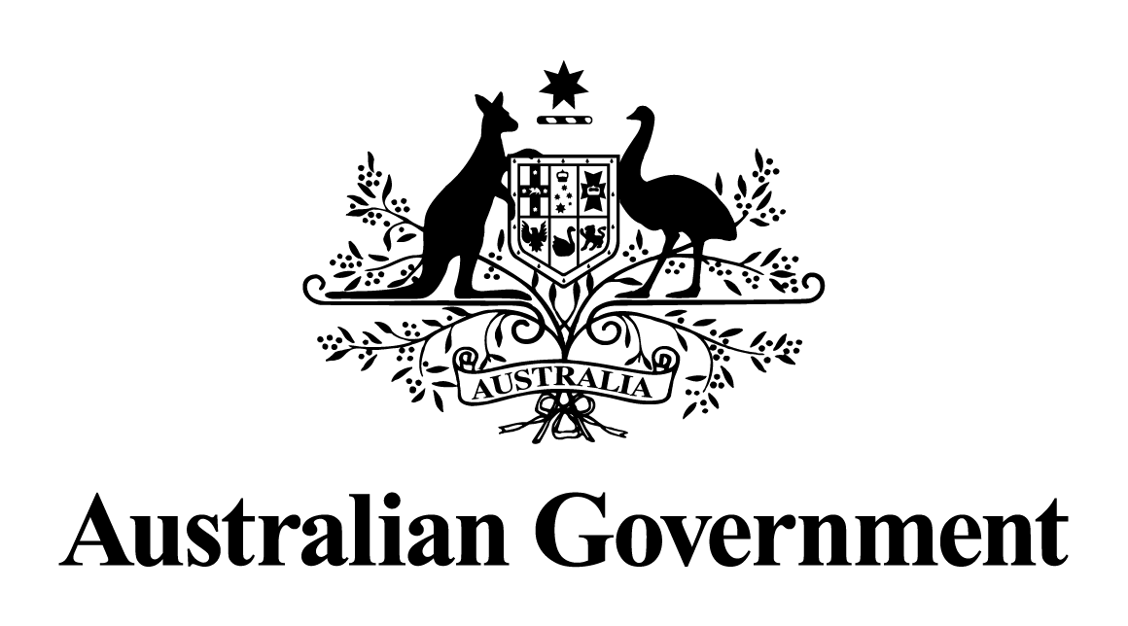

Australian Government response to the   
Senate Committee on Economics report:

Superannuation (Objective) Bill 2016 [Provisions]

May 2024

# Response to the recommendations

|  |
| --- |
| Recommendation 1  The committee recommends that the compliance of future superannuation reforms with the legislated objective be periodically assessed and reported on as part of the Intergenerational Report.  Australian Government response  The Government **notes** this recommendation. However, given the passage of time since this report was tabled, a substantive Government response is no longer appropriate. |
| Dissenting Report by Labor Senators - Recommendation 2  The Government recommence discussions with the Opposition and with stakeholders to reach broad political and industry support for a superannuation objective.  Australian Government response  The Government **notes** this recommendation. However, given the passage of time since this report was tabled, a substantive Government response is no longer appropriate. |