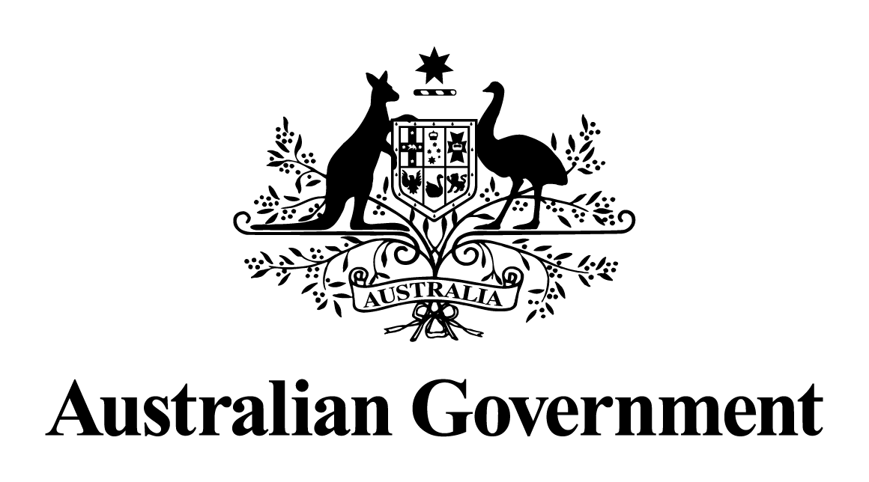

Australian Government response to the   
Senate Committee on Economics report:

Regulatory framework for the protection of consumers in the banking, insurance and financial services sector

May 2024

# Response to the recommendations

|  |
| --- |
| Recommendation 1  The committee recommends that the Commonwealth Government give the Royal Commission into Misconduct in the Banking, Superannuation and Financial Services Industry an extension of time to report.  Australian Government response  The Government **notes** this recommendation. However, given the passage of time since this report was tabled, a substantive Government response is no longer appropriate. |
| Recommendation 2  The committee recommends that the Commonwealth Government provide a response to the Parliamentary Joint Committee on Corporations and Financial Services' inquiry into the impairment of customer loans.  Australian Government response  The Government **notes** this recommendation. However, given the passage of time since this report was tabled, a substantive Government response is no longer appropriate. |
| Recommendation 3  The committee recommends that the Commonwealth Government consider increased funding for community legal and financial counselling services dealing with victims of financial misconduct.  Australian Government response  The Government **notes** this recommendation. However, given the passage of time since this report was tabled, a substantive Government response is no longer appropriate. |