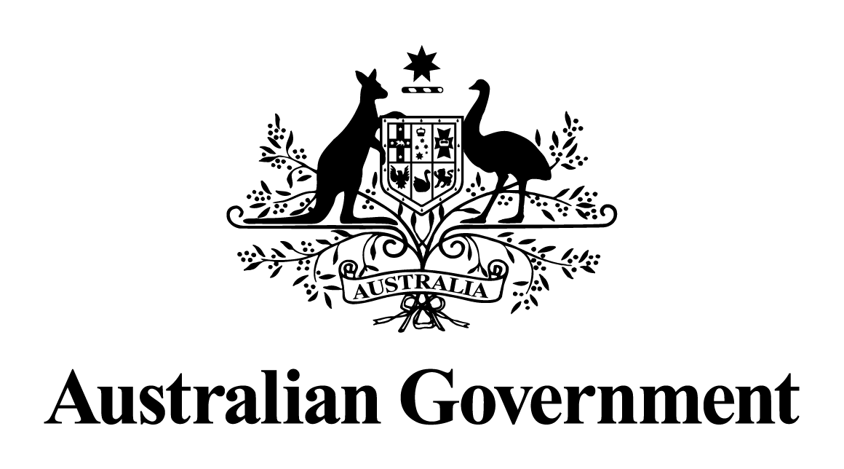

Australian Government response to the   
Senate Select Committee on Red Tape report:

Effect of red tape on the sale, supply and taxation of alcohol — Interim report

May 2024

# Response to the recommendations

|  |
| --- |
| Recommendation 1  The committee recommends that the Australian Government: provide leadership on the issue of alcohol taxation by establishing clear policy objectives for the taxation of alcohol; and progress the reform of alcohol taxation, including: introduction of a single volumetric tax rate across all alcohol products, to be phased in to allow reasonable adjustment; enactment of legislative changes to enable monthly settlement of alcohol tax liability for big businesses and quarterly settlement of alcohol tax liability for small businesses, with the Australian Taxation Office to be granted discretion to further extend settlement periods based on trading terms.  Australian Government response  The Government **notes** this recommendation. However, given the passage of time since this report was tabled, a substantive Government response is no longer appropriate. |
| Recommendation 2  The committee recommends that the Australian Taxation Office move toward the provision of online services as expeditiously as possible, to facilitate applications for manufacturer and storage licences, as well as movement permissions, in respect of excise equivalent goods.  Australian Government response  The Government **notes** this recommendation. However, given the passage of time since this report was tabled, a substantive Government response is no longer appropriate. |
| Recommendation 3  The committee recommends that the Australian Government and COAG support the sale and supply of alcohol through consideration and implementation of evidence-based policies that aim to reduce red tape and promote job creation, and business growth and investment, including: recognition of Responsible Service of Alcohol certification acquired interstate, whether through online or face-to-face training; streamlining and simplification of liquor licencing systems to reduce the number and types of licences/permits to a minimum viable level; allowing packaged alcohol to be sold in convenience stores, petrol stations and supermarkets; abolishing restrictions on trading hours for liquor stores; shifting resources toward targeted enforcement of existing regulation, rather than a blanket approach of increased regulation for all licensees; developing liquor licensing fees based on empirical assessments of risk, rather than social perceptions of risk.  Australian Government response  The Government **notes** this recommendation. However, given the passage of time since this report was tabled, a substantive Government response is no longer appropriate. |