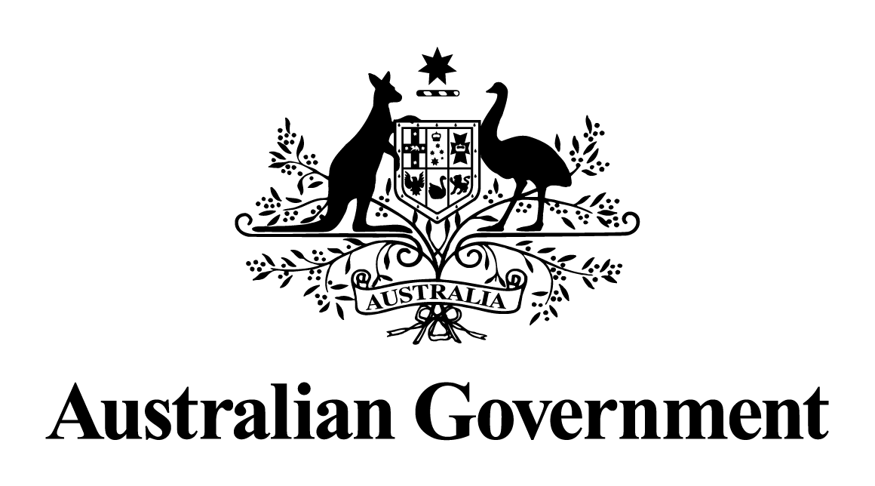

Australian Government response to the   
Senate Committee on Economics report:

Corporate tax avoidance—Part II: Gaming the system

May 2024

# Response to the recommendations

|  |
| --- |
| Recommendation 1  The committee recommends that the inquiry be extended until 30 September 2016 to explore the implications arising from the Panama Papers.  Australian Government response  The Government **notes** this recommendation. However, given the passage of time since this report was tabled, a substantive Government response is no longer appropriate. |
| Additional Comments from the Australian Greens - Recommendation 1  That the government implements a comprehensive response to corporate tax avoidance, starting with the establishment of a public register of beneficial ownership and a public register of tax settlements.  Australian Government response  The Government **notes** this recommendation. However, given the passage of time since this report was tabled, a substantive Government response is no longer appropriate. |