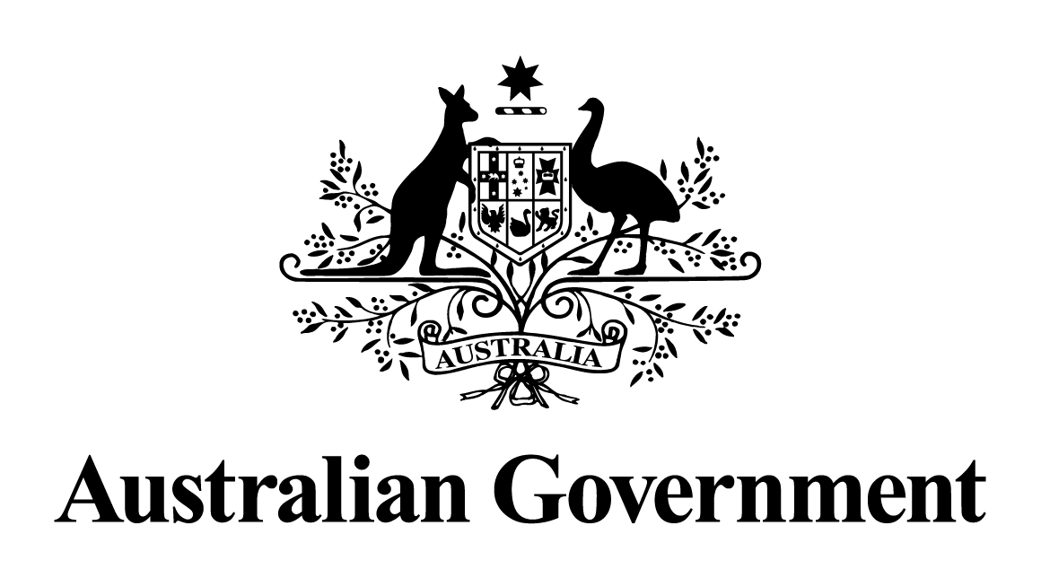
Australian Government response to the
Senate Committee on Environment and Communications report:
Competition and Consumer Amendment (Prevention of Exploitation of Indigenous Cultural Expressions) Bill 2019
May 2024

Response to the recommendations
Recommendation 1
The committee recommends that the Commonwealth consult Indigenous artists, organisations and communities to develop legislation to prohibit the sale of inauthentic Indigenous products sold as souvenirs, either through amendment of the Competition and Consumer Act 2010 or through another mechanism.
Australian Government response
The Government notes this recommendation. However, given the passage of time since this report was tabled, a substantive Government response is no longer appropriate.
Labor Senators' dissenting report - Recommendation 1
Labor Senators call on the Government to respond to the 2018 HRSCIA ‘Report on the impact of inauthentic art and craft in the style of First Nations peoples’, as a matter of urgency.
Australian Government response
The Government notes this recommendation. However, given the passage of time since this report was tabled, a substantive Government response is no longer appropriate.
Labor Senators' dissenting report - Recommendation 2
Labor Senators call on the Government to work with First Nations people on a comprehensive legislative framework to prevent exploitation through inauthentic art, craft and cultural expression, and address deficiencies with the current Bill; consistent with the recommendations of the HRSCIA report.
Australian Government response
The Government notes this recommendation. However, given the passage of time since this report was tabled, a substantive Government response is no longer appropriate.

