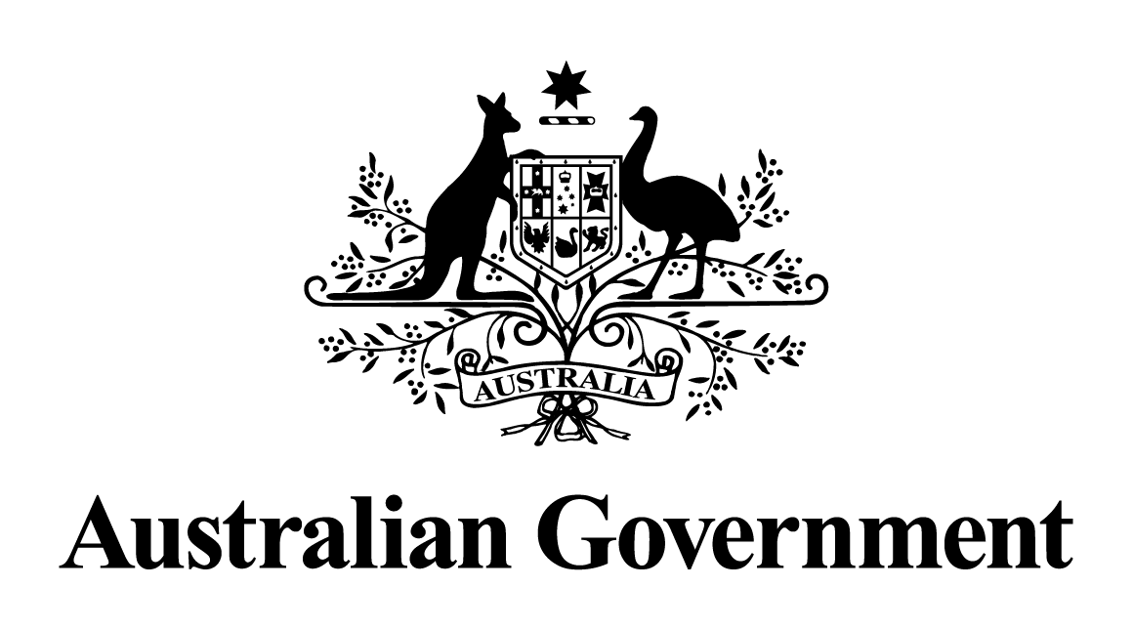
Australian Government response to the
Joint Committee on Corporations and Financial Services report:
Options for greater involvement by private sector life insurers in worker rehabilitation
May 2024

Response to the recommendations
Recommendation 1
The committee recommends that the Australian Securities and Investments Commission undertake a thorough investigation of the use of in-house rehabilitation services in the life insurance industry to determine whether all the concerns, (including inappropriate financial incentives) regarding the Financial Services Council's proposal have been resolved for the current non-medical rehabilitation services.
Australian Government response
The Government notes this recommendation. However, given the passage of time since this report was tabled, a substantive Government response is no longer appropriate.
Recommendation 2
The committee recommends that the life insurance industry be required to disclose all of its discretionary, off-contract arrangements to the Australian Securities and Investments Commission and that these arrangements be examined.
Australian Government response
The Government notes this recommendation. However, given the passage of time since this report was tabled, a substantive Government response is no longer appropriate.
Recommendation 3
The committee recommends that the government and the life insurance industry implement the committee's recommendations from its report on the life insurance industry.
Australian Government response
The Government notes this recommendation. However, given the passage of time since this report was tabled, a substantive Government response is no longer appropriate.
Recommendation 4
The committee recommends that the government conduct a holistic analysis of the sustainability of the life insurance industry that considers all key elements of the issue, including the reasons for the prudential issues and options for reform.
Australian Government response
The Government notes this recommendation. However, given the passage of time since this report was tabled, a substantive Government response is no longer appropriate.
Recommendation 5
The committee recommends that the government not proceed with the Financial Services Council's proposal.
Australian Government response
The Government notes this recommendation. However, given the passage of time since this report was tabled, a substantive Government response is no longer appropriate.

