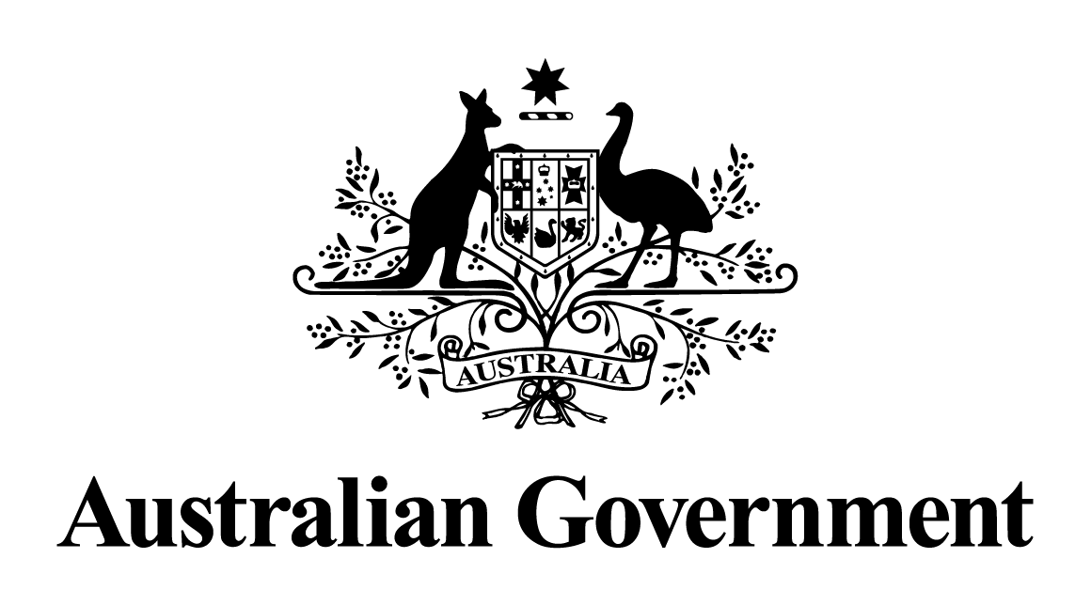
Australian Government response to the
Joint Committee on Corporations and Financial Services report:
Statutory Oversight of the Australian Securities and Investments Commission, the Takeovers Panel and the Corporations Legislation: Report No. 1 of the 45th Parliament
May 2024

Response to the recommendations
Recommendation 1
The committee recommends that ASIC devise and conduct, alongside or within its current Audit Inspection Program, a study which will generate results which are comparable over time to reflect changes in audit quality.
Australian Government response
The Government notes this recommendation. However, given the passage of time since this report was tabled, a substantive Government response is no longer appropriate.
Recommendation 2
The committee recommends that ASIC work with the International Organisation of Securities Commissions to conduct a comparative analysis of integrity and anti-corruption measures being undertaken in similar jurisdictions.
Australian Government response
The Government notes this recommendation. However, given the passage of time since this report was tabled, a substantive Government response is no longer appropriate.

