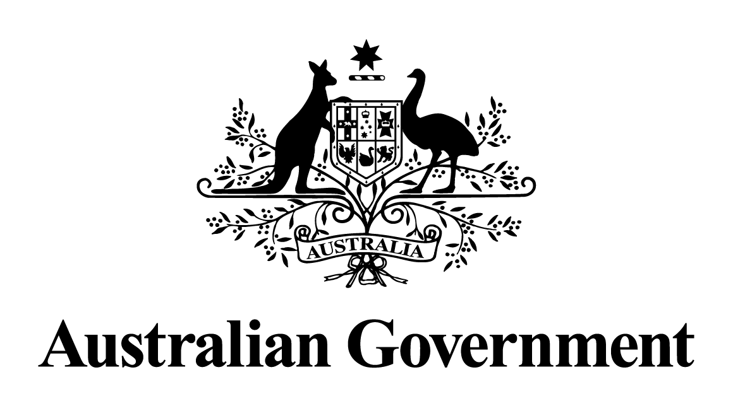
Australian Government response to the
Joint Committee on Corporations and Financial Services report:
Regulation of auditing in Australia – Interim Report
May 2024

Response to the recommendations
Recommendation 1
The committee recommends that ASIC: formally review the manner in which it publicly reports the periodic findings of its audit inspection program, giving appropriate consideration to approaches used internationally; and based on this review, develop and implement, by the end of the 2020–21 reporting period for its audit inspection program, a revised framework for reporting inspection findings, with a focus on the transparency and relative severity of identified audit deficiencies.
Australian Government response
The Government notes this recommendation. However, given the passage of time since this report was tabled, a substantive Government response is no longer appropriate.
Recommendation 2
The committee recommends that the Australian Government introduce, by the end of the 2020–21 financial year, through appropriate legislation, a requirement that ASIC publish all future individual audit firm inspection reports on its website once ASIC has adopted a revised reporting framework referred to in Recommendation 1.
Australian Government response
The Government notes this recommendation. However, given the passage of time since this report was tabled, a substantive Government response is no longer appropriate.
Recommendation 3
The committee recommends that the Financial Reporting Council, in partnership with ASIC, by the end of the 2020–21 financial year, oversee consultation, development and introduction under Australian standards of: defined categories and associated fee disclosure requirements in relation to audit and non-audit services; and a list of non-audit services that audit firms are explicitly prohibited from providing to an audited entity.
Australian Government response
The Government notes this recommendation. However, given the passage of time since this report was tabled, a substantive Government response is no longer appropriate.

Recommendation 4
The committee recommends that the Corporations Act 2001 be amended so that an auditor's independence declaration is expanded to require the auditor to specifically confirm that no prohibited non-audit services have been provided.
Australian Government response
The Government notes this recommendation. However, given the passage of time since this report was tabled, a substantive Government response is no longer appropriate.
Recommendation 5
The committee recommends that the Accounting Professional and Ethical Standards Board consider revising the APES 110 Code of Ethics to include a safeguard that no audit partner can be incentivised, through remuneration advancement or any other means or practice, for selling non-audit services to an audited entity.
Australian Government response
The Government notes this recommendation. However, given the passage of time since this report was tabled, a substantive Government response is no longer appropriate.
Recommendation 6
The committee recommends that the Financial Reporting Council, by the end of the 2020–21 financial year, oversee the revision and implementation of Australian standards to require audited entities to disclose auditor tenure in annual financial reports. Such disclosure should include both the length of tenure of the entity's external auditor, and of the lead audit partner.
Australian Government response
The Government notes this recommendation. However, given the passage of time since this report was tabled, a substantive Government response is no longer appropriate.
Recommendation 7
The committee recommends that the Corporations Act 2001 be amended to implement a mandatory tendering regime such that entities required to have their financial reports audited under the Act must: undertake a public tender process every ten years; or if an entity elects not to undertake a public tender process, the entity must provide an explanation to shareholders in its annual report as to why this has not occurred. The committee further recommends that such a tender process be implemented by 2022 for any entity that has had the same auditor for a continuous period of ten years since 2012.
Australian Government response
The Government notes this recommendation. However, given the passage of time since this report was tabled, a substantive Government response is no longer appropriate.
Recommendation 8
The committee recommends that the Financial Reporting Council oversee a formal review, to report by the end of the 2020–21 financial year, of the sufficiency and effectiveness of reporting requirements under the Australian standards in relation to: the prevention and detection of fraud; and management's assessment of going concern.
Australian Government response
The Government notes this recommendation. However, given the passage of time since this report was tabled, a substantive Government response is no longer appropriate.
Recommendation 9
The committee recommends that the Corporations Act 2001 be amended such that entities required to have their financial reports audited under the Act must establish and maintain an internal controls framework for financial reporting. In addition, such amendments should require that: management evaluate and annually report on the effectiveness of the entity's internal control framework; and the external auditor report on management's assessment of the entity's internal control framework.
Australian Government response
The Government notes this recommendation. However, given the passage of time since this report was tabled, a substantive Government response is no longer appropriate.
Recommendation 10
The committee recommends that the Australian Government take appropriate action to make digital financial reporting standard practice in Australia.
Australian Government response
The Government notes this recommendation. However, given the passage of time since this report was tabled, a substantive Government response is no longer appropriate.

