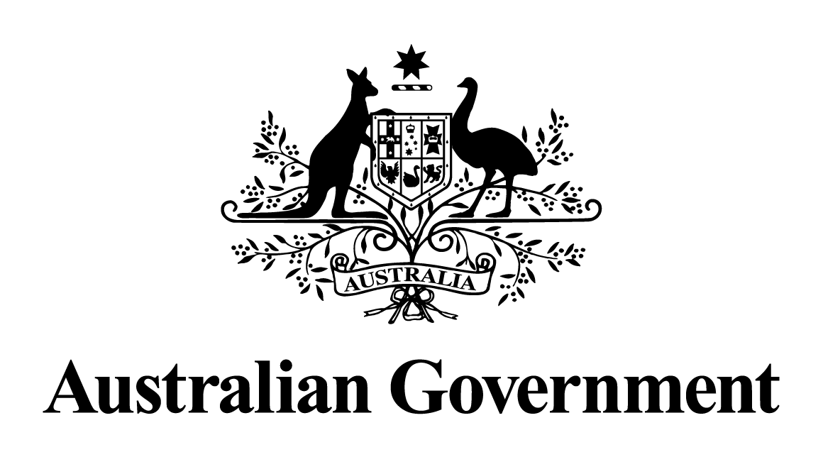
Australian Government response to the
Joint Committee on Corporations and Financial Services report:
Regulation of Auditing in Australia: Final Report
May 2024

Response to the recommendations
Dissenting report by the Australian Greens - Recommendation 1
That any firm that provides audit services for a significant proportion (for example, more than 5 per cent) of companies capitalised or operating in Australia be prevented from providing non-audit services.
Australian Government response
The Government notes this recommendation. However, given the passage of time since this report was tabled, a substantive Government response is no longer appropriate.
Dissenting report by the Australian Greens - Recommendation 2
That the regulatory regime for auditing be simplified, with a single body being responsible for accounting, auditing and assurance standards; and another body being responsible for enforcement, currently ASIC.
Australian Government response
The Government notes this recommendation. However, given the passage of time since this report was tabled, a substantive Government response is no longer appropriate.

