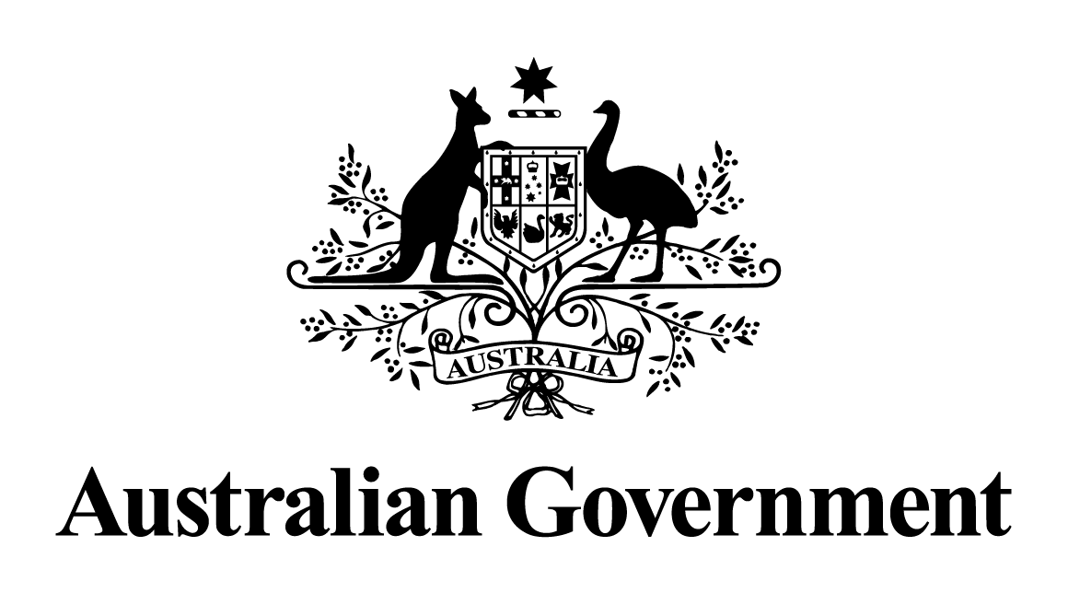
Australian Government response to the
Joint Committee on Corporations and Financial Services report:
Corporations Amendment (Improving Outcomes for Litigation Funding Participants) Bill 2021
May 2024

Response to the recommendations
Dissenting Report by Labor Members - Recommendation 2
If the Government insists on proceeding with the bill, it should not do so until:
- The bill has been the subject of a proper inquiry process (whether by this committee or another parliamentary committee). Necessarily, such an inquiry must provide witnesses with sufficient time to respond to questions.
- The Attorney-General’s Department has comprehensively addressed, in writing, the concerns raised by Justin Gleeson SC and other legal experts about the constitutionality of the bill.
Australian Government response
The Government notes this recommendation. However, given the passage of time since this report was tabled, a substantive Government response is no longer appropriate.

